Ferrocene heteroconjugation of DNA duplex aids Fowler–Nordheim tunnelling.

Supplementary Information

- Synthesis of psoralen compounds 2
- Synthesis of ferrocenylpsoralen-DNA conjugate 3
- Self-assembly of DNA and atomic force microscopy imaging 4
- Determination of electrical parameters for the tunnel diode based on Fowler-Nordheim theory 5
- Estimation of the contact parameters between the Pt-probe and the FcDNA SAs using Hertz's theory 8
- Supplementary information references 9

- Synthesis of psoralen compounds
2 g of trioxsalen (4,5',8-trimethylpsoralen, Sigma-Aldrich, Co., St. Louis, MO, USA) was dissolved in 230 mL of glacial acetic acid with gentle heating (45°C). After being allowed to cool, 7.6 mL of chloromethyl methyl ether (Tokyo Chemical Industry Co., Ltd., Tokyo, Japan) was added (caution: chloromethyl methyl ether is highly toxic and causes severe skin burns, requiring extreme caution when handled). The reaction mixture was allowed to react for 72 hours at room temperature¹. Let the solution stand overnight at 4 °C, and 4'-chloromethyl-4,5',8-psolaren was obtained as a white flocculent precipitate. 0.5 g of the intermediate product was dissolved in 8 mL of CHCl₃ and mixed with 8 mL of a CHCl₃ solution containing 0.44 g of N, N-dimethylaminomethyl ferrocene (Tokyo Chemical Industry Co., Ltd., Tokyo, Japan). The solution was heated at 75 °C with stirring for four hours, then the target compound (FcPSO) was obtained as a pale yellow precipitate. During the synthetic procedure, the reaction mixture was protected from exposure to light. As a control, a psoralen derivative having a quaternary ammonium functional group, 4'-[1-(trimethylammonium)methyl]-4,5',8-trimethylpsoralen chloride (TMAPSO) was synthesised according to the procedure as described.²

4'-[1-(N,N-dimethy-N-ferrocenylmethylammonium)methyl]-4,5',8-trimethylpsolaren chloride (FcPSO). HPLC (linear gradient separation from 0.1% TFA to 70% acetonitrile (0.1 % TFA) in 40 min on a C18 silica column): t_{R}=32.5 min (single peak); ¹H-NMR (400 MHz, CDCl₃, TMS): δ 8.10 p.p.m. (s, 1H, H-5), 6.25 (s, 1H, H-3), 4.80 (m, 2H, H-Cp-3, -4), 4.45 (m, 2H, H-Cp-2, -5), 4.35 (m, 5H, H-Cp), 4.11 (s, 4H, Ar-H), 2.90 (s, 8H, CH₂N(CH₃)₂), 2.05 (s, 11H, Ar-CH₃); UV/vis: λ_{max} 245, 290, 335 nm; MALDI MS (m/z): [M+] calcd for C₂₈H₃₀FeNO₃ 484.388, found 483.5; analysis (% calcd, % found for C₂₈H₃₀ClFeNO₃•2H₂O): C (60.50, 60.43), H (6.17, 6.00), N (2.52, 2.57); Cyclic voltammetry: E°' +0.184 V (Ag/AgCl).
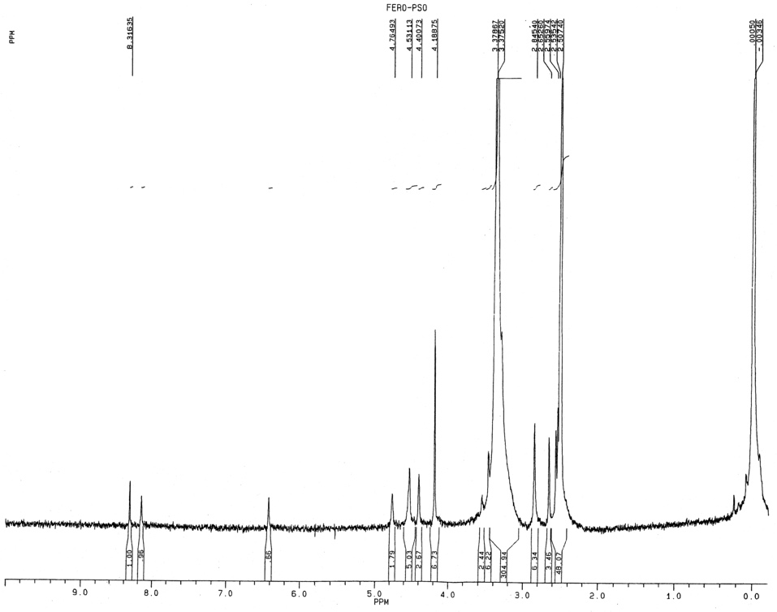

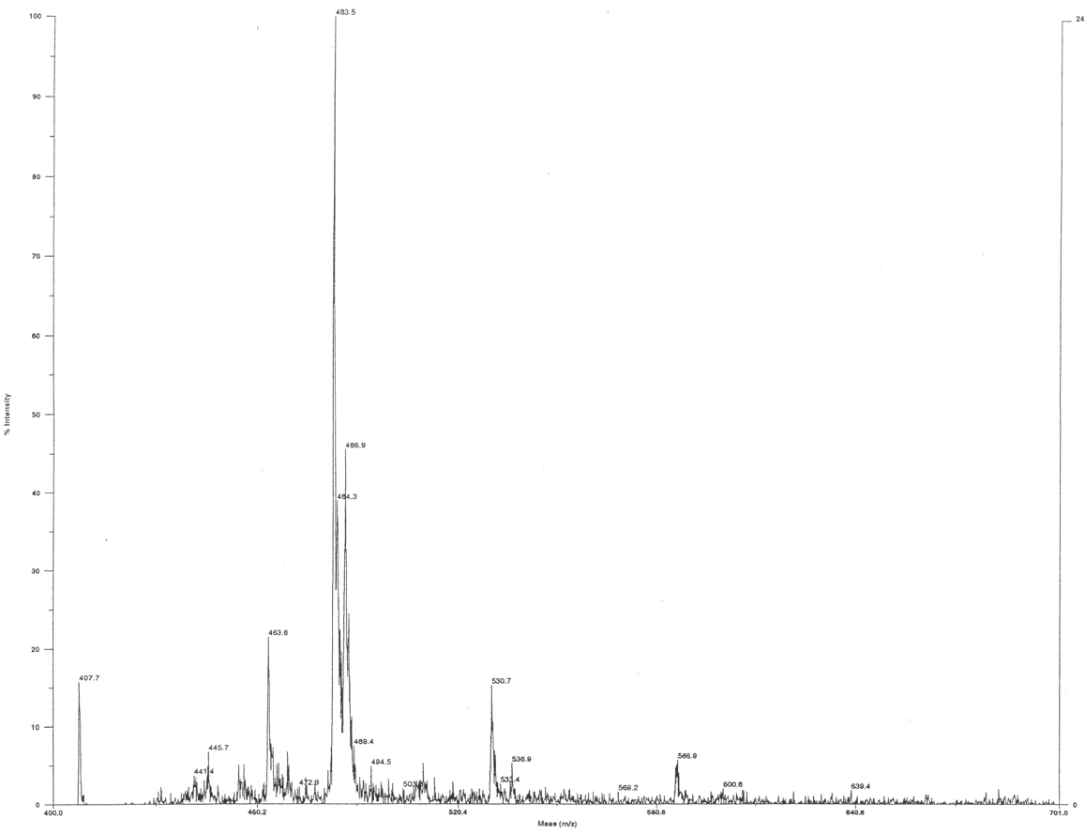
b)
- Synthesis of ferrocenylpsoralen-DNA conjugate
All DNA sequences were obtained from custom synthesis and were used as received. The DNA sequences, either thiol-modified, 5'-HS-(AT)₅-3', or native form, 5'-(TA)₅-3' were dissolved in TEAA buffer solution. Each 10 μL portion containing 10 nmol DNA was mixed with a 70 µL portion of TEAA buffer, and the solution was heated at 35 °C for one hour, followed by annealing at 8 °C for one hour. Into the solution, a 20 μL portion of FcPSO solution (20 mM in 50% DMF-H₂O) was added. The reaction mixture was equilibrated at 8 °C for one hour and then irradiated on an ice bath for 10 minutes (365 nm, 24000 µJ cm⁻²) using a UV crosslinker (CL-1000, UVP Inc.).
HPLC analysis on a C18 silica column revealed that the specific derivatisation reaction yielded a mixture of DNA conjugates (FcDNA). Among them, the baseline-resolved HPLC fractions eluted at around t_{R} = 14 min exhibited both UV absorptions for the DNA nucleobase (at 260 nm) and the psoralen moiety (at 320 nm). Each HPLC fraction detected at t_{R} = 13.55, 14.03, 14.35, and 14.61 minutes was collected and lyophilised for further experiments. MALDI MS analysis revealed that these HPLC fractions have a specific molecular mass of approximately 6,700. For the t_{R} = 14.35 fraction, an exact molecular mass of 6755.615 was detected, which is slightly lower than that of the 1:1 conjugate of dsDNA and FcPSO (6766.12). However, the experimental data can reasonably be reproduced by assuming a structure in which one of the backbone phosphoric acids is replaced with the corresponding sodium salt and the chloride ion in the (N, N-dimethyl-N-ferrocenylmethylammonium)methyl function is detached (6752.529). We used the t_{R} = 14.35 fraction for the following experiments.

- Self-assembly of DNA and atomic force microscopy imaging
Evaporated gold films having (111) texture (1.25×1.25 cm, Agilent Technologies, Inc., Santa Clara, CA, USA) were used as received. In a sealed chamber purged with N₂ gas, either the 5 μM solution of the native dsDNA or the FcPSO conjugate (t_{R} = 14.35) solution was immediately cast atop the substrate surface. The substrate was then placed in an airtight vessel that maintained saturated humidity to prevent dryness. Self-assembly was allowed to proceed at an ambient temperature (25 °C) for 24 hours. Finally, the substrate was rinsed thoroughly with TEAA, followed by sterile water, and then dried under reduced pressure for 1 hour.
AFM measurements were made using a JSPM-4210 scanning probe microscope (JEOL Ltd., Tokyo, Japan). For conductive AFM (CAFM) measurements, silicone-nitride cantilevers with Pt surface coating (JEOL Ltd. CSC-38, k = 0.03 N/m, f₀ = 10 kHz, r = 30 nm) were used throughout the study. In CAFM, the Pt-probe had the GND potential, and a differential voltage supply controlled the bias of the Au(111) substrate. The instrument was equipped with a current-voltage (I-V) converter utilising an op-amp to detect current. During the measurement, the sample environment was maintained in a vacuum using a turbo molecular pump (approximately 10⁻⁴ Pa). CAFM images were obtained at a 512 × 512 pixel resolution under contact mode operation, with the external voltage of the tip maintained at a specific value. In the case of I-V measurement, the instrument was initially operated in an autoregulatory approach control. Then the Pt-probe was manually overridden to give zero contact force. The bias voltage was scanned from +10 V to –10 V in 16 milliseconds, and the collected data were averaged over 10 successive scans.
For non-contact (NC) imaging, the instrument was operated in frequency-modulation detection mode. Silicon cantilevers (MikroMasch Ltd., k = 14.0 N/m, f₀ = 315 kHz) were used throughout the experiments. All NCAFM images were obtained with a 512×512 pixel resolution. Some standard image processing filters reduced the noise in the raw data, which was provided by Gwyddion data visualisation and analysis software.³

- Determination of electrical parameters for the tunnel diode based on Fowler-Nordheim theory
The Fowler-Nordheim tunnelling theory well explains electron emission from a metal surface into the vacuum.⁴⁻⁶ The relationship between the emission current, I, and the applied voltage, V.
$$I=\frac{AV^{2}}{sϕ_{b}}exp\left(\frac{-Bs{\left(ϕ_{b}\right)}^{\frac{3}{2}}}{V}\right) (S1)$$
where A and B are constants, V is the applied voltage driving electron emission, s is the thickness of the barrier, and $ϕ_{b}$ is the barrier height. Eq. (S1) further leads to the Fowler-Nordheim plot, representing a linear dependence between $\ln\left(\left|I/{V^{2}}\right|\right)$ and $1/V$. According to the literatures, the electron tunnelling to a metal-insulator-metal (MIM) thin-film structure is defined, featuring two barriers, $ϕ_{b1}$ and $ϕ_{b2}$, block the conducting electrons.⁵⁻⁷ The tunnelling current is Eq. (S2) for a MIM diode using dissimilar metals.
$$I=\frac{A{\left(V+∆ϕ\right)}^{2}}{sϕ_{b}}exp\left(\frac{-Bs{\left(ϕ_{b}\right)}^{\frac{3}{2}}}{V+∆ϕ}\right) (S2)$$
Where $∆ϕ=ϕ_{b1}-ϕ_{b2}$ is the difference in barrier heights.
With the energy band diagram of the FcDNA MIM diode, when the magnitudes of a positive voltage $V^{+}$ exceed the collecting barrier height $ϕ_{b2}$, forward current $I^{+}$ flows as given in Eq. (S3).

$$I^{+}=\frac{\left(Area\right)C_{1}}{ϕ_{b1,Pt}}∙\frac{{\left(V+∆ϕ\right)}^{2}}{s^{2}}∙exp\left(-C_{2}\sqrt{m^{*}}{\left(ϕ_{b1,Pt}\right)}^{\frac{3}{2}}\frac{s}{V+∆ϕ}\right) \left(S3\right)$$

Where (Area) is the device area, $ϕ_{b1}$ is the height of the injecting barrier formed between the Pt-probe and FcDNA SAs (thicknesses), and $m^{*}$ is the tunnelling effective mass of an electron in FcDNA SAs. $Δϕ$ is the difference between the two barrier heights, $∆ϕ=ϕ_{b,Pt}-ϕ_{b,Au}$.
$C_{1}$ and $C_{1}$ are equal to Eq. (S4) and Eq. (S5), respectively.

$$C_{1}=\frac{2.2q^{2}}{8πh}=3.4×{10}^{-6} \left(S4\right)$$

$$C_{2}=\frac{23π\sqrt{qm_{0}}}{6h}=6.9×{10}^{9} (S5)$$

Where $q$ is the charge of an electron, $h$ is Planck's constant, and $m_{0}$ is the electron rest mass. As defined, both C₁ and C₂ are entirely universal constants, and are not related to the material properties of the MIM components.
Similarly, the reverse current $I^{-}$, to the minus direction, is by Eq. (S6).

$$I^{-}=\frac{-\left(Area\right)C_{1}}{ϕ_{b2,Au}}∙\frac{{\left(V+∆ϕ\right)}^{2}}{s^{2}}∙exp\left(-C_{2}\sqrt{m^{*}}{\left(ϕ_{b,Au}\right)}^{\frac{3}{2}}\frac{s}{V+∆ϕ}\right) \left(S6\right)$$

Where $ϕ_{b2,Au}$ is the injection barrier height between FcDNA and the Au(111) substrate. Eqs. (S3) and (S6) are linearised as (S7) and (S8), respectively.

$$\log\left(\frac{I^{+}}{{\left(V+∆ϕ\right)}^{2}}\right)=\frac{-C_{2}s\sqrt{m^{*}}{\left(ϕ_{b,Pt}\right)}^{\frac{3}{2}}}{2.3}\frac{1}{V+∆V}+\log\left(\frac{\left(Area\right)C_{1}}{s^{2}ϕ_{b,Pt}}\right) \left(S7\right)$$

$$\log\left(\left|\frac{I^{-}}{{\left(V+∆ϕ\right)}^{2}}\right|\right)=\frac{-C_{2}s\sqrt{m^{*}}{\left(ϕ_{b,Pt}\right)}^{\frac{3}{2}}}{2.3}\frac{1}{V+∆V}+\log\left(\frac{\left(Area\right)C_{1}}{s^{2}ϕ_{b,Pt}}\right) \left(S8\right)$$

Based on the energy band diagram (Fig. 5), we plotted $\log\left({I^{+}}/{{\left(V+Δϕ\right)}^{2}}\right)$ versus $1/{\left(V+Δϕ\right)}$, as well as $\log\left(\left|{I^{-}}/{{\left(V+Δϕ\right)}^{2}}\right|\right)$ versus $1/{\left(V+Δϕ\right)}$ for the I-V data (Extended Data Fig. 2). As given by Eqs. (S9) and (S10), regression analysis determined the data set, including slope m, intercept b, and correlation coefficient R² to be –3.52, –9.64, and 0.991 for the forward current. Similarly, they were 1.99, -9.81, and 0.964 in the case of reverse bias (Eqs. (S11) and (S12)). Obtaining these data, we can finally determine the effective tunnelling mass, $m^{*}$ of an electron in FcDNA (Eq (S13)).

$$m^{+}=\frac{-C_{2}s\sqrt{m^{*}}{\left(ϕ_{b,Pt}\right)}^{\frac{3}{2}}}{2.3} (S9)$$

$$b^{+}=\log\left(\frac{\left(Area\right)C_{1}}{s^{2}ϕ_{b,Pt}}\right) \left(S10\right)$$

$$m^{-}=\frac{C_{2}s\sqrt{m^{*}}{\left(ϕ_{b,Au}\right)}^{\frac{3}{2}}}{2.3} (S11)$$

$$b^{-}=\log\left(\frac{\left(Area\right)C_{1}}{s^{2}ϕ_{b,Au}}\right) \left(S12\right)$$

$$m^{*}={\left(\frac{2.3m^{+}}{-C_{2}s{\left(ϕ_{b, Pt}\right)}^{\frac{3}{2}}}\right)}^{2}={\left(\frac{2.3m^{-}}{C_{2}s{\left(ϕ_{b, Au}\right)}^{\frac{3}{2}}}\right)}^{2} (S13)$$

- Estimation of the contact parameters between the Pt-probe and the FcDNA SA using Hertz's theory

We used Hertz's equation (S14) to estimate the mechanical parameters found at the electrical junction between the Pt probe and the FcDNA SA.⁷ Here, E is Young's modulus and $σ$ is Poisson's ratio. We set 168 GPa and 0.38 for the Pt-probe and, for DNA, 2 GPa and −0.34., By multiplying the cantilever's spring constant (0.03 N/m) by the surface roughness (0.2 nm) of the FcDNA SAM, we obtained the force applied, F_{t}. The curvature radius of the Pt-tip, R_{tip,} was 30 nm. Thus, we estimated the contact radius, r_{c}, and area to be 0.45 nm and 0.63 nm², respectively.

$$r_{c}^{3}=\frac{3}{4}\left(\frac{1-σ_{Au}}{E_{Au}}+\frac{1-σ_{DNA}}{E_{DNA}}\right)F_{t}R_{tip} \left(S14\right)$$

Supplementary information references

- Isaacs, S. T., Shen, C.-k. J., Hearst, J. E. & Rapoport, H. Synthesis and characterisation of new psoralen derivatives with superior photoreactivity with DNA and RNA. Biochemistry, 1977, 16, 1058–1064. https://doi.org/10.1021/bi00625a005
- Nakano, K., Katsumi, Y., Soh, N. & Imato, T. An Atomic Force Microscopy Assay of Intercalation Binding, Unwinding, and Elongation of DNA, Using a Water-Soluble Psoralen Derivative as a Covalent Binding Probe Molecule. Bull. Chem. Soc. Jpn., 2010, 83, 273–275. https://doi.org/10.1246/bcsj.20090166
- Nečas, D. & Klapetek, P. Gwyddion: an open-source software for SPM data analysis. Central European Journal of Physics, 2012, 10, 181–188. DOI: 10.2478/s11534-011-0096-2
- Simmons, J. Generalized Formula for Electric Tunnel Effect Between Similar Electrodes Separated by a Thin Insulating Film. G. J. App. Phys., 1963, 34, 1793–1803. https://doi.org/10.1063/1.1702682
- Simmons, J. Electric Tunnel Effect Between Dissimilar Electrodes Separated by a Thin Insulating Film. J. App. Phys., 1963, 34, 2581–2590. https://doi.org/10.1063/1.1729774
- Cowell, E. W., Muir, S. W., Keszler, D. A. & Wager, J. F. Barrier height estimation of asymmetric metal-insulator-metal tunneling diodes. J. Appl. Phys. 2013, 114, 213703. https://doi.org/10.1063/1.4839695
- K. L. Johnson, Contact Mechanics, Cambridge University Press, Cambridge, UK, 1985. https://doi.org/10.1017/CBO9781139171731

