Table S1. Factors associated with lung metastasis in synchronous metastatic colorectal cancer patients (n = 19,161).
Variable | Lung metastasis |  | Pearson χ² P-value | Multivariate analysis
Variable | Yes; n = 5,601  No. (%) | No; n = 13,560  No. (%) | Pearson χ² P-value | OR | 95% CI | P-value
Age, years old |  |  | <0.001
0-49 | 819 (26.45) | 2,277 (73.55) |  | 1.000
50-64 | 2,155 (28.77) | 5,335 (71.23) |  | 1.148 | (1.034,1.275) | 0.009
65-79 | 1,851 (30.95) | 4,130 (69.05) |  | 1.271 | (1.140,1.417) | <0.001
≥80 | 776 (29.92) | 1,818 (70.08) |  | 1.165 | (1.020,1.329) | 0.024
Sex |  |  | 0.156 | NI
Male | 3,084 (28.82) | 7,618 (71.18)
Female | 2,517 (29,76) | 5,942 (70.24)
Race |  |  | <0.001
White | 4,077 (28.41) | 10,275 (71.59) |  | 1.000
Black | 940 (30.92) | 2,100 (69.08) |  | 1.157 | (1.053,1.272) | 0.002
Other | 584 (33.01) | 1,185 (66.99) |  | 1.220 | (1.086,1.372) | 0.001
Location |  |  | <0.001
Right colon | 1,621 (23.88) | 5,167 (76.12) |  | 1.000
Left colorectal | 3,548 (31.92) | 7,568 (68.08) |  | 1.299 | (1.202,1.405) | <0.001
Unknown | 432 (34.37) | 8,25 (65.63) |  | 1.111 | (0.954,1.292) | 0.175
Tumor size |  |  | <0.001
<3cm | 311 (24.74) | 946 (75.26) |  | 1.000
≥3 & <5cm | 1,061 (25.49) | 3,102 (74.51) |  | 1.285 | (1.087,1.519) | 0.003
≥5cm | 1,969 (26.55) | 5,446 (73.45) |  | 1.342 | (1.145,1.574) | <0.001
Unknown | 2,260 (35.73) | 4,066 (64.27) |  | 1.389 | (1.180,1.635) | <0.001
T stage |  |  | <0.001
T0-3 | 2,465 (26.57) | 6,814 (73.43) |  | 1.000
T4 | 1,251 (26.40) | 3,488 (73.60) |  | 1.089 | (0.995,1.193) | 0.065
Tx | 1,885 (36.65) | 3,258 (63.35) |  | 1.200 | (1.090,1.323) | <0.001
N stage |  |  | <0.001
N0 | 1,894 (30.93) | 4,229 (69.07) |  | 1.000
N1 | 1,906 (30.00) | 4,447 (70.00) |  | 1.238 | (1.132,1.353) | <0.001
N2 | 940 (21.52) | 3,429 (78.48) |  | 1.104 | (0.981,1.244) | 0.102
Nx | 861 (37.18) | 1,455 (62.82) |  | 1.137 | (1.014,1.274) | 0.028
Bone metastasis |  |  | <0.001
Yes | 582 (43.53) | 755 (56.47) |  | 1.000
No | 5,019 (28.16) | 12,805 (71.84) |  | 0.921 | (0.806,1.054) | 0.233
Brain metastasis |  |  | <0.001
Yes | 156 (48.30) | 167 (51.17) |  | 1.000
No | 5,445 (28.90) | 13,393 (71.10) |  | 1.318 | (0.999,1.739) | 0.051
Liver metastasis |  |  | <0.001
Yes | 4,061 (23.48) | 13,233 (76.52) |  | 1.000
No | 1,540 (82.49) | 327 (17.51) |  | 18.144 | (15.880,20.730) | <0.001
CEA |  |  | <0.001
Positive | 3,459 (30.42) | 7,912 (69.58) |  | 1.000
Negative | 488 (24.53) | 1,501 (75.47) |  | 0.605 | (0.530,0.690) | <0.001
Unknown | 1,654 (28.51) | 4,147 (71.49) |  | 0.835 | (0.773,0.903) | <0.001
Tumor deposit |  |  | <0.001
Positive | 673 (21.74) | 2,422 (78.26) |  | 1.000
Negative | 1,309 (21.61) | 4,747 (78.39) |  | 0.930 | (0.824,1.049) | 0.237
Unknown | 3,619 (36.15) | 6,391 (63.85) |  | 1.730 | (1.509,1.984) | <0.001
Perineural invasion |  |  | <0.001
Positive | 560 (21.88) | 1,999 (78.12) |  | 1.000
Negative | 1,977 (25.43) | 5,796 (74.57) |  | 0.995 | (0.878,1.127) | 0.938
Unknown | 3,064 (34.70) | 5,765 (65.30) |  | 1.074 | (0.931,1.238) | 0.329
Grade |  |  | <0.001
I | 242 (30.63) | 548 (69.37) |  | 1.000
II | 2,854 (28.58) | 7,133 (71.42) |  | 1.030 | (0.865,1.227) | 0.740
III | 803 (23.78) | 2,574 (76.22) |  | 0.758 | (0.626,0.918) | 0.005
IV | 130 (21.14) | 485 (78.86) |  | 0.795 | (0.604,1.046) | 0.102
Unknown | 1,572 (35.79) | 2,820 (64.21) |  | 1.055 | (0.877,1.268) | 0.573
Abbreviations: CEA, carcinoembryonic antigen; CI, confidence interval; NI, not included; OR, odds ratio.

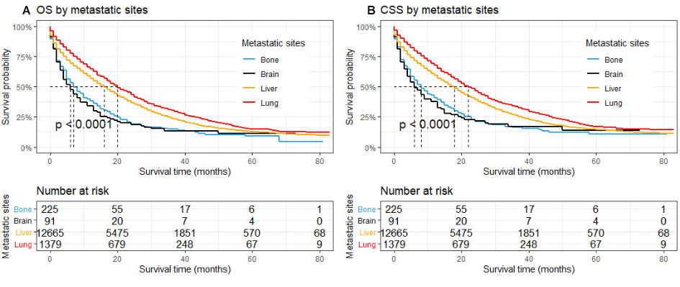
Figure S1. Kaplan-Meier curves of OS (A) and CSS (B) for patients with only bone, brain, liver, or lung metastasis (n = 14,360).

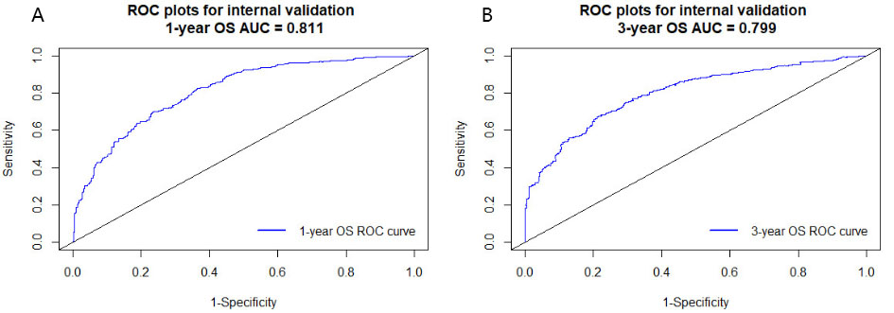
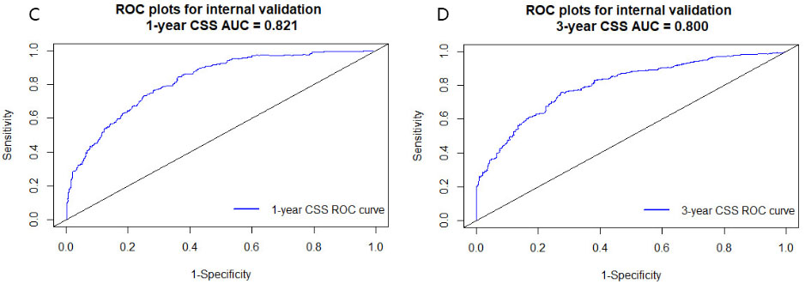
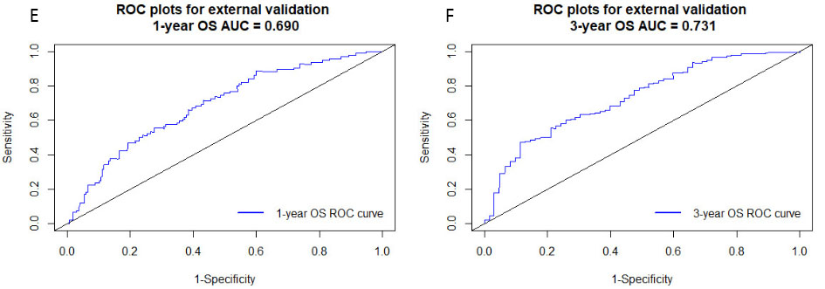
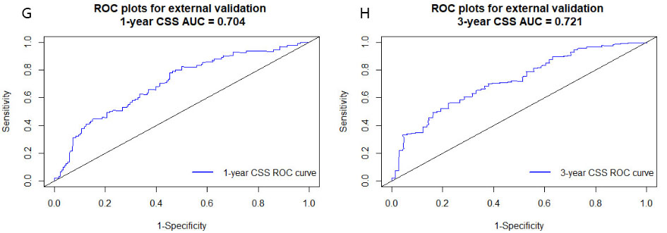
Figure S2. ROC analysis for internal and external validation cohorts
(A, B) The ROC of 1- and 3-year OS for internal validation; (C, D) the ROC of 1- and 3-year CSS for internal validation; (E, F) the ROC of 1- and 3-year OS for external validation; (G, H) the ROC of 1- and 3-year CSS for external validation.

