Prognostic Factors Analysis in Breast Cancer Patients with Brain Metastases: Identification of Key Determinants of Survival

Supplementary Material 1
Supplementary Table 1. Results of univariate and multivariate analysis of survival related factors in 505 breast cancer patients with brain metastases.
Variables | Univariate analysis |  |  |  | Multivariate analysis
Variables | P | HR (95%CI) |  | P | HR (95%CI)
Age
＞45
≤45 | 0.879 | 1.02 (0.83 ~ 1.25)
Menopausal conditions
No
Yes | 0.356 | 1.11 (0.89 ~ 1.37)
Histological grade
1 grade
2 grade | 0.207 | 1.77 (0.73 ~ 4.31)
3 grade | 0.780 | 1.04 (0.80 ~ 1.34)
unknow | 0.820 | 0.97 (0.72 ~ 1.30)
T stage
T1
T2 | 0.974 | 1.01 (0.67 ~ 1.50)
T3 | 0.380 | 1.23 (0.78 ~ 1.94)
T4 | 0.891 | 0.97 (0.64 ~ 1.48)
Tx | 0.313 | 1.23 (0.82 ~ 1.83)
N stage
N0
N1 | 0.647 | 1.08 (0.77 ~ 1.52)
N2 | 0.868 | 0.97 (0.67 ~ 1.41)
N3 | 0.218 | 1.25 (0.88 ~ 1.77)
Nx | 0.297 | 1.20 (0.85 ~ 1.69)
M stage
M 0
M1 | 0.229 | 0.86 (0.66 ~ 1.10)
Estrogen receptor
Negative
Positive | 0.671 | 0.95 (0.76 ~ 1.19)
unknown | 0.705 | 0.93 (0.65 ~ 1.34)
HER2
Negative
Positive | 0.102 | 0.81 (0.64 ~ 1.04)
unknown | 0.841 | 1.03 (0.80 ~ 1.33)
Molecular subtyping
Luminal A
Luminal B | 0.082 | 0.72 (0.50 ~ 1.04) |  | 0.078 | 0.71 (0.49 ~ 1.04)
HER2 overexpression type | 0.094 | 0.70 (0.46 ~ 1.06) |  | 0.140 | 0.71 (0.46 ~ 1.12)
Triple negative type | 0.742 | 0.93 (0.62 ~ 1.41) |  | 0.644 | 0.90 (0.59 ~ 1.39)
unknown | 0.173 | 0.76 (0.51 ~ 1.13) |  | 0.066 | 0.69 (0.46 ~ 1.02)
Neoadjuvant chemotherapy
No
Yes | 0.089 | 0.83 (0.68 ~ 1.03) |  | 0.584 | 0.94 (0.74 ~ 1.18)
Breast Surgery
No
Radical surgery | 0.666 | 1.06 (0.82 ~ 1.37)
Breast-conserving surgery | 0.609 | 0.88 (0.54 ~ 1.44)
unknown | 0.666 | 1.12 (0.68 ~ 1.85)
Adjuvant chemotherapy
No
Yes | 0.075 | 1.22 (0.98 ~ 1.51) |  | 0.068 | 1.24 (0.98 ~ 1.57)
Radiotherapy for the Breast
No
Yes | 0.276 | 0.89 (0.72 ~ 1.10)
Maintenance treatment
No
Endocrine Therapy | 0.746 | 1.04 (0.81 ~ 1.34)
Targeted Therapy | 0.237 | 0.79 (0.53 ~ 1.17)
Endocrine and targeted therapy | 0.136 | 0.68 (0.41 ~ 1.13)
Chemotherapy | 0.455 | 1.13 (0.82 ~ 1.56)
Size of brain metastases
＞1cm
≤1cm | 0.903 | 0.98 (0.76 ~ 1.28)
Number of brain metastases
＞4
≤4 | 0.002 | 1.40 (1.13 ~ 1.74) |  | <.001 | 1.55 (1.23 ~ 1.95)
Leptomeningeal metastases
No
Yes | 0.009 | 1.54 (1.11 ~ 2.14) |  | 0.084 | 1.35 (0.96 ~ 1.89)
Location of brain metastases
Supratentorial transfer
Subtentorial transfer | 0.023 | 1.28 (1.03 ~ 1.58) |  | 0.166 | 1.17 (0.94 ~ 1.46)
unknown | 0.629 | 1.16 (0.64 ~ 2.08) |  | 0.167 | 1.54 (0.84 ~ 2.82)
Clinical symptoms
No
Yes | 0.919 | 1.01 (0.82 ~ 1.24)
Craniocerebral surgery
No
Yes | 0.032 | 0.65 (0.44 ~ 0.96) |  | 0.100 | 0.71 (0.48 ~ 1.07)
Endocrine Therapy
No
Yes | 0.064 | 0.79 (0.62 ~ 1.01) |  | 0.259 | 0.86 (0.66 ~ 1.12)
Chemotherapy
No
Yes | 0.045 | 0.80 (0.65 ~ 0.99) |  | 0.661 | 0.95 (0.74 ~ 1.21)
Targeted Therapy
No
Yes | 0.085 | 0.80 (0.63 ~ 1.03) |  | 0.904 | 1.02 (0.75 ~ 1.39)
Craniocerebral radiotherapy
No
Yes | <.001 | 0.52 (0.42 ~ 0.64) |  | <.001 | 0.47 (0.38 ~ 0.60)

Supplementary Table 2. Baseline table before and after propensity matching between TBI group and non-TBI group.
Variable | Before PSM |  |  |  |  |  |  | After PSM
Variable | Total (n = 505) | No RT (n = 212) | RT (n = 293) | Statistic | P | SMD |  | Total (n = 308) | No RT (n = 154) | RT (n = 154) | Statistic | P | SMD
Histological grade, n (%) |  |  |  | - | 0.877 |  |  |  |  |  | - | 0.655
unknown | 304 (60.2) | 131 (61.79) | 173 (59.04) |  |  | -0.056 |  | 184 (59.74) | 93 (60.39) | 91 (59.09) |  |  | -0.026
I grade | 6 (1.19) | 3 (1.42) | 3 (1.02) |  |  | -0.039 |  | 2 (0.65) | 0 (0.00) | 2 (1.30) |  |  | 0.115
II grade | 112 (22.18) | 45 (21.23) | 67 (22.87) |  |  | 0.039 |  | 65 (21.1) | 34 (22.08) | 31 (20.13) |  |  | -0.049
III grade | 83 (16.44) | 33 (15.57) | 50 (17.06) |  |  | 0.040 |  | 57 (18.51) | 27 (17.53) | 30 (19.48) |  |  | 0.049
Estrogen receptor, n (%) |  |  |  | χ²=16.121 | <.001 |  |  |  |  |  | χ²=0.232 | 0.890
Negative | 194 (38.42) | 71 (33.49) | 123 (41.98) |  |  | 0.172 |  | 129 (41.88) | 64 (41.56) | 65 (42.21) |  |  | 0.013
Positive | 259 (51.29) | 106 (50.00) | 153 (52.22) |  |  | 0.044 |  | 155 (50.32) | 79 (51.30) | 76 (49.35) |  |  | -0.039
unknown | 52 (10.3) | 35 (16.51) | 17 (5.80) |  |  | -0.458 |  | 24 (7.79) | 11 (7.14) | 13 (8.44) |  |  | 0.047
Age, n (%) |  |  |  | χ²=0.727 | 0.394 |  |  |  |  |  | χ²=0.211 | 0.646
＜45 | 216 (42.77) | 86 (40.57) | 130 (44.37) |  |  | 0.077 |  | 136 (44.16) | 66 (42.86) | 70 (45.45) |  |  | 0.052
≥45 | 289 (57.23) | 126 (59.43) | 163 (55.63) |  |  | -0.077 |  | 172 (55.84) | 88 (57.14) | 84 (54.55) |  |  | -0.052
Menopausal conditions, n (%) |  |  |  | χ²=5.680 | 0.017 |  |  |  |  |  | χ²=0.891 | 0.345
No | 314 (62.18) | 119 (56.13) | 195 (66.55) |  |  | 0.221 |  | 194 (62.99) | 93 (60.39) | 101 (65.58) |  |  | 0.109
Yes | 191 (37.82) | 93 (43.87) | 98 (33.45) |  |  | -0.221 |  | 114 (37.01) | 61 (39.61) | 53 (34.42) |  |  | -0.109
T stage, n (%) |  |  |  | χ²=10.091 | 0.039 |  |  |  |  |  | χ²=0.561 | 0.967
T1 | 43 (8.51) | 15 (7.08) | 28 (9.56) |  |  | 0.084 |  | 30 (9.74) | 14 (9.09) | 16 (10.39) |  |  | 0.043
T2 | 150 (29.7) | 52 (24.53) | 98 (33.45) |  |  | 0.189 |  | 86 (27.92) | 42 (27.27) | 44 (28.57) |  |  | 0.029
T3 | 58 (11.49) | 27 (12.74) | 31 (10.58) |  |  | -0.070 |  | 36 (11.69) | 17 (11.04) | 19 (12.34) |  |  | 0.039
T4 | 110 (21.78) | 44 (20.75) | 66 (22.53) |  |  | 0.042 |  | 72 (23.38) | 38 (24.68) | 34 (22.08) |  |  | -0.063
Tx | 144 (28.51) | 74 (34.91) | 70 (23.89) |  |  | -0.258 |  | 84 (27.27) | 43 (27.92) | 41 (26.62) |  |  | -0.029
N stage, n (%) |  |  |  | χ²=13.917 | 0.008 |  |  |  |  |  | χ²=0.807 | 0.938
N0 | 75 (14.85) | 31 (14.62) | 44 (15.02) |  |  | 0.011 |  | 48 (15.58) | 24 (15.58) | 24 (15.58) |  |  | 0.000
N1 | 126 (24.95) | 46 (21.70) | 80 (27.30) |  |  | 0.126 |  | 71 (23.05) | 38 (24.68) | 33 (21.43) |  |  | -0.079
N2 | 88 (17.43) | 29 (13.68) | 59 (20.14) |  |  | 0.161 |  | 55 (17.86) | 25 (16.23) | 30 (19.48) |  |  | 0.082
N3 | 102 (20.2) | 42 (19.81) | 60 (20.48) |  |  | 0.017 |  | 64 (20.78) | 32 (20.78) | 32 (20.78) |  |  | 0.000
Nx | 114 (22.57) | 64 (30.19) | 50 (17.06) |  |  | -0.349 |  | 70 (22.73) | 35 (22.73) | 35 (22.73) |  |  | 0.000
M stage, n (%) |  |  |  | χ²=7.780 | 0.005 |  |  |  |  |  | χ²=0.266 | 0.606
M0 | 384 (76.04) | 148 (69.81) | 236 (80.55) |  |  | 0.271 |  | 226 (73.38) | 111 (72.08) | 115 (74.68) |  |  | 0.060
M1 | 121 (23.96) | 64 (30.19) | 57 (19.45) |  |  | -0.271 |  | 82 (26.62) | 43 (27.92) | 39 (25.32) |  |  | -0.060
Pathological pattern, n (%) |  |  |  | χ²=10.079 | 0.006 |  |  |  |  |  | χ²=1.864 | 0.394
Non-invasive carcinoma | 19 (3.76) | 10 (4.72) | 9 (3.07) |  |  | -0.095 |  | 10 (3.25) | 7 (4.55) | 3 (1.95) |  |  | -0.188
Invasive carcinoma | 453 (89.7) | 180 (84.91) | 273 (93.17) |  |  | 0.328 |  | 282 (91.56) | 140 (90.91) | 142 (92.21) |  |  | 0.048
unknown | 33 (6.53) | 22 (10.38) | 11 (3.75) |  |  | -0.348 |  | 16 (5.19) | 7 (4.55) | 9 (5.84) |  |  | 0.055
Neoadjuvant chemotherapy, n (%) |  |  |  | χ²=9.828 | 0.002 |  |  |  |  |  | χ²=0.117 | 0.732
No | 278 (55.05) | 134 (63.21) | 144 (49.15) |  |  | -0.281 |  | 165 (53.57) | 84 (54.55) | 81 (52.60) |  |  | -0.039
Yes | 227 (44.95) | 78 (36.79) | 149 (50.85) |  |  | 0.281 |  | 143 (46.43) | 70 (45.45) | 73 (47.40) |  |  | 0.039
HER2, n (%) |  |  |  | χ²=34.551 | <.001 |  |  |  |  |  | χ²=0.231 | 0.891
Negative | 183 (36.24) | 70 (33.02) | 113 (38.57) |  |  | 0.114 |  | 125 (40.58) | 64 (41.56) | 61 (39.61) |  |  | -0.040
Positive | 184 (36.44) | 56 (26.42) | 128 (43.69) |  |  | 0.348 |  | 110 (35.71) | 53 (34.42) | 57 (37.01) |  |  | 0.054
unknown | 138 (27.33) | 86 (40.57) | 52 (17.75) |  |  | -0.597 |  | 73 (23.7) | 37 (24.03) | 36 (23.38) |  |  | -0.015
Molecular subtyping, n (%) |  |  |  | χ²=18.984 | <.001 |  |  |  |  |  | χ²=0.774 | 0.942
Luminal A | 44 (8.71) | 13 (6.13) | 31 (10.58) |  |  | 0.145 |  | 22 (7.14) | 11 (7.14) | 11 (7.14) |  |  | 0.000
Luminal B | 188 (37.23) | 81 (38.21) | 107 (36.52) |  |  | -0.035 |  | 116 (37.66) | 58 (37.66) | 58 (37.66) |  |  | 0.000
HER2 overexpression type | 94 (18.61) | 27 (12.74) | 67 (22.87) |  |  | 0.241 |  | 56 (18.18) | 26 (16.88) | 30 (19.48) |  |  | 0.066
Triple negative type | 73 (14.46) | 31 (14.62) | 42 (14.33) |  |  | -0.008 |  | 53 (17.21) | 29 (18.83) | 24 (15.58) |  |  | -0.090
HER2, n (%) | 106 (20.99) | 60 (28.30) | 46 (15.70) |  |  | -0.346 |  | 61 (19.81) | 30 (19.48) | 31 (20.13) |  |  | 0.016
Breast-conserving surgery |  |  |  | χ²=11.815 | 0.008 |  |  |  |  |  | χ²=0.889 | 0.828
unknown | 114 (22.57) | 60 (28.30) | 54 (18.43) |  |  | -0.255 |  | 76 (24.68) | 40 (25.97) | 36 (23.38) |  |  | -0.061
Adjuvant chemotherapy, n (%) | 332 (65.74) | 122 (57.55) | 210 (71.67) |  |  | 0.313 |  | 196 (63.64) | 95 (61.69) | 101 (65.58) |  |  | 0.082
No | 31 (6.14) | 14 (6.60) | 17 (5.80) |  |  | -0.034 |  | 21 (6.82) | 12 (7.79) | 9 (5.84) |  |  | -0.083
Yes | 28 (5.54) | 16 (7.55) | 12 (4.10) |  |  | -0.174 |  | 15 (4.87) | 7 (4.55) | 8 (5.19) |  |  | 0.029
Radiotherapy for the Breast, n (%) |  |  |  | χ²=0.083 | 0.773 |  |  |  |  |  | χ²=0.056 | 0.813
No | 194 (38.42) | 83 (39.15) | 111 (37.88) |  |  | -0.026 |  | 114 (37.01) | 58 (37.66) | 56 (36.36) |  |  | -0.027
Yes | 311 (61.58) | 129 (60.85) | 182 (62.12) |  |  | 0.026 |  | 194 (62.99) | 96 (62.34) | 98 (63.64) |  |  | 0.027
Maintenance treatment, n (%) |  |  |  | χ²=1.998 | 0.158 |  |  |  |  |  | χ²=0.054 | 0.816
No | 284 (56.24) | 127 (59.91) | 157 (53.58) |  |  | -0.127 |  | 186 (60.39) | 92 (59.74) | 94 (61.04) |  |  | 0.027
Endocrine Therapy | 221 (43.76) | 85 (40.09) | 136 (46.42) |  |  | 0.127 |  | 122 (39.61) | 62 (40.26) | 60 (38.96) |  |  | -0.027
Targeted Therapy |  |  |  | χ²=8.028 | 0.091 |  |  |  |  |  | χ²=0.498 | 0.974
Endocrine and targeted therapy | 240 (47.52) | 108 (50.94) | 132 (45.05) |  |  | -0.118 |  | 155 (50.32) | 79 (51.30) | 76 (49.35) |  |  | -0.039
Chemotherapy | 119 (23.56) | 49 (23.11) | 70 (23.89) |  |  | 0.018 |  | 70 (22.73) | 35 (22.73) | 35 (22.73) |  |  | 0.000
Breast-conserving surgery | 50 (9.9) | 13 (6.13) | 37 (12.63) |  |  | 0.196 |  | 24 (7.79) | 11 (7.14) | 13 (8.44) |  |  | 0.047
unknown | 32 (6.34) | 11 (5.19) | 21 (7.17) |  |  | 0.077 |  | 16 (5.19) | 7 (4.55) | 9 (5.84) |  |  | 0.055
Adjuvant chemotherapy, n (%) | 64 (12.67) | 31 (14.62) | 33 (11.26) |  |  | -0.106 |  | 43 (13.96) | 22 (14.29) | 21 (13.64) |  |  | -0.019
Size of brain metastases, n (%) |  |  |  | χ²=0.201 | 0.654 |  |  |  |  |  | χ²=0.090 | 0.764
≤1cm | 405 (80.2) | 172 (81.13) | 233 (79.52) |  |  | -0.040 |  | 254 (82.47) | 126 (81.82) | 128 (83.12) |  |  | 0.035
＞1cm | 100 (19.8) | 40 (18.87) | 60 (20.48) |  |  | 0.040 |  | 54 (17.53) | 28 (18.18) | 26 (16.88) |  |  | -0.035
Number of brain metastases, n (%) |  |  |  | χ²=9.096 | 0.003 |  |  |  |  |  | χ²=0.000 | 1.000
≤4 | 344 (68.12) | 160 (75.47) | 184 (62.80) |  |  | -0.262 |  | 220 (71.43) | 110 (71.43) | 110 (71.43) |  |  | 0.000
＞4 | 161 (31.88) | 52 (24.53) | 109 (37.20) |  |  | 0.262 |  | 88 (28.57) | 44 (28.57) | 44 (28.57) |  |  | 0.000
Leptomeningeal metastases, n (%) |  |  |  | χ²=7.398 | 0.007 |  |  |  |  |  | χ²=0.132 | 0.716
No | 455 (90.1) | 182 (85.85) | 273 (93.17) |  |  | 0.290 |  | 274 (88.96) | 136 (88.31) | 138 (89.61) |  |  | 0.043
Yes | 50 (9.9) | 30 (14.15) | 20 (6.83) |  |  | -0.290 |  | 34 (11.04) | 18 (11.69) | 16 (10.39) |  |  | -0.043
Location of brain metastases, n (%) |  |  |  | χ²=15.929 | <.001 |  |  |  |  |  | χ²=0.119 | 0.730
Supratentorial transfer | 247 (48.91) | 116 (54.72) | 131 (44.71) |  |  | -0.201 |  | 173 (56.17) | 85 (55.19) | 88 (57.14) |  |  | 0.039
Subtentorial transfer | 240 (47.52) | 96 (45.28) | 144 (49.15) |  |  | 0.077 |  | 135 (43.83) | 69 (44.81) | 66 (42.86) |  |  | -0.039
unknown | 18 (3.56) | 0 (0.00) | 18 (6.14) |  |  | 0.256
Clinical symptoms, n (%) |  |  |  | χ²=11.362 | <.001 |  |  |  |  |  | χ²=0.000 | 1.000
No | 287 (56.83) | 139 (65.57) | 148 (50.51) |  |  | -0.301 |  | 192 (62.34) | 96 (62.34) | 96 (62.34) |  |  | 0.000
Yes | 218 (43.17) | 73 (34.43) | 145 (49.49) |  |  | 0.301 |  | 116 (37.66) | 58 (37.66) | 58 (37.66) |  |  | 0.000
Craniocerebral surgery, n (%) |  |  |  | χ²=0.598 | 0.439 |  |  |  |  |  | χ²=0.000 | 1.000
No | 463 (91.68) | 192 (90.57) | 271 (92.49) |  |  | 0.073 |  | 280 (90.91) | 140 (90.91) | 140 (90.91) |  |  | 0.000
Yes | 42 (8.32) | 20 (9.43) | 22 (7.51) |  |  | -0.073 |  | 28 (9.09) | 14 (9.09) | 14 (9.09) |  |  | 0.000
Endocrine Therapy, n (%) |  |  |  | χ²=3.979 | 0.046 |  |  |  |  |  | χ²=0.189 | 0.664
No | 390 (77.23) | 173 (81.60) | 217 (74.06) |  |  | -0.172 |  | 249 (80.84) | 123 (79.87) | 126 (81.82) |  |  | 0.051
Yes | 115 (22.77) | 39 (18.40) | 76 (25.94) |  |  | 0.172 |  | 59 (19.16) | 31 (20.13) | 28 (18.18) |  |  | -0.051
Chemotherapy, n (%) |  |  |  | χ²=10.674 | 0.001 |  |  |  |  |  | χ²=1.991 | 0.158
No | 187 (37.03) | 96 (45.28) | 91 (31.06) |  |  | -0.307 |  | 116 (37.66) | 64 (41.56) | 52 (33.77) |  |  | -0.165
Yes | 318 (62.97) | 116 (54.72) | 202 (68.94) |  |  | 0.307 |  | 192 (62.34) | 90 (58.44) | 102 (66.23) |  |  | 0.165
Targeted Therapy, n (%) |  |  |  | χ²=12.393 | <.001 |  |  |  |  |  | χ²=0.449 | 0.503
No | 379 (75.05) | 176 (83.02) | 203 (69.28) |  |  | -0.298 |  | 235 (76.3) | 120 (77.92) | 115 (74.68) |  |  | -0.075
Yes | 126 (24.95) | 36 (16.98) | 90 (30.72) |  |  | 0.298 |  | 73 (23.7) | 34 (22.08) | 39 (25.32) |  |  | 0.075

Supplementary Table3. Univariate and Multivariate Analysis of Intracranial PFS in 298 BCBM Patients Treated with RT. HER2: Human Epidermal Growth Factor Receptor 2; SRS: Stereotactic Radiosurgery; WBRT: Whole Brain Radiation Therapy

Variables | Univariate analysis |  |  |  |  |  | Multivariate analysis
Variables | P | HR (95%CI) |  |  | P | HR (95%CI)
Age
＞45 |  | 1.00 (Reference)
≤ 45 | 0.311 | 0.85 (0.63 ~ 1.16)
Pathological pattern
Invasive carcinoma |  | 1.00 (Reference)
Other | 0.343 | 1.35 (0.73 ~ 2.51)
Estrogen receptor
Unknow |  | 1.00 (Reference)
Positive | 0.771 | 1.12 (0.52 ~ 2.43)
Negative | 0.704 | 1.16 (0.53 ~ 2.53)
HER2
Unknow |  | 1.00 (Reference)
Positive | 0.577 | 1.14 (0.72 ~ 1.79)
Negative | 0.120 | 1.43 (0.91 ~ 2.24)
Ki67
＜14% |  | 1.00 (Reference)
≥14% | 0.903 | 1.03 (0.69 ~ 1.53)
Unknow | 0.613 | 0.85 (0.46 ~ 1.57)
Size of brain metastases
＞1cm |  | 1.00 (Reference)
≤1cm | 0.853 | 0.96 (0.66 ~ 1.42)
Unknow | 0.921 | 1.04 (0.48 ~ 2.26)
Number of brain metastases
＞4 |  | 1.00 (Reference)
≤4 | 0.551 | 1.12 (0.77 ~ 1.63)
Unknow | 0.499 | 1.18 (0.73 ~ 1.92)
Leptomeningeal metastases
No |  | 1.00 (Reference) |  |  |  | 1.00 (Reference)
Yes | <.001 | 3.43 (1.94 ~ 6.06) |  |  | <.001 | 3.07 (1.73 ~ 5.45)
Location of brain metastases
Unknow |  | 1.00 (Reference)
Supratentorial transfer | 0.658 | 0.86 (0.44 ~ 1.67)
Subtentorial transfer | 0.701 | 0.88 (0.45 ~ 1.70)
Clinical symptoms
No |  | 1.00 (Reference)
Yes | 0.291 | 0.85 (0.62 ~ 1.15)
Craniocerebral surgery
No |  | 1.00 (Reference) |  |  |  | 1.00 (Reference)
Yes | 0.081 | 0.55 (0.28 ~ 1.08) |  |  | 0.077 | 0.54 (0.27 ~ 1.07)
Endocrine Therapy
No |  | 1.00 (Reference) |  |  |  | 1.00 (Reference)
Yes | 0.094 | 0.73 (0.51 ~ 1.05) |  |  | 0.079 | 0.72 (0.50 ~ 1.04)
Chemotherapy
No |  | 1.00 (Reference) |  |  |  | 1.00 (Reference)
Yes | 0.063 | 0.74 (0.54 ~ 1.02) |  |  | 0.070 | 0.75 (0.54 ~ 1.02)
Targeted Therapy
No |  | 1.00 (Reference)
Yes | 0.978 | 1.01 (0.70 ~ 1.45)
Methods of radiotherapy
SRS |  | 1.00 (Reference)
WBRT | 0.744 | 1.06 (0.76 ~ 1.46)
Concomitant medications for radiotherapy
No |  | 1.00 (Reference)
Yes | 0.339 | 0.86 (0.63 ~ 1.17)
Extracranial metastasis
No |  | 1.00 (Reference)
Yes | 0.154 | 1.31 (0.90 ~ 1.90)

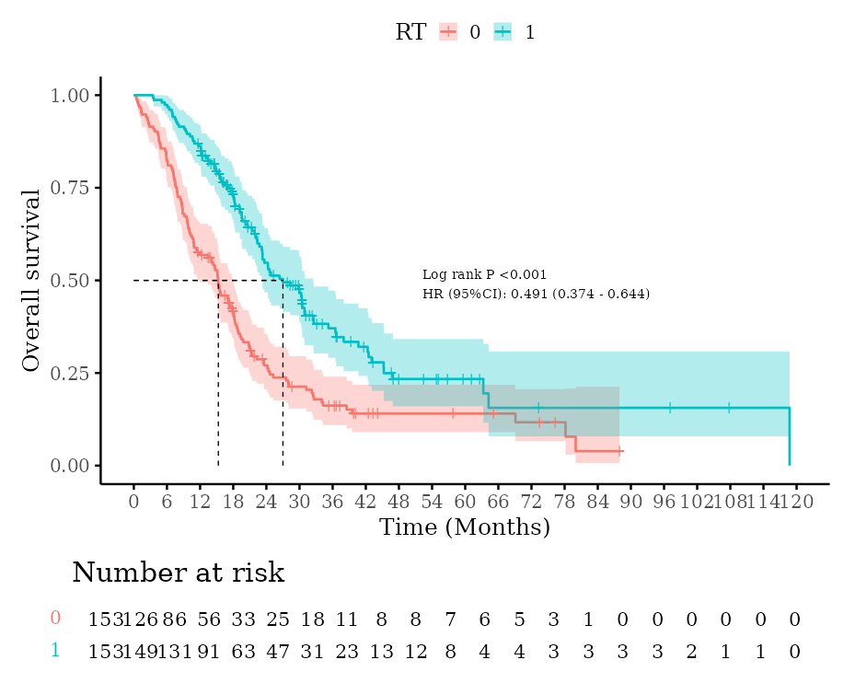
Supplementary Figure 1. After propensity score matching, Kaplan-Meier analysis and log-rank test were used to compare the survival time between the brain radiotherapy group and the non-radiotherapy group of breast cancer patients with brain metastases.
（A）
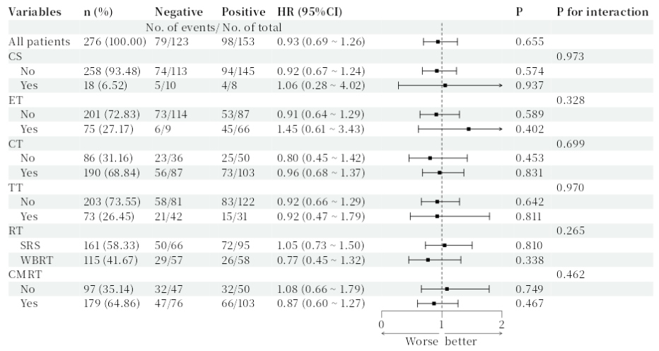
（B）
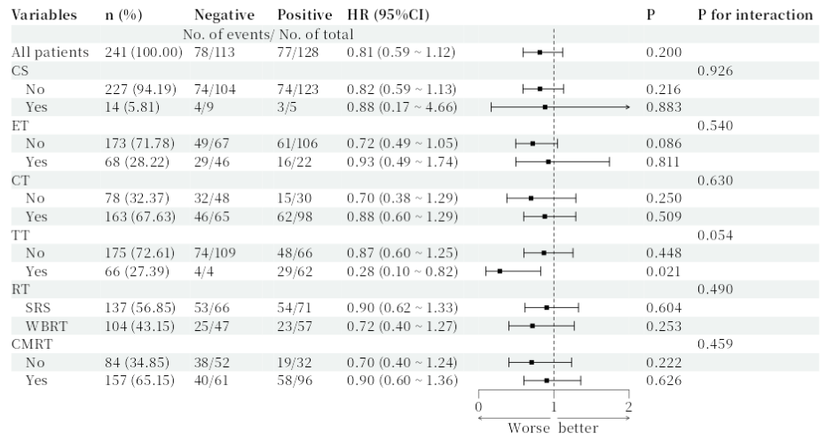
Supplementary Figure 2. Forest Plot of Subgroup Analysis for BCBM Patients Treated with RT. (A) Association between different treatment strategies after BM and RT-OS, stratified by ER expression status. (B) Association between different treatment strategies after BM and RT-OS, stratified by HER2 expression status. CS: Craniocerebral surgery; ET: Endocrine Therapy; CT: Chemotherapy; TT: Targeted Therapy; RT: Radiation therapy; CMRT: Concomitant medications for radiotherapy.

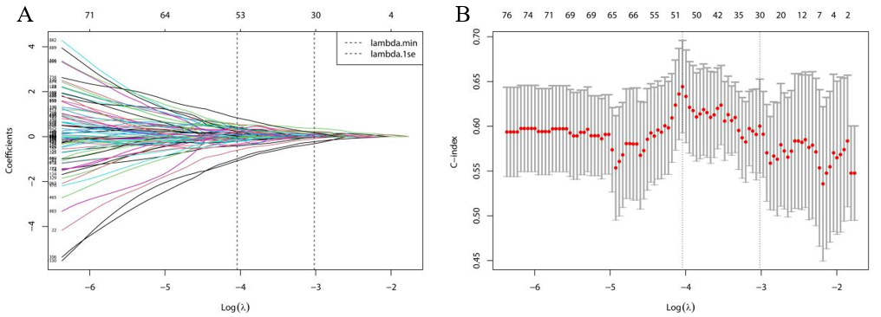
Supplementary Figure 3. Feature Selection Using LASSO-Cox Regression for Survival-Associated Predictors. (A) Trajectory of LASSO regression coefficients across different values of log(λ). (B) Relationship between log(λ) and the corresponding model deviance (error).

Supplementary Material 2

Predictive model related code
library(Matrix)
library(glmnet) # Core package for LASSO regression
library(survival) # Survival analysis package
install.packages("survminer")
library(ggpubr)
library(survminer) # Survival analysis visualization
library(ggplot2)

surv_data <- X149AA ### Imported Excel name

# Data Preprocessing
y <- Surv(surv_data$OS, surv_data$live) # Create survival object
x <- as.matrix(surv_data[, 3:ncol(surv_data)]) # Predictor variable matrix

# Check and handle missing values (adjust based on actual situation)
if(sum(is.na(x)) > 0) {
x <- na.omit(x) # Simply delete rows with missing values (or use imputation)
y <- y[rownames(x), ]
warning("Deleted samples containing missing values")}

# Standardize predictor variables (LASSO requires standardization)
x_scaled <- scale(x) # Mean = 0, Standard deviation = 1

#### LASSO Cox Regression
# Set up cross-validation
install.packages("doParallel")
library(foreach)
library(iterators)
library(parallel)
library(doParallel)

cv_fit <- cv.glmnet(
x = x_scaled,
y = y,
family = "cox", # Cox proportional hazards model
type.measure = "C", # Evaluate model using C-index
alpha = 1, # 1 = LASSO (0 = Ridge regression)
nfolds = 10, # 10-fold cross-validation
parallel = TRUE # Enable parallel processing if doParallel is installed
)

# Visualize cross-validation results
plot(cv_fit) # Show C-index and error at different lambda values
title("LASSO Cox Regression Cross-Validation Results", line = 2.5)

# Select optimal lambda values
lambda_min <- cv_fit$lambda.min # Lambda giving best C-index
lambda_1se <- cv_fit$lambda.1se # Most simplified model within 1 standard error

cat("Optimal lambda (min):", lambda_min, "\n")
cat("Simplified model lambda (1se):", lambda_1se, "\n")

# Extract final model
## Use lambda.min (prioritizes prediction accuracy) or lambda.1se (prioritizes simplicity)
final_model <- glmnet(
x = x_scaled,
y = y,
family = "cox",
alpha = 1)

# Get non-zero coefficient features
coef_min <- coef(final_model, s = lambda_min)
coef_1se <- coef(final_model, s = lambda_1se)

selected_min <- which(as.vector(coef_min) != 0)
selected_1se <- which(as.vector(coef_1se) != 0)

cat("\nNumber of features selected using lambda.min:", length(selected_min), "\n")
cat("Feature names:", colnames(x)[selected_min], "\n")

cat("\nNumber of features selected using lambda.1se:", length(selected_1se), "\n")
cat("Feature names:", colnames(x)[selected_1se], "\n")

# Visualize coefficient path
plot(final_model, xvar = "lambda", label = TRUE)
abline(v = log(c(lambda_min, lambda_1se)), lty = 2)
title("LASSO Coefficient Path Plot", line = 2.5)
legend("topright", legend = c("lambda.min", "lambda.1se"), lty = 2, col = 1)

# Model Evaluation
# Calculate predicted risk scores
risk_scores <- predict(final_model, newx = x_scaled, s = lambda_1se, type = "response")

# Save important results
# Output selected features and their coefficients
final_coef <- coef(final_model, s = lambda_1se)
selected_features <- final_coef[which(final_coef != 0), ]
cat("\nFinal model features and coefficients:\n")
print(selected_features)

### Multivariate COX Regression Analysis
install.packages("survival")
library(survival)
model <- coxph(Surv(OS, live) ~ ART+Size+Location+CT+KPS+YXLLHWFK+YXLLHWFmedian+
YXLHLWGLALGLE+YXLHLWNS+YXHLLWFmedian+YXHLLWGDV+YXHLHWFmean+
YXHLHWGLRLGLE+YXHHLWFmean+YXHHLWGSAE+YXHHHWGZE+JLOF10P+JLOGLGLE+
JLLLHWGSZNUN+JLLHLWFSn+JLLHHWGSE+JLLHHWGSAE+JLHLLWFSn+JLHLLWGMCC+
JLHLHWGDeE+JLHHLWGLGLZE+JLHHLWGSZNUN+JLHHHWFSn+JLLLLWGCl+
JLLLLWGLGLZE ,data = surv_data)
summary(model)

## Dynamic Nomogram
library(Hmisc)
library(rms)
install.packages("regplot")
library(regplot)
f <- cph(Surv(OS_years, live) ~ Location+CT+KPS+YXLLHWFK+
YXLHLWGLALGLE+YXLHLWNS+JLLHHWGSAE+JLHHLWGLGLZE+JLLLLWGLGLZE, data = da, maxit=15, x=T, y=T, surv=T)
regplot(f, observation = Idw_exper[4,], # Specify a specific patient, 85 means selecting the 85th patient in the dataset
interval = "confidence", title = "Nomogram",
plots = c("violin", "boxes"), clickable = T,
failtime = c(3, 2, 1)) # Set follow-up times: 1 year, 2 years, 3 years

# Time-dependent ROC for Nomogram: 1-year, 2-year, 3-year ROC
install.packages("survivalROC")
library(survivalROC)
da1 <- data.frame(Idw_exper)
cutoff <- 3
newdata <- predict(f, type = "lp") # Calculate combined prediction probability
write.csv(newdata, file = "C:/Users/Administrator/Desktop/final_prediction_probability_lp.csv")

# Set prediction time points (Year 1, 2, 3)
times <- c(1, 2, 3)

# Calculate ROC curves for each time point
roc_data <- lapply(times, function(t) {
survivalROC(
Stime = Idw_exper$OS_years, # Survival time
status = Idw_exper$live, # Event status
marker = Idw_exper$x, # Prediction values
predict.time = t, # Prediction time point
method = "NNE", # Non-parametric kernel estimation method
span = 0.25 * nrow(Idw_exper)^(-0.20) # Smoothing parameter
)
})

# Set plot colors
colors <- c("#E41A1C", "#377EB8", "#4DAF4A")

# Plot combined ROC curves
plot(roc_data[[1]]$FP, roc_data[[1]]$TP,
type = "l", col = colors[1], lwd = 2,
xlim = c(0, 1), ylim = c(0, 1),
xlab = "1 - Specificity (False Positive Rate)",
ylab = "Sensitivity (True Positive Rate)",
main = "Time-Dependent ROC Curves for COX Model")
abline(0, 1, lty = 2, col = "gray") # Add reference line

# Add curves for other time points
for (i in 2:length(times)) {
lines(roc_data[[i]]$FP, roc_data[[i]]$TP,
col = colors[i], lwd = 2)
}

# Add legend and AUC values
legend_text <- paste0("Year ", times, " (AUC = ",
sapply(roc_data, function(x) round(x$AUC, 3)), ")")
legend("bottomright",
legend = legend_text,
col = colors,
lty = 1,
lwd = 2,
title = "Time Points",
bty = "n")

# Add grid lines
grid(col = "lightgray", lty = "dotted")
box()

################## Calculate various statistical metrics
roc <- survivalROC(
Stime = Idw_exper$OS_years, # Survival time
status = Idw_exper$live, # Event status
marker = Idw_exper$x, # Prediction values
predict.time = 3, # Prediction time point
method = "KM", # Kaplan-Meier method
)

#### Optimal threshold
youden_index <- roc$TP - roc$FP
best_idx <- which.max(youden_index)
best_threshold <- roc$cut.values[best_idx]

# Calculate confusion matrix
predicted_class <- ifelse(Idw_exper$x >= best_threshold, 1, 0)
actual_class <- ifelse(Idw_exper$OS_years <= 3 & Idw_exper$live == 1, 1, 0)

# Calculate metrics
TP <- sum(predicted_class == 1 & actual_class == 1)
TN <- sum(predicted_class == 0 & actual_class == 0)
FP <- sum(predicted_class == 1 & actual_class == 0)
FN <- sum(predicted_class == 0 & actual_class == 1)
sensitivity <- TP / (TP + FN)
specificity <- TN / (TN + FP)
accuracy <- (TP + TN) / (TP + TN + FP + FN)

# Output results
cat("Threshold =", best_threshold, "\n",
"Sensitivity =", round(sensitivity, 3), "\n",
"Specificity =", round(specificity, 3), "\n",
"Accuracy =", round(accuracy, 3))

# Nomogram Calibration Curve
da <- data.frame(Idw_exper)
dc <- datadist(da)
options(datadist = "dc")
ff0.5 <- cph(Surv(OS_days, live) ~ Location+CT+KPS+YXLLHWFK+
YXLHLWGLALGLE+YXLHLWNS+JLLHHWGSAE+JLHHLWGLGLZE+JLLLLWGLGLZE, data = da, x=T, y=T, surv=T, time.inc=360)
cal_0.5 <- calibrate(ff0.5, cmethod='KM', method='boot', u=360, m=40, B=1000)
par(mar=c(7,4,4,3), cex=1.0)
plot(cal_0.5, lwd=2, lty=1, errbar.col=c(rgb(0,118,192,maxColorValue=255)), xlab='Nomogram 1-year OS Calibration Curve', ylab='1-year OS', col=c(rgb(192,98,83,maxColorValue=255)),
xlim=c(0,1), ylim=c(0,1))

## DCA (Decision Curve Analysis)
library(dcurves)
library(foreign)
library(survival)
library(dplyr)
str(Idw_exper)
f1 <- coxph(Surv(OS, live) ~ Location+CT+KPS+YXLLHWFK+
YXLHLWGLALGLE+YXLHLWNS+JLLHHWGSAE+JLHHLWGLGLZE+JLLLLWGLGLZE, data = Idw_exper)

Idw_exper$pr_failure1 = c(1-(summary(survfit(f1, newdata=Idw_exper), times=36)$surv))
dca(Surv(OS, live) ~ pr_failure1, data = Idw_exper, time=36, thresholds=1:50/100) %>%
plot(smooth=T)

