Deciphering developmental gradients in human hippocampus

Debin Zeng^{1,2}, Qiongling Li^{2,3,4}, Deyu Li^{1,5}, Yirong He², Xiaoxi Dong², Zekun Yang², Yiyu Zhang², Shaoxian Li², Shenghan Bi², Ting Xu⁶, Xuhong Liao⁷, Tengda Zhao^{2,3,4}, Xiaodan Chen^{2,3,4}, Yunman Xia^{2,3,4}, Tianyuan Lei^{2,3,4}, Lianglong Sun^{2,3,4}, Weiwei Men^{8,9}, Yanpei Wang², Daoyang Wang², Mingming Hu², Zhiying Pan², Shuping Tan¹⁰, Jia-Hong Gao^{8,9,11}, Shaozheng Qin^{2,3,4,12}, Sha Tao², Qi Dong², Yong He^{2,3,4,12*}, Xi-Nian Zuo^{2,4,13,14*†}, Shuyu Li^{2*†}

¹Beijing Advanced Innovation Center for Biomedical Engineering, School of Biological Science & Medical Engineering, Beihang University, Beijing 100083, China
²State Key Laboratory of Cognitive Neuroscience and Learning, Beijing Normal University, Beijing, 100875, China
³Beijing Key Laboratory of Brain Imaging and Connectomics, Beijing Normal University, Beijing, 100875, China
⁴IDG/McGovern Institute for Brain Research, Beijing Normal University, Beijing, 100875, China
⁵State Key Laboratory of Virtual Reaility technology and Systems, Beihang University, Beijing 100083, China
⁶Child Mind Institute, New York, NY, USA
⁷School of Systems Science, Beijing Normal University, Beijing 100875, China
⁸Center for MRI Research, Academy for Advanced Interdisciplinary Studies, Peking University, Beijing 100871, China,
⁹Beijing City Key Laboratory for Medical Physics and Engineering, Institute of Heavy Ion Physics, School of Physics, Peking University, Beijing 100871, China
¹⁰Beijing Huilongguan Hospital, Peking University Huilongguan Clinical Medical School, Beijing 100096, China
¹¹IDG/McGovern Institute for Brain Research, Peking University, Beijing 100871, China
¹²Chinese Institute for Brain Research, Beijing 102206, China
¹³National Basic Science Data Center, Beijing, 100109, China
¹⁴Developmental Population Neuroscience Research Center, Beijing Normal University, Beijing, 100875, China

†These authors contributed equally

*Corresponding authorship.

Shuyu Li (shuyuli@bnu.edu.cn)
Yong He (yong.he@bnu.edu.cn)
Xi-Nian Zuo (xinian.zuo@bnu.edu.cn)

Supplementary Figures
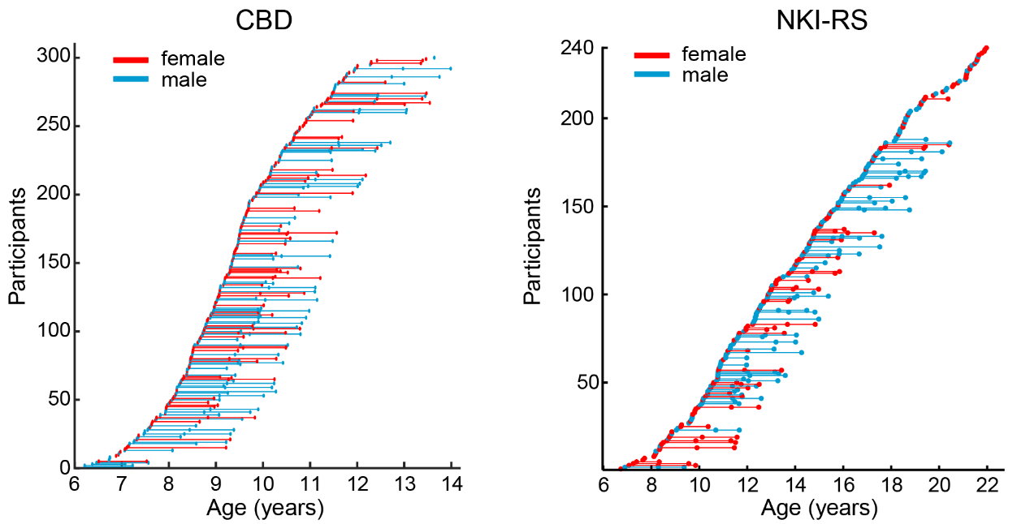
Supplementary Fig. 1 Demographic information of the CBD and NKI-RS samples: age information for each scan of all participants.

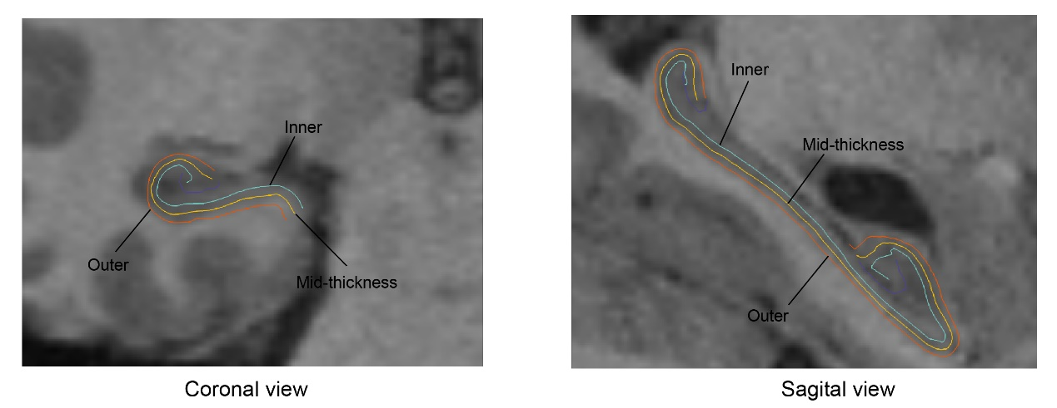
Supplementary Fig. 2 Sagittal and coronal view of the inner, outer, and mid-thickness surface (I-O axis).

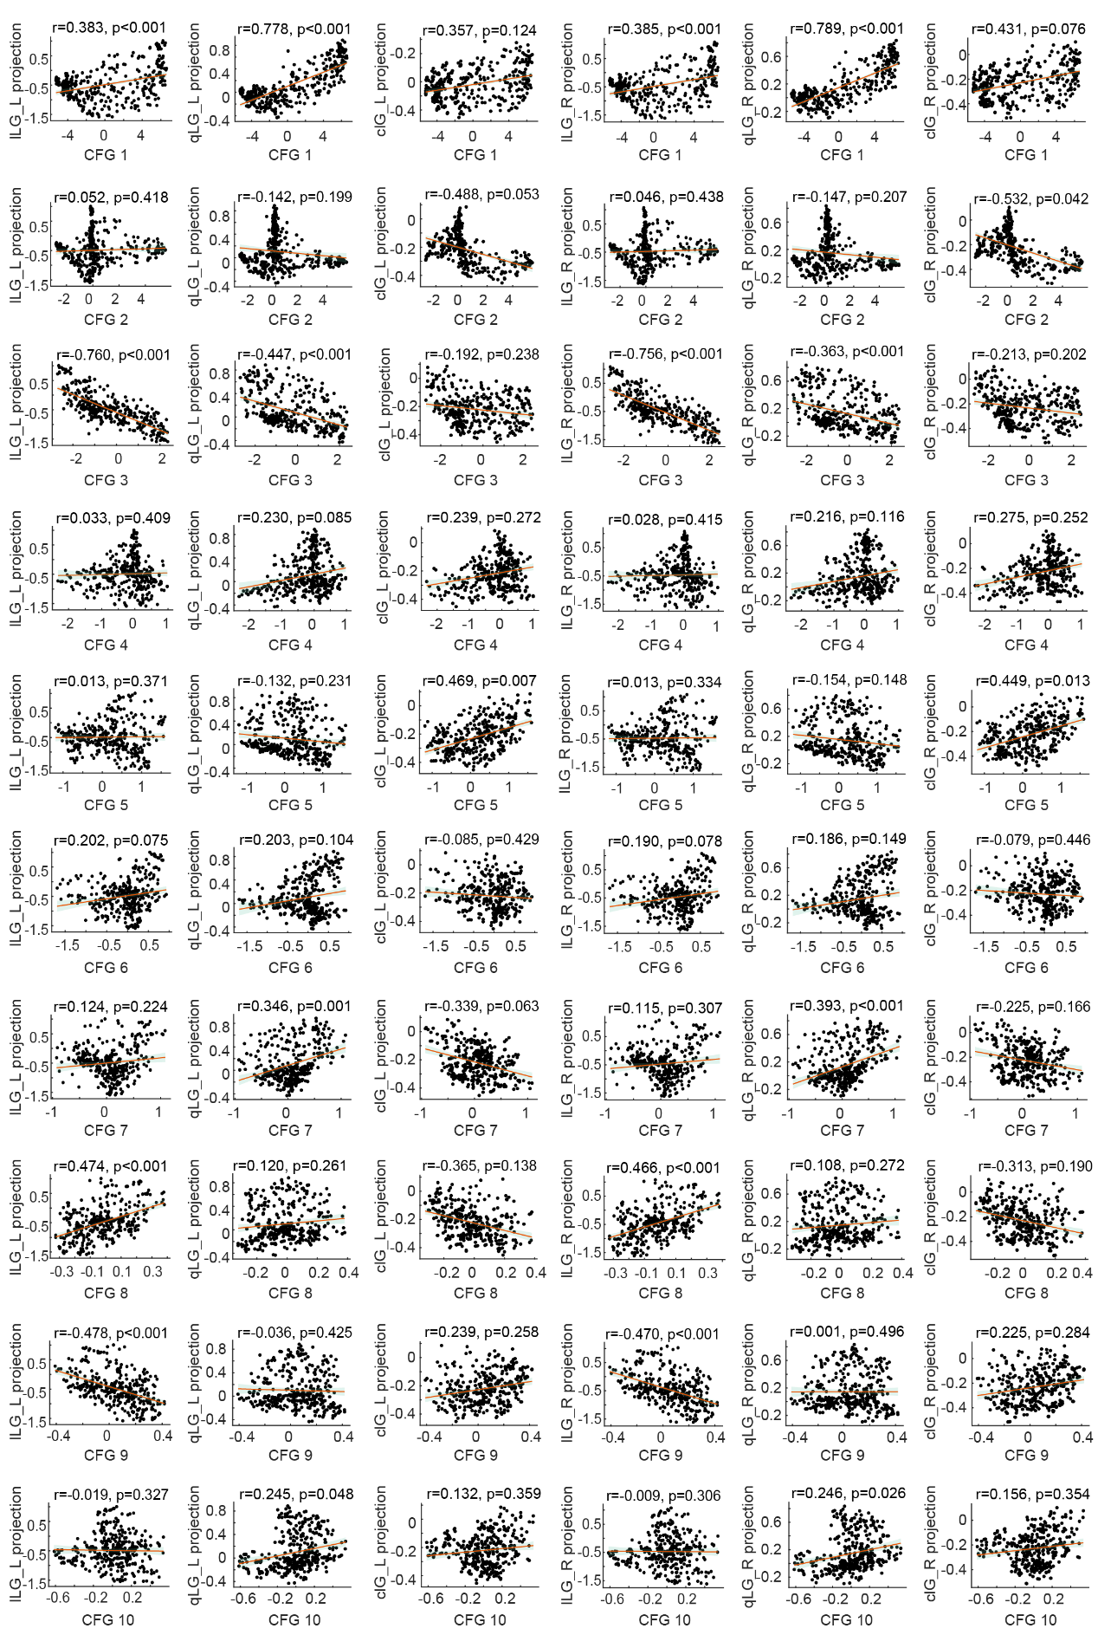
Supplementary Fig. 3 The associations between hippocampal projection maps and cortical functional gradients.

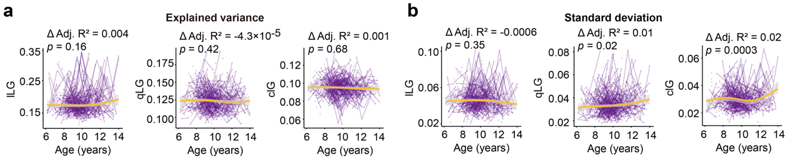
Supplementary Fig. 4 Replication results for the development of explained variance and standard deviation of hippocampal triple gradients on CBD dataset, respectively.

Supplementary Tables

Supplementary Table 1. Δ Adjusted $R^{2}$ and FDR-corrected p value for three bins along the group-averaged T1w/T2w axis

Bin | T1w/T2w |  | G1 (lLG) |  | G2 (qLG) |  | G3 (IAG)
Bin | Δ Adj. $R^{2}$ | p value | Δ Adj. $R^{2}$ | p value | Δ Adj. $R^{2}$ | p value | Δ Adj. $R^{2}$ | p value
1 | 0.1596 | <1E-16 | 0.0076 | 0.0008 | -0.0066 | 0.0029 | 3.09E-6 | 0.8818
2 | 0.1979 | <1E-16 | -1.6 E-04 | 0.2739 | -1.04E-7 | 0.4773 | 3.01E-6 | 0.8818
3 | 0.2377 | <1E-16 | -0.0158 | 8.43E-6 | 0.0207 | <1E-16 | 2.10E-5 | 0.8818

Supplementary Table 2. Δ Adjusted $R^{2}$ and FDR-corrected p value for six bins along the group-averaged T1w/T2w axis

Bin | T1w/T2w |  | G1 (lLG) |  | G2 (qLG) |  | G3 (IAG)
Bin | Δ Adj. $R^{2}$ | p value | Δ Adj. $R^{2}$ | p value | Δ Adj. $R^{2}$ | p value | Δ Adj. $R^{2}$ | p value
1 | 0.1507 | <1E-16 | 0.0084 | 0.0010 | -0.0028 | 0.0617 | -0.0009 | 0.4072
2 | 0.1628 | <1E-16 | 0.0009 | 0.1365 | -0.0019 | 0.0935 | -6.39E-8 | 0.9801
3 | 0.1858 | <1E-16 | 1.45E-6 | 0.9168 | -0.0003 | 0.2811 | 2.25E-6 | 0.9909
4 | 0.2172 | <1E-16 | -0.0034 | 0.0414 | -1.64E-6 | 0.7249 | 3.26E-6 | 0.9909
5 | 0.2335 | <1E-16 | -0.0133 | 0.0001 | 0.0135 | 4.75E-5 | -1.87E-6 | 0.9909
6 | 0.2366 | <1E-16 | -0.0097 | 0.0002 | 0.0158 | 2.05E-5 | 0.0017 | 0.4072

Supplementary Table 3. Δ Adjusted $R^{2}$ and FDR-corrected p value for twelve bins along the group-averaged T1w/T2w axis

Bin | T1w/T2w |  | G1 (lLG) |  | G2 (qLG) |  | G3 (IAG)
Bin | Δ Adj. $R^{2}$ | p value | Δ Adj. $R^{2}$ | p value | Δ Adj. $R^{2}$ | p value | Δ Adj. $R^{2}$ | p value
1 | 0.1282 | <1E-16 | 0.0247 | <1E-16 | -0.0029 | 0.0702 | -0.0009 | 0.6610
2 | 0.1540 | <1E-16 | 0.0003 | 0.2891 | -0.0003 | 0.3988 | -0.0005 | 0.6819
3 | 0.1565 | <1E-16 | 0.0005 | 0.2622 | -0.0020 | 0.0949 | 5.11E-5 | 0.7720
4 | 0.1706 | <1E-16 | 1.28E-7 | 0.4351 | -2.15E-6 | 0.9862 | 1.53E-6 | 0.9583
5 | 0.1772 | <1E-16 | 3.79E-5 | 0.3861 | -1.60E-5 | 0.4233 | 2.19E-6 | 0.9583
6 | 0.1991 | <1E-16 | -0.0010 | 0.2244 | -4.39E-5 | 0.4233 | 8.87E-7 | 0.7865
7 | 0.2134 | <1E-16 | -3.51E-6 | 0.3899 | 1.20E-6 | 0.8249 | -2.67E-6 | 0.7784
8 | 0.2215 | <1E-16 | -0.0075 | 0.0040 | 6.39E-6 | 0.4325 | 0.0004 | 0.6819
9 | 0.2322 | <1E-16 | -0.0096 | 0.0007 | 0.0023 | 0.0949 | 9.68E-7 | 0.8043
10 | 0.2316 | <1E-16 | -0.0109 | 0.0004 | 0.0218 | <1E-16 | -7.33E-7 | 0.7865
11 | 0.2391 | <1E-16 | -0.0149 | 1.50E-5 | 0.0177 | 8.92E-6 | 0.0027 | 0.4340
12 | 0.2229 | <1E-16 | -0.0011 | 0.1928 | 0.0056 | 0.0162 | -1.18E-7 | 0.7865

Supplementary Table 4. Δ Adjusted $R^{2}$ and FDR-corrected p value for fifteen bins along the group-averaged T1w/T2w axis

Bin | T1w/T2w |  | G1 (lLG) |  | G2 (qLG) |  | G3 (IAG)
Bin | Δ Adj. $R^{2}$ | p value | Δ Adj. $R^{2}$ | p value | Δ Adj. $R^{2}$ | p value | Δ Adj. $R^{2}$ | p value
1 | 0.1199 | <1E-16 | 0.0232 | <1E-16 | -0.0029 | 0.0682 | -0.0004 | 0.4881
2 | 0.1524 | <1E-16 | 0.0024 | 0.0510 | -0.0030 | 0.0682 | -0.0002 | 0.4881
3 | 0.1568 | <1E-16 | 0.0007 | 0.2421 | 9.98E-7 | 0.6996 | 3.00E-6 | 0.7896
4 | 0.1564 | <1E-16 | -1.36E-6 | 0.7956 | -0.0015 | 0.1452 | 0.0003 | 0.4881
5 | 0.1723 | <1E-16 | 7.75E-6 | 0.4625 | 2.56E-6 | 0.9859 | 1.39E-6 | 0.7896
6 | 0.1795 | <1E-16 | 4.73E-7 | 0.5380 | -1.31E-7 | 0.5927 | -2.80E-7 | 0.6933
7 | 0.1908 | <1E-16 | -2.90E-10 | 0.7956 | -1.02E-5 | 0.5927 | -0.0015 | 0.4661
8 | 0.2041 | <1E-16 | -0.0009 | 0.2421 | -2.93E-6 | 0.5927 | -1.91E-6 | 0.7896
9 | 0.2126 | <1E-16 | -5.16E-6 | 0.4866 | -5.51E-7 | 0.9859 | -0.0004 | 0.4881
10 | 0.2192 | <1E-16 | -0.0069 | 0.0059 | 4.96E-7 | 0.5927 | 0.0014 | 0.4661
11 | 0.2320 | <1E-16 | -0.0078 | 0.0020 | 0.0005 | 0.3771 | -1.82E-6 | 0.6373
12 | 0.2329 | <1E-16 | -0.0094 | 0.0003 | 0.0165 | 1.62E-5 | 2.40E-6 | 0.6373
13 | 0.2279 | <1E-16 | -0.0100 | 0.0002 | 0.0216 | <1E-16 | 0.0011 | 0.4661
14 | 0.2420 | <1E-16 | -0.0137 | 9.25E-5 | 0.0139 | 6.38E-5 | 0.0014 | 0.4661
15 | 0.2177 | <1E-16 | -0.0007 | 0.2421 | 0.0064 | 0.0085 | -7.19E-7 | 0.7513

