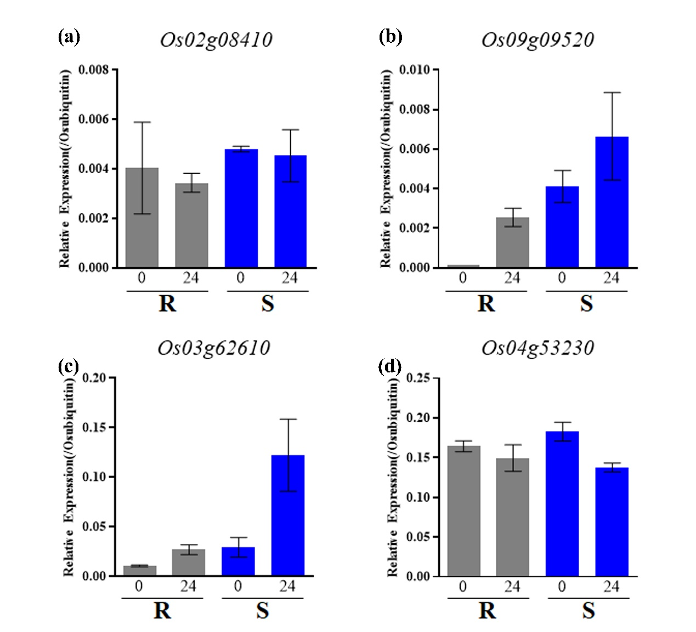
Supplementary Fig. 1 qRT-PCR verification of the expression pattern of type 2 and 3 genes. The grey bars indicate the resistant rice accession of 120963, the blue bars represent the susceptible rice accession of 121403. M.oryzae isolate RO1-1 was used to do the inoculation. The y-axis indicates the relative transcription levels (compare with the rice ubiquitin reference gene) and the x-axis represents the different time points of hours post inoculation (hpi). (a) Os02g08410, (b) Os09g09520, (c) Os03g62610, (d) Os04g53230.

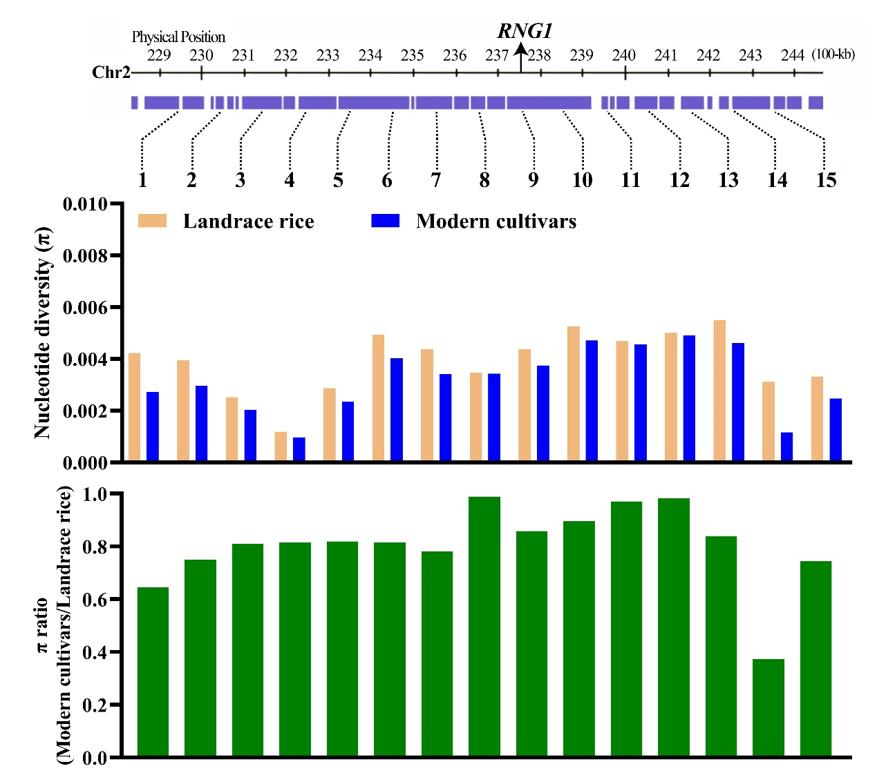
Supplementary Fig. 2: Nucleotide diversity (π) of landrace rice and modern cultivars at the loci of RNG1. Nucleotide diversity (π) of landrace rice and modern cultivars at the loci of and RNG1. top: The location of sampled loci in genomic region of ~1.5 Mb around genes on chromosome; middle: nucleotide diversity of landrace rice and modern cultivars at the sample loci; bottom: the relative π ratio in modern cultivars to landrace rice.

