Human subthalamic neurons encode speech features during listening and couple with auditory cortex
Additional Result and Discussion:
We observed a relatively small subgroup of auditory-specific (a*/s⁰, 7%) units, none of which encoded syllable features. The time course of these units is similar to that of the STG gamma response and faster than that of auditory-speech (a*/s*) units, suggesting that these units may convey sound information for rapid motor action. The absence of a response from these units to self-generated sounds may reflect a role for the STN in gating or filtering different types of auditory information.
Additionally, we extended our previous findings related to functional connectivity between STN and STG via analyses of spike-phase coupling. The alpha band is often associated with functional inhibition, particularly in gating information flow and regulating task-relevant cortical excitability, generating supragranular cortical layers, and propagating via feedback projections from higher-order to lower-order cortical areas and from cortex to thalamus ^{1,2}. We found SPC entrainment between STG and auditory-specific units in the alpha band during baseline that was suppressed at auditory epoch onset and resumed after auditory epoch offset, suggesting that auditory input transiently disrupts ongoing inhibitory dynamics, possibly to enable stimulus-driven processing. This may reflect a preparatory mechanism that is actively disengaged upon sensory onset, allowing for the rapid integration of new auditory information. Similarly, SPC was suppressed in auditory-speech units during intervals of firing rate modulation. The non-overlap of SPC modulation with firing rate modulation suggests parallel mechanisms for integrating auditory information into speech motor planning.
Although not a direct test, the above data functionally suggest the possibility that some auditory information enters the basal ganglia via the hyperdirect pathway. We previously reported evidence for such a monosynaptic connectivity between the STG and STN in humans ³, cortical evoked potential latencies between 2-10ms, consistent with prior observations of assumed antidromic latencies for evoked potentials in the primary motor cortex ⁴ and inferior frontal gyrus ⁵. Although we can’t rule out the possibility that STN and STG both receive coincidental inputs from more upstream in the auditory pathway, there is no evidence yet of a functional or anatomical connection established between the STN and these structures, for example, the medial geniculate body (MGB). The existence of hyperdirect auditory input to the basal ganglia has implications for understanding rapid auditory-driven modulation of basal ganglia circuits, speech disorders, and potentially auditory hallucinations (e.g., in schizophrenia). Similarly, SPC was suppressed in auditory-speech units during intervals of firing rate modulation. The non-overlap of SPC modulation with firing rate modulation suggests parallel mechanisms for integrating auditory information into speech motor planning.
These results may also explain auditory processing dysfunction in Parkinson's disease, such as alterations in patients' high-order auditory perception (emotional prosody and sensitivity to valence)^{6,7}. STN DBS can also modulate auditory processing in advanced PD ⁸ ⁹. After DBS surgery, there are rare reports of tinnitus or phantom auditory perceptions ¹⁰. It has also been hypothesized that STN DBS may restore motor control in response to altered auditory feedback, e.g., pitch-shift compensation ¹¹⁻¹⁴. In addition, we also observed that beta suppression coincides with auditory-speech integration unit activity, which could reflect one mechanism through which rhythmic auditory stimulation, such as playing marching music and dance therapy, is effective in improving gait in PD patients ¹⁵.
We acknowledge several limitations. The study was focused on a triplet task. To overcome this limitation, we obtained task-independent, naturalistic auditory stimuli in the operating room, where it is possible that the neural response was not solely attributable to the early auditory process. Validation of a monosynaptic connection from STG to STN has not been shown in nonhuman primate viral tracing studies, although our interpretation of the literature is that no study has asked this question. For the macrostimulation study, although the macrostimulation can’t selectively modulate individual units, it still indicates that macrostimulation likely engages local neuronal populations, including auditory-responsive neurons. The spatial proximity provides indirect anatomical support for the hypothesis that auditory-specific units are located near or within STN subregions that project strongly to auditory cortical regions.

Methods:
Subjects. The participants were Parkinson's disease or essential tremor patients who volunteered to perform the syllable triplet speech production task during electrode implantation surgery for deep brain stimulation. This study, which was approved by the University of Pittsburgh Institutional Review Board (Study # 20070368), enrolled 29 patients. Datasets with excessive noise, glitches or incomplete metadata were excluded, resulting in 25 analyzed subjects (4 female and 21 male). Table 1 provides a summary of subject attributes.
Surgery. Dr. Mark Richardson inserted leads for deep brain stimulation at the UPMC Presbyterian Hospital in Pittsburgh, Pennsylvania. The subthalamic nucleus was identified by magnetic resonance imaging as the target for deep brain stimulation. Microelectrode recordings were performed along three trajectories toward the subthalamic nucleus, as delineated by the Ben Gun configuration, to physiologically map the boundaries of the target before lead placement (2mm spacing; central, posterior, medial).
Audio recording. Speech output was recorded using an omnidirectional microphone positioned at an angle of 45° and a distance of 8 cm from the subject's mouth (8 subjects: Audio-Technica, model ATR3350iS, frequency response 50 –18,000 Hz; 4 subjects: PreSonus, model PRM1 Precision Flat Frequency Mic, frequency response 20 –20,000 Hz). In the four instances where the PreSonus PRM1 microphone was utilized, the audio was digitized at 96 kHz using a Zoom H6 digital recorder. The audio signal was separated and digitized at 30 kHz in every instance by a Grapevine Neural Interface Processor. The audio signal was synchronized with neural recordings and auditory cue events using USB data acquisition unit-delivered digital pulses (Measurement Computing, model USB-1208FS).
STN/GPi and cortical recording. As described, unit recordings were performed using Parylene-insulated, microphonics-free tungsten microelectrodes and the Neuro-Omega recording system (Alpha Omega)¹⁶. Targeting of the dorsolateral STN and microelectrode recording (MER) was accomplished using a standard combination of indirect (starting AC-PC coordinates of x = 12, y = -3, z = -4) and direct (visualization of the STN in the z = -4 plane of a T2-weighted MRI obtained at 3 teslas) targeting ¹⁷. The impedances of microelectrodes ranged from 200 to 600 k. The signals from microelectrodes were bandpass filtered from 0.075 Hz to 10 kHz and then digitized at 44 kHz. The macroelectrode, DBS, and ECoG electrodes are recorded similarly for local field potential recording.
STN/GPi stimulation. Before clinical microelectrode recording, patients were at their neurological baseline by sedation, as determined by clinical examination. For clinical mapping, STN or GPi monopolar stimulation was performed via the macro cylindrical contact ("ring electrode," diameter 0.7 mm, length 1 mm) utilizing the Neuro Omega (Alpha Omega Co, Alpharetta, GA, USA) simulation software. Upon completion of clinical testing, approximately 45 minutes of monitored anesthesia were administered. Then, research stimulation was conducted at 1Hz for 30 seconds (30 stimulation pulses) or 10Hz for 30 seconds (300 stimulation pulses) at stimulation intensities of 1, 2, and 3 mA at two different depths within the STN that was at least 2 mm apart in the z-dimension. High-density ECoG was used to record cortical evoked potentials concurrently with stimulation.
Anatomical localization of recordings. As previously described, the location of the ECoG strip was determined using intraoperative fluoroscopy imaging or CT imaging, preoperative in-frame CT, and preoperative MRI¹⁸. A posteriori normalization of each subject's MRI to MNI brain space and automatic identification of ECoG electrode and gyri location were performed with FreeSurfer and the Destrieux atlas^{19,20}. According to this atlas, eight anatomical categories were covered by ECoG recordings in this study, including the opercular part of the inferior frontal gyrus (Pars O.), the triangular part of the inferior frontal gyrus (Pars T.), the middle frontal gyrus (MFG), the precentral gyrus (PreCG), the postcentral gyrus (PostCG), the subcentral gyrus (SC), the supramarginal (STG). The locations of STN contacts were determined using the Lead-DBS MNI ICBM atlas and software ²¹. DICOM images were coregistered using Advanced Normalization Tools(ANTs) and hybrid statistical parametric mapping (SPM) algorithms and then normalized to the International Consortium for Brain Mapping (ICMB) 152 nonlinear 2009b template. Coordinates were recorded in MNI space, and STN geometry (i.e., motor, associative, limbic) was defined by the DISTAL atlas²².
Syllable triplet speech production task. Patients were instructed to listen to and repeat triplets of consonant-vowel triplet syllables during the awake mapping portion of the deep brain stimulation electrode implantation procedure. Each trial began with a one-second pre-stimulus baseline period, followed by the auditory presentation of a unique syllable triplet through earphones (Etymotic SR4). The participants were told to repeat the syllable triplet at their own pace. After recording the subject's response, the experimenter initiated the subsequent trial manually. Consonant-vowel triplets in syllables contained one of four consonants (/v/, /s/, /t/, /g/) and one of three vowels (/a/, /u/, /i/). Each session consisted of 120 trials in which the number of consonant and vowel presentations at each syllable triplet position were evenly distributed. The responses of the subjects were recorded using an omnidirectional microphone (PreSonus, model PRM1 Precision Flat Frequency Mic, frequency response 20–20,000 Hz), the audio signal was segmented offline into trials, and the responses were coded by a speech-language pathologist utilizing a custom-designed graphical user interface implemented in MATLAB.
Spike Sorting and firing rate estimation. A high-pass filter and a voltage threshold were applied to microelectrode recordings to identify waveforms to be spike-sorted. The spikes were sorted, and the firing rate was estimated as described previously23. Spike density function (firing rate, FR) computed by convolving binned single- or multi-unit spike time series with a Gaussian kernel (sigma = 25 ms) and inter-spike-interval (ISI, the reciprocal of instantaneous spike rate). Across-trial means of the FR and ISI functions were constructed aligned on two epochs of interest: (1) 1.5s before auditory cue presentation to 3.5s after (the auditory epoch), and (2) 3.5s before speech onset to 1.5s after (termed the speech epoch). Each trial's baseline epoch was defined as the 1s to 0.5s preceding the auditory cue presentation. The baseline FR for each unit was defined as the mean trial-to-trial firing rate during the baseline period. During a given epoch, a unit was considered to have significantly increased or decreased FR if its mean FR exceeded a threshold for at least 50 milliseconds. The threshold was set at the top 5 percent of a normal distribution with a mean and of the baseline mean FR, false discovery rate corrected for multiple comparisons.
LFP preprocessing. LFP recordings from the STN and cortical region are obtained similarly. A Grapevine Neural Interface Processor was used to amplify and digitize the signal (Ripple Neuro, Salt Lake City, UT, USA). Signals were sampled at 10 kHz, and all channels were referenced to the scalp ground. As described previously, artifact rejection removes the narrowband gamma component contributed by patient speech ²³. Using a band-pass filter and the Hilbert transform, we extracted the analytic amplitude in the high gamma frequency range (70 – 150 Hz, HGA) and beta band activity (13-30 Hz).
Time-frequency decomposition. Time-varying power and phase were obtained by applying the Hilbert Transform to the band-pass filtered ECoG signal. The signal was band-pass filtered using a 4th-order Butterworth filter, with the following frequency ranges: 5–8 Hz for θ, 8–12 Hz for α, 12–20 Hz for low β, 20–30 Hz for high β, and center frequencies ranging from 40 to 150 Hz with a bin width of 10 Hz, incrementing by 10 Hz for γ.
STN unit activity during speech. The changes in spike firing during the syllable triplet task were estimated using two measures. (1) Firing rate to determine task-related increases or decreases following the auditory cue and during patient-directed speech. (2) Spectral-temporal modifications following the auditory cue and during patient-directed speech. With significant variance (p<0.01, Python scipy library one-way ANOVA function f_oneway with FDR correction), both methods compare the resting period to the 1 to 0.5 seconds preceding the triplet cue. The mean firing rate for auditory and speech onsets was calculated for the selected units. The onset and peak of the firing rate were defined as 10% and 50% of the integer of the firing rate curve. Similar to those previously described in ²⁴. We did not use maxima indices because the signal is a sinusoidal wave with numerous fluctuations or noise. Local fluctuations or noise primarily influence the local index of the maxima. Consequently, a 50% firing rate curve integer is preferable to fluctuations or noise. This method disregards the difference in amplitude between electrodes or trials.
Stimulation task signal preprocessing. The stimulation start time was determined by identifying the first-time bin with the greatest voltage deflection on a channel exhibiting a significant stimulation artifact. The remaining ECoG channels were synchronized with these stimulation times, and each stimulation time defined a trial. Raw voltage values were de-trended for each test by subtracting a low-order polynomial fit from the signal (eighth order) to filter out low-frequency fluctuations without introducing filter artifacts. Thirty trials per channel per session were averaged and smoothed using a 5-bin (0.17 ms) moving window for 1 Hz stimulation (Miocinovic et al., 2018). After stimulation, the first positive voltage peak deflection (peak 0) was designated cortical evoked potential 0 (EP0), with subsequent positive voltage peak deflections established EP1 through EP3. All data processing and analysis were performed with MATLAB 2017-specific code (Mathworks, Natick, MA).
Spike-Phase Coupling. To investigate the coordination between STN neuronal activity and cortical oscillations during speech, we analyzed spike-phase coupling (SPC). This involved assessing how the timing of individual STN neuron spikes aligned with the phase of cortical LFPs. We focused on specific frequency bands, particularly theta (4–8 Hz) and alpha (8–12 Hz), which are relevant to speech processing. We determined the corresponding phase of the cortical LFP for each spike using the Hilbert transform. To quantify the consistency of this alignment, we employed the Pairwise Phase Consistency (PPC) metric, which measures the uniformity of spike-phase relationships across trials. Higher PPC values indicate stronger coupling between neuronal spikes and specific phases of cortical oscillations. This analysis allowed us to identify transient periods where STN neurons exhibited significant phase-locking to cortical rhythms, suggesting functional connectivity during speech tasks. For a comprehensive description of the methodology, including preprocessing steps and statistical analyses, please refer to the original publication: Vissani, M., Bush, A., Lipski, W.J. et al. Spike-phase coupling of subthalamic neurons to posterior perisylvian cortex predicts speech sound accuracy. Nat Commun 16, 3357 (2025).
Unsupervised convex non-negative matrix factorization. We utilized an unsupervised convex non-negative matrix factorization (CNMF) approach to identify patterns in time-series data without prior labels. This method decomposes the data into a set of non-negative basis components and corresponding coefficients, ensuring that each basis component is a convex combination of the original data points. This constraint enhances the interpretability of the resulting components, as they directly relate to the original data. By applying CNMF, we effectively clustered the time-series data, revealing underlying structures and patterns inherent in the dataset. This approach is particularly useful for uncovering latent features in complex biological signals. For a comprehensive and detailed description of this method, including preprocessing steps and implementation details, please refer to the original publication: Hamilton, Liberty S., Erik Edwards, and Edward F. Chang. "A spatial map of onset and sustained responses to speech in the human superior temporal gyrus." Current Biology 28.12 (2018): 1860-1871.
Classification. To decode syllable identity from STN single‑unit activity, we aligned trial‑wise firing‑rate time series to the auditory epoch and temporally compressed each unit’s activity (smoothing, optional baseline subtraction, time‑binning), and concatenated units to form feature vectors. Decoding used a leakage‑proof, nested cross‑validation pipeline in which all preprocessing, feature selection, and model fitting occurred strictly within training folds. Within each fold, we standardized features, applied univariate ANOVA to select informative time bins, and fit a multinomial logistic regression with elastic‑net regularization. Two formulations were evaluated: a direct 12‑class decoder and a factorized approach that trained separate consonant and vowel heads and combined their held‑out probabilities to recover syllable identity. The complete procedure was run per unit (using only that unit’s bins) and on the combined multi‑unit data. Performance is summarized as mean accuracy with standard deviation across folds; balanced accuracy and confusion matrices were also computed.

Supplementary Figure 1 | STN local field potential across all macroelectrode or DBS lead channels. (A) Raw STN LFP, sampling rate 1000Hz, frequency range (0, 200)Hz. Each row is one macroelectrode channel. Time aligns to the auditory epoch onset. (B) STN LFP in high gamma band (70, 150) Hz. (C) STN LFP in beta band (13, 30) Hz. (D) STN LFP in low gamma band (30, 70) Hz. The grey shaded area indicates the auditory epoch. The STN LFP is z-scored relative to the -1.5 to 0 second prior to the auditory epoch onset.

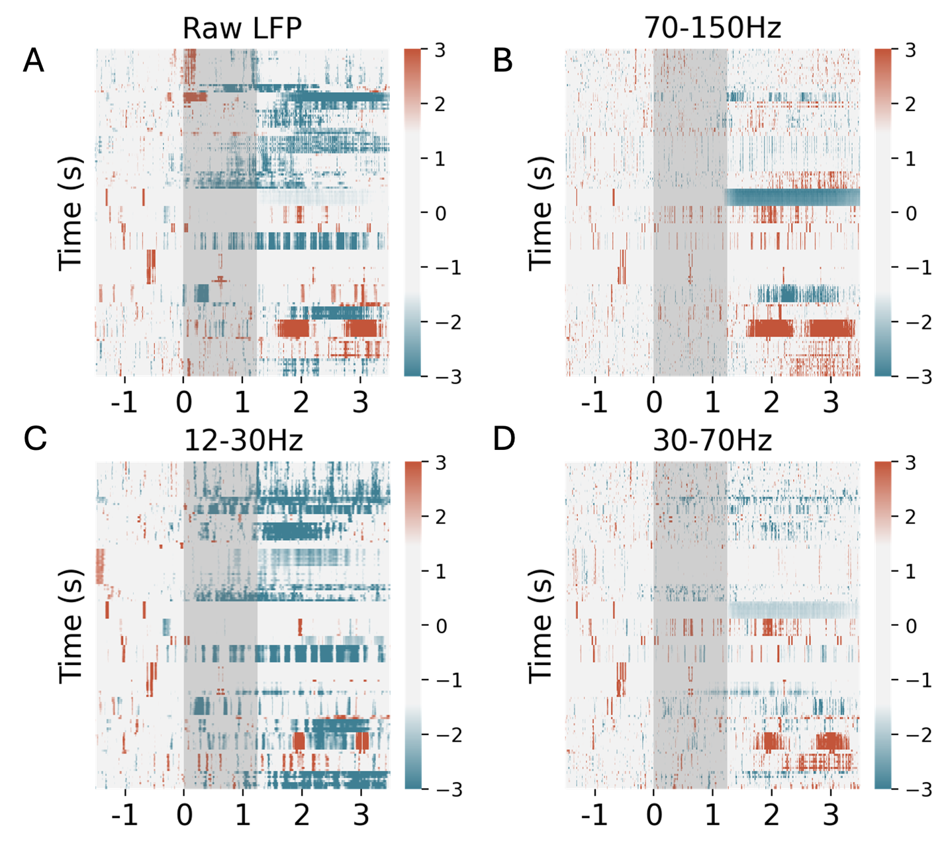
Supplementary Figure 2 | STN Beta desynchronization units presented spatial aggregation. Permutation results show auditory stimuli-locked beta-suppression aggregated in the medial STN when compared to a random sample of recorded units’ location in the STN. Permutation n=10,000, p=0.0116.

Supplementary Figure 3 | Positive and all negative units. Firing rate of all auditory-responsive units. The two vertical lines indicate the onset and offset of the auditory epoch. The color bar indicates the unit firing rate after z-score relative to the -1.5 to 0 second prior to the auditory epoch onset.
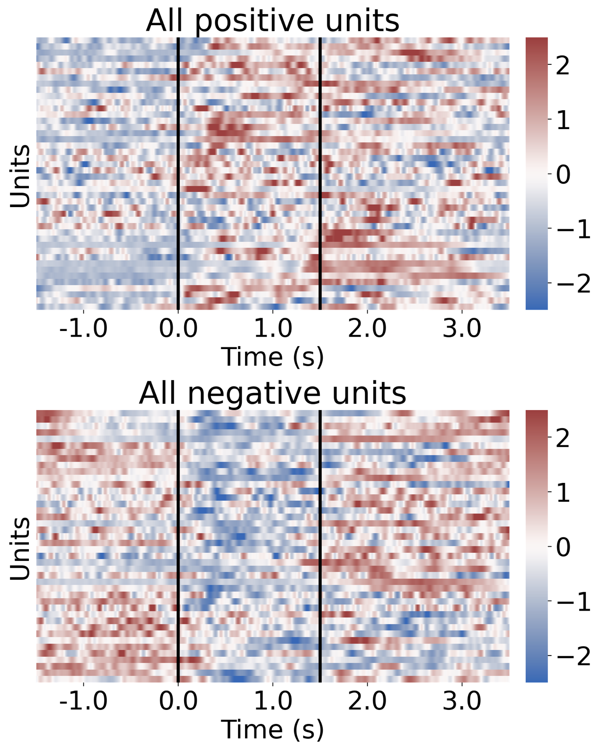

Supplementary Figure 4 | Paradoxical units. Units showing both activation and inhibition during the auditory epoch. Green lines indicate auditory syllable onset, and red lines indicate speech syllable onset. Grey-shaded areas indicate significant modulation compared to the resting state.
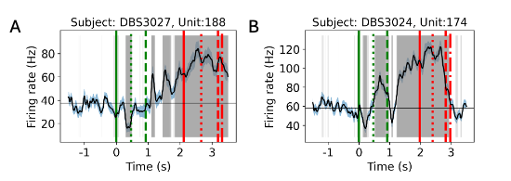

Supplementary Figure 5 | STN a*s⁰/a*s* units presented spatial aggregation. Permutation results show auditory-specific units (a*s⁰) and auditory-speech units (a*s*) aggregated in the STN when compared to a random sample of recorded units’ location in the STN. Permutation n=10,000, p(a*s⁰)=0.02355, p(a*s*)=0.02667.

Supplementary Figure 6 | STN auditory modulation during the triplet task and ambient auditory stimuli. Representative units’ firing rate modulation (mean ± SEM) and local field potential modulation of the local field during the auditory presentation. Top row, modulation during triplet task; Bottom row, modulation during non-task-related auditory stimuli, i.e., doctors talking to the patient and ambient sounds. The left two columns are single-unit recordings from a microelectrode; The right column is the local field potential auditory-related potentials.
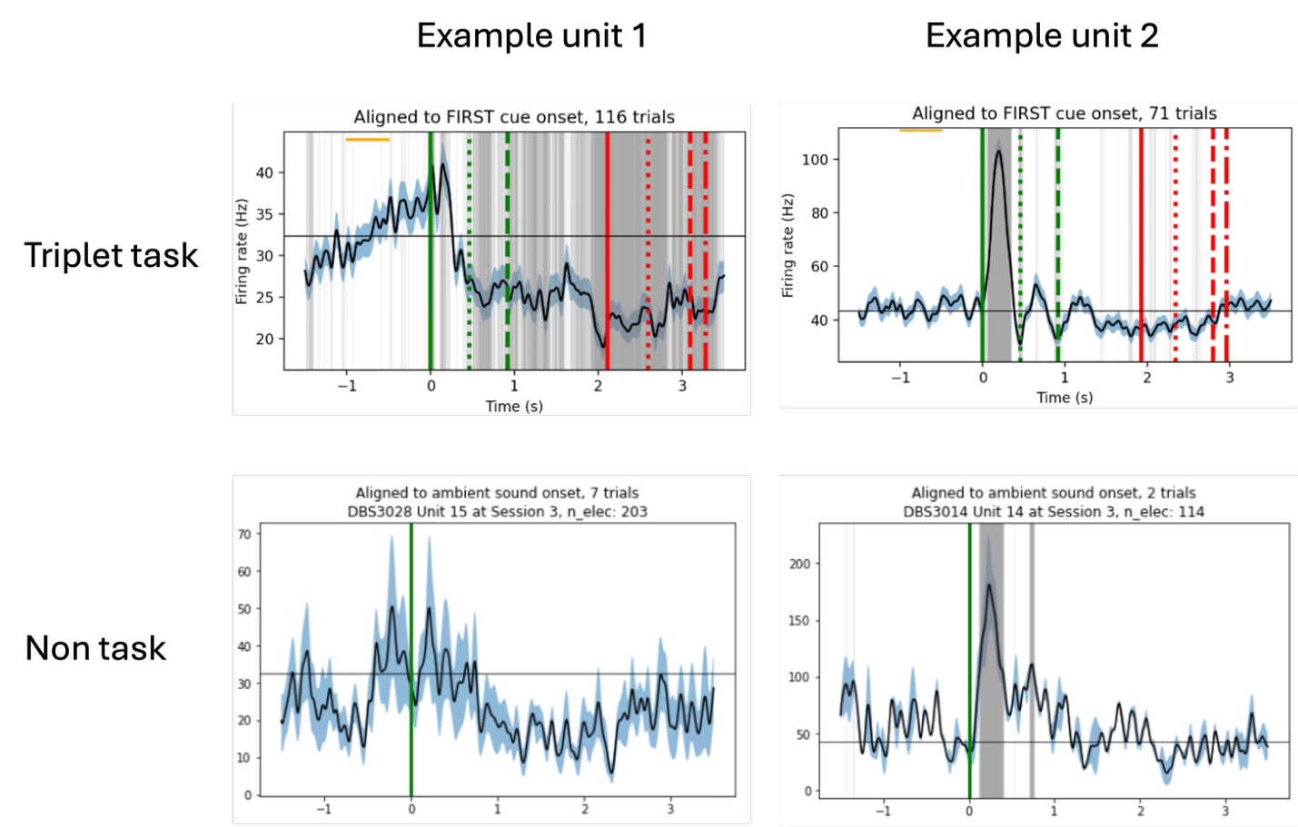

Supplementary Figure 7 | STN consonant-, vowel-, and sequence encoding units presented spatial aggregation. Permutation results show syllable units (consonant- and vowel-) aggregated in the STN when compared to a random sample of recorded units’ location in the STN. The sequence encoding units did not aggregate in the STN when compared to a random sample of recorded units’ location in the STN. Permutation n=10,000, p(Auditory-C)=0.0090, p(Auditory-V)=1.798e-8, p(Auditory-ID)=0.1630. Corrected for number of units=51.

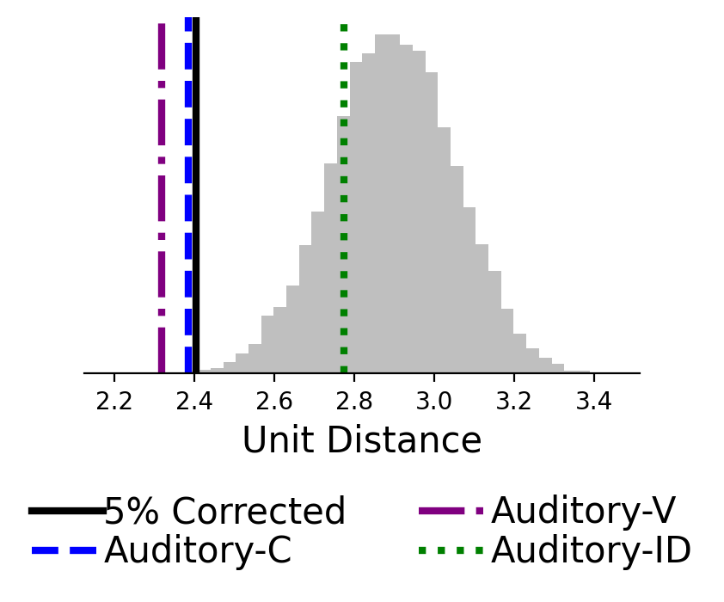

Supplementary Figure 8 | Time-resolved STN encoding of syllable feature using one-way ANOVA. Response selectivity for all syllable feature encoding units (measures how differentiable each syllable type is at the given time point). Grey-shaded areas indicate significantly different consonants or vowels. 12 units combined. One-way ANOVA compares the firing rate of all units in response to each consonant or vowel. Horizontal line indicates the significant threshold (mean + 1.96 STD)
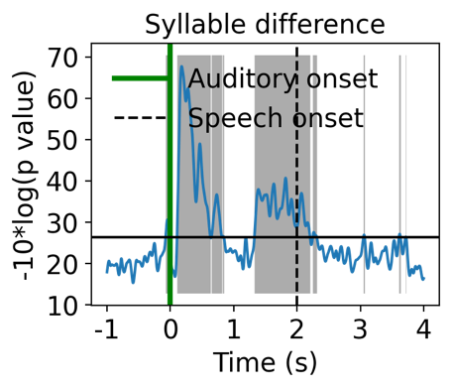

Supplementary Figure 9 | Time-resolved STN encoding of syllable feature using moving window linear model. Left: Multiple regression was performed using the mean firing rate within a series of 200-ms windows that were lagged relative to the auditory onset to assess the timing of syllable feature encoding relative to auditory and speech epochs. Middle: Results of regression models with time lags for all auditory-syllable units. Blue and orange shaded bars indicate time periods that encode consonants or vowels. The green line indicates the auditory onset. Right: Results of regression models with time lags for all auditory-syllable units. Blue and purple representation of the unit encodes for consonants and vowels, respectively. The alpha of the color indicated the value of Partial R². The black line indicates the auditory onset.
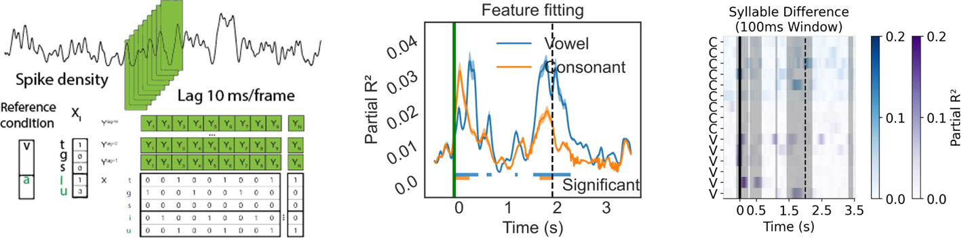

Supplementary Figure 10 | STN auditory stimuli volume modulation. Modulation of firing rate by stimulus volume similar to syllable encoding. Grey-shaded areas indicate significant modulation between low and high volume.
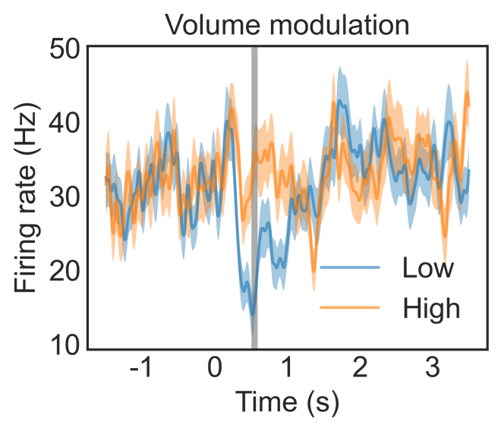

Supplementary Figure 11 | Time-resolved STG two-component NMF. NMF of each type of neural response along time (onset: blue, sustained: orange, and syllable: green). Auditory onset = 1500ms, auditory offset=2750ms.
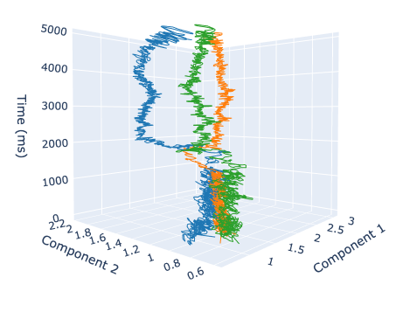

Supplementary Figure 12 | STG high gamma activity during the triplet task. (Top) Representative high gamma activity of STG electrodes of the triplet, sustained, and onset types. Green lines indicate auditory onset, and red lines indicate speech onset. Grey-shaded areas indicate significant modulation compared to the resting state. (Bottom) Time course of high gamma (70, 150) Hz power of LFPs for all STG ECoG electrodes, hierarchically clustered based on Euclidean distance.
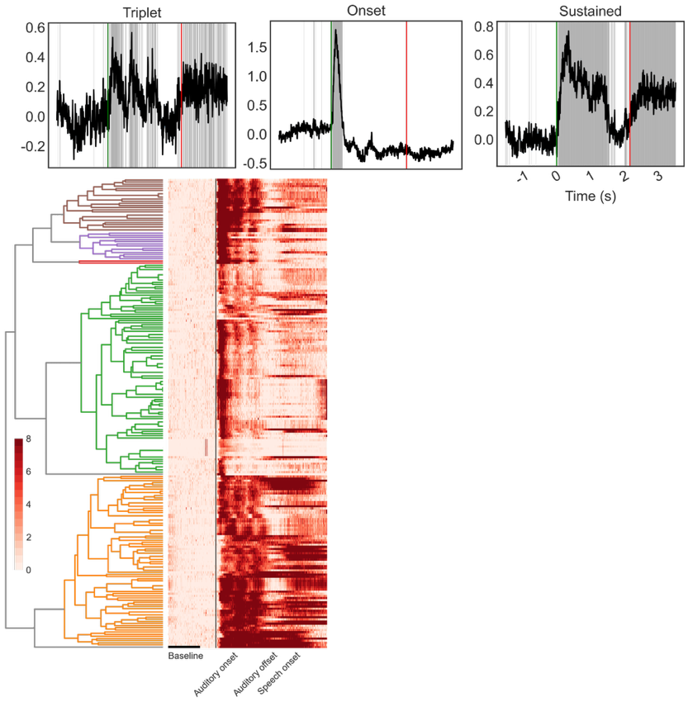

Supplementary Figure 13 | Selection of the number of components appropriate for NMF analysis. Left: Percentage of variance explained by the number of NMF components. Right: Unsupervised non-negative matrix factorization (NMF) with four components for STG high gamma activity, onset and triplet-like components, along with two triplet-like components that are anti-phase, can be identified. The grey shaded area indicates the auditory epoch. The sustained type shown in two-component NMF can be depicted with the two syllable “triplet-like” components in anti-phase, which is defined as a peak in one component is the valley of the other component, and the peak in one component has a 0.5-second difference to the peak of the other component; here, are, components 1 and 4.
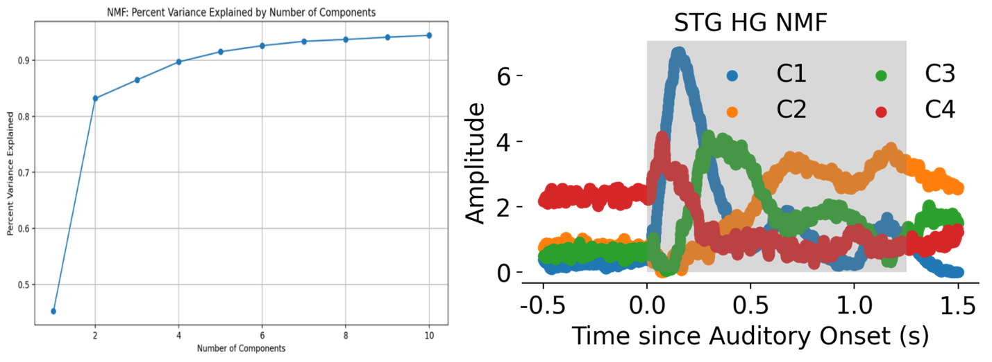

Supplementary Figure 14 | STN local field potential NMF with five components. (A) Raw STN LFP NMF, sampling rate 1000Hz, frequency range (0, 200)Hz. Across all macroelectrode channels. Time aligns to the auditory epoch onset. (B) STN LFP NMF in high gamma band (70, 150) Hz. (C) STN LFP NMF in beta band (13, 30) Hz. (D) STN LFP NMF in low gamma band (30, 70) Hz. Grey shaded area indicates the auditory epoch.
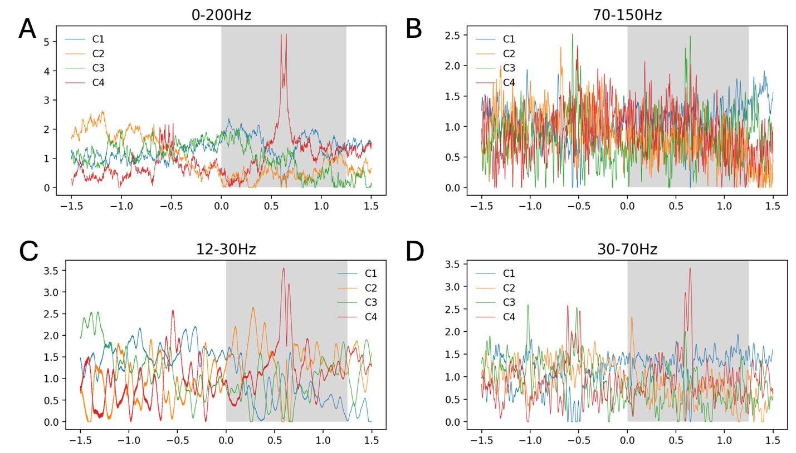

Supplementary Figure 15 | STN-cortical SPC. STN spike-cortical phase locking across frequency bands (theta and low gamma) and cortical regions during auditory epochs.
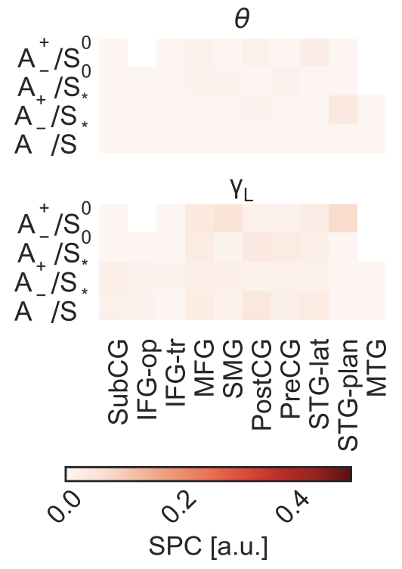

Supplementary Figure 16 | STG evoked potential after STN stimulation. Left: Averaged evoked potential at STG after STN macro-stimulation from a representative STG electrode. Right: Latency of the first evoked potential peak at STG. Y-axis: the number of recorded peaks.
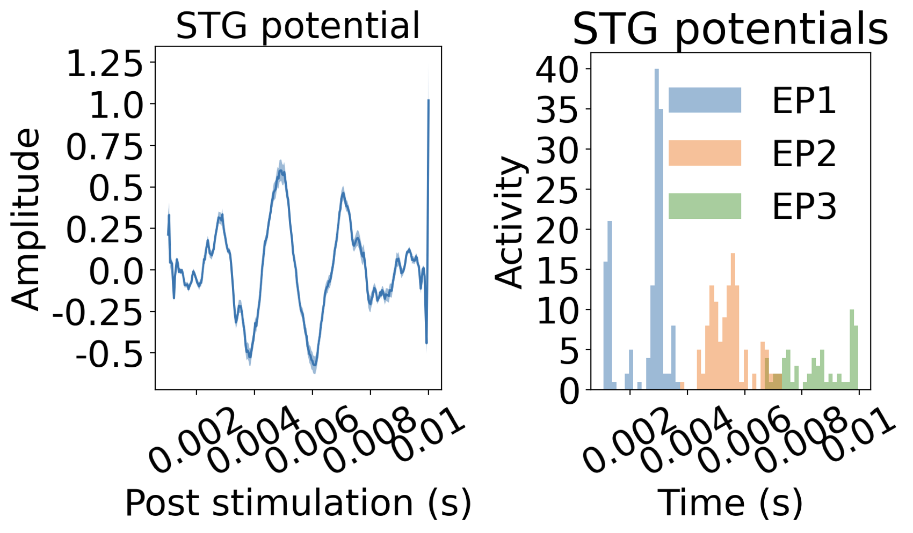

Supplementary Figure 17 | STG evoked potential after STN stimulation. Permutation results show that STN^{Stim-STG} locations significantly differ from the rest of the STN^{Stim} locations. Permutation n=10,000, p=5.9147e-7.

Supplementary Figure 18 | STN unit categorization. Summarize all STN units and categorize them based on their behavior. Black indicated the unit had fallen into the unit type shown at the bottom. Grey indicated the unit was not modulated during either auditory or speech epochs.
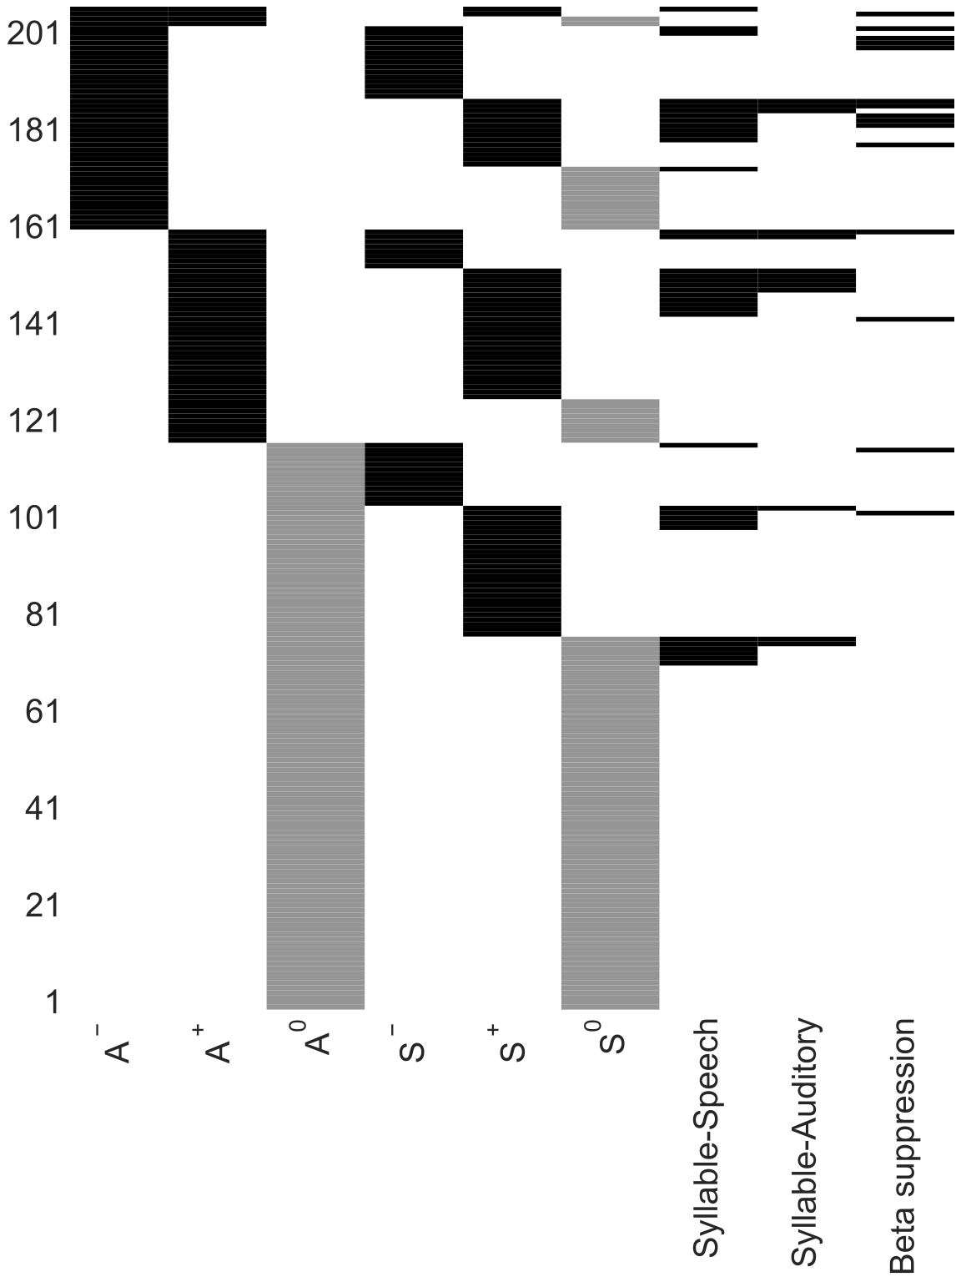

Supplementary Table 1 | Participant demographics. Summary of the clinical description of the patient cohort, including symptom severity, recording availability, and behavioral performance. M/F: male/female, UPDRS: Unified Parkinson's Disease Rating Scale, NR: value was not recorded in the medical record. We report age and gender in aggregate (mean ± SD) in the Methods section of the manuscript.
ID | Surgery side | UPDRS III OFF | UPDRS III Speech OFF | UPDRS III ON | UPDRS III Speech ON | #task runs | #ECoG strips | MER tracks | #Units | Speech duration, s | #trials | Phonetic accuracy %
DBS3001 | L | 25 | 0 | 10 | 0 | 4 | 1 | MCP | 22(19) | 1.29 | 344 | 86.61
DBS3002 | L | 29 | 1 | 16 | 1 | 2 | 1 | MCP | 5 (4) | 0.99 | 360 | 60.34
DBS3003 | L | 17 | 1 | 3 | 0 | 3 | 2 | MCP | 13 (13) | 1.39 | 480 | 77.60
DBS3004 | L | 61 | 1 | 36 | 2 | 3 | 1 | MCP | 11 (9) | 1.35 | 360 | 55.00
DBS3008 | L | NR | NR | NR | NR | 2 | 1 | MCP | 11 (10) | 1.54 | 360 | 74.17
DBS3010 | L | 34 | 1 | 14 | 1 | 3 | 3 | MCP | 14 (13) | 1.16 | 480 | 78.96
DBS3011 | L | 30 | 1 | 7 | 0 | 3 | 2 | MCP | 8 (8) | 0.89 | 480 | 69.05
DBS3012 | L | 43 | 2 | 26 | 2 | 4 | 2 | ACP | 13 (11) | 1.19 | 600 | 84.01
DBS3014 | L | 30 | 0 | 19 | 0 | 3 | 2 | MCP | 15 (15) | 1.52 | 480 | 50.42
DBS3015 | L | 42 | 1 | 24 | 1 | 3 | 1 | MCP | 9 (9) | 1.61 | 480 | 87.29
DBS3017 | L | 34 | 1 | 26 | 1 | 3 | 1 | MCP | 6 (2) | 1.59 | 345 | 48.83
DBS3018 | L | 21 | 1 | 13 | 0 | 3 | 2 | MCP | 9 (8) | 1.27 | 480 | 88.08
DBS3019 | L | 40 | NR | 18 | NR | 3 | 2 | MCP | 13 (7) | 1.13 | 360 | 20.55
DBS3020 | L | 19 | 0 | 15 | 0 | 2 | 2 | MCP | 7 (7) | 1.28 | 360 | 26.76
DBS 3022 | L | 38 | 1 | 20 | 1 | 2 | 2 | MCP | 9 (9) | 1.05 | 360 | 3.89
DBS 3023 | L | 30 | 2 | 7 | 1 | 3 | 2 | MCP | 11 (11) | 1.24 | 360 | 27.94
DBS3024 | L | 37 | 1 | 27 | 1 | 2 | 2 | MCP | 11 (8) | 1.13 | 360 | 69.05
DBS3026 | L | 50 | 1 | 24 | 1 | 2 | 2 | MCP | 7 (5) | 1.23 | 148 | 6.40
DBS3027 | L | 33 | 0 | 30 | 0 | 2 | 2 | MCP | 9 (9) | 1.37 | 360 | 39.17
DBS3028 | L | 39 | 2 | 29 | 2 | 3 | 2 | MCP | 18 (16) | 1.48 | 480 | 88.57
DBS3029 | L | NR | NR | NR | NR | 2 | 2 | MCP | 6 (5) | 1.40 | 240 | 52.08
DBS3030 | L | 43 | 2 | 30 | 2 | 2 | 2 | MCP | 5 (5) | 2.49 | 240 | 56.25
DBS3031 | L | 39 | 2 | 26 | 2 | 2 | 2 | MCP | 5 (4) | 1.26 | 240 | 22.38
DBS3032 | L | 47 | 1 | 27 | 1 | 3 | 2 | MCP | 8 (4) | 1.49 | 360 | 80.39
Mean (SD) |  | 35.5 (10.18) |  |  |  | 2.67 (0.62) | 1.79 (0.49) |  | 24 5 (211) | 1.35 (0.41) | 379.88 (99.49) | 56.41 (26.91)

1 Jensen, O. & Mazaheri, A. Shaping functional architecture by oscillatory alpha activity: gating by inhibition. Front Hum Neurosci 4, 186, doi:10.3389/fnhum.2010.00186 (2010).
2 Halgren, M. et al. The generation and propagation of the human alpha rhythm. Proceedings of the National Academy of Sciences 116, 23772-23782 (2019).
3 Jorge, A. et al. Hyperdirect connectivity of opercular speech network to the subthalamic nucleus. Cell Rep 38, 110477, doi:10.1016/j.celrep.2022.110477 (2022).
4 Miocinovic, S. et al. Cortical Potentials Evoked by Subthalamic Stimulation Demonstrate a Short Latency Hyperdirect Pathway in Humans. The Journal of Neuroscience 38, 9129-9141, doi:10.1523/jneurosci.1327-18.2018 (2018).
5 Chen, W. et al. Prefrontal-subthalamic hyperdirect pathway modulates movement inhibition in humans. Neuron 106, 579-588. e573 (2020).
6 Dara, C., Monetta, L. & Pell, M. D. Vocal emotion processing in Parkinson's disease: Reduced sensitivity to negative emotions. Brain Research 1188, 100-111, doi:https://doi.org/10.1016/j.brainres.2007.10.034 (2008).
7 Péron, J. et al. Recognition of emotional prosody is altered after subthalamic nucleus deep brain stimulation in Parkinson's disease. Neuropsychologia 48, 1053-1062, doi:https://doi.org/10.1016/j.neuropsychologia.2009.12.003 (2010).
8 Valkonen, K. et al. Deep brain stimulation of subthalamic nucleus modulates cortical auditory processing in advanced Parkinson's Disease. PloS one 17, e0264333, doi:10.1371/journal.pone.0264333 (2022).
9 Airaksinen, K. et al. Effects of DBS on auditory and somatosensory processing in Parkinson's disease. Hum Brain Mapp 32, 1091-1099, doi:10.1002/hbm.21096 (2011).
10 Akbar, U. et al. Tinnitus after Deep Brain Stimulation Surgery, a Case Series (P6.074). Neurology 82, P6.074 (2014).
11 Huang, X. et al. The impact of Parkinson's disease on the cortical mechanisms that support auditory–motor integration for voice control. Human Brain Mapping 37, 4248-4261 (2016).
12 Chen, X. et al. Sensorimotor control of vocal pitch production in Parkinson's disease. Brain Research 1527, 99-107 (2013).
13 Behroozmand, R. et al. Effect of deep brain stimulation on vocal motor control mechanisms in Parkinson's disease. Parkinsonism Relat Disord 63, 46-53, doi:10.1016/j.parkreldis.2019.03.002 (2019).
14 Bahners, B. H. et al. Deep brain stimulation does not modulate auditory-motor integration of speech in Parkinson's disease. Frontiers in Neurology 11, 655 (2020).
15 Ashoori, A., Eagleman, D. M. & Jankovic, J. Effects of auditory rhythm and music on gait disturbances in Parkinson’s disease. Frontiers in neurology 6, 234 (2015).
16 Lipski, W. J. et al. Subthalamic Nucleus Neurons Differentially Encode Early and Late Aspects of Speech Production. J Neurosci 38, 5620-5631, doi:10.1523/jneurosci.3480-17.2018 (2018).
17 Starr, P. A., Theodosopoulos, P. V. & Turner, R. Surgery of the Subthalamic Nucleus: Use of Movement-related Neuronal Activity for Surgical Navigation. Neurosurgery 53, 1146-1149, doi:10.1227/01.Neu.0000088803.79153.05 (2003).
18 Randazzo, M. J. et al. Three-dimensional localization of cortical electrodes in deep brain stimulation surgery from intraoperative fluoroscopy. Neuroimage 125, 515-521, doi:10.1016/j.neuroimage.2015.10.076 (2016).
19 Dale, A. M., Fischl, B. & Sereno, M. I. Cortical surface-based analysis: I. Segmentation and surface reconstruction. Neuroimage 9, 179-194 (1999).
20 Destrieux, C., Fischl, B., Dale, A. & Halgren, E. Automatic parcellation of human cortical gyri and sulci using standard anatomical nomenclature. Neuroimage 53, 1-15, doi:10.1016/j.neuroimage.2010.06.010 (2010).
21 Horn, A. & Kühn, A. A. Lead-DBS: a toolbox for deep brain stimulation electrode localizations and visualizations. Neuroimage 107, 127-135, doi:10.1016/j.neuroimage.2014.12.002 (2015).
22 Ewert, S. et al. Toward defining deep brain stimulation targets in MNI space: A subcortical atlas based on multimodal MRI, histology and structural connectivity. Neuroimage 170, 271-282, doi:10.1016/j.neuroimage.2017.05.015 (2018).
23 Bush, A. et al. Differentiation of speech-induced artifacts from physiological high gamma activity in intracranial recordings NeuroImage 250, 118962, doi:https://doi.org/10.1016/j.neuroimage.2022.118962 (2022).
24 Zhu, Y. et al. Distinct spatiotemporal patterns of syntactic and semantic processing in human inferior frontal gyrus. Nature Human Behaviour 6, 1104-1111, doi:10.1038/s41562-022-01334-6 (2022).

