ICU Nurses’ Knowledge, Attitudes, and Practices in Identifying Patient–Ventilator Asynchrony: A Cross-Sectional Study

Part 1: Informed Consent Statement
Dear Nursing Colleagues,
Thank you for participating in this multicenter survey on ICU nurses' ability, attitude, and practice in recognizing ventilator waveforms. This study aims to evaluate ICU nurses' ability, attitude, and practice in recognizing PVA from ventilator waveforms to provide a reference for improving treatment outcomes and nursing quality for mechanically ventilated patients. Please read the following information:
1. This survey is completely anonymous, and no personally identifiable information is collected.
2. Participation is entirely voluntary, and you may withdraw at any time without providing a reason.
3. The data will only be used for academic research, and the results will be presented in aggregate form.
4. The survey is time-limited to 30 minutes, including a knowledge testing section.
□ I have read and understood the above and voluntarily participate in this study.
If you have any questions, please feel free to contact us.
Contact Person: Xianming Ge, Email: 531040415@qq.com
Jiuhong Ma, Email: 870915878@qq.com
Part 2: Basic Information
(Please check or fill in the appropriate content)
A. Demographic Data
1. Gender: □ Male □ Female
2. Age: □ <25 years □ 25–30 years □ 31–35 years □ 36–40 years
3. Highest Degree: □ Associate Degree □ Bachelor's Degree □ Master's Degree □ Doctoral Degree
Clinical Experience
4. Years of experience in ICU: □ <5 years □ 5–10 years □ >10 years
5. Have you received any training related to mechanical ventilation courses?
□ Yes (please select total duration) for example: special courses organized by hospitals, provincial/national continuing education programs, respiratory therapist systematic training, etc.:
□ ≤100 hours □ >100 hours
□ No
C. Institutional Characteristics
6. ICU Type: □ General ICU □ Specialized ICU (please specify______)
Part 3: Ventilator Waveform Recognition Ability Test
Please select the most appropriate PVA type or normal waveform based on the characteristics of the ventilator waveform diagram.
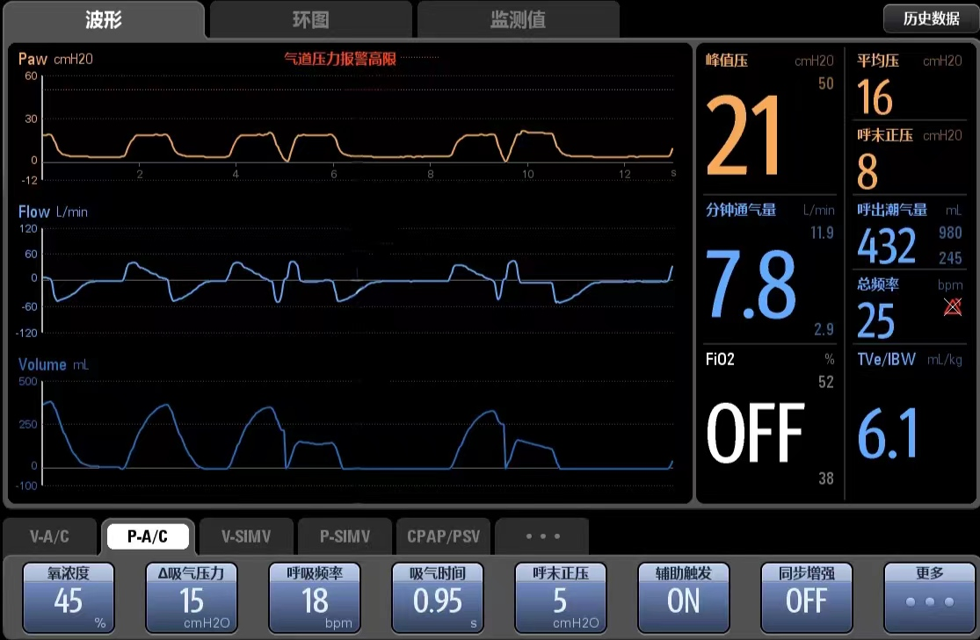
1. As shown in the diagram: the flow and pressure waveforms show the patient's inspiratory effort, but the ventilator is not delivering air. Which of the following situations is most consistent with this waveform?
□ Auto-triggering □ Double triggering □ Insufficient flow □ Invalid triggering □ Normal waveform
2. As shown in the diagram: a single inspiratory effort is followed by two ventilator air deliveries. Which of the following situations is most consistent with this waveform?
□ Premature switching □ Insufficient flow □ Double triggering □ Invalid triggering □ Delayed switching
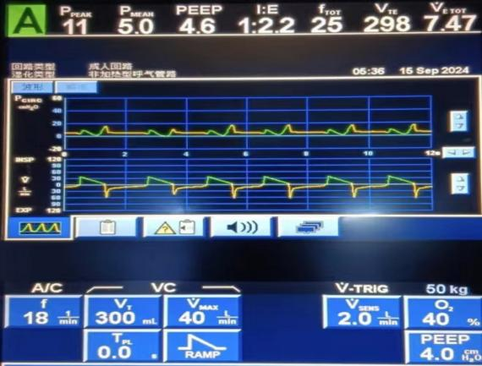
3. As shown in the diagram: the pressure in the inspiratory phase rapidly drops, showing a 'cave sign.' Which of the following situations is most consistent with this waveform?
□ Auto-triggering □ Insufficient flow □ Delayed switching □ Invalid triggering □ Premature switching
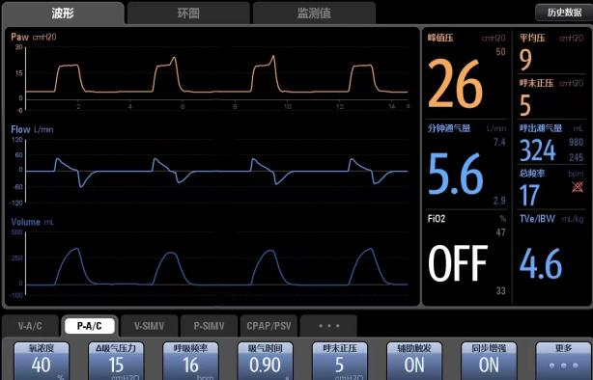
4. As shown in the diagram: the pressure-time curve rises at the end of inspiration; the inspiratory flow has dropped to zero, but the ventilator is still delivering air. Which of the following situations is most consistent with this waveform?
□ Auto-triggering □ Insufficient flow □ Delayed switching □ Double triggering □ Normal waveform
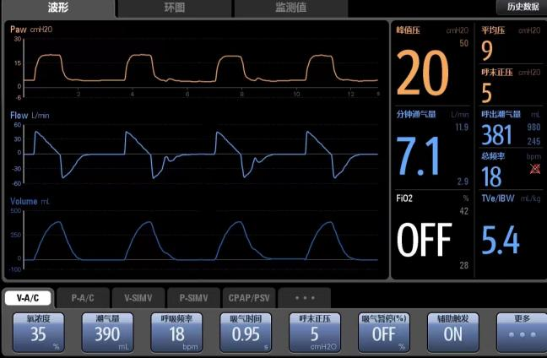
5. As shown in the diagram: the patient’s repeated inspiratory efforts do not lead to volume change. Which of the following situations is most consistent with this waveform?
□ Auto-triggering □ Delayed switching □ Invalid triggering □ Premature switching □ Insufficient flow
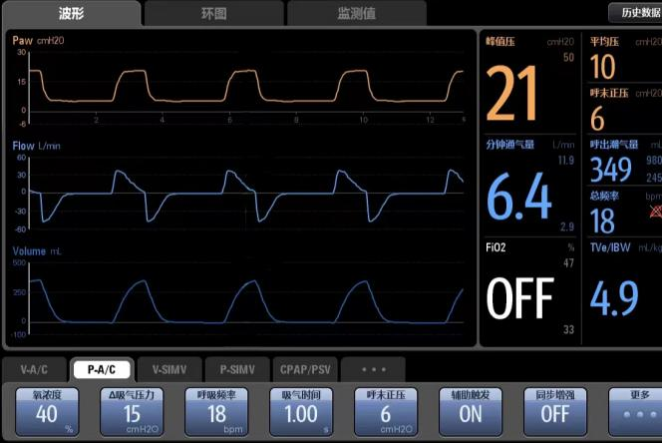
6. As shown in the diagram: the volume-time curve shows symmetrical volume changes between inspiration and expiration; the flow-time curve rapidly rises and then remains relatively stable in each cycle. Which of the following situations is most consistent with this waveform?
□ Invalid triggering □ Double triggering □ Auto-triggering □ Delayed switching □ Normal waveform
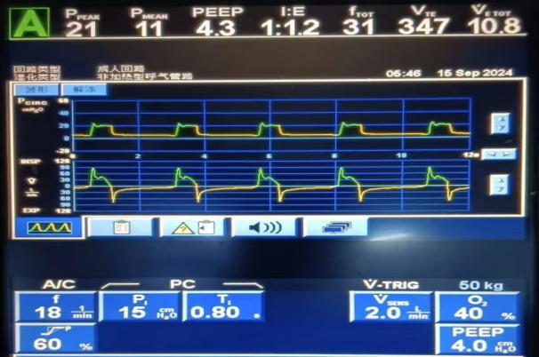
7. As shown in the diagram: a high peak appears at the beginning of the inspiratory phase of the pressure-time waveform. Which of the following situations is most consistent with this waveform?
□ Auto-triggering □ Air leakage □ Excessive flow rate □ Delayed switching □ Normal waveform
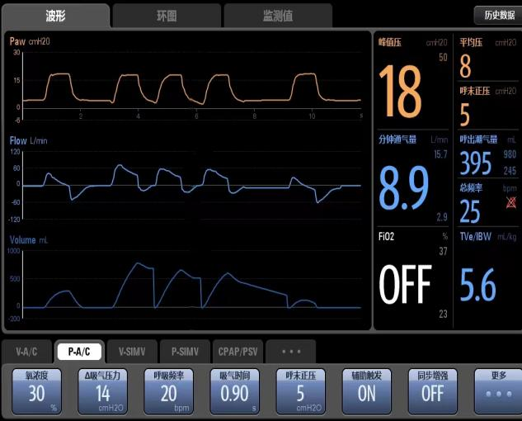
8. As shown in the diagram: the ventilator delivers regular breaths without patient inspiratory effort, and the exhalation in the volume-time curve does not return to baseline. Which of the following situations is most consistent with this waveform?
□ Delayed triggering □ Invalid triggering □ Normal waveform □ Excessive flow rate □ Auto-triggering
9. As shown in the diagram: Please comprehensively assess the (pressure, flow, volume) time curves. Which of the following situations is most consistent with this waveform?
□ Delayed switching □ Excessive flow rate □ Double triggering □ Auto-triggering □ Normal waveform
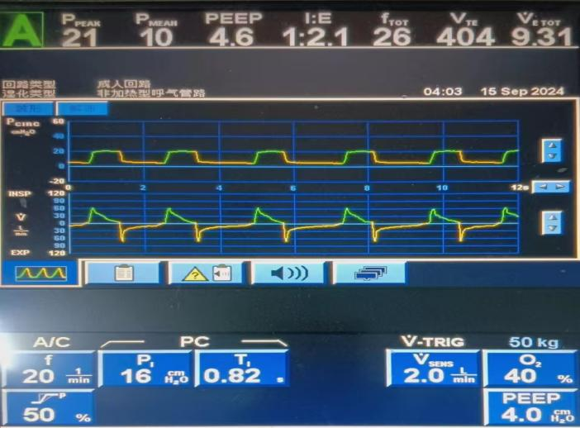
10. As shown in the diagram: Please comprehensively assess the (pressure, flow) time curves. Which of the following situations is most consistent with this waveform?
□ Delayed switching □ Excessive flow rate □ Double triggering □ Auto-triggering □ Normal waveform
Part 4: Attitude Situation
Instructions: Please indicate your level of agreement with the following statements. (1 = Strongly Disagree, 2 = Disagree, 3 = Neutral, 4 = Agree, 5 = Strongly Agree)
1. I believe that mastering ventilator waveform analysis is one of the core competencies for becoming an excellent ICU nurse.
□ Strongly Disagree □ Disagree □ Neutral □ Agree □ Strongly Agree
2. I believe that using waveform analysis can significantly improve the management quality of mechanically ventilated patients and improve patient outcomes.
□ Strongly Disagree □ Disagree □ Neutral □ Agree □ Strongly Agree
3. I believe that ventilator waveform analysis is a key tool for identifying early patient-ventilator asynchrony and potential respiratory system problems.
□ Strongly Disagree □ Disagree □ Neutral □ Agree □ Strongly Agree
4. I believe that providing information about patient ventilation status to doctors based on waveform analysis is an important part of the nurse's role.
□ Strongly Disagree □ Disagree □ Neutral □ Agree □ Strongly Agree
5. I am confident that I can learn and master ventilator waveform analysis skills.
□ Strongly Disagree □ Disagree □ Neutral □ Agree □ Strongly Agree
6. I am eager to receive more systematic training and continuing education opportunities on ventilator waveform analysis.
□ Strongly Disagree □ Disagree □ Neutral □ Agree □ Strongly Agree
7. Even during busy work periods, I believe it is worthwhile to spend time observing and analyzing ventilator waveforms.
□ Strongly Disagree □ Disagree □ Neutral □ Agree □ Strongly Agree
8. I am willing to share and discuss difficult cases and insights in waveform analysis with colleagues.
□ Strongly Disagree □ Disagree □ Neutral □ Agree □ Strongly Agree
9. I believe the department should provide us with more learning resources for ventilator waveform analysis.
□ Strongly Disagree □ Disagree □ Neutral □ Agree □ Strongly Agree
10. I believe that, compared to other routine nursing tasks, spending time learning ventilator waveform analysis is of equal or greater importance.
□ Strongly Disagree □ Disagree □ Neutral □ Agree □ Strongly Agree
Part 5: Practice Situation
Instructions: Please select based on the frequency of your actual behaviors in clinical work over the past three months. (1 = Never, 2 = Occasionally, 3 = Sometimes, 4 = Often, 5 = Always)
1. When caring for mechanically ventilated patients, I consciously observe the ventilator waveform screen during each bedside round.
□ Never □ Occasionally □ Sometimes □ Often □ Always
2. When the ventilator alarms, I check the waveform to help determine the real cause of the alarm rather than simply resetting it.
□ Never □ Occasionally □ Sometimes □ Often □ Always
3. When I observe abnormal waveforms, I immediately assess them in combination with the patient’s clinical signs (e.g., respiratory rate, chest movement, SpO2, etc.).
□ Never □ Occasionally □ Sometimes □ Often □ Always
4. I can identify common patient-ventilator asynchrony (e.g., double triggering, ineffective effort, auto-triggering, inspiratory-expiratory switching, etc.) through waveforms.
□ Never □ Occasionally □ Sometimes □ Often □ Always
5. I use the flow-time waveform to assess whether exhalation is complete or to guide me in suctioning.
□ Never □ Occasionally □ Sometimes □ Often □ Always
6. When I suspect issues such as endogenous PEEP or increased airway resistance based on ventilator waveform analysis, I proactively report my findings to the doctor.
□ Never □ Occasionally □ Sometimes □ Often □ Always
7. During bedside handover, I mention ventilation status-related information to the next shift nurse.
□ Never □ Occasionally □ Sometimes □ Often □ Always
8. I assess whether the current ventilator parameters (e.g., tidal volume, PEEP) are suitable for the patient based on observed waveforms.
□ Never □ Occasionally □ Sometimes □ Often □ Always
9. I describe important waveform observations in the nursing record (e.g., 'Detected ineffective triggering, reported to doctor').
□ Never □ Occasionally □ Sometimes □ Often □ Always
10. When I observe abnormal waveforms (e.g., sawtooth waveform due to increased airway secretions), I prioritize performing relevant nursing measures (e.g., suctioning) within my scope of responsibility and monitor for improvements.
□ Never □ Occasionally □ Sometimes □ Often □ Always

