Definition of Functional Dyspepsia According to the Rome IV Criteria
According to the revised Rome IV criteria, functional dyspepsia is officially defined by:
i) Persistent or recurring dyspepsia for more than 3 months within the past 6 months;
ii) No demonstration of a possible organic cause of the symptoms on endoscopy;
iii) No sign that the dyspepsia is relieved only by defecation or of an association with stool irregularities.
In the current Rome IV criteria, 2 subgroups of functional dyspepsia are divided according to the cardinal symptoms (Figure S1.):
i) Epigastric pain syndrome (EPS)—predominant epigastric pain or burning;
ii) Postprandial distress syndrome (PDS)—feeling of fullness and early satiation.

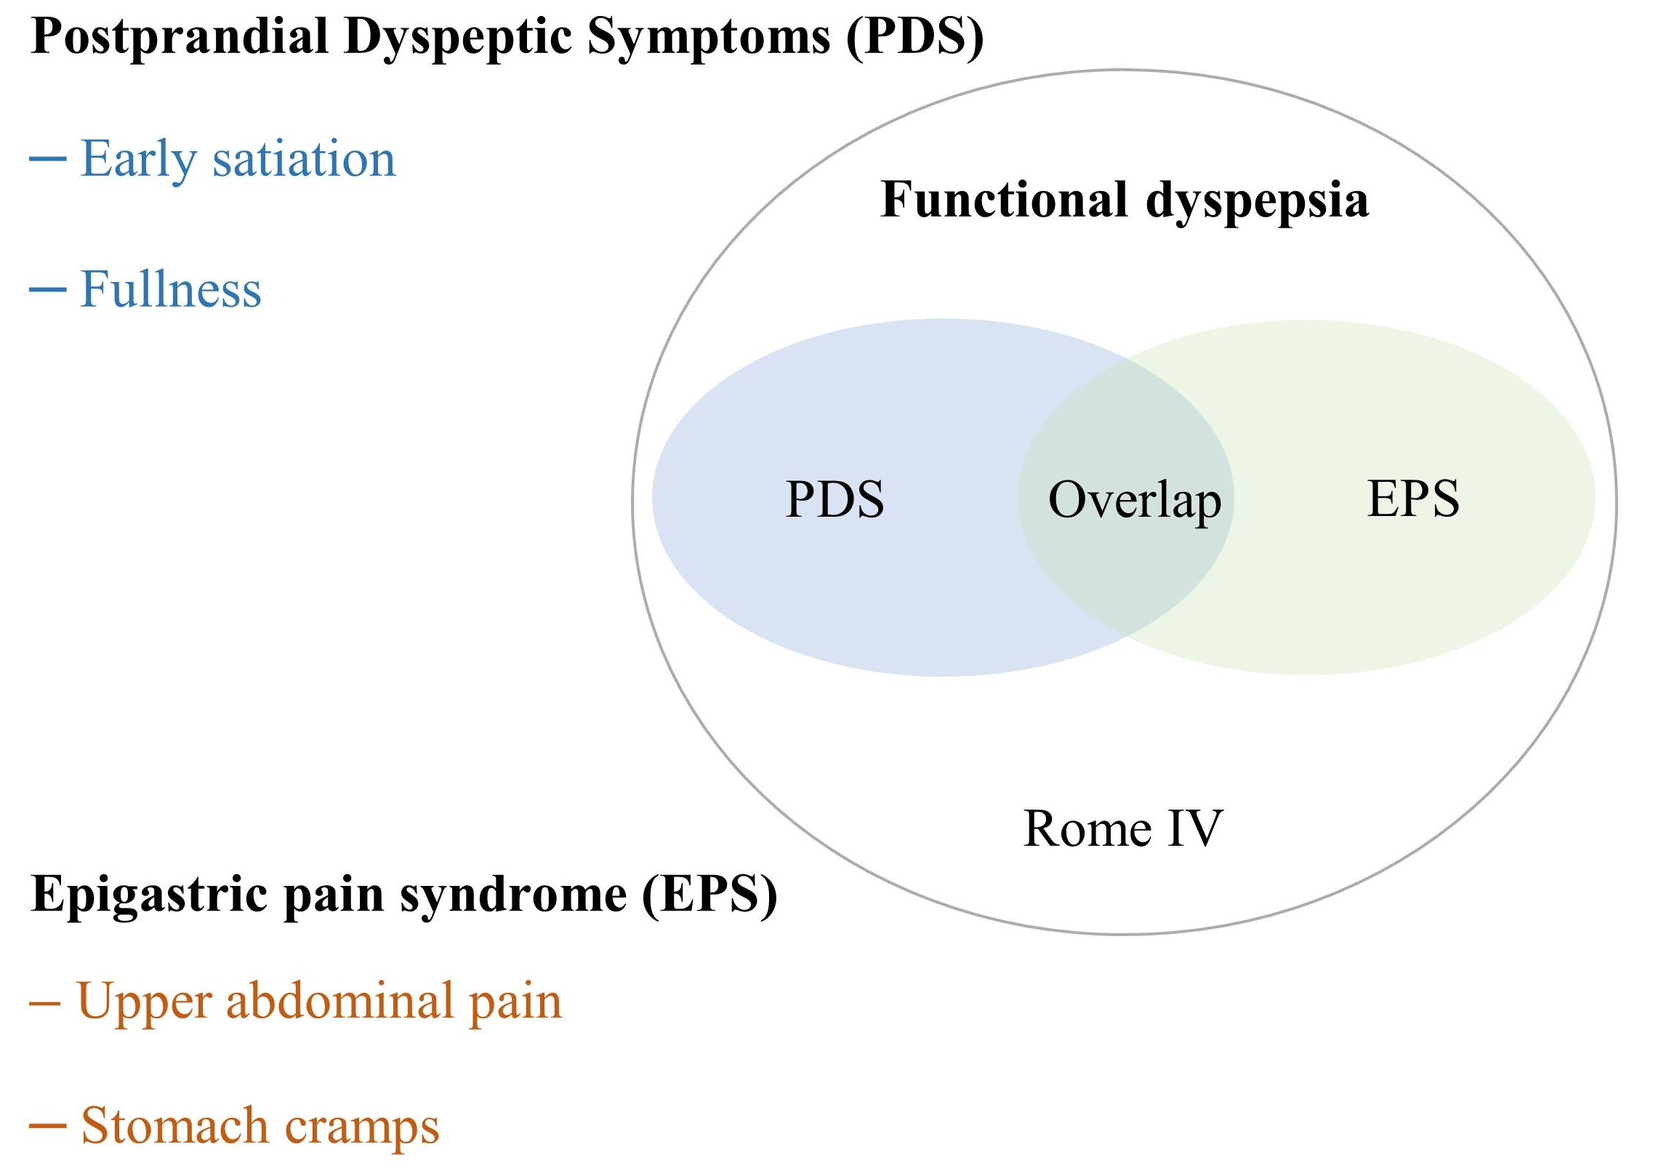
Figure S1.

