Supplementary material
Appendix A: Estonian pension system
Appendix B: Screenshots of the reminder texts
Appendix C: Reminder texts
Appendix D: Moderator variables
Appendix E: Identifying heterogeneous treatment effects using random forest
Appendix F: R script (osf)

Appendix A: Estonian pension system
The Estonian pension system is based on three pillars:
- 1st Pillar: State pension, pay-as-you-go
- 2nd Pillar: Mandatory funded pension, defined contributions
- 3rd Pillar: Supplementary funded pension, defined contribution
This study focuses on the 3rd pillar, which is voluntary and offers tax incentives. Account holders can claim a 20% income tax return on contributions up to 15% of their gross income (maximum 6,000€ per year). Despite these incentives, saving for retirement has not reached a sufficient level to ensure people's financial well-being in the future. According to the OECD, the pension savings of Estonians provide, on average, only 34.4% of their pre-retirement income. With this indicator, Estonia is far behind the OECD average of 61.4%, creating a clear need for interventions to enhance voluntary savings.
Moreover, in 2021 Estonia implemented a pension reform in which participation in the 2nd pension pillar was made voluntary and the opportunity was introduced for people to withdraw pension savings they had accumulated in their second pillar accounts. Significant penalties, including a 20% tax on their savings and a 10-year waiting period to rejoin the second pillar. Since the reform, €1.5 billion has been disbursed in second pillar payouts. As of the end of August 2023, nearly 30 percent of those with second pension pillar accounts had withdrawn their money from them. This reform represents a significant shift in the Estonian pension system increasing the relevance of interventions to increase pension savings.
Contributions in the 2nd and 3rd pillar can be invested in a pre-defined selection of mutual funds. These include low-fee index funds as well as actively managed funds.
Upon retirement, individuals can choose between different income options, withdrawing a lumpsum (taxed at 10% rate) or annuities (not taxed).

Appendix B: Reminder texts in Estonian, Russian, English

Subject line for all groups, only in Estonian:
Meeldetuletus: kuni 27.12 saab panustada III samba tulumaksutagastusse
(Direct translation: Reminder: until 27.12 it is possible to contribute to 3rd pillar income tax return)

Group # 1 Baseline reminder

Hea III pensionisamba omanik

Kuni 27. detsembrini tehtud sissemaksed pensioni III sambasse jõuavad 2023. aasta tulumaksutagastuse arvestusse. Võid tagasi saada 20% III sambasse makstud rahast.
Vaata üle, kas kasutad selle võimaluse ära: Küsimused ja vastused III samba maksutagastuse kohta www.pensionikeskus.ee/iii-sammas/sissemaksed/kusimused-ja-vastused-iii-samba-maksutagastuse-kohta/?III-samba-KKK-I
Tulumaksuvabalt saad III sambasse paigutada kuni 15% aasta brutosissetulekust, aga mitte rohkem kui 6000 eurot.

Lugupidamisega
Pensionikeskus
Töötleme andmeid vastavalt Pensionikeskuse privaatsuspõhimõtetele, millega saab tutvuda: https://www.pensionikeskus.ee/meist/isikuandmete-tootlemine/

Уважаемый инвестор III пенсионной ступени!

Платежи, поступившие в III ступень пенсионного фонда до 27 декабря, успеют войти в расчет возврата подоходного налога за 2023 год. Вы можете получить обратно 20% от суммы, вложенной в III ступень.
Проверьте, воспользовались ли Вы этой возможностью: Вопросы и ответы касательно налогового возврата с III ступени www.pensionikeskus.ee/ru/iii-ступень/взносы/вопросы-и-ответы-касательно-налогово/?iii-ступень-ЧаВо-I
Вы можете вложить в III ступень без вычета подоходного налога до 15% от своего годового дохода (брутто), но не более 6000 евро.
С уважением
Пенсионный регистр

Мы обрабатываем данные в соответствии с принципами приватности Пенсионного регистра, с которыми можно ознакомиться здесь: https://www.pensionikeskus.ee/meist/isikuandmete-tootlemine/

Dear III pillar account holder,
Contributions made to the III pension pillar until December 27 will be included in the income tax refund for 2023. You can get back 20% of your III pillar payment.
Check if you are taking advantage of this opportunity: Questions and answers about the III pillar tax refund www.pensionikeskus.ee/en/iii-pillar/contributions/questions-and-answers-about-the-iii-pillar-tax-refund/?III-pillar-FAQ-I
The income tax refund applies to III pillar contributions up to 15% of your gross income, but not more than 6,000 euros per year.
Yours sincerely,
Pension Center
Your data is processed in accordance with the Pension Centre's privacy policy found here: https://www.pensionikeskus.ee/en/about-us/gdpr/

Appendix C: Screenshots of the reminder texts

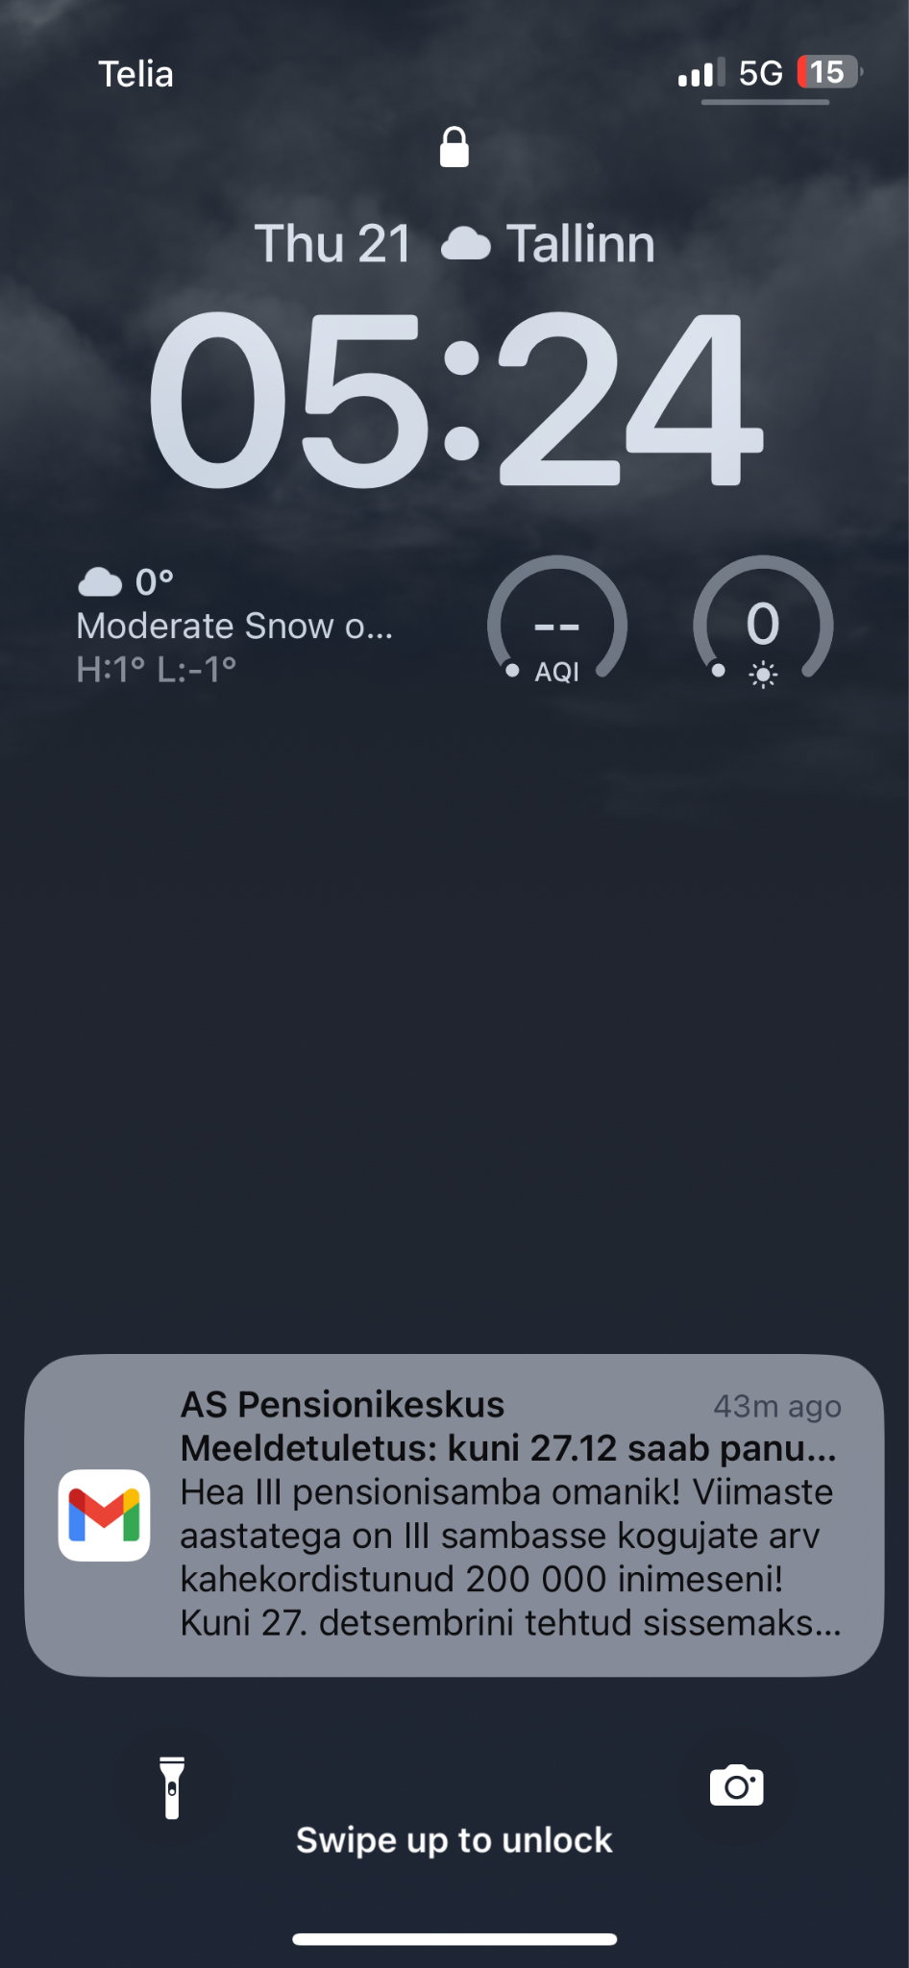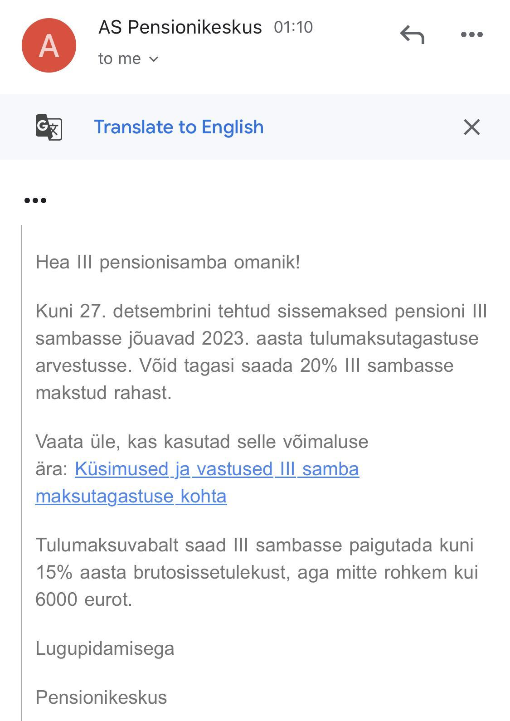

Appendix D. Supplemental Table 1: Randomization success and moderator variables
 | Passive no reminder control  (N=23238) | Active control  (N=11633) | Loss aversion  (N=11631) | Psychological ownership  (N=11646) | Short & long term gain  (N=11633) | Investment boost  (N=11635) | Pennies-a- day  (N=11633) | Family security  (N=11639) | Social norm  (N=11653) | The power of now  (N=11633) | Overall  (N=127974)
Gender
Female | 11944 (51.4%) | 5911 (50.8%) | 6010 (51.7%) | 5911 (50.8%) | 5894 (50.7%) | 6045 (52.0%) | 5954 (51.2%) | 5982 (51.4%) | 5896 (50.6%) | 5994 (51.5%) | 65541 (51.2%)
Male | 11294 (48.6%) | 5722 (49.2%) | 5621 (48.3%) | 5735 (49.2%) | 5739 (49.3%) | 5590 (48.0%) | 5679 (48.8%) | 5657 (48.6%) | 5757 (49.4%) | 5639 (48.5%) | 62433 (48.8%)
Age
Mean (SD) | 38.3 (8.26) | 38.3 (8.22) | 38.2 (8.26) | 38.2 (8.17) | 38.3 (8.23) | 38.2 (8.27) | 38.4 (8.23) | 38.4 (8.29) | 38.3 (8.24) | 38.1 (8.25) | 38.3 (8.24)
Median [Min, Max] | 38.0 [22.0, 53.0] | 38.0 [22.0, 53.0] | 38.0 [22.0, 53.0] | 38.0 [22.0, 53.0] | 38.0 [22.0, 53.0] | 38.0 [22.0, 53.0] | 38.0 [22.0, 53.0] | 38.0 [22.0, 53.0] | 38.0 [22.0, 53.0] | 38.0 [22.0, 53.0] | 38.0 [22.0, 53.0]
Age group
21 - 30 | 4576 (19.7%) | 2300 (19.8%) | 2293 (19.7%) | 2320 (19.9%) | 2298 (19.8%) | 2292 (19.7%) | 2236 (19.2%) | 2237 (19.2%) | 2253 (19.3%) | 2343 (20.1%) | 25148 (19.7%)
31 - 40 | 9295 (40.0%) | 4614 (39.7%) | 4659 (40.1%) | 4682 (40.2%) | 4645 (39.9%) | 4716 (40.5%) | 4688 (40.3%) | 4666 (40.1%) | 4678 (40.1%) | 4670 (40.1%) | 51313 (40.1%)
41 - 53 | 9367 (40.3%) | 4719 (40.6%) | 4679 (40.2%) | 4644 (39.9%) | 4690 (40.3%) | 4627 (39.8%) | 4709 (40.5%) | 4736 (40.7%) | 4722 (40.5%) | 4620 (39.7%) | 51513 (40.3%)
Annual 2nd pillar payments
Mean (SD) | 1220 (1360) | 1210 (1430) | 1210 (1420) | 1220 (1430) | 1210 (1370) | 1220 (1440) | 1210 (1480) | 1220 (1400) | 1190 (1400) | 1220 (1390) | 1210 (1410)
Median [Min, Max] | 976 [0, 33200] | 939 [0, 38300] | 934 [0, 28600] | 958 [0, 38900] | 971 [0, 28200] | 955 [0, 39500] | 953 [0, 58800] | 939 [0, 17500] | 924 [0, 28800] | 943 [0, 23600] | 951 [0, 58800]
Annual 2nd pillar payment levels
up to 599€ | 7668 (33.0%) | 3946 (33.9%) | 3898 (33.5%) | 3881 (33.3%) | 3828 (32.9%) | 3853 (33.1%) | 3905 (33.6%) | 3930 (33.8%) | 3991 (34.2%) | 3915 (33.7%) | 42815 (33.5%)
600€ - 1162€ | 3642 (15.7%) | 1810 (15.6%) | 1873 (16.1%) | 1825 (15.7%) | 1846 (15.9%) | 1875 (16.1%) | 1814 (15.6%) | 1824 (15.7%) | 1829 (15.7%) | 1829 (15.7%) | 20167 (15.8%)
1163€ - 1678€ | 3794 (16.3%) | 1841 (15.8%) | 1843 (15.8%) | 1872 (16.1%) | 1894 (16.3%) | 1840 (15.8%) | 1897 (16.3%) | 1847 (15.9%) | 1921 (16.5%) | 1877 (16.1%) | 20626 (16.1%)
1679€ - 2426€ | 4004 (17.2%) | 1982 (17.0%) | 2001 (17.2%) | 2046 (17.6%) | 2024 (17.4%) | 2036 (17.5%) | 1964 (16.9%) | 1969 (16.9%) | 1948 (16.7%) | 1932 (16.6%) | 21906 (17.1%)
more than 2426€ | 4130 (17.8%) | 2054 (17.7%) | 2016 (17.3%) | 2022 (17.4%) | 2041 (17.5%) | 2031 (17.5%) | 2053 (17.6%) | 2069 (17.8%) | 1964 (16.9%) | 2080 (17.9%) | 22460 (17.6%)
Membership of 2nd pillar
Has left | 5456 (23.5%) | 2759 (23.7%) | 2753 (23.7%) | 2743 (23.6%) | 2723 (23.4%) | 2708 (23.3%) | 2777 (23.9%) | 2812 (24.2%) | 2819 (24.2%) | 2741 (23.6%) | 30291 (23.7%)
Is member or never joined | 17782 (76.5%) | 8874 (76.3%) | 8878 (76.3%) | 8903 (76.4%) | 8910 (76.6%) | 8927 (76.7%) | 8856 (76.1%) | 8827 (75.8%) | 8834 (75.8%) | 8892 (76.4%) | 97683 (76.3%)
Number of years using 3rd pillar
Mean (SD) | 3.72 (1.25) | 3.72 (1.23) | 3.72 (1.23) | 3.72 (1.23) | 3.70 (1.25) | 3.70 (1.25) | 3.70 (1.24) | 3.70 (1.25) | 3.72 (1.24) | 3.71 (1.24) | 3.71 (1.24)
Median [Min, Max] | 4.00 [1.00, 5.00] | 4.00 [1.00, 5.00] | 4.00 [1.00, 5.00] | 4.00 [1.00, 5.00] | 4.00 [1.00, 5.00] | 4.00 [1.00, 5.00] | 4.00 [1.00, 5.00] | 4.00 [1.00, 5.00] | 4.00 [1.00, 5.00] | 4.00 [1.00, 5.00] | 4.00 [1.00, 5.00]
Annual 3rd pillar payments
Mean (SD) | 674 (1310) | 649 (1260) | 644 (1260) | 663 (1270) | 658 (1290) | 658 (1260) | 663 (1280) | 676 (1290) | 663 (1290) | 667 (1360) | 663 (1290)
Median [Min, Max] | 120 [0, 25000] | 120 [0, 17100] | 120 [0, 21600] | 120 [0, 15500] | 110 [0, 27800] | 120 [0, 16000] | 120 [0, 12500] | 150 [0, 12100] | 127 [0, 21300] | 120 [0, 44000] | 120 [0, 44000]
Annual 3rd pillar payments at trial outset
0€ | 9770 (42.0%) | 4840 (41.6%) | 4856 (41.8%) | 4896 (42.0%) | 4911 (42.2%) | 4811 (41.3%) | 4916 (42.3%) | 4747 (40.8%) | 4885 (41.9%) | 4909 (42.2%) | 53541 (41.8%)
up to 500€ | 6011 (25.9%) | 3081 (26.5%) | 3017 (25.9%) | 2997 (25.7%) | 3063 (26.3%) | 3076 (26.4%) | 3001 (25.8%) | 3077 (26.4%) | 3008 (25.8%) | 3071 (26.4%) | 33402 (26.1%)
501€ - 6000€ | 7373 (31.7%) | 3667 (31.5%) | 3709 (31.9%) | 3713 (31.9%) | 3620 (31.1%) | 3708 (31.9%) | 3675 (31.6%) | 3771 (32.4%) | 3714 (31.9%) | 3611 (31.0%) | 40561 (31.7%)
more than 6000€ | 84 (0.4%) | 45 (0.4%) | 49 (0.4%) | 40 (0.3%) | 39 (0.3%) | 40 (0.3%) | 41 (0.4%) | 44 (0.4%) | 46 (0.4%) | 42 (0.4%) | 470 (0.4%)

Appendix E: Identifying heterogeneous treatment effects using random forest: baseline message vs control

There is significant heterogeneity based on all three criteria.
Best linear fit using forest predictions (on held-out data) as well as the mean forest prediction as regressors, along with one-sided heteroskedasticity-robust (HC3) SEs:

Estimate Std. Error t value Pr(>t)
mean.forest.prediction 0.99557 0.31445 3.1661 0.0007732 ***
differential.forest.prediction 1.13535 0.50520 2.2473 0.0123130 *
---
Signif. codes: 0 ‘***’ 0.001 ‘**’ 0.01 ‘*’ 0.05 ‘.’ 0.1 ‘ ’ 1

Unvariate variable effects
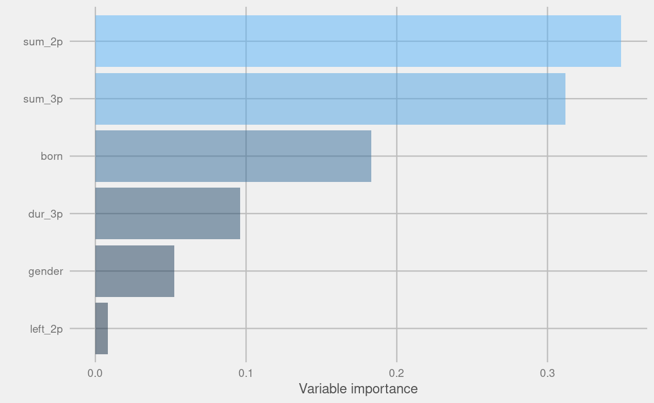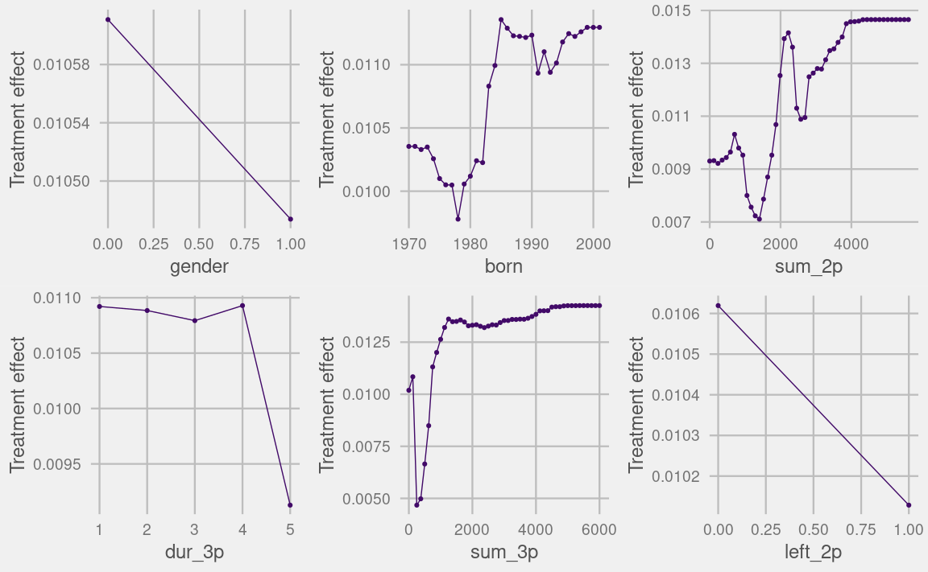

Interactions
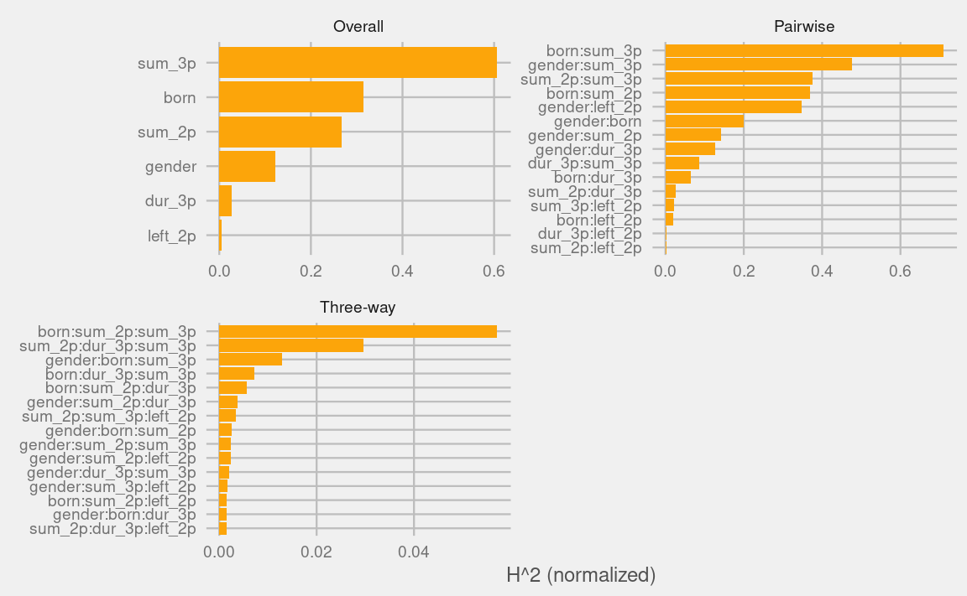

Partial dependence plots
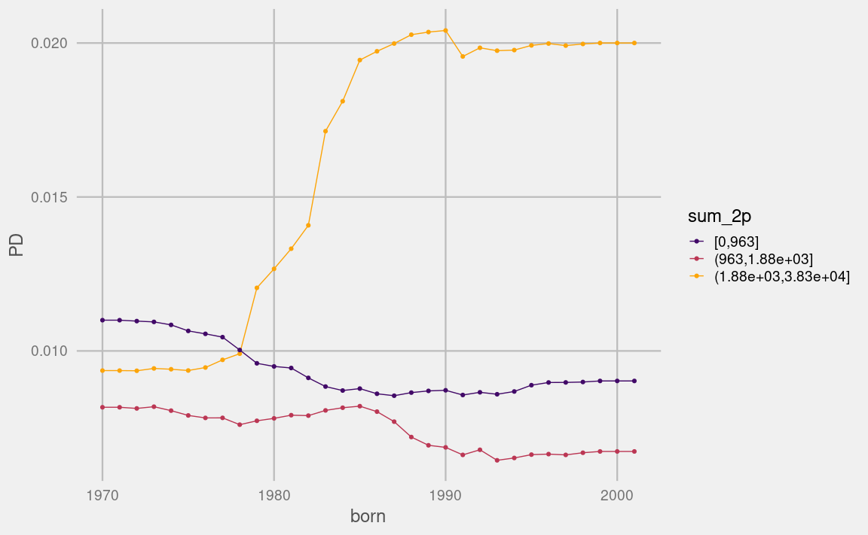
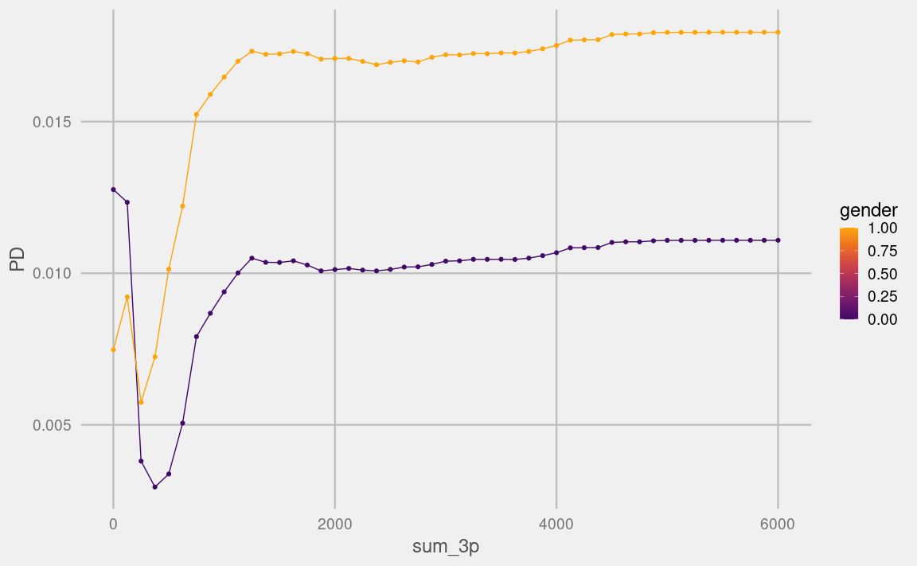

Estonian pension system overview: Pensionikeskus: https://www.pensionikeskus.ee/en/pension-system/estonian-pension-system-overview/
OECD, 2022: https://www.oecd.org/en/data/indicators/net-pension-replacement-rates.html
Pension Reform 2021: Pensionikeskus: https://www.pensionikeskus.ee/en/pension-reform-2021/; Restructuring of the second pillar of the funded pension: Ministry of Finance: https://fin.ee/en/restructuring-second-pillar-funded-pension

