Supplementary materials

1. Parameter details
We used the following parameters for peak calling with Genrich [1]:
Assay | Parameter | Description
All | -r | Remove PCR duplicates
All | -e MT | Exclude reads aligning to the mitochondrial genome when present
All | -E | BED file of genomic regions to exclude (see Peak calling in Methods)
All | -s 20 | Keep secondary alignments with an Alignment Score (AS) >= best AS - <value>
All | -y | Keep unpaired alignments  This is necessary for experiments with single-end reads. This does not affect how paired alignments are processed since our alignment step for paired-end uses only properly paired reads.
ATAC-seq, DNase-seq | -j | ATAC-seq mode
ATAC-seq, DNase-seq | -q 0.1 or -p 0.1 | Maximum p-value or maximum q-value  We used a q-value of 0.1 when at least two biological replicates were available. Otherwise, we used a p-value of 0.1.
DNase-seq | -D | Skips Tn5 adjustments of cut sites

For ChIP-seq peak calling, we used further parameters, which depended on:
- whether the histone target is considered narrow or broad by ENCODE standards (https://www.encodeproject.org/chip-seq/histone/)
- the type of ChIP-seq assay: the standard assay has an adapter ligation step; ChIPmentation uses Tn5 tagmentation instead
- the availability of controls
- read length

Narrow peaks
H3K27ac, H3K4me3 and CTCF are considered narrow peaks.

Standard ChIP-seq:
- With all controls and all read lengths > 75bp: -p 0.1
- With at least one missing control or at least one file with read length <=75bp: -q 0.1

ChIPMentation:
- With all controls: -q 0.1

Gapped peaks
H3K27me3 and H3K4me1 are considered broad marks. For a broad mark experiment, we created a gapped peak track, which first calls broad peaks, which are then annotated with peaks called with more restrictive parameters.
Broad peaks are called with:
-g: The maximum distance between significant sites is relaxed from 100 to 200 for broad peaks.
-a: The minimum AUC for a broad peak is increased from 200 to 800.
-p: We used a p-value with a threshold empirically optimized:
Standard ChIP-seq:
- With all controls and all read lengths > 75bp: p: 0.2
- With at least one missing control or at least one file with read length <= 75bp: p: 0.1
ChIPMentation:
- With all controls: p: 0.2
Narrow peaks within these broad peaks are called using:
-p: We use a p-value with a threshold empirically optimized across all species:
Standard ChIP-seq:
- With all controls and all read lengths > 75bp: p: 0.1
- With at least one missing control or at least one file with read length <= 75bp: p: 0.05
ChIPMentation:
- With all controls: p: 0.1

2. Process flow for pipeline
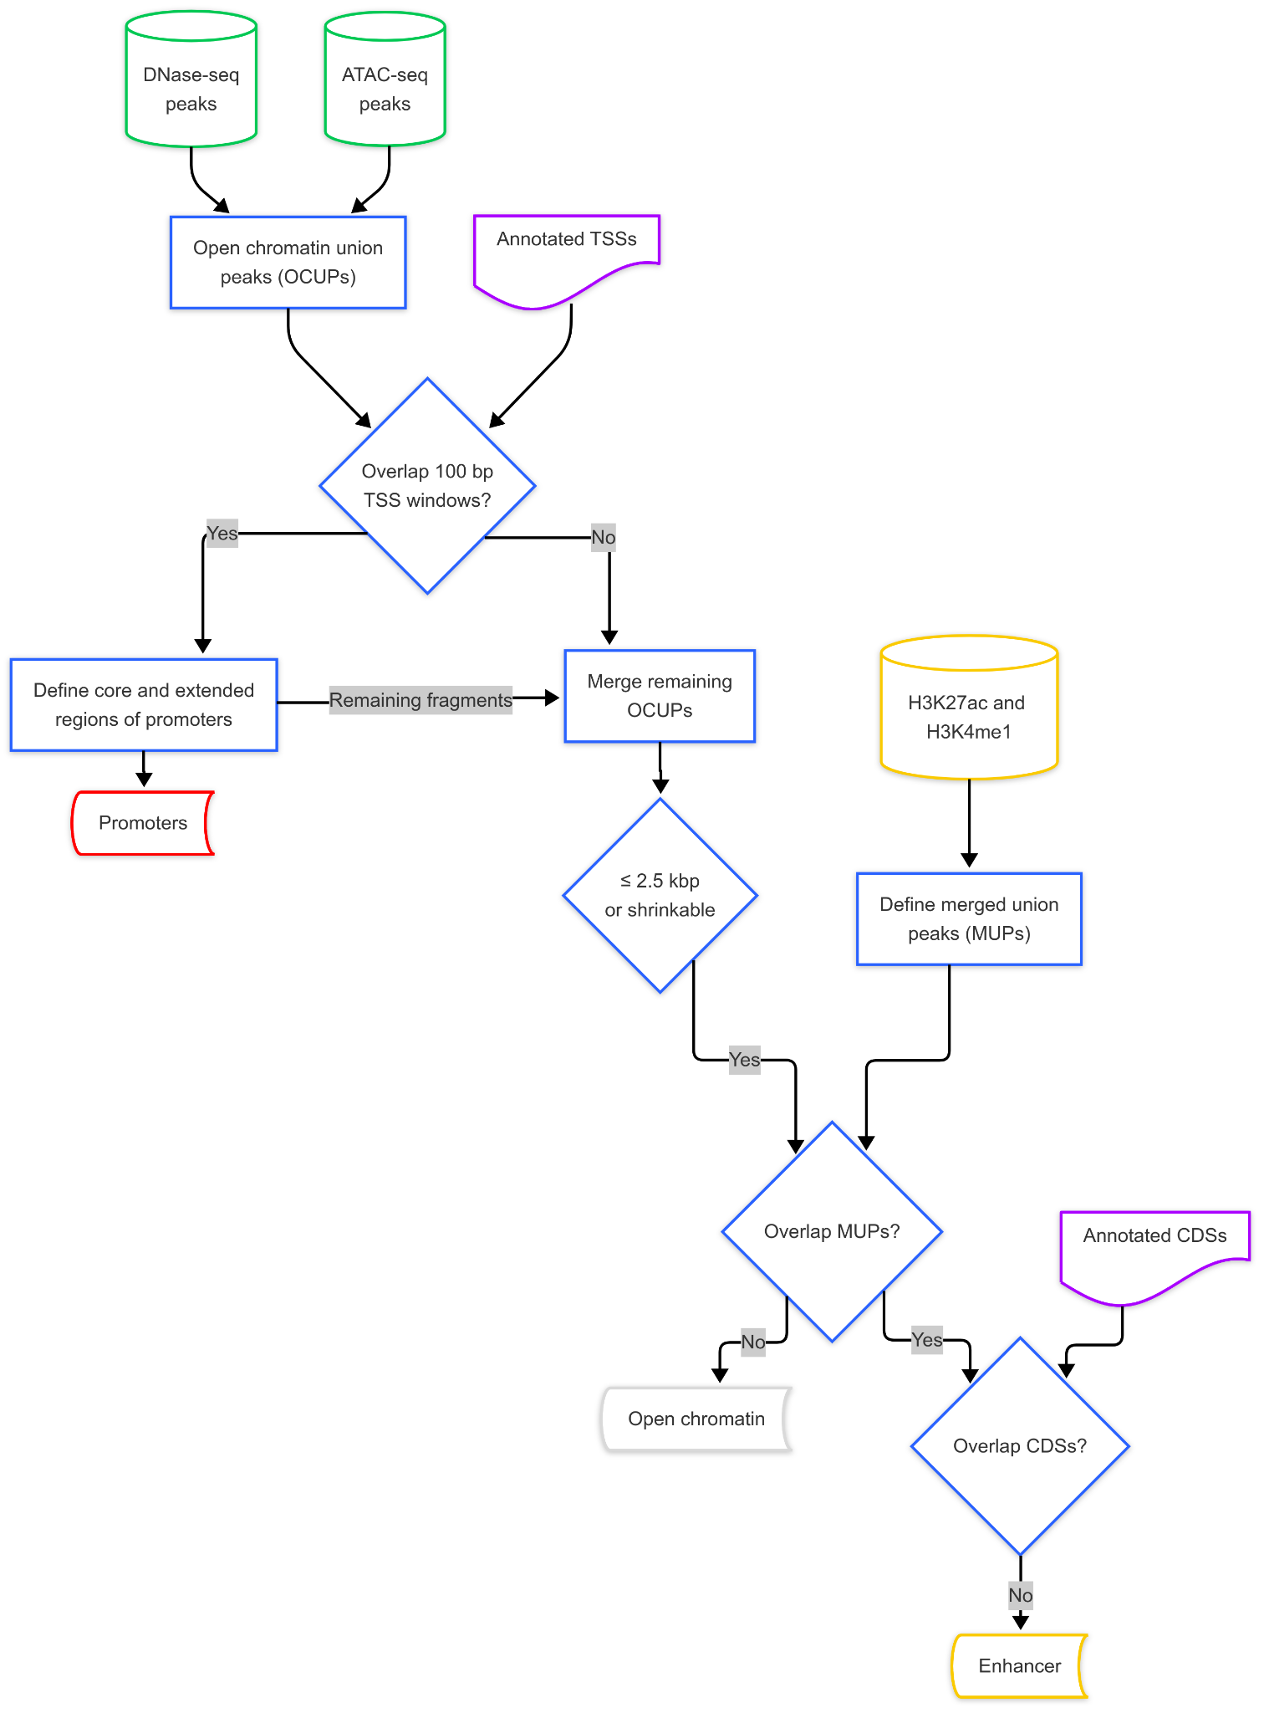
Supplementary Figure 1: Ensembl’s regulatory annotation process. The results of peak calling, along with gene annotation, are used to identify potential regulatory regions in the genome. Candidate regulatory features are regions that have been detected as open. If a candidate regulatory feature overlaps within 100 bp of the 5’ end of a transcript, it can be classified as a promoter; if it overlaps histone marks associated with enhancers (H3K4me1 or H3K27ac) but does not overlap a coding region of a gene (CDS), it can be classified as an enhancer. Remaining features are kept as unclassified open chromatin features.

3. β-globin locus of mouse
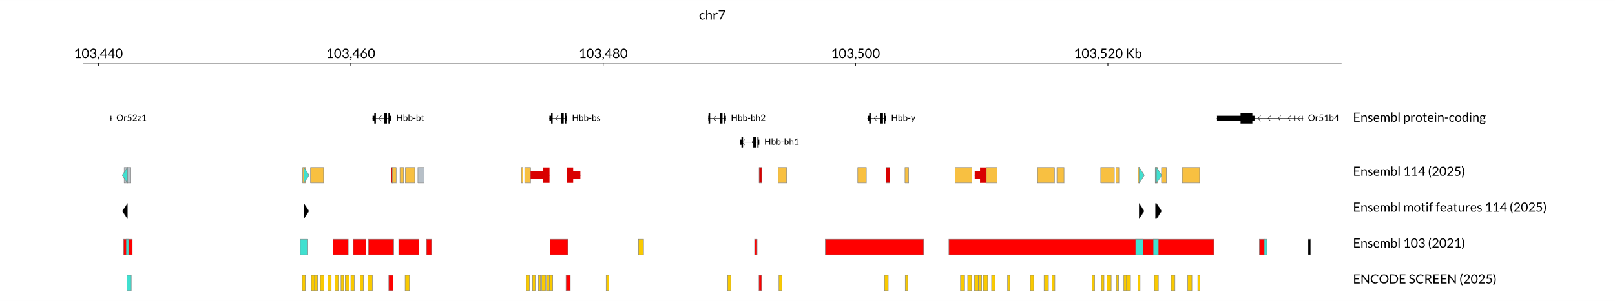
Supplementary Figure 2: A genome view of chr7:103,438,805-103,532,360 in GRCm39. Hbb-y is a mouse orthologue of human HBE1 (see Figure 3). Potential clusters of regulatory elements can be identified upstream of Hbb-y. Ensembl annotation also includes promoters for annotated lncRNA, such as ENSMUSG00000143602, which are not shown in the gene track. Ensembl motif features are only available for Ctcf in mouse. The Ensembl 103 track shows the annotation from the previous regulatory build [2,3]. The last track is ENCODE SCREEN annotation v4 [4].

4. Feature count across species, including embryonic tissue
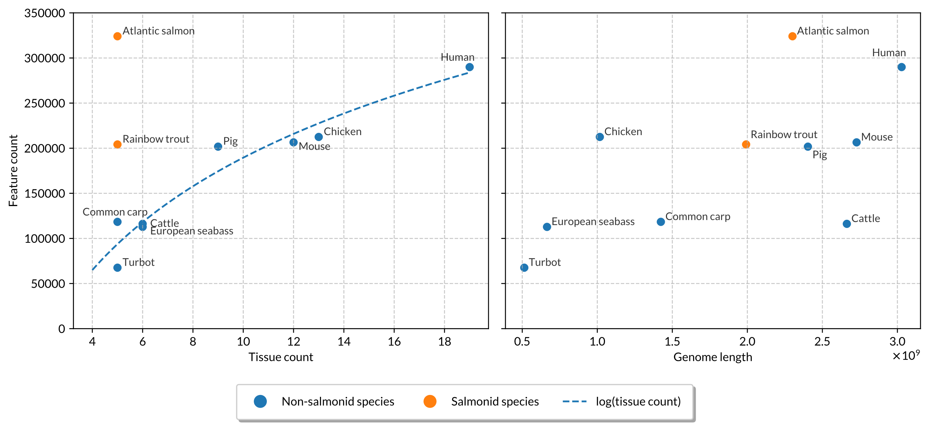
Supplementary Figure 3: Feature count across species by tissue count and genome length as in Figure 2, but including embryonic tissue.

References
1. Gaspar JM. Genrich: detecting sites of genomic enrichment [Internet]. 2023 [cited 2023 Sept 15]. https://github.com/jsh58/Genrich. Accessed 15 Sept 2023
2. Zerbino DR, Wilder SP, Johnson N, Juettemann T, Flicek PR. The Ensembl Regulatory Build. Genome Biology. 2015;16:56. https://doi.org/10.1186/s13059-015-0621-5
3. Cunningham F, Allen JE, Allen J, Alvarez-Jarreta J, Amode MR, Armean IM, et al. Ensembl 2022. Nucleic Acids Research. 2022;50:D988–95. https://doi.org/10.1093/nar/gkab1049
4. Moore JE, Pratt HE, Fan K, Phalke N, Fisher J, Elhajjajy SI, et al. An Expanded Registry of Candidate cis-Regulatory Elements for Studying Transcriptional Regulation [Internet]. bioRxiv; 2024 [cited 2025 Jan 24]. p. 2024.12.26.629296. https://doi.org/10.1101/2024.12.26.629296

