Supplementary Tables and Figures

Supplementary Figure 1. Study locations for semi-structured interviews
Top left and right: Callao (urban municipality)
Bottom left and right: Ventanilla (desert shantytown)
Original photos by Amrita D’Souza and Jessica Franco
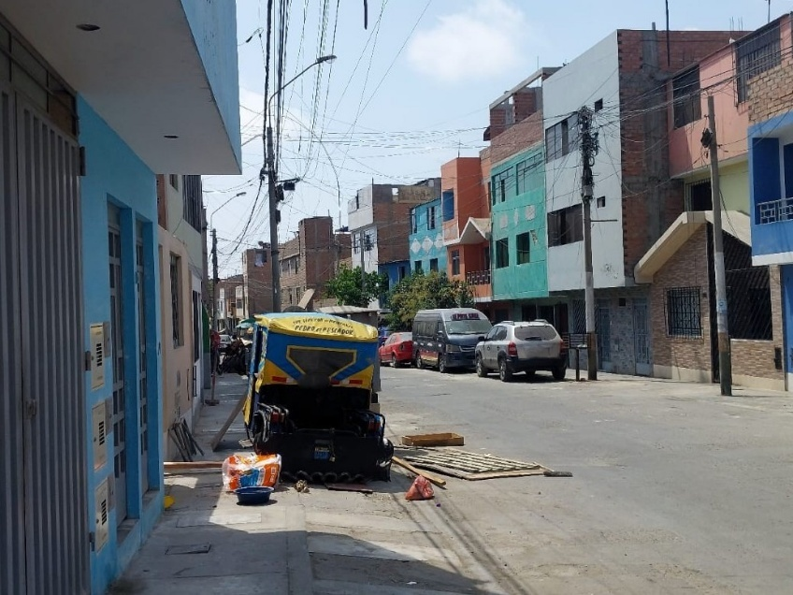
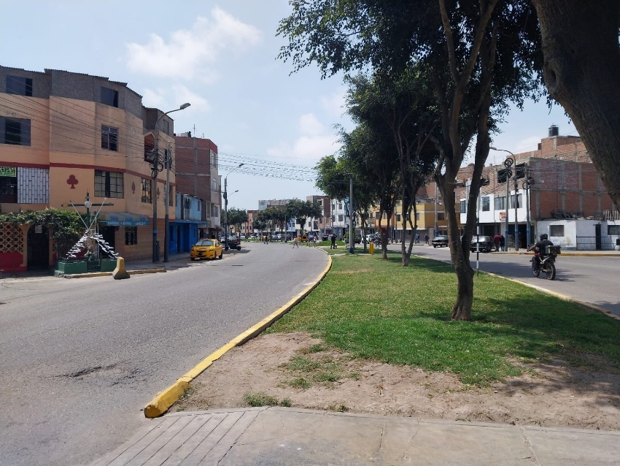
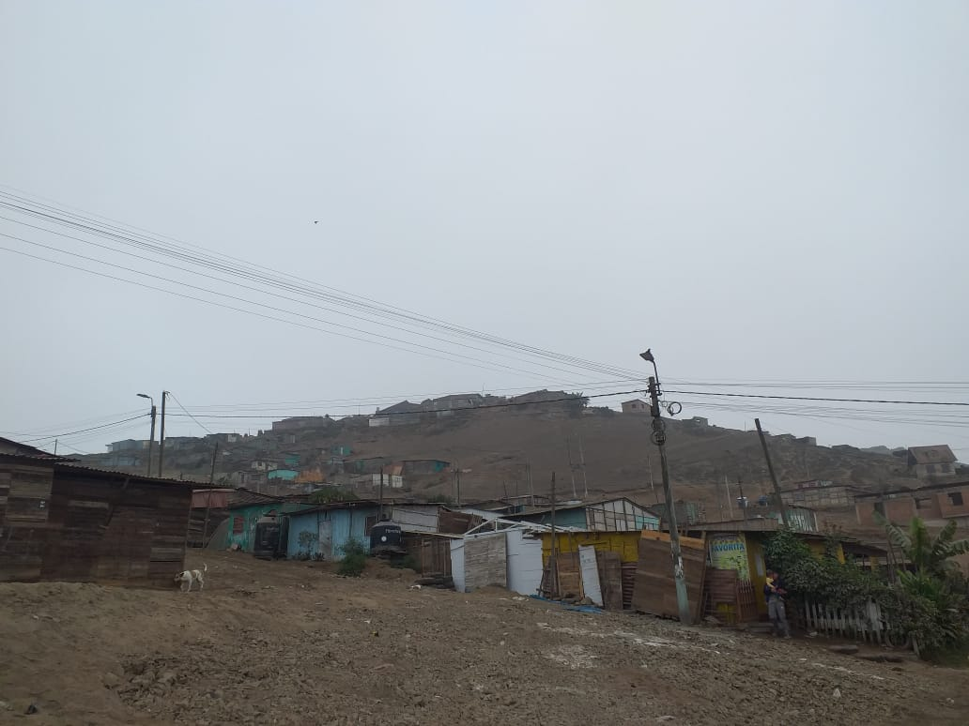
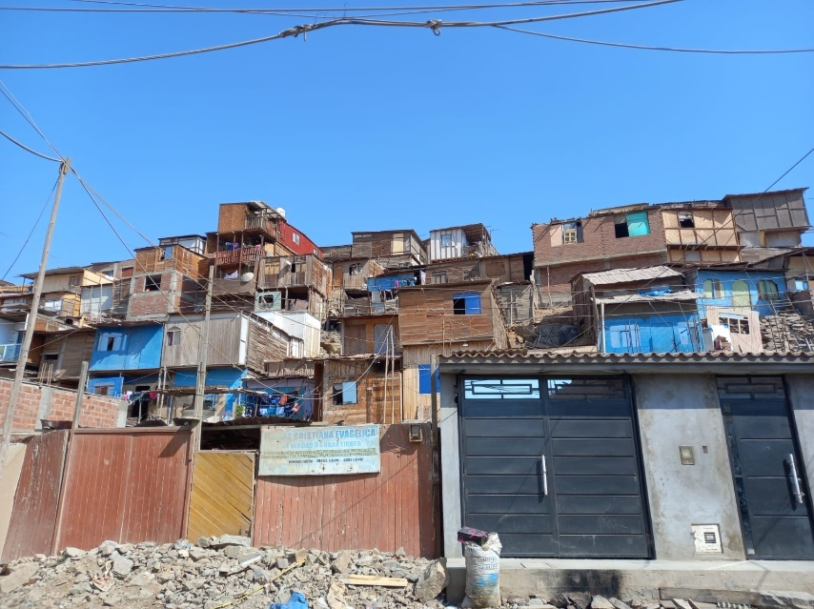
Supplementary Table 1. Semi-structured interview topic guide
Theme* | SASCAT item | Additional probe and prompt
Groups and networks  Structural social capital (bonding, bridging and linking ties) | In the past 12 months, have you been a member of or frequently participated in…? [group/ association]?  Have you received any type of emotional support such as advice or encouragement, financial or material support, support in learning something?  In the past 12 months, have you received from [replace with the name of one of the people or organizations listed below] any kind of emotional support such as advice/encouragement, financial/material support, or support in learning something?  If you had a problem, would there always be someone to help you?  If you had a contagious health problem (such as tuberculosis), would there always be someone to help you? | How useful or helpful did you find it? What made it helpful?  What do you think makes this type of support valuable or meaningful?  Is it the quality or the quantity of these social connections which make them useful?  Other groups or networks: work-related, dance or fitness groups, music groups  Other assistance: picking up prescriptions, topping up mobile/ internet credit, school drop offs/ picks for children, bringing religious/ faith services to the home or access to joining religious/ faith services remotely  What type of emotional/ financial/ learning support did you receive from them?  How useful or helpful did you find the support you were given? Why?  Of all the groups to which you belong to, which two are the most important to you?  What would make it more valuable or meaningful?  What does ‘good support’ look like to you?  How has having TB affected your social connections?  What were your social connections like before versus during versus after TB diagnosis and treatment?  How has TB treatment affected your personal relationships? How does your TB diagnosis and/or TB treatment affect your household or family life?  Would it be the same person or authority for different types of support?  Do you think the government or a health programme should provide a certain type of support or different types of support?
Collective Action and Co-operation  Structural (bridging ties), relational and cognitive social capital | In the past 12 months, have you joined with other residents where you live to solve a problem or do a job together? | If yes:  - What kind of problem or job did you do together?  - Did you feel socially connected to these other residents through this?  - Did you feel this made a difference to your experience of living with TB?  - Did this make a difference to your overall quality of life?
Empowerment and political action  Structural (linking ties), relational and cognitive social capital | In the last 12 months, have you talked to local authorities or government representatives about anything or any problem where you live? | How useful or helpful did you find it? Why?  What do you think ‘good support’ is from local authorities or government representatives while living with TB?  For example, is it the frequency of contact/ accessibility of staff/ breadth of provisions which make them useful?  What social support do you know of for people living with TB in your community from the Municipality or Government (Ministry of Health)?  What do you think of the quality of social support currently in place for people living with TB?  What services would you want to see offered to help provide social support for people living with TB?  How important do you think it is for local and national TB programmes to include social interventions for people living with TB?  Who do you think should ‘prescribe ‘social support’ for people living with TB? For example, the PCT/CdS, local hospital/ MDT, National TB Programme?
Trust and Solidarity  Relational and cognitive social capital | In general, can you trust most people where you live?  Do you feel that most people where you live would try to take advantage of you (in any way) if they had the chance?  Do you feel that most people where you live are only interested in their own well-being?  Are most people where you live willing to help if you need it? | Why or why not?  How would they help?
Safety, crime and violence  Relational and cognitive social capital | In general, how safe do you feel where you live?  How safe do you feel in your home?  How safe do you feel when walking around where you live?  How safe do you feel walking alone in your area at night?  Do you think there is crime and violence where you live? | Why?  If so, what kind of crime or violence?  Why do you think this is?
Social cohesion, inclusion and sociability  Relational and cognitive social capital | Do you feel like you belong where you live?  Does the friendship you have with the people where you live mean a lot to you?  Do you talk regularly with people from where you live?  Do most people where you live get along with each other? | Why? What makes you feel/ not feel that you belong in your community?  If no:  - Does this make you feel lonely or isolated?  - Does this affect your mental health?  Do you think you feel more connected to those who are similar or different to you?  What do you think is the basis of trust or harmony in your community?  For example, does it rely on shared social values or norms or beliefs?  If so, which values or norms or beliefs?
*Using SC-IQ domains (Grootaert et al, 2004) and Social Capital dimensions (Nahapiet and Ghoshal, 1998)

Themes and subthemes from SSIs (n=24)
*Brackets indicate the number of PTB highlighting a subtheme, bold text indicates themes, italicised text indicates subthemes
- Social connections
Quality vs Quantity | Quality of connections (22)
Source of support | Family (22)
 | Friends (17)
 | Religion or faith-based groups (14)
- Religion
Support gained | Emotional support (13)
 | Learning support (9)
Source of support | Word of God/ Bible (6)
 | Faith-based friendships (3)
- Community mistrust
Can you trust your community? | No (13) Don't know (3) Yes (8)
Perceptions of neighbours
 | Not knowing neighbours (4)
 | Greed or selfishness of neighbours (4)
Types of crime and violence
 | Robberies (13) Organised crime (3)
 | Killings (5) Murder (1) Assassination (1)
 | Substance misuse (4)
 | Fights (4)
- Everyday life
Family life
 | Economic/material support (18)
 | Changed personal relations with family (6)
 | Changed household roles or daily activities (6)
Friends
 | Changed social relations with friends/distancing (10)
Unemployment
 | Inability to work/job loss (9)
- Health education
 | Health education gained from social networks (10)
 | Perceived low TB education of others (2)
- PTB preferences for programmatic interventions
 | Public awareness campaigns or TB information (7)
 | Distractions (2) Workshops (2) Courses (1)
Supplementary Table 2. Themes and subthemes from SSIs

