Supplemental data
The correlation analysis was conducted in 8 normal and 66 male and female NHPs initially enrolled in the screen by an open source statistic software (R 3.6.1). On the bottom panel of Figs. S1-S6, the density plots are displayed on the diagonal line along with all pairwise scatter plots being displayed in the upper right triangle and the corresponding correlation coefficients being displayed in the lower left triangle. The correlation matrices are also presented graphically in the top panel, with the size and darkness of each circle being proportional to the absolute value of its corresponding correlation coefficient, and blue and red color representing respective positive and negative values.
Figure S1 Correlations between different blood chemistry parameters in 8 normal control NHPs and 66 dysmetabolic NHPs with different degree of proteinuria
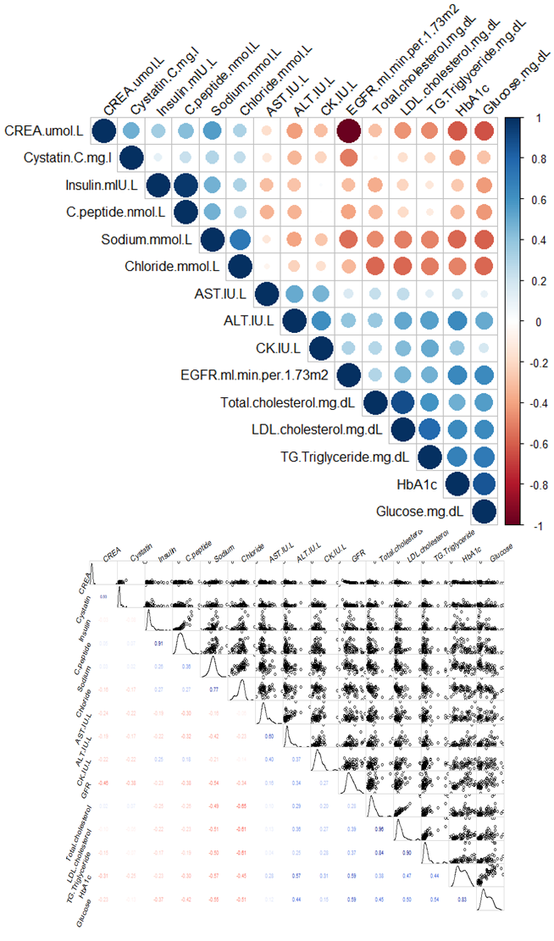
Figure S2. Correlation between different urinary chemistry parameters in 8 normal control NHPs and 66 dysmetabolic NHPs with different degree of proteinuria.
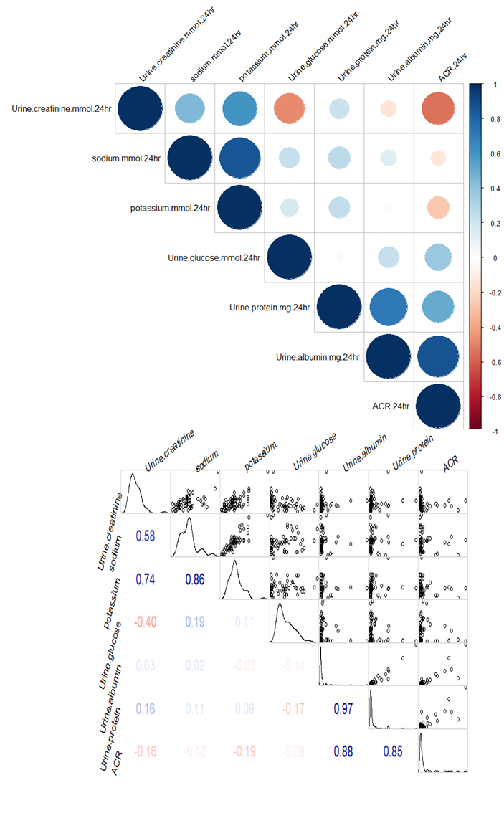
Figure S3. Correlation between different cardiac functional parameters in 8 normal control NHPs and 66 dysmetabolic NHPs with different degree of proteinuria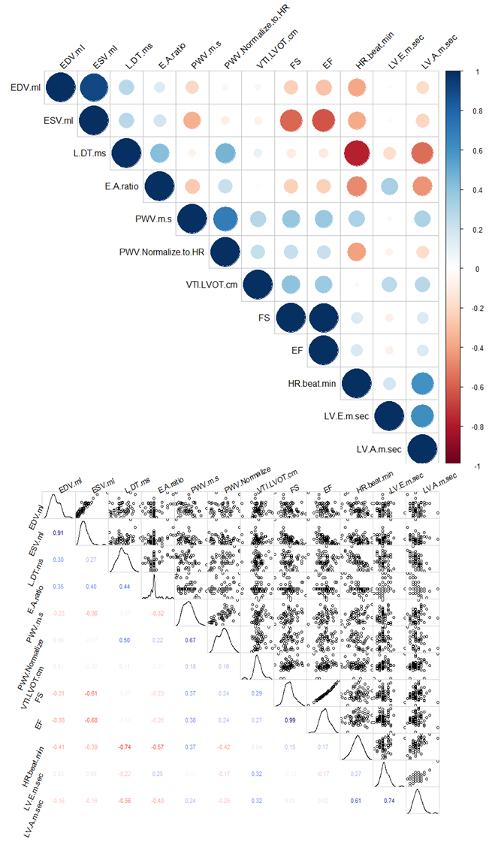
Figure S4. Correlation between blood and urine chemistry parameters in parameters in 8 normal control NHPs and 66 dysmetabolic NHPs with different degree of proteinuria
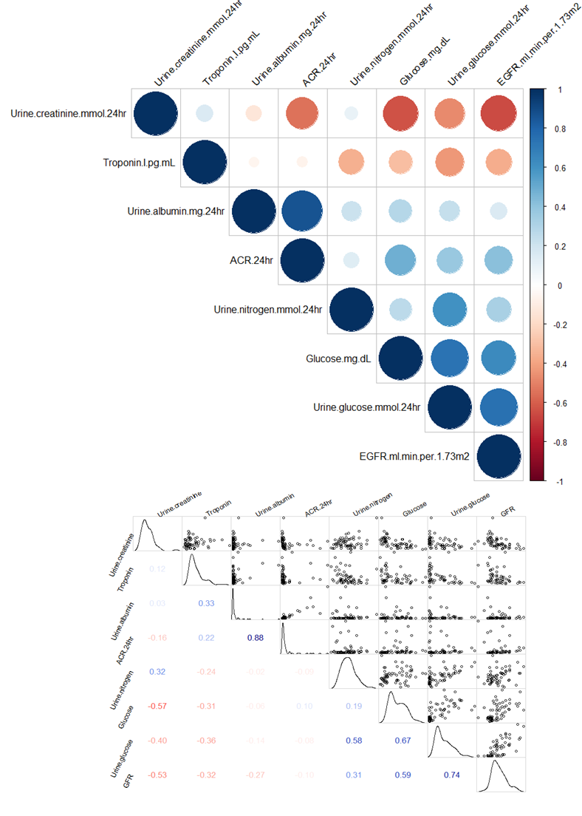
Figure S5. Correlation between blood chemistry and resting cardiac function parameters in 8 normal control NHPs and 66 dysmetabolic NHPs with different degree of proteinuria
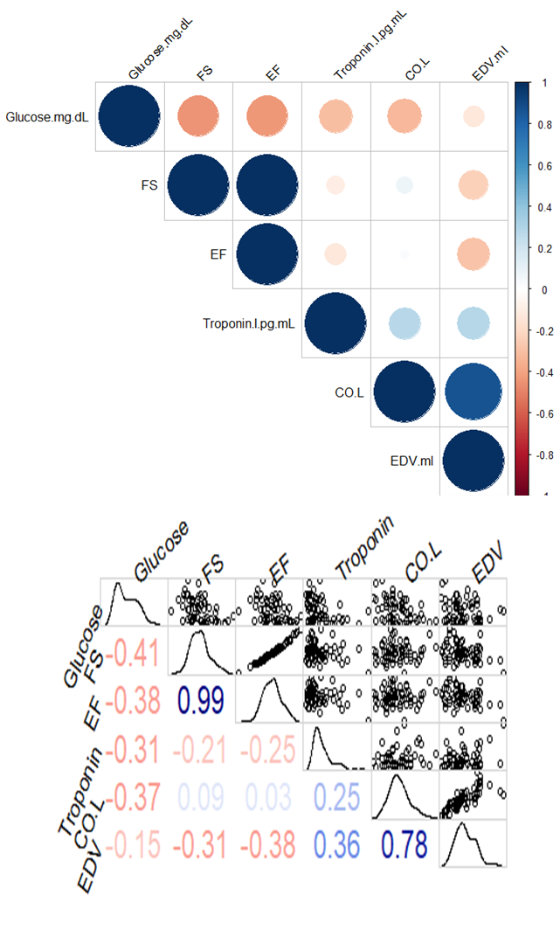
Figure S6. Correlation between blood chemistry and body composition in parameters in 8 normal control NHPs and 66 dysmetabolic NHPs with different degree of proteinuria
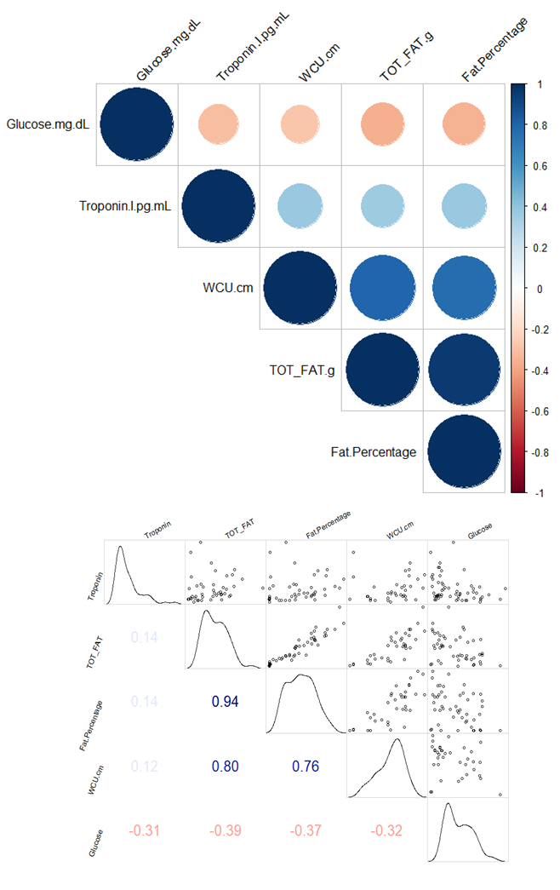
Figure S7. Correlation between total body fat and waist circumference (WCU) (top); as well as hemoglobin A1c (HbA1c) and liver ALT (bottom) in 8 normal control NHPs and 66 dysmetabolic NHPs with different degree of proteinuria
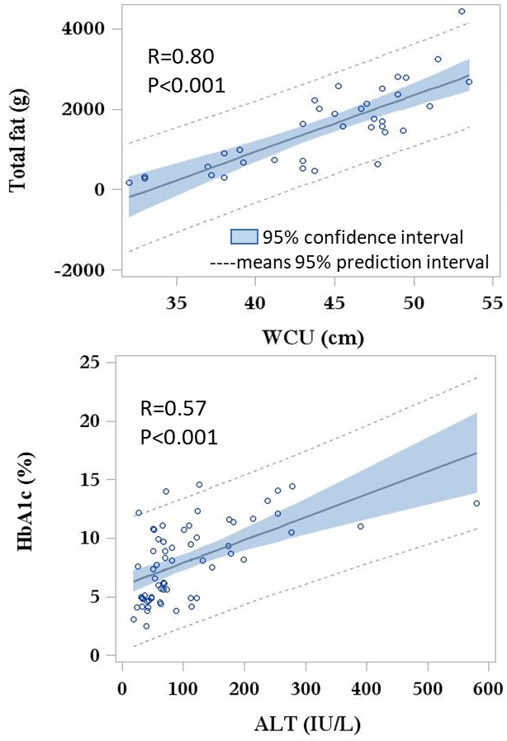
Figure S8. Correlation between different cardiac functional parameters: Left ventricular (LV) end diastolic (EDV) vs. end systolic (ESV) volume (top), stroke volume (SV, middle); or cardiac output (CO, bottom) in 8 normal control NHPs and 66 dysmetabolic NHPs with different degree of proteinuria
