Interfacial Synergetic integration of Graphitic Carbon Nitride-Polypyrrole Anchored on Carbon Nanorod For Efficient water Electrolysis.
Anup Kumar Pradhan*^{,a} ,Amrutha Radhakrishnan,ª Anirban Biswas,ª, Sankar Ganesh Palani,^{b} and Chanchal Chakraborty*^{,a,c}
ªDepartment of Chemistry, Birla Institute of Technology and Science (BITS) Pilani, Hyderabad Campus. Jawaharnagar, Samirpet, Hyderabad, Telangana 500078, India.
^{b}Environmental Biotechnology Laboratory, Department of Biological Sciences, Birla Institute of Technology and Science – Pilani, Hyderabad Campus, Hyderabad, Telangana 500078, India
^{c}Materials Center for Sustainable Energy & Environment (McSEE), Birla Institute of Technology and Science (BITS) Pilani, Hyderabad Campus, Hyderabad 500078, India
*Corresponding Author: Chanchal Chakraborty & Anup Kumar Pradhan
E-mail: chanchal@hyderabad.bits-pilani.ac.in
E-mail: p20220409@hyderabad.bits-pilani.ac.in

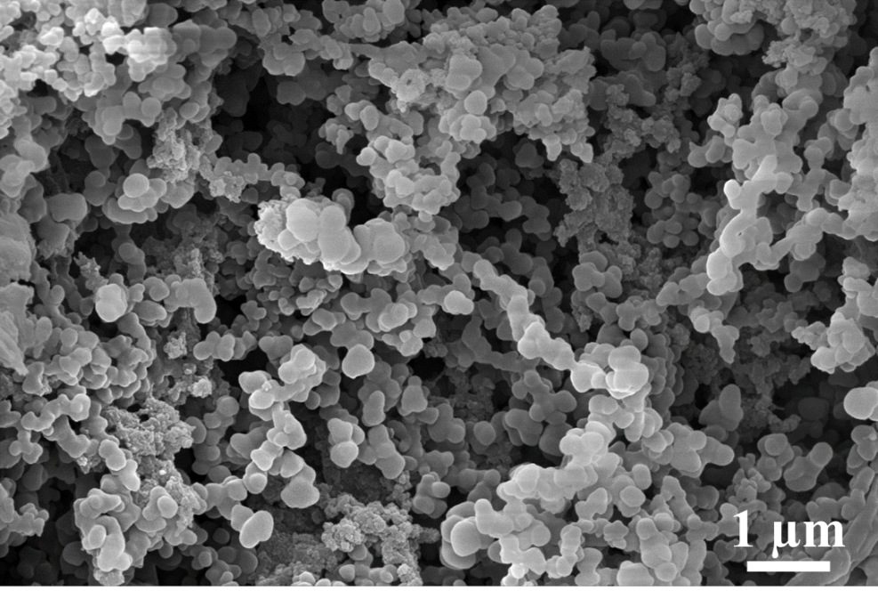
Fig. S1. FE-SEM image of g-C₃N₄-Ppy.

Fig. S2. XPS survey spectra of g-C₃N₄–Ppy/CR

Fig. S3. CV curves obtained in the non-Faradic region of g-C₃N₄–Ppy/CR at different scan rates.

Fig. S4. Calculated C_{dl} value of of g-C₃N₄–Ppy/CR obtained from CV curves

Fig. S5. CV curves obtained in the non-Faradic region of g-C₃N₄–Ppy at different scan rates.

Fig. S6. Calculated C_{dl} value of g-C₃N₄–Ppy obtained from CV curves.

