Supporting Information

Biomimetic non-classical crystallization induced hierarchically structured efficient circularly polarized phosphors
Li-Zhe Feng^{1,2}, Jing-Jing Wang^{1,2}, Tao Ma³, Yi-Chen Yin^{1,2}, Kuang-Huang Song^{1,2}, Zi-Du Li^{4,5,6}, Man-Man Zhou⁷, Shan Jin⁷, Tao-Tao Zhuang^{1,3}, Feng-Jia Fan^{4,5,6}, Man-Zhou Zhu⁷, Hong-Bin Yao^{1,2,}*

¹Hefei National Laboratory for Physical Sciences at the Microscale, University of Science and Technology of China, Hefei, Anhui 230026, China
²Department of Applied Chemistry, Hefei Science Center of Chinese Academy of Sciences, University of Science and Technology of China, Hefei, Anhui 230026, China
³Department of Chemistry, Hefei Science Center of Chinese Academy of Sciences, University of Science and Technology of China, Hefei, Anhui 230026, China
⁴Department of Physics, Hefei Science Center of Chinese Academy of Sciences, University of Science and Technology of China, Hefei, Anhui 230026, China
⁵CAS Key Laboratory of Microscale Magnetic Resonance, University of Science and Technology of China, Hefei, Anhui 230026, China
⁶Synergetic Innovation Center of Quantum Information and Quantum Physics, University of Science and Technology of China, Hefei, Anhui 230026, China
⁷Key Laboratory of Structure and Functional Regulation of Hybrid Materials, Anhui University, Ministry of Education, Hefei, Anhui 230601, China

*Correspondence and requests for materials should be addressed to H.-B.Y. (yhb@ustc.edu.cn)

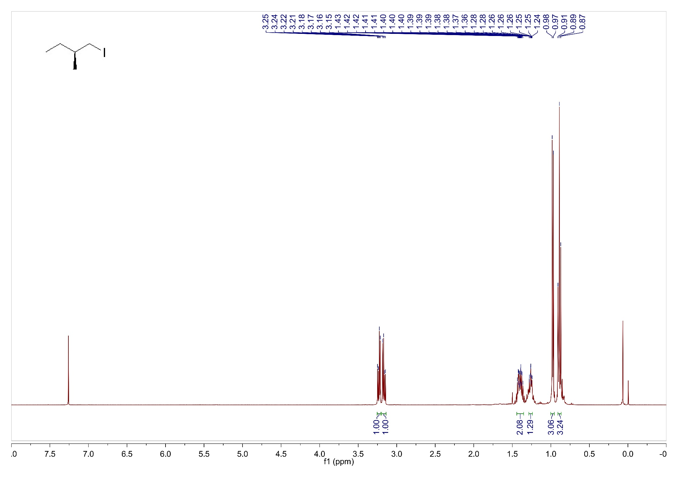
Supplementary Fig. 1. ¹H NMR spectrum of (S)-1-iodo-2-methylbutane in CDCl₃.
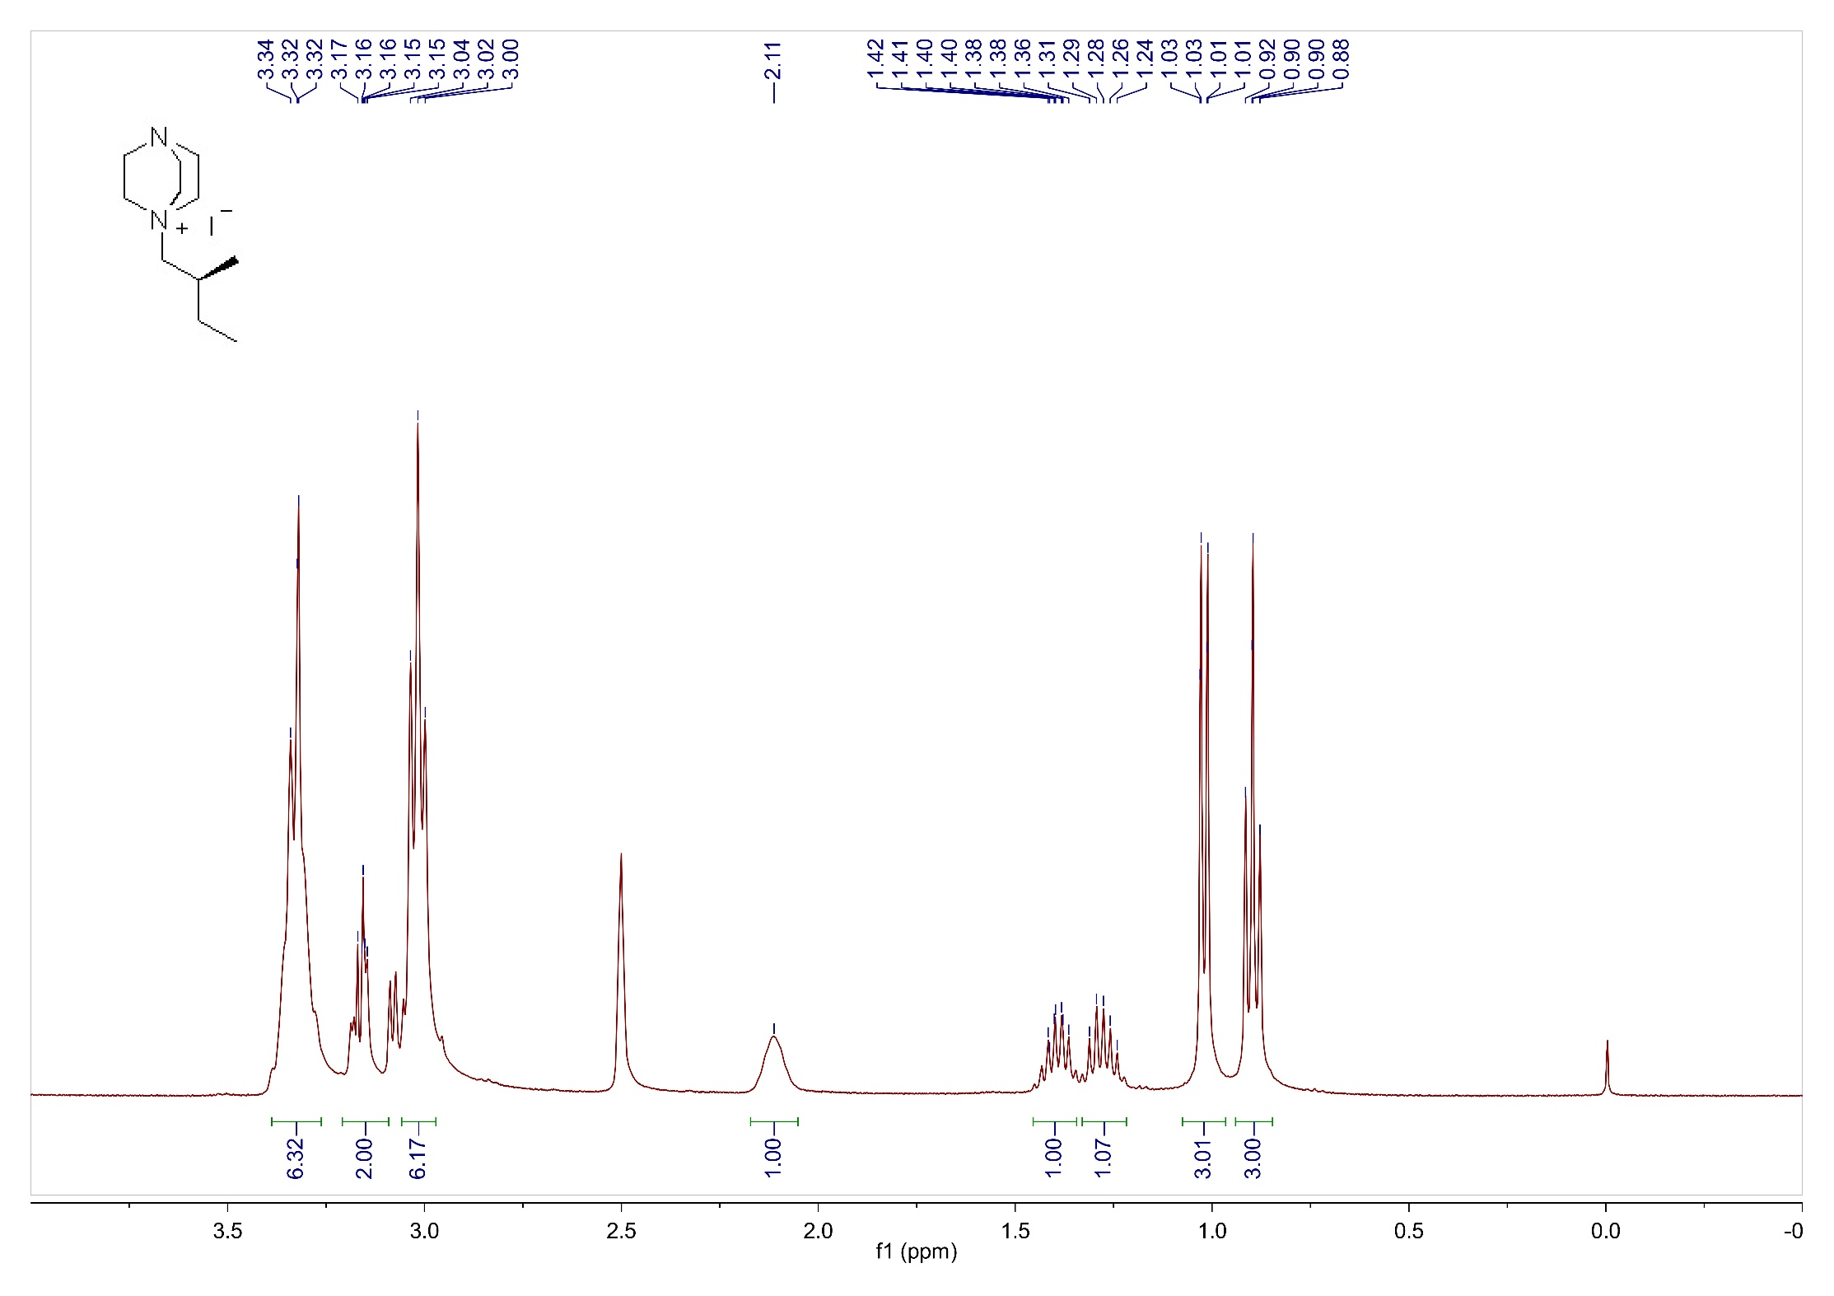
Supplementary Fig. 2. ¹H NMR spectrum of L₁ in DMSO-d6.

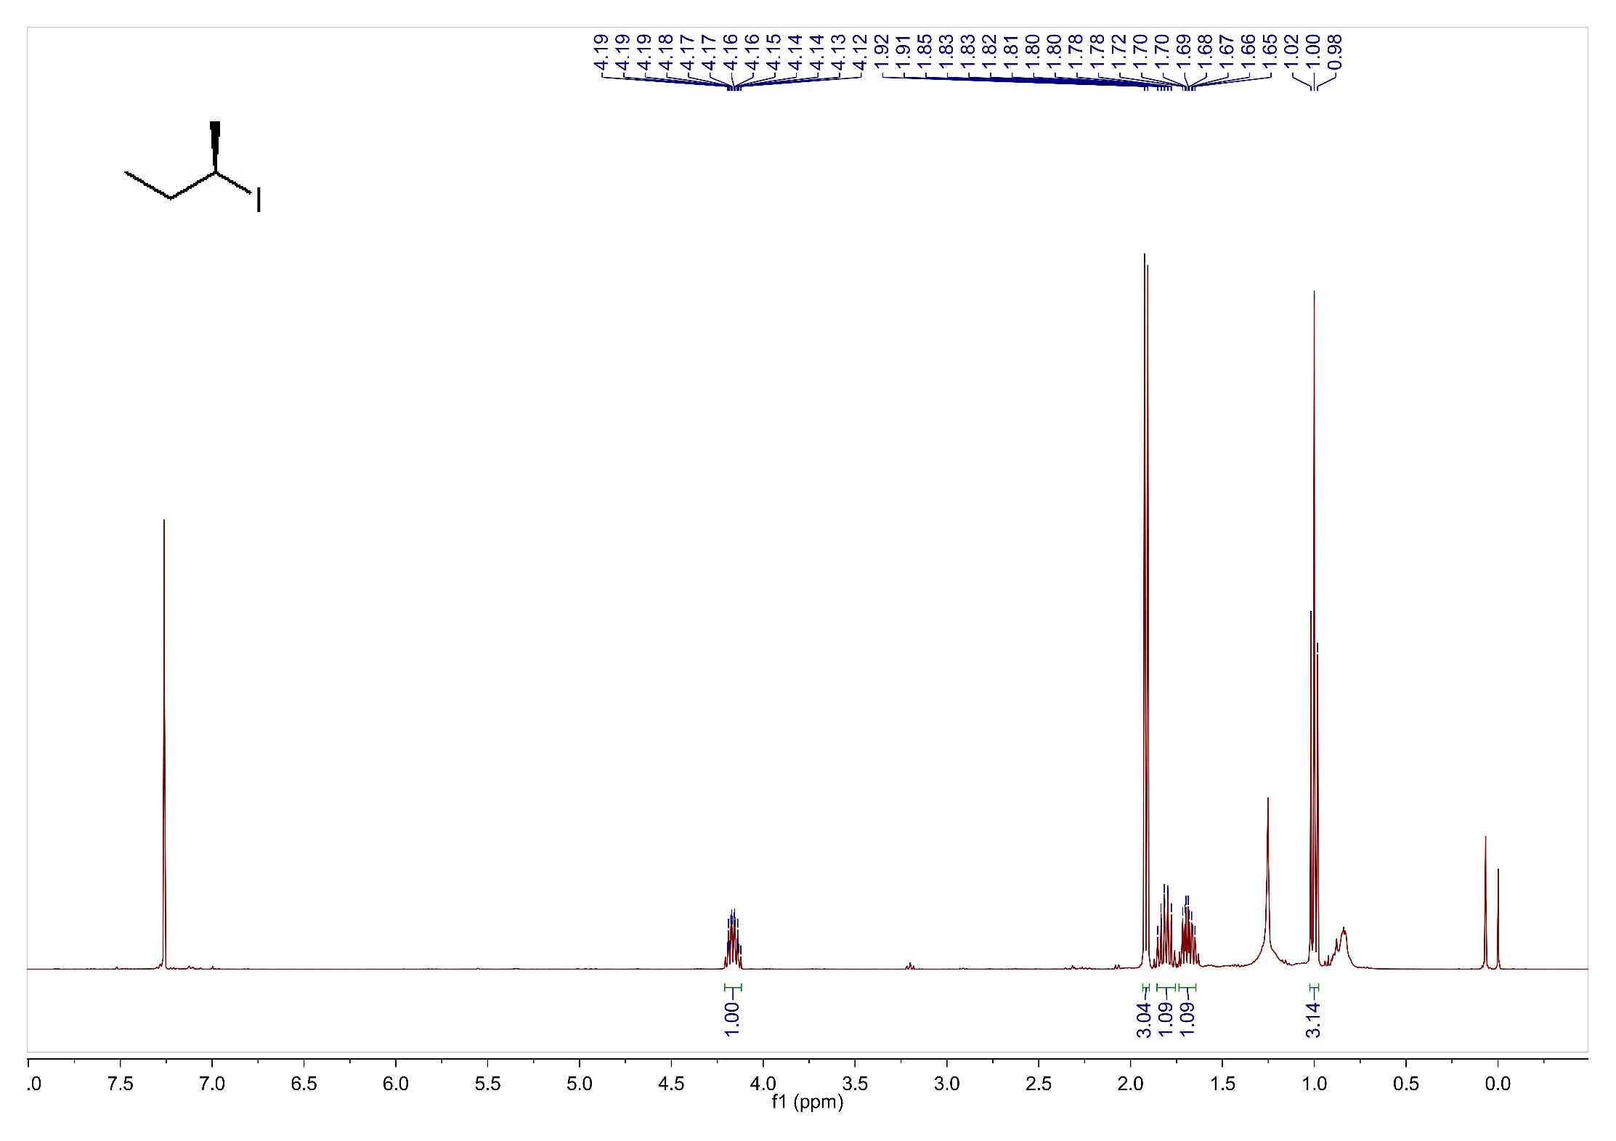
Supplementary Fig. 3. ¹H NMR spectrum of (R)-2-iodobutane in CDCl₃.

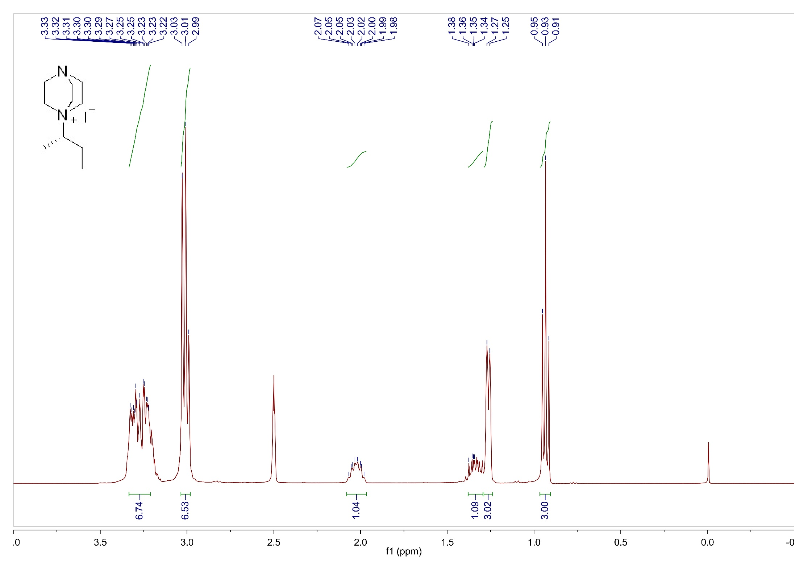
Supplementary Fig. 4. ¹H NMR spectrum of L₂ in DMSO-d6.

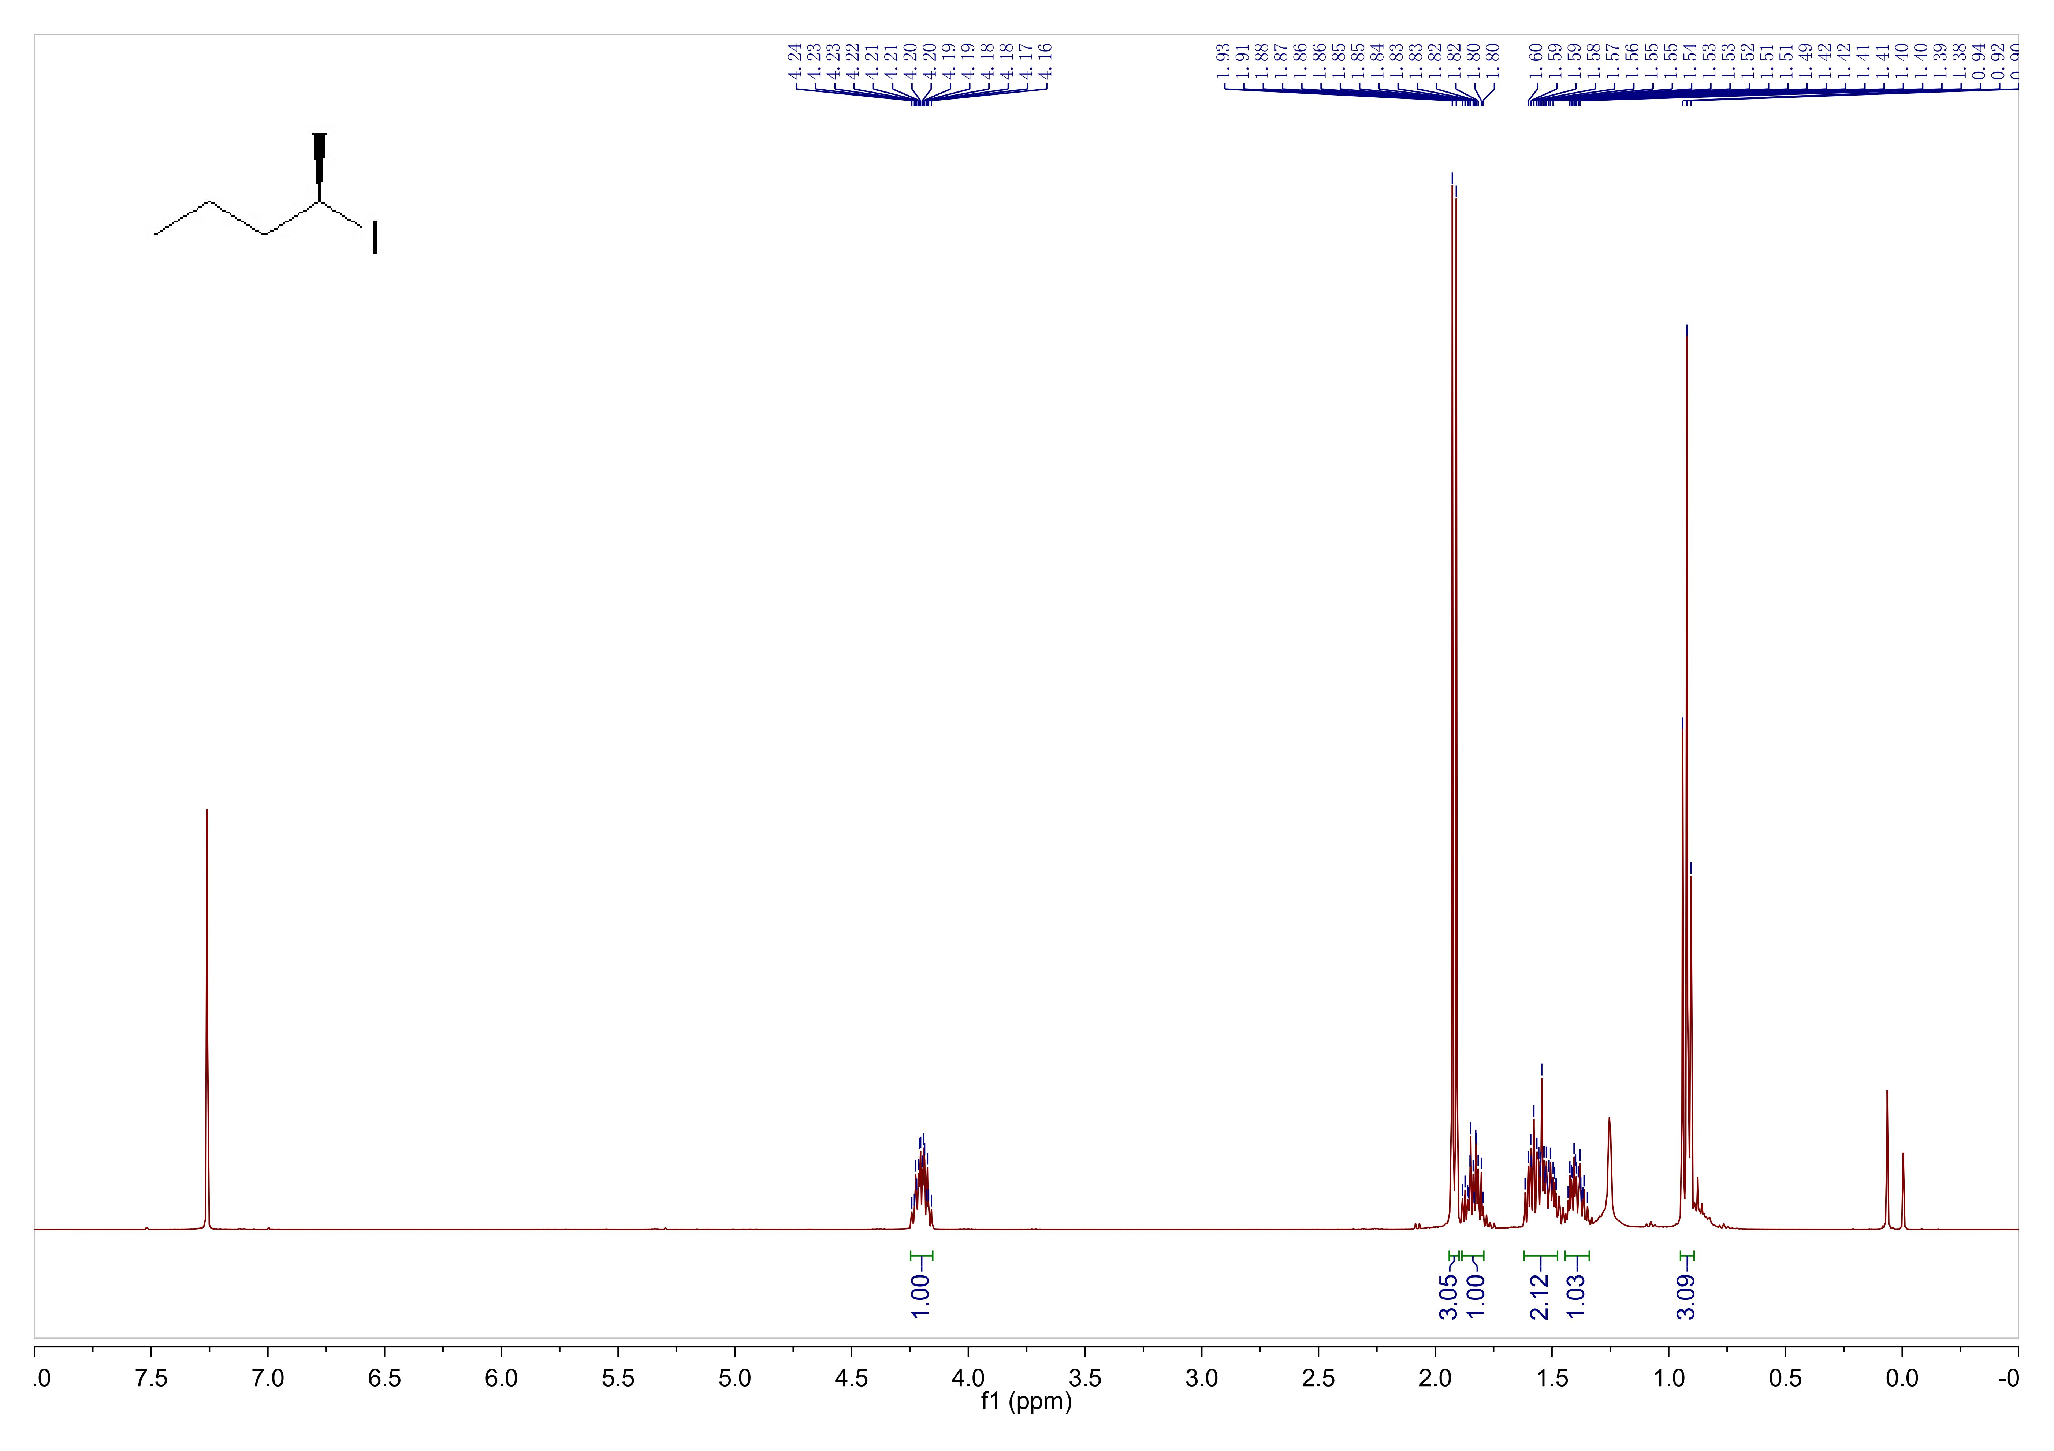
Supplementary Fig. 5. ¹H NMR spectrum of (R)-2-iodoheptane in CDCl₃.

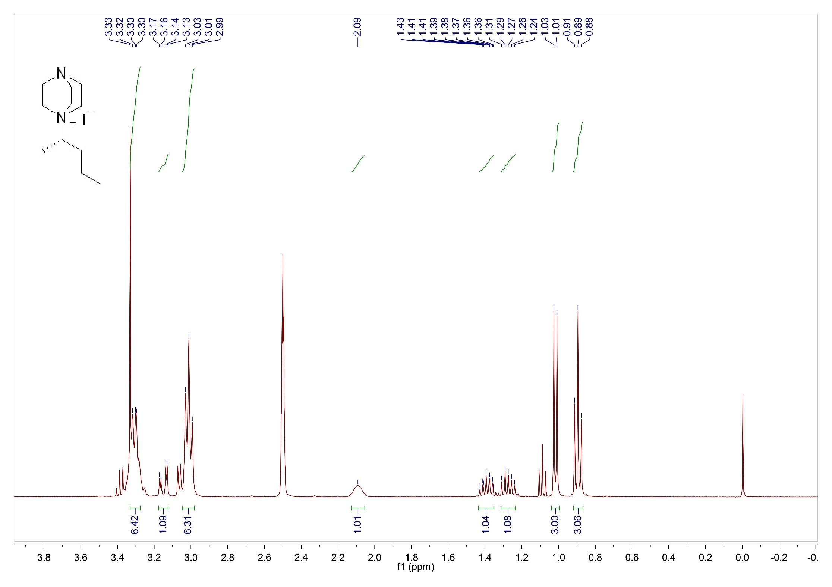
Supplementary Fig. 6. ¹H NMR spectrum of L₃ in DMSO-d6.

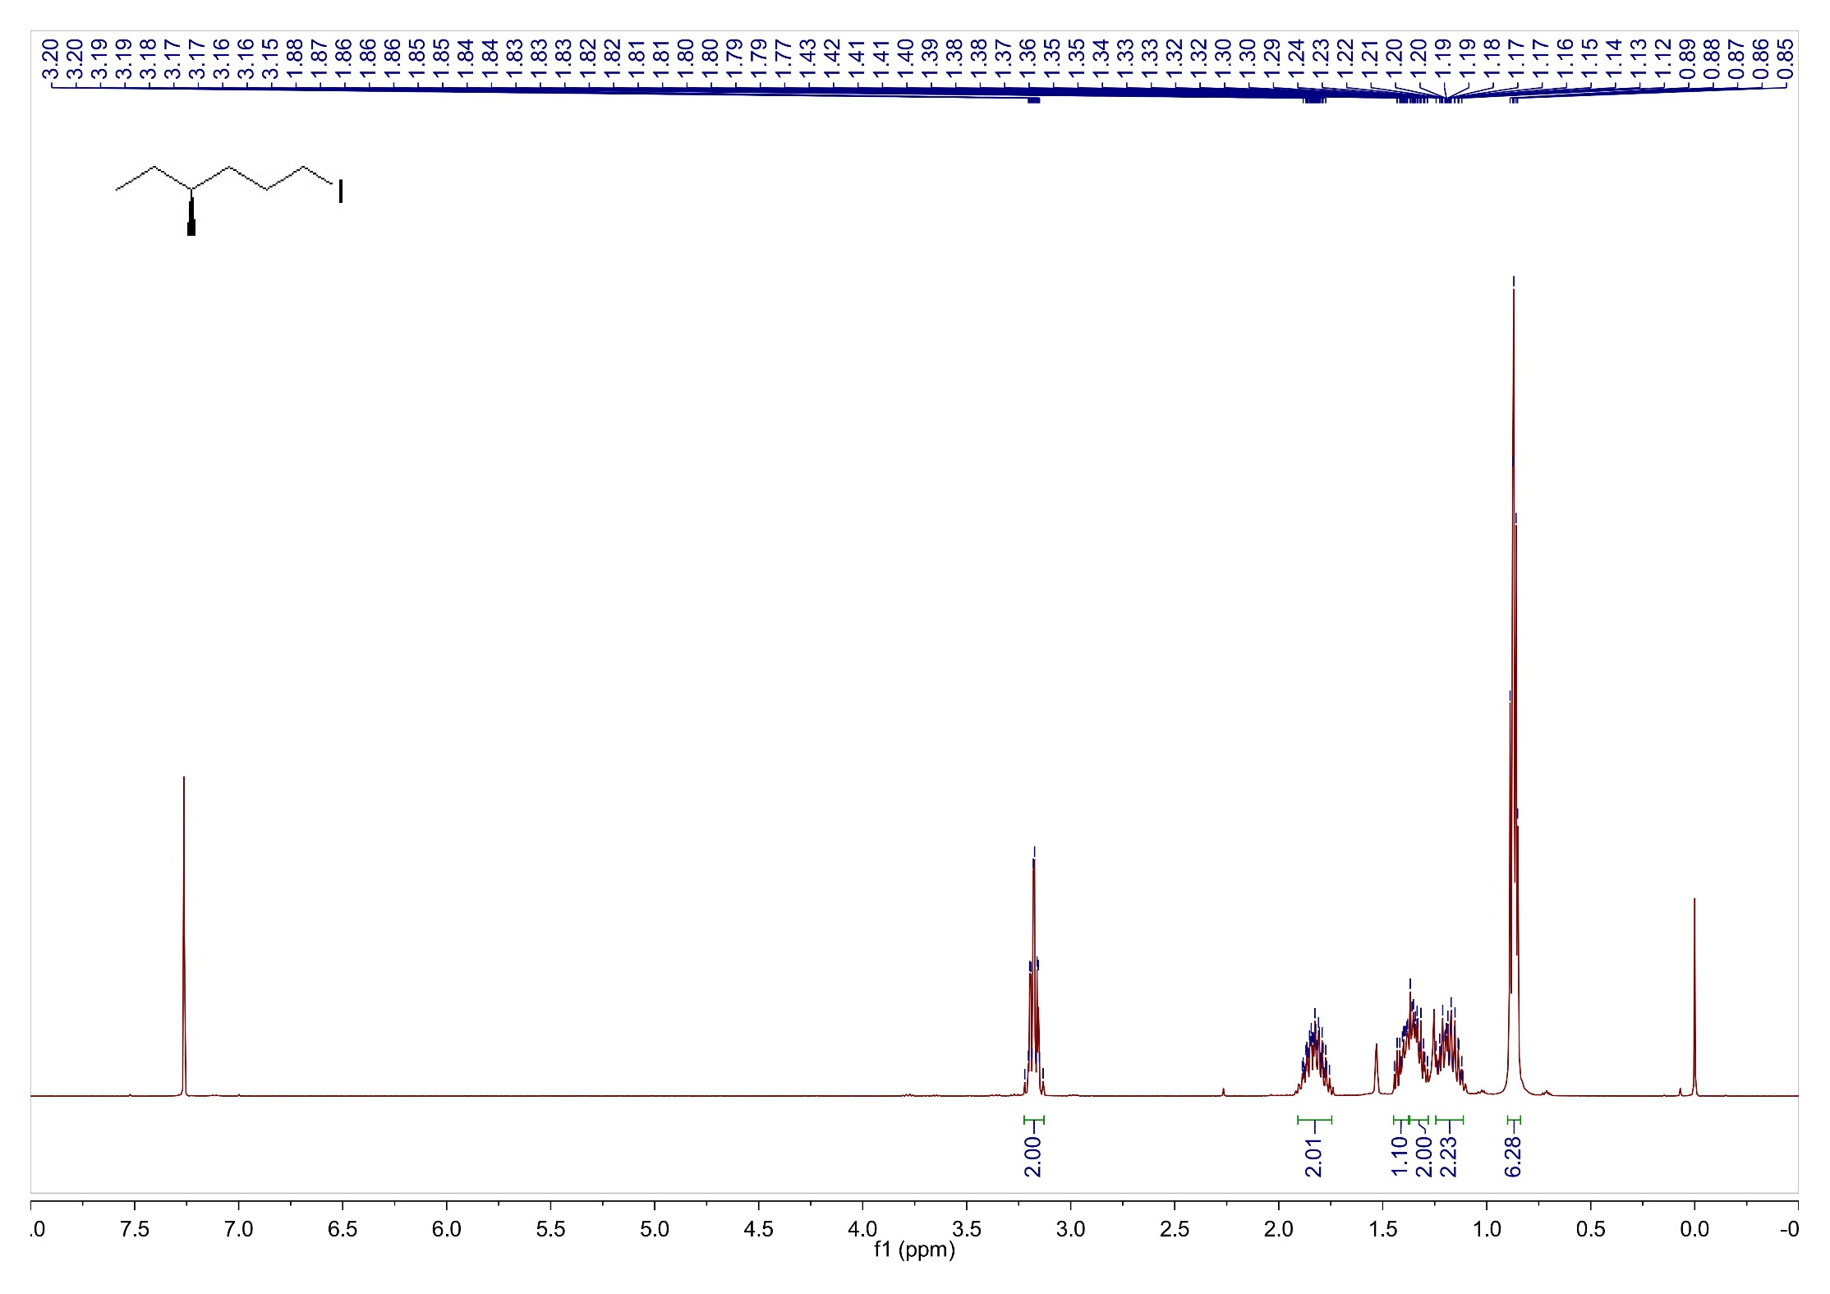
Supplementary Fig. 7. ¹H NMR spectrum of (S)-1-iodo-4-methylhexane in CDCl₃.

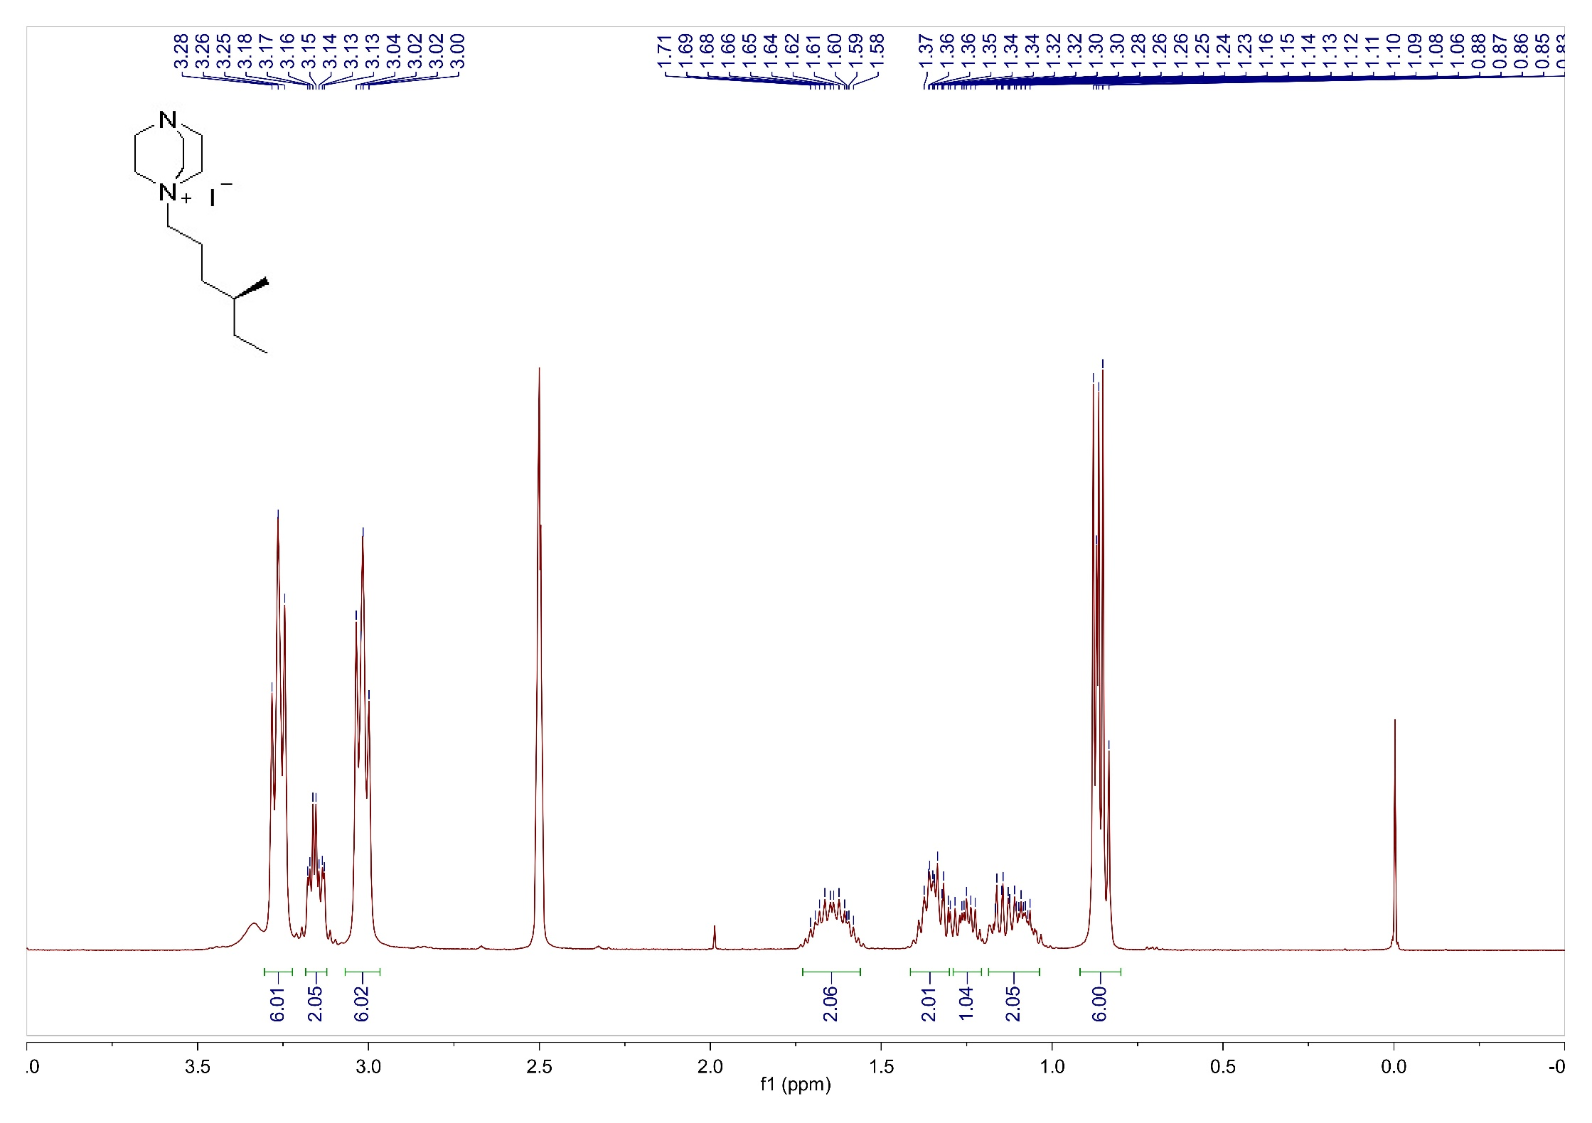
Supplementary Fig. 8. ¹H NMR spectrum of L₄ in DMSO-d6.

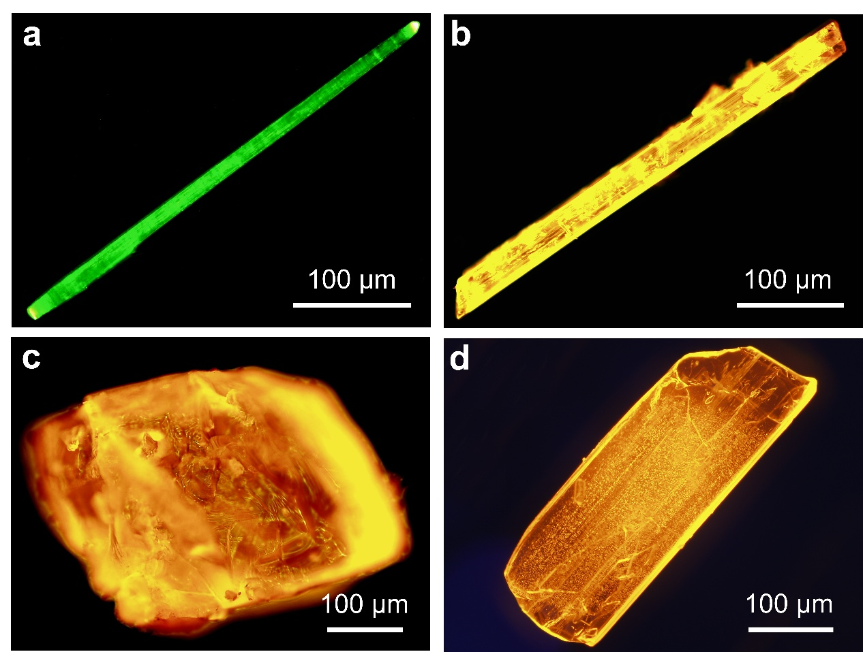
Supplementary Fig. 9. Fluorescence microscopy images of Cu₄I₄(L₁)₄⁴⁺ Cu₈I₁₂⁴⁻ (a), Cu₅I₇(L₂)₂ (b), Cu₅I₇(L₃)₂ (c) and Cu₅I₇(L₄)₂ (d) single crystals.

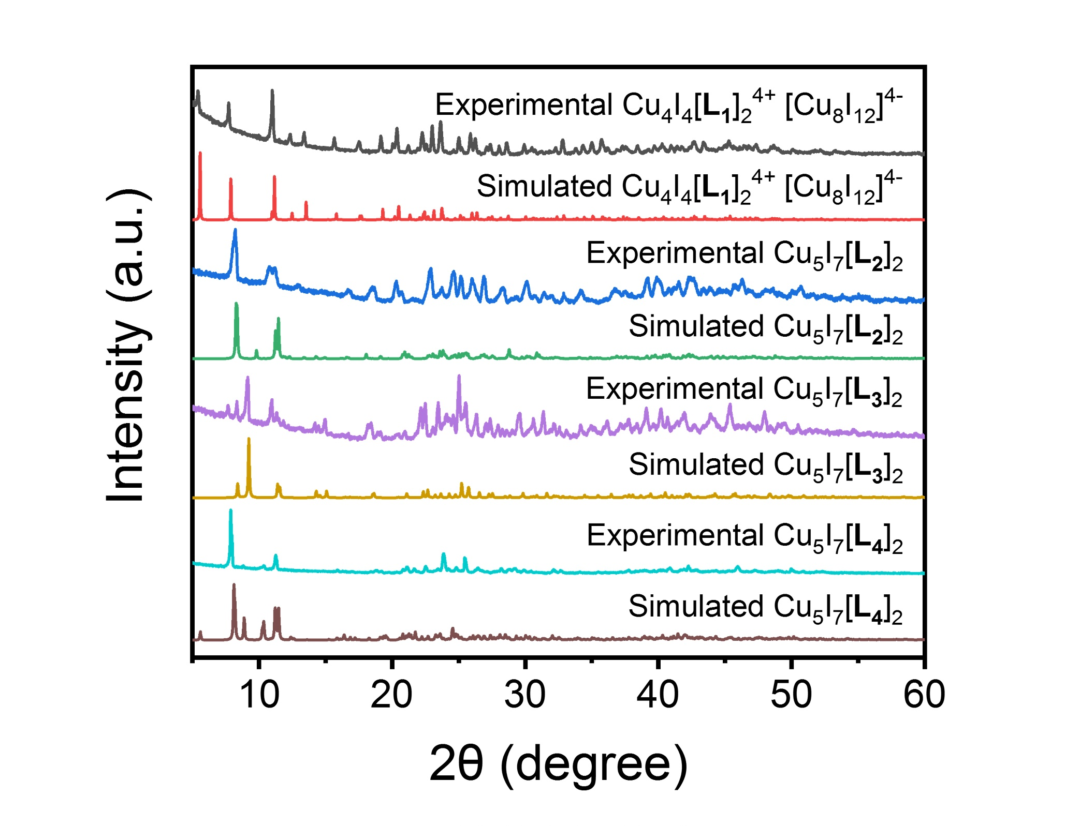
Supplementary Fig. 10. Experimental and simulated PXRD patterns of Cu₄I₄(L₁)₄⁴⁺ Cu₈I₁₂⁴⁻, Cu₅I₇(L₂)₂, Cu₅I₇(L₃)₂ and Cu₅I₇(L₄)₂.

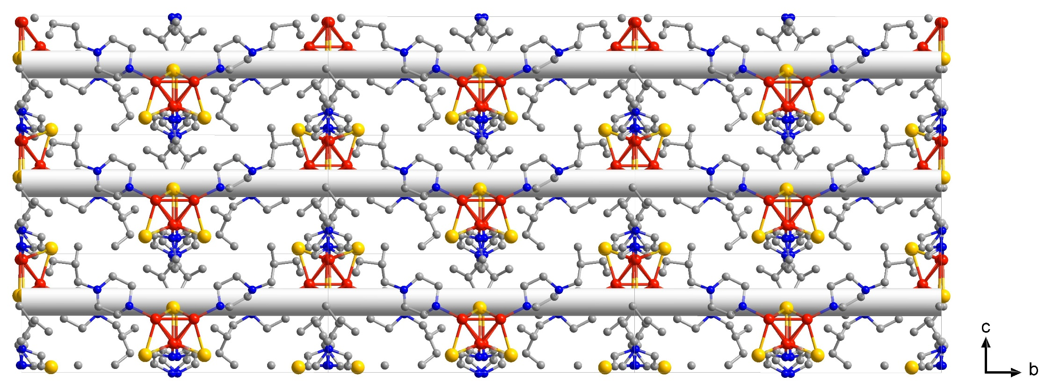
Supplementary Fig. 11. Helical arrangement of Cu₄I₄(L₁)₄⁴⁺ Cu₈I₁₂⁴⁻ hybrid clusters in crystal lattices along the b axis. The Cu-I inorganic chains were omitted in the helical arrangement structure of Cu₄I₄(L₁)₄⁴⁺ Cu₈I₁₂⁴⁻ for clarity. Color scheme: Cu, red; I, yellow; N, blue; C, Gray.

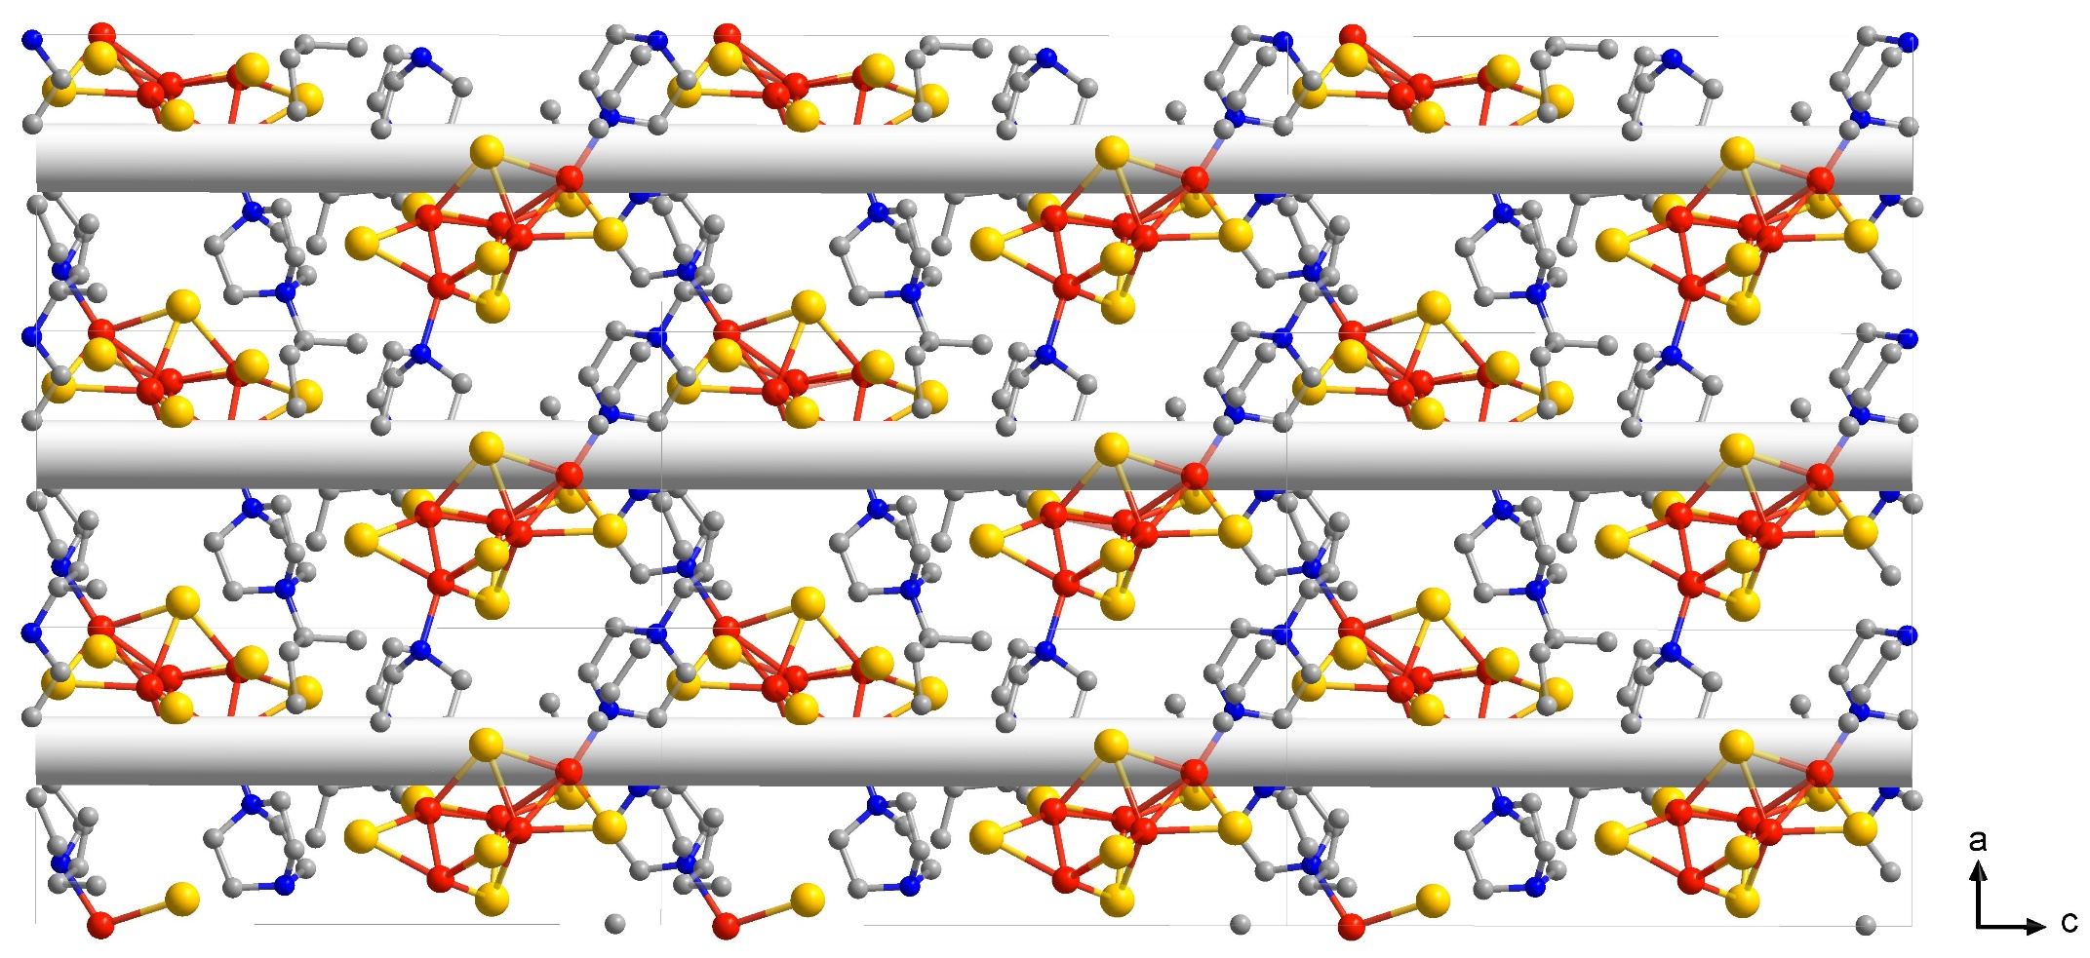
Supplementary Fig. 12. Helical arrangement of Cu₅I₇(L₂)₂ hybrid clusters in crystal lattices along the c axis. Color scheme: Cu, red; I, yellow; N, blue; C, Gray.

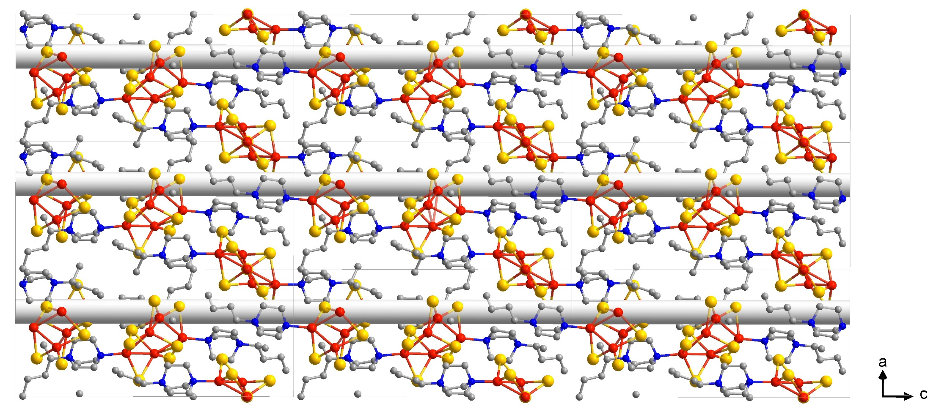
Supplementary Fig. 13. Helical arrangement of Cu₅I₇(L₃)₂ hybrid clusters in crystal lattices along the c axis. Color scheme: Cu, red; I, yellow; N, blue; C, Gray.

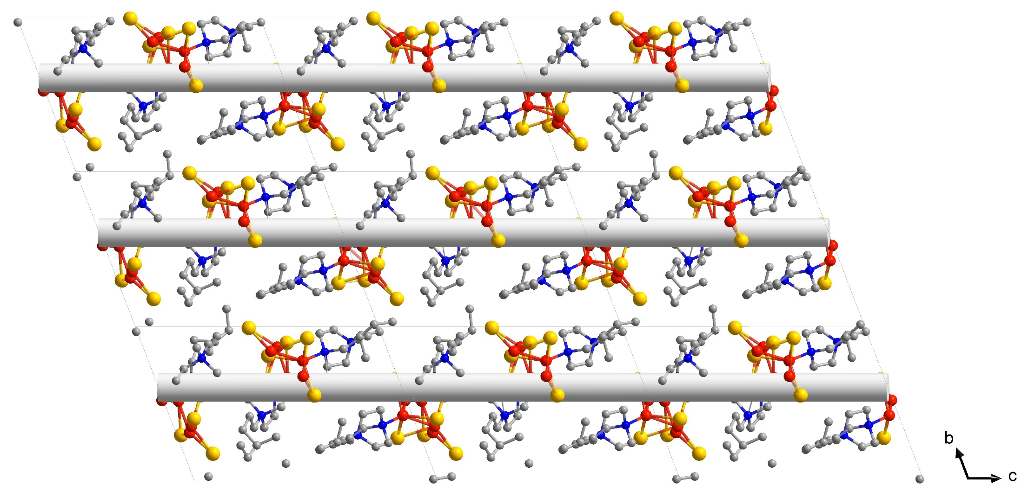
Supplementary Fig. 14. Helical arrangement of Cu₅I₇(L₄)₂ hybrid clusters in crystal lattices along the c axis. Color scheme: Cu, red; I, yellow; N, blue; C, Gray.

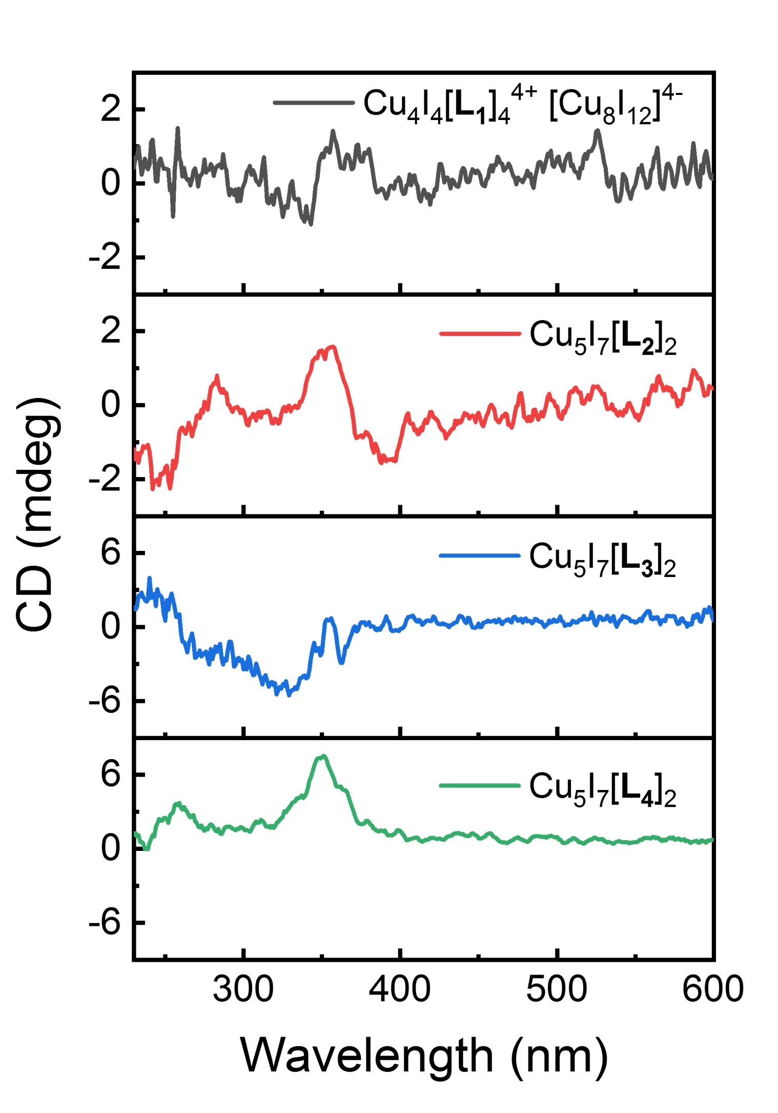
Supplementary Fig. 15. CD spectra of Cu₄I₄(L₁)₄⁴⁺ Cu₈I₁₂⁴⁻, Cu₅I₇(L₂)₂, Cu₅I₇(L₃)₂ and Cu₅I₇(L₄)₂ single crystal powders.

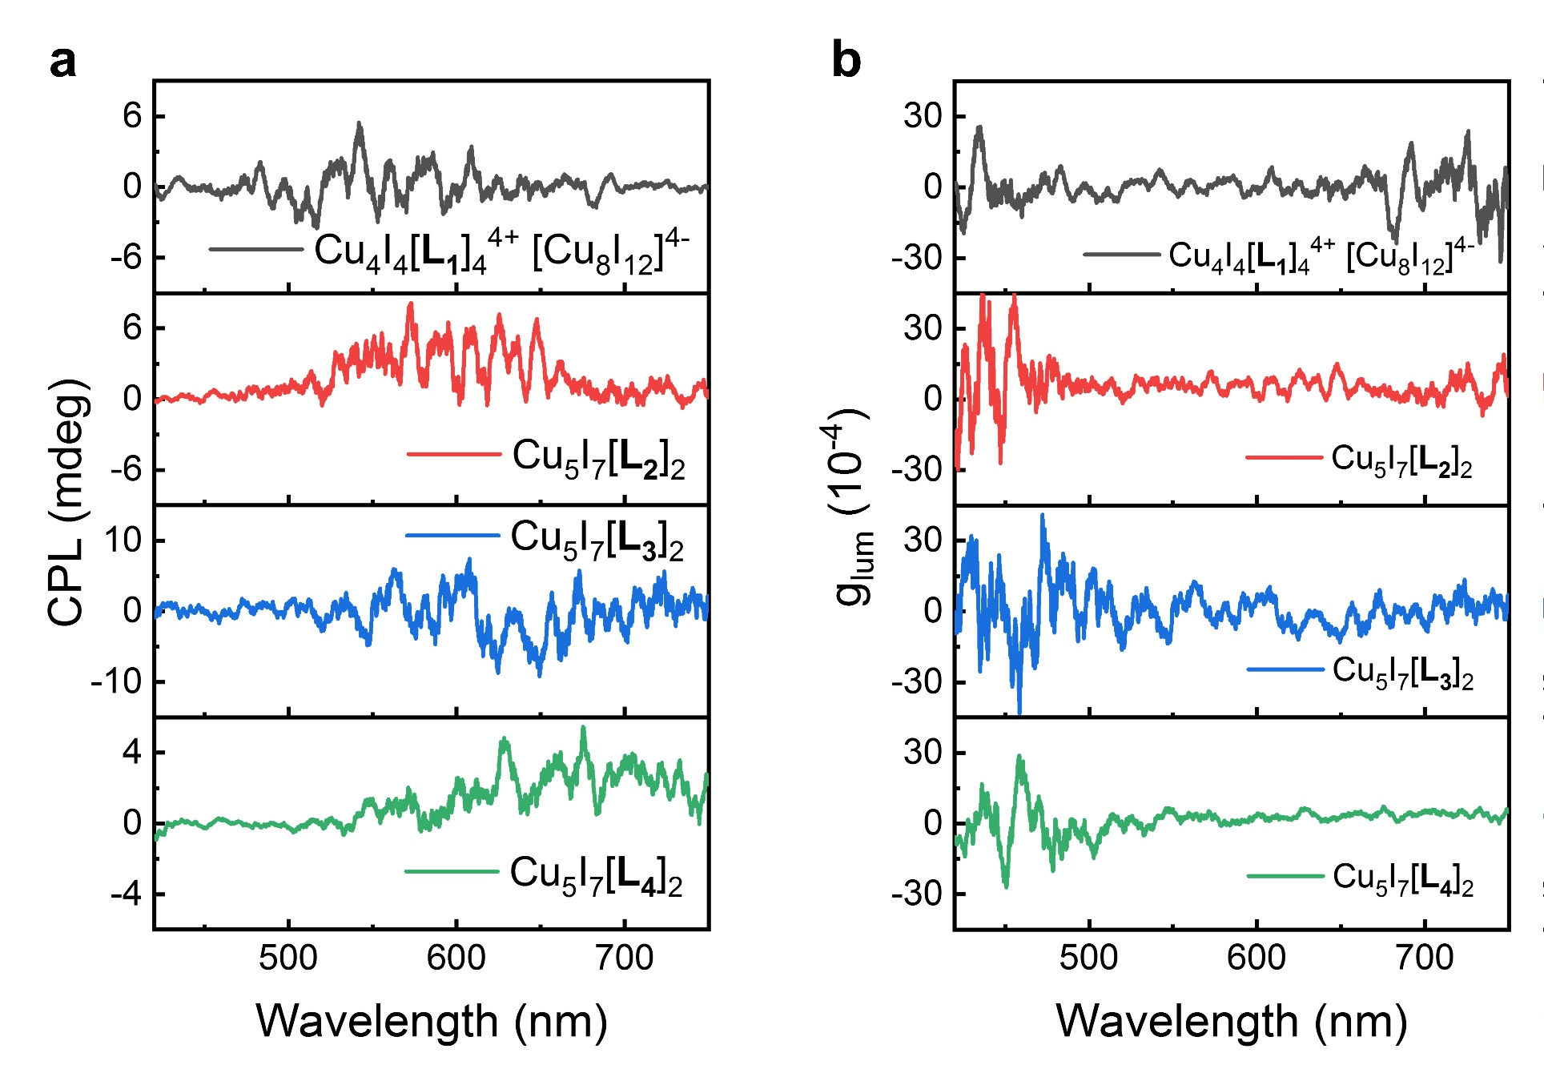
Supplementary Fig. 16. CPL (a) and g_{lum} (b) spectra of Cu₄I₄(L₁)₄⁴⁺ Cu₈I₁₂⁴⁻, Cu₅I₇(L₂)₂, Cu₅I₇(L₃)₂ and Cu₅I₇(L₄)₂ single crystal powders.

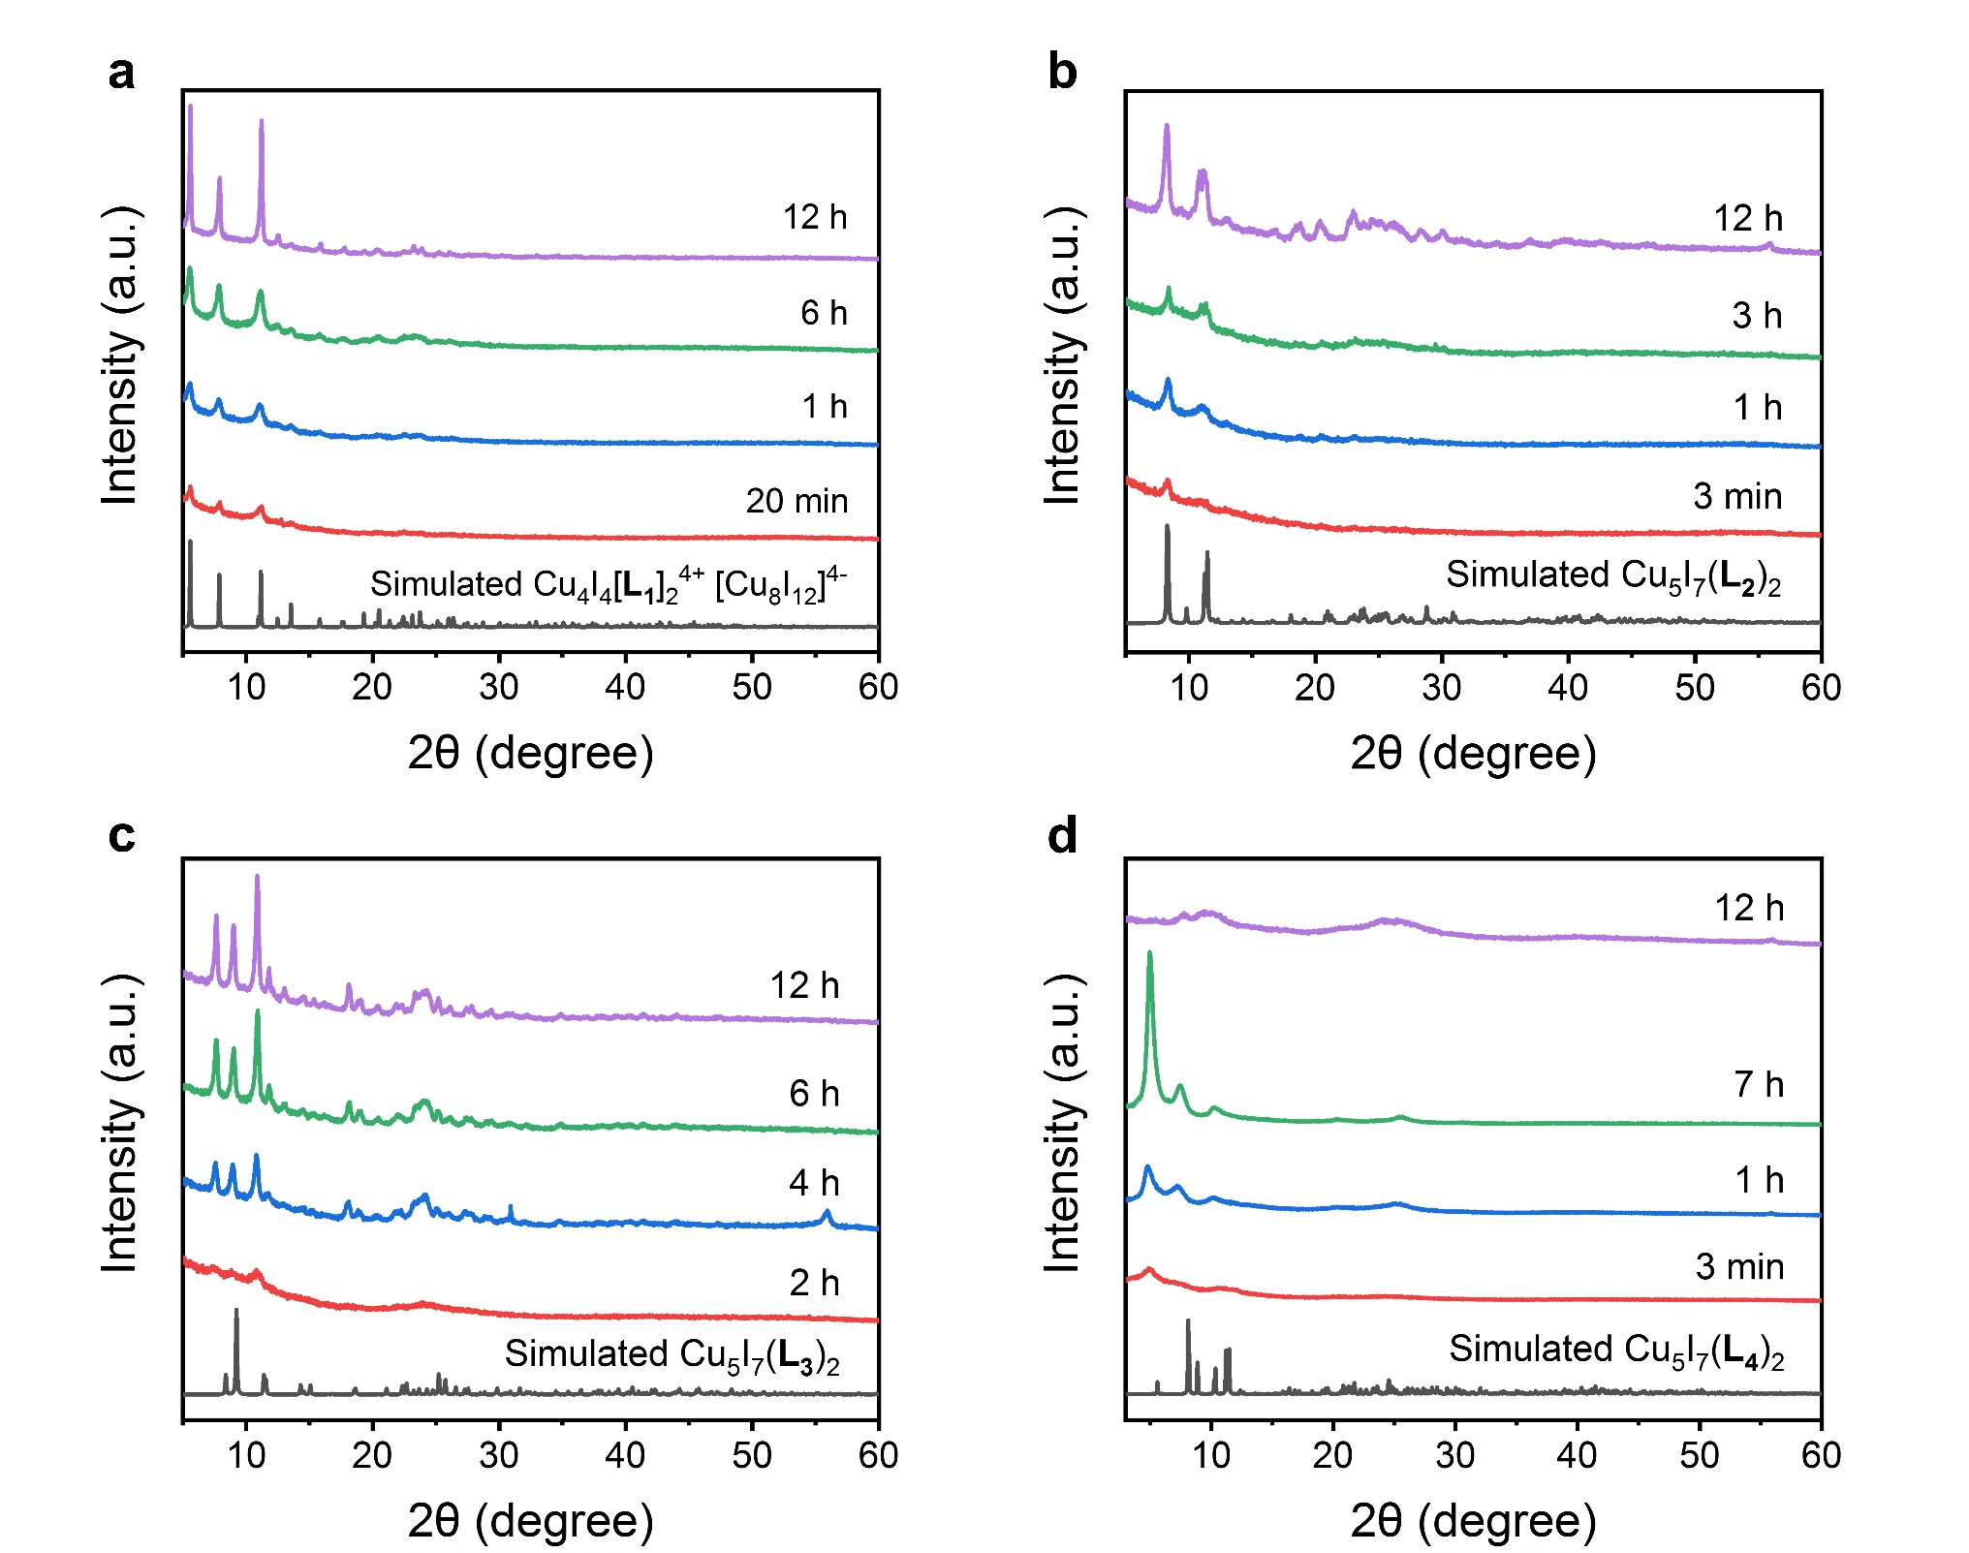
Supplementary Fig. 17. a, PXRD patterns of Cu₄I₄(L₁)₄⁴⁺ Cu₈I₁₂⁴⁻ polycrystals with different reaction time ([L₁] = 6 mM). b, PXRD patterns of Cu₅I₇(L₂)₂ polycrystals with different reaction time ([L₂] = 20 mM). c, PXRD patterns of Cu₅I₇(L₃)₂ polycrystals with different reaction time ([L₃] = 25 mM). d, PXRD patterns of Cu₅I₇(L₄)₂ polycrystals with different reaction time ([L₄] = 20 mM).

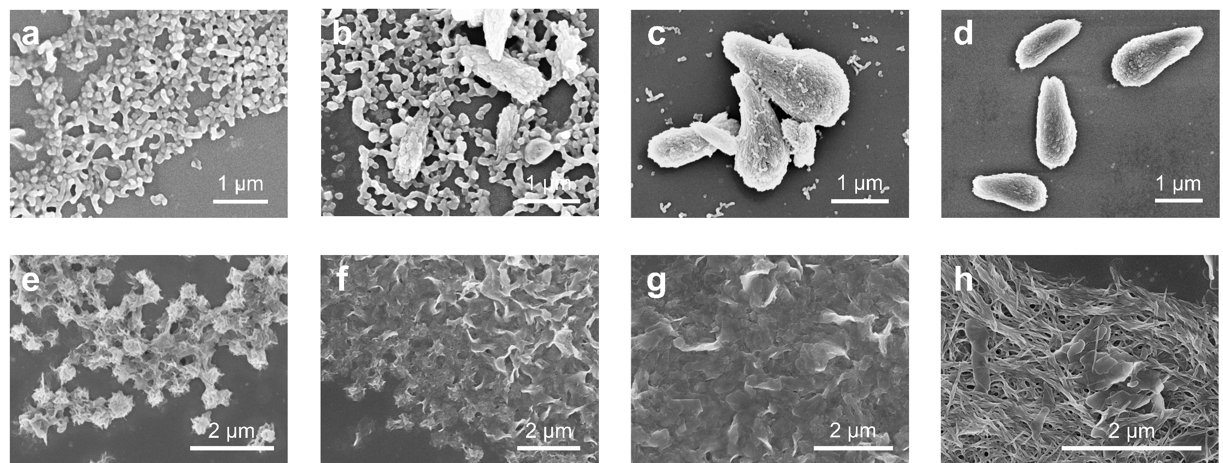
Supplementary Fig. 18. a-d, SEM images of different stages of crystallization for Cu₅I₇(L₂)₂ polycrystals with reaction time of 3 min (a), 2 h (b), 3 h (c), 6 h (d), respectively ([L₂] = 20 mM). e-h, SEM images of different stages of crystallization for Cu₅I₇(L₄)₂ polycrystals with reaction time as 3 min (e), 1 h (f), 7 h (g), 12 h (h), respectively ([L₄] = 20 mM).

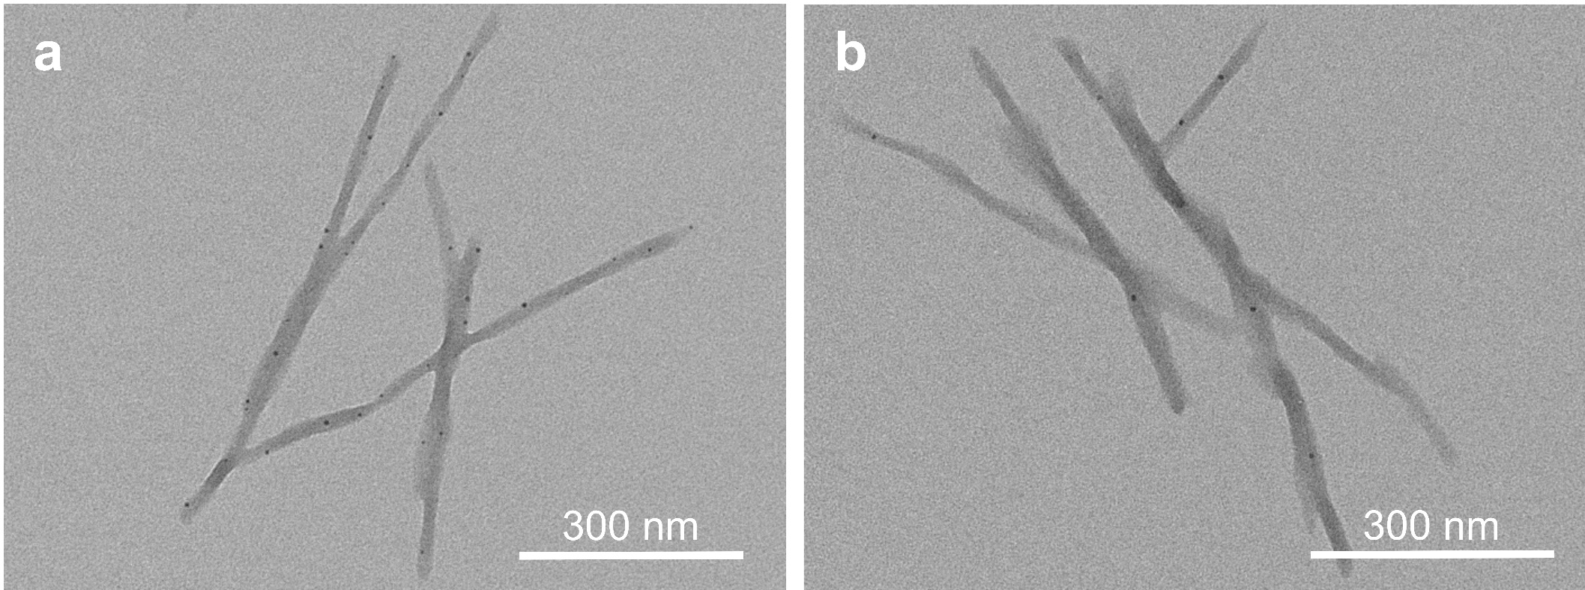
Supplementary Fig. 19. TEM images of Cu₅I₇(L₄)₂ helical nanobelts.

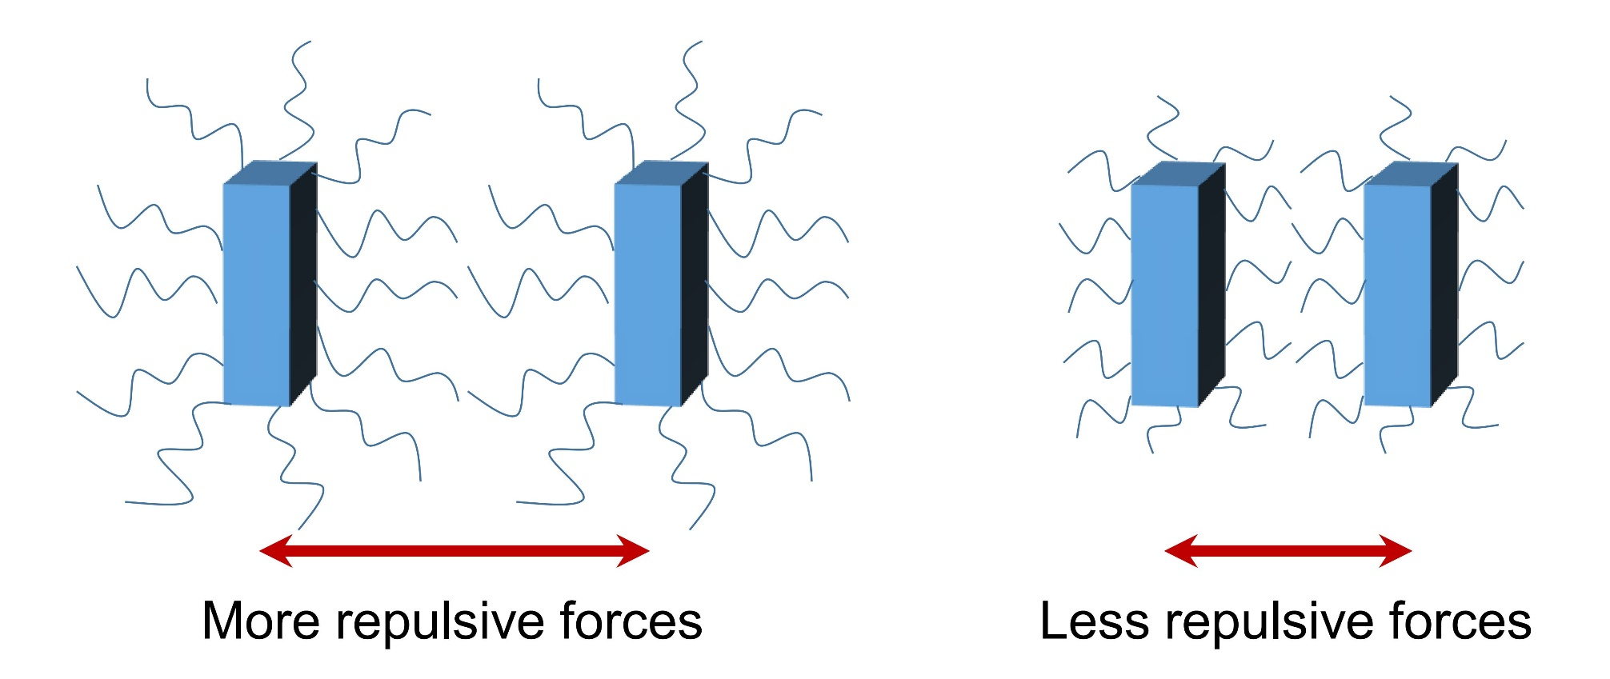
Supplementary Fig. 20. Schematic diagram of repulsive forces between assembly units caused by long (left) and short (right) chains of ligands absorbed on the surfaces, respectively. Blue cuboids represent the assembly units, and the wavy lines attached to the surfaces of cuboids represent ligands.

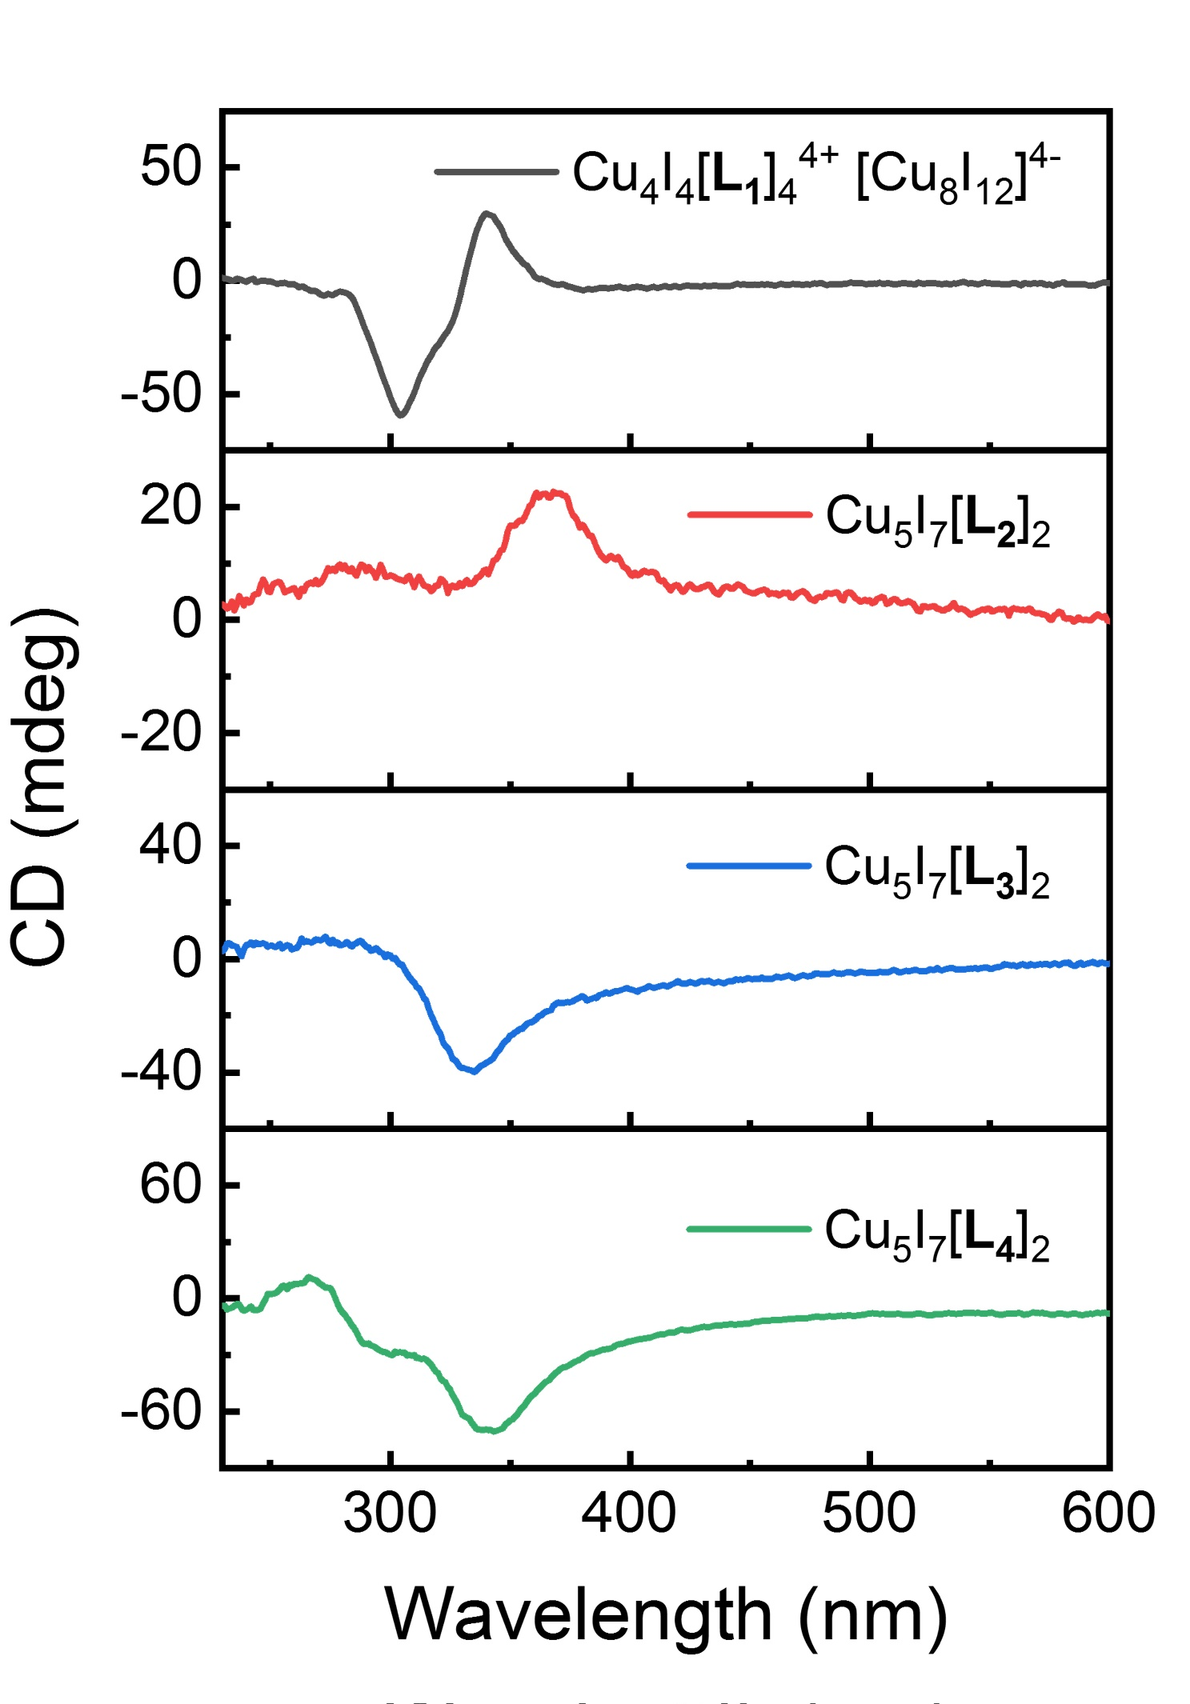
Supplementary Fig. 21. CD spectra of Cu₄I₄(L₁)₄⁴⁺ Cu₈I₁₂⁴⁻, Cu₅I₇(L₂)₂, Cu₅I₇(L₃)₂ and Cu₅I₇(L₄)₂ hierarchically structured polycrystals with the concentrations of L₁-L₄ as 6 mM, 20 mM, 25 mM, 20 mM, respectively.

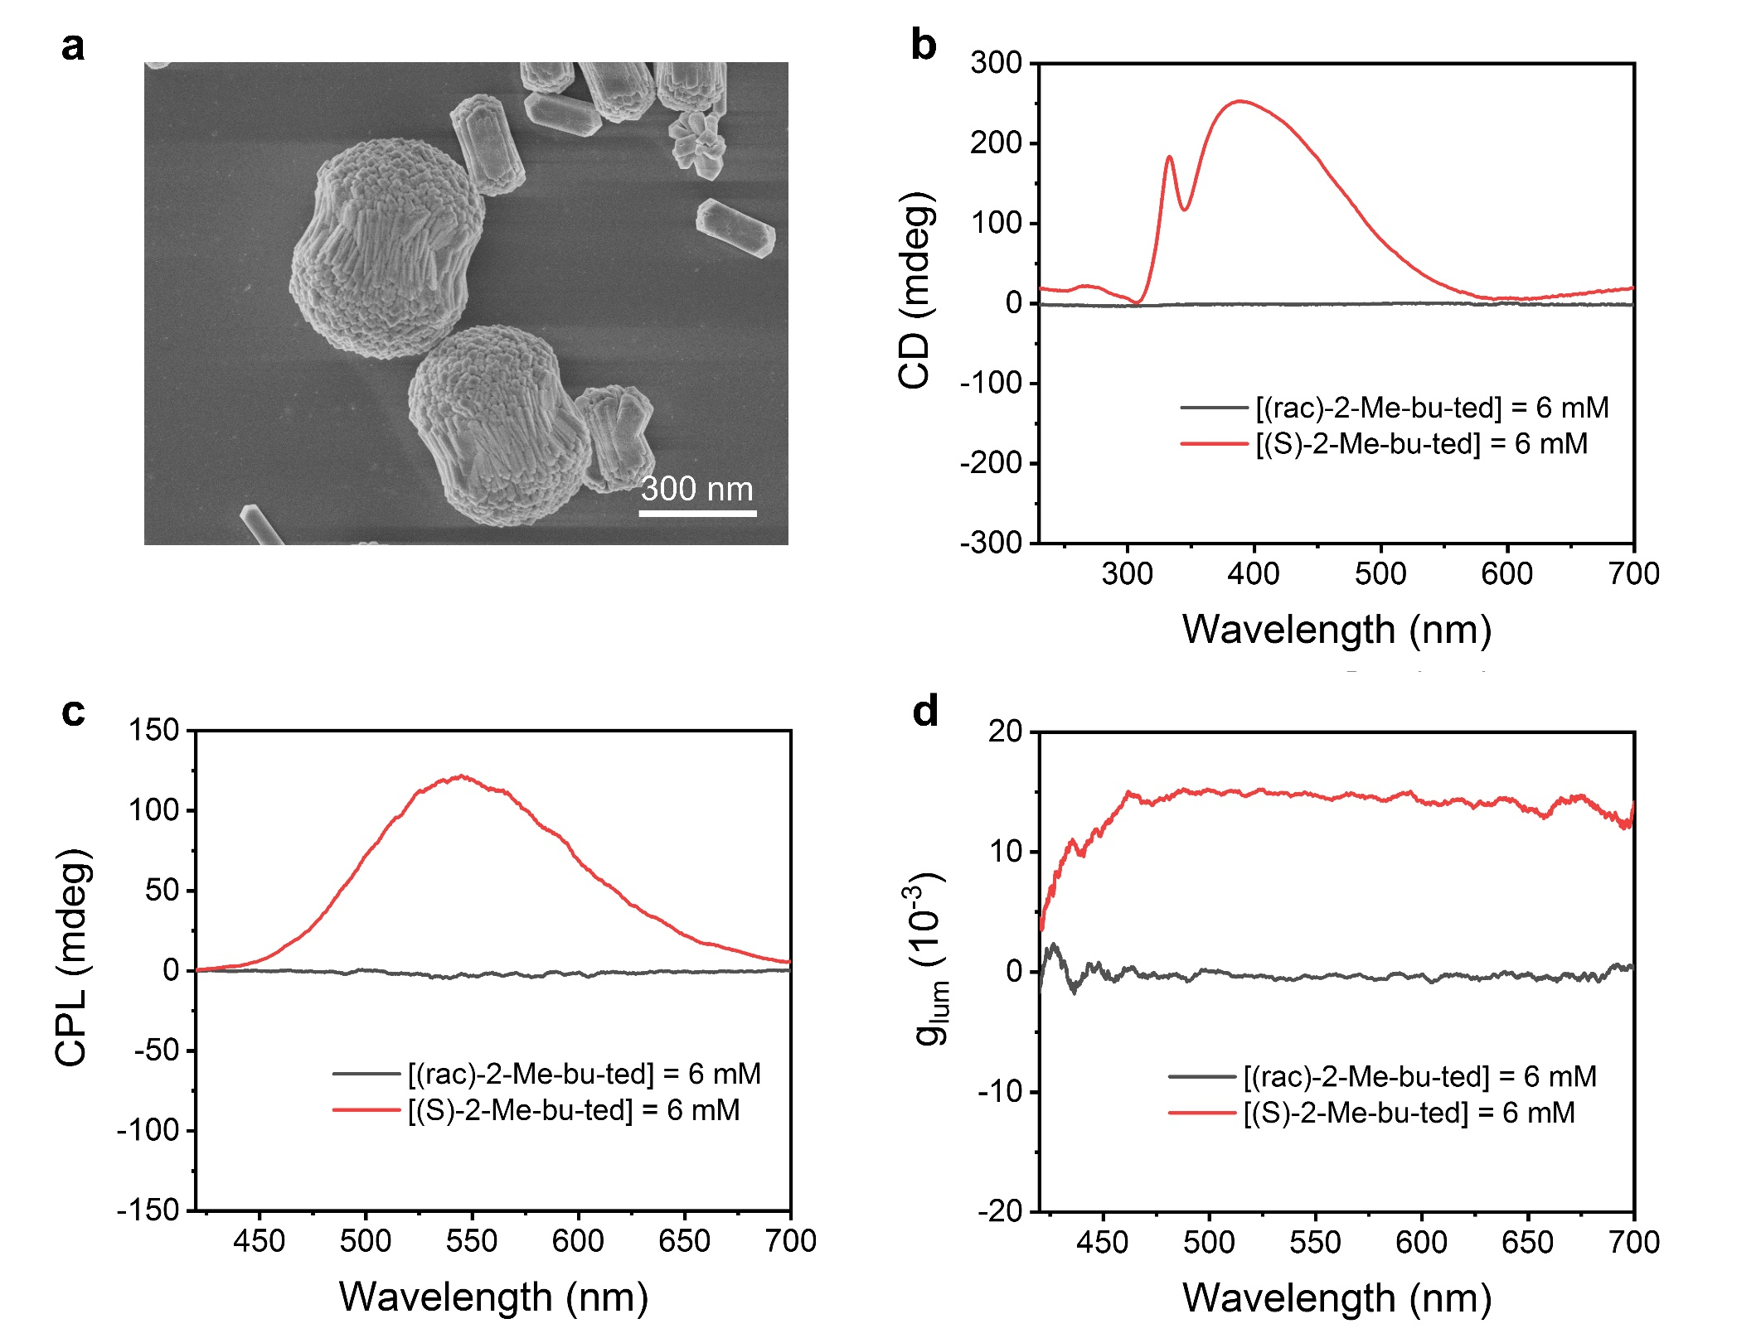
Supplementary Fig. 22. a, SEM images of (rac)-Cu₄I₄(L₁)₄⁴⁺ Cu₈I₁₂⁴⁻ hierarchically structured polycrystals synthesized by racemic L₁ ligands. b-d, CD (b), CPL (c), and g_{lum} (d) spectra of hierarchically structured polycrystals synthesized by racemic and chiral L₁ ligands, respectively. Other conditions: [racemic L₁] = [L₁] = 6 mM.

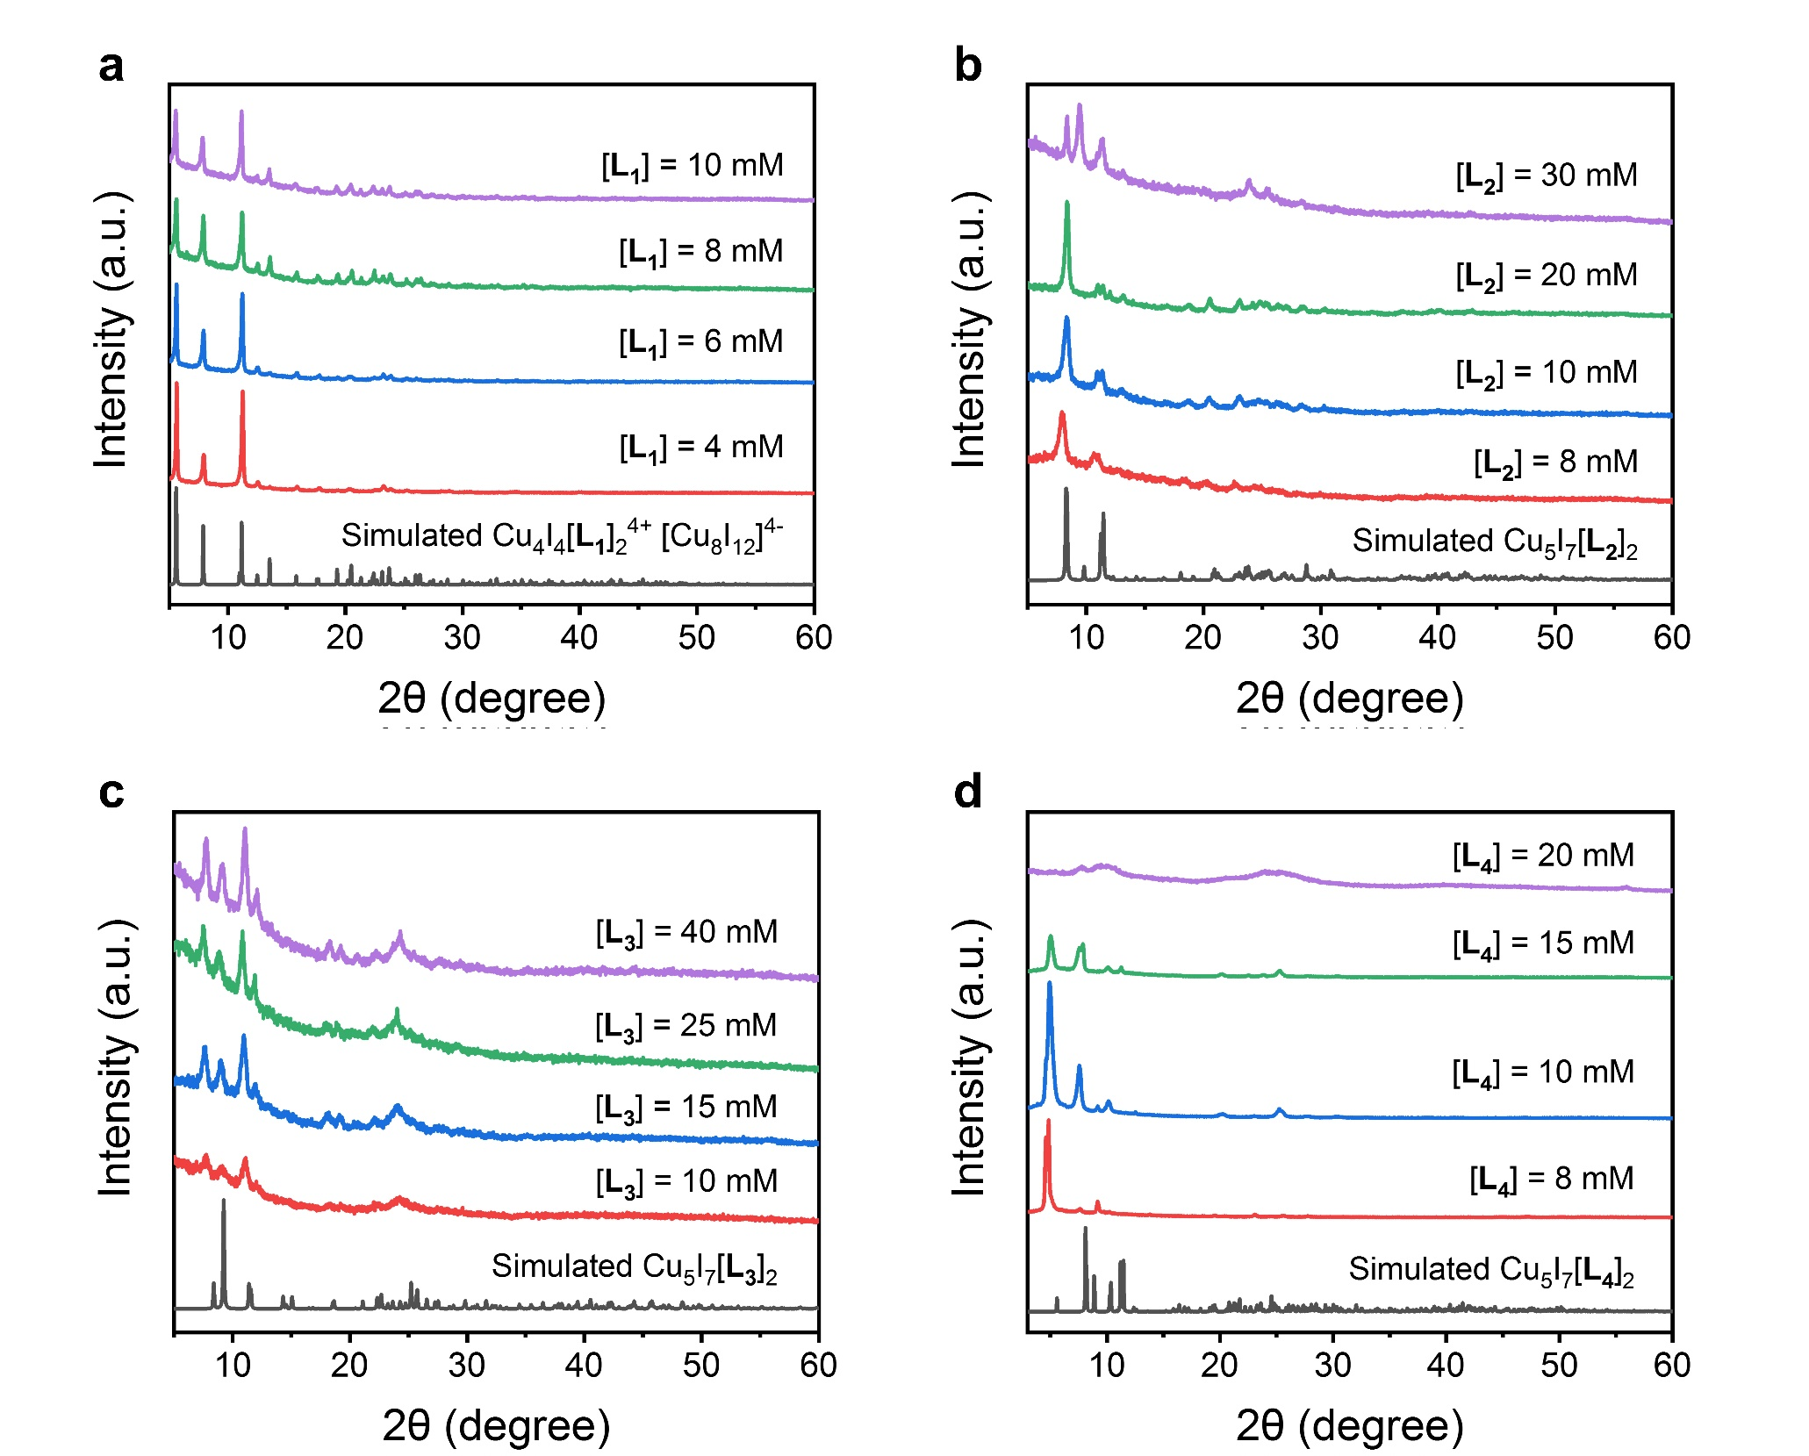
Supplementary Fig. 23. PXRD patterns of Cu₄I₄(L₁)₄⁴⁺ Cu₈I₁₂⁴⁻ (a), Cu₅I₇(L₂)₂ (b), Cu₅I₇(L₃)₂ (c) and Cu₅I₇(L₄)₂ (d) polycrystals with different concentration of ligands.

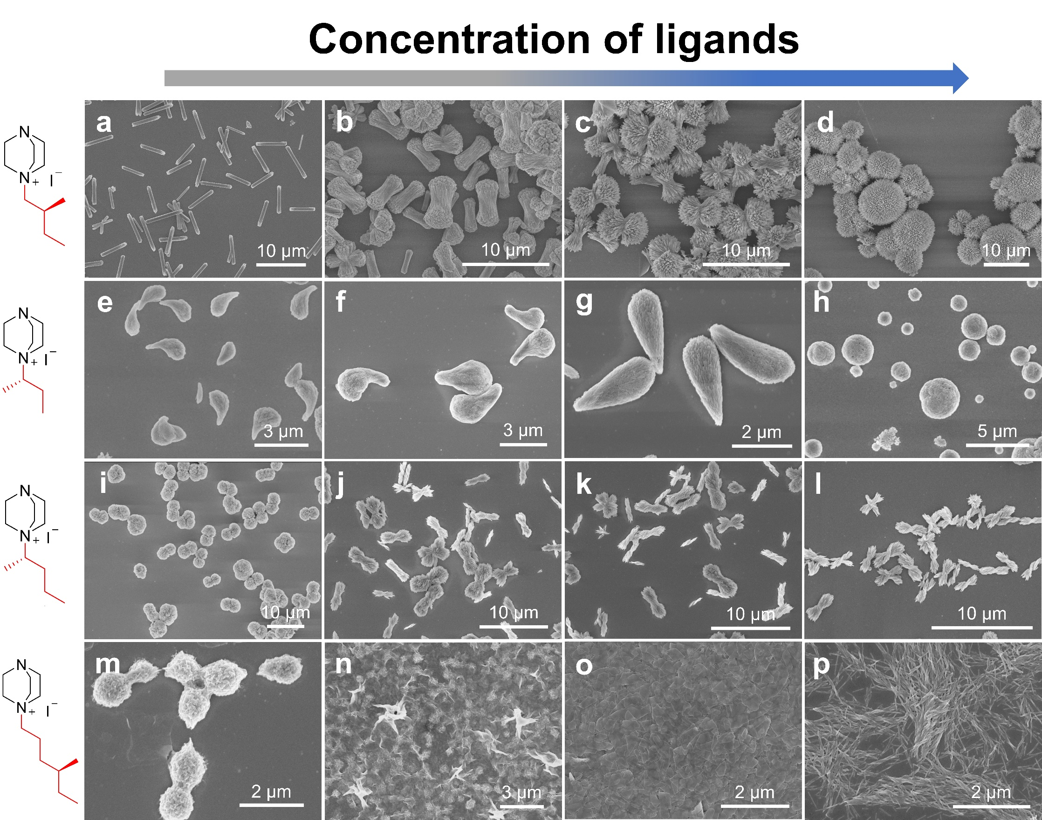
Supplementary Fig. 24. a-d, SEM images of Cu₄I₄(L₁)₄⁴⁺ Cu₈I₁₂⁴⁻ polycrystals with the concentrations of L₁ as 4 mM (a), 5 mM (b), 6 mM (c), 10 mM (d), respectively. e-h, SEM images of Cu₅I₇(L₂)₂ polycrystals with concentrations of L₂ as 5 mM (e), 10 mM (f), 20 mM (g), 30 mM (h), respectively. i-l, SEM images of Cu₅I₇(L₃)₂ polycrystals with concentrations of L₃ as 10 mM (i), 20 mM (j), 25 mM (k), 40 mM (l), respectively. m-p, SEM images of Cu₅I₇(L₄)₂ polycrystals with concentration of L₄ as 3 mM (m), 5 mM (n), 10 mM (o), 20 mM (p), respectively.

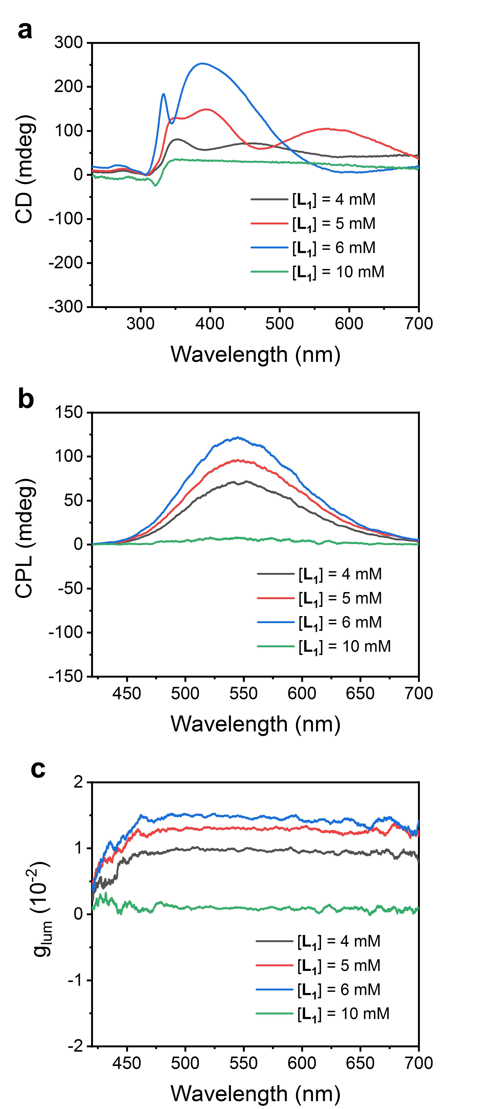
Supplementary Fig. 25. CD (a), CPL (b), and g_{lum} (c) spectra of Cu₄I₄(L₁)₄⁴⁺ Cu₈I₁₂⁴⁻ polycrystals with different concentration of L₁, respectively.

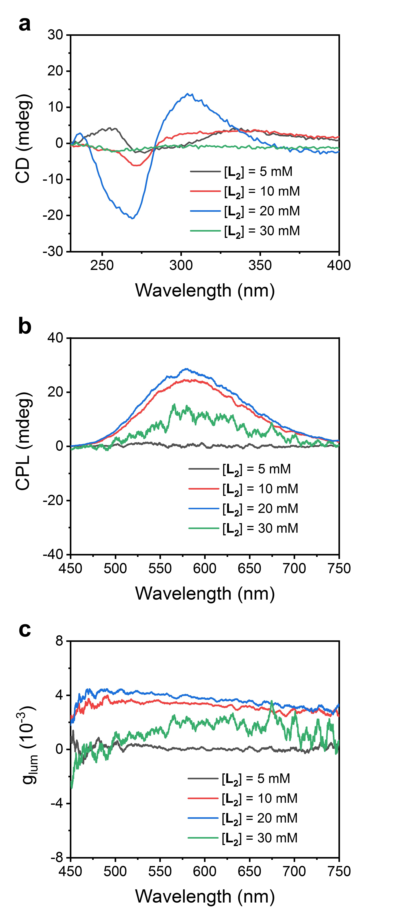
Supplementary Fig. 26. CD (a), CPL (b), and g_{lum} (c) spectra of Cu₅I₇(L₂)₂ polycrystals with different concentration of L₂, respectively.

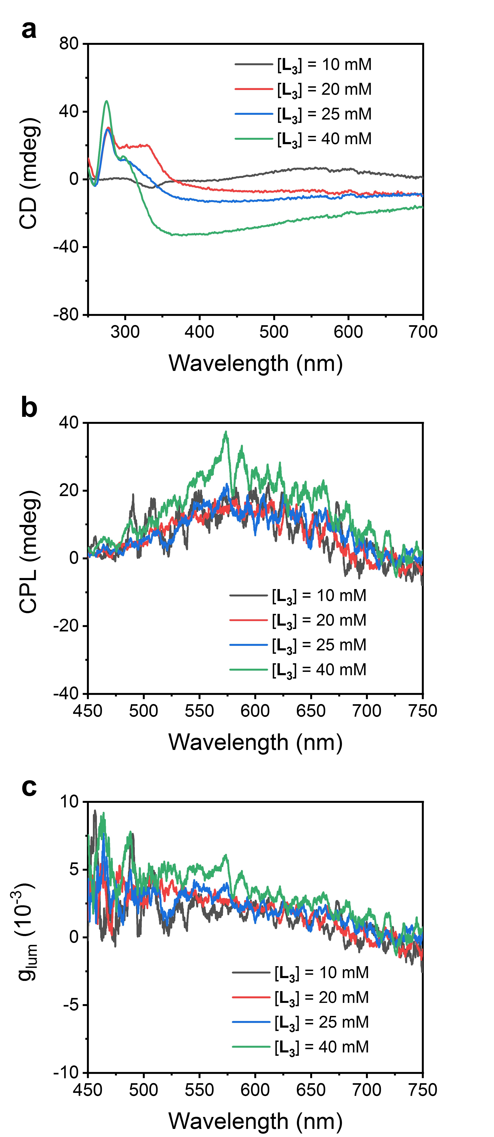
Supplementary Fig. 27. CD (a), CPL (b), and g_{lum} (c) spectra of Cu₅I₇(L₃)₂ polycrystals with different concentration of L₃, respectively.

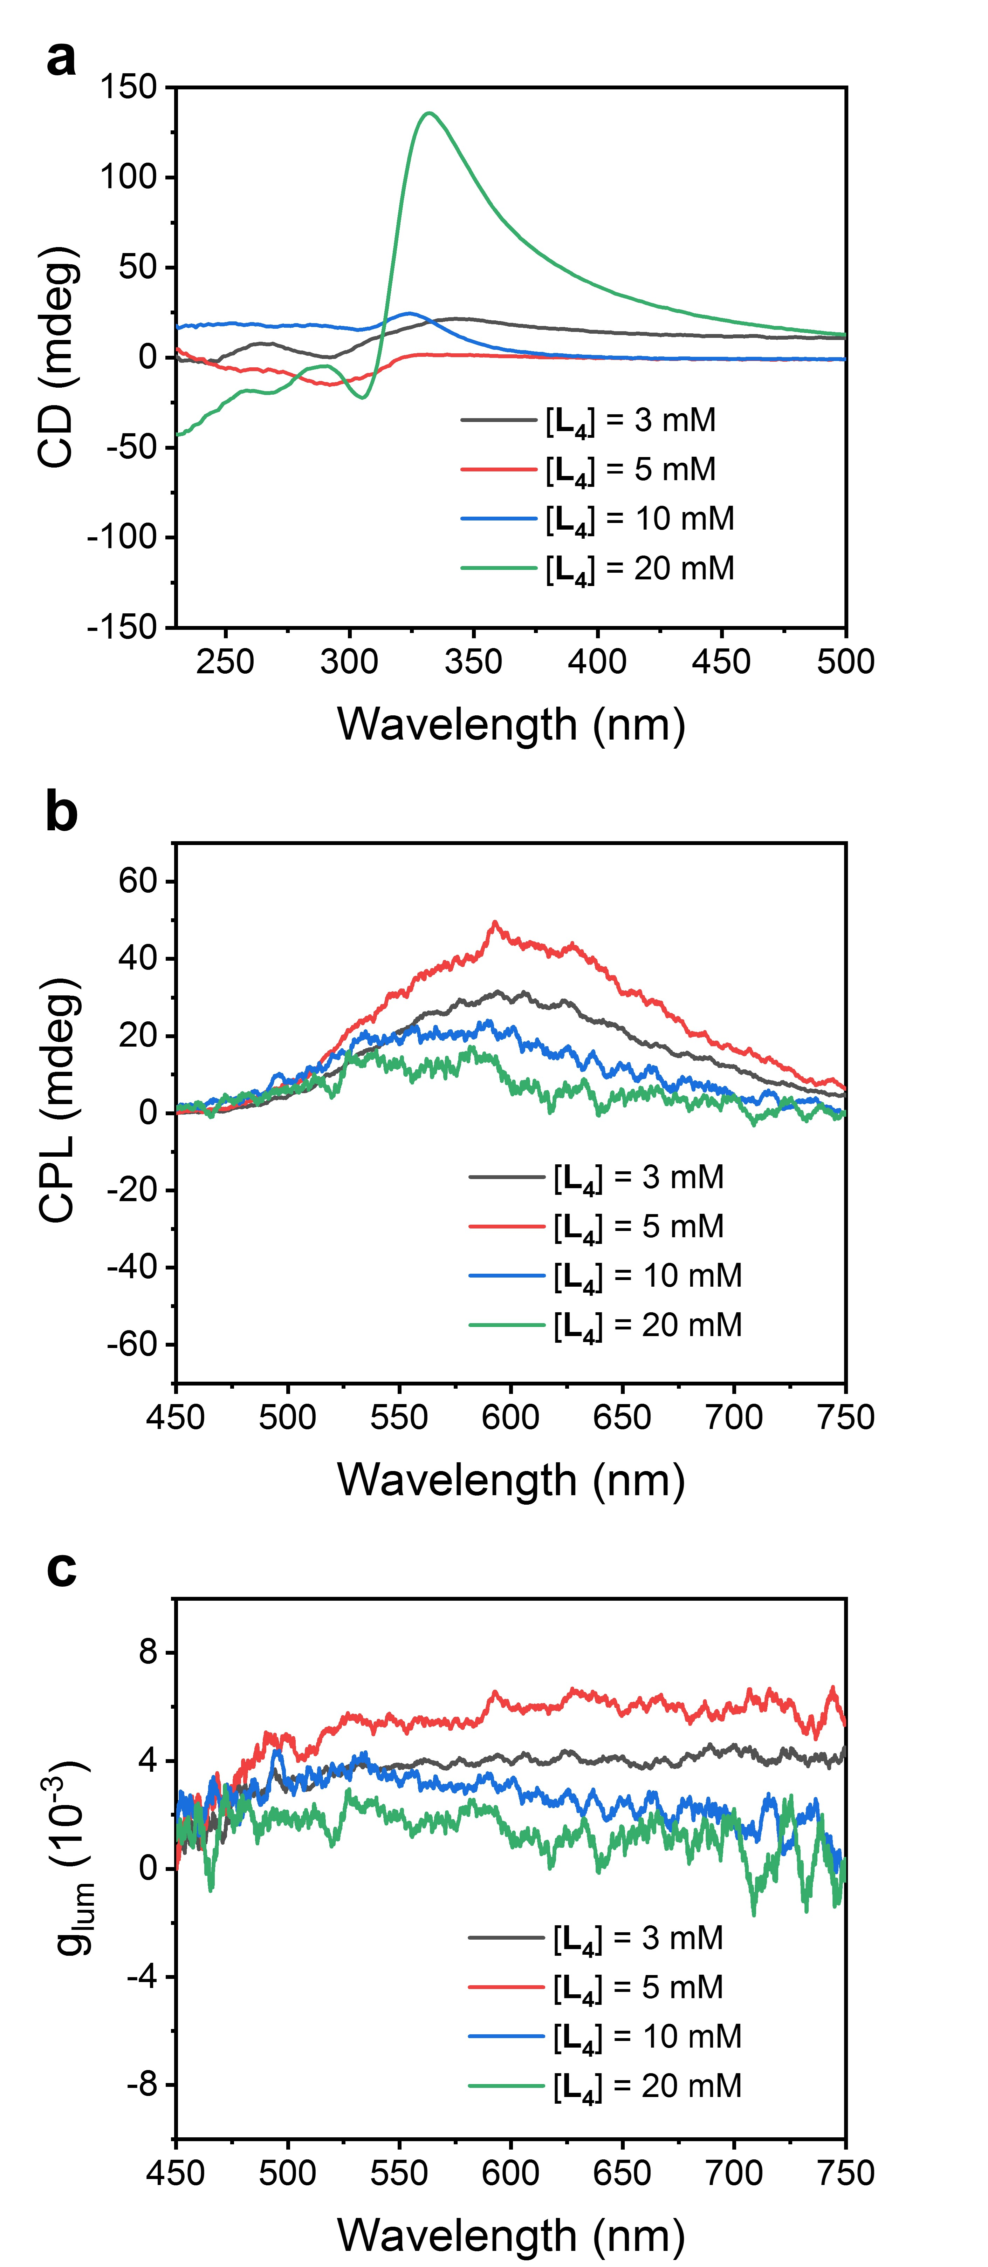
Supplementary Fig. 28. CD (a), CPL (b), and g_{lum} (c) spectra of Cu₅I₇(L₄)₂ polycrystals with different concentration of L₄, respectively.

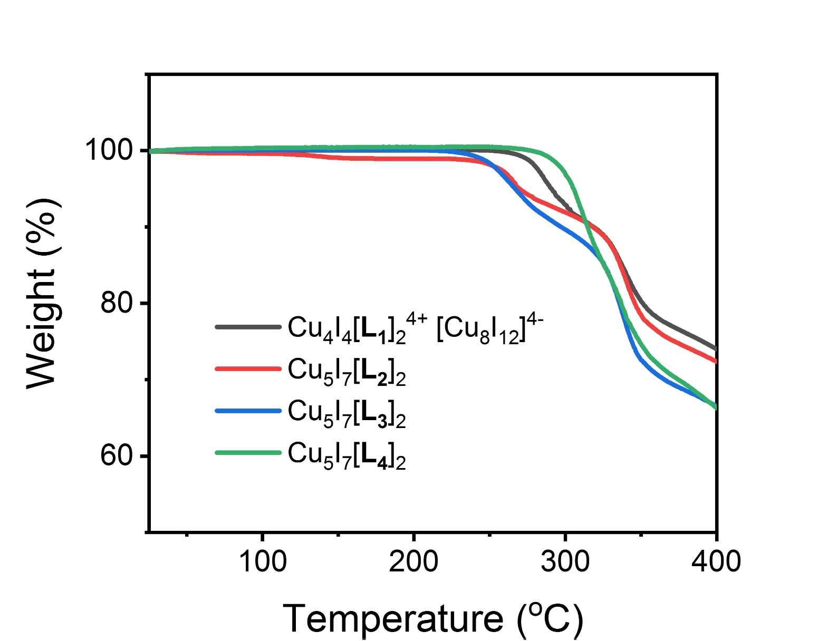
Supplementary Fig. 29. TGA curves of Cu₄I₄(L₁)₄⁴⁺ Cu₈I₁₂⁴⁻, Cu₅I₇(L₂)₂, Cu₅I₇(L₃)₂ and Cu₅I₇(L₄)₂ hierarchically structured polycrystals.

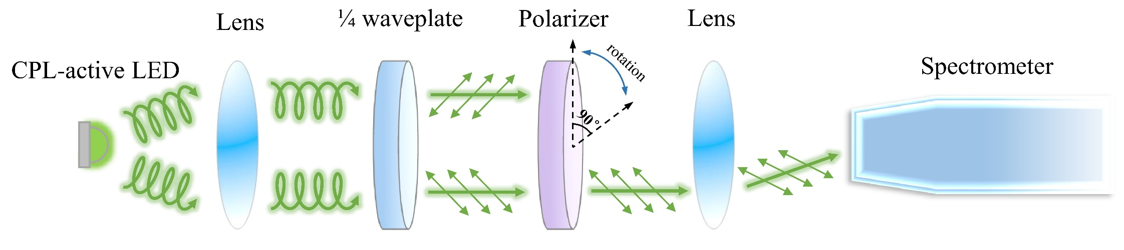
Supplementary Fig. 30. Schematic illustration of LED polarization measurement system. We measured the circularly polarized light emitted by the fabricated LED device by dividing the emitted light into left- and right-handed portions, respectively, using a quarter-wave plate and a linear polarizer to eliminate the influence of linear polarized light.

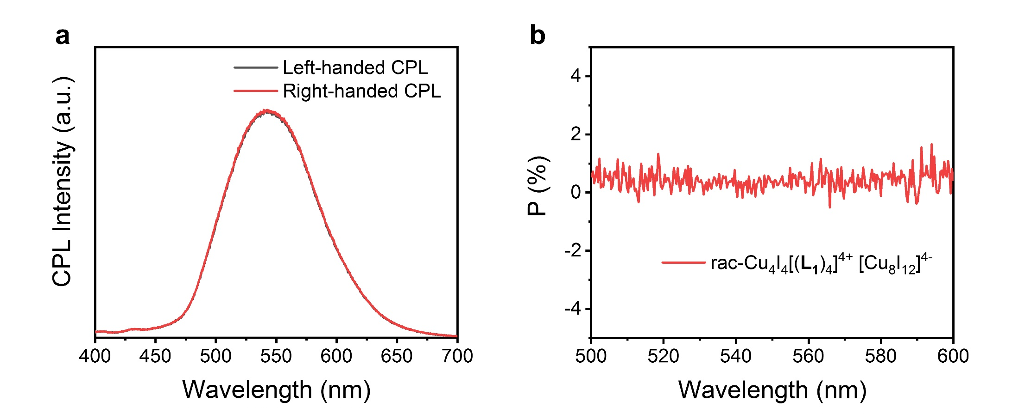
Supplementary Fig. 31. CPL spectra (a) and the polarized degree (b) of the fabricated LED device based on racemic Cu₄I₄(L₁)₄⁴⁺ Cu₈I₁₂⁴⁻ polycrystals powered by 2.4 V electric source.

Supplementary text 1: The crystallization process of Cu₅I₇(L₄)₂ polycrystals. As shown in Supplementary Fig. 18e and f, at the beginning, Cu₅I₇(L₄)₂ clusters aggregated into conglobate particles, and then grew into nanosheets. PXRD patterns of nanoparticles and nanosheets show wide width of diffraction peaks, indicating low crystallinity of Cu₅I₇(L₄)₂ at this stage (Supplementary Fig. 17d). Additionally, strong diffraction peak at 5° does not belong to the phase of Cu₅I₇(L₄)₂. According to the Bragg’s law, we speculate that it is owing to the two dimensional layered structure with large distance between two layers due to the long alkyl chain length of L₄, which give rise to the peak at small degree of 5°. But, as the reaction time prolonged, nanosheets were avulsed, restructured and twisted into M-helical nanobelts (Supplementary Fig. 18g, h). And the helicity of nanobelts can also be verified by transmission electron microscopy (TEM) images (Supplementary Fig. 19). Correspondingly, diffraction peak at 5° in PXRD pattern is disappeared at this time, indicating the disappearance of two dimensional structures and the transformation of nanosheets to nanobelts (Supplementary Fig. 17d).

Supplementary Table 1. Crystallography parameters of Cu₄I₄(L₁)₄⁴⁺ Cu₈I₁₂⁴⁻, Cu₅I₇(L₂)₂, Cu₅I₇(L₃)₂ and Cu₅I₇(L₄)₂ single crystals.
Compounds | Cu₄I₄(L₁)₄⁴⁺ Cu₈I₁₂⁴⁻ | Cu₅I₇(L₂)₂ | Cu₅I₇(L₃)₂ | Cu₅I₇(L₄)₂
Empirical formula | C₂₂H₄₅Cu₆I₈N₄ | C₂₄H₄₈Cu₅I₇N₆ | C₂₂H₄₆Cu₅I₇N₄ | C₂₆H₅₄Cu₅I₇N₄
Formula weight | 1762.06 | 1626.68 | 1572.63 | 1628.73
Temperature/K | 100.15 | 100.00(10) | 100.00(10) | 100.00(10)
Crystal system | tetragonal | triclinic | trigonal | triclinic
Space group | P4₂ | P1 | P3₂21 | P1
a/Å | 22.0722(2) | 8.69065(18) | 12.1489(5) | 11.5081(2)
b/Å | 22.0722(2) | 13.3957(3) | 12.1489(5) | 11.6450(3)
c/Å | 8.55280(10) | 18.0042(5) | 22.9488(9) | 16.9677(4)
α/° | 90 | 89.407(2) | 90 | 109.679(2)
β/° | 90 | 89.889(2) | 90 | 95.9038(16)
γ/° | 90 | 79.2342(19) | 120 | 98.0117(19)
Volume/Å³ | 4166.77(9) | 2059.01(9) | 2933.4(3) | 2092.61(9)
Z | 4 | 2 | 3 | 2
ρ_{calc}g/cm³ | 2.809 | 2.624 | 2.671 | 2.585
μ/mm⁻¹ | 50.026 | 7.813 | 8.220 | 7.686
F(000) | 3212.0 | 1500.0 | 2166.0 | 1508.0
Final R indexes  [I>=2σ (I)] | R₁ = 0.0615  wR₂ = 0.1539 | R₁ = 0.0355  wR₂ = 0.0806 | R₁ = 0.0346  wR₂ = 0.0637 | R₁ = 0.0307  wR₂ = 0.0719
Final R indexes  [all data] | R₁ = 0.0679  wR₂ = 0.1607 | R₁ = 0.0392  wR₂ = 0.0834 | R₁ = 0.0362  wR₂ = 0.0647 | R₁ = 0.0315  wR₂ = 0.0724
Flack parameter | 0.05(2) | 0.00(3) | 0.04(3) | 0.056(12)

Supplementary Table 2. Summary of the photoluminescence quantum yields (PLQYs) and luminescence dissymmetry factor (g_{lum}) of previously reported CPL materials.
Material types |  | CPL Material | Peak Wavelength (nm) | PLQY (%) | |g_{lum}| | Ref.
Clusters | (R-MBA)₄Cu₄I₄ |  | 630 | 52.8 | 1.0 × 10⁻² | 1
Clusters | (S-MBA)₄Cu₄I₄ |  | 630 | 59.7 | 6 × 10⁻³ | 1
Clusters | [Cu₃(R-BINAP)₃CO₃](^{t}BuSO₃) |  | 605 | 1.2 | 2 × 10⁻² | 2
Clusters | [Cu₃(S-BINAP)₃CO₃](^{t}BuSO₃) |  | 605 | 1.2 | 2 × 10⁻² | 2
Clusters | Ag₆PD₆ |  | 575 | 95 | 4.42 × 10⁻³ | 3
Clusters | Ag₆PL₆ |  | 575 | 95 | 4.42 × 10⁻³ | 3
Clusters | [D-valinol(18-crown-6)]⁺[Cu₅(S^{t}Bu)6]⁻ |  | 660 | 47.4 | 9.77 × 10⁻³ | 4
Clusters | [L-valinol(18-crown-6)]⁺[Cu₅(S^{t}Bu)6]⁻ |  | 660 | 46.5 | 9.77 × 10⁻³ | 4
Coordination compounds | L-Cysteine capped CaAl₂O₄:Eu,Nd |  | 440 | - | 2.1 × 10⁻² | 5
Coordination compounds | D-Cysteine capped CaAl₂O₄:Eu,Nd |  | 440 | - | 1.9 × 10⁻² | 5
Coordination compounds | [Au(NHC)₂][Au(CN)₂] (RC-A) |  | 500 | 65 | 1.6 × 10⁻³ | 6
Coordination compounds | [Au(NHC)₂][Au(CN)₂] (SC-A) |  | 500 | 65 | 1.45 × 10⁻³ | 6
Coordination compounds | CsEu(hfbc)₄ |  | 595 | 3 | 1.38 | 7
Organic molecules | P-2-aza[4]helicene |  | 402 | - | 8.7 × 10⁻³ | 8
Organic molecules | M-2-aza[4]helicene |  | 402 | - | 9.5 × 10⁻³ | 8
Organic molecules | Helical carbazole-based BODIPY analogues |  | 411~532 | 20.0~36.4 | 7 × 10⁻⁴~1.9 × 10⁻³ | 9
Organic molecules | g-BNMe₂-Cp |  | 525 | 53 | 4.24 × 10⁻³ | 10
Organic molecules | m-BNMe₂-Cp |  | 487 | 33 | - | 10
Nanocrystals | R-α-octylamine modified CsPbBr₃ NCs |  | 520 | 60-70 | 7 × 10⁻³ | 11
Nanocrystals | S-α-octylamine modified CsPbBr₃ NCs |  | 520 | 60-70 | 6.5 × 10⁻³ | 11
Nanocrystals | LGAM capped CsPbBr₃ NCs |  | 511 | 47.4 | 7.3 × 10⁻³ | 12
Nanocrystals | DGAM capped CsPbBr₃ NCs |  | 511 | 47.4 | 7.3 × 10⁻³ | 12
Nanocrystals | D-cysteine-CdSe/CdS NCs |  | 614 | 20 | 5.17 × 10⁻⁴ | 13
Assemblies | LPF/DPF-2An co-gel |  | 500 | 18.5 | 4.2 × 10⁻³ | 14
Assemblies | R-Py/TCNB |  | 508 | 5.2 | 1.7 × 10⁻² | 15
Assemblies | L/D-NDI-GE π-nanotube |  | 546 | - | 7× 10⁻² | 16
Assemblies | Au-L-Cys twisted ribbons |  | 620 | - | 2 × 10⁻³ | 17
Assemblies | Au-D-Cys twisted ribbons |  | 620 | - | 2 × 10⁻³ | 17
Assemblies | NDI^{•−} radical anion gels |  | 560-700 | - | 0.26-0.20 | 18
This work | Cu₄I₄(L₁)₄⁴⁺ Cu₈I₁₂⁴⁻ polycrystals |  | 544 | 32 | 1.5 × 10⁻²
This work | Cu₅I₇(L₂)₂ polycrystals |  | 580 | 50 | 4.0 × 10⁻³
This work | Cu₅I₇(L₃)₂ polycrystals |  | 590 | 7 | 3.7 × 10⁻³
This work | Cu₅I₇(L₄)₂ polycrystals |  | 620 | 6 | 6.0 × 10⁻³

References.
1. Yao, L. et al. Circularly polarized luminescence from chiral tetranuclear copper(I) iodide clusters. J. Phys. Chem. Lett. 11, 1255-1260 (2020).
2. Kong, Y.-J. et al. Photoresponsive Propeller-like Chiral AIE Copper(I) Clusters. Angew. Chem. Int. Ed. 59, 5336-5340 (2020).
3. Han, Z. et al. Ultrastable atomically precise chiral silver clusters with more than 95% quantum efficiency. Sci. Adv. 6, eaay0107 (2020).
4. Jin, Y. et al. Cations controlling the chiral assembly of luminescent atomically precise copper (I) clusters. Angew. Chem. Int. Ed. 131, 12271-12276 (2019).
5. Hao, W., Li, Y. & Liu, M. Endowing phosphor materials with long-afterglow circularly polarized phosphorescence via ball milling. Adv. Opt. Mater., 2100452 (2021).
6. Yang, J. G. et al. Controlling metallophilic interactions in chiral gold (I) double salts towards excitation wavelength-tunable circularly polarized luminescence. Angew. Chem. Int. Ed. 59, 6915-6922 (2020).
7. Zinna, F., Giovanella, U. & Bari, L. D. Highly circularly polarized electroluminescence from a chiral europium complex. Adv. Mater. 27, 1791-1795 (2015).
8. Wang, F., Gan, F., Shen, C. & Qiu, H. Amplifiable symmetry breaking in aggregates of vibrating helical molecules. J. Am. Chem. Soc. 142, 16167-16172 (2020).
9. Wade, J. et al. 500-Fold amplification of small molecule circularly polarised luminescence through circularly polarised FRET. Angew. Chem. Int. Ed. 60, 222-227 (2021).
10. Zhang, M.-Y. et al. Solid-state emissive triarylborane-based [2.2] paracyclophanes displaying circularly polarized luminescence and thermally activated delayed fluorescence. Org. Lett. 20, 6868-6871 (2018).
11. Chen, W. et al. Two-photon absorption-based upconverted circularly polarized luminescence generated in chiral perovskite nanocrystals. J. Phys. Chem. Lett. 10, 3290-3295 (2019).
12. Shi, Y., Duan, P., Huo, S., Li, Y. & Liu, M. Endowing perovskite nanocrystals with circularly polarized luminescence. Adv. Mater. 30, 1705011 (2018).
13. Hao, J. et al. Ligand-induced chirality in asymmetric CdSe/CdS nanostructures: a close look at chiral tadpoles. ACS Nano 14, 10346-10358 (2020).
14. Yang, L. et al. Highly efficient full-color and white circularly polarized luminescent nanoassemblies and their performance in light emitting devices. Nanoscale 12, 6233-6238 (2020).
15. Han, J. et al. Enhanced circularly polarized luminescence in emissive charge-transfer complexes. Angew. Chem. Int. Ed. 131, 7087-7093 (2019).
16. Wang, Y. et al. Bamboo-like π-nanotube with tunable helicity and circularly polarized luminescence. Angew. Chem. Int. Ed. 133, 16751-16757 (2021).
17. Jiang, W. et al. Emergence of complexity inhierarchically organized chiral particles. Science 368, 642-648 (2020).
18. Wang, Y., Jiang, Y. Q., Zhu, X. F. & Liu, M. H. Significantly boosted and inversed circularly polarized luminescence from photogenerated radical anions in dipeptide naphthalenediimide assemblies. J. Phys. Chem. Lett. 10, 5861-5867 (2019).

