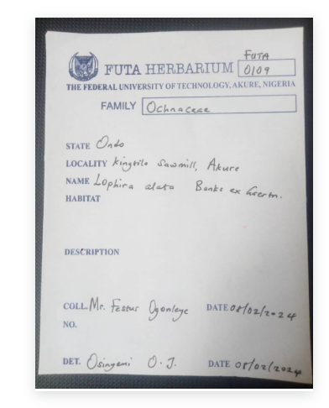
Fig. S1:Herbarium Details

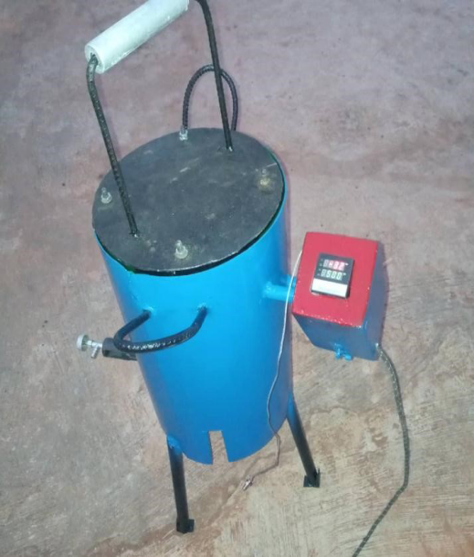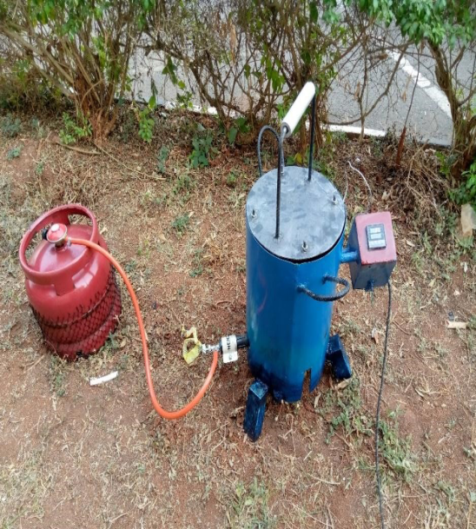
Fig 1(a): Laboratory scale torrefier Fig 1(b): Set-up of the lab-scale Torrefier

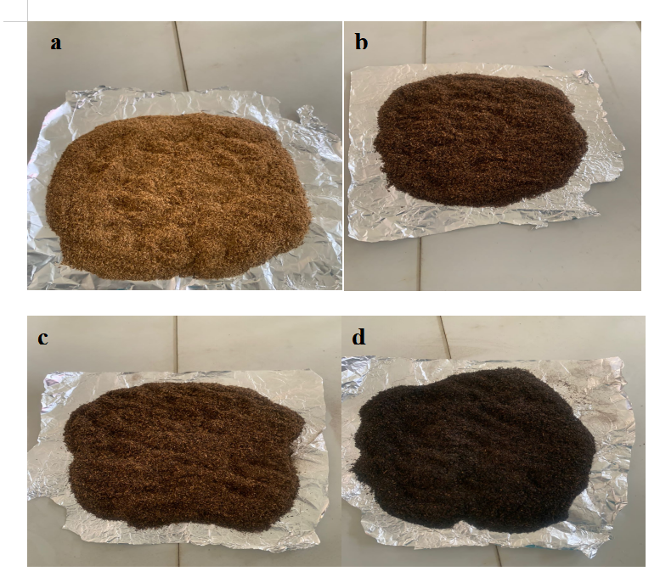

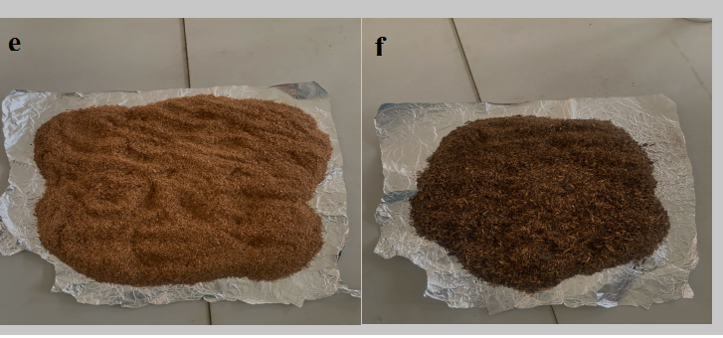

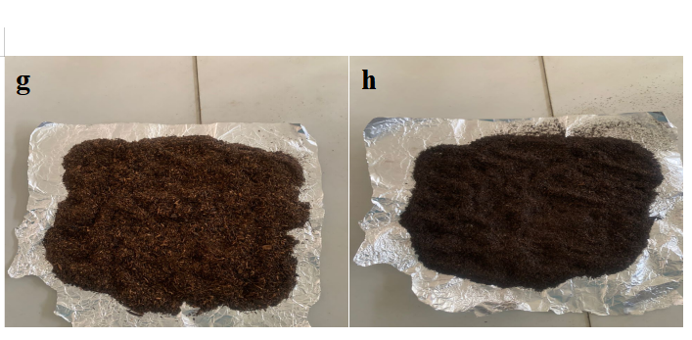

Fig. 1.1: Pictures of: (a) Raw Iron Wood Dust, (b) Torrefied Iron Wood Dust at 200 ℃, (c) Torrefied Iron Wood Dust at 250 ℃ (d) Torrefied Iron Wood Dust at 300 ℃ (e) Hydrolysed Iron Wood Dust(f) HydrolysedTorrefied Iron Wood Dust at 200 ℃ (g) Hydrolysed Torrefied Iron Wood Dust at 250 ℃ (h) Hydrolysed Torrefied Iron Wood Dust at 283 ℃.
Table 1: Proximate Composition of the raw, torrecfied, hydrolyzed and hydrolyzed torrified wood dust ofLophira alata
Sample | Moisture (%) | Volatile matter (%) | Ash (%) | Fixed carbon (%)
RIWD | 13.28 | 1.57 | 1.06 | 80.09
TIWD 200^{O}C | 6.60 | 2.45 | 2.29 | 88.66
TIWD 250^{O}C | 5.77 | 7.38 | 2.89 | 83.96
TIWD 300^{O}C | 6.82 | 20.69 | 5.70 | 82.79
HIWD | 15.16 | 0.44 | 0.60 | 83.80
HTIWD 200^{O}C | 7.04 | 1.93 | 0.41 | 90.62
HTIWD 250^{O}C | 4.81 | 4.79 | 0.10 | 90.30
HTIWD 283 ^{O}C | 3.89 | 3.44 | 1.01 | 91.66
Key: RIWD means Raw Iron Wood Dust
TIWD 200 ^{O}C, 250 ^{O}C, 300 ^{O}C means Torrefied Iron Wood Dust at 200 ^{O}C, 250 ^{O}C, 300 ^{O}C
HIWD means Hydrolysed Iron Wood Dust
HTIWD 200 ^{O}C, 250 ^{O}C, 283 ^{O}C means Hydrolysed Torrefied Iron Wood Dust at 200 ^{O}C, 250 ^{O}C, 283 ^{O}C
Table 2: Fibre Composition of Untorrefied, Torrefied and Hydrolysed Wood Dust Sample
Sample | Hemicellulose% | Lignin% | Cellulose% | Extractive%
RIWD | 11.71 | 15.43 | 65.58 | 7.28
RTIWD 300 ^{O}C | 7.60 | 29.73 | 60.67 | 2.07
HTIWD 283 ^{O}C | 3.58 | 35.33 | 59.10 | 1.99
Where RIWD means Raw Iron Wood Dust
RTIWD 300 ^{O}C means Raw Torrefied Iron Wood Dust at 300 ^{O}C
HTIWD 283 ^{O}C means Hydrolysed-torrefied Iron Wood Dust at 283 ^{O}C
Table 3: The High Heating Value (Energy Value) of the Raw (Untorrefied), Torrefied, Hydrolysed and Hydrolysed-torrefied Wood Dust of Lophira alata

Sample | Energy (MJ/Kg)
RIWD | 17.315
TIWD 200 | 18.740
TIWD 250 | 19.776
TIWD 300 | 19.921
HIWD | 16.390
HTIWD 200 | 18.497
HTIWD 250 | 19.508
HTIWD 283 | 22.721
Table 4: The Effect Variation in Temperature on the Energy Value of Hydrolysed-torrefied Lophira alata
Sample | Energy  MJ/Kg
HIWD | 16.390
HTIWD 200 | 18.497
HTIWD 250 | 19.508
HTIWD 283 | 22.721
Table 5: Ultimate result of raw, torrefied, hydrolyzed and hydrolyzed-torrefied wood dust biomass
Sample | %C | %S | %H | %N | %O H/C O/C
RIWD | 55.83 | 0.00 | 2.45 | 0.149 | 21.58 0.043 0.386
TIWD 300^{O}C | 75.36 | 1.36 | 0.32 | 0.380 | 4.53 0.004 0.060
HIWD | 56.07 | 0.00 | 6.09 | 0.412 | 32.78 0.109 0.585
HTIWD 283^{O}C | 81.31 | 1.92 | 0.31 | 0.137 | 8.20 0.003 0.100
Key: Where RIWD means Raw Iron Wood Dust, TIWD 300 ^{O}C means Torrefied Iron Wood Dust at 300 ^{O}C, HIWD means Hydrolysed Iron Wood Dust, HTIWD 283 ^{O}C means Hydrolysed-torrefied Iron Wood Dust 283 ^{O}C.
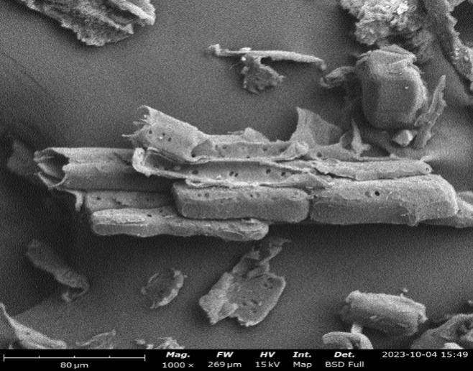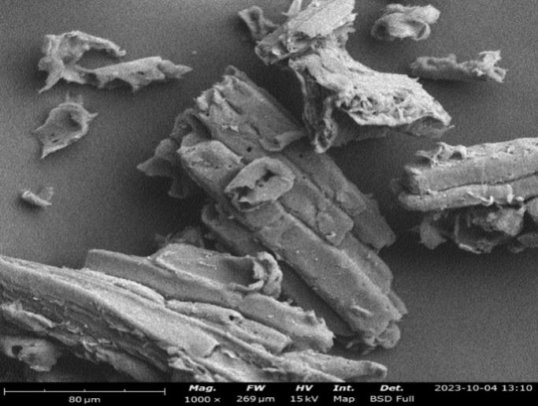
b
a
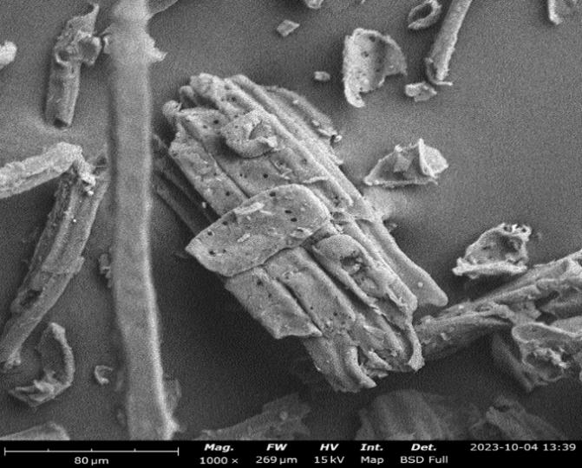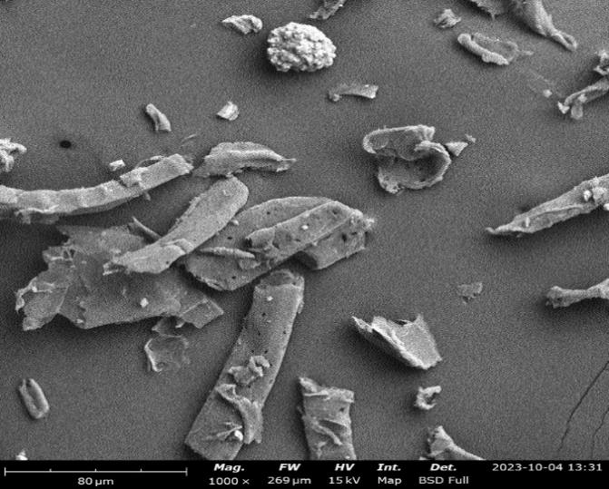
d
c
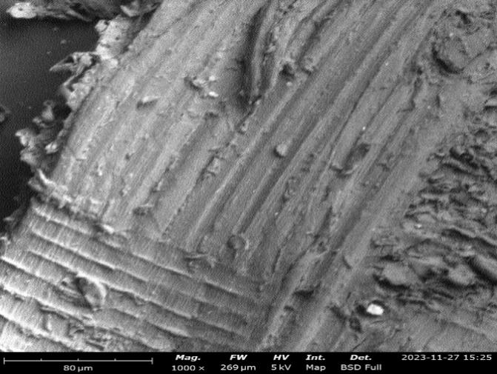
e
Figure 2: Surface morphologies of (a) Untorrefied Wood Dust Biomass of Lophira alata, (b) Torrefied Wood Dust Biomass at 200℃, (c) Torrefied Wood Dust Biomass at 250℃, (d) Torrefied Wood Dust Biomass at 300℃, (e) Hydrolysed-Torrefied Wood Dust Biomass at 283 ℃

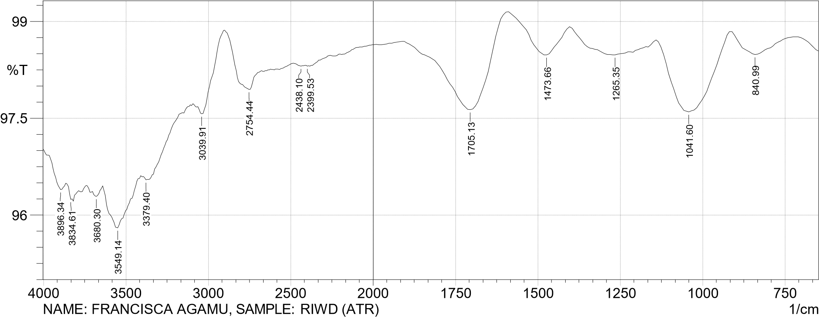
Figure 3: The FTIR Spectra of untorrefied (raw) wood dust sample sourced from Lophira alata (LA)

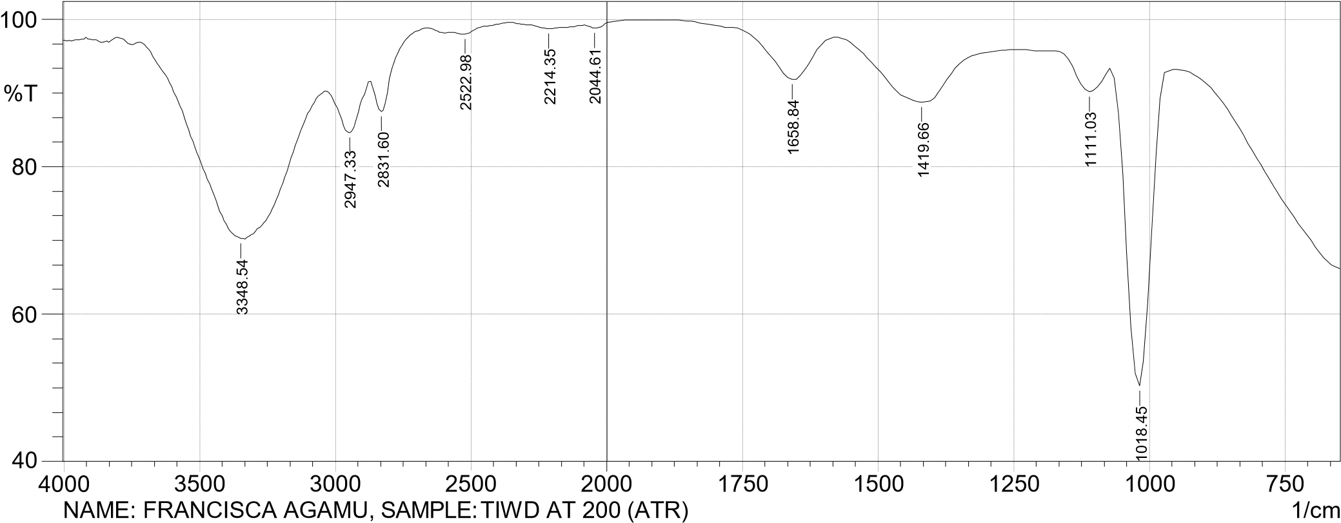
Figure 4: The FTIR Spectra of torrefied at 200 ℃ wood dust sample sourced from Lophira alata (LA)

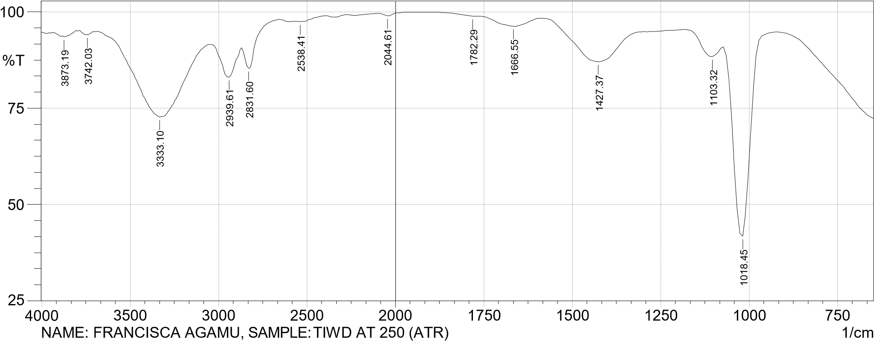
Figure 5: The FTIR Spectra of torrefied at 250 ℃ wood dust sample sourced from Lophira alata (LA)

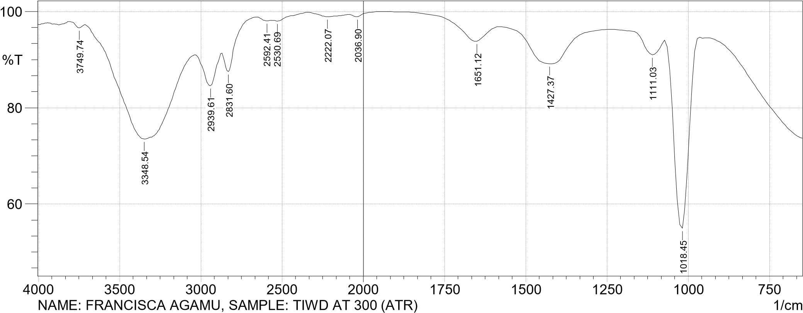
Figure 6: The FTIR Spectra of torrefied at 300 ℃ wood dust sample sourced from Lophira alata (LA)

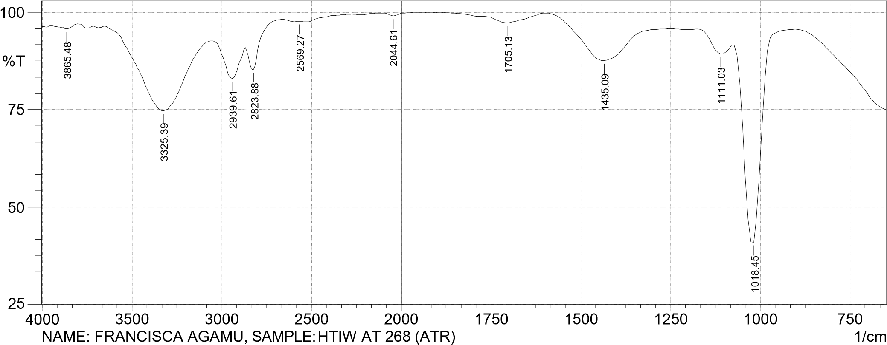

Figure 7: The FTIR Spectra of hydrolysed-torrefied wood dust sample sourced from Lophira alata (LA)

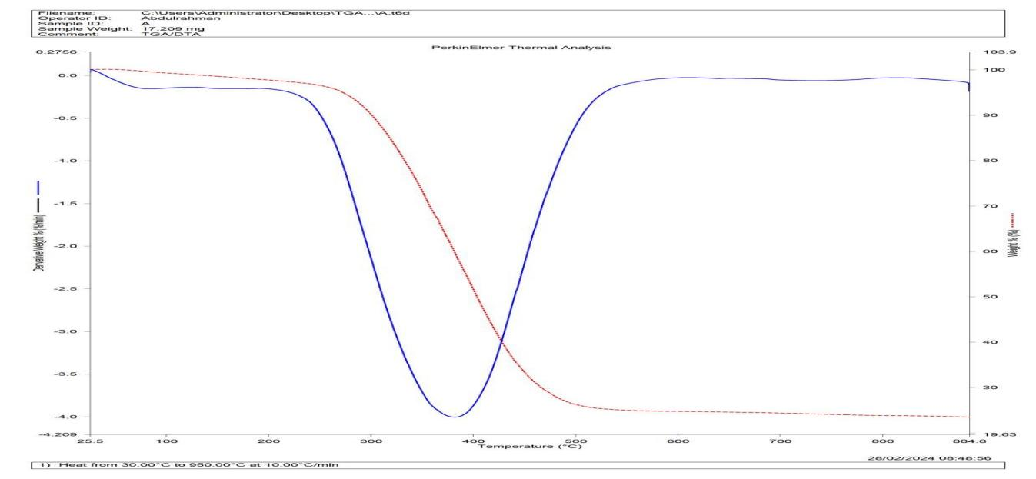
Figure 8: The Thermogram of Untorrefied Wood Dust Sample of Lophira alata tree

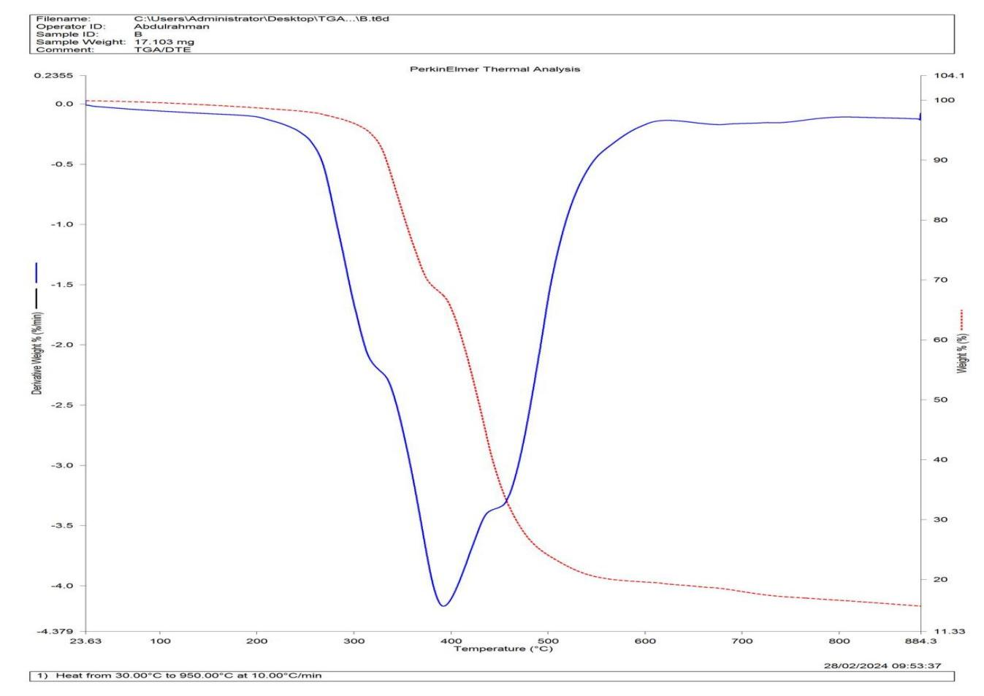
Figure 9: The Thermogram of Torrefied Wood Dust Sample at 300 ℃ of Lophira alata tree
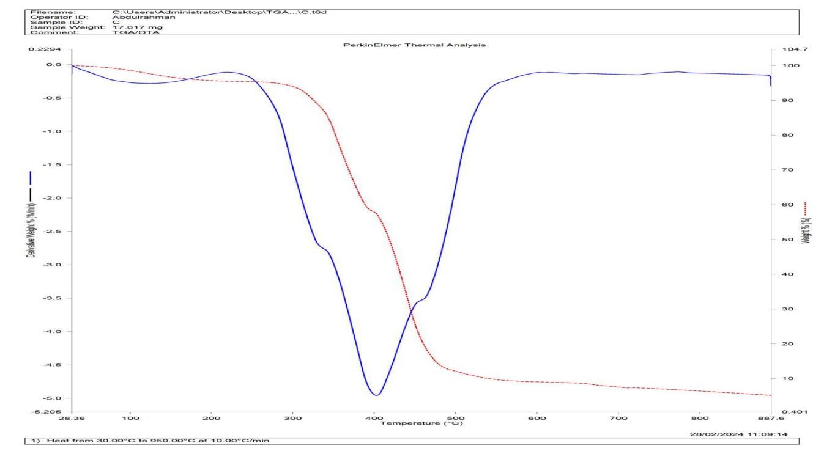
Figure 10: The Thermogram of Hydrolysed-torrefied Wood Dust Sample at 300 ℃ of Lophira alata tree

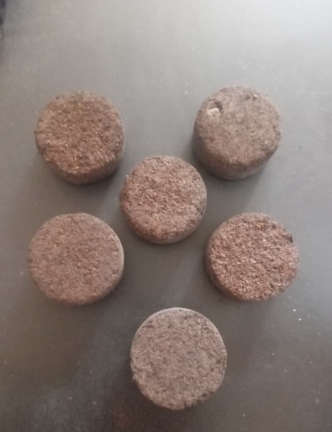
TORRIFIED-DENSIFIED WOOD DUST

