Graphical abstract


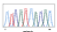

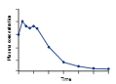


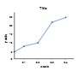


Isolated bacterial endophyte
Molecular Identification
(16S rDNA)
Molecular and functional characterization of plant growth-promoting bacterial endophytes from Curcuma longa rhizomes for microbiome-based agricultural solutions
Functional
characterization
Identified endophytes: Pseudomonas putida; Priestia megaterium; Brevundimonas bullata; Leucobacter aridicollis and Pseudomonas syringae
Stress tolerance: acidity, salinity and Aluminum
Plant growth promoting: ACC, IAA, NH3
Enzyme production: catalase, cellulase, protease, gelatinase, amylase.
Phosphate solubilization
Biostimulating activities: Arginine and ornithine decarboxylase
Native microbiome-based agricultural solutions
(Excluded: Pathogenic strain)

