Supplement
Title: Response of ground beetle diversity to the habitat structural heterogeneity of different clearing types in boreal pine forests
Journal: Environmental Management
Corresponding author:
Gennadi Sushko. e-mail: gennadisu@tut.by, phone +375 33 380 44 42, University P.M. Masherov, Moscovski Ave. 33, 21005 Vitebsk, Belarus
Authors:
Anatoly Lakotko, Anastasia Tkachenok; University P.M. Masherov, Moscovski Ave. 33, 21005 Vitebsk, Belarus

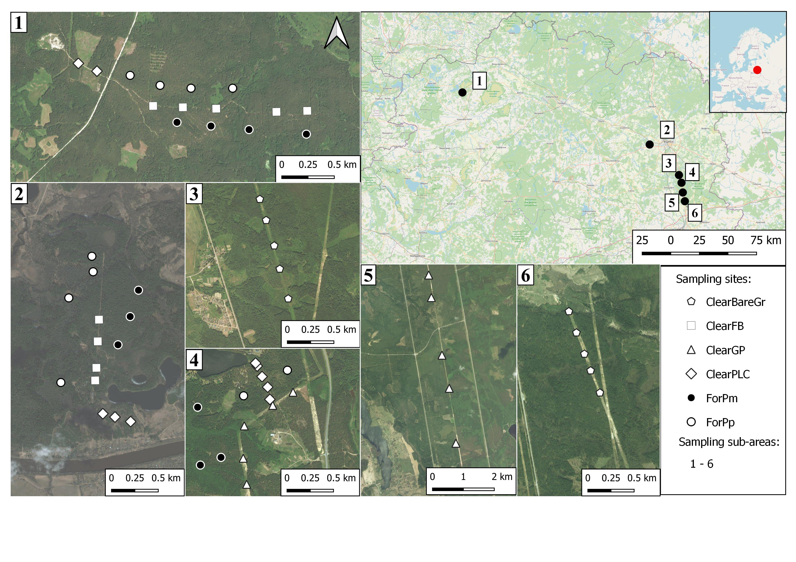
Fig. S1 Location of the study area, sub-areas, and study sites: natural gas pipeline clearings with bare soil (ClearBareGr), natural gas pipeline clearings covered by herbs (ClearGP), firebreaks (ClearFB), power-line corridors (ClearPLC), control pine forests (Pinetum pleurozium, ForPp), control pine forests (Pinetum myrtillosum, ForPm).

(a)
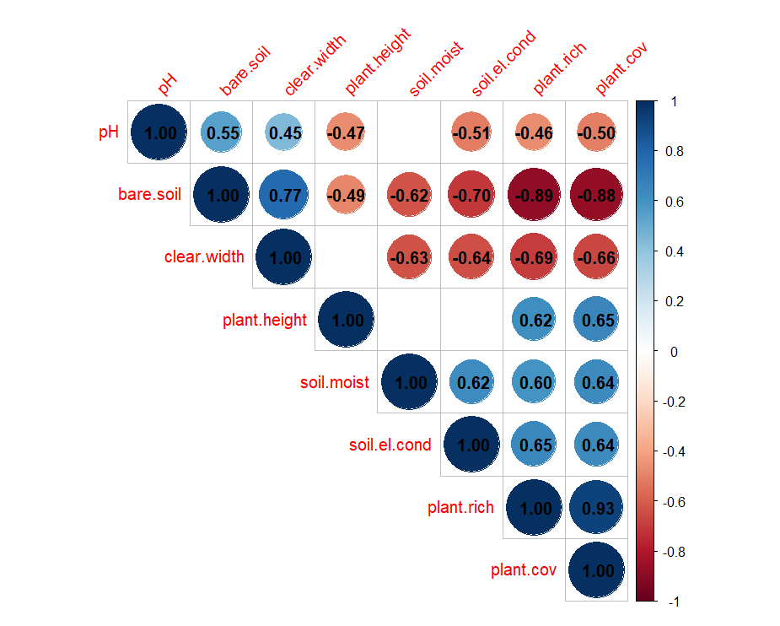
(b)
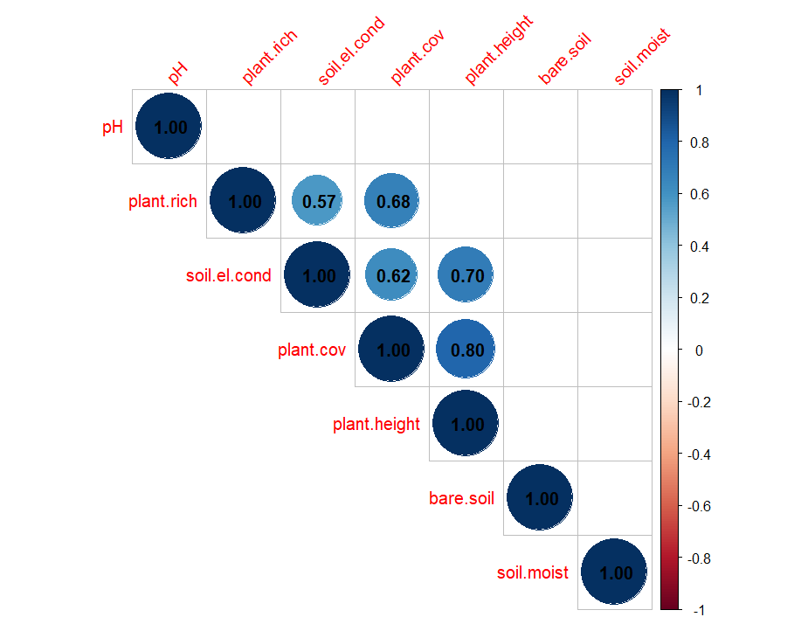

Fig. S2 The results of the correlation analysis (Spearman rank-correlation, a correlation coefficient threshold was set at 0.6) of the variables measured in clearings (a) and control pine forests (b). The analyzed environmental variables include: soil moisture (soil.moist), soil electrical conductivity (salinity) (soil.el.cond), soil pH (рН), bare soil proportion (bare.soil), clearing width (clear.width), total vascular plant cover (plant.cov), plant height (plant.height), plant richness (plant.rich).

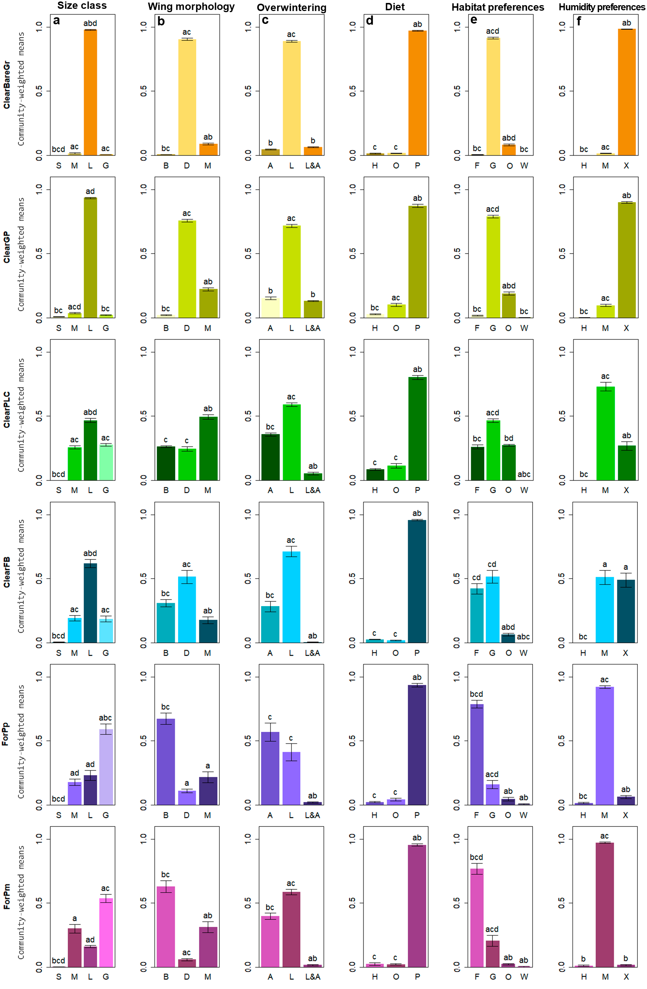
Fig. S3 Differences in community weighted mean values of species traits (mean ±standard error) in ground beetle assemblages of clearings and control forests: a) body size class (species with body lengths > 15 mm are abbreviated as (G), ranging from 10.1 to 15 mm as (L), ranging from 6 to 10 mm as (M), shorter than 6 mm (S)); b) wing morphology (brachypterous species are abbreviated as (B), macropterous as (M) and dimorphic as (D)); c) overwintering stage (species overwintering as imago are abbreviated as (A), as larva as (L), as imago and larva as (L&A); d) diet (predator species are abbreviated as (P), omnivorous as (O) and herbivorous as (H)); e) habitat preferences (forest species are abbreviated as (F), generalists as (G), open-habitat species as (O) and wetland species as (W); f) humidity preferences (hygrophilous species are abbreviated as (H), xerophilous as (H) and mesophilous as (M)). Different letters indicate statistically significant differences among estimated means within each trait category (Kruskal–Wallis test with Dunn’s post hoc test, least significant difference post hoc test, p<0.05). Abbreviations of studied habitats: natural gas pipeline clearings with bare soil (ClearBareGr), natural gas pipeline clearings covered by herbs (ClearGP), firebreaks (ClearFB), power-line corridors (ClearPLC), control pine forests (Pinetum pleurozium, ForPp), control pine forests (Pinetum myrtillosum, ForPm).

Table S1 Ground beetle species trait characteristics used to assess of functional diversity of studied clearings and control pine forests
Trait | Trait category | Ecological meaning | Abbreviation
Diet
Predator species | Typical zoophagous known for generalist predation on various invertebrates | Feeding preferences determine the structure and complexity of ecological networks, nutritional niche differentiation and functional responses on habitat conditions; species having similar habitat use can be separated in their feeding strategies | P
Omnivorous species | Zoophagous carabids that supplement their diet with the seeds of herbaceous plants |  | O
Herbivorous species | Phytophagous carabids that feed on the seeds of herbaceous plants |  | H
Wing development

Macropterous species | Species with fully developed hind wings, which predominantly flight active. | Wing development linked to dispersal capacity and recolonization potential | M
Brachypterous species | Flightless species with reduced or absent hind wings. |  | B
Wing-dimorphic species | Population of such species contain specimens with long and short wings. |  | D
Body size
Largest-sized species | Species with body lengths > 15 mm | Body size correlates with species physiology and metabolism intensity in different environmental conditions | G
Large-sized species | Species with body lengths ranging from 10.1 to 15 mm |  | L
Medium-sized species | Species with body lengths ranging from 6 to 10 mm |  | M
Small-sized species | Species with body lengths shorter than 6 mm |  | S
Larval instar period
Species with larval period in summer | Spring breeder or species that breed in the first part of the summer season | The larval stage is more vulnerable and is more susceptible to the fluctuations of environmental factors during overwintering compared to the imago | L
Species with larval period in winter | Autumn breeder or species that breed at the end of the summer season |  | A
Species that overwintering as both larvae and adults | Species whose larval instar lasts longer than 12 months |  | L&A
Moisture preference

Hygrophilous species | Species occurring in humid habitat conditions | Moisture preference is indicator of one of the main environmental characteristics and reflects the current habitat soil humidity state | H
Xerophilous species | Species occurring in dry habitat conditions |  | X
Mesophilous species | Species occurring in intermediate humidity conditions |  | M
Habitat preference
Forest species | Species occurring in many forest types | The higher degree of habitat specialization represents a wide niche | F
Generalist species | Species occurring in a wide range of habitats |  | G
Open-habitat species | Species occurring in meadows, pastures and crops |  | O

Table S2 Mean values (±standard error) of environmental variables recorded in the clearings and control pine forests. Significant differences (Kruskal–Wallis test): ***p< 0.001, ** p< 0.01, * p< 0.05. Pairwise comparisons were conducted using the post hoc tests (Dunn’s tests) and different superscript letters indicate significant differences between groups at p< 0.05.
Environmental  variable | Natural gas pipeline clearings (bare soil) ª | Natural gas pipeline clearings (cowered by herbs) ^{b} | Firebreaks ^{c} | Power-line  corridors ^{d} | Control pine forests (Pinetum pleurozium) ^{e} | Control pine forests (Pinetum myrtillosum) ^{f}
Plant richness | 1.00±0.26^{bcd} | 3.70±0.21^{ae} | 5.70±0.65^{aef} | 6.40±0.52^{aef} | 1.50±0.17^{bcd} | 2.40±0.27^{cd}
Total vascular plant cover (%) | 2.10±0.82^{bcdef} | 36.90±2.96^{acdef} | 61.00±9.93^{abe} | 65.10±6.15^{abe} | 5.40±1.33^{abcdf} | 60.50±5.35^{abe}
Plant height, cm | 3.10±0.90^{bcdef} | 43.20±4.69^{aef} | 39.80±3.83 ^{aef} | 44.60±2.97 ^{aef} | 7.40±1.03^{abcdf} | 32.10±1.61 ^{abcde}
Bare soil proportion (%) | 97.80±0.80 ^{bcdef} | 63.10±2.96 ^{acdef} | 31.60±11.25^{abef} | 34.50±6.18 ^{abef} | 1.10±0.38 ^{abcd} | 0.80±0.33^{abcd}
Soil рН | 5.18±0.02 ^{cdef} | 5.11±0.02e | 4.77±0.07^{ae} | 4.91±0.09^{ae} | 4.41±0.24^{abcd} | 4.74±0.29ª
Soil electrical conductivity (salinity) (µS/cm) | 7.30±0.37^{cdef} | 7.90±0.50^{cdef} | 12.20±0.44^{abf} | 11.20±0.57^{abf} | 12.60±0.58^{abf} | 14.00±0.88^{abcde}
Soil moisture (%) | 5.66±0.29^{bcdef} | 4.97±0.46^{bcdef} | 14.09±0.99^{abd} | 9.30±1.02^{adc} | 10.12±0.72^{ad} | 9.95±0.68^{ab}
Clearing width (m) | 33.60±1.02^{cd} | 34.70±0.87^{cd} | 24.90±0.82^{ab} | 25.23±0.66^{ab}

Table S3 Criterion AIC_{C} results for effect of measured environmental parameters on carabid abundance, species and functional richness, species and functional diversity in clearings and control pine forests. The analyzed environmental variables include: soil moisture (soil.moist), soil electrical conductivity (salinity) (soil.el.cond), soil pH (рН), bare soil proportion (bare.soil), clearing width (clear.width), total vascular plant cover (plant.cov), plant height (plant.height), plant richness (plant.rich). ∆ AIC_{C} are the AIC_{C} differences, wi is the Akaike weight support for each model. The most parsimonious (∆AIC_{C}<3) models are displayed.
Explanatory variables included in model | AICc | △AICc | wi
Clearings
Species richness | 209.9 | 0.00 | 0.15
plant.height | 211.0 | 1.13 | 0.08
bare.soil+ plant.height+ soil.el.cond | 211.1 | 1.24 | 0.08
plant.height+ soil.el.cond | 211.6 | 1.76 | 0.06
bare.soil+ plant.height | 212.0 | 2.09 | 0.05
pH+ plant.height | 212.1 | 2.19 | 0.04
plant.height+ soil.moist | 212.2 | 2.34 | 0.04
clear.width+ plant.height | 212.7 | 2.81 | 0.03
Abundance
pH+ plant.height | 409.3 | 0.00 | 0.14
clear.width+ pH+ plant.height | 410.1 | 0.84 | 0.09
pH+ plant.height+ soil.el.cond | 410.6 | 1.32 | 0.07
clear.width+ pH+plant.height+ soil.el.cond | 411.0 | 1.69 | 0.05
clear.width+ plant.height | 411.1 | 1.83 | 0.04
bare.soil+ clear.width+ plant.height | 411.5 | 2.26 | 0.04
clear.width+ plant.height+ soil.el.cond | 411.6 | 2.32 | 0.03
Diversity (Shannon index)
plant.height+ soil.el.cond | 12.5 | 0.00 | 0.10
clear.width+plant.height+soil.el.cond | 12.7 | 0.20 | 0.09
clear.width+plant.height | 13.1 | 0.55 | 0.08
plant.height | 13.8 | 1.24 | 0.05
clear.width+soil.el.cond | 14.3 | 1.27 | 0.04
soil.el.cond | 14.5 | 1.94 | 0.04
Functional richness (FRic index)
bare.soil+ soil.el.cond | 49.5 | 0.00 | 0.14
clear.width+soil.el.cond | 48.0 | 1.45 | 0.06
bare.soil+ soil.el.cond+ soil.moist | 47.3 | 2.17 | 0.04
bare.soil+ clear.width+soil.el.cond | 47.2 | 2.21 | 0.04
soil.el.cond+ soil.moist | 47.0 | 2.29 | 0.04
bare.soil+ plant.height+soil.el.cond | 46.5 | 2.52 | 0.03
Functional diversity (RaoQ index)
soil.moist | 189.2 | 0.00 | 0.15
soil.el.cond+soil.moist | 188.6 | 0.66 | 0.10
plant.height+ soil.moist | 187.2 | 2.04 | 0.05
soil.el.cond | 186.8 | 2.39 | 0.04
bare.soil+soil.moist | 186.8 | 2.43 | 0.04
clear.width | 186.7 | 2.44 | 0.04
Control forests
Species richness
plant.height+plant.cov | 106.8 | 0.00 | 0.14
plant.height+ soil.moist+plant.cov | 107.3 | 0.49 | 0.11
plant.height+ soil.el.cond+plant.cov | 108.0 | 1.21 | 0.07
plant.height+plant.rich+plant.cov | 109.3 | 2.23 | 0.04
pH+plant.height+plant.cov | 109.1 | 2.59 | 0.04
bare.soil+plant.height+plant.cov | 110.0 | 3.13 | 0.03
Abundance
pH+ soil.el.cond | 199.4 | 0.00 | 0.43
pH+soil.moist | 202.6 | 3.17 | 0.08
pH+ plant.height+ soil.el.cond | 202.8 | 3.40 | 0.07
pH+soil.el.cond+soil.moist | 203.0 | 3.56 | 0.07
bare.soil+pH+soil.el.cond | 203.5 | 4.14 | 0.05
plant.height+soil.moist | 203.8 | 4.40 | 0.04
soil.moist | 203.9 | 4.48 | 0.04
Diversity (Shannon index)
pH | 17.6 | 0.00 | 0.17
plant.height | 17.8 | 0.22 | 0.15
bare.soil+pH | 18.7 | 1.16 | 0.09
bare.soil | 19.2 | 1.65 | 0.07
soil.el.cond | 19.3 | 1.73 | 0.07
pH+plant.height | 19.5 | 1.90 | 0.06
Functional richness (FRic index)
bare.soil+ soil.el.cond | 49.5 | 0.00 | 0.14
clear.width+soil.el.cond | 48.0 | 0.22 | 0.06
bare.soil+ soil.el.cond+ soil.moist | 47.3 | 1.16 | 0.04
bare.soil+ clear.width+soil.el.cond | 47.2 | 1.65 | 0.04
soil.el.cond+ soil.moist | 47.0 | 1.73 | 0.04
bare.soil+ plant.height+soil.el.cond | 46.5 | 1.90 | 0.03
Functional diversity (RaoQ index)
pH | 35.5 | 0.00 | 0.17
pH+plant.cov | 34.3 | 1.19 | 0.09
pH + soil.moist | 33.9 | 1.56 | 0.08
pH+ soil.el.cond+plant.cov | 33.7 | 1.82 | 0.07
bare.soil+pH | 33.5 | 1.97 | 0.06
plant.rich | 32.7 | 2.67 | 0.04

Table S4 List of sampled carabid beetle species with the relative abundance (%) of individuals and their species trait characteristics recorded in clearings and control pine forests: natural gas pipeline clearings with bare soil (ClearBareGr), natural gas pipeline clearings covered by herbs (ClearGP), firebreaks (ClearFB), power-line corridors (ClearPLC), control pine forests (Pinetum pleurozium, ForPp), control pine forests (Pinetum myrtillosum, ForPm).
Species |  |  | Habitat |  |  |  |  |  |  |  |  |  | Species trait
Species | ClearBareGr | ClearGP | ClearFB | ClearPLC | ForPp | ForPm |  |  | Size klass |  | Wing morphology |  | Hibernation stage |  | Diet |  | Habitat preference |  | Humidity preference
Cicindela campestris Linnaeus, 1758 | 0.00 | 7.06 | 0.00 | 0.00 | 0.00 | 0.00 |  | L |  | M |  | L&A |  | P |  | O |  | X
Cicindela hybrida Linnaeus, 1758 | 5.87 | 0.30 | 0.00 | 0.00 | 0.00 | 0.00 |  | L |  | M |  | L&A |  | P |  | O |  | X
Leistus ferrugineus (Linnaeus, 1758) | 0.06 | 0.12 | 3.37 | 0.00 | 1.28 | 0.11 |  | M |  | B |  | L |  | P |  | F |  | M
Nebria brevicollis (Fabricius, 1792) | 0.00 | 0.00 | 0.00 | 0.15 | 0.00 | 0.00 |  | L |  | M |  | L |  | P |  | G |  | M
Notiophilus palustris (Duftschmid, 1812) | 0.00 | 0.00 | 0.31 | 0.23 | 0.16 | 0.43 |  | 2 |  | D |  | A |  | P |  | F |  | M
Carabus coriaceus Linnaeus, 1758 | 0.03 | 0.00 | 0.00 | 0.00 | 1.12 | 0.53 |  | G |  | B |  | L |  | P |  | F |  | M
Carabus violaceus Linnaeus, 1758 . | 0.00 | 0.00 | 0.00 | 0.00 | 3.83 | 0.75 |  | G |  | B |  | L |  | P |  | F |  | M
Carabus convexus Fabricius, 1775 | 0.00 | 0.00 | 0.92 | 0.23 | 0.32 | 0.21 |  | G |  | B |  | L |  | P |  | F |  | X
Carabus hortensis Linnaeus, 1758 . | 0.12 | 0.30 | 0.92 | 2.08 | 8.13 | 6.52 |  | G |  | B |  | L |  | P |  | F |  | M
Carabus granulatus Linnaeus, 1758 | 0.00 | 0.00 | 0.00 | 0.00 | 0.48 | 0.32 |  | G |  | B |  | A |  | P |  | G |  | H
Carabus glabratus Paykull, 1790 | 0.00 | 0.00 | 1.84 | 1.00 | 0.96 | 1.07 |  | G |  | B |  | L |  | P |  | F |  | M
Carabus cancellatus Illiger, 1798 | 0.00 | 0.00 | 0.92 | 0.00 | 1.44 | 0.32 |  | G |  | B |  | A |  | P |  | G |  | M
Carabus arvensis Herbst, 1784 | 0.19 | 1.34 | 3.99 | 11.08 | 33.01 | 19.87 |  | G |  | B |  | A |  | P |  | F |  | M
Carabus nemoralis O.F. Müller, 1764 | 0.00 | 0.00 | 0.00 | 0.00 | 0.64 | 0.00 |  | G |  | B |  | A |  | O |  | G |  | M
Cychris caraboides (Linnaeus, 1758) | 0.00 | 0.00 | 0.61 | 0.69 | 0.48 | 5.98 |  | G |  | B |  | L |  | P |  | F |  | M
Broscus cephalotes (Linnaeus, 1758) | 0.15 | 0.24 | 3.07 | 0.00 | 0.00 | 0.00 |  | G |  | B |  | L |  | P |  | O |  | X
Epaphius secalis (Paykull, 1790) | 0.00 | 0.00 | 0.00 | 0.23 | 0.00 | 0.11 |  | S |  | B |  | L&A |  | P |  | G |  | M
Bembidion pygmaeum (Fabricius, 1792) | 0.00 | 0.67 | 0.00 | 0.00 | 0.00 | 0.00 |  | S |  | B |  | A |  | P |  | O |  | M
Poecilus cupreus (Linnaeus, 1758) | 0.00 | 0.43 | 4.60 | 0.15 | 2.39 | 0.11 |  | L |  | B |  | A |  | O |  | G |  | M
Poecilus lepidus Leske, 1785 | 2.07 | 4.57 | 0.00 | 0.46 | 0.96 | 0.53 |  | L |  | B |  | A |  | P |  | G |  | X
Poecilus versicolor (Sturm, 1824) | 0.37 | 1.77 | 13.19 | 4.31 | 2.39 | 1.71 |  | L |  | B |  | A |  | P |  | O |  | M
Pterostichus oblongopunctatus (Fabricius, 1787) | 0.00 | 0.00 | 2.45 | 6.46 | 11.16 | 9.19 |  | L |  | B |  | A |  | P |  | F |  | M
Pterostichus niger (Schaller, 1783) | 0.15 | 0.24 | 14.11 | 2.46 | 5.58 | 20.62 |  | G |  | B |  | L |  | P |  | G |  | M
Pterostichus melanarius (Illiger, 1798) | 0.00 | 0.00 | 0.92 | 0.08 | 1.28 | 0.43 |  | G |  | B |  | L&A |  | P |  | G |  | M
Pterostichus nigrita (Paykull, 1790) | 0.00 | 0.30 | 0.00 | 0.00 | 0.64 | 0.32 |  | L |  | B |  | A |  | P |  | W |  | H
Pterostichus strenuus (Panzer, 1796) | 0.00 | 0.00 | 0.00 | 0.00 | 0.16 | 0.43 |  | M |  | B |  | A |  | O |  | G |  | H
Pterostichus aethiops (Panzer, 1796) | 0.00 | 0.00 | 0.00 | 1.46 | 2.39 | 2.56 |  | L |  | B |  | A |  | P |  | F |  | M
Calathus erratus (Sahlberg, 1827) | 87.76 | 70.52 | 22.39 | 50.31 | 4.78 | 0.64 |  | L |  | B |  | L |  | P |  | G |  | X
Calathus melanocephalus (Linnaeus, 1758) | 0.12 | 0.00 | 0.00 | 0.23 | 0.32 | 0.11 |  | M |  | B |  | L |  | O |  | O |  | M
Calathus micropterus (Duftschmid, 1812) | 0.09 | 0.00 | 10.43 | 15.00 | 12.28 | 23.61 |  | M |  | B |  | L |  | P |  | F |  | M
Agonum sexpunctatum (Linnaeus, 1758) | 0.00 | 0.00 | 0.61 | 0.00 | 0.00 | 0.00 |  | M |  | M |  | A |  | P |  | O |  | M
Synuchus vivalis (Illiger, 1798) | 0.00 | 0.43 | 1.84 | 0.85 | 0.32 | 0.32 |  | M |  | D |  | L |  | O |  | O |  | M
Amara plebeja (Gyllenhal, 1810) | 0.00 | 0.43 | 1.23 | 0.00 | 0.32 | 0.00 |  | M |  | M |  | A |  | H |  | O |  | M
Amara aenea (De Geer, 1774) | 0.00 | 0.61 | 0.31 | 0.00 | 0.00 | 0.00 |  | M |  | M |  | A |  | H |  | O |  | X
Amara communis (Panzer, 1797) | 0.00 | 0.79 | 1.23 | 0.00 | 0.00 | 0.00 |  | M |  | M |  | A |  | H |  | O |  | M
Amara eurynota (Panzer, 1797) | 0.00 | 0.00 | 0.00 | 0.00 | 0.16 | 0.00 |  | L |  | M |  | A |  | H |  | O |  | M
Amara similata (Gyllenhal, 1810) | 0.00 | 0.00 | 3.68 | 0.00 | 0.32 | 0.00 |  | M |  | M |  | A |  | H |  | O |  | M
Amara brunnea (Gyllenhal, 1810) | 0.00 | 0.00 | 0.00 | 2.00 | 1.59 | 2.03 |  | M |  | M |  | A |  | H |  | F |  | M
Amara fulva (O.F. Müller, 1776) | 1.55 | 0.79 | 2.15 | 0.31 | 0.00 | 0.00 |  | M |  | M |  | A |  | H |  | O |  | X
Harpalus signaticornis (Duftschmid, 1812) | 0.00 | 0.43 | 0.00 | 0.00 | 0.16 | 0.00 |  | L |  | M |  | L&A |  | O |  | O |  | X
Harpalus rufipes (De Geer, 1774) | 0.49 | 3.11 | 4.60 | 0.00 | 0.32 | 0.53 |  | L |  | M |  | L&A |  | O |  | G |  | M
Harpalus affinis (Schrank, 1781) | 0.00 | 0.24 | 0.00 | 0.00 | 0.00 | 0.00 |  | L |  | M |  | L&A |  | O |  | O |  | X
Harpalus anxius (Duftschmid, 1812) | 0.03 | 0.37 | 0.00 | 0.00 | 0.00 | 0.00 |  | M |  | M |  | L&A |  | O |  | O |  | X
Harpalus autumnalis (Duftschmid, 1812) | 0.09 | 1.28 | 0.00 | 0.00 | 0.00 | 0.00 |  | L |  | M |  | L&A |  | O |  | O |  | X
Harpalus distinquendus (Duftschmid, 1812) | 0.00 | 0.24 | 0.00 | 0.00 | 0.00 | 0.00 |  | L |  | M |  | L&A |  | O |  | O |  | X
Harpalus latus (Linnaeus, 1758) | 0.00 | 0.00 | 0.00 | 0.00 | 0.00 | 0.53 |  | L |  | M |  | L&A |  | O |  | G |  | M
Harpalus laevipes Zetterstedt, 1828 | 0.00 | 0.06 | 0.31 | 0.00 | 0.48 | 0.11 |  | L |  | M |  | A |  | O |  | F |  | M
Harpalus smaragdinus (Duftschmid, 1812) | 0.40 | 0.18 | 0.00 | 0.08 | 0.00 | 0.00 |  | L |  | M |  | A |  | O |  | G |  | X
Harpalus solitaris Dejean, 1829 | 0.34 | 3.11 | 0.00 | 0.00 | 0.00 | 0.00 |  | L |  | M |  | A |  | O |  | O |  | X
Harpalus tardus (Panzer, 1797) | 0.09 | 0.06 | 0.00 | 0.15 | 0.16 | 0.00 |  | L |  | M |  | A |  | O |  | O |  | X
Abbreviations of species traits: body size class – G (body lengths > 15 mm), L (body lengths ranging from 10.1 to 15 mm), M (body lengths ranging from 6 to 10 mm), S (body lengths < 6 mm); b) wing morphology – B (brachypterous), M (macropterous), D (dimorphic); c) overwintering stage – A (species overwintering as imago), L (as larva), L&A (as imago and larva); d) diet – P (predators), O (omnivorous), H (herbivorous); e) habitat preferences – F (forest species, G (generalists), O (open-habitat species), W (wetland species); f) humidity preferences – H (hygrophilous species H), X (xerophilous), M (mesophilous)

Table S5 Overview of the diversity parameters of carabid beetle assemblages of clearings and control pine forests
 | Natural gas pipeline clearings (bare soil) | Natural gas pipeline clearings (cowered by herbs) | Firebreaks | Power-line  corridors | Control pine forests (Pinetum pleurozium) | Control pine forests (Pinetum myrtillosum)
Observed number of species | 19 | 28 | 25 | 23 | 33 | 29
Mean number of species | 10.6±0.88 | 17.7±0.49 | 16.7±0.76 | 14.3±0.57 | 13.4±1.43 | 13.5±1.11
Sample coverage | 0.98 | 0.91 | 0.82 | 0.88 | 0.88 | 0.92
Abundance | 323.7±35.88 | 165±4.33 | 65.2±4.73 | 130.5±10.45 | 63.4±8.83 | 94.2±10.36
Shannon index | 0.55±0.03 | 1.37±0.05 | 2.53±0.04 | 1.76±0.11 | 2.04±0.13 | 2.0±0.07
Pielou evenness index | 0.23±0.01 | 0.46±0.01 | 0.85±0.01 | 0.64±0.03 | 0.76±0.03 | 0.75±0.01
Functional richness index (FRic) | 0.26±0.05 | 0.48±0.04 | 0.53±0.03 | 0.19±0.01 | 0.14±0.03 | 0.13±0.03
Functional diversity index (RaoQ) | 0.15±0.01 | 0.17±0.003 | 0.18±0.003 | 0.15±0.003 | 0.13±0.01 | 0.12±0.005

Table S6 Indicator values (IndVal) of ground beetle species in assemblages of clearings and and controlpine forests
Species | Habitats | IndVal | p
Cicindela hybrida Linnaeus, 1758 | Natural gas pipeline clearings (bare soil) | 0.97 | 0.02
Harpalus smaragdinus (Duftschmid, 1812) | Natural gas pipeline clearings (bare soil) | 0.76 | 0.02
Calathus erratus (Sahlberg, 1827) | Natural gas pipeline clearings (bare soil) | 0.57 | 0.02
Cicindela campestris Linnaeus, 1758 | Natural gas pipeline clearings (cowered by herbs) | 0.99 | 0.03
Bembidion pygmaeum (Fabricius, 1792) | Natural gas pipeline clearings (cowered by herbs) | 0.80 | 0.02
Harpalus solitaries Dejean, 1829 | Natural gas pipeline clearings (cowered by herbs) | 0.74 | 0.03
Amara aenea (De Geer, 1774) | Natural gas pipeline clearings (cowered by herbs) | 0.61 | 0.02
Harpalus autumnalis (Duftschmid, 1812) | Natural gas pipeline clearings (cowered by herbs) | 0.61 | 0.03
Amara similata (Gyllenhal, 1810) | Firebreaks | 0.63 | 0.02
Leistus ferrugineus (Linnaeus, 1758) | Firebreaks | 0.55 | 0.03
Poecilus cupreus (Linnaeus, 1758) | Firebreaks | 0.52 | 0.02
Amara brunnea (Gyllenhal, 1810) | Power-line corridors | 0.57 | 0.02
Pterostichus oblongopunctatus (Fabricius, 1787) | Control pine forests (Pinetum pleurozium) | 0.84 | 0.01
Carabus arvensis Herbst, 1784 | Control pine forests (Pinetum pleurozium) | 0.76 | 0.02
Cychris caraboides (Linnaeus, 1758) | Control pine forests (Pinetum myrtillosum) | 0.64 | 0.02
Calathus micropterus (Duftschmid, 1812) | Control pine forests (Pinetum myrtillosum) | 0.55 | 0.01
Carabus hortensis Linnaeus, 1758 | Control pine forests (Pinetum myrtillosum) | 0.51 | 0.03

