Leaf Microbiome Differences Between Winter (Invasive) and Summer (Non-invasive) Annual Growth forms of Anthemis cotula L.: Insights into Invasiveness

Iqra Bashir and Zafar A Reshi*

Department of Botany

University of Kashmir, Srinagar-190006, Jammu & Kashmir, India

*Corresponding author:zreshi@gmail.com
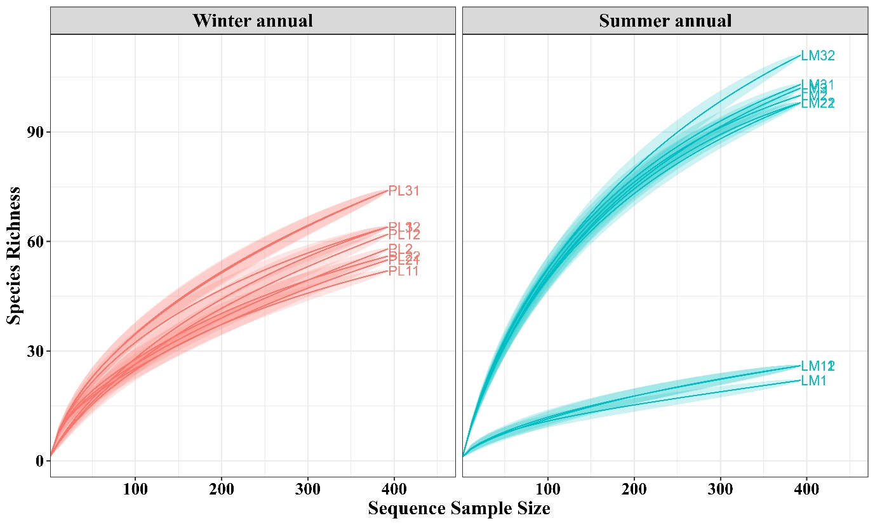

Supplementary Fig. S1. Rarefaction curves showing bacterial species richness as a function of sequence sample size for winter annual (left, red) and summer annual (right, blue) samples. Each curve corresponds to an individual sample; shaded areas indicate confidence intervals.
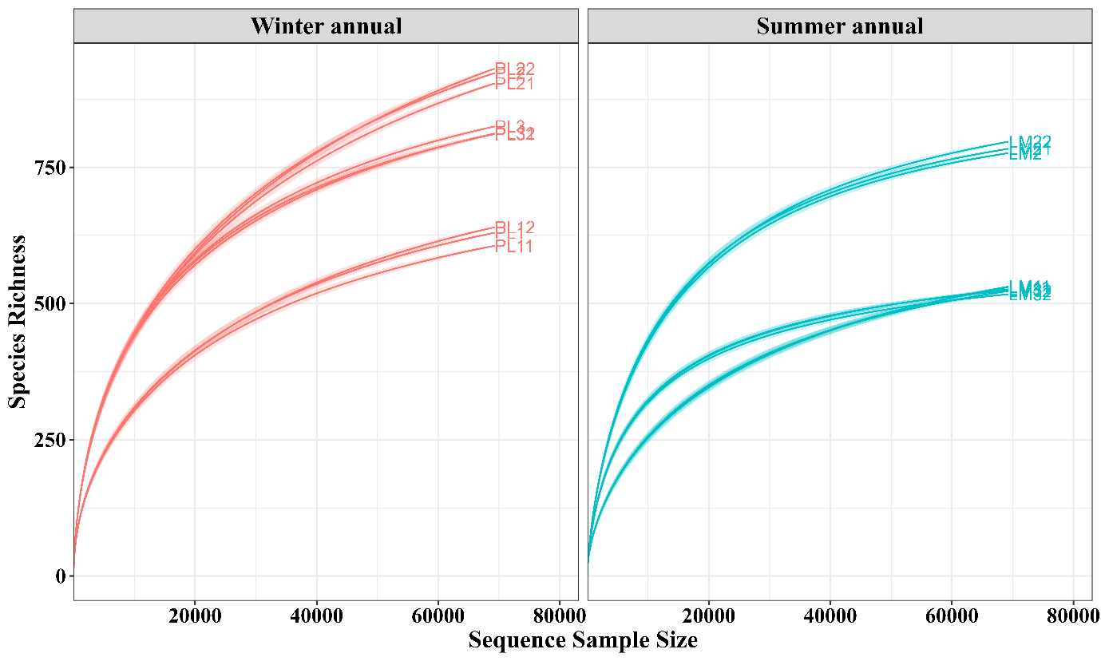
Supplementary Fig. S2. Rarefaction curves showing fungal species richness as a function of sequence sample size for winter annual (left, red) and summer annual (right, blue) samples. Each curve corresponds to an individual sample; shaded areas indicate confidence intervals.
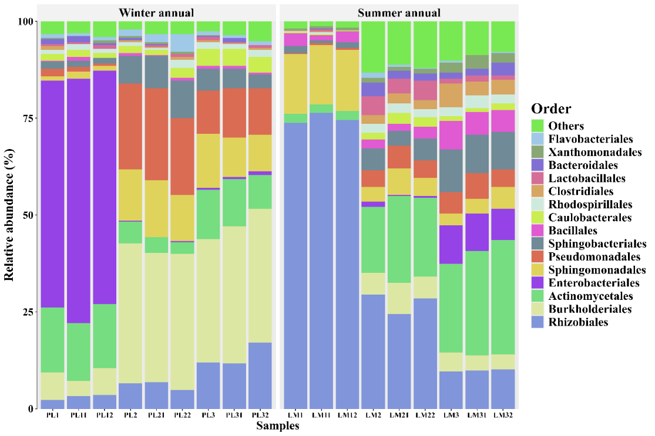

Supplementary Fig. S3. Stacked bar plot displaying the relative abundance of bacterial orders across winter annual and summer annual samples.
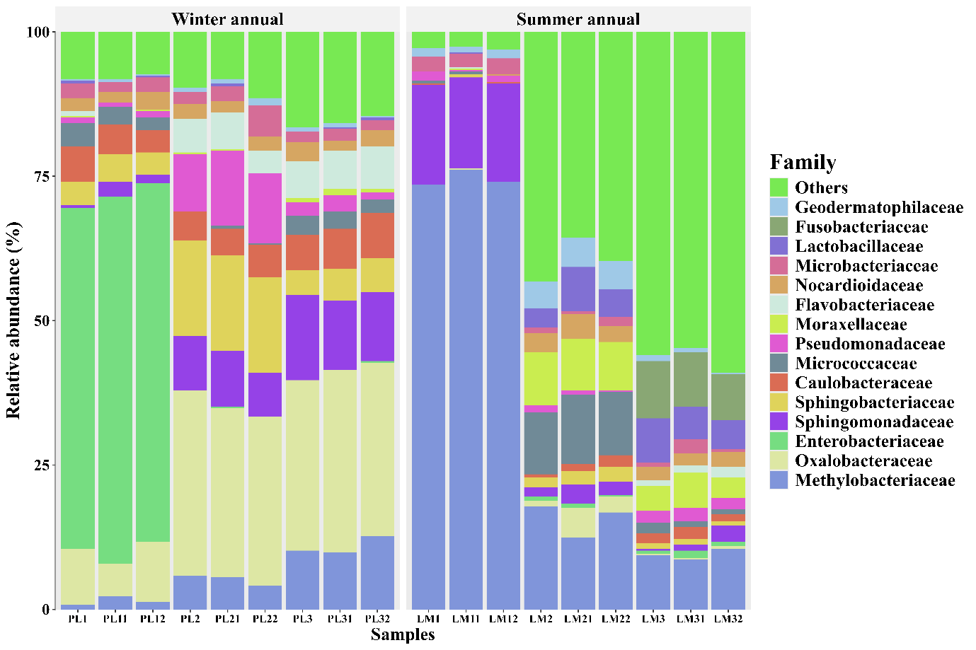
Supplementary Fig. S4. Stacked bar plot displaying the relative abundance of bacterial families across winter annual and summer annual samples.
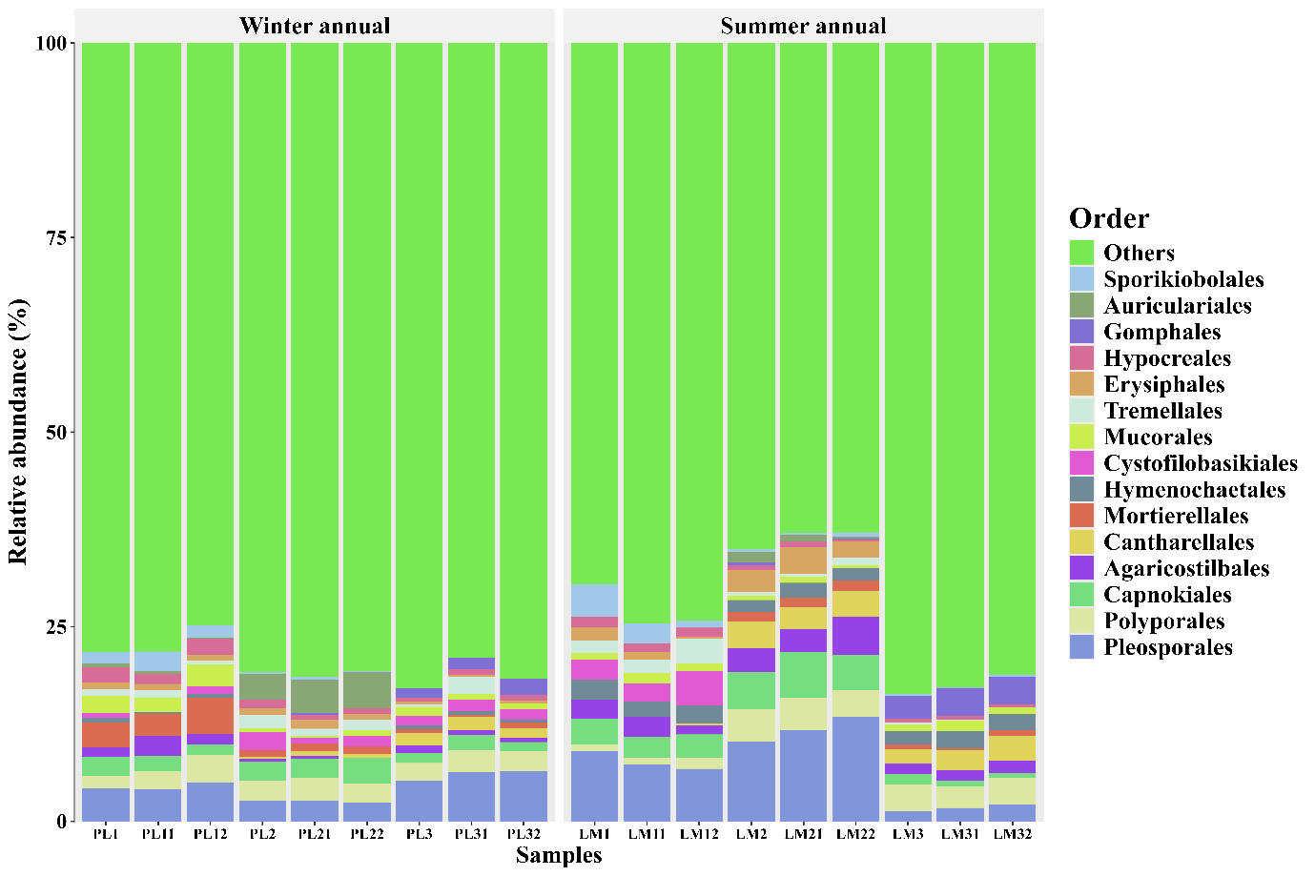

Supplementary Fig. S5. Stacked bar plot displaying the relative abundance of fungal orders across winter annual and summer annual samples.
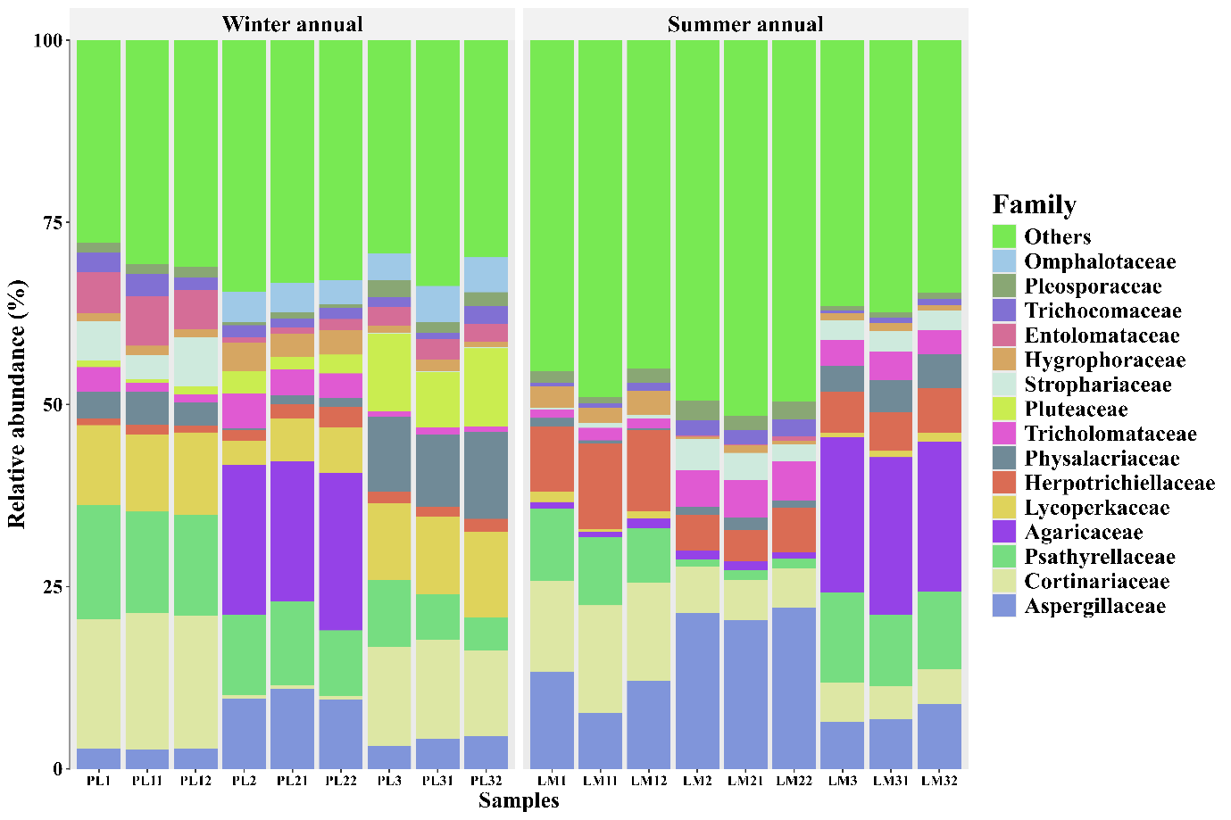
Supplementary Fig. S6. Stacked bar plot displaying the relative abundance of fungal families across winter annual and summer annual samples.

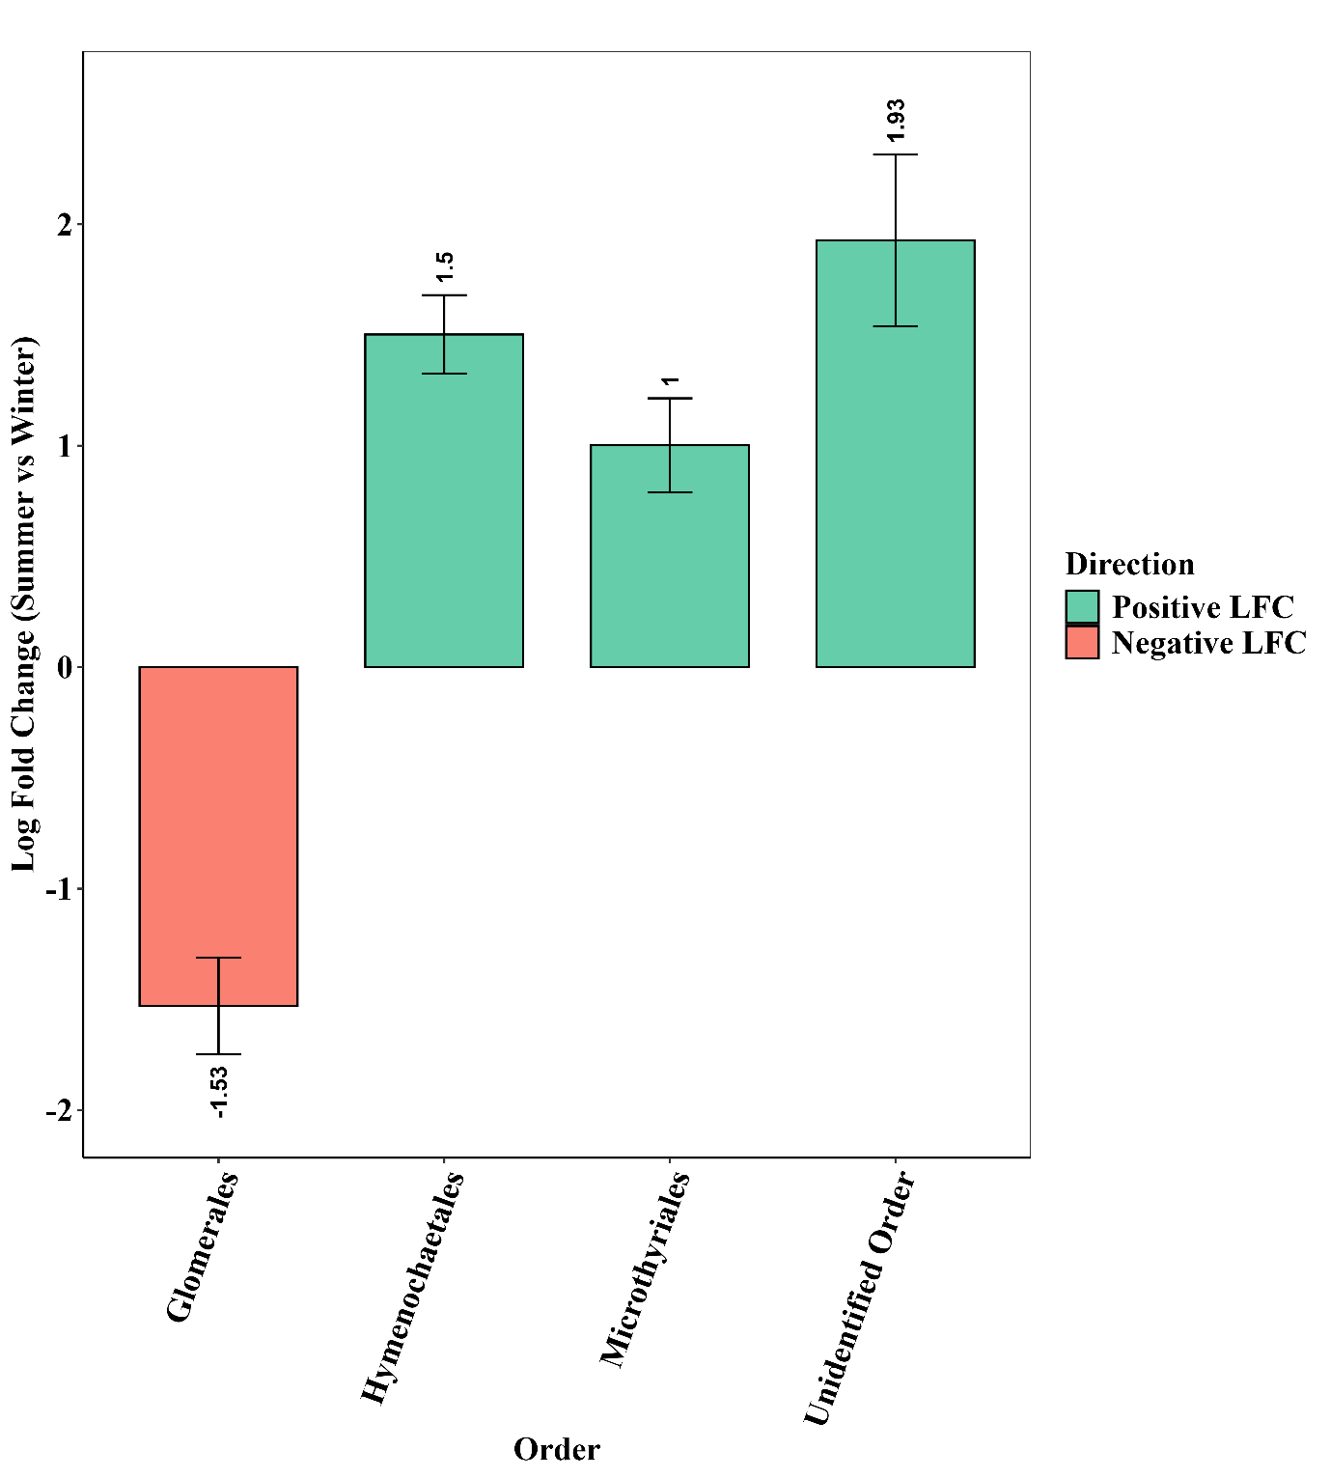
Supplementary Fig. S7. Bar plots illustrating the log fold change (summer vs. winter annuals) in the relative abundance of significantly dominant bacterial orders. Positive log fold changes (green bars) indicate genera enriched in summer annuals, while negative values (red bars) represent those more abundant in winter annuals. Error bars denote standard errors of the log fold change.

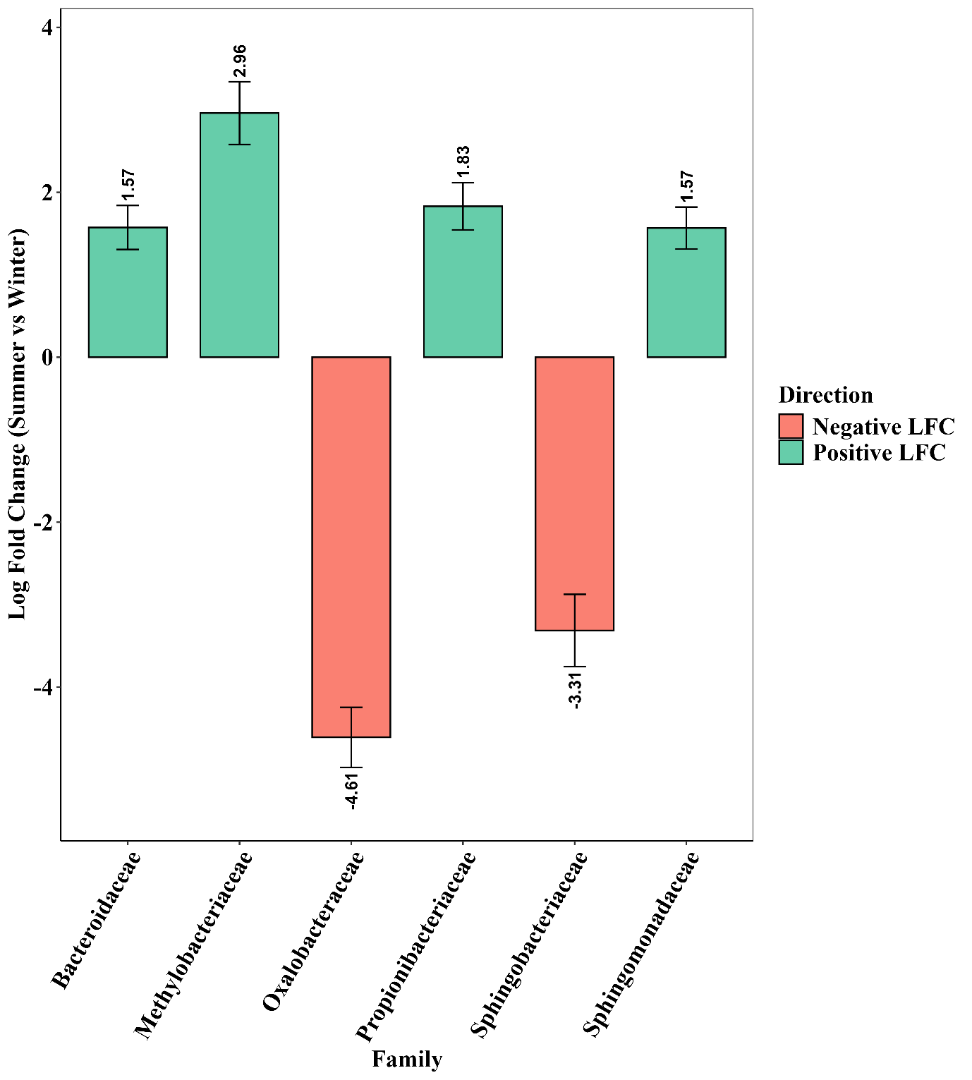

Supplementary Fig. S8. Bar plots illustrating the log fold change (summer vs. winter annuals) in the relative abundance of significantly dominant bacterial families. Positive log fold changes (green bars) indicate genera enriched in summer annuals, while negative values (red bars) represent those more abundant in winter annuals. Error bars denote standard errors of the log fold change.

Supplementary Fig. S9. Bar plots illustrating the log fold change (summer vs. winter annuals) in the relative abundance of significantly dominant fungal order. Positive log fold changes (green bars) indicate genera enriched in summer annuals, while negative values (red bars) represent those more abundant in winter annuals. Error bars denote standard errors of the log fold change.

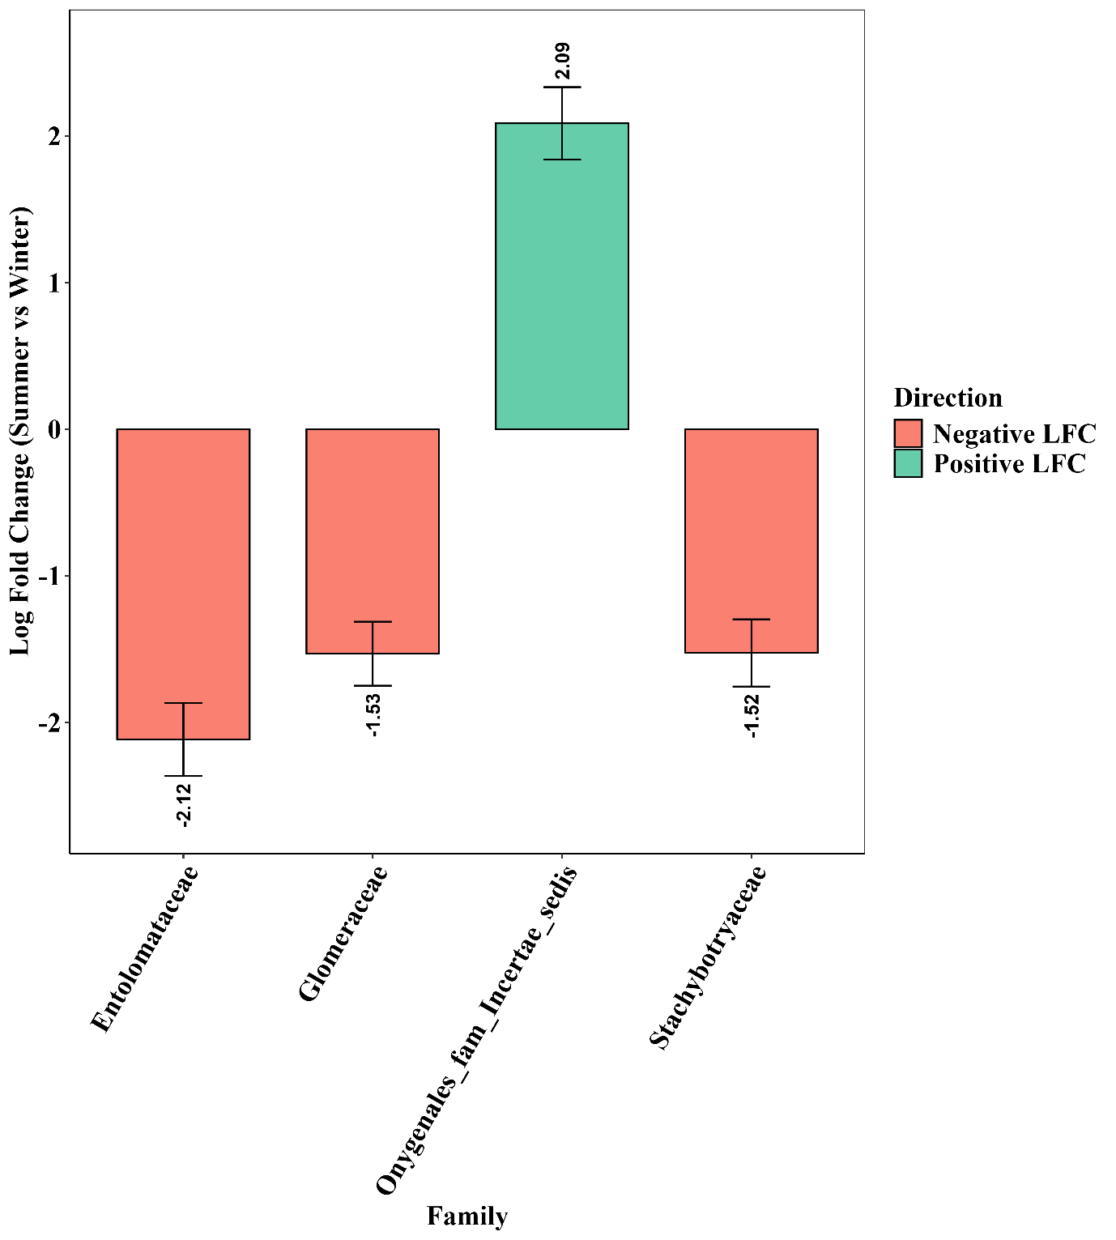
Supplementary Fig. S10. Bar plots illustrating the log fold change (summer vs. winter annuals) in the relative abundance of significantly dominant fungalfamilies. Positive log fold changes (green bars) indicate genera enriched in summer annuals, while negative values (red bars) represent those more abundant in winter annuals. Error bars denote standard errors of the log fold change.

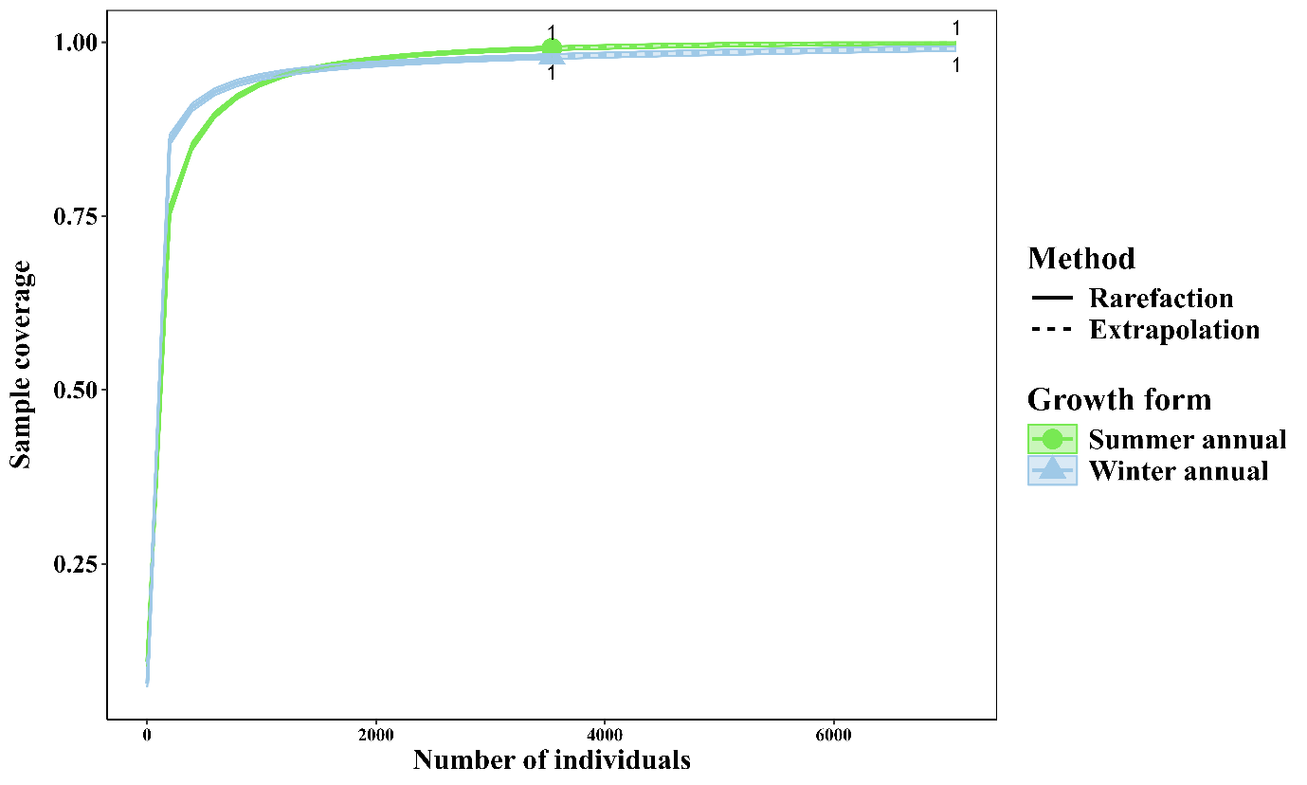
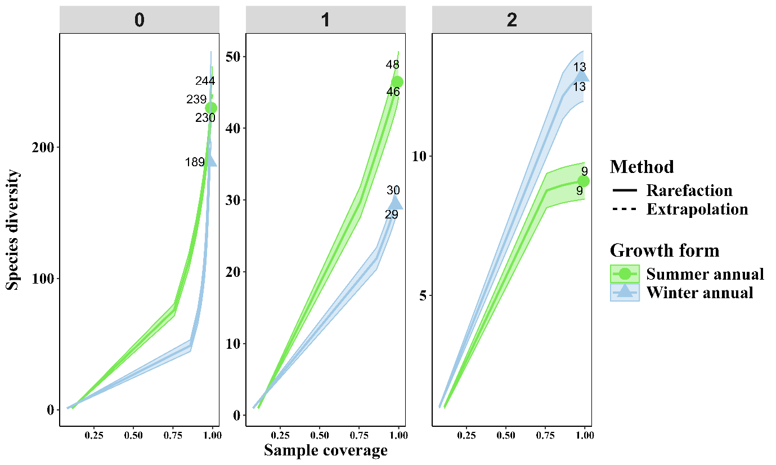
Supplementary Fig. S11. Sample coverage rarefaction and extrapolation curves for summer annual (green) and winter annual (blue) growth forms plotted against the number of individuals of bacteria. Solid lines represent observed (rarefaction) and dashed lines represent extrapolated sample coverage. Coverage approaches unity for both groups, indicating that most species present were sampled and sequencing depth was sufficient.

Supplementary Fig. S12. Coverage-based rarefaction and extrapolation plots showing three Hill diversity orders (q = 0, 1, 2) for summer annual (green) and winter annual (blue) communities. The plots highlight how bacterial diversity changes with increasing coverage and sampling completeness for each growth form.

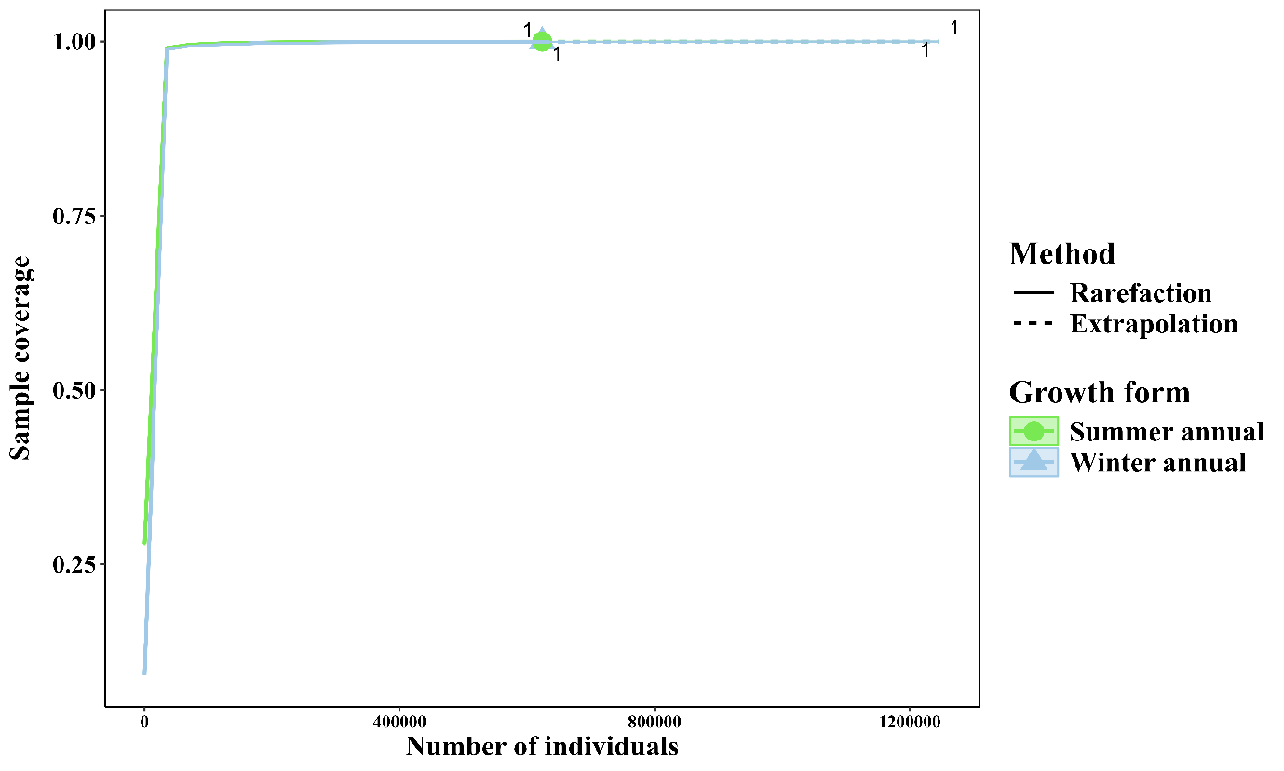
Supplementary Fig. S13. Sample coverage rarefaction and extrapolation curves for summer annual (green) and winter annual (blue) growth forms plotted against the number of individuals of fungi. Solid lines represent observed (rarefaction) and dashed lines represent extrapolated sample coverage. Coverage approaches unity for both groups, indicating that most species present were sampled and sequencing depth was sufficient
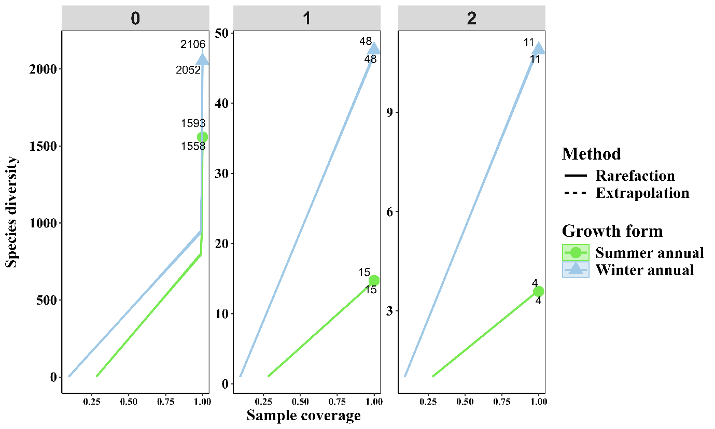

Supplementary Fig. S14. Coverage-based rarefaction and extrapolation plots showing three Hill diversity orders (q = 0, 1, 2) for summer annual (green) and winter annual (blue) communities. The plots highlight how fungal diversity changes with increasing coverage and sampling completeness for each growth form.

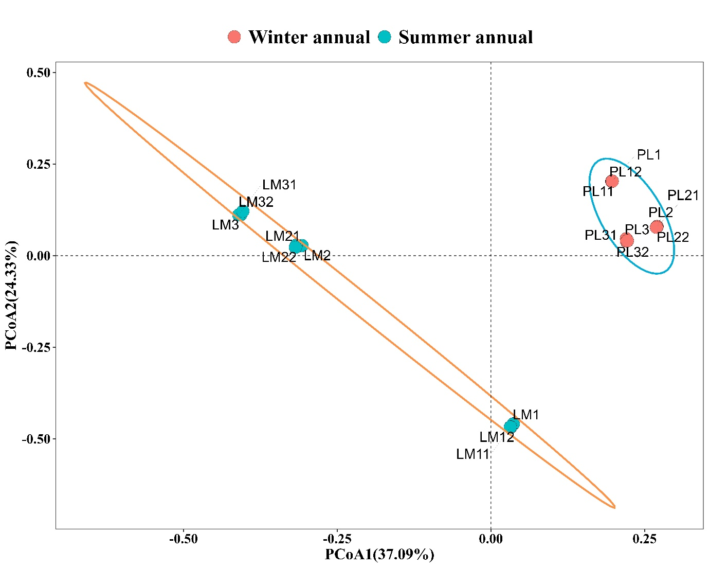
Supplementary Fig. S15. Principal coordinate analysis (PCoA) ordination plot showing beta-diversity patterns of bacterial communities in winter annual (red) and summer annual (blue) samples. Each point represents a sample, with ellipses indicating the 95% confidence intervals for each seasonal group.
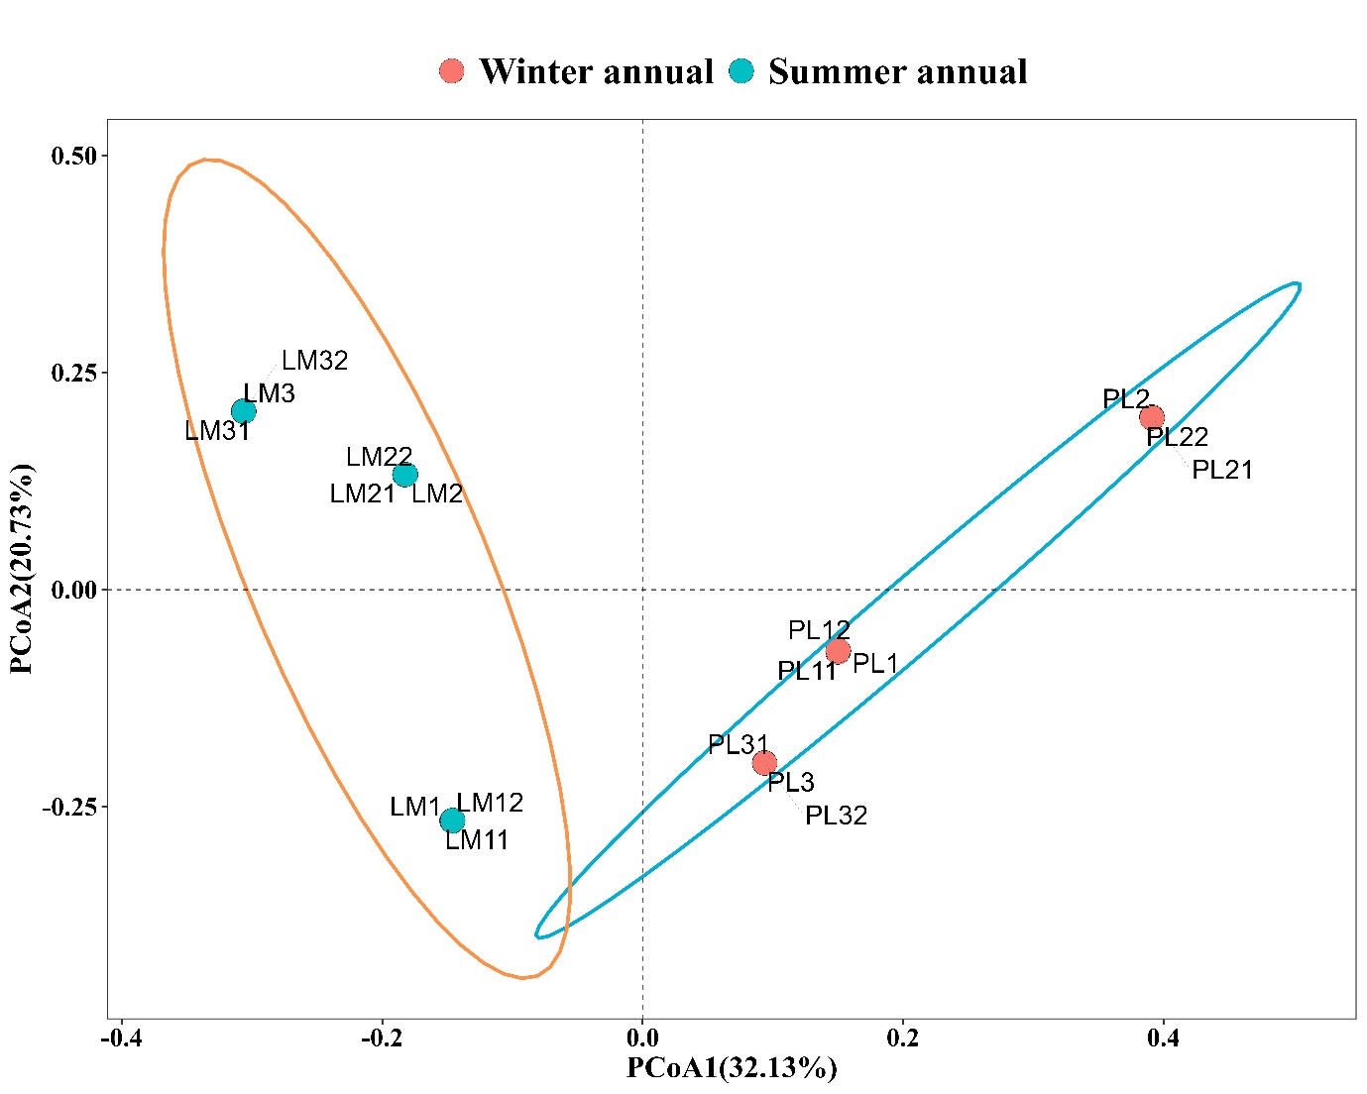

Supplementary Fig. S16. Principal coordinate analysis (PCoA) ordination plot showing beta-diversity patterns of fungal communities in winter annual (red) and summer annual (blue) samples. Each point represents a sample, with ellipses indicating the 95% confidence intervals for each seasonal group.

