Supplementary Material

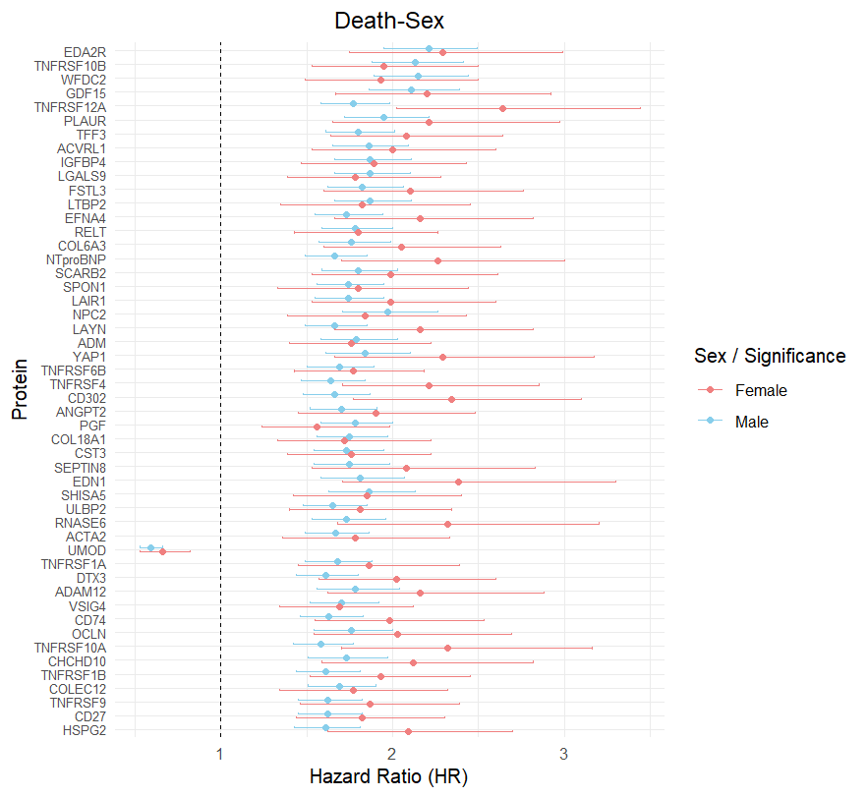
Supplementary Figure 1. Forest plot of sex subgroup analysis in all-cause mortality outcome group: top 50 significant proteins from main analysis.
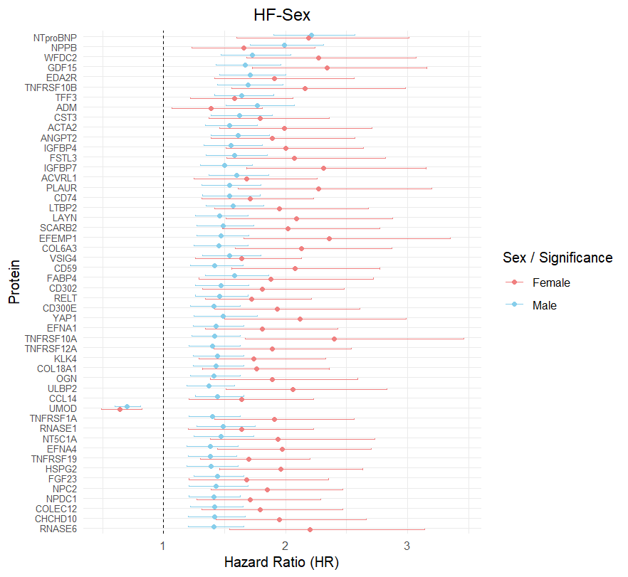
Supplementary Figure 2. Forest plot of sex subgroup analysis in HF outcome group: top 50 significant proteins from main analysis.
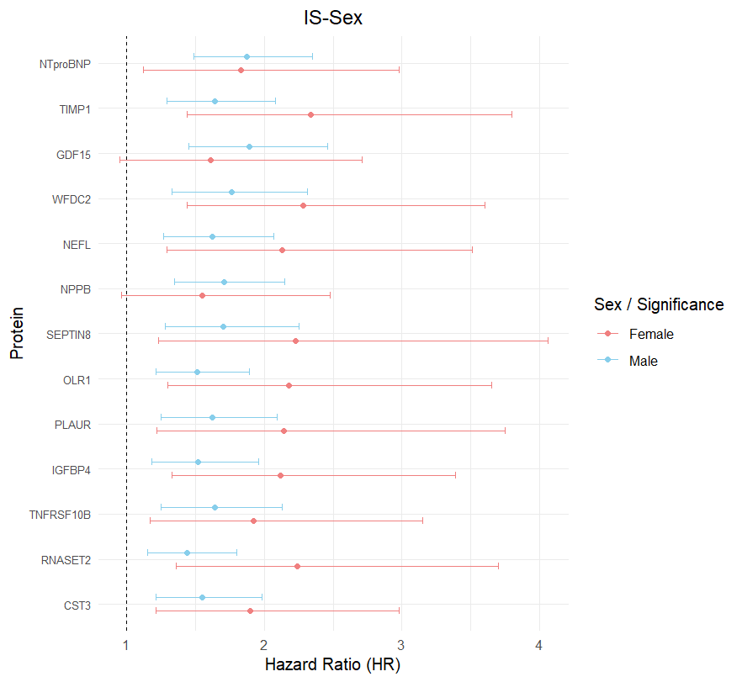
Supplementary Figure 3. Forest plot of sex subgroup analysis in IS outcome group: top 50 significant proteins from main analysis.
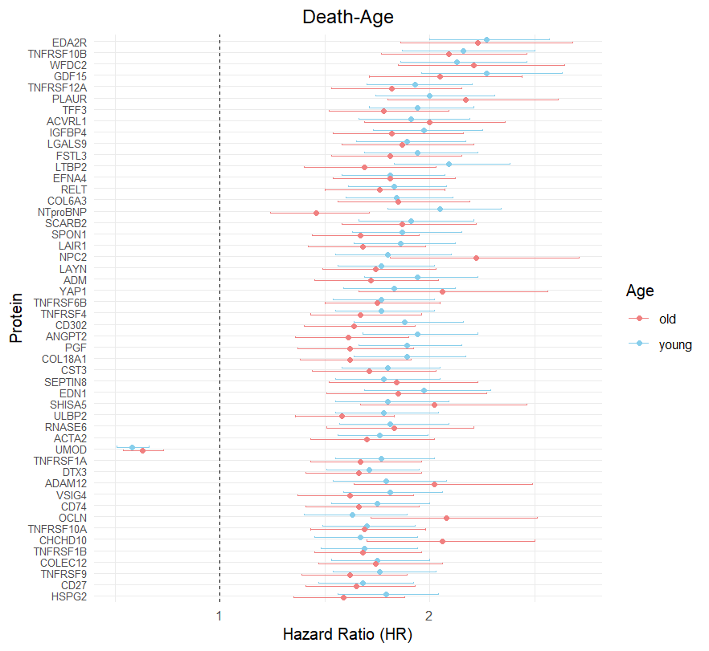
Supplementary Figure 4. Forest plot of age subgroup analysis in all-cause mortality outcome group: top 50 significant proteins from main analysis.

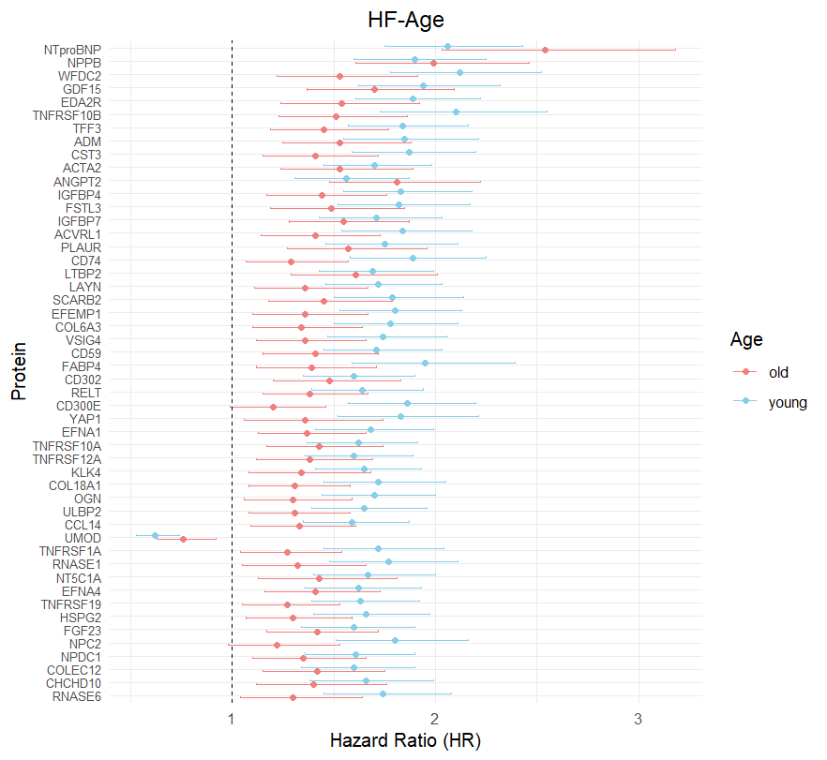
Supplementary Figure 5. Forest plot of age subgroup analysis in HF outcome group: top 50 significant proteins from main analysis.

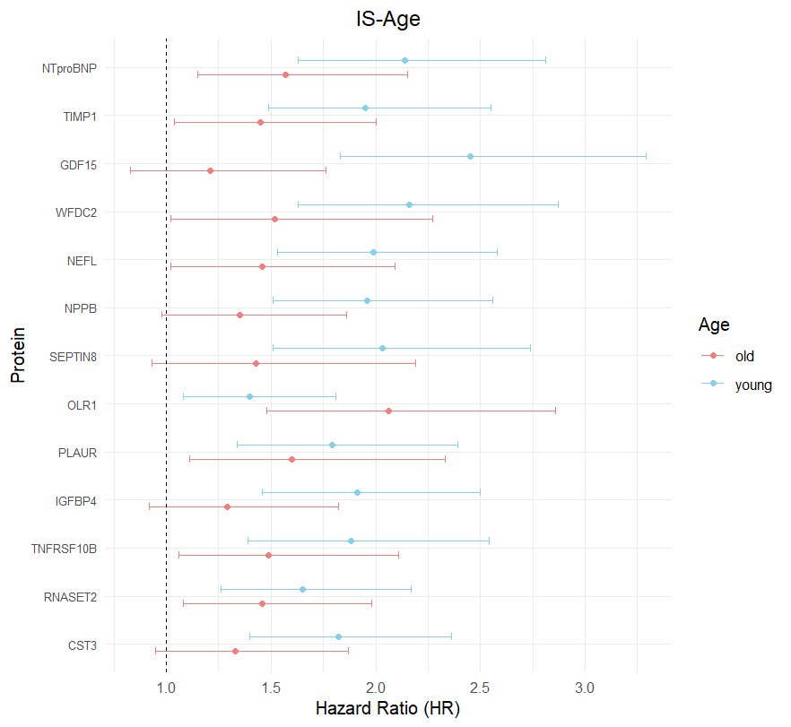
Supplementary Figure 6. Forest plot of age subgroup analysis in IS outcome group: top 50 significant proteins from main analysis.

Supplementary Figure 7. Cumulative incidence curves of HF and death over time.

Supplementary Figure 8. Cumulative incidence curves of IS and death over time.

Supplementary Figure 9. Comparison of HRs across different models.

Supplementary Figure 10. Top 20 features importance of XGBoost for all-cause mortality outcome prediction.

Supplementary Figure 11. Top 20 features importance of LightGBM for HF outcome prediction.

Supplementary Figure 12. Top 20 features importance of Random Forest for IS outcome prediction

