Supplementary Information
Crosslinkable poloxamer in-situ gel as a submucosal cushion for endoscopic submucosal dissection
Yuan Gao^{1,2,#}, Chao Huang^{3,#}, Jiyuan Chen^{1,#} , Zongguang Tai², Yan Li², Shen Gao^{2,}*, Xinjian Wan^{4,}*
¹ Department of Clinical Pharmacy and Pharmaceutical Management, School of Pharmacy, Fudan University, Shanghai, 201203, China
² Department of Pharmacy, Changhai Hospital, Second Military Medical University, Shanghai, 200433, China
³ Department of Gastroenterology, The Tenth People's Hospital, Tongji University, School of Medicine, Shanghai, 200072, China
⁴ Department of Gastroenterology, The Sixth People's Hospital, Shanghai Jiaotong University, School of Medicine, Shanghai, 200233, China

# These authors contributed equally to this work.
* Corresponding authors. Shen Gao, Department of Pharmacy, Changhai Hospital, Second Military Medical University, Shanghai, 200433, China. Tel: +86-21-31162309, E-mail: liullk@126.com; Xinjian Wan, Department of Gastroenterology, The Sixth People's Hospital, Shanghai Jiaotong University, School of Medicine, Shanghai, 200233, China. Tel: +86-13311986536, E-mail: wanxj99@163.com.
Materials
Poloxamer 407 (P407) was a commercial product from BASF Co., Ltd. (Shanghai, China). Petroleum ether (60.0-90.0 °C), tetrahydrofuran (THF), acryloyl chloride, formalin, ethanol, triethyl amine, xylene, D,L-dithiothreitol (DTT), 3,3- dithiodipropionic acid (DTDP), hematoxylin, eosin, D₂O, 0.1 moL/L phosphate buffer solution (PBS) (pH=7.4) and methylene blue were offered by Aldrich Chemical Company (Shanghai, China); An injection of glycerol (10 wt.%), fructose (5 wt.%) and sodium chloride (0.9 wt.%) abbreviated as glycerol was acquired from Cisen Pharmaceutical Co. Ltd (PR China). All these materials were analytical grade and used without further puriﬁcation except that THF was dried by natrium and distilled twice at ~85.0 °C.
Three minipigs (30 kg) were provided by the Experimental Animal Center of the Second Military Medical University. The animal experiments were approved by the Animal Use and Care Committee of the Second Military Medical University.
Synthesis of PA-PSH
The PA-PSH was prepared as described previously ^{1,2}. Firstly, P407 (34.4 g, 4.0 mmol) and triethyl amine (1.9 g, 16.0 mmol) were dissolved in THF. The reacted solution was centrifuged to remove triethyl amine-hydrochloride, and the supernatant was dropped into petroleum ether. After precipitation, PA was obtained and dried at ambient temperature under vacuum for 24 h.
Secondly, DTDP (4.2 g, 20 mmol) and thionyl chloride (10.0 mL) were added into a round-bottom flask, then the mixture was heated at 85 °C for 4 h. The mixture was distilled under vacuum to remove unreacted thionyl chloride, and then dithiodipropionic chloride was obtained. P407 (17.2 g, 2.0 mmol), triethyl amide (1.0 g, 8.0 mmol) and dithiodipropionic chloride (2.0 g, 8.0 mmol) were dissolved into THF. The solution was kept at 75 °C for 6 h under stirring, then was centrifuged to remove triethyl amine-hydrochloride at room temperature (RT). The product was obtained by dropping the supernatant into petroleum ether. The product was puriﬁed three times by precipitating in petroleum ether/THF mixture, then dried under vacuum, and the disulfide crosslinked P407 (PSS) was obtained.
DTT was used to cleave the disulﬁde bonds in PSS in a PSS : DTT (mol/mol) rate of 30.0. The cleavage reaction was carried out in 10.0 wt%. PSS aqueous solution at pH7.0 for 4 h with nitrogen gas protection. After reaction, the solution was adjusted to pH 3.5 with 10.0% (v/v) HCl and freeze-dried to obtain thiol-capped Poloxamer 407 (PSH). The puriﬁed PSH was obtained by participating in THF/ petroleum ether mixture.
The aqueous solution of PA–PSH mixture (pH 3.5) was prepared between PA and PSH at a C=C/SH molar ratio of 1.5. Then the reaction between PA and PSH was evaluated at 25 and 37°C. After the solution was freeze dried, PA–PSH copolymers were obtained.
References
1. Niu G, Zhang H, Song L, et al. Thiol/Acrylate-Modified PEO-PPO-PEO Triblocks Used as Reactive and Thermosensitive Copolymers. Biomacromolecules 2008; 9: 2621–8.
2. Niu G, Du F, Song L, et al. Synthesis and characterization of reactive poloxamer 407s for biomedical applications. J Control Release 2009; 13849–56.

Fig. S1. Illustration of the synthesis route of PA (A), PSH (B) and PA-PSH conjugate (C).
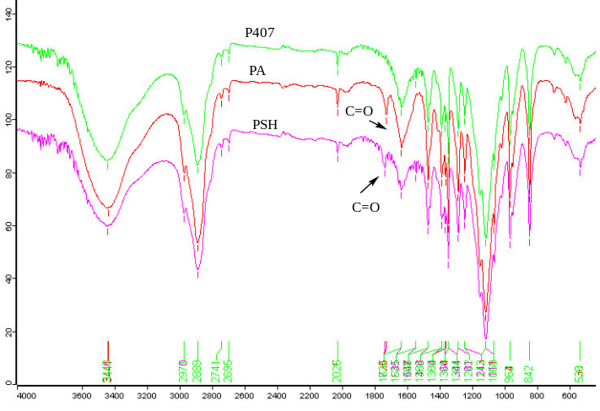
Fig. S2. FT-IR of P407, PA and PSH.
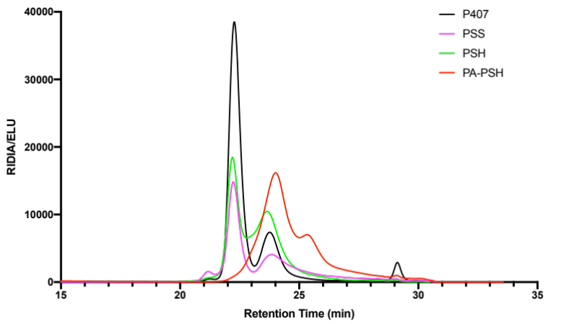
Fig. S3. GPC results of P407, PSS, PSH and PA-PSH.

