Supplementary Figure 1. Differential gene expression analysis of HCT116 colorectal cancer cells in response to 5-fluorouracil (5FU) and cisplatin treatments. (A) Top five upregulated genes following treatment with 5FU, showing increased expression of DHRS2, IFI44, SCN1A, KIF1A, and SPARC. (B) Top five downregulated genes in 5FU-treated cells, including BRD3OS, MAL2-AS1, VASH1-AS1, LOC112268088, and ITGB1P1. (C) Top five upregulated genes upon treatment with 30M cisplatin, including KRT8P45, LOC107987134, ACE3P, LOC105372385, and GCAWKR. (D) Top five downregulated genes in 30M cisplatin-treated cells: DST, CENPF, OR51Q1, H1-4, and OR51M1. (E) Upregulated genes in response to 300M cisplatin, with notable increase in TEX54, KMT2E-AS1, LINC01465, CDC27P10, and LOC100499489. (F) Downregulated genes following 300M cisplatin treatment, including LOC112268166, LINC01271, LOC112268006, MTND2P28, and DSP.
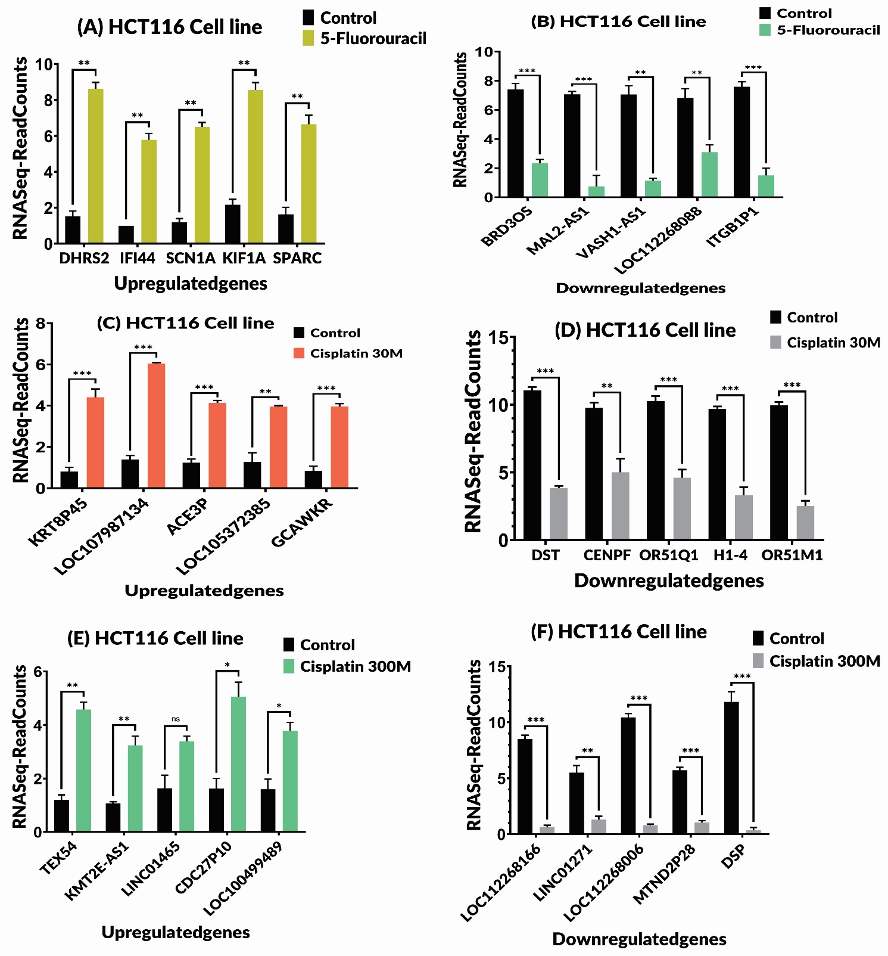

Supplementary Figure 2. Differential gene expression profiles in HT29 colorectal cancer cells following cisplatin treatment. (A) Top five upregulated genes in response to 30M cisplatin treatment, including FBXO44, LOC105375064, PDZD3, PHYHIP, and FGF17. (B) Top five downregulated genes at 30M cisplatin, including LOC105369149, LOC100128653, PCED1B, TSC22D1-AS1, and EGFR-AS1. (C) Genes most upregulated after treatment with 300M cisplatin, including RNU2-13P, TRV-AAC1-1, TEX54, MIR23AHG, and SEC22B4P. (D) Top five downregulated genes in HT29 cells treated with 300M cisplatin: LOC107985873, ZNF225-AS1, RRBP1, NUMA1, and OBI1-AS1.
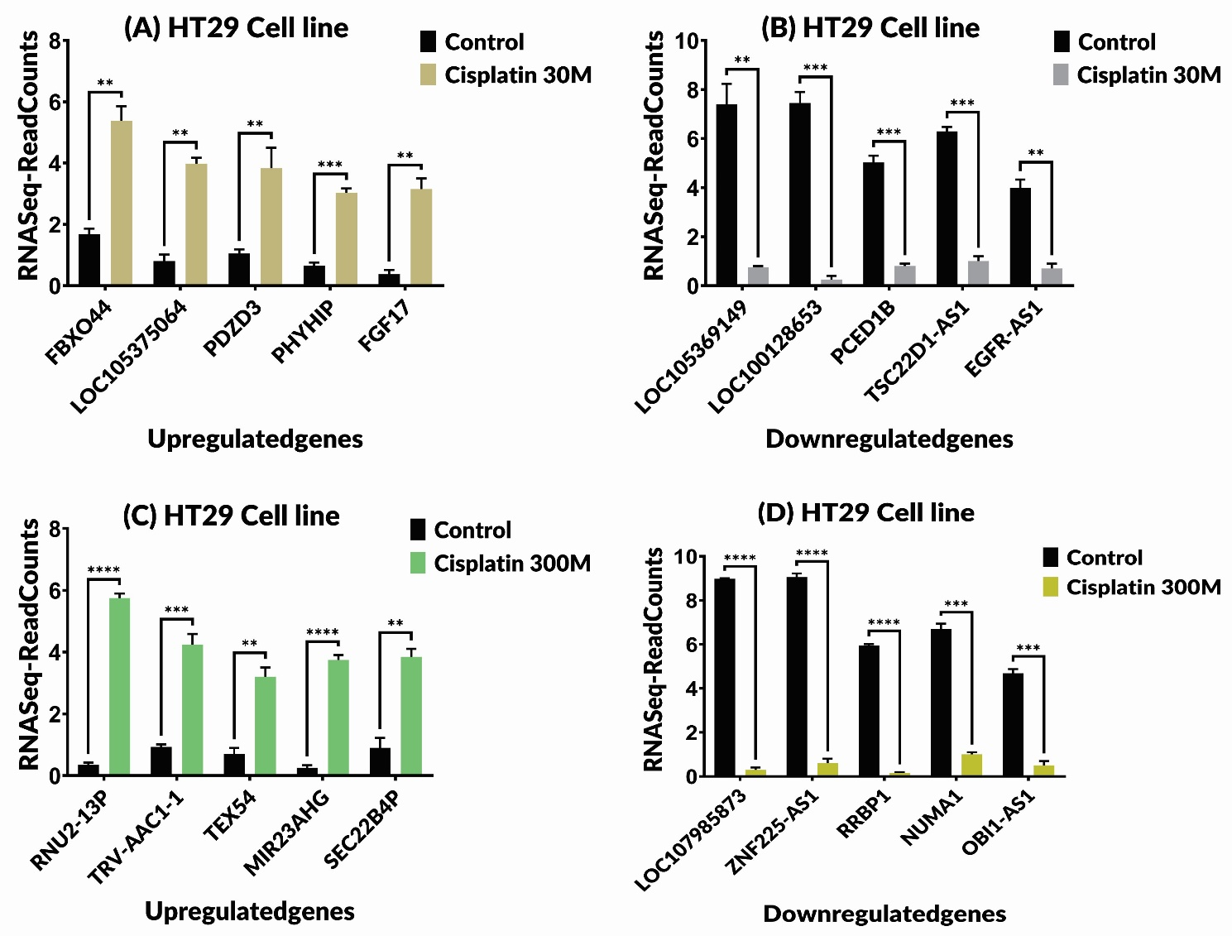

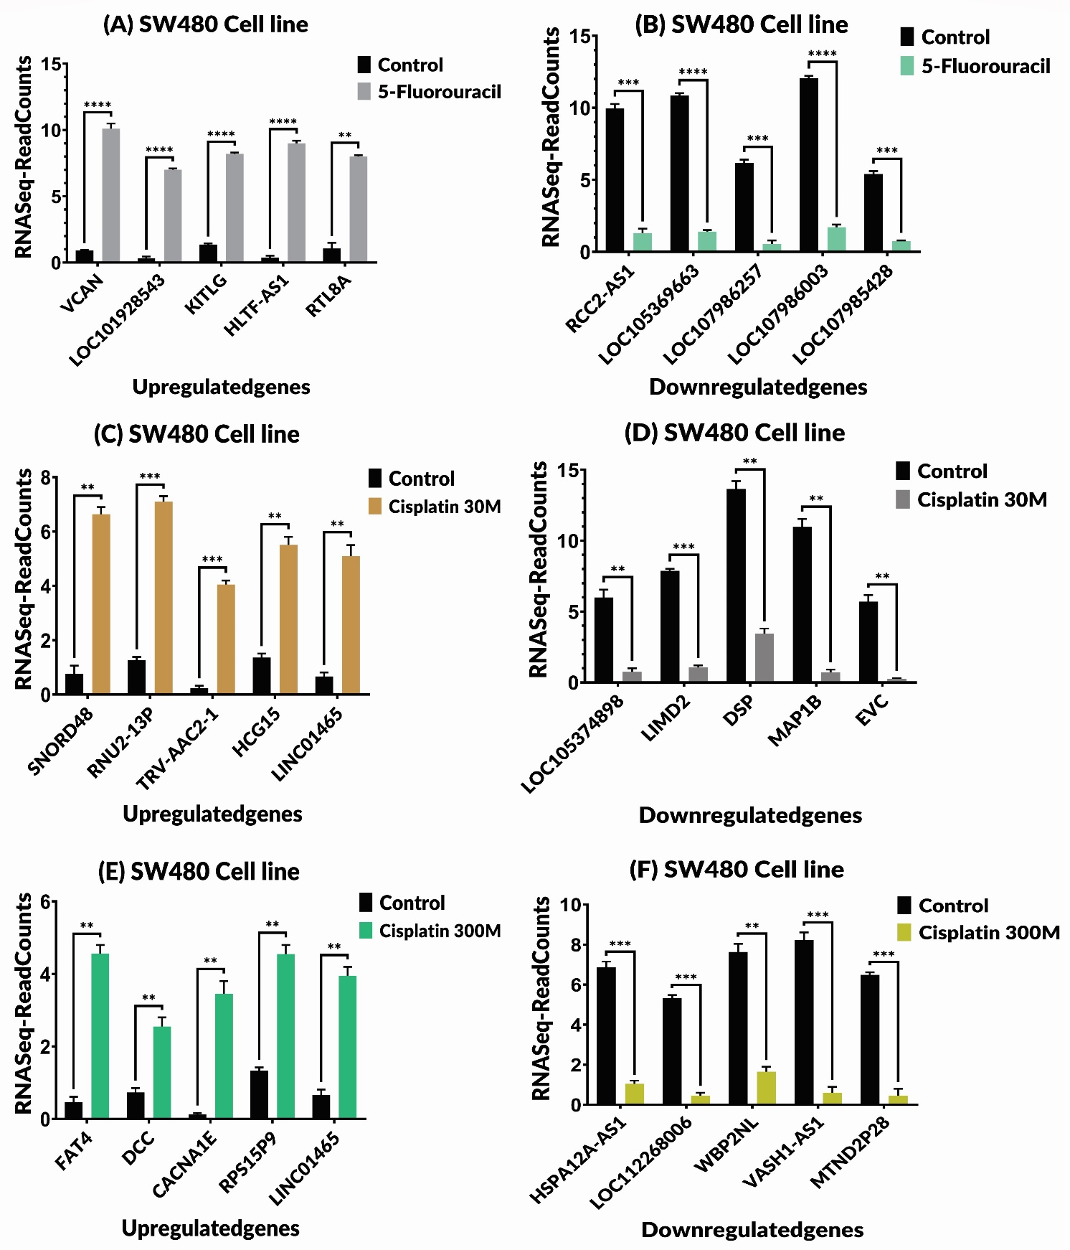
Supplementary Figure 3. Differential gene expression analysis in SW480 colorectal cancer cells following treatment with 5-fluorouracil (5FU) and cisplatin. (A) Top five upregulated genes after 5FU treatment, including VCAN, LOC101928543, KITLG, HLTF-AS1, and RTL8A. (B) Top five downregulated genes in response to 5FU, including RCC2-AS1, LOC105369663, LOC107986257, LOC107986003, and LOC107985428. (C) Top five upregulated genes in cells treated with 30M cisplatin: SNORD48, RNU2-13P, TRV-AAC2-1, HCG15, and LINC01465. (D) Most downregulated genes at 30M cisplatin, including LOC105374898, LIMD2, DSP, MAP1B, and EVC. (E) Upregulated genes in response to 300M cisplatin: FAT4, DCC, CACNA1E, RPS15P9, and LINC01465. (F) Top downregulated genes following 300M cisplatin treatment: HSPA12A-AS1, LOC112268006, WBP2NL, VASH1-AS1, and MTND2P28.

Supplementary Figure 4. Comparative transcriptomic analysis of common differentially expressed genes (DEGs) in colorectal cancer cell lines treated with 5-fluorouracil (5FU) and cisplatin (30M and 300M). (A) In HCT116 cells, five genes (EHBP1-AS1, WNT8B, MEF2C-AS2, DNAH10, and GPR68) were commonly downregulated across all treatment conditions. (B) In HT29 cells, five genes (TBCB, STK16, MRPL38, SMPD4, and LOC107987209) were consistently upregulated in response to both cisplatin concentrations. (C) The same treatments in HT29 cells led to consistent downregulation of RBP5, PKP4-AS1, NEPRO-AS1, C11orf42, and MACF1. (D) In SW480 cells, SUSD2 and OLFML2A were upregulated following 5FU and cisplatin treatment at both doses. (E) Five genes (LOC102724748, EVC, EFNB1, GARS1, and SPINT1-AS1) were downregulated in SW480 cells under all treatment conditions.
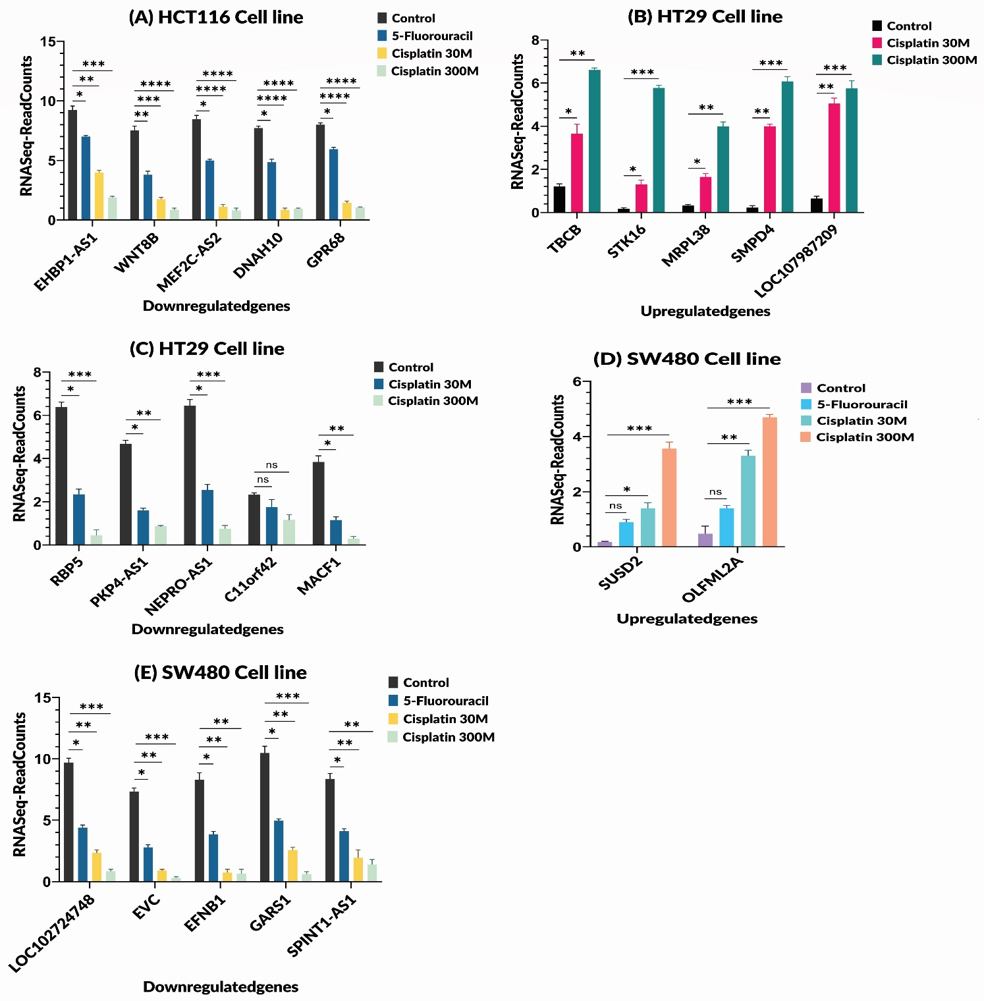

Supplementary Figure 5. Protein–protein interaction (PPI) networks of differentially expressed genes (DEGs) in colorectal cancer (CRC) cell lines (HCT116, HT29, and SW480) treated with 5-fluorouracil (5-FU) and cisplatin at two concentrations (30M and 300M), constructed using STRING and visualized via Cytoscape. (A) In HCT116 cells treated with 5-FU, a total of 1,561 DEGs (276 upregulated, 1,285 downregulated) formed a PPI network consisting of 50 nodes and 45 edges. Key hub proteins included ISG15, IFIT2, IFI44, IFIT1, IFIT3, KRT15, and OASL. (B) Upon treatment with 30M cisplatin in HCT116 cells, 806 DEGs were identified and used to construct a network of 61 nodes and 63 edges. Major hub proteins were H2BC21, H2AC20, H2BC4, ATRX, SETD2, H4C5, USP34, and SMC1A. (C) Increasing cisplatin concentration to 300M in HCT116 cells yielded 1,260 DEGs, resulting in a PPI network of 41 nodes and 40 edges. Prominent hubs included MYH9, CHD4, HNRNPU, ACTN4, RANBP2, and TPR. (D) In HT29 cells treated with 30M cisplatin, 1,940 DEGs formed a network of 67 nodes and 27 edges. Central proteins in this network included BRCA2, FGFR2, PDGFRA, FGF17, and FGF19. (E) For SW480 cells exposed to 5-FU, 3,219 DEGs generated a PPI network of 49 nodes and 17 edges, with hub proteins such as COL12A1, ITGA4, PXDN, VCAN, and KITLG. (F) In SW480 cells treated with 30M cisplatin, 1,285 DEGs formed a network with 46 nodes and 16 edges. Hub proteins included MED1, DST, EPRS1, and STT3A. (G) At 300M cisplatin treatment in SW480 cells, 2,209 DEGs were identified, leading to the construction of a more complex network with 61 nodes and 63 edges. Major hub proteins comprised HSPA4, HSP90AB1, CTNNA1, YWHAE, TJP1, and CHD4.
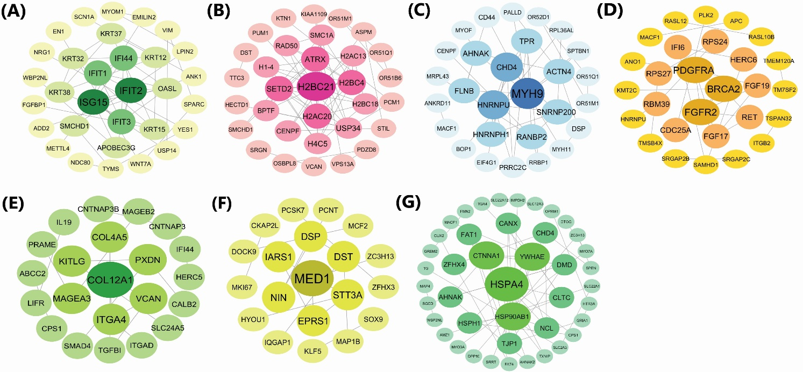

Supplementary Figure 6. Correlation analysis of commonly deregulated genes in colorectal cancer (CRC) cell lines under chemotherapeutic treatment. (A) In the SW480 cell line, correlation heatmap of shared up- and downregulated genes across 5-FU and cisplatin (30M and 300M) treatments reveals two distinct gene clusters. The upregulated genes SUSD2 and OLFML2A display strong positive correlation with each other and negative correlation with downregulated genes including LOC102724748, EFNB1, and SPINT1-AS1. Interestingly, SUSD2 and OLFML2A also showed positive correlation with other downregulated genes such as EVC and GARS1, suggesting possible regulatory cross-talk. Additionally, LOC102724748 positively correlates with SPINT1-AS1, and EVC with GARS1. (B) In the HT29 cell line, a similar dichotomous pattern was observed. Upregulated genes (TBCB, STK16, MRPL38, SMPD4, and LOC107987209) showed strong positive intra-group correlation and a negative correlation with a cluster of downregulated genes (RBP5, PKP4-AS1, NEPRO-AS1, C11orf42, and MACF1), indicating potential opposing roles in treatment response.
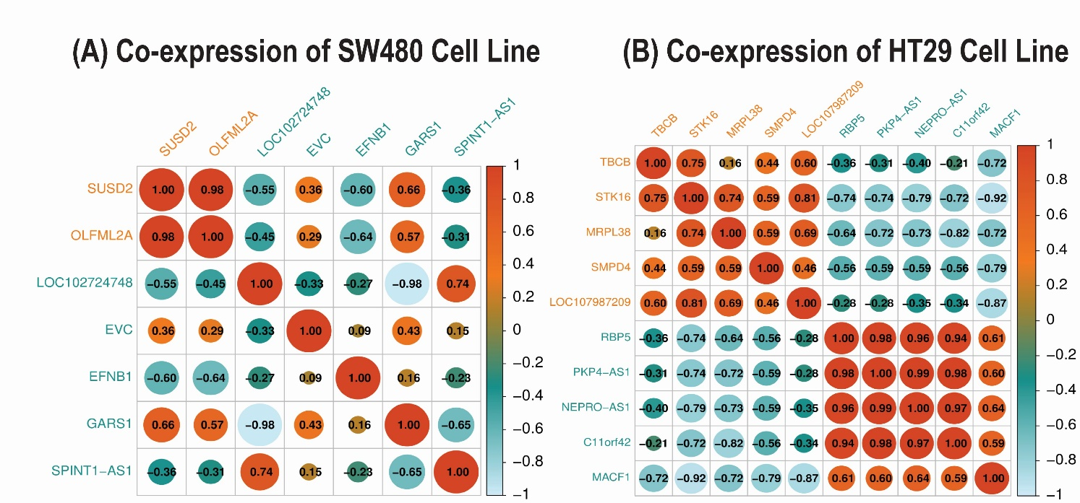

Supplementary Figure 7. Clinical relevance of drug-responsive genes: (A) HCT116-derived genes: Upregulated in tumor/metastatic tissues: DHRS2, IFI44, KIF1A, SCN1A, SPARC, VASH1 (5-FU); CENPF (cisplatin 30M). Downregulated: DST (cisplatin 30 M), DSP (cisplatin 300M). (B) HT29-derived genes: Upregulated: PHYHIP (cisplatin 30M), NUMA1, RRBP1, ZNF225 (cisplatin 300M). Downregulated: EGFR, FGF17, PDZD3, TSC22D1 (cisplatin 30M). (C) SW480-derived genes: Upregulated: HLTF, VCAN (5-FU); LIMD2, MAP1B (cisplatin 30M); CACNA1E, DCC, FAT4, RPS15, VASH1 (cisplatin 300M). Downregulated: HSPA12A (cisplatin 300M), KITLG (5-FU).

Supplementary Figure 8. Expression levels of PPI-derived hub genes in colorectal tissues: (A) HCT116-derived hub genes: Upregulated in tumor/metastatic tissues: IFIT2 (5-FU, P = 1.08e−15). Downregulated: MYH9 (cisplatin 300M, P = 3.64e−06). (B) HT29-derived hub genes: Upregulated: BRCA2 (cisplatin 30M, P = 2.56e−66). Downregulated: FGFR2 (P = 4.48e−117), PDGFRA (P = 7.15e−20). (C) SW480-derived hub genes: Upregulated: MED1 (cisplatin 30M, P = 6.19e−72), HSPA4 (cisplatin 300M, P = 5e−25).

Supplementary Figure 9. Overview of scRNA-seq data preprocessing and dimensionality reduction. (A) Quality control filtering of low-quality cells from normal and tumor colorectal tissues. (B) Selection of the top 2000 highly variable genes. (C) PCA analysis showing sample distribution based on variable genes. (D) Elbow plots identifying top principal components. (E–F) Heatmaps highlighting gene expression patterns across key principal components.

Supplementary Figure 10. Pseudotime expression dynamics of hub and treatment-common genes in colorectal tumor microenvironment. (A) In the hub genes group, FGFR2 showed high expression in epithelial cells, while PDGFRA was highly expressed in fibroblasts. Moderate expression was detected for IFIT2, MYH9, HSPA4, and MED1 in epithelial cells, and COL12A1 in fibroblasts. ISG15 and BRCA2 exhibited very low expression in epithelial cells. (B) In the HT29-common gene group, MRPL38 and SMPD4 had high expression, and TBCB and STK16 moderate expression in epithelial cells during pseudotime progression. (C) In the SW480-common gene group, SUSD2 and OLFML2A showed moderate expression in epithelial cells and fibroblasts, respectively, throughout pseudotime.
