Supplementary Information
Active/Conductive Layer Stacked Superlattices for Highly Selective CO₂ Electroreduction
Junyuan Duan, Yinghe Zhao, Ruoou Yang, Yang Zhao, Wenbin Wang, Youwen Liu*, Huiqiao Li & Tianyou Zhai *
State Key Laboratory of Materials Processing and Die & Mould Technology, and School of Materials Science and Engineering, Huazhong University of Science and Technology, Wuhan, Hubei, 430074, P. R. China
*Corresponding authors: E-mail: zhaity@hust.edu.cn; ywliu@hust.edu.cn

S1. XRD pattern and Raman spectrum of BiCuSeO
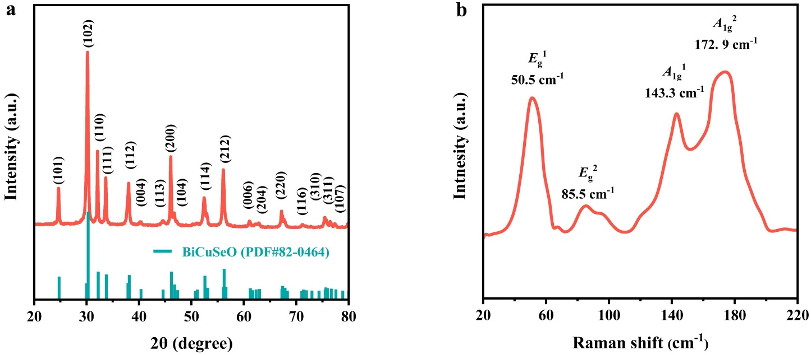
Fig. S1 (a) XRD pattern and (b) Raman spectrum of ultrathin BiCuSeO nanosheets. All the characteristic diffraction peaks of XRD pattern (Fig. S1a) can be assigned to the tetragonal BiCuSeO phase with the P4/nmm space group (JCPDS card No. 82-0464)^{2, 3}, and no other impurity peaks are discernable, indicating that the crystalline BiCuSeO single phase is successfully obtained. Moreover, two-humped peaks located at 50.5 (E_{g}¹) and 85.5 cm⁻¹ (E_{g}²) corresponding to the in-plane motion of Cu atoms, and peaks at 143.3 (A_{1g}¹) and 179.2 cm⁻¹ (A_{1g}²) corresponding to the out-of-plane vibration of Bi and Se atoms in the tetrahedral can be clearly observed from Raman spectrum (Fig. S1b)⁴, further illustrating the production of BiCuSeO nanosheets.

S2. TEM of BiCuSeO
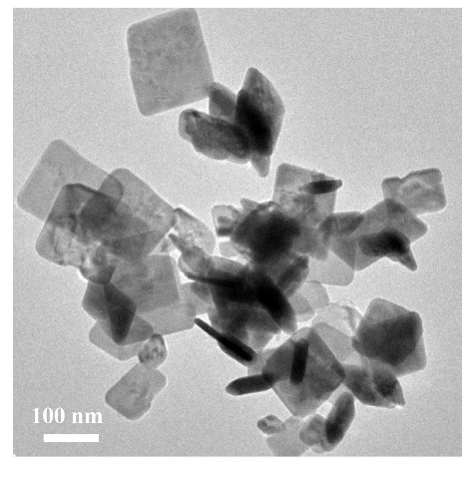
Fig. S2 TEM image of ultrathin BiCuSeO nanosheets.

S3. Schematic diagram of flow cell
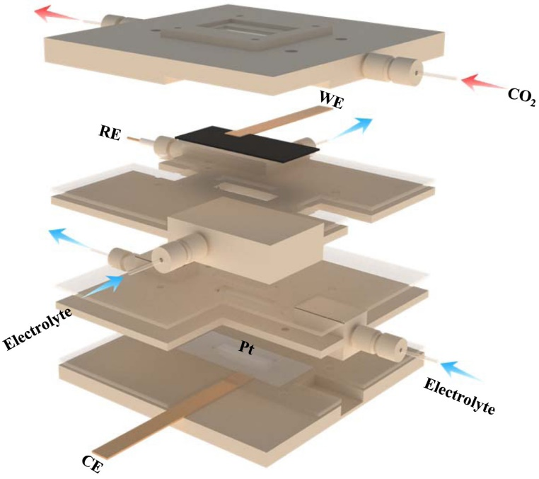
Fig. S3 The schematic diagram of the three-electrode flow cell system. The working electrode (WE) is a catalyst-deposited on gas diffusion layer of working area in 1 cm². The reference electrode (RE) and counter electrode (CE) are Ag/AgCl and Pt plate, respectively. CO₂ gas is continually supplied by a steady flow pump with a flow rate of 20 mL min⁻¹. Electrolyte is correspondingly pumped into anode and cathode cell by a peristaltic pump.

S4. Structural characterizations of Cu₂Se
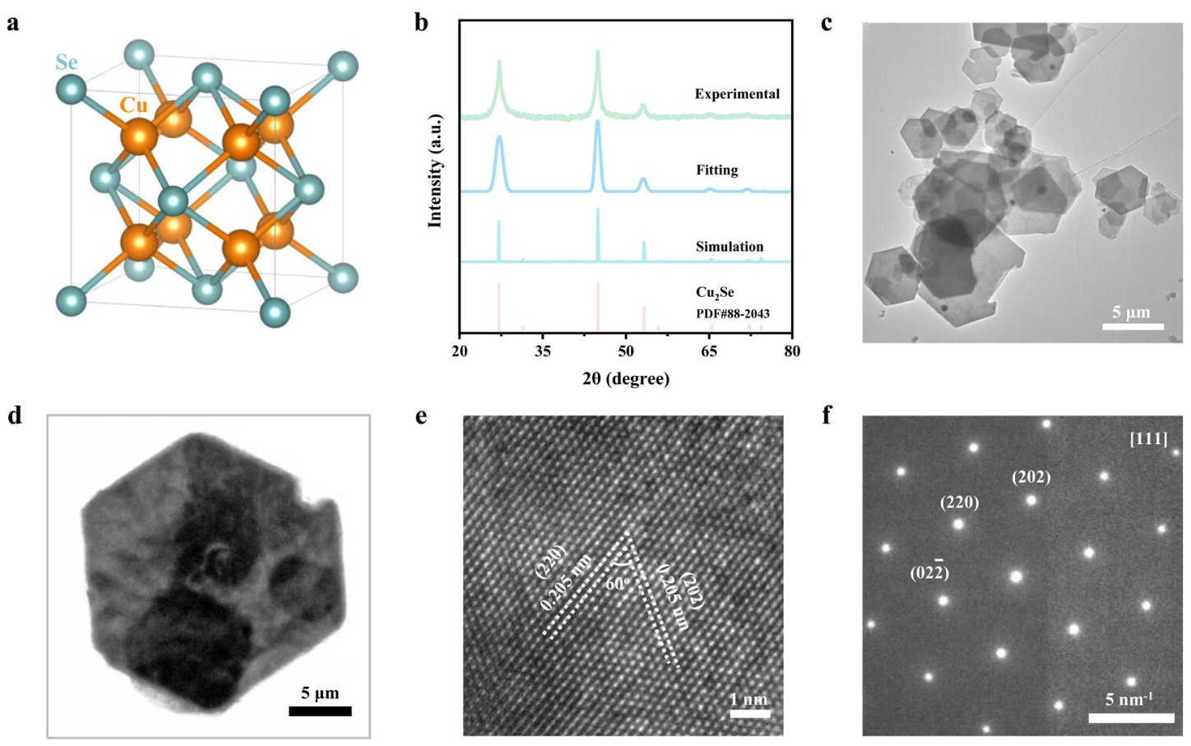
Fig. S4 (a) Structure model, (b) XRD pattern, (c, d) TEM images, (e) HRTEM image and (d) SAED of the as-prepared Cu₂Se nanosheets. XRD pattern exhibits the only diffraction peaks of cubic phase Cu₂Se, which is consistent with the reported data (JCPDS No. 88-2044)⁵. Sharp and intense peaks suggest their highly crystalline nature. TEM images shows that the Cu₂Se samples are uniform hexagonal nanosheets. HRTEM image and SAED pattern illustrate that the as-obtained Cu₂Se is single crystal. Taken together, the above results indicate that uniform and dispersible Cu₂Se single crystalline hexagonal nanosheets of high purity are obtained.

S5. Structural characterizations of Bi₂O₃
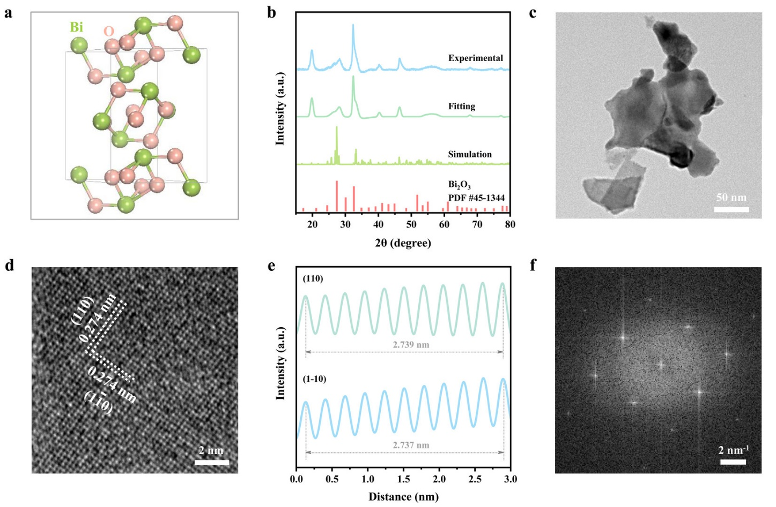
Fig. S5 (a) Structure model, (b) XRD pattern, (c) TEM image, (d) HRTEM image and (d) SAED of the as-prepared Bi₂O₃ nanosheets. (e) The interplanar spacings of the lattice fringes. (f) FFT image of Fig. S5d. XRD pattern show crystalline Bi₂O₃ is obtained. TEM image reveals the obvious nanosheet-liked shape. HRTEM and FFT images illustrates the its single-crystal nature. The characterization results in Fig. S4 show that single-crystalline Bi₂O₃ nanosheets are successfully prepared.

S6. Electrochemical measurements of BiCuSeO in CO₂-saturated 1M KOH solution
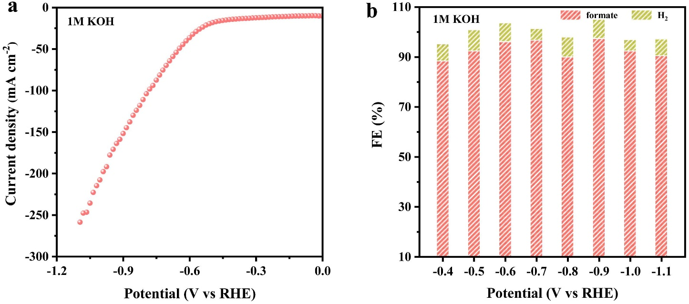
Fig. S6 (a) LSV curve. (b) Potential-dependent Faradaic efficiency (FE) of formate and H₂. When BiCuSeO catalyst is measured in CO₂-saturated 1M KOH solution, the LSV curve clearly manifests the significantly larger current density in compared with that tested in KHCO₃ solution. The current density reaches to ~267 mA cm⁻² at -1.1 V, which is 4.63 times of that gained in KHCO₃ solution. The formate selectivity in 1M KOH is also satisfactory, and measured to be ~90% in wide potential window (from -0.4 to -1.1 V).

S7. SEM images of BiCuSeO and BiCuSeO_{R}
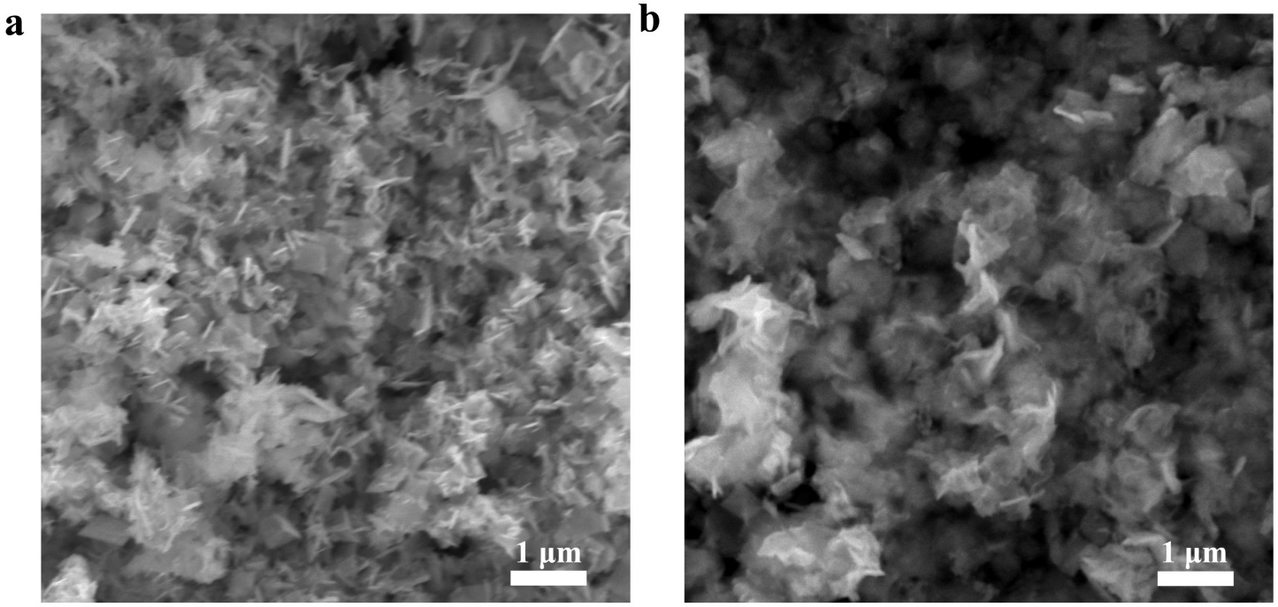
Fig. S7 (a) Pristine BiCuSeO samples. (b) BiCuSeO_{R} samples collected after 10 h electrochemical measurements for CO₂RR. It can be clearly observed from SEM images that BiCuSeO_{R} after 10 h CO₂RR testing exhibits a similar nanosheet-liked morphology and size as pristine BiCuSeO, suggesting both of them are relatively stable during the electro-catalytic CO₂RR process.
S8. Schematic illustration of reaction mechanism for the CO₂RR to formate
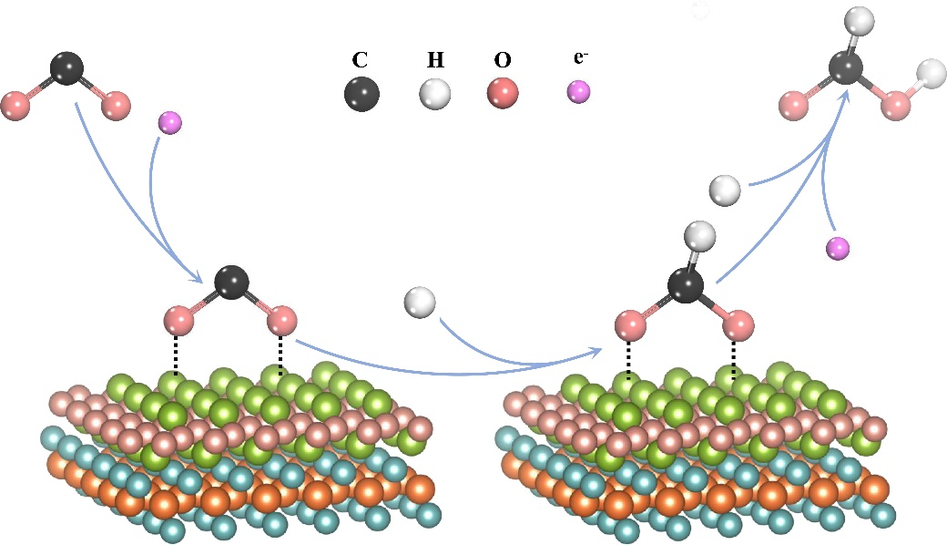
Fig. S8. Schematic illustration of reaction mechanism for the CO₂RR to formate from in situ Raman spectroscopy. Raman peaks of ν_{s}CO₂^{•-} and ν_{as}CO₂^{•-} respectively corresponding to two key intermediates of formate formation *CO₂^{•-} and HCOO*can be detected by Raman spectroscopy virtually^{6, 7}. And, the reaction mechanism for CO₂RR to formate can be proposed. Firstly, one electron transfers to surface-adsorbed CO₂ molecule to form first intermediate *CO₂^{•-} (CO₂ + e⁻ = *CO₂⁻). Subsequently the *CO₂^{•-} is changed into *OCHO by coupling a proton through its C atom (*CO₂⁻ + H⁺ = HCOO*). Further one electron and proton, HCOO*can be directed toward formate (HCOO* + H⁺+ e⁻ = HCOOH).

S9. Structural characterizations of BiCuSeO_{R} samples collected after CO₂RR
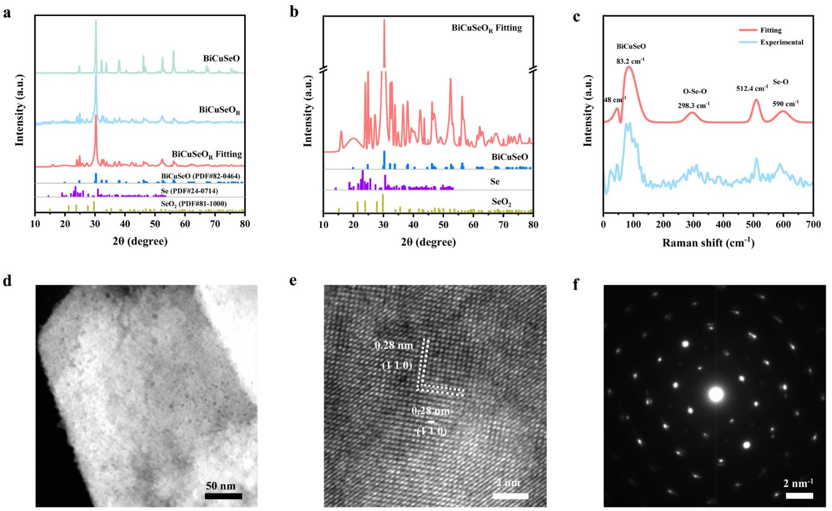
Fig. S9 (a) Comparisons of XRD patterns for pristine BiCuSeO, experimental BiCuSeO_{R} and fitting BiCuSeO_{R}. (b) The corresponding enlarged XRD pattern of BiCuSeO_{R} after fitting. (c) Raman spectrum of experimental and fitting BiCuSeO_{R.} The XRD pattern as-shown in Fig. S9a visibly displays that the dominant phase in BiCuSeO_{R} samples is composed of the tetragonal BiCuSeO phase (JCPDS card No. 82-0464). This result illustrates the BiCuSeO phase can be well retained during CO₂RR process. Further enlarging its XRD pattern, a small quantity of Se and SeO₂ phase are also observed, reasonably suggesting that Se atoms are escaped from Cu₂Se₂ layers through the interlayer space during electrochemical reaction process. Noteworthy, besides the peak at 83.2 cm⁻¹ corresponding to the in-plane motion of Cu atoms of BiCuSeO⁴, peaks at 298.3, 512.4 and 512.4 cm⁻¹ respectively corresponding to O-Se-O bending vibration mode (e_{g}), Se-O stretching vibration mode (e_{g}) and Se-O stretching vibration modes (a_{1g},) of solid SeO₂ are examined in the Raman spectrum of BiCuSeO_{R} sample⁸, further confirming the reservations of BiCuSeO phase and simultaneous escaping of Se atoms. Moreover, TEM image in Fig. S9c shows that the sheet-liked morphology remains essentially unchanged, which is good consistent with the SEM images. Close observation displays that the nanosheets contain numerous pores, which is probably ascribed to the escaping of Se atoms. Mutually perpendicular lattice fringe appearing in HRTEM and a single set of diffraction spots presenting in SAED demonstrate its single-crystalline nature. Taken together, the above results suggest that the geometric structure of BiCuSeO can be topologically maintained during CO₂RR process.

S10. q space curves of Fourier-transform EXAFS spectra
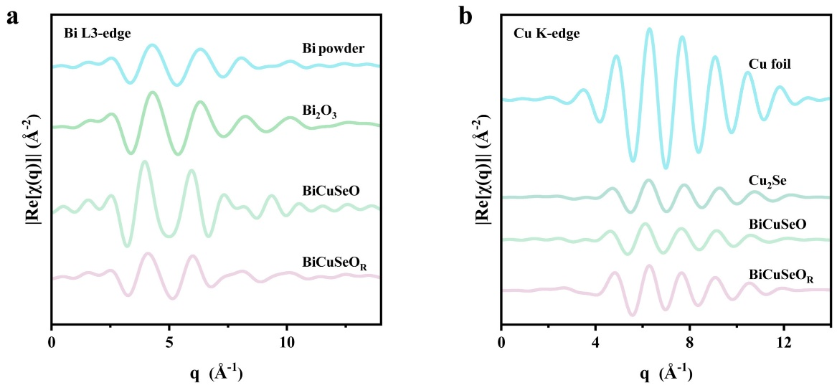
Fig. S10 q space curves of (a) Bi L3-edge and (b) Cu K-edge FT-EXAFS for BiCuSeO, BiCuSeO_{R} and reference samples.

S11 EXAFS R and k space fitting results
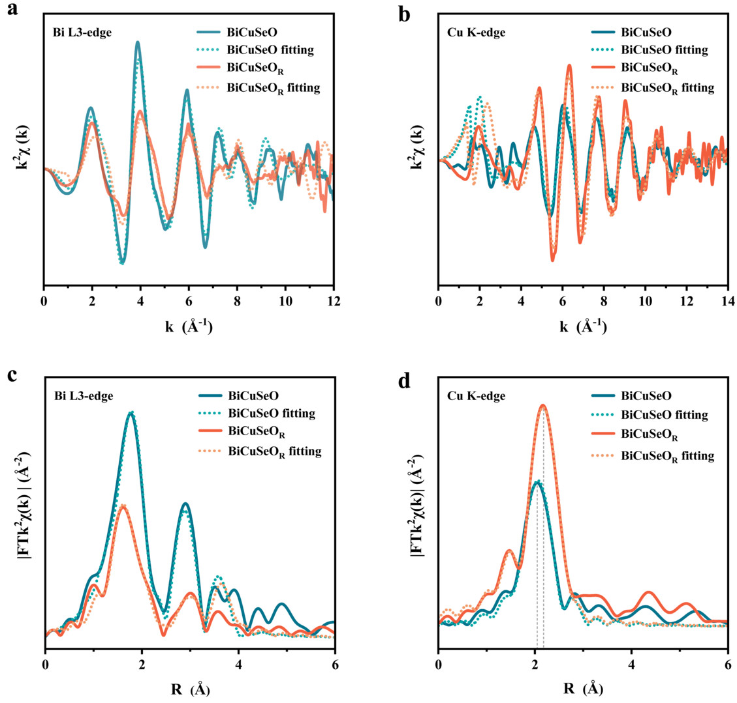
Fig. S11 Experimental and fitting data of k²χ(k) oscillation functions curves for (a) Bi L3-edge and (b) Cu K-edge EXAFS spectra. The corresponding Fourier-transform curves for (c) Bi L3-edge and (d) Cu K-edge EXAFS spectra. A good fitting quality with the curve fitting in k and R spaces can be obtained from Fig. S11.

S12. Bi L3-edge EXAFS fitting
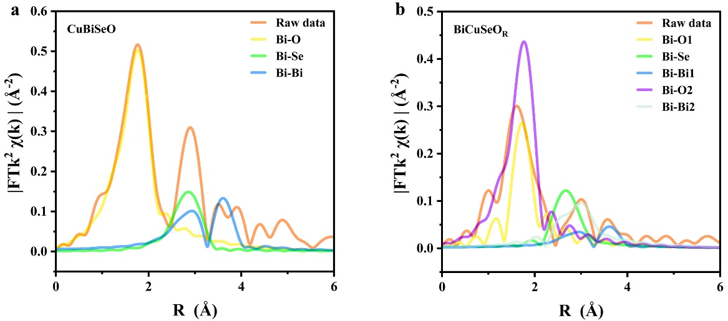
Fig. S12 Bi L3-edge EXAFS fitting curves of (a) BiCuSeO and (b) BiCuSeO_{R} samples. By fitting Bi L3-edge EXAFS of BiCuSeO_{R}, the first nearest backscattering path of Bi-O includes two coordination states of Bi-O1 and Bi-O2.

S13. Cu K-edge EXAFS Fitting
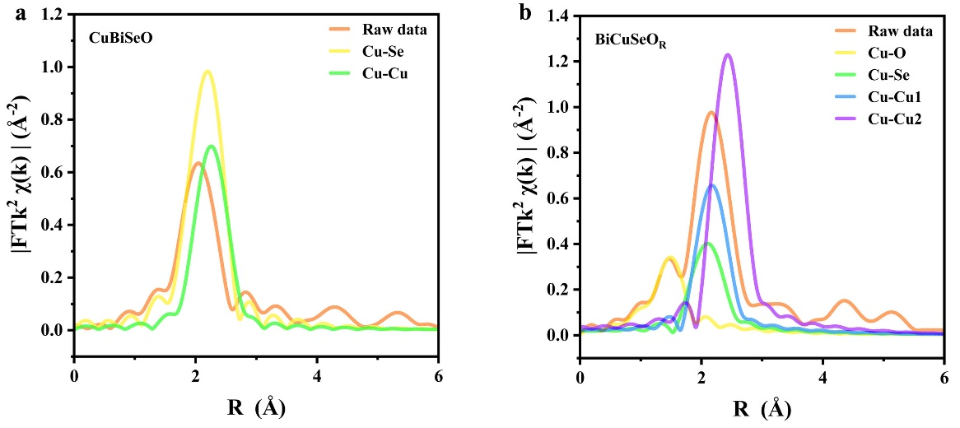
Fig. S13 Cu K-edge EXAFS fitting cures of (a) BiCuSeO and (b) BiCuSeO_{R} samples. By fitting Cu K-edge EXAFS of BiCuSeO_{R}, a new peak appearing at ~1.5 Å can be corresponded to Cu-O. Moreover, the sharply reducing peak intensity of Cu-Se evidentially illustrates that Se atoms escape from BiCuSeO during CO₂RR.

S14. Schematic illustration of in situ XAFS device
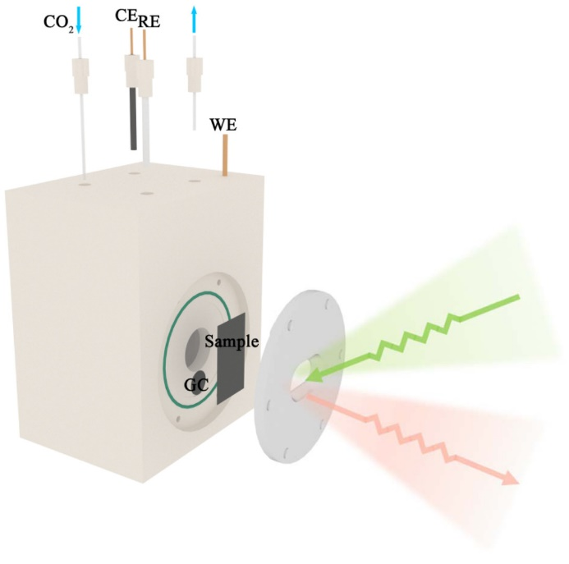
Fig. S14 Schematic illustration of in situ XAFS device. The working electrode (WE) is a catalyst-deposited on carbon paper (Sample), and connected by a glassy carbon electrode (GC). The reference electrode (RE) and counter electrode (CE) are Ag/AgCl and carbon rod, respectively. CO₂ gas is supplied before in situ XAFS test. Electrolyte is 0.5 M KHCO₃ solution.
S15. In situ Cu K-edge XAFS spectra of BiCuSeO at different potentials
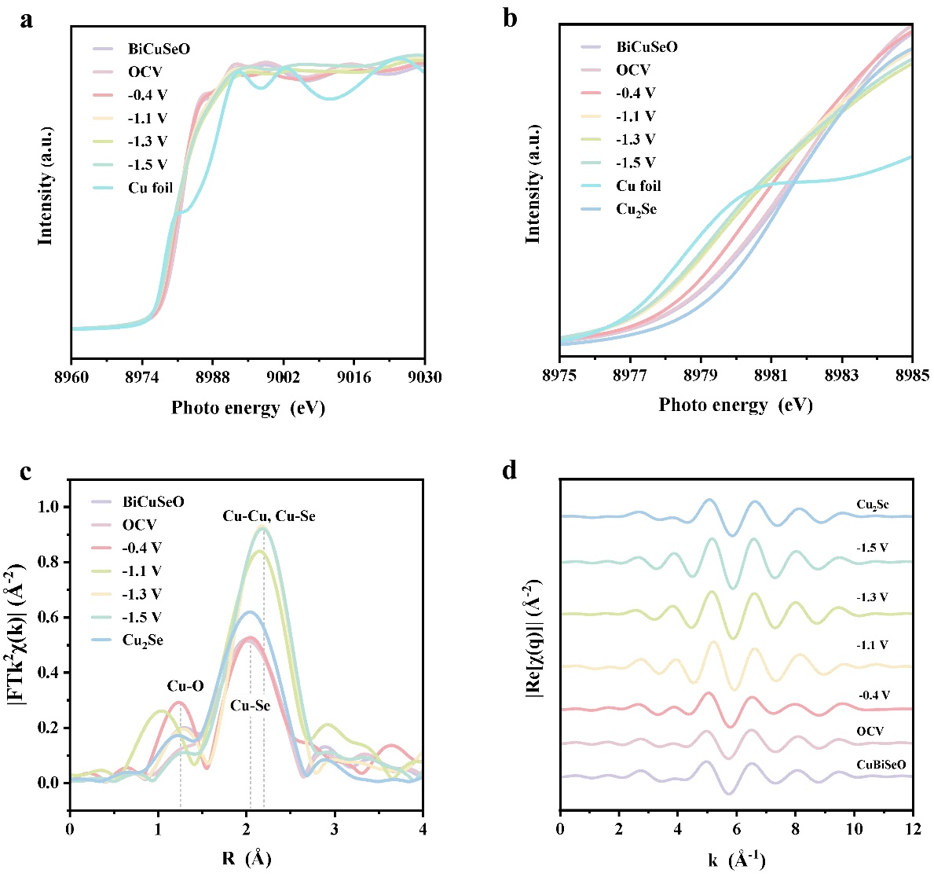
Fig. S15 (a, b) Cu K-edge XANS spectra of BiCuSeO at different potentials and Cu fiols. (c) Corresponding Fourier transform of Cu K-edge EXAFS spectra of BiCuSeO at different potentials and Cu fiols. (d) Fitted k-space EXAFS spectra of BiCuSeO at different potentials and Cu foils reference. In order to monitor the structural changes of BiCuSeO during the CO₂RR, in situ XAFS measurement is conducted. From the Cu K-edge XANES spectra, the absorption edge and white line peak of BiCuSeO under OCV aligns well with pristine BiCuSeO and Cu₂Se sample, suggesting its monovalent feature. As the potential is decreased from -0.4 V to -1.3 V, the absorption edge shifts to lower energy gradually and keeps unchanged at -1.5 V. This combined with the EXAFS spectra indicate the massive escape of Se atoms. A new peak at ~1.29 Å corresponding to the Cu-O bond occurs in EXAFS spectra suggests O entrance. It is worth noting that there remain peak features in the R=1~4 Å range under all operating potentials, BiCuSeO structure can be maintained to a great degree. Taken together, the above results illustrate Cu-Se bonds breaking, Se atoms escaping, concomitant O entrance and Cu aggregation take place in BiCuSeO under CO₂RR.

S16. Structural characterization of Bi₂O₃ before and after CO₂RR
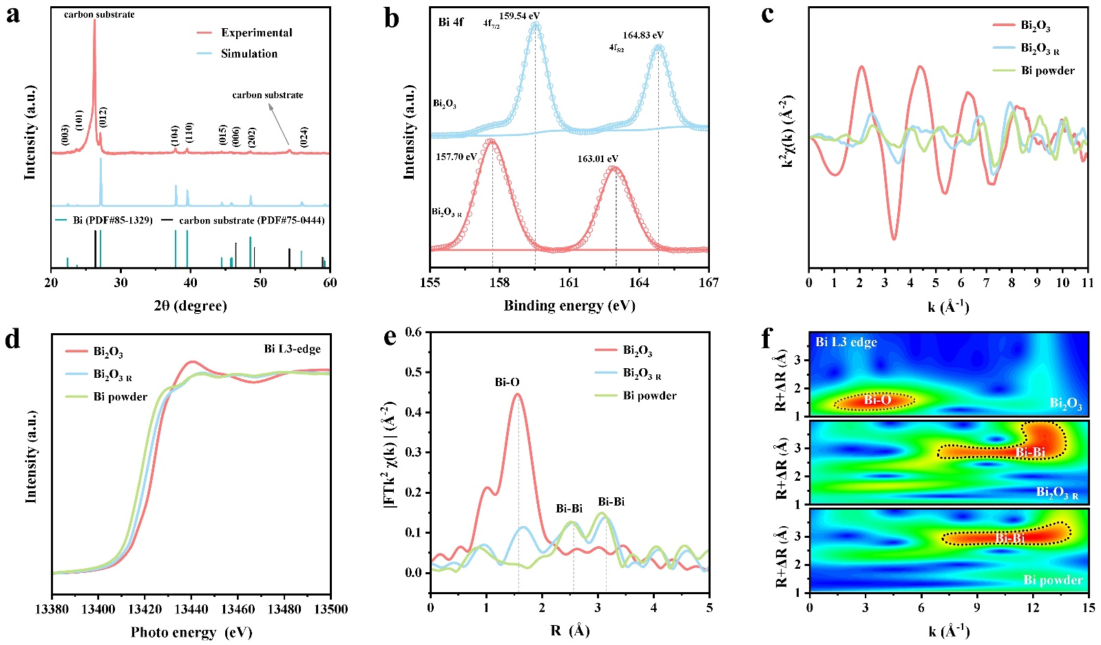
Fig. S16 (a) XRD pattern. (b) Bi 4f XPS spectra. (c) Bi L3-edge EXAFS k²(χk) oscillation functions curves. (d) XNES spectra. (e) EXAFS spectra. (f) Wavelet transform of the k³-weighted EXAFS data (WT-EXAFS). Bi₂O₃ before and after CO₂RR are named as Bi₂O₃ and Bi₂O₃ _{R} respectively. Bsides the peaks of Carbon substrate for catalysts depositing, all the peaks in the XRD pattern can correspond to Bi (PDF# 85-1329), suggesting that Bi₂O₃ is reduced to metallic Bi after CO₂RR. Peaks corresponding to zero valent metal in Bi 4f XPS spectra further confirm the easy self-reduction of Bi₂O₃ during electrocatalytic CO₂ reduction reaction. Bi L3-edge EXAFS k²(χk) oscillation functions curves, XNES spectra, EXAFS spectra and WT-EXAFS consistently display that Bi₂O₃ are mostly reduced to the metal bismuth after CO₂RR.

S17. The structural characterization of Cu₂Se before and after CO₂RR
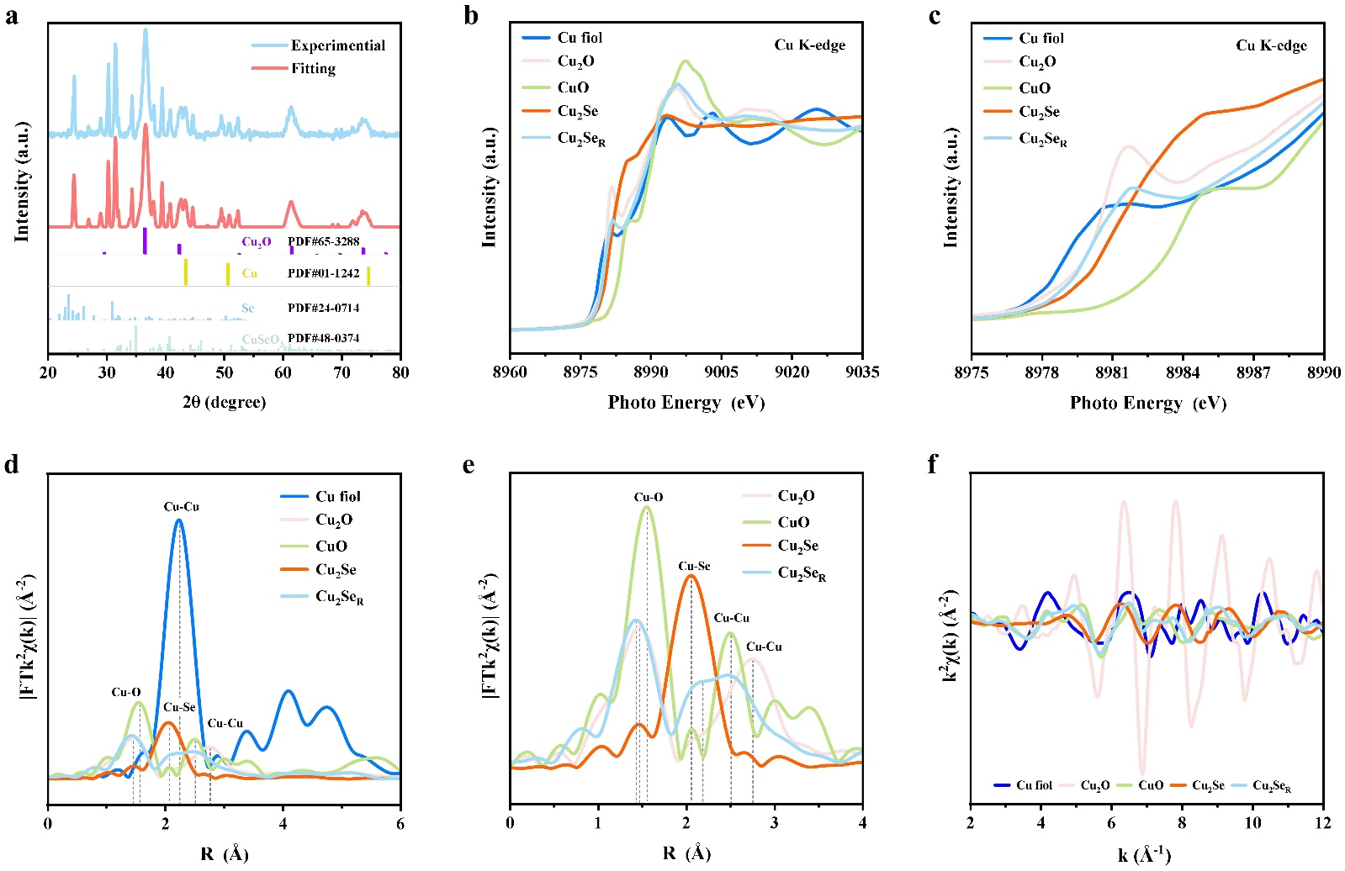
Fig. S17 (a) Experimental and fitting XRD pattern. (b, c) Cu K-edge XANES of Cu₂Se, Cu₂Se_{R} and reference samples. (d, e) FT-EXAFS spectra of Cu₂Se, Cu₂Se_{R} and reference samples. (f) Cu K-edge EXAFS k²(χk) oscillation functions curves of Cu₂Se, Cu₂Se_{R} and reference samples. XRD pattern shows that Cu₂Se is dominantly transformed into Cu₂O and Cu, complying a small quality of CuSeO₃. XANES and EXAFS spectra also demonstrates that valence states of Cu atoms in Cu₂Se_{R} include the mixture of monovalent and divalent Cu, which is consistent with the XRD results.

S18. XPS spectra of Cu₂Se before and after CO₂RR
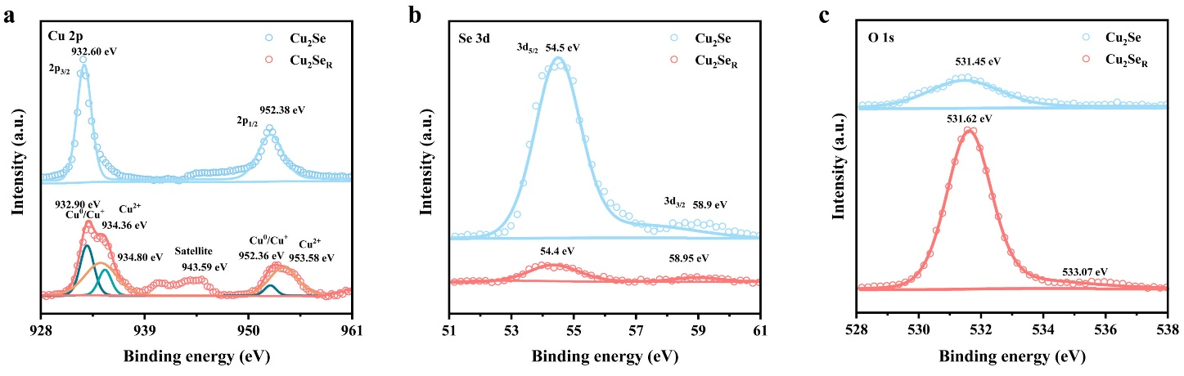
Fig. S18 XPS spectra of Cu₂Se before and after CO₂RR. (a) Cu 2p, (b) Se 3d, and (c) O 1s XPS spectra of Cu₂Se after CO₂RR. After CO₂RR, typical peaks of Cu⁰, Cu⁺ and Cu²⁺ can be observed in the Cu 2p XPS spectra, indicating partial Cu is reduced and oxidized. Moreover, the peak of the Se 3d_{5/2} for Cu₂Se after CO₂RR shows a sharp decrease, suggesting the massive escaping of Se atoms. Meanwhile, greatly enhanced peak intensity of O1s reveals that the entrance of O. XPS results are in well agreed with the XRD, XANES and EXAFS analyses.

S19 Structural models for DFT calculations
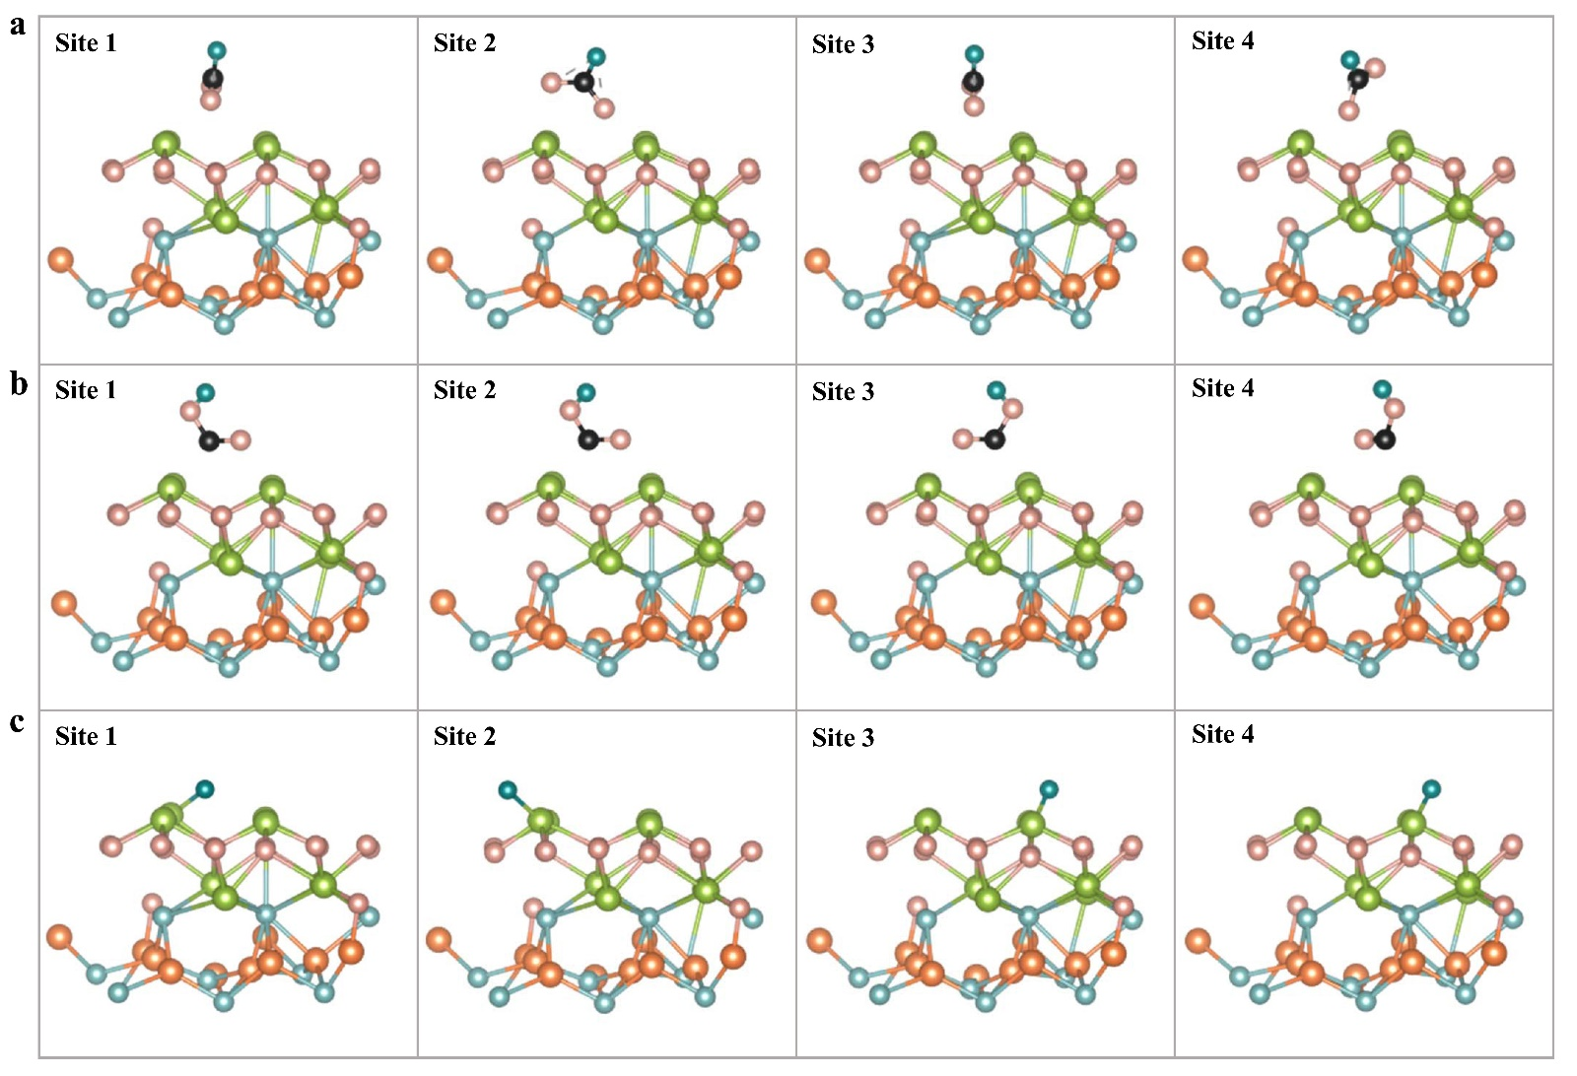
Fig. S19 Structural model for DFT calculations. (a) HCOO* formation. (b)*COOH formation. (c) HER

S20 Charge difference density
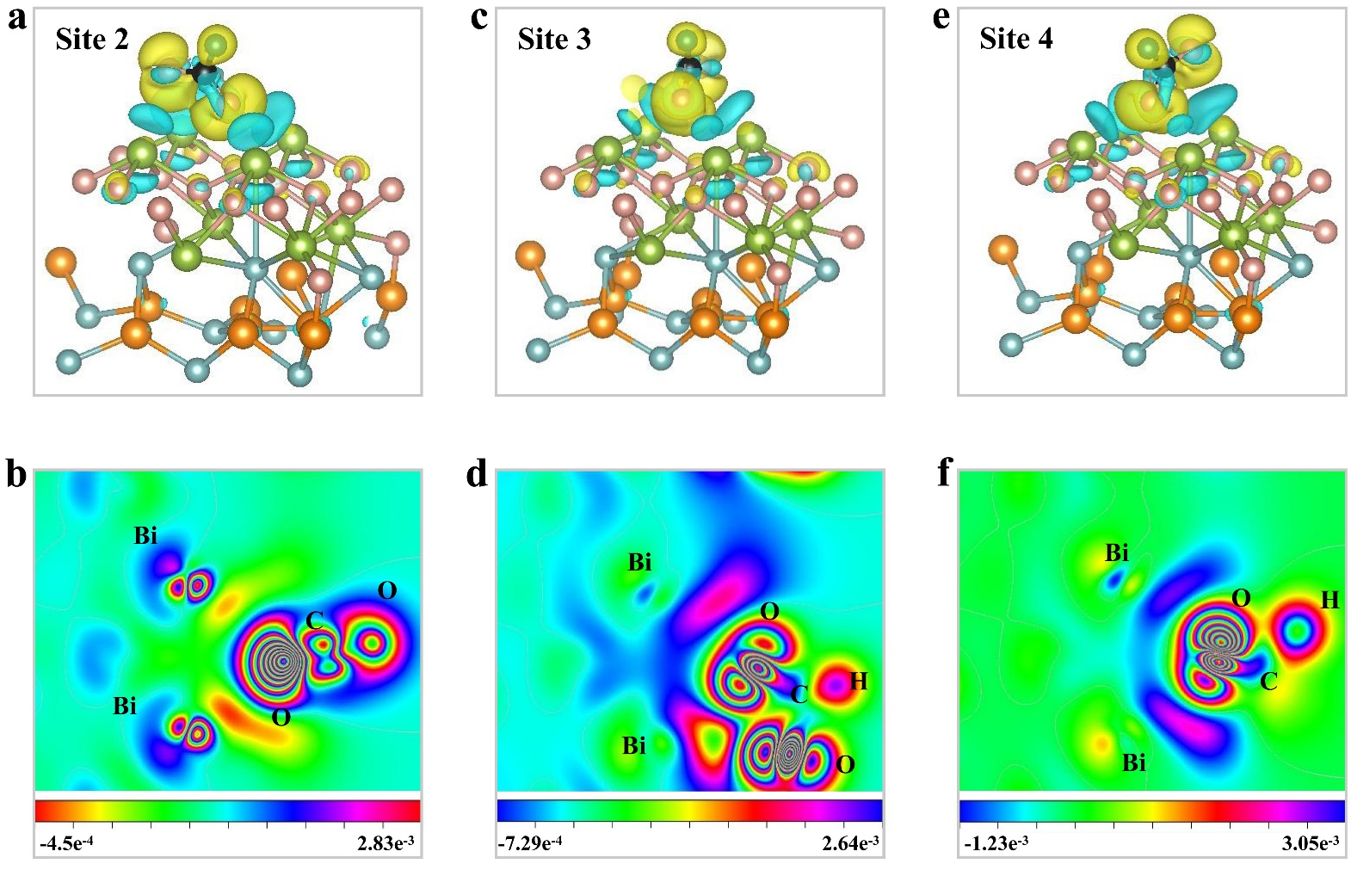
Fig. S20 Charge difference density of HCOO* absorbed on BiCuSeO_{R} on site 2-4. (a, b) Site 2. (c, d) Site 3. (e, f) Site 4.

S21 Total DOS
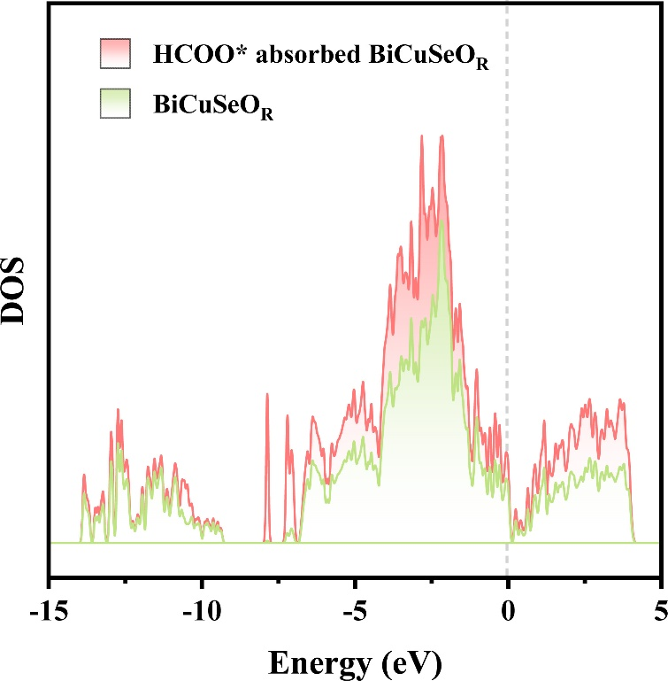
Fig. S21 Total DOS comparisons of BiCuSeO_{R} and HCOO* absorbed on BiCuSeO_{R.}

S22 PDOS of Bi and HCOO*
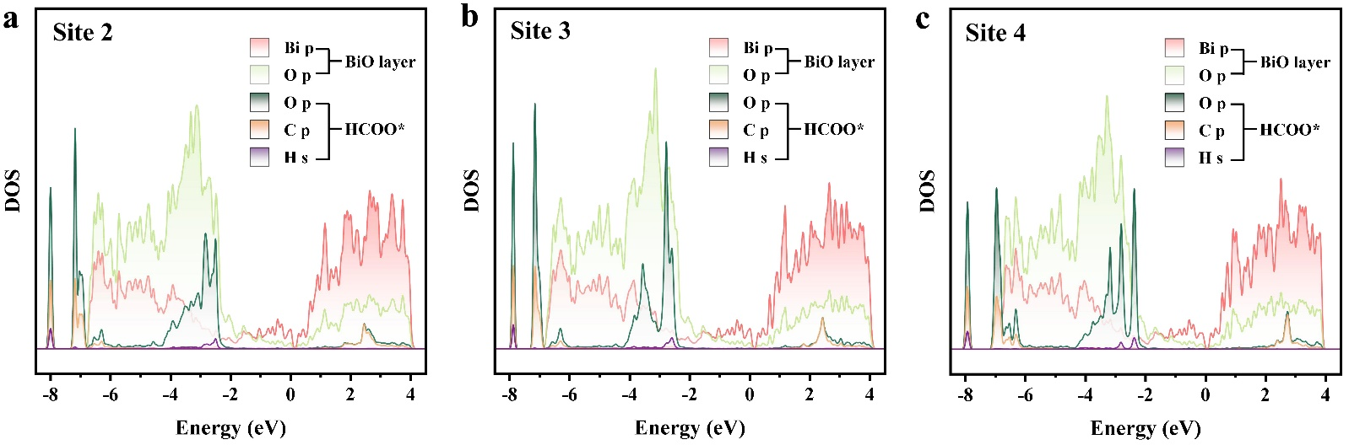
Fig. S22 PDOS of p orbitals for Bi and O atoms in BiO layer, PDOS of p orbitals for O and C atoms from HCOO*, and PDOS of s orbital from the adsorbed HCOO*.

Table S1. EXAFS curves fitting results
XAS edge | Sample | Shell | N | R(Å) | σ²*10³ (Å²) | R-factor (%)
Bi L3-edge | Bi₂O₃ | Bi-Bi | 3 | 3.06 | / | /
Bi L3-edge | Bi₂O₃ | Bi-O | 3 | 2.13 | / | /
Bi L3-edge | BiCuSeO | Bi-O | 4 | 2.29 | 8.9 | 1.2
Bi L3-edge | BiCuSeO | Bi-Se | 8 | 3.25 | 15.0
Bi L3-edge | BiCuSeO | Bi-Bi | 4 | 3.72 | 15.3
Bi L3-edge | BiCuSeO_{R} | Bi-O1 | 0.4 | 2.13 | 6.1 | 0.6
Bi L3-edge | BiCuSeO_{R} | Bi-O2 | 2.5 | 2.27 | 4.5
Bi L3-edge | BiCuSeO_{R} | Bi-Bi1 | 0.3 | 3.09 | 3.3
Bi L3-edge | BiCuSeO_{R} | Bi-Se | 0.8 | 3.15 | 5.2
Bi L3-edge | BiCuSeO_{R} | Bi-Bi2 | 2.4 | 3.71 | 15.1
Cu K-edge | Cu foil | Cu-Cu | 12 | 2.56 | / | /
Cu K-edge | BiCuSeO | Cu-Se | 4 | 2.47 | 11.6 | 0.8
Cu K-edge | BiCuSeO | Cu-Cu | 4 | 2.72 | 9.4
Cu K-edge | BiCuSeO_{R} | Cu-O | 0.8 | 1.93 | 9.9 | 0.3
Cu K-edge | BiCuSeO_{R} | Cu-Se | 0.7 | 2.43 | 3.6
Cu K-edge | BiCuSeO_{R} | Cu-Cu | 4.0 | 2.58 | 12.5
N, coordination number; R, distance between absorber and backscatter atoms; σ², Debye-Waller factor to account for both thermal and structural disorders; R-factor (%) indicate the goodness of the fit. The obtained S₀² of Cu foil was 0.87 and it was fixed in the subsequent fitting of Cu foil K-edge data for the catalyst.The obtained S₀² of Bi₂O₃ standard was 0.79 and it was fixed in the subsequent fitting of Bi foil L3-edge data for the catalyst.

References
1. Zhao, L. D., et al. BiCuSeO oxyselenides: new promising thermoelectric materials. Energy Environ. Sci. 7, 2900-2924 (2014).
2. Samanta, M., Guin, S. N. & Biswas, K. Ultrathin few layer oxychalcogenide BiCuSeO nanosheets. Inorg. Chem. Front. 4, 84-90 (2017).
3. Zhu H, et al. Efficient interlayer charge release for high-performance layered thermoelectrics. Natl. Sci. Rev. 8, nwaa085 (2021).
4. Viennois, R. et al. Lattice dynamics study of thermoelectric oxychalcogenide BiCuChO (Ch = Se, S). J. Phys. Chem. C 123, 16046-16057 (2019).
5. Yang, B., Yang, J., Huang, Z., Qin, L., Lin, H. & Li, Q. Green fabrication of large-size Cu₂Se hexagonal sheets with visible light photocatalytic activity. Appl. Surf. Sci. 535, 147712 (2021).
6. Bohra, D., Ledezma-Yanez, I., Li, G., de Jong, W., Pidko, E. A. & Smith WA. Lateral adsorbate interactions inhibit HCOO- while promoting CO selectivity for CO₂ electrocatalysis on silver. Angew. Chem. Int. Ed. 58, 1345-1349 (2019).
7. Chernyshova, I. V., Somasundaran, P. & Ponnurangam, S. On the origin of the elusive first intermediate of CO₂ electroreduction. Proc. Natl Acad. Sci. USA 115, E9261-E9270 (2018).
8. Stanila, D., Smith, W. & Anderson, A. Raman spectra of selenium dioxide at high pressures. Spectrosc. Lett. 33, 555-567 (2000).

