Table of Contents
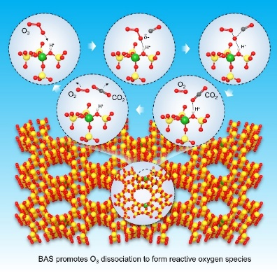
To address the issue of CO emission in industrial applications, we have developed a cost-effective proton-type beta zeolite catalyst with good resistance to water and sulfur. Brønsted acid sites (BAS) in protonated zeolites can effectively activate O₃ to generate reactive oxygen species for efficient CO oxidation.

