Brønsted Acid Sites in Zeolites Activate Ozone to Generate Reactive Oxygen Species for CO Oxidation
Lingcong Li,^{1,2}* Akihiko Anzai,² Yixin Chen,² Shunsaku Yasumura,⁴ Nobutaka Maeda,⁵ Yucheng Qian,² Sida Ren,⁶ Ningqiang Zhang,^{2,3}* Zhen Zhao,¹ Takashi Toyao,² Ken-ichi Shimizu^{2,5}*
¹ Institute of Catalysis for Energy and Environment, College of Chemistry and Chemical Engineering, Shenyang Normal University, Shenyang 110034, P. R. China
² Institute for Catalysis, Hokkaido University, N-21, W-10, Sapporo 001-0021, Japan
³ School of Resources and Civil Engineering, Northeastern University, Shenyang 110819, P. R. China
⁴ Institute of Industrial Science, The University of Tokyo, Tokyo 153-8505, Japan
⁵ The Center for Energy Systems Design (CESD), International Institute for Carbon-Neutral Energy Research (WPI-I2CNER), Kyushu University, 744 Moto-oka, Fukuoka 819-0395, Japan
⁶ Shougang Group Research Institute of Technology, Beijing 100043, China

Corresponding author:
*Lingcong Li (lilingcong@synu.edu.cn)
*Ningqiang Zhang (zhangningqiang@mail.neu.edu.cn)
*Ken-ichi Shimizu (kshimizu@cat.hokudai.ac.jp)

Number of Pages: 9
Number of Figures: 6
Number of Tables: 1

Experimental Sections
Catalysts preparations
Proton-type H beta zeolites with a Si/Al ratio of 5 (Hβ5) was obtained by calcining the NH₄⁺-type β zeolite (Mitsui Mining & Smelting Co., Ltd.). The Hβ20, Hβ50, and Hβ255 (the number represents the Si/Al ratio) were purchased from Tosoh Co. (product no. HSZ-940HOA, HSZ-960HOA and HSZ-980HOA, respectively). HMOR (Si/Al = 10) and HY (HSZ-960HOA, Si/Al = 50) were also purchased from Tosoh Co. HCHA was prepared by calcination of a NH₄⁺-form CHA (Tosoh, Si/Al = 12) at 600 °C for 3 h in air. HZSM-5 (Si/Al = 75) was purchased from N.E. CHEMCAT Co. Amorphous silica-alumina (Al₂O₃ = 13.75 wt%, JRC-SAL-2) was supplied by Japanese Catalysis Society. γ-Al₂O₃ was obtained by calcination of boehmite (CATAPAL B, Sasol) at 900 °C for 3 h. CeO₂ (type A) and ZrO₂ were supplied by Daiichi Kigenso Kogyo. ZrO₂ was calcined at 700 °C for 2 h under flow air before use. MnO₂ was prepared by a facile hydrothermal redox reaction of MnSO₄·H₂O (Alfa Aesar), (NH₄)₂S₂O₈ (Wako Pure Chemical), and (NH₄)₂SO₄ (Wako Pure Chemical). First, the mixtures were dissolved in 40 mL of distilled water, and then transferred to a 100 mL Teflon bottle, which was sealed tightly in a stainless-steel autoclave. The autoclave was placed in an electrical oven, heated to 120 °C, and kept at that temperature for 20 h. After the autoclave had cooled to room temperature, the precipitate was washed with distilled water. The resulting powder was calcined in air at 400 °C for 5 h to obtain MnO₂. Pt/CeO₂ was prepared by impregnation method as follows. Aqueous solution of (NH₃)₂Pt(NO₃)₂ (KFK Factory, Japan) was added to CeO₂ (type A, Daiichi Kigenso Kogyo), followed by evaporation at 50 °C, and by drying in an oven at 90 °C, and by calcination in air at 500 °C for 3 h. Au/CeO₂ (RR2Ce-1), prepared by the deposition precipitation method, purchased from Haruta Gold Inc.
Powder XRD measurements were carried out on a Rigaku MiniFlex II/AP diffractometer with Cu Kɑ radiation.

Catalytic test
Prior to catalytic tests, the catalysts were pretreated at 500 °C under 10% O₂/He for 10 min. Typically, the catalyst (50 mg) was placed on quartz wool in the middle of the reactor, which was set in an electric tube furnace and heated to 150 °C under a 0.5% CO + 1% O₃ + 9% O₂ flow with He as a balance (total gas flow: 100 mL min⁻¹). O₃ was fed to the flow system by passing O₂ flow into an ozonizer (F0G-AC5G, EcoDesign Inc.). The concentration of CO, O₃, and CO₂ in the outlet gas was quantitatively analyzed using an IR spectrometer (JASCO FT/IR-4600) combined with a home-made gas cell. The area intensity of the O₃ band (1071-968 cm⁻¹) was calibrated employing an O₃ analyzer (EG-550, EcoDesign Inc.) to convert the area into concentration. For kinetic analysis, the catalyst weight was adjusted to keep the CO and O₃ conversions below 30%.
Modulation excitation (ME) DRIFTS
Diffuse reflectance infrared Fourier transform (DRIFT) spectra were collected from 4000 to 900 cm⁻¹ at a resolution of 4 cm⁻¹ and scanner velocity of 80 kHz using an FT/IR-4600 spectrometer (JASCO) equipped with a MCT detector. The sample and background spectra resulted from averaging 5 and 15 scans, respectively. Approximately 40 mg of each sample was loaded into the DR-600Ai spectroscopic cell, which was equipped with a 2-mm-thick zinc selenide window (Pie Optics Co., Ltd. Japan). For deuteration of the sample, 4 μL of D₂O was dropped onto the sample in the DRIFTS cup, followed by heating under a He stream at 150 °C for 10 min to deuteroxylate the surface hydroxyl groups. The sample was then heated to 500 °C for 10 min to remove excess water, cooled to 100 °C under 10% O₂/He, and the background spectrum was recorded under He. For the operando experiments, various mixtures of 0.5% CO + 5% O₂ balanced in He were admitted to the cell. During each period, the concentration of O₃ was switched between 0 and 0.5%. The total flow for all experiments was fixed at 100 mL min⁻¹.
DFT calculations
Spin-polarized DFT calculations were conducted using the Perdew–Burke–Ernzerhof (PBE) functional^{[1]} within the generalized-gradient approximation (GGA), as implemented in the Vienna Ab Initio Simulation Package (VASP).^{[2,3]} The projected augmented waves method^{[4,5]} was applied to solve the Kohn–Sham equations^{[6,7]} with a cut-off energy set at 500 eV. The Brillouin zone was sampled at the Γ point. DFT-D3 dispersion correction with Becke–Johnson damping was considered in all calculations.^{[8,9]} The structure of beta zeolite was sourced from the International Zeolite Association database^{[10]}, with lattice constants fixed at their initial values (a = b = 12.632 Å, c = 26.186 Å, α = β = γ = 90.0°) throughout the calculations. The intermediate structures in the climbing-image nudged elastic band (CI–NEB) calculations were optimized using the conjugate gradient method, as implemented in VTST-Tools.^{[11]} During the CI–NEB calculations, a spring constant of 5.0 eV/Å² was applied between adjacent images, and the calculations were considered converged when the maximum force on any atom fell below 0.05 eV/Å.

Table S1
CO oxidation by ozone over 50 mg catalysts under 0.5% CO + 1% O₃ + 9% O₂ + He at 150 °C.
Catalyst | CO conv. | O₃ conv.
Hβ (Si/Al = 5) | 100 | 98
Hβ (Si/Al = 20) | 76 | 74
Hβ (Si/Al = 50) | 50 | 60
Hβ (Si/Al = 255) | 25 | 36
HMOR (Si/Al = 10) | 63 | 100
HZSM-5 (Si/Al = 15) | 53 | 100
HY (Si/Al = 50) | 3 | 9
HCHA (Si/Al = 12) | 35 | 51
SiO₂/Al₂O₃ (Si/Al = 5) | 15 | 35
Al₂O₃ | 22 | 90
CeO₂ | 2 | 100
ZrO₂ | 2 | 99
MnO₂ | 51 | 100

Figure S1. CO and O₃ conversions over 25 mg of Hβ20.

Figure S2. CO and O₃ conversions over 25 mg of Hβ255.

Figure S3. CO and O₃ conversions at 100 °C over Hβ5 as functions of the catalyst weight.

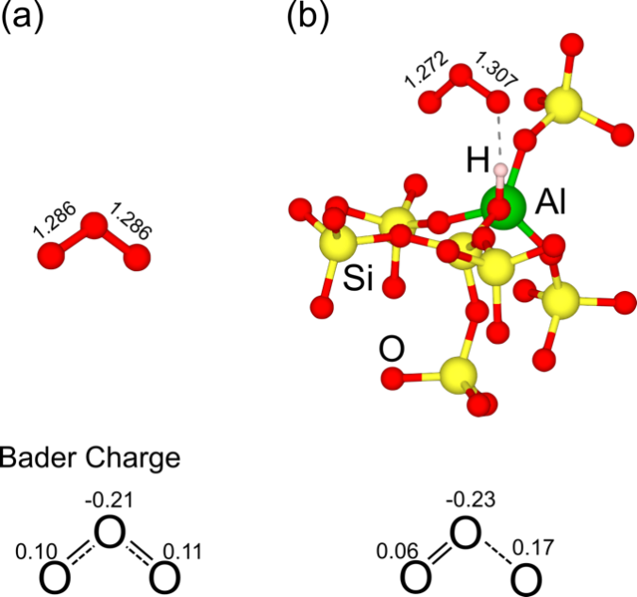
Figure S4. Structures of (a) isolated O₃ and (b) O₃ adsorbed on the acid site of the zeolite. The O–O bond lengths are shown (unit: Å). The calculated Bader net charges of the O atoms are given below.

Figure S5. Time course of CO and O₃ conversion over 50 mg of Hβ5 and 300 mg of Hβ255 in 0.5% CO + 0.5% O₃ + 4.5% O₂ + 1% H₂O + 40 ppm SO₂ at 175 °C. The number of Brønsted acid sites in 300 mg of Hβ255 is close to that in 50 mg of Hβ5.
Figure S6. XRD patterns of Hβ5 (A) and Hβ255 (B) before and after the catalytic tests under 0.5% CO + 0.5% O₃ + 4.5% O₂ + 1% H₂O + 40 ppm SO₂ at 175 °C for 16 h.

Reference
- Perdew, J. P.; Burke, K.; Ernzerhof, M. Generalized gradient approximation made simple. Phys. Rev. Lett.77 (18), 3865 (1996).
- Kresse, G.; Furthmüller, J. Efficient iterative schemes for Ab initio total-energy calculations using a plane-wave basis set. Phys. Rev. B. 54 (16), 11169 (1996).
- Kresse, G.; Furthmüller, J. Efficiency of Ab-initio total energy calculations for metals and semiconductors using a plane-wave basis set. Comput. Mater. Sci.6 (1), 15–50 (1996).
- Blöchl, P. E. Projector augmented-wave method. Phys. Rev. B.50 (24), 17953 (1994).
- Kresse, G.; Joubert, D. From ultrasoft pseudopotentials to the projector augmented-wave method. Phys. Rev. B. 59 (3), 1758 (1999).
- Hohenberg, P.; Kohn, W. Inhomogeneous electron gas. Phys. Rev. 136 (3B), B864 (1964).
- Kohn, W.; Sham, L. J. Self-consistent equations including exchange and correlation effects. Phys. Rev.140 (4A), A1133 (1965).
- Grimme, S.; Ehrlich, S.; Goerigk, L. Effect of the damping function in dispersion corrected density functional theory. J. Comput. Chem.32 (7), 1456–1465 (2011).
- Grimme, S.; Antony, J.; Ehrlich, S.; Krieg, H. A consistent and accurate Ab initio parametrization of density functional dispersion correction (DFT-D) for the 94 elements H-Pu. J. Chem. Phys. 132 (15) (2010).
- Ch. Baerlocher, D. B. B. M. and L. B. M. Database of zeolite structures. Http://Www.Iza-Structure.Org/Databases/. (2024).
- Henkelman, G.; Uberuaga, B. P.; Jónsson, H. A climbing image nudged elastic band method for finding saddle points and minimum energy paths. J. Chem. Phys.,113 (22), 9901–9904 (2000).

