Supplemental Table 1. HPV distribution by ethnicity among HPV-positive individuals
 |  | HR-Normal (N = 94) |  |  | Dysplasia (N = 63)
 |  | TX Non-Hispanic White  (N = 24) | TX Hispanic  (N = 24) | PR Hispanic  (N = 46) | TX Non-Hispanic White  (N = 22) | TX Hispanic  (N = 20) | PR Hispanic  (N = 21)
Infection Type†
 | Single | 17 (70.8) | 9 (37.5) | 17 (37.0) | 15 (68.2) | 13 (65.0) | 12 (57.1)
 | Multiple | 7 (29.2) | 15 (62.5) | 29 (63.0) | 7 (31.8) | 7 (35.0) | 9 (42.9)
Vaccine Inclusion‡
 | No | 14 (58.3) | 16 (66.7) | 36 (78.3) | 16 (72.7) | 9 (45.0) | 10 (47.6)
 | Yes | 10 (41.7) | 8 (33.3) | 10 (21.7) | 6 (27.3) | 11 (55.0) | 11 (52.4)
Abbreviations: HR-Normal = high-risk normal; TX = Texas; PR = Puerto Rico; HPV = human papillomavirus
† Infection type indicates whether one or more HPV genotypes were detected in the sample.
‡ Vaccine inclusion indicates whether all detected HPV genotypes are included in the available HPV vaccines (Cervarix, Gardasil, and Gardasil9)
Supplemental Table 2. Clinical status and patient characteristics of Hispanic dysplasia individuals
 |  | TX Hispanic | PR Hispanic
 |  | (N = 30) | (N = 29)
Age (yrs.)
 | Mean (SD) | 43.3 (9.4) | 35.5 (8.6)
BMI (kg/$m^{2}$)
 | Mean (SD) | 31.2 (8.4) | 29.7 (6.2)
Smoking Status
 | No | 19 (63.3) | 24 (82.8)
 | Yes | 10 (33.3) | 3 (10.3)
 | Unknown | 1 (3.3) | 2 (6.9)
Histology
 | LGSIL | 22 (73.3) | 12 (41.4)
 | HGSIL | 8 (26.7) | 17 (58.6)
HPV Status
 | HPV 16 | 5 (16.7) | 7 (24.1)
 | High-Risk † | 15 (50.0) | 14 (48.3)
 | Other ‡ | 10 (33.3) | 8 (27.6)
Abbreviations: TX = Texas; PR = Puerto Rico; SD = standard deviation; BMI = body mass index; LGSIL = low-grade squamous intraepithelial lesion; HGSIL = high-grade squamous intraepithelial lesion; HPV = human papillomavirus
† High-risk includes HPV 18, 26, 31, 33, 35, 39, 45, 51, 52, 56, 58, 59, 68, 69, 73, and 82
‡ Other includes HPV low-risk genotypes, HPV-negative, and unknown HPV status

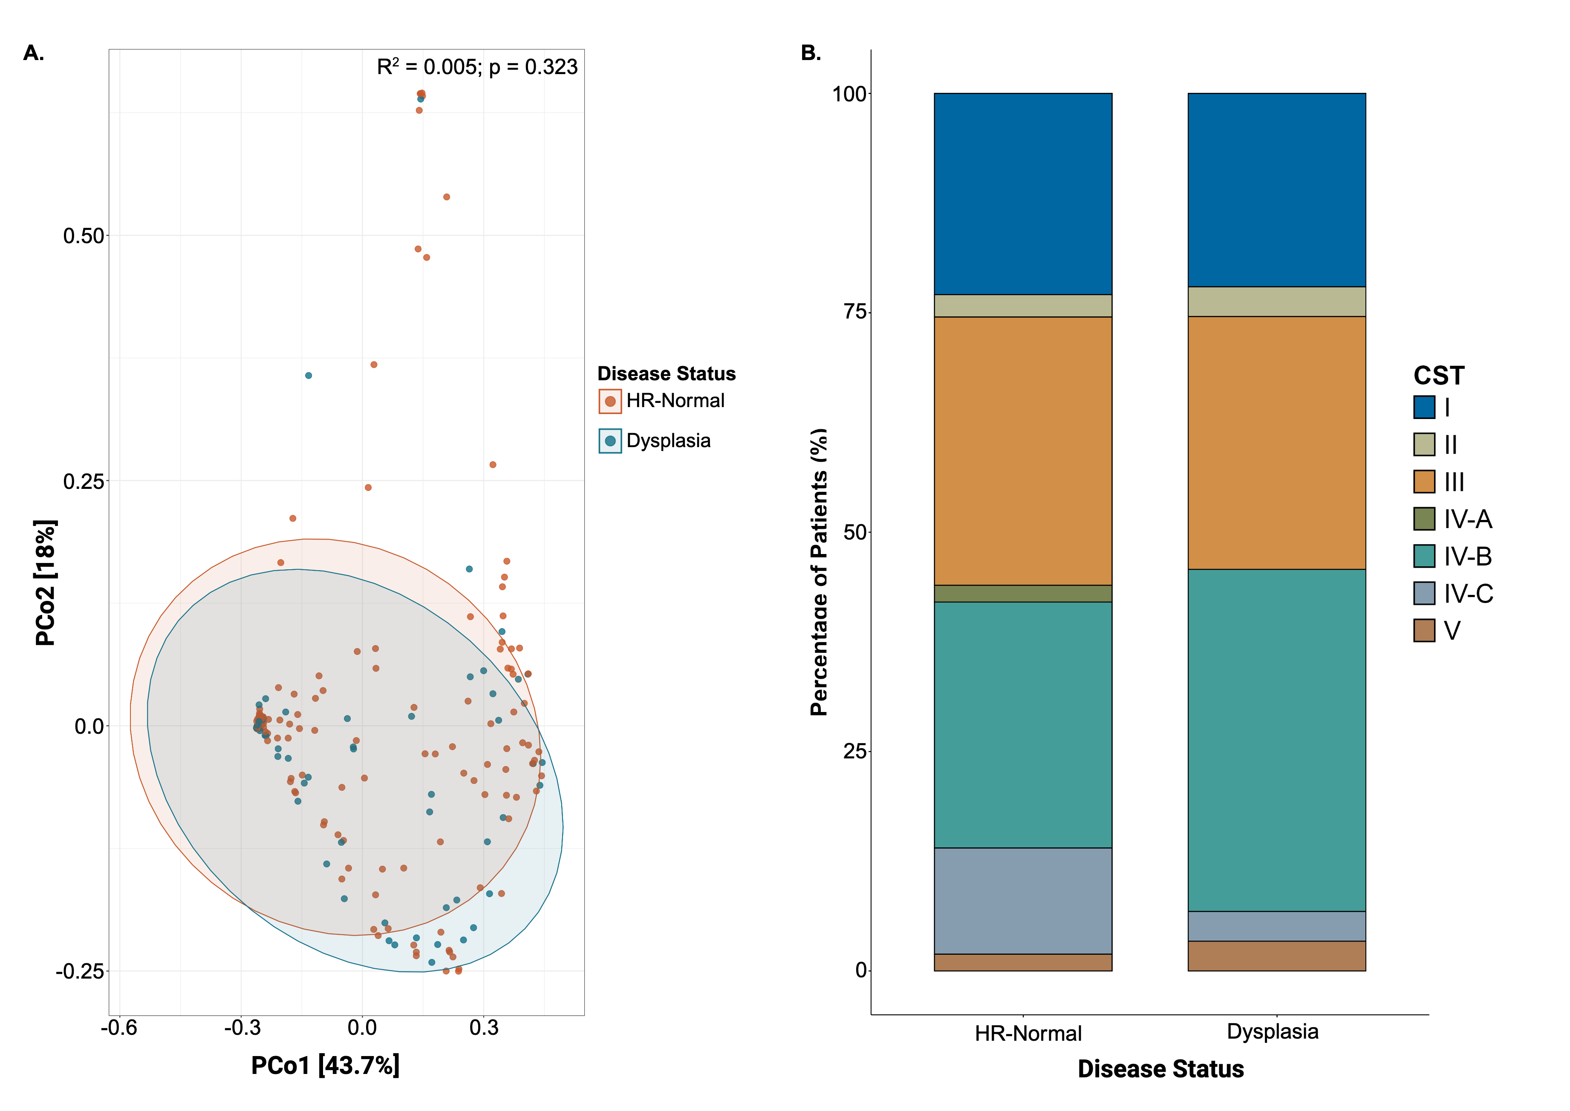
Supplemental Figure 1. Cervical microbiome community composition association with patient disease state. (A) Principal coordinate analysis of beta diversity employing weighted UniFrac, along with subsequent analysis using PerMANOVA. (C) Stacked bar plot summarizing the distribution of CSTs across the two disease states. Abbreviations: TX = Texas; PR = Puerto Rico; HR-Normal = high-risk normal; CST = community state types.

