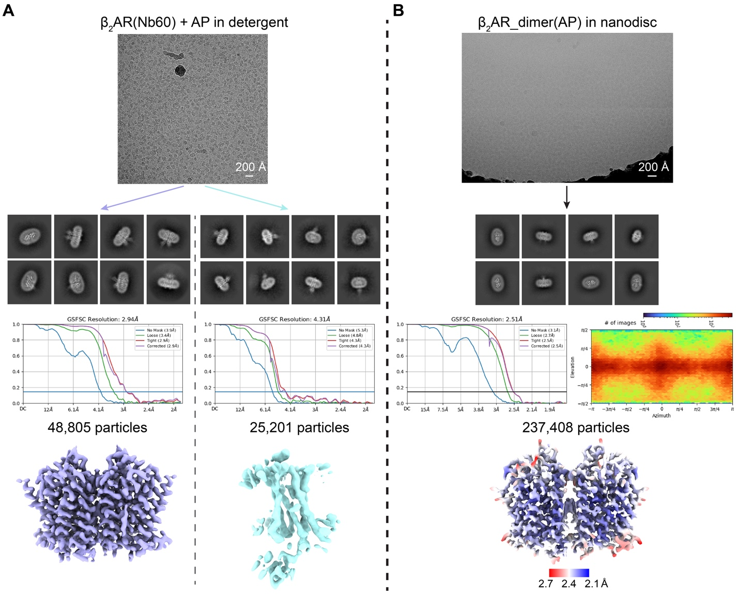
Supplementary Fig. 1: Cryo-EM structural determination of AP-bound β₂AR. Representative micrographs, 2D class averages, gold-standard Fourier shell correlation (GSFSC) curves, and final maps of A, β₂AR bound to Nb60 in detergent with AP added post-purification and B, AP-bound β₂AR dimer in nanodiscs. Dimeric and monomeric particles were processed separately after 2D classification to reconstruct final maps of the dimer (lavender) and monomer (cyan) in A. The direction distribution of particles and local resolution heat map for the final reconstruction of β₂AR(AP)_dimer in nanodiscs are shown in B.

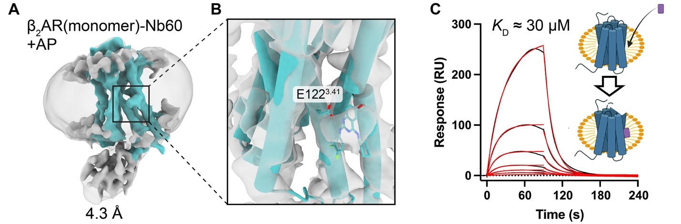
Supplementary Fig. 2: Cryo-EM structure and binding analysis of AP to monomeric β₂AR. A, Cryo-EM map of Nb60-bound monomeric β₂AR in the presence of AP. B, Evidence of AP binding to the monomer at a similar site as in the dimer. One protomer of the dimer (cyan) is fitted into the map. C, SPR sensorgrams (black) with corresponding kinetic fits (red) showing AP binding to surface-immobilized monomeric β₂AR in detergent. k_{on} = 1.92 ×10³ M⁻¹ s⁻¹, k_{off} = 6.02 ×10⁻² s⁻¹.
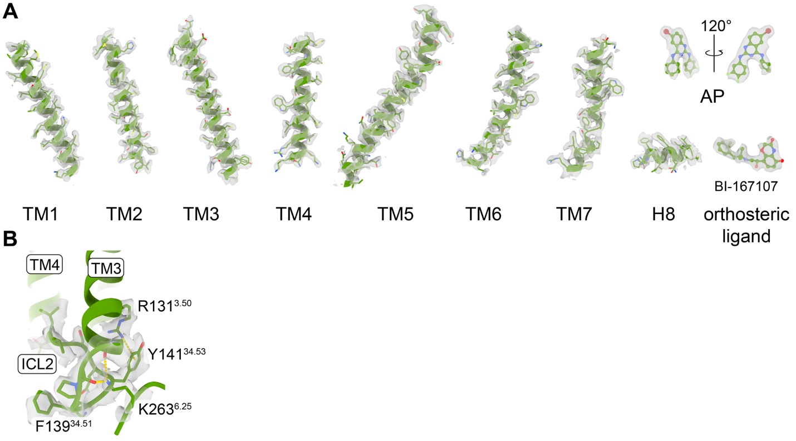
Supplementary Fig. 3: Model-to-map fit of the AP-bound β₂AR dimer structure in nanodiscs. A, Side chains of TM1–TM7, H8, AP, and the orthosteric ligand BI from one protomer are shown as sticks with corresponding cryo-EM densities overlaid. B, Conformational rearrangement near ICL2 with EM densities overlaid.

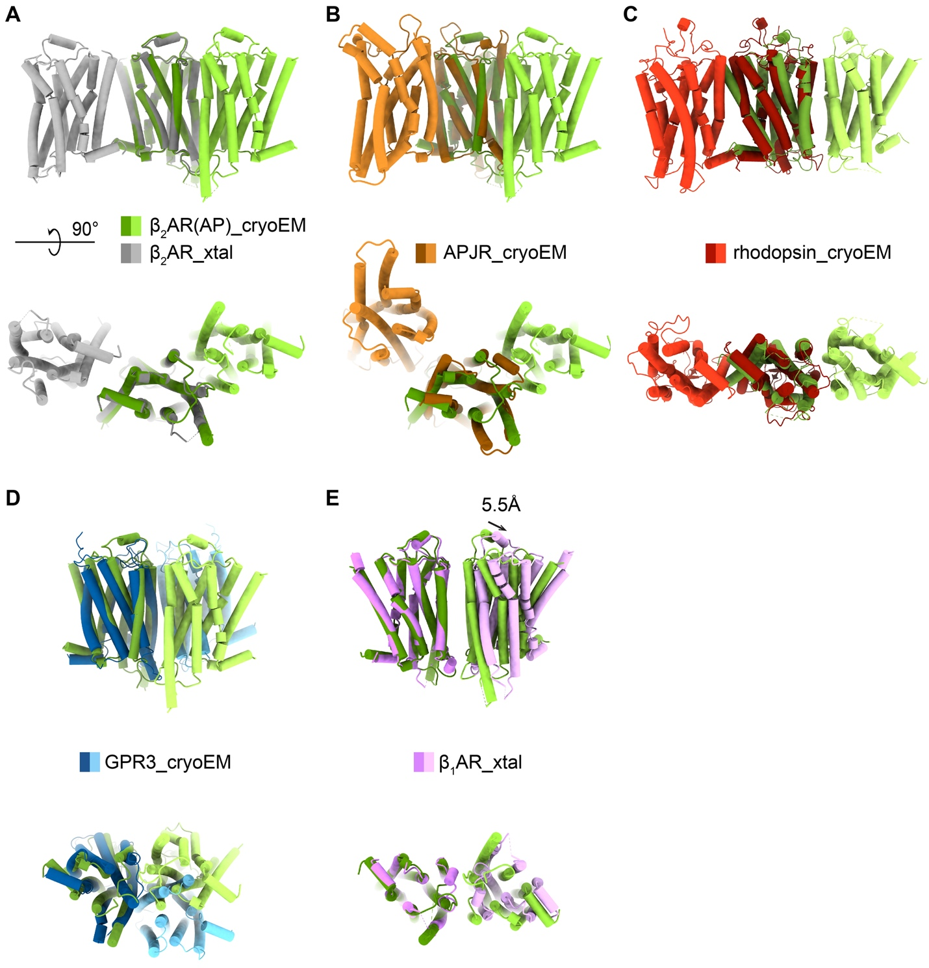
Supplementary Fig. 4: Distinct structural arrangement of AP-bound β₂AR dimer compared to other class A GPCR dimers. Structural comparisons with A, the potential dimer observed in the LCP crystal structure of β₂AR (PDB ID: 2RH1); B, the cryo-EM structure of the human apelin receptor (APJR) dimer (PDB ID: 7W0L); C, the cryo-EM structure of bovine rhodopsin dimer (PDB ID: 6OFJ); D, the cryo-EM structure of human GPR3 (PDB ID: 9LYD); E, the potential dimer interface of the turkey β₁AR LCP crystal structure (PDB ID: 4GPO). One protomer from each dimer is aligned for structural comparison. The AP-bound dimer shares similarity with the potential β₁AR dimer; however, the two protomers in the β₁AR dimer are positioned ~5.5 Å further apart.

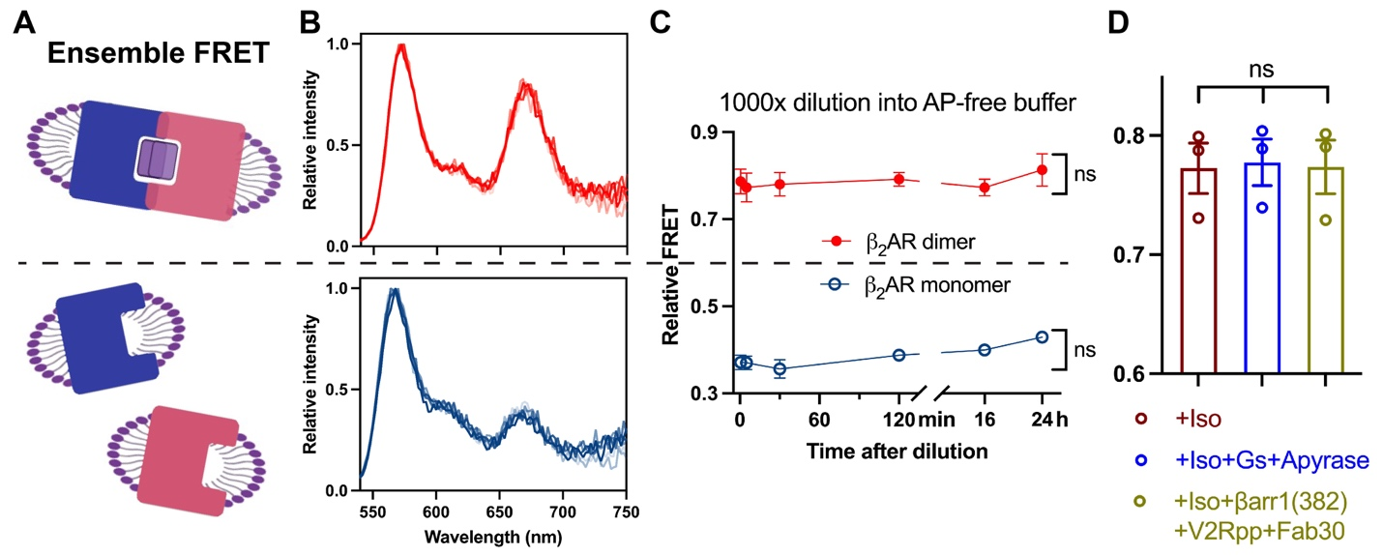
Supplementary Fig. 5: Stability of the AP-bound β₂AR dimer in solution. A, Schematic of ensemble FRET assay for receptor dimerization. Red and blue rectangles with an indentation represent receptors labeled with donor or acceptor fluorophores. Purple rectangles represent AP molecules. B, Normalized fluorescence spectra of AP-bound β₂AR dimer (top) and β₂AR monomer (bottom) in AP-free buffer. C, Time course of relative FRET for AP-bound β₂AR dimer (red) and β₂AR monomer (blue) in AP-free buffer. D, Relative FRET in the AP-bound β₂AR dimer sample is not affected by agonist, Gs, or activated β-arrestin1. Data are presented as mean with SEM, n = 3. ns, not significant.

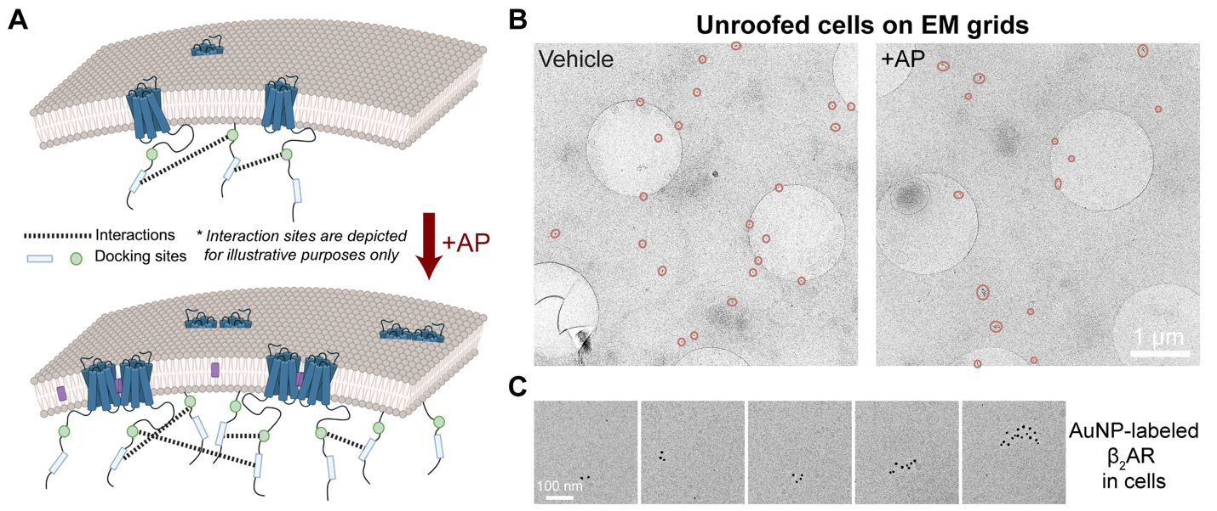
Supplementary Fig. 6: β₂AR nanoclustering on cell membranes visualized by immuno-gold labeling cryo-EM. A, Schematic illustrating a potential mechanism by which AP-induced β₂AR dimerization leads to enlarged nanoclusters. The locations of transient receptor–receptor interactions are shown for conceptual purposes; molecular details remain undefined. Potential contacts observed in Supplementary Fig. 8C may contribute to the formation of HOTS. B, Representative cryo-EM images of unroofed cell membranes on grids (Quantifoil R1.2/1.3), showing β₂AR labeled with gold nanoparticle (AuNP)–conjugated antibodies. Nanoclusters are highlighted with orange circles. C, Gallery of AuNP-labeled β₂AR nanoclusters displaying varying numbers of particles.

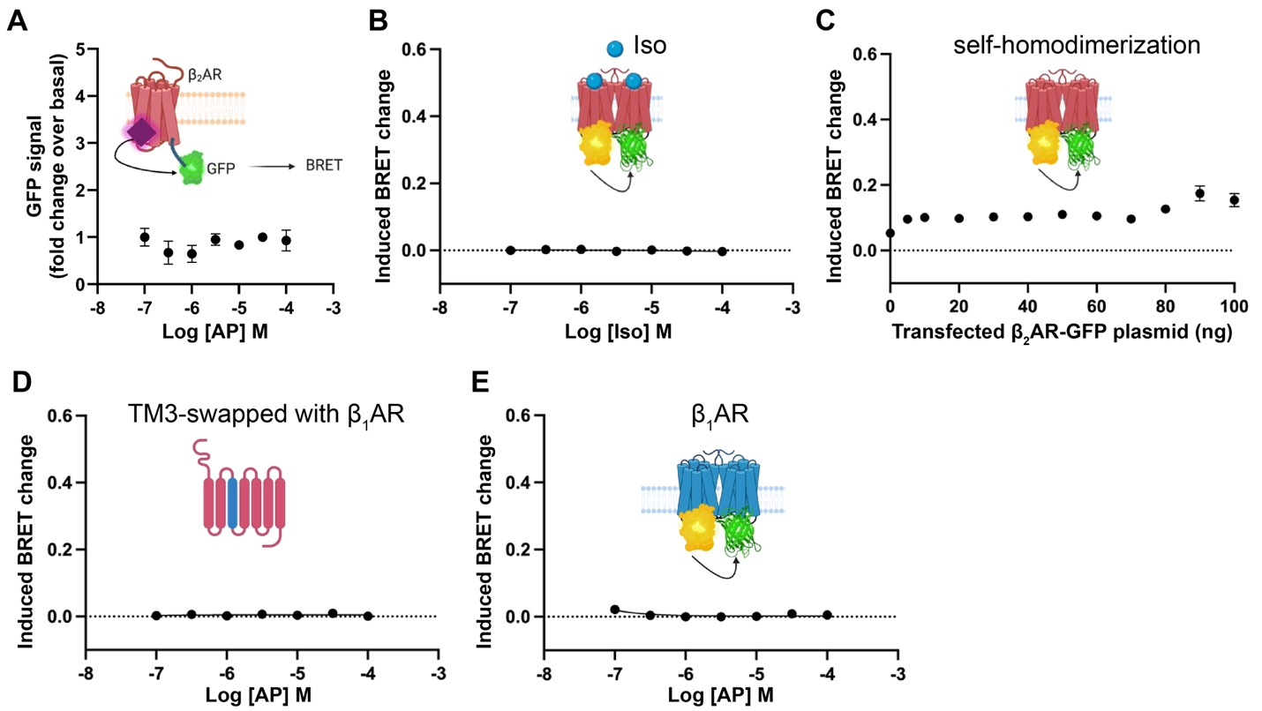

Supplementary Fig. 7: Validation of cell-based BRET assays on receptor dimerization. A, AP does not generate nonspecific BRET signals. B, Agonist Iso does not induce β₂AR dimerization in the assay. C, Saturation BRET assays show no significant change in baseline BRET signal with increasing amounts of transfected β₂AR–GFP plasmid. D, Swapping TM3 of β₂AR with that of β₁AR disrupts AP-induced dimerization. E, AP does not induce dimerization of β₁AR. All data are presented as mean with SEM, n = 3.
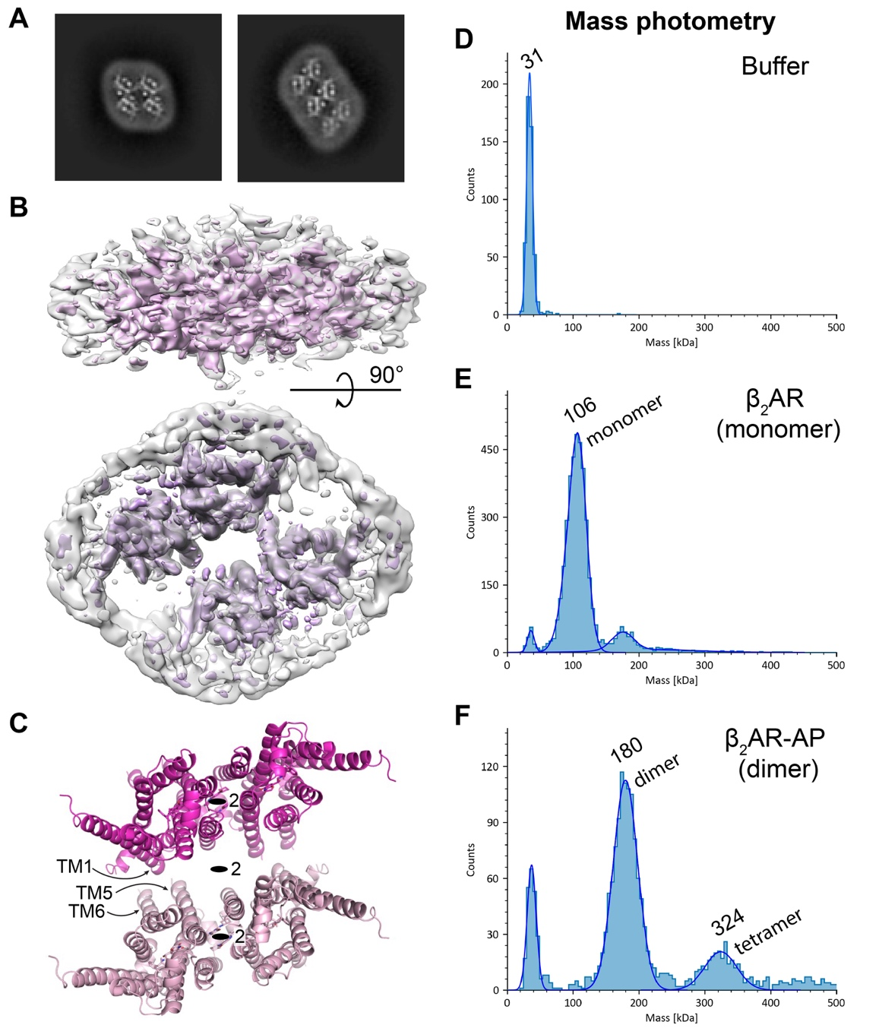
Supplementary Fig. 8: Higher-order oligomers of AP-bound β₂AR. A, 2D class averages from the cryo-EM dataset of AP-bound β₂AR show top views of dimer-of-dimer and trimer-of-dimer species. B, 3D reconstruction of the dimer-of-dimer species. Resolution anisotropy in the map is due to the scarcity of side views. C, Structural model of the dimer-of-dimer, with two β₂AR dimers docked into the cryo-EM map. TM1–ICL1 and the cytosolic ends of TM5–TM6 form potential inter-dimer contacts. Two-fold symmetry axes are indicated. D–F, Particle mass distributions from mass photometry of buffer alone (D), monomeric β₂AR (E), and AP-bound β₂AR dimer (F) samples. Samples were diluted to 20 nM for measurements. A significant population of particles corresponding to tetrameric β₂AR is detected in F.

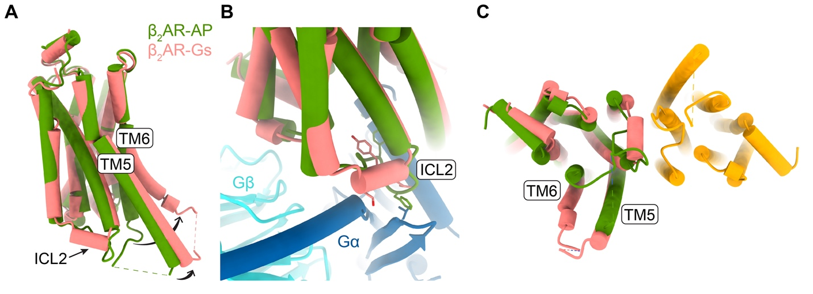
Supplementary Fig. 9: Conformational changes between AP-bound β₂AR and Gs-bound activated β₂AR. A, Structural comparison of one protomer from the AP-bound dimer (green) and monomeric Gs-bound β₂AR (pink, PDB ID: 3SN6). B, Conformational changes in ICL2 in the active β₂AR. Gs bound to active β₂AR is shown in dark blue and cyan. Side chains of key contact residues are shown as sticks. C, Intracellular view of active β₂AR (pink) superimposed onto one protomer (green) of the AP-bound dimer (green and orange).

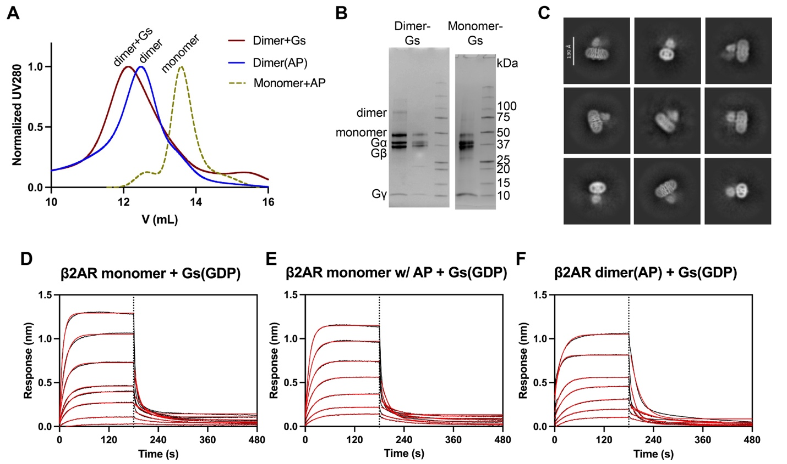
Supplementary Fig. 10: AP-bound β₂AR dimer can effectively form a complex with Gs. A, SEC profiles showing the formation of a stable dimer–Gs complex after GDP removal by apyrase. B, Coomassie-stained SDS-PAGE gel of peak fractions from A. C, Preliminary cryo-EM 2D class averages of the dimer–Gs complex. Sensorgrams of BLI binding assays of GDP-bound Gs to β₂AR monomer (D), monomer with 10 µM AP (E), and AP-bound β₂AR dimer (F). Iso is present at 10 µM in all the conditions. Kinetics and equilibrium binding constants are summarized in Supplementary Table 2.

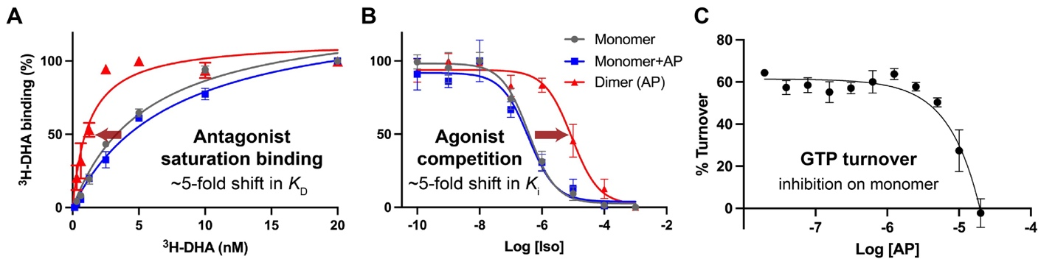
Supplementary Fig. 11: Radioligand binding and GTP turnover assays of β₂AR in the presence of AP. A, Saturation binding of β₂AR to the radiolabeled antagonist [³H]-DHA. Shifts in binding affinity (K_{D}) between monomeric β₂AR with AP and AP-bound dimer are indicated. B, Competition binding of [³H]-DHA with agonist Iso in monomeric β₂AR (gray), monomer with 10 µM AP (blue), and AP-bound dimer (red). Shifts in the inhibition constant (K_{i}) of Iso are indicated. C, GTP turnover by Gs, catalyzed by monomeric β₂AR, is inhibited by AP at high concentrations. All assays were performed with β₂AR reconstituted in nanodiscs. Data are shown as mean with SEM. In A and B, n = 3; in (C), n = 5.

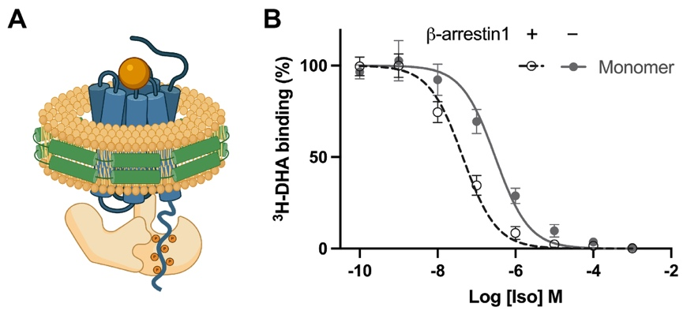
Supplementary Fig. 12: Allosteric effect of β-arrestin1 on radioligand binding of β₂AR. A, Schematic of β₂AR ligated to V₂Rpp in nanodisc illustrating core engagement with β-arrestin. B, Competition binding of [³H]-DHA with agonist Iso in monomeric β₂AR in the presence (black) or absence (gray) of β-arrestin1.
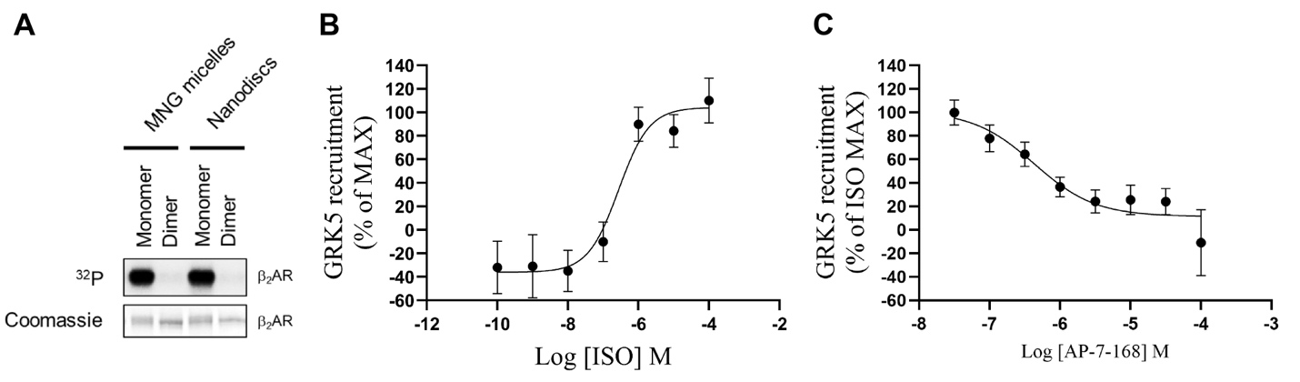
Supplementary Fig. 13: β₂AR phosphorylation and GRK5 recruitment in cells. A, Radiometric kinase assay of β₂AR in detergent or nanodisc. Left: Coomassie staining and ³²P autoradiography of β₂AR. Quantification of phosphorylation levels is shown in Fig. 5H. B, Dose-dependent curve of ISO-stimulated GRK5 recruitment in cells. C, Dose-dependent inhibition of GRK5 recruitment by AP. 1 µM ISO was used to stimulate GRK5 recruitment. All data are presented as mean with SEM, n = 3.

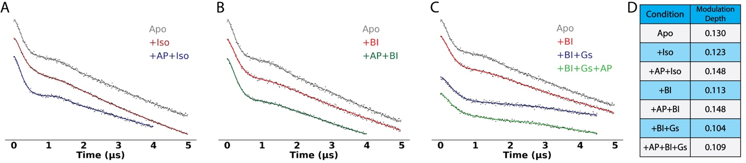
Supplementary Fig. 14: DEER dipolar evolution traces of spin-labeled β₂AR in detergent micelles. DEER measurements were performed on β₂AR with spin labels attached to TM4 and TM6. A–C, Background-corrected dipolar evolution traces under different ligand conditions. Black dots represent experimental data; colored lines represent fitted curves which are used to derive the distance distributions shown in Fig. 5F–H. D, The modulation depths for each experimental condition.
Supplementary Table 1: Cryo-EM data collection, refinement, and validation statistics
Protein | Human β₂AR_dimer(AP) in MSPE3D1 nanodisc | Human β₂AR_dimer(AP) in detergent
Cryo-EM Data Collection
Voltage (kV) | 300 | 300
Magnification (x) | 130,000 | 130,000
Pixel Size (Å) | 0.83 | 0.95
Electron exposure (e⁻/Å²/frame) | 1.25 | 1.25
Defocus range (µm) | [−2.0, −0.8] | [−2.0, −0.8]
Number of image stacks | 17,997 | 7,139
Number of frames per stack | 40 | 40
Cryo-EM Data Processing
Initial number of particles | 2,371,430 | 1,961,893
Final number of particles | 237,408 | 48,805
Symmetry imposed | C2 | C2
Map sharpening B factor (Å²) | 100 | 125
Map resolution (Å) | 2.5 | 2.9
Map resolution range (Å) | 2.1 – 2.8 | 2.4 – 3.5
FSC threshold | 0.143 | 0.143
Model Refinement
Number of amino acids | 287
Total non-hydrogen atoms | 2479
Model-to-map resolution (Å) | 2.6
Average B factor (Å²) | 18.10
Bond length RMSD (Å) | 0.003
Bond angle RMSD (°) | 0.513
Ramachandran Plot
Favored (%) | 100
Allowed (%) | 0
Outliers (%) | 0
Rotamer outliers (%) | 0.39
MolProbity Score | 0.98

Supplementary Table 2: Kinetic and binding constants for Gs(GDP) interactions with β₂AR measured by BLI
Sample | monomer | monomer + AP | dimer (AP)
K_{D} (µM) | 0.96 ± 0.30 | 1.71 ± 0.48 | 3.11 ± 0.89
k_{on} (×10⁴ M⁻¹ s⁻¹) | 7.53 ± 1.53 | 5.37 ± 2.80 | 2.82 ± 2.22
k_{off} (×10⁻² s⁻¹) | 2.42 ± 0.22 | 2.30 ± 0.68 | 1.57 ± 0.10

