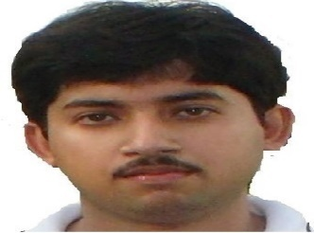Soumya Ray is presently working as an assistant professor in the Department of Computer Science &Engg, Birla Institute of Technology, Mesra, Deoghar campus. He has received his M. Tech in Computer Science &Engg. from BIT Mesra, Ranchi. Prof. Ray is pursuing his Ph.D. in the Computer Science department from BIT Mesra, Ranchi. His research interest includes network security, big data security, cloud computing, fog computing and Internet of Things.

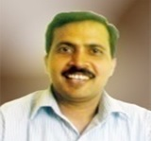
Dr. Kamta Nath Mishra
Computer Science & Engineering
Birla Institute of Technology, Jharkhand, India
Deoghar, Jharkhand, Pin 814142
Phone +91-9695052989
Email: mishrakn@yahoo.com
Short Biography: Dr. Kamta Nath Mishra was born on August 15, 1973, in the Chandrauta Village of Kushinagar district, Uttar Pradesh, INDIA. He received his Bachelor of Science (B.Sc., Maths) degree from the University of Gorakhpur, India, in 1992, and Master of Computer Application (MCA) degree from Madan Mohan Malviya Engineering College (Currently MMMUT), Gorakhpur, U. P., India in 1996. Dr. Mishra completed his M.Tech. (Software Systems) degree from Birla Institute of Technology and Science (BITS) Pilani, India in 2003 and Ph.D. (Engg.) from CSE department of B.I.T. Mesra – India, in May 2015.
Dr. Mishra has more than twenty-one years of teaching and research experience. Currently, he is working as a senior faculty member (Associate Professor) at Dept. of CS&E, Birla Institute of Technology, India since August 2009; He has worked as a faculty member in the Department of Computer Science, Joint program of Michigan State University the USA and University of Sebha, LIBYA, from October 2006 to July 2009. He was a senior lecturer at B.I.T. Mesra, (Noida Campus) from July 2004 to September 2006. Dr. Mishra has worked as a senior project engineer from September 2003 to June 2004 and project engineer from September 2000 to August 2003, in Centre for Development of Advanced Computing (CDAC), Ministry of Communication & IT, Govt. of India, Noida, Uttar Pradesh. Before joining CDAC, Dr. Mishra worked as a lecturer in the CS&E department at Krishna Institute of Engineering & Technology (KIET), Ghaziabad, India, from July 1998 to August 2000. Dr. Mishra has published two authored research books (IGI Global USA, Nova Science Publishers Inc., USA), fourteen book chapters, and more than thirty-five research papers in journals and conferences of international repute. His research interest includes Biometric Systems, Image Processing, Analysis of Algorithms and Distributed Cloud Computing. Dr. Mishra is a professional member of IEEE Biometric Society USA, and ACM, USA.
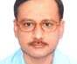Dr.Sandip Dutta is presently working as a professor in the Department of Computer Science &Engg, Birla Institute of Technology, Mesra, Ranchi campus and he is also the Dean Admission and Academic Coordination of this institute. He has received his Ph.D. in the Computer Science department from BIT Mesra, Ranchi. Prof. Dutta has 19 years of teaching experience. His research area is Network Security and Cryptography, Biometric Security. He has published nine International journals, four International Proceedings in his research area.

