Additional file 1. Study patient´s characteristics.

Patient | Age | Gender | Grade of resection | Diagnosis | Tumor Grade | IDH | ATRX | Immune Profile | MGMT | TERT | 1st line treatment | Time to PD | Time of F/U | Status after F/U
G001 | 82 | female | complete | astrocitoma | IV | WT | WT | GBMwt_hi | methylated | C228T | Stupp | 4.5 | 7.6 | death
G002 | 36 | female | complete | astrocitoma | IV | Mut | Mut | IDHmut or LGG | methylated | wt | Stupp | No PD | 25 | alive
G003 | 68 | male | complete | astrocitoma | IV | WT | Mut | GBMwt_hi | methylated | wt | Stupp | 8.2 | 8.9 | death
G004 | 42 | male | complete | astrocitoma | IV | Mut | Mut. | IDHmut or LGG | methylated | wt | Stupp | 4.3 | 5.5 | death
G005 | 70 | male | complete | astrocitoma | IV | WT | WT | GBMwt_lo | methylated | C228T | none | 4.6 | 4.6 | death
G006 | 57 | male | complete | astrocitoma | IV | WT | WT | GBMwt_lo | methylated | C228T | none | 1 | 1 | death
G007 | 34 | female | complete | astrocitoma | IV | WT | WT | GBMwt_hi | methylated | wt | Stupp | 16.7 | 23 | death
G010 | 30 | female | complete | astrocitoma | III | Mut | Mut | IDHmut or LGG | methylated | wt | Stupp | No PD | 22.4 | alive
G011 | 52 | male | complete | astrocitoma | IV | WT | WT | GBMwt_hi | unmethylated | C228T | Stupp | 17.3 | 21.6 | alive
G012 | 53 | male | partial | astrocitoma | IV | WT | WT | GBMwt_lo | methylated | C228T | Stupp | 6.6 | 13.6 | death
G014 | 30 | female | partial | oligodendroglioma | II | Mut | WT | IDHmut or LGG | methylated | C228T | RT+PCV | No PD | 20 | alive
G020 | 46 | male | complete | oligodendroglioma | II | Mut | WT | IDHmut or LGG | methylated | C228T | RT+PCV | No PD | 18.9 | alive
G021 | 55 | female | complete | astrocitoma | IV | WT | WT | GBMwt_hi | methylated | wt | Stupp | 6.6 | 14.7 | death
G023 | 45 | female | complete | astrocitoma | III | Mut | Mut | IDHmut or LGG | methylated | wt | Stupp | No PD | 14.9 | alive
G024 | 35 | female | complete | oligodendroglioma | II | Mut | WT | IDHmut or LGG | methylated | C228T | none | No PD | 16.8 | alive
G030 | 63 | male | complete | astrocitoma | IV | WT | WT | GBMwt_lo | methylated | C228T | Stupp | 5.5 | 5.5 | death
G035 | 65 | female | complete | astrocitoma | IV | WT | WT | GBMwt_hi | no data | C228T | Stupp | 4 | 14.2 | alive
G036 | 76 | female | partial | astrocitoma | III | WT | WT | IDHmut or LGG | methylated | C228T | temozolomide | 4.1 | 4.2 | death
G038 | 39 | male | complete | astrocitoma | III | Mut | Mut | IDHmut or LGG | no data | wt | Stupp | No PD | 13.3 | alive
G039 | 47 | male | complete | astrocitoma | IV | Mut | Mut. | IDHmut or LGG | methylated | wt | Stupp | No PD | 13 | alive
G043 | 38 | male | partial | astrocitoma | III | Mut | Mut. | IDHmut or LGG | methylated | C228T | Stupp | No PD | 12 | alive
G045 | 65 | male | complete | astrocitoma | IV | WT | WT | GBMwt_hi | no data | no data | Stupp | No PD | 11 | alive
G048 | 69 | female | complete | astrocitoma | IV | WT | WT | GBMwt_hi | no data | C228T | Stupp | 9.3 | 10.6 | alive
G054 | 42 | male | complete | astrocitoma | IV | WT | WT | GBMwt_lo | no data | wt | Stupp | No PD | 9.7 | alive
G055 | 71 | female | partial | astrocitoma | IV | WT | WT | GBMwt_hi | methylated | C228T | none | 4.4 | 4.4 | death
G058 | 70 | male | complete | astrocitoma | IV | WT | WT | GBMwt_lo | methylated | C250T | Stupp | No PD | 7.6 | alive
G059 | 50 | male | complete | astrocitoma | III | WT | WT | IDHmut or LGG | unmethylated | C228T | Stupp | No PD | 7.2 | alive
G060 | 50 | male | complete | astrocitoma | IV | WT | WT | GBMwt_hi | methylated | C228T | Stupp | No PD | 7.1 | alive

Additional file 2. List of antibodies used for flow cytometry (FACS), Western Blot (WB) and immunohistochemistry (IHC) analysis.

Purpose | Antigen | Conjugated | Catalog number | Supplier | Clone
FACS | cd25 | 421 | 302629 | Biolegend | BC96
FACS | cd3 | vg | 563109 | BD | UCHT1
FACS | cd45 | 488 | 130-080-202 | Miltenyi | REA747
FACS | cd127 | pe | 561028 | BD | HIL-7R-M21
FACS | cd8 | pecy5 | 565310 | BD | SK1
FACS | cd4 | 647 | 300520 | Biolegend | RPA-T4
FACS | pd1 | 421 | 562516 | BD | EH12.1
FACS | cd16 | 421 | 302037 | Biolegend | 3G8
FACS | cd14 | pe | 130-110-577 | Miltenyi | REA599
FACS | cd15 | vg | 301910 | Biolegend | HI98
FACS | cd33 | pecy5 | 366615 | Biolegend | P67.6
FACS | cd11b | 647 | 130-098-087 | Miltenyi | M1/70
FACS | pdl1 | vg | 329713 | Biolegend | 29E.2A3
FACS | cd206 | pecy5 | 321121 | Biolegend | 15-2
FACS | mhcii | 421 | 562805 | BD | G46-6
WB | CD11b | Purified | SAB1305652 | Sigma | 40TST
WB | IBA1 | Purified | ab16588 | Abcam | EPR 16588
WB | GAPDH | Purified | sc-47724 | Santa cruz | 0411
WB | Tau | Purified | 577801 | CALBIOCHEM | Tau-5
IHC | CD34 | Purified | NCL-L-END | Leica | QBEND/10
IHC | CD248 | Purified | 564994 | BD | B1/35
IHC | CD45 | Purified | M0701 | Dako | 2B11 + PD7/26
IHC | CD3 | Purified | A0452 | Dako | Polyclonal Rabbit
IHC | endomucin | Purified | sc-65495 | Santa cruz | (V.7C7)

Additional file 3. List of primers used for qRT-PCR analysis.
Genes | Forward (5´-3´) | Reverse (3´-5´)
hP2RY12 | TGCCAAACTGGGACCAGGACCA | TGGTGGCTTCTGGTAGCGATC
hIBA1 | CCCTCCAAACTGGAAGGCTTCA | CTTTAGCTCAGGTGAGTCTTGG
hDLL3 | AAACCTATGGGCTTGAGGAG | CGCTGAGTACAATCAGTGGAA
hOLIG2 | CGGCTTTCCTCTATTTTGGTT | GTTACACGGCAGACGCTACA
hBCAM | CTGTCTGGAGAGAACTGCGT | TCTTGCAGGTGTAGGACAGG
hYKL40 | ACACCTGGGAGTGGAATGAT | AGTTCCATCCTCCGACAGAC
hCD44 | AGAAGGTGTGGGCAGAAGAA | AAATGCACCATTTCCTGAGA
hSERPINE1 | CATAGTGGAAGTGATAGAT | ACTCTGTTAATTCGTCTT
hCD34 | CCCTCAGTGTCTACTGCTGGTCT | GGAATAGCTCTGGTGGCTTGCA
hCD248 | AGACCACCACTCATTTGCCTGGAA | AGTTGGGATAATGGGAAGCGTGGT
hEMCN | GCAAGCACTTCAGCAACCAGCC | GGATCTGCCTTCCAGCACATTC
hIDH1 | CTATGATGGTGACGTTGCAGTCG | CCTCTGCTTCTACTGTCTTGCC
mEMCN | GCACACACCATGTCACTGCTTC | CAGCGCGATAACCACAGGCAAA
mCD248 | TTGATGGCACCTGGACAGAGGA | TCCAGGTGCAATCTCTGAGGCT
mCD3 | TCTCATTGCGGGACAGGATGGA | CCTTGGAGATGGCTGTACTGGT

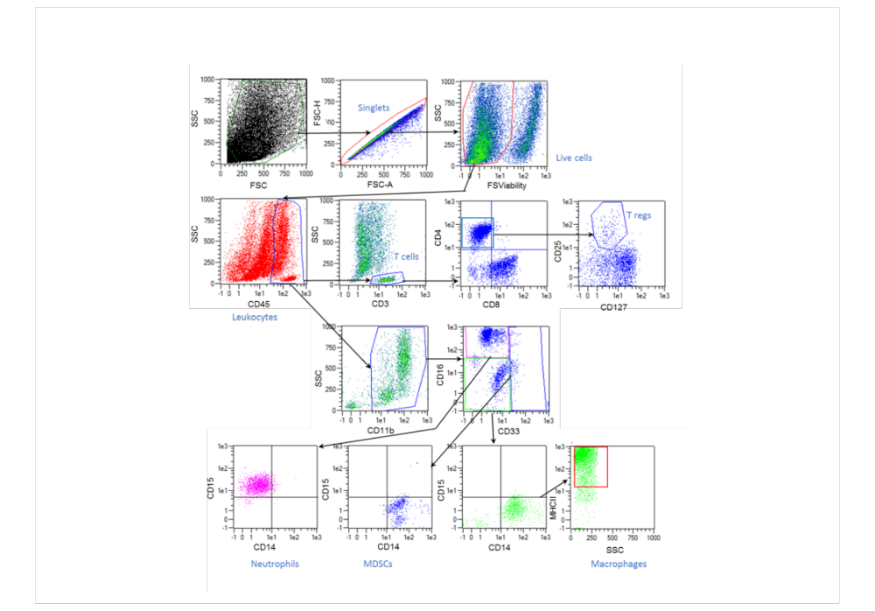
Additional file 4. Representative plots of the gating on FACS to identify leukocytes and myeloid cells in human glioma tissues. A Fixable Staining for Viable cells detection has been used for excluding dead cells.
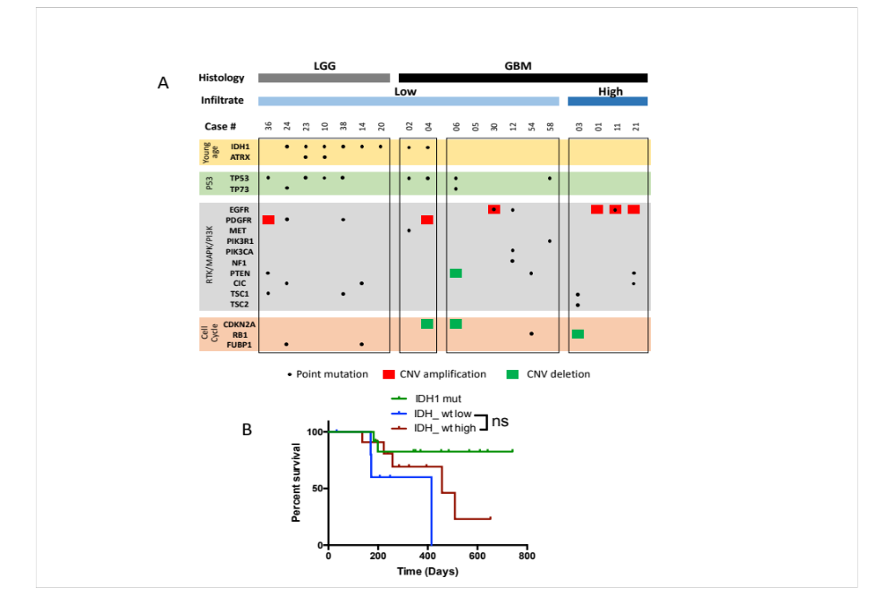
Additional file 5. Sequencing and Overall survival in de glioma cohort (A) Distribution of point mutations and copy number variations in 20 genes frequently altered in gliomas. (B) Kaplan-Meier survival curves of the three different groups associated with the immune phenotype, IDHmut, GBMwt_lo, GBMwt_hi gliomas.

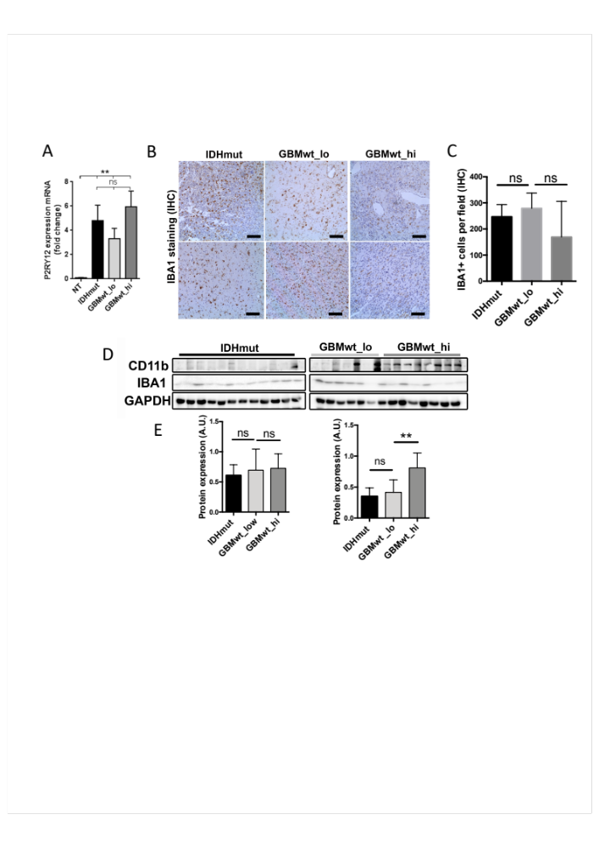
Additional file 6. Microglia content is similar in IDHmut, GBMwt_lo, GBMwt_hi gliomas. (A) Fold change values of qRT-PCR analysis of P2RY12 expression in tumor tissue from IDHmut, GBMwt_lo, GBMwt_hi (n=6) NT (normal brain tissue). (B) Representative pictures obtained from IHQ for IBA1 in the three groups of gliomas. Scale bars: 100 μm. (C) Quantification of IBA1 positive cells per field using conventional microscope at 20X from IHQ showed in B (n=6). (D) WB analysis of CD11b and IBA1 expression in tumor tissue extracts from IDHmut (black), GBMwt_lo (light grey), GBMwt_hi (dark grey) tumors. GAPDH level as a loading control. (E) Quantification of levels of CD11b and IBA1 expression from WB showed in D. **p<0.01, ns not significant.

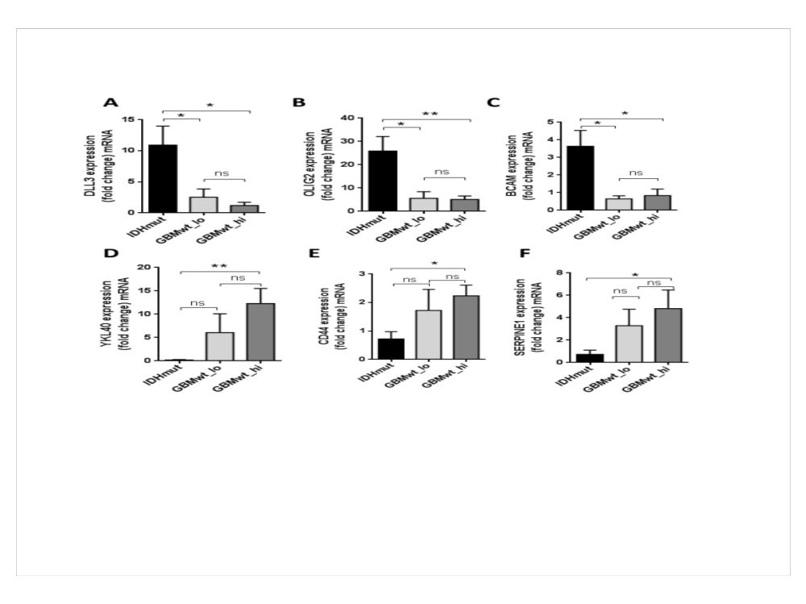

Additional file 7. Proneural or mesenchymal markers expression in IDHmut, GBMwt_lo, GBMwt_hi gliomas. Fold change values of qRT-PCR analysis of expression of (A-C) typical proneural markers as DLL3, OLIG2 and BCAM. (D-F) typical mesenchymal markers as YKL40, CD44 and SERPINE1. HPRT was used for normalization (n=26). * p<0.05, **p<0.01, ns not significant.

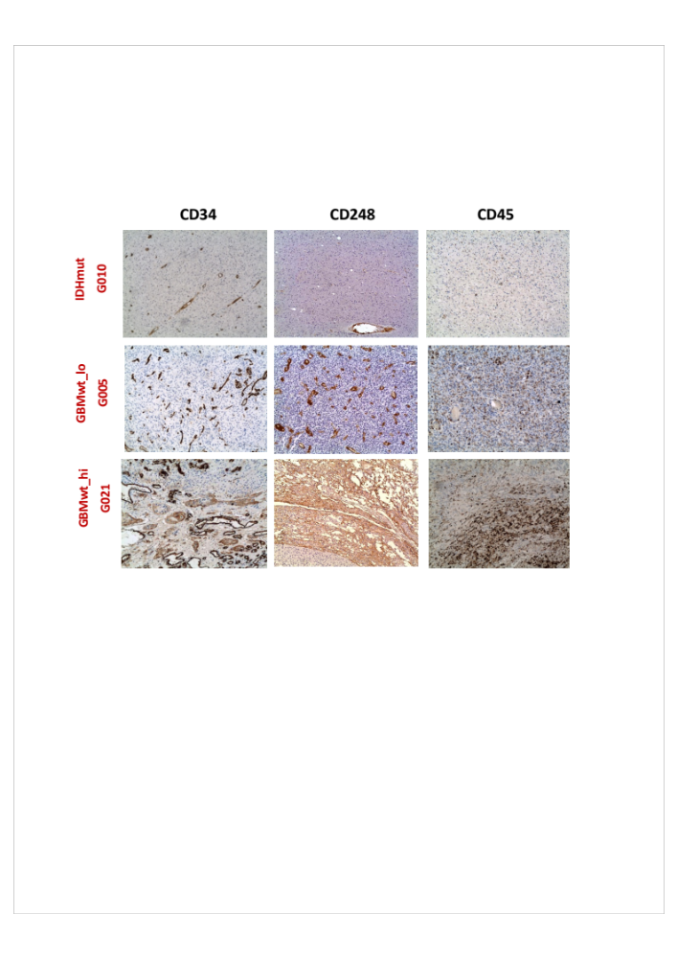

Additional file 8. Positive correlation between CD45⁺ and CD34⁺ or CD248⁺ cells content in gliomas. Representative pictures from IHQs of CD45 (leukocyte marker), CD34 (endothelial marker) or CD248 (pericyte marker) in each group of gliomas. Scale bars: 100 μm.

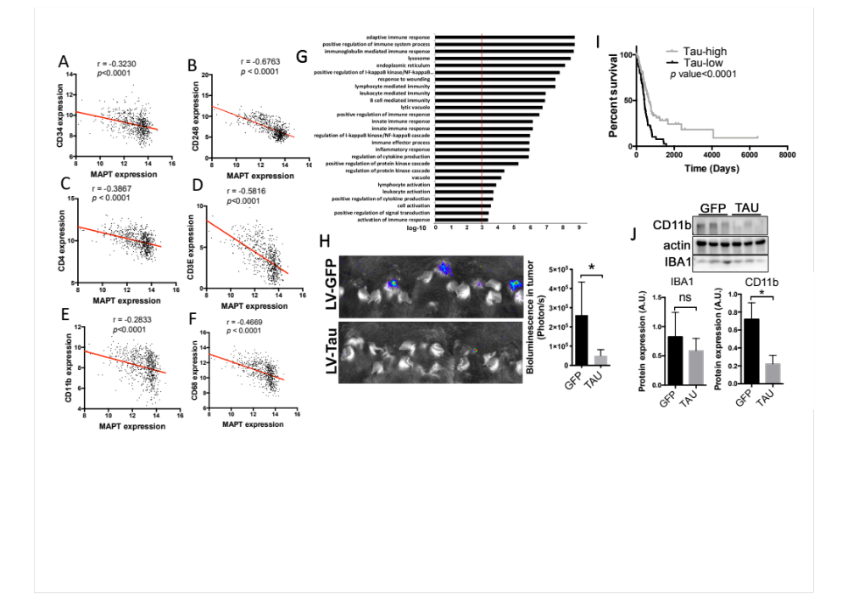

Additional file 9. Inverse correlation between Tau expression and vascular alterations or immune cells content in gliomas. Correlation of the mRNA expression by RNAseq of Tau (MAPT) with that of (A) CD34 (B) CD248 (C) CD3E (D) CD4 (E) CD11b and (F) CD68 in gliomas using the TCGA cohort (n=661). (G) Top enriched Gene Ontology (GO) biological process for the cluster of 500 genes which expression is negatively correlated with Tau (MAPT) expression in gliomas. LGG+GBM merge cohort and the DAVID gene ontology program are used. (H) Representative image and quantification of tumor growth using IVIS ILUMINA through luciferase-luciferin system. (I) Kaplan-Meier overall survival curves of patients from the TCGA cohort glioma IDH wt (n=191) and patients in each cohort were stratified into 2 groups based on high and low Tau/MAPT expression values, log-rank (Mantel-Cox) test. (J) WB analysis of CD11b and IBA1 expression in tumor tissue extracts from GFP and Tau-GL261. GAPDH level as a loading control and quantification of levels of CD11b and IBA1 expression. * p<0.05, **p<0.01, ns not significant.

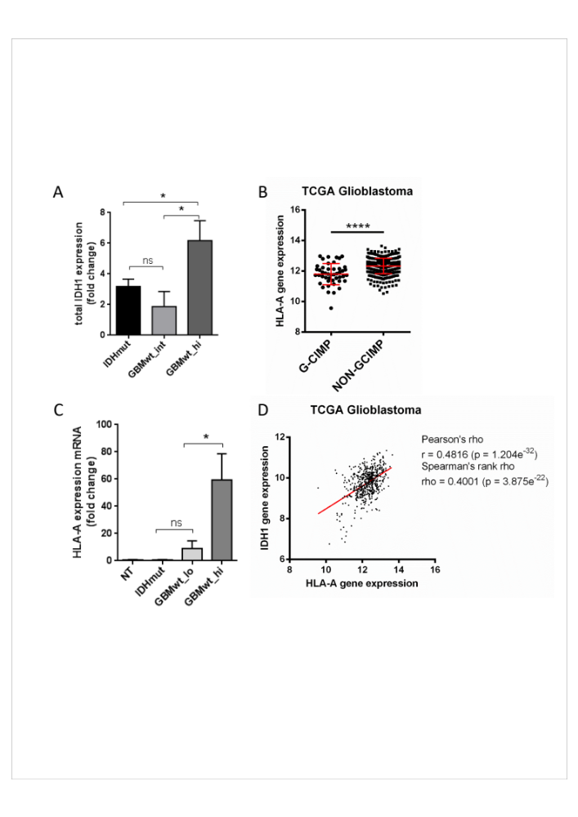

Additional file 10. Epigenetic changes could explain differences between the groups. (A) Fold change values of qRT-PCR analysis of IDH1 expression (n=6). (B) Analysis of HLA-A mRNA expression by RNAseq in gliomas (TCGA cohort) grouped according to their G-CIMP status (G-CIMP n=46 and NON-GCIMP n=475). (C) Fold change values of qRT-PCR analysis of HLA-A expression (n=6). Normal Tissue (NT). (D) Correlation of the expression mRNA of IDH1 and HLA-A using TCGA glioma cohort (n=539). Paired T-test was performed. *p<0.05, ****p<0.0001, ns not significant.

