A Mutation-Agnostic EP2–cAMP–Driven Strategy Restores Ciliogenesis and Retinal Function in Ciliopathies.
France de Malglaive^{1,2,7}, Iris Barny^{2,7}, Solène Revy^{2,8}, Cathy Obringer^{3,8}, Lucie Menguy⁴, Shahd Machroub², Lucas Fares-Taie¹, Ema Cano¹, Nicolas Goudin⁵, Amandine Viau⁴, Tania Attie-Bittach⁶, Josseline Kaplan¹, Alexandre Benmerah⁴, Isabelle Perrault¹, Luis Briseno-Roa², Sophie Saunier^{4,9}, Hélène Dollfus^{3,9}✉, Jean-Michel Rozet^{1,9}✉, Jean-Philippe Annereau^{2,9}

Supplemental Material

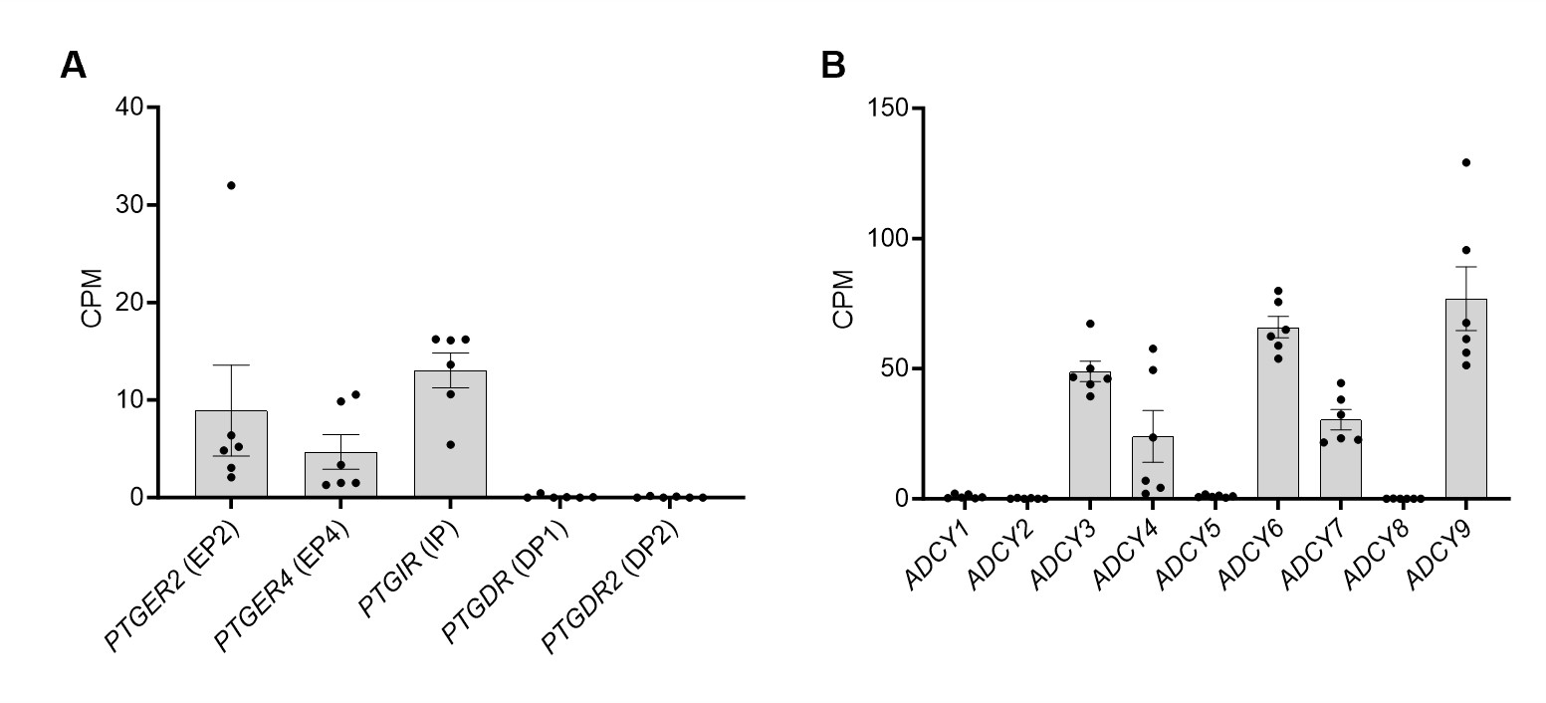
Supplemental Figure 1. Relative expression of prostanoid receptors involved in cAMP signaling (A) and adenylyl cyclases (ADCY) (B) in control fibroblasts. Gene expression levels given as counts per million (CPM) were assessed using publicly available RNA-seq datasets from control human skin fibroblasts (S-BSST1762). Each point represents a biological replicate (n = 6), and the bars indicate the mean ± SEM.

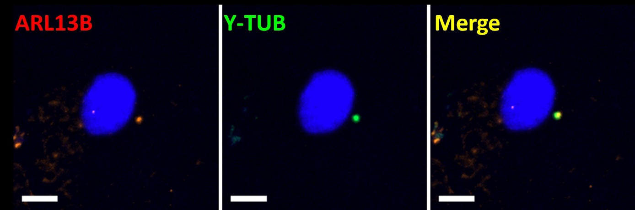
Supplemental Figure 2. Centrosomal colocalization of ARL13B and γ-tubulin in CEP290-Meckel (P5) fibroblasts. Representative immunocytochemistry images of serum-starved fibroblasts from the poorly ciliated CEP290-Meckel patient (P5) showing a foci of colocalization between ARL13B (ciliary membrane, red) and γ-tubulin (basal body, green). These colocalized signals indicate a basal body bearing ciliary vesicle in the cell lacking fully formed cilia. The nucleus is counterstained with DAPI (blue). Scale bars: 10 µm.

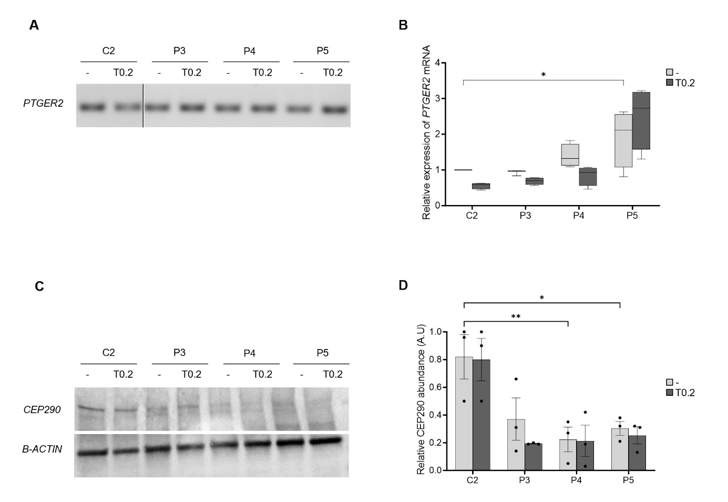
Supplemental Figure 3. Effect of taprenepag on PTGER2 mRNA and CEP290 protein levels in control and CEP290-mutant fibroblasts. (A) End-point PCR detection of PTGER2 (encoding the EP2 receptor) in control (C2) and mutant fibroblasts (P3, P4, P5) following 24-hour exposure to DMSO (–) or 0.2 µM taprenepag (T0.2) under serum starvation. (B) Relative PTGER2 transcript levels in the same cell lines and conditions, as determined by RT-qPCR; data were normalized to GUSB and RPLP0. Data were collected from ≥ 3 independent experiments. Statistical analysis involved an ordinary two-way ANOVA followed by a Tukey multiple comparison test. * p < 0.05. (C) Western blot detection of CEP290 and β-actin in control and mutant fibroblasts under the same conditions. (D) Quantification of CEP290 protein levels normalized to β-actin from (C). Bars represent mean ± SEM from three independent experiments. Statistical analysis was performed using two-way ANOVA followed by Sidak multiple comparisons test: ** for p < 0.01 and * for p < 0.05.

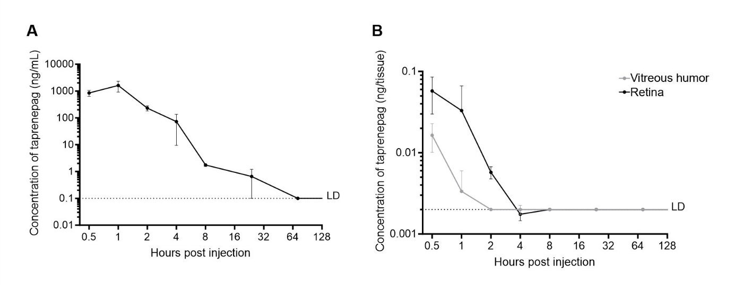
Supplemental Figure 4. Measurement of taprenepag levels in plasma and ocular tissues following a single intraperitoneal injection of 8mg/kg taprenepag in WT Mice. Taprenepag concentration (ng/mL) over time post-injection in (A) the plasma and (B) the retina (dark) and vitreous humor (light grey) of WT mice. Bars represent the mean ± SEM from 4 mice. LD denotes the limit of detection.

Supplemental Table 1. Taprenepag and cAMP analogs differentially enhance cilia formation and axonemal elongation in control and CEP290-mutant fibroblasts. (A) Quantification of cilia incidence and length in control (C2) and patient-derived fibroblasts (P3–P5) under basal conditions (DMSO) or after stimulation with taprenepag (0.2 µM) or forskolin (25 µM). Data are expressed as mean ± SD or ± SEM as indicated. “Gain from baseline” represents the percentage increase relative to DMSO. Statistical comparisons were performed using Two-way ANOVA with Tukey tests. (B) Cilia incidence and length in control (C2) and patient-derived fibroblasts (P3–P4) under basal conditions (water) or after treatment with cAMP analogs: 6-Bnz-cAMP (50 µM), 8-Br-cAMP (500 µM), or db-cAMP (500 µM). “Gain from baseline” indicates percentage increase relative to vehicule (water) condition. Statistical significance was assessed by Two-way ANOVA with Dunnett test. FKS: forskolin;

A | Baseline (DMSO) |  |  | Taprenepag (T) 0.2μM |  |  |  | Forskolin (F) 25μM |  |  |  | Gain F vs T
Cell line | Incidence (%) | ± SD | ± SEM | Incidence (%) | ± SD | ± SEM | Gain ± SEM (%) | Incidence (%) | ± SD | ± SEM | Gain ± SEM (%) | P value
C2 | 79.7 | 13.7 | 3.4 | 89.1 | 7.5 | 2.0 | 11.7±4.0; p = 0.1487 | 81.6 | 17.2 | 4.3 | 2.4±5.5; p=0.9183 | 0.2952
P3 | 70.0 | 15.8 | 3.9 | 81.1 | 16.3 | 4.1 | 15.8±5.7; p=0.0591 | 81.4 | 11.0 | 2.9 | 16.2±4.9; p= 0.0627 | 0.9984
P4 | 50.4 | 11.5 | 2.9 | 63.6 | 11.1 | 2.8 | 26.2±4.0; p=0.0189 | 64.8 | 11.5 | 3.1 | 28.7±4.2; p =0.0119 | 0.9653
P5 | 13.0 | 4.7 | 1.2 | 33.0 | 22.6 | 5.6 | 154.3±5.8 p=0.0002 | 26.7 | 9.2 | 2.4 | 106.0±2.7; p=0.0174 | 0.4091
Cell line | Length (µm) | ± SD | ± SEM | Length (µm) | ± SD | ± SEM | Gain ± SEM (%) | Length (µm) | ± SD | ± SEM | Gain ± SEM (%) | P value
C2 | 3.72 | 0.46 | 0.15 | 4.38 | 0.42 | 0.14 | 17.7±0.20 ; p=0.0472 | 4.70 | 0.31 | 0.10 | 26.3±0.18; p=0.0015 | 0.4874
P3 | 3.37 | 0.47 | 0.15 | 3.59 | 0.44 | 0.15 | 6.4±0.21 p=0.7093 | 4.13 | 0.45 | 0.14 | 22.7±0.21; p=0.0137 | 0.1165
P4 | 4.96 | 0.52 | 0.16 | 5.17 | 0.51 | 0.17 | 4.3±0.24 p=0.7175 | 5.49 | 0.36 | 0.12 | 10.8±0.20; p=0.1278 | 0.4850
P5 | 5.12 | 0.98 | 0.31 | 4.68 | 1.03 | 0.34 | -8.6±0.46 p=0.2487 | 4.58 | 0.68 | 0.23 | –10.6±0.39; p=0.1210 | 0.9266

B | Baseline (Water) | 6Bnz-cAMP 50µM |  | 8-Br-cAMP 500 µM |  | db-cAMP 500 µM
Cell line | Incidence±SD (%) | Incidence±SD (%) | Gain (%) | Incidence±SD (%) | Gain (%) | Incidence±SD (%) | Gain (%)
C2 | 79.7±14.0 | 83.5±13.0 | 4.8; p=0.8731 | 88.1±6.4 | 10.5; p = 0.2561 | 87.0±5.5 | 9.1; p=0.3168
P3 | 66.7±10.4 | 77.8±8.6 | 16.7; p=0.0378 | 74.8±9.2 | 12.2; p = 0.2113 | 77.5±7.9 | 16.3; p= 0.0448
P4 | 56.2±13.5 | 73.5±13.0 | 30.9; p=0.0002 | 76.2±8.7 | 35.7; p < 0.0001 | 79.0±6.9 | 40.7; p < 0.0001
Cell line | Length±SD (µm) | Length±SD(µm) | Gain (%) | Length±SD (µm) | Gain (%) | Values ± SD (µm) | Gain (%)
C2 | 4.45±1.02 | 4.78±0.32 | 7.4; p=0.8405 | 5.3 ±0.26 | 19.1; p = 0.0936 | 5.28±0.37 | 18.6; p = 0.0703
P3 | 4.78±0.58 | 4.91±0.29 | 2.7; p=0.9978 | 5.30±0.44 | 10.9; p = 0.4355 | 5.06±0.34 | 5.9; p = 0.9066
P4 | 5.06±0.95 | 5.55±0.40 | 9.7; p=0.4913 | 6.39±0.24 | 26.4; p = 0.0006 | 5.91±0.38 | 16.8; p = 0.0578

Supplemental Table 2. Taprenepag enhances cilia Incidence and length in fibroblasts from patients with BBS1 and BBS10 mutations. Quantification of cilia incidence and axonemal length in fibroblasts derived from BBS1 (P6, P7) and BBS10 (P8, P9) patients under basal conditions (vehicle, DMSO) and following stimulation with taprenepag (0.2 µM). Data are presented as mean ± SD or ± SEM as indicated. “Gain from baseline” represents the percentage increase relative to DMSO-treated cells. Statistical analysis was performed using unpaired One-way ANOVA with Tukey tests; all comparisons showed p < 0.0001.
 | Baseline (DMSO) |  |  |  | Taprenepag 0.2μM
Cell line | Incidence (%) | ± SD % | ± SEM | Incidence (%) |  | ± SD | ± SEM | Gain ± SEM (%)
P6 | 50.7 | 1.65 | 0.46 | 56.8 |  | 2.49 | 0.69 | 12.0 ± 0.83; p<0.0001
P7 | 53.8 | 2.30 | 0.64 | 61.2 |  | 2.20 | 0.61 | 13.7 ± 0.88; p<0.0001
P8 | 62.7 | 2.25 | 0.62 | 70.2 |  | 2.09 | 0.58 | 12.0 ± 0.85; p<0.0001
P9 | 64.8 | 2.94 | 0.82 | 75.1 |  | 1.61 | 0.45 | 15.8 ± 0.93; p<0.0001
Cell line | Length (µm) | ± SD | ± SEM | Length (µm) |  | ± SD | ± SEM | Gain ± SEM (%)
P6 | 4.25 | 0.25 | 0.04 | 5.47 |  | 0.69 | 0.10 | 28.8 ± 0.10; p<0.0001
P7 | 4.28 | 0.35 | 0.05 | 5.09 |  | 0.44 | 0.06 | 18.8 ± 0.08; p<0.0001
P8 | 5.19 | 0.32 | 0.05 | 6.45 |  | 0.69 | 0.10 | 24.3 ± 0.11; p<0.0001
P9 | 5.01 | 0.43 | 0.06 | 5.81 |  | 0.54 | 0.08 | 16.1 ± 0.10; p<0.0001

