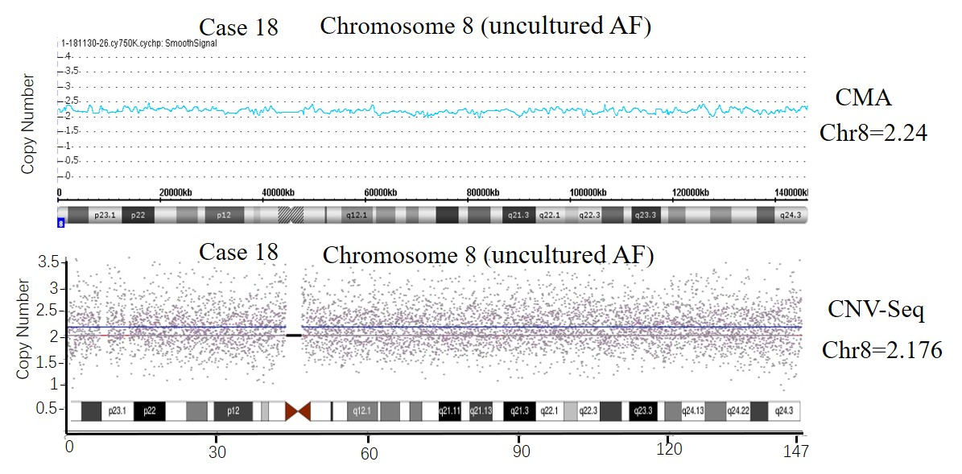
Figure S1. chromosomal microarray (CMA)and CNV sequencing (CNV-Seq) profiles of Case 18. The CMA analysis on uncultured AF samples (Panel a) shows a mosaic trisomy 8 (approximately 24%). The CNV‐seq profiles of the same sample (Panel b) show low ratio of mosaic trisomy 8 (approximately 18%). The blue line represents the mean copy number and the black box represents the centromere.

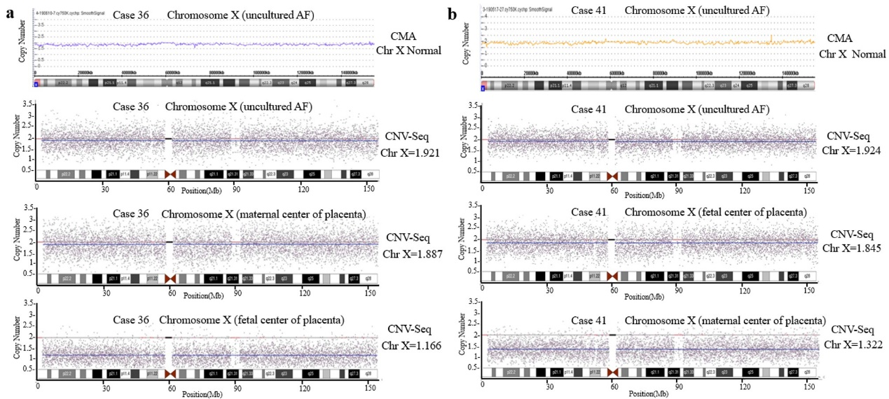
Figure S2. Chromosomal microarray (CMA) and CNV sequencing (CNV-Seq) profiles of Case 36 and Case 41. a.The CMA analysis on uncultured AF samples(Panel a) shows a normal result. The CNV‐seq profiles of the same AF samples (Panel b) show low ratio of mosaic monosomy X(approximately 8%). The CNV‐seq profiles of the maternal and fetal center of placenta show monosomy X with the level of 11% and 83%. The blue line represents the mean copy number and the black box represents the centromere. (b) The CMA analysis on uncultured AF samples shows a normal result. The CNV‐seq profiles of the same AF samples show low ratio of mosaic monosomy X(approximately 8%). The CNV‐seq profiles of the maternal and fetal center of placenta show monosomy X with the level of 15% and 78%. The blue line represents the mean copy number and the black box represents the centromere.

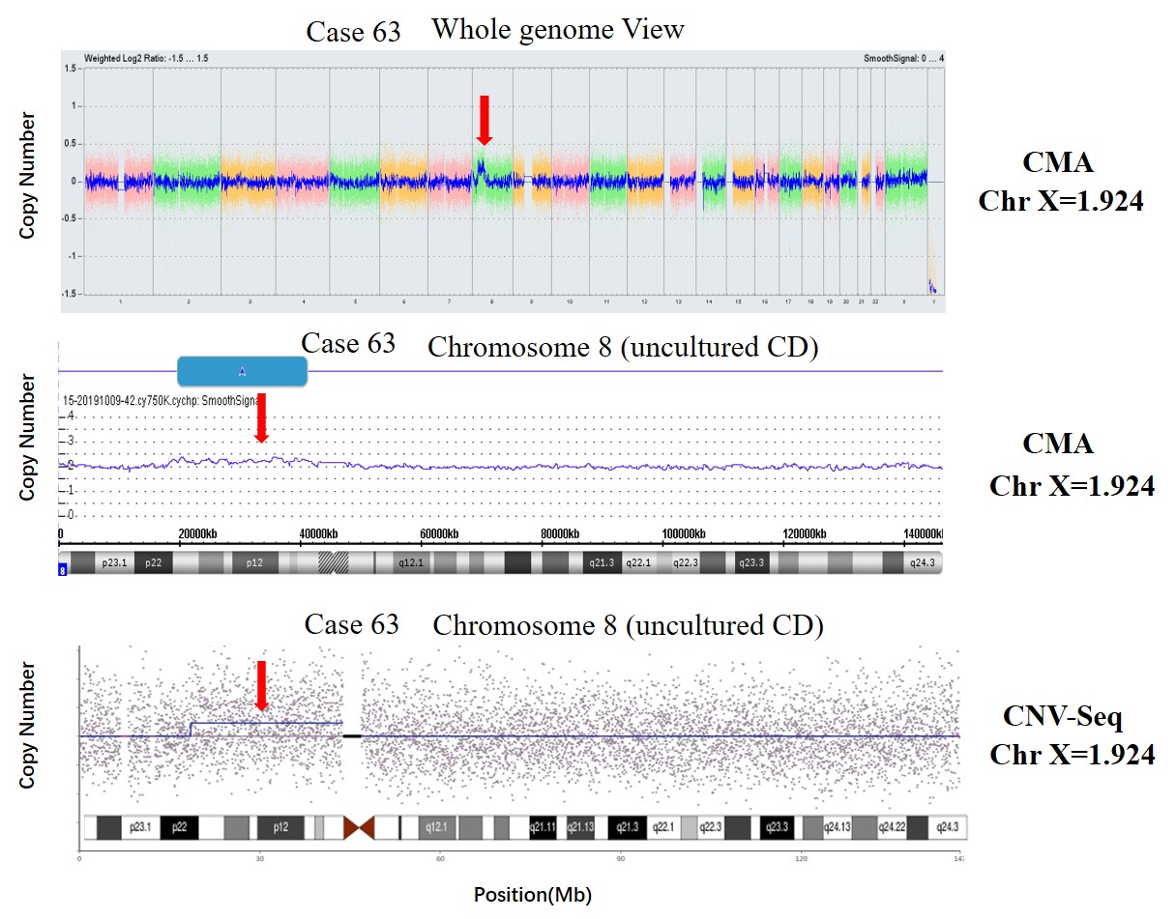
Figure S3. Discordant chromosomal abnormalities detected by karyotyping and copy number variation sequencing (CNV-Seq) in Case 63. The CMA analysis on uncultured CD sample shows a 20.44 Mb mosaic duplication at chromosome 8p21.3p11.21 (approximately 23 % of cells) marked by arrow. CNV-Seq profile are shown for Case 63 (8p22p11.1 dup 25.3 Mb, approximately 23 % of cells). Positions of CNVs are indicated by arrows.

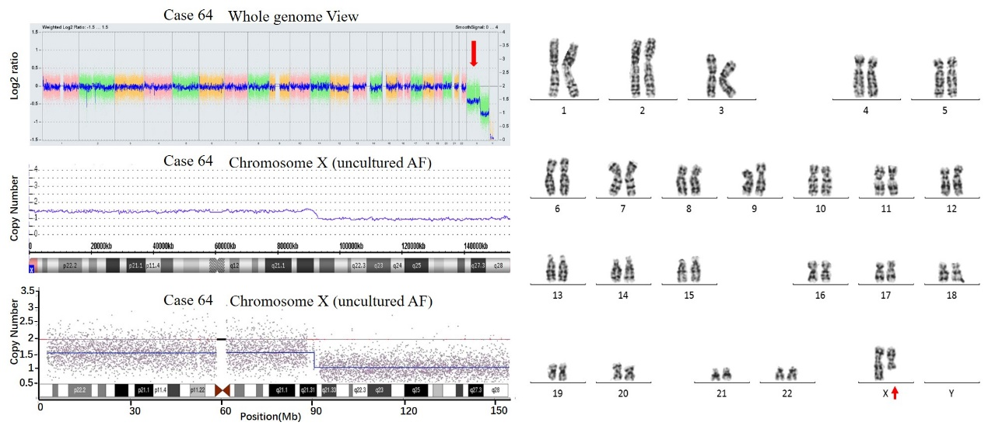
Figure S4. Chromsomal mosaicism for Xp2.33q21.31 detected by chromosomal microarray (CMA) and copy number variation sequencing (CNV-Seq) in Case 64. CMA (left), CNV-Seq (left) and karyotypes profiles (right) are shown for Case 64. Blue lines on sequencing plots represent mean copy number change.

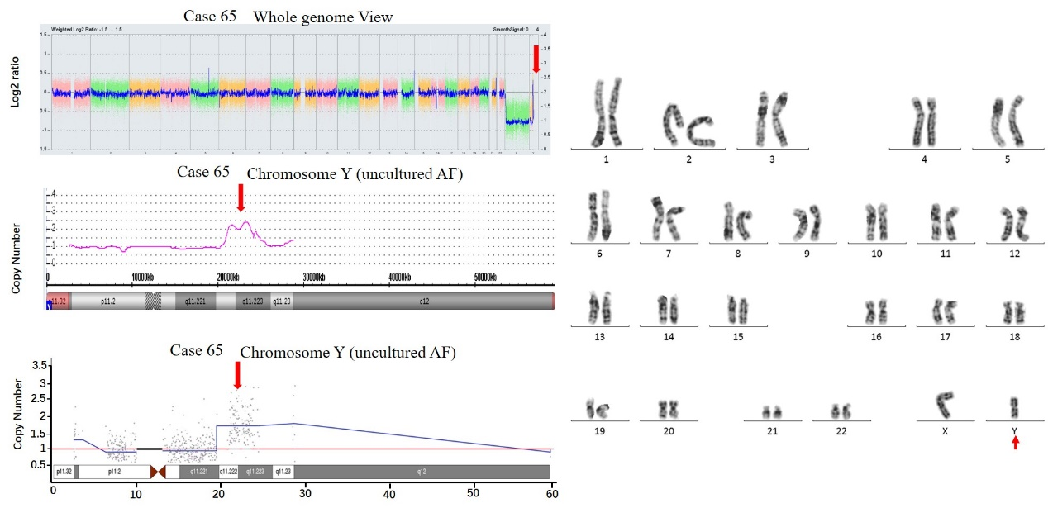
Figure S5. Duplication of Yq11.222q11.223 detected by chromosomal microarray (CMA) and copy number variation sequencing (CNV-Seq) in Case 65. CMA (left), CNV-Seq (left) and karyotypes profiles (right) are shown for Case 65. Blue lines on sequencing plots represent mean copy numbe. Positions of CNVs are indicated by arrows change.

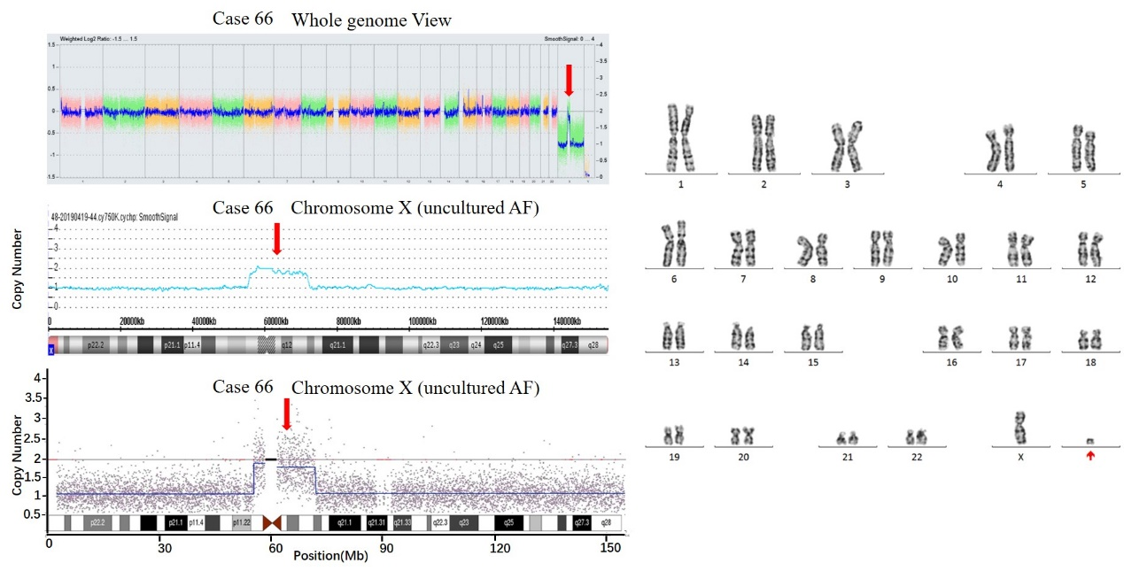
Figure S6. Deletion of Xp22.33p11.21 and Xq13.2q28 detected by chromosomal microarray (CMA) and copy number variation sequencing (CNV-Seq) in Case 66. CMA (left), CNV-Seq (left) and karyotypes profiles (right) are shown for Case 66. Blue lines on sequencing plots represent mean copy number change. Positions of CNVs are indicated by arrows.

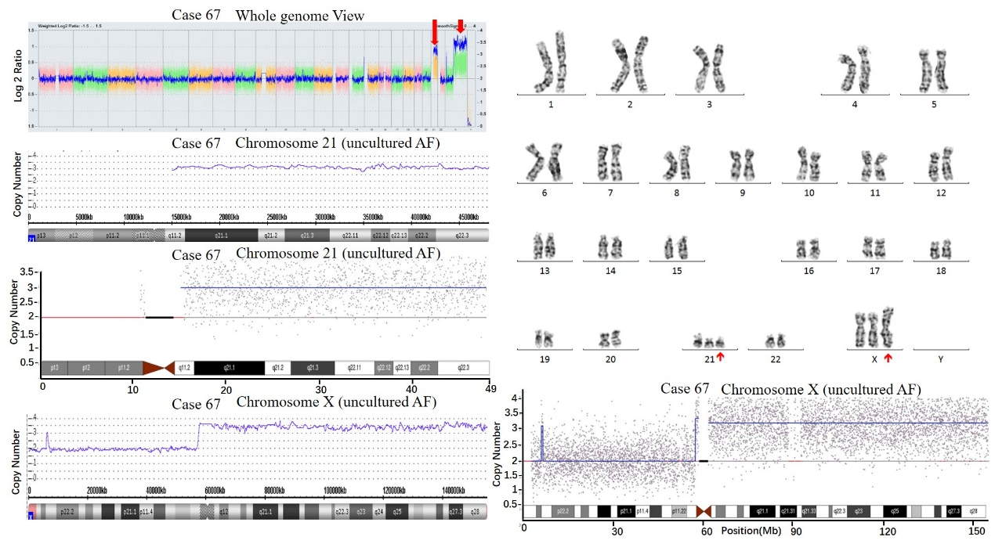
Figure S7. Trisomy 21 and duplication of Xp11.21q28 detected by chromosomal microarray (CMA) and copy number variation sequencing (CNV-Seq) in Case 67. CMA, CNV-Seq and karyotypes profiles are shown for Case 67. Blue lines on sequencing plots represent mean copy number change. Positions of CNVs are indicated by arrows.

