Supporting Information
for
Bioinspired All-in-One Wound Dressing: Integrating Photothermal-Enhanced Drainage and Strain-Sensing Monitoring for Intelligent Healing

Zhihua Liu^{a,b,c}, Naiqian Zhangª, Tianjia Jiangª, Cheng Wang^{b}, Hui Zheng^{d}, Lin Lin^{d,*}, Na Li^{a,*}, Dapeng Yang^{a,c,*}
ª Shandong Engineering Research Center for Tissue Rehabilitation Materials and Devices, School of Rehabilitation Sciences and Engineering, University of Health and Rehabilitation Sciences, Qingdao 266113, China
^{b} Key Laboratory of Marine Drugs, Chinese Ministry of Education, School of Medicine and Pharmacy, Ocean University of China, Qingdao 266003, China
^{c} College of Chemical Engineering and Materials Science, Quanzhou Normal University, Quanzhou 362000, China
^{d} Department of Radiology, Fujian Medical University Union Hospital, Fuzhou 350001, China
Corresponding Author
* E-mail: linlin@fjmu.edu.cn; lina@uhrs.edu.cn; yangdapeng@uhrs.edu.cn

2.3. Photothermal performance and unidirectional drainage capability
Using an 808 nm NIR laser (1.5 W/cm², Distance: 3cm) as the irradiation source, the photothermal properties of a series of PU-xTA/Fe³⁺ (x = 0%, 0.5%, 1.5%, 2.5%, 3%) nanofiber membranes were systematically evaluated. The 1 cm × 1 cm nanofiber membrane samples were irradiated with an 808 nm NIR laser for 180 s, and the temperature changes were recorded in real time using an infrared thermal imaging camera. To simulate the moist environment of wound exudate, the PU-xTA/Fe³⁺ nanofiber membranes were soaked in ultrapure water for 30 s before undergoing the same parameter laser irradiation to evaluate their photothermal behavior in a wet state. Additionally, the photothermal stability of the material was investigated through three consecutive cycles of laser on-off irradiation experiments.
To study the performance of photothermal enhanced unidirectional guide fluid, we continuously monitored the weight of the drainage using a precision balance. The brief steps are as follows: Carefully place the water collection trough containing 30 g of water on the ceiling platform, so that the upper and lower surfaces of the suspended PU-2.5TA/Fe³⁺/10Ag@PU nanofiber membrane are in contact with the water surface respectively to study the effect of unidirectional guide fluid on water evaporation. In addition, a NIR with a power of 1.5 W/cm² was applied to the upper hydrophilic layer to study the photothermal enhanced liquid conduction effect. In addition, a systematic study was conducted on the evaporation performance of PU-xTA/Fe³⁺(x=0, 0.5, 1.5, 2.5) nanofiber membranes under NIR. Finally, the computer software was used to continuously record the water weight change data on the balance platform, with a monitoring duration of 60 min.
To further study the liquid guiding ability of the double-layer nanofiber membrane, PU-2.5%TA/Fe³⁺/10Ag@PU was selected as a representative model for testing. After fixing the sample horizontally, a dropper was used to drop approximately 50 μL of red dye on both the hydrophilic layer (PU-2.5TA/Fe³⁺/10Ag) and the hydrophobic layer (PU), and the liquid penetration behavior in the fiber membrane was recorded through video. To simulate the upward liquid drainage requirement that may exist in practical applications, the hydrophilic layer was placed on the top layer, and the water droplet drainage experiment from below was conducted to evaluate its unidirectional drainage performance.
2.4 The sensing performance of nanofiber membranes
To systematically evaluate the strain sensing performance of PU-2.5TA/Fe³⁺/xAg (x = 1, 5, 10) nanofiber membranes, a comprehensive analysis was conducted in this study on the relationship between the relative resistance variation and strain. Firstly, we use a universal tensile testing machine to conduct tensile tests on the material to obtain its resistance response under different strains. To further explore its application potential in wearable sensing, we fixed PU-2.5TA/Fe³⁺/10Ag nanofiber membranes on human joints such as fingers, wrists and elbows. We monitored the resistance signals during the joint bending process in real time through Keithley 2450 and calculated the corresponding relative resistance changes (ΔR/R₀). In addition, the resistance response behavior of the PU-2.5TA/Fe³⁺/10Ag nanofiber membranes under different traction speeds and stress conditions was systematically investigated to evaluate its sensing stability in different deformation environments. To characterize the dynamic response capability of the PU-2.5TA/Fe³⁺/10Ag nanofiber membranes, we tested its rapid response performance under step strain. Meanwhile, the signal stability and durability of PU-2.5TA/Fe³⁺/10Ag nanofiber membranes under long-term mechanical loading were evaluated by conducting a 50-min cyclic tensile test on them. In the experiment, the relative change of resistance (RCR) of resistance is calculated by the following formula:
$$\begin{aligned}ΔR/R_{0} \left(\%\right)=\frac{R-R_{0}}{R_{0}}×100\%\#\left(1-1\right)\end{aligned}$$Here, ΔR represents the change in resistance, and R₀ and R respectively denote the initial resistance and instantaneous resistance during the stretching process.
GF is a key parameter for measuring the strain sensitivity of sensors and is determined by the slope of the RCR-strain curve. Its calculation formula is:
$$\begin{aligned}GF=\frac{d(ΔR/R₀)}{dε}×100\%\#\left(1-2\right)\end{aligned}$$ Here, ε is the tensile strain applied.
2.5. In vitro antibacterial assays
The antibacterial performance of PU-xTA/Fe³⁺ (x=0%, 0.5%, 1.5%, 2.5%) nanofiber membranes against Gram-positive bacteria S. aureus and Gram-negative bacteria E. coli was evaluated using the plate counting method. The specific steps are as follows: In each well of a 96-well plate, add 200 µL of bacterial suspension with a concentration of 1×10⁷ CFU/mL, and place a 0.5 cm × 0.5 cm PU-xTA/Fe³⁺ nanofiber membrane in each well. Place the plate under an 808 nm NIR (1.5 W/cm², Distance: 3cm) and irradiate it for 0, 5, and 10 min respectively. After irradiation, dilute each group of bacterial suspensions 100 times with sterile LB medium. Take 30 µL of the diluted bacterial solution and spread it evenly on the surface of the agar plate, then place the plate in a 37 ℃ constant temperature incubator for 18 h of cultivation. After cultivation, take photos of the colonies and count them, and calculate the antibacterial rate according to the following formula:
$$\begin{aligned}Antibacterial ratio \left(\%\right)=\frac{Aa-Ab}{Aa}×100\%\#\left(1-3\right)\end{aligned}$$
Where Aa and Ab represent the number of bacterial colonies in the control and sample groups, respectively.
To assess the antibacterial effect more intuitively, this study used field emission scanning electron microscopy (FE-SEM) to observe the bacterial morphology. The specific steps are as follows: After completing the aforementioned antibacterial experiments, slowly aspirate the bacterial suspension in the wells, and let the PU-2.5TA/Fe³⁺ nanofiber membrane stand for 2 h. Then, add 200 µL of 2.5% glutaraldehyde solution to each well and fix the bacterial samples for 2 h. After fixation, sequentially use 30%, 50%, 70%, 90%, and 100% ethanol gradients to dehydrate the samples, each at a concentration for 15 min. Finally, dry the samples and conduct FE-SEM observation.
To investigate the photothermal antibacterial mechanism of PU-xTA/Fe³⁺ nanofiber membranes, this study used O-nitrophenyl β-galactoside (ONPG) to assess the effect of this material on the permeability of the cell membranes of S. aureus and E. coli. The experimental steps are as follows: First, the bacterial suspension was mixed with an Isopropyl-β-D-thiogalactoside (IPTG) solution (10 μg/mL) and incubated at 37 ℃ for 12 h. Then, the suspension was centrifuged at 5000 r/min for 5 min under low temperature conditions, the supernatant was discarded, and the bacteria were resuspended in phosphate-buffered saline (PBS) and adjusted to an OD=600 value of 0.05-0.1 for subsequent antibacterial experiments. 15 μL of the above bacterial suspension was taken, mixed with 10 μL of 7% dimethyl sulfoxide (DMSO), 15 μL of 2-Nitrophenyl β-D-galactopyranoside (ONPG) solution (3.7 mg/mL), and 110 μL of PBS, and then the mixture was homogenized. After the reaction, the absorbance value was measured at a wavelength of 420 nm.
The effect of the samples on bacterial protein leakage was further evaluated using the bisquinoline carboxylic acid (BCA) method. The bacterial suspension from the PU-xTA/Fe³⁺ nanofiber membrane treatment group after the antibacterial experiment was centrifuged at 10000 r/min for 5 min at a low temperature. The supernatant was collected and 200 µL of BCA working reagent was mixed with an appropriate amount of the supernatant in a 96-well plate. The mixture was incubated at 37 ℃ for 30 min, and then the absorbance value was measured at a wavelength of 562 nm.
Subsequently, the total amount of ROS produced was detected using the 2',7'-dichlorofluorescein diacetate (DCFH-DA). The brief steps are as follows: Take 0.5 mL of a bacterial suspension with a concentration of 1×10⁹ CFU/mL, centrifuge at 6000 r/min for 5 min, and collect the bacteria. Then, wash three times with PBS buffer solution and resuspend in 100 μL of DCFH-DA working solution diluted at a ratio of 1:1000 with PBS. Incubate at 37 ℃ in the dark for 30 min to allow the probe to fully enter the cells and hydrolyze into DCFH. Then, centrifuge to remove the excess probe, and repeat the above antibacterial operation with the labeled bacteria. Finally, transfer the samples to a 96-well plate and use a microplate reader to measure the fluorescence intensity at an excitation wavelength of 488 nm and an emission wavelength of 525 nm, thereby reflecting the amount of ROS generated.
The electronic spin resonance spectroscopy method (ESR, JES-FA200, JEOL Corporation) was employed to conduct qualitative and quantitative analysis of reactive oxygen species (ROS) generated by the sample under 808 nm NIR light irradiation (1.5 W/cm²). To detect singlet oxygen (⋅¹O₂), 1 μL of TEMP capture agent was added to 200 μL of sample aqueous solution, and ESR measurements were carried out at 0, 5, and 10 min after the light exposure. To detect hydroxyl radicals (⋅OH) and superoxide anion (⋅O₂⁻), different solvent systems of deionized water and methanol were used, and DMPO was employed as the capture agent. ESR measurements were conducted under the same light conditions, with all other experimental parameters remaining consistent.
2.6. In vitro biocompatibility experiments
To evaluate the in vitro biocompatibility of PU-2.5TA/Fe³⁺/xAg@PU (x=1, 5, 10) nanofiber membranes, in this study, L929 cells were used as the model and a 7-day cytotoxicity experiment was conducted. Before the experiment, the nanofiber membrane was first immersed in DMEM for 24 h to prepare the material extraction solution. Specifically: L929 cells were respectively inoculated in 96-well plates and confocal culture dishes. The experimental group was cultured using the above-mentioned extract, while the control group was cultured using DMEM medium without the extract. All cells were cultured at 37 °C and 5% CO₂ for 1, 3 and 7 days. At each time point, Dead/Live staining was performed on the cells in the confocal culture dish, and the cell morphology and survival status were observed using a confocal microscope (live cells showed green fluorescence and dead cells showed red fluorescence). Meanwhile, CCK-8 reagent was added to the 96-well plate. After a certain period of reaction, the absorbance value at 450 nm was detected using a microplate reader, and the cell viability was calculated according to the following formula:
$$\begin{aligned}V\%=\frac{B_{a}-B_{c}}{B_{b}-B_{c}} × 100\%\#\left(1-4\right)\end{aligned}$$
Where B_{a} is the absorbance of CCK-8 product with L929 and extract solution, B_{b} is the absorbance of CCK-8 product with L929 and no extract solution, and B_{c} is the absorbance of L929 product with pure cell culture medium.
To evaluate the regulatory effect of PU-2.5TA/Fe³⁺/xAg@PU (x=1, 5, 10) nanofiber membranes on cell migration behavior during wound repair, cell scratch experiments were used in this study to simulate their biological effects. Before the experiment, draw uniform black horizontal lines at the bottom of the six-well plate (with a spacing of 0.5 to 1 cm), at least three lines per well, and use the intersection points as the observation reference for the subsequent scratch width. Cells in the logarithmic growth phase were seeded in six-well plates at a density of 5×10⁵ per well and cultured in DMEM medium containing 10% fetal bovine serum (FBS) until the plates were fully covered with cells. Subsequently, use a 200 µL sterile pipette tip perpendicular to the surface of the culture plate and make a scratch along the direction perpendicular to the background horizontal line to form a clear cross-shaped cell defect area. After aspirating the original culture medium, wash it three times with PBS to remove the exfoliated cells, and then re-add it to the culture medium. The experimental groups included: a medium containing 1% FBS as the negative control group, and a medium containing 1% FBS and loaded with different nanofiber membrane extracts respectively as the experimental group. The culture plates were placed in a 37 °C, 5% CO₂ incubator for continued culture. The changes in scratch width of each group were observed and recorded at 0 h, 12 h, 24 h and 36 h respectively. Process the data using Image-J. The cell mobility is calculated by the following formula:
$$\begin{aligned}Cell migration rate (\%)=\frac{C_{m}-C_{0}}{C_{0}} × 100\%\#\left(1-5\right)\end{aligned}$$
Here, C₀ represents the initial scratch area and C_{m} represents the final scratch area.
To evaluate the blood compatibility of PU-2.5TA/Fe³⁺/xAg@PU (x = 0, 1, 5, 10) and PU-xTA/Fe³⁺ (x = 0%, 0.5%, 1.5%, 2.5%, 3%) nanofiber membranes, hemolysis experiments were conducted using mouse blood in this study. First, take 0.5 mL of whole blood, centrifuge it at 1000 r/min for 5 min, discard the supernatant, and then wash it twice with PBS buffer. Finally, prepare a 2% red blood cell suspension. Subsequently, equal volumes of 2% red blood cell suspension were added to each centrifuge tube, and nanofiber membrane samples of different groups were added respectively. All samples were incubated at 37 °C for 30 min, then centrifuged at 5000 r/min for 5 min. The supernatant was collected and the absorbance was measured at 450 nm using a microplate reader. In the experiment, deionized water was used as the positive control and PBS buffer as the negative control to systematically evaluate the hemolytic behavior of the materials.
2.7. In vivo wound healing test
This animal experiment protocol has been approved by the Animal Ethics Committee of Rehabilitation University (Approval Number: KFDX: N0. 2025-2013). The study selected 8-week-old male SD rats with a body weight of 200–250 g. After one week of adaptive feeding, a full-thickness skin wound model was constructed. The specific operation steps are as follows: rats were anesthetized by inhaling isoflurane under aseptic conditions. Using a puncher, two circular full-thickness skin defect wounds with a diameter of 1 cm were made on the back skin. Subsequently, 1×10⁷ CFU/mL of Staphylococcus aureus bacterial solution was inoculated into each wound. The experimental grouping and treatment are as follows: Different compositions of nanofiber membranes (PU-2.5TA/Fe³⁺, PU-2.5%TA/Fe³⁺/0Ag@PU, PU-2.5TA/Fe³⁺/10Ag@PU) were respectively covered on the wounds, and then an 808 nm NIR laser (0.375 W/cm²) was irradiated for 5 min. Another blank control group was set up, with the wounds only covered by sterile gauze. To evaluate the in vivo antibacterial effect, the wound exudate was collected on the 3rd and 10th days after the operation, and the bacterial colony counts were calculated using the spread plate method, and the antibacterial rate was calculated. The wound healing process was quantitatively evaluated by taking photos of the wounds on days 0, 3, 7, 10, and 14. The wound contraction ratio (Wc) was calculated according to the following formula:
$$\begin{aligned}Wc (\%)=\frac{S_{0}-S_{n}}{S_{n}} × 100\%\#\left(1-6\right)\end{aligned}$$
Among them, S0 and Sn represent the wound area measured on the 0th day and the nth day respectively. On the 14th day after the operation, the rats were sacrificed, and the skin tissue from the wound area was collected. After being washed with normal saline, some samples were subjected to hematoxylin-eosin (HE) staining and Masson staining for morphological observation of the tissue. The other samples were stored at -80 ℃ for RNA sequencing analysis.
2.8. Statistical analysis
The experimental data are presented as mean±standard deviation (mean±S.D.). One-way analysis of variance (one-way ANOVA) was used to conduct statistical comparisons between the control group and the experimental group. The significance levels are indicated as follows: * p < 0.05, ** p < 0.01, *** p < 0.001.

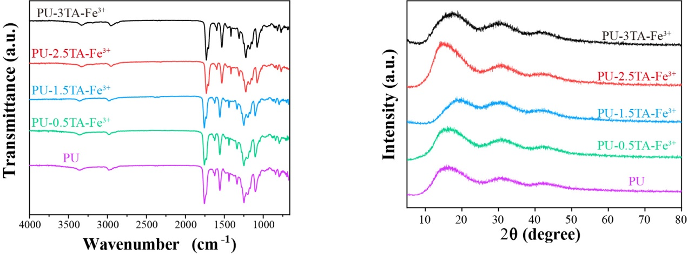
Figure S1. The XRD results of PU-xTA/Fe³⁺ (x = 0%, 0.5%, 1.5%, 2.5%, 3%) nanofiber membranes.
Figure S2. The FT-IR results of PU-xTA/Fe³⁺ (x = 0%, 0.5%, 1.5%, 2.5%, 3%) nanofiber membranes.
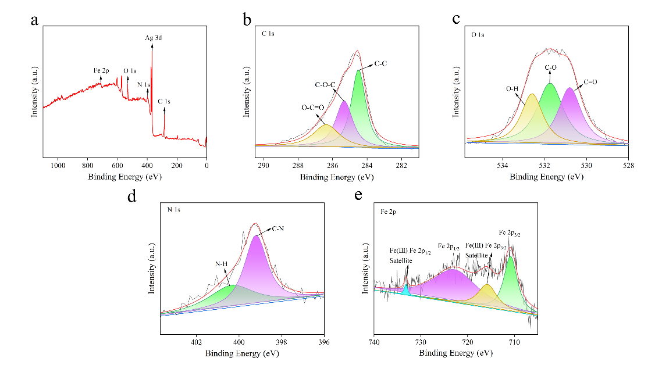
Figure S3. (a-e) Elemental spectra of PU-2.5TA/Fe³⁺/1Ag@PU janus nanofiber membranes (Full spectrum, C 1s, O 1s, N1s, Fe 2p). 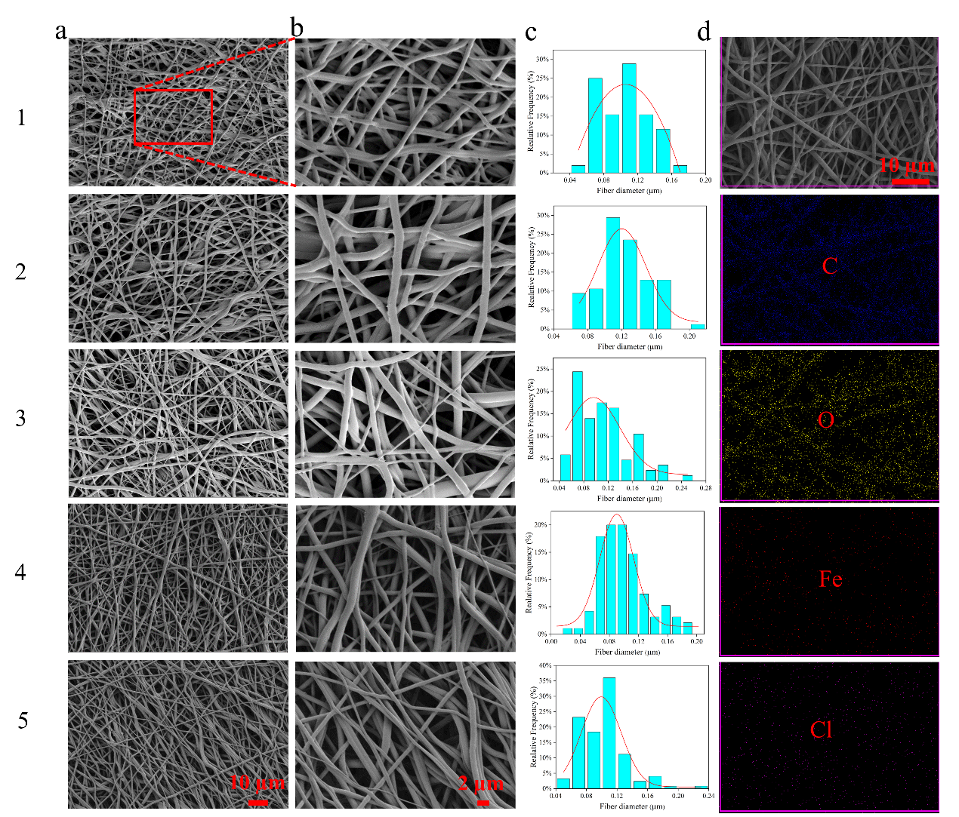
Figure S4. (a) SEM images of PU-xTA/Fe³⁺ (x=0, 0.5, 1.5, 2.5, 3) nanofiber membranes. (b) SEM image under a magnified perspective. (c) The distribution of filament diameters. (d) Mapping diagram.
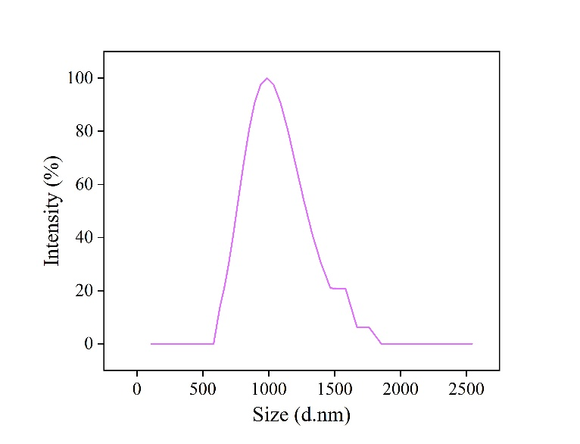
Figure S5. The diameter of the Ag nanowires.
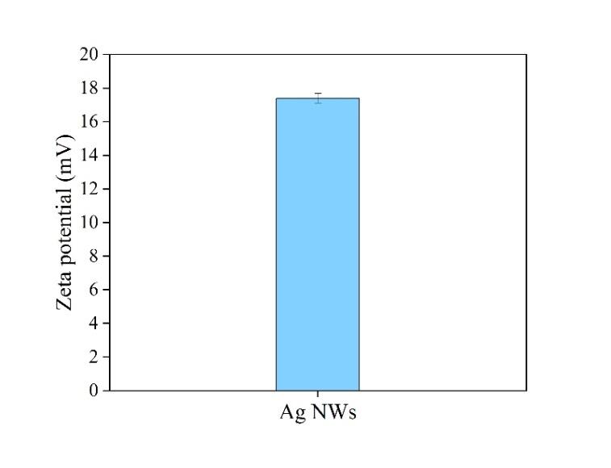
Figure S6. The Zeta potential of Ag nanowires.
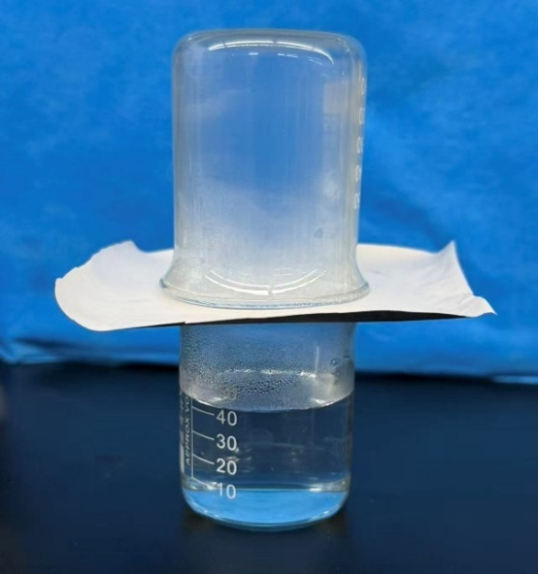
Figure S7. Permeability test of the PU-2.5TA/Fe³⁺/1Ag@PU Janus nanofiber membrane.
Figure S8. Video showing the liquid-conducting process of the PU-2.5TA/Fe³⁺/1Ag@PU nanofiber membrane with hydrophilic upper layer and hydrophobic lower layer.
Figure S9. Video showing the liquid-conducting process of the PU-2.5TA/Fe³⁺/1Ag@PU nanofiber membrane with hydrophobic upper layer and hydrophilic lower layer.
Figure S10. Video showing the liquid-conducting process of the PU-2.5TA/Fe³⁺/1Ag@PU nanofiber membrane with hydrophilic upper layer and hydrophobic lower layer.
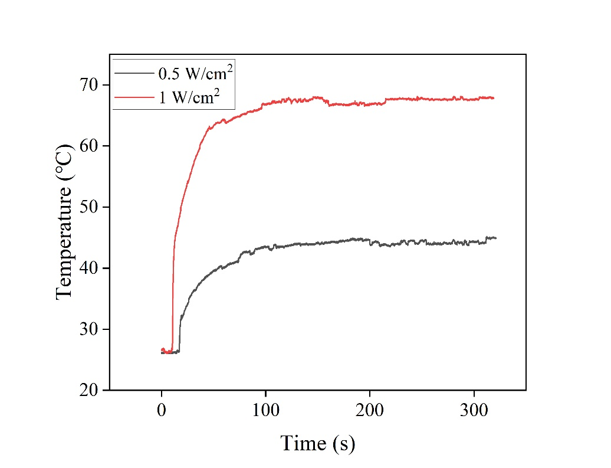
Figure S11. The temperature rise curves of the PU-2.5TA/Fe³⁺ nanofiber membranes in a dry state under different power near-infrared irradiation for 300 s.
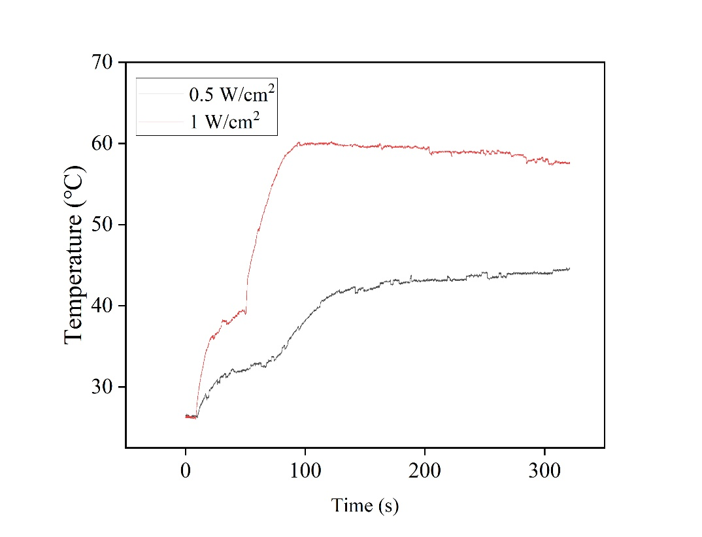
Figure S12. The temperature rise curves of the PU-2.5TA/Fe³⁺ nanofiber membranes in a humid state under different power near-infrared irradiation for 300 s.
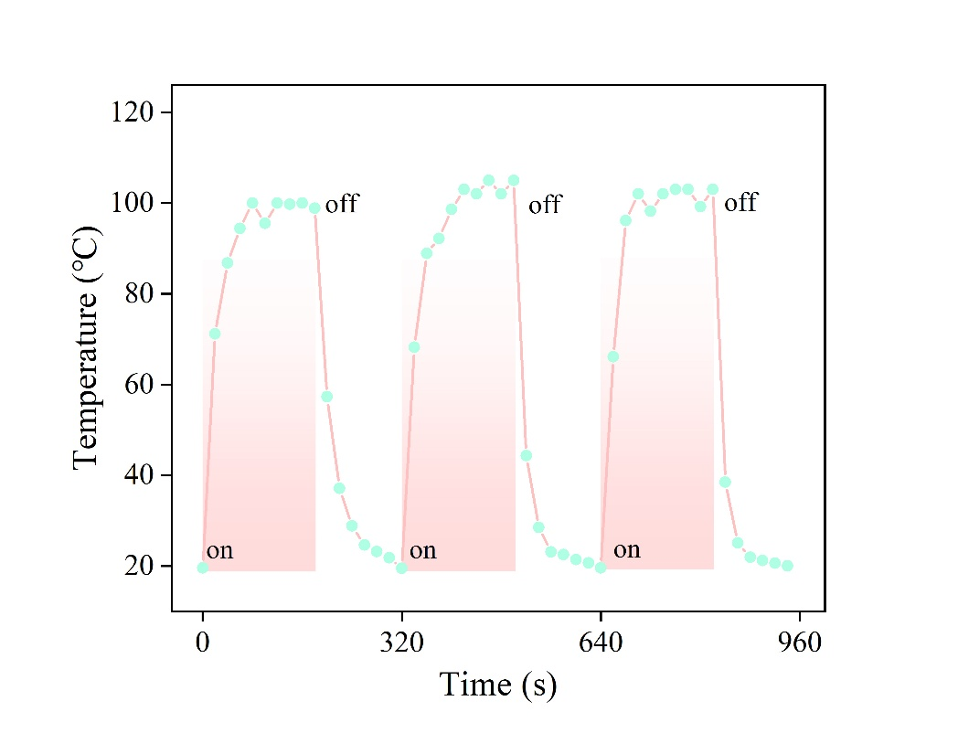
Figure S13. Evaporation rate of ultrapure water in PU-2.5TA/Fe³⁺/10Ag@PU nanofiber membrane group under near-infrared light. Temperature changes under three switch cycles.
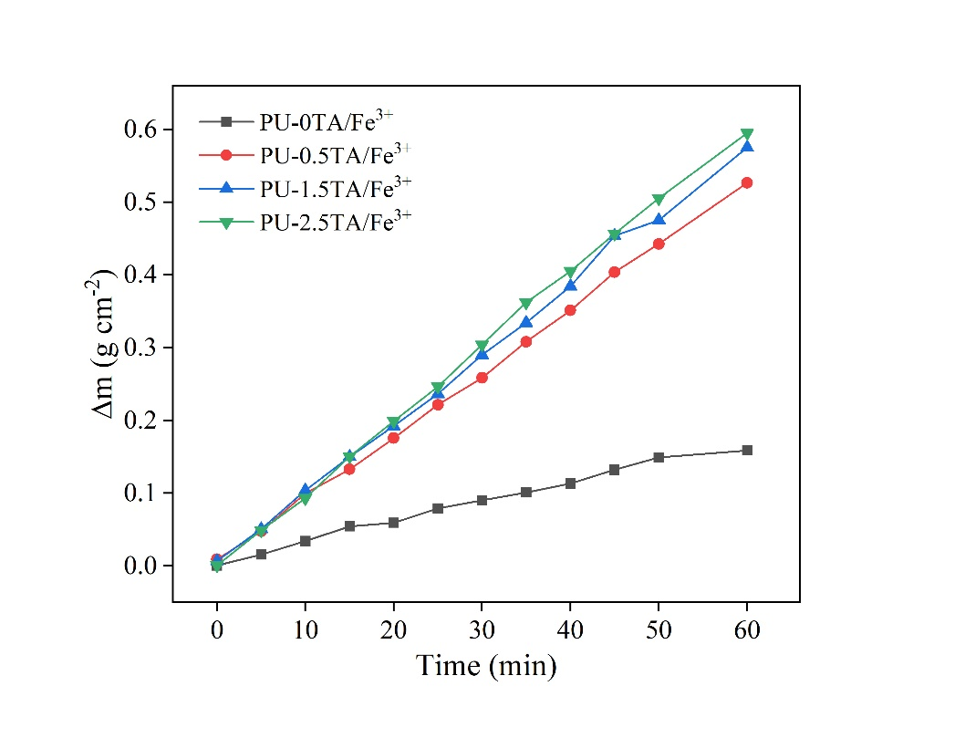
Figure S14. Evaporation volume of ultrapure water from PU-xTA/Fe³⁺ (x=0, 0.5, 1.5, 2.5) nanofiber membranes.
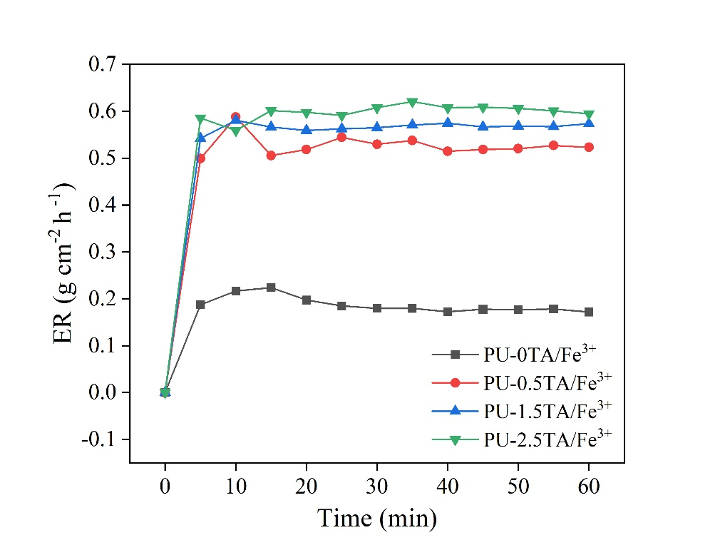
Figure S15. The evaporation rate of ultra-pure water on the PU-xTA/Fe³⁺@PU (x=0, 0.5, 1.5, 2.5) nanofiber membrane under NIR light.
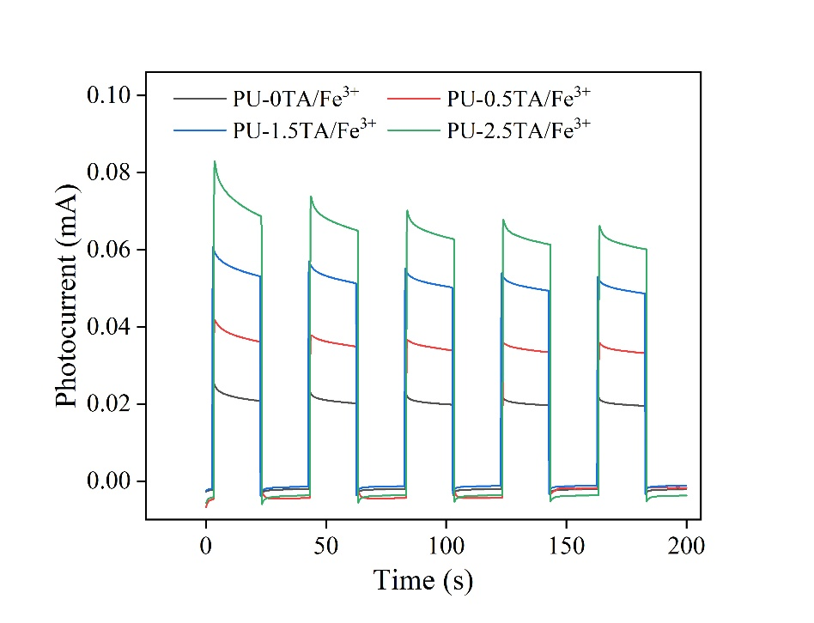
Figure S16. The photocurrent results of PU-xTA/Fe³⁺ (x=0, 0.5, 1.5, 2.5) nanofiber membranes.
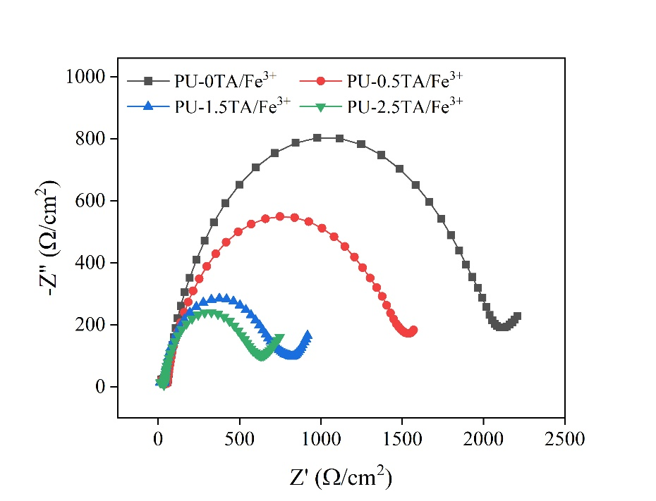
Figure S17. The impedance results of PU-xTA/Fe³⁺ (x=0, 0.5, 1.5, 2.5) nanofiber membranes.
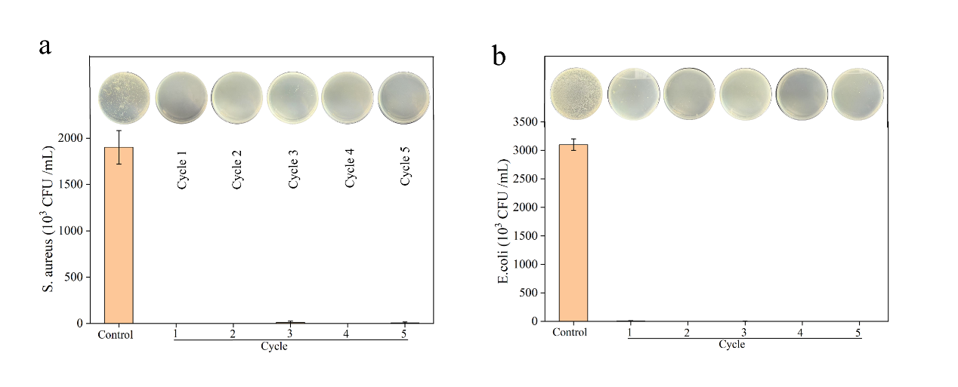
Figure S18. The antibacterial results of PU-2.5TA/Fe³⁺ nanofiber membranes after being exposed to near-infrared light for five cycles.
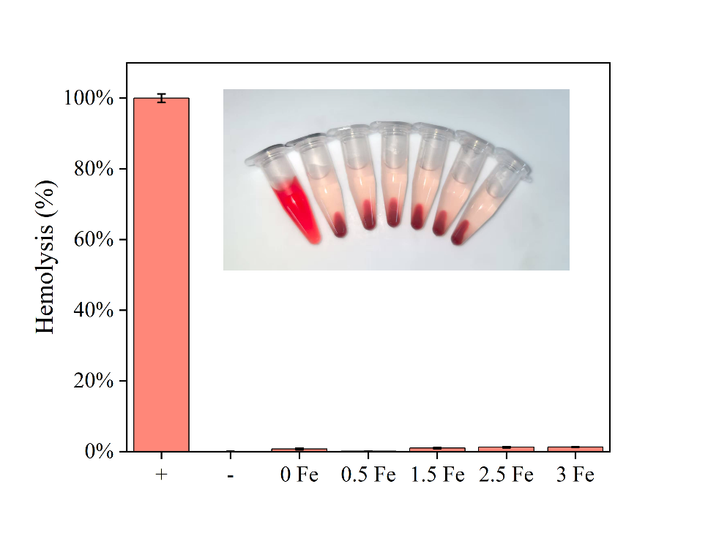
Figure S19. Hemolysis rate of red blood cells in PU-xTA/Fe³⁺ (x = 0, 0.5, 1.5, 2.5, 3) nanofiber membranes.
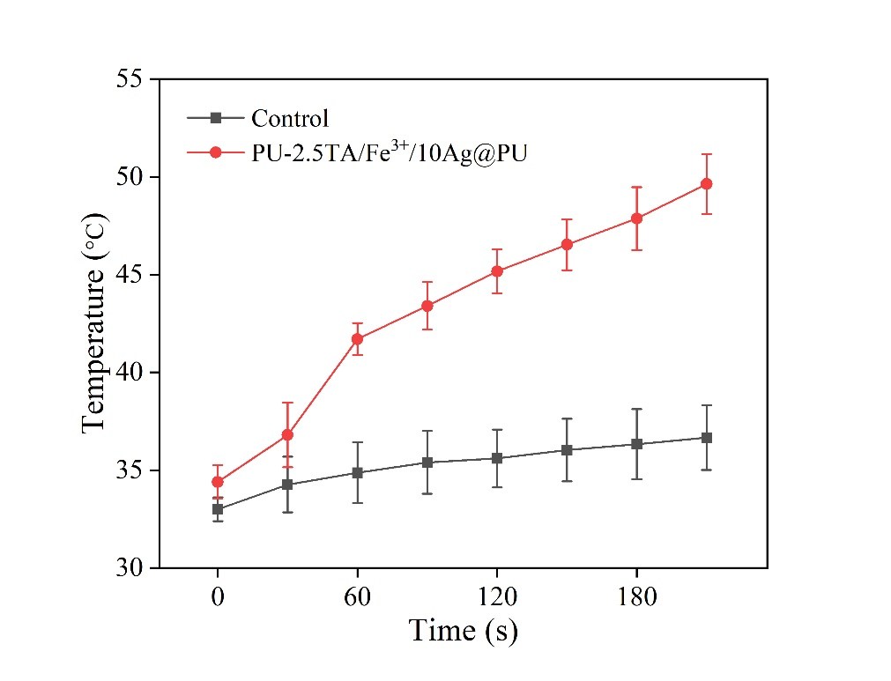
Figure S20. Temperature rise curves of rats in the control group and the PU-2.5TA/Fe³⁺/10Ag@PU group under near-infrared light irradiation.
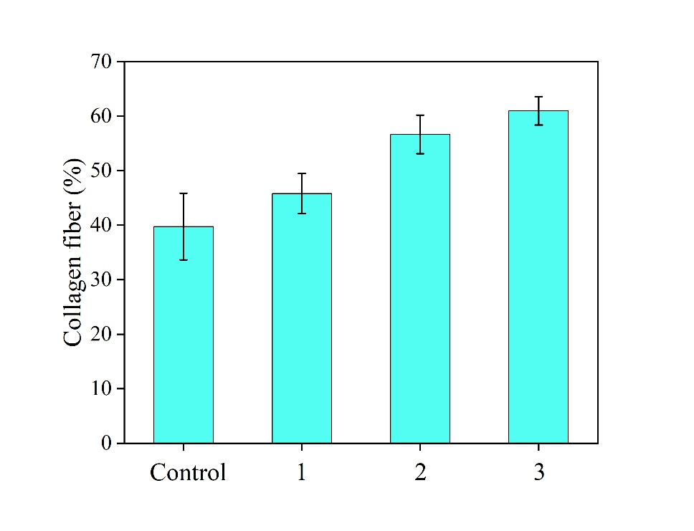
Figure S21. The proportion of collagen fibers in each group.
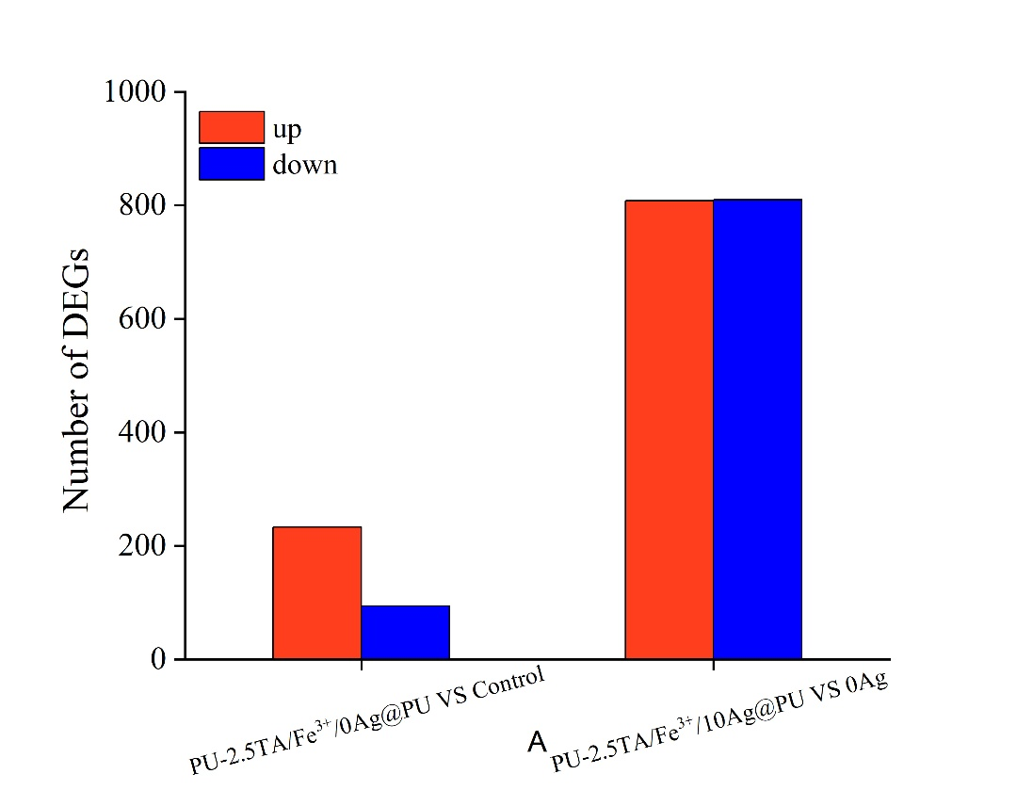
Figure S22. The results of gene upregulation and downregulation.
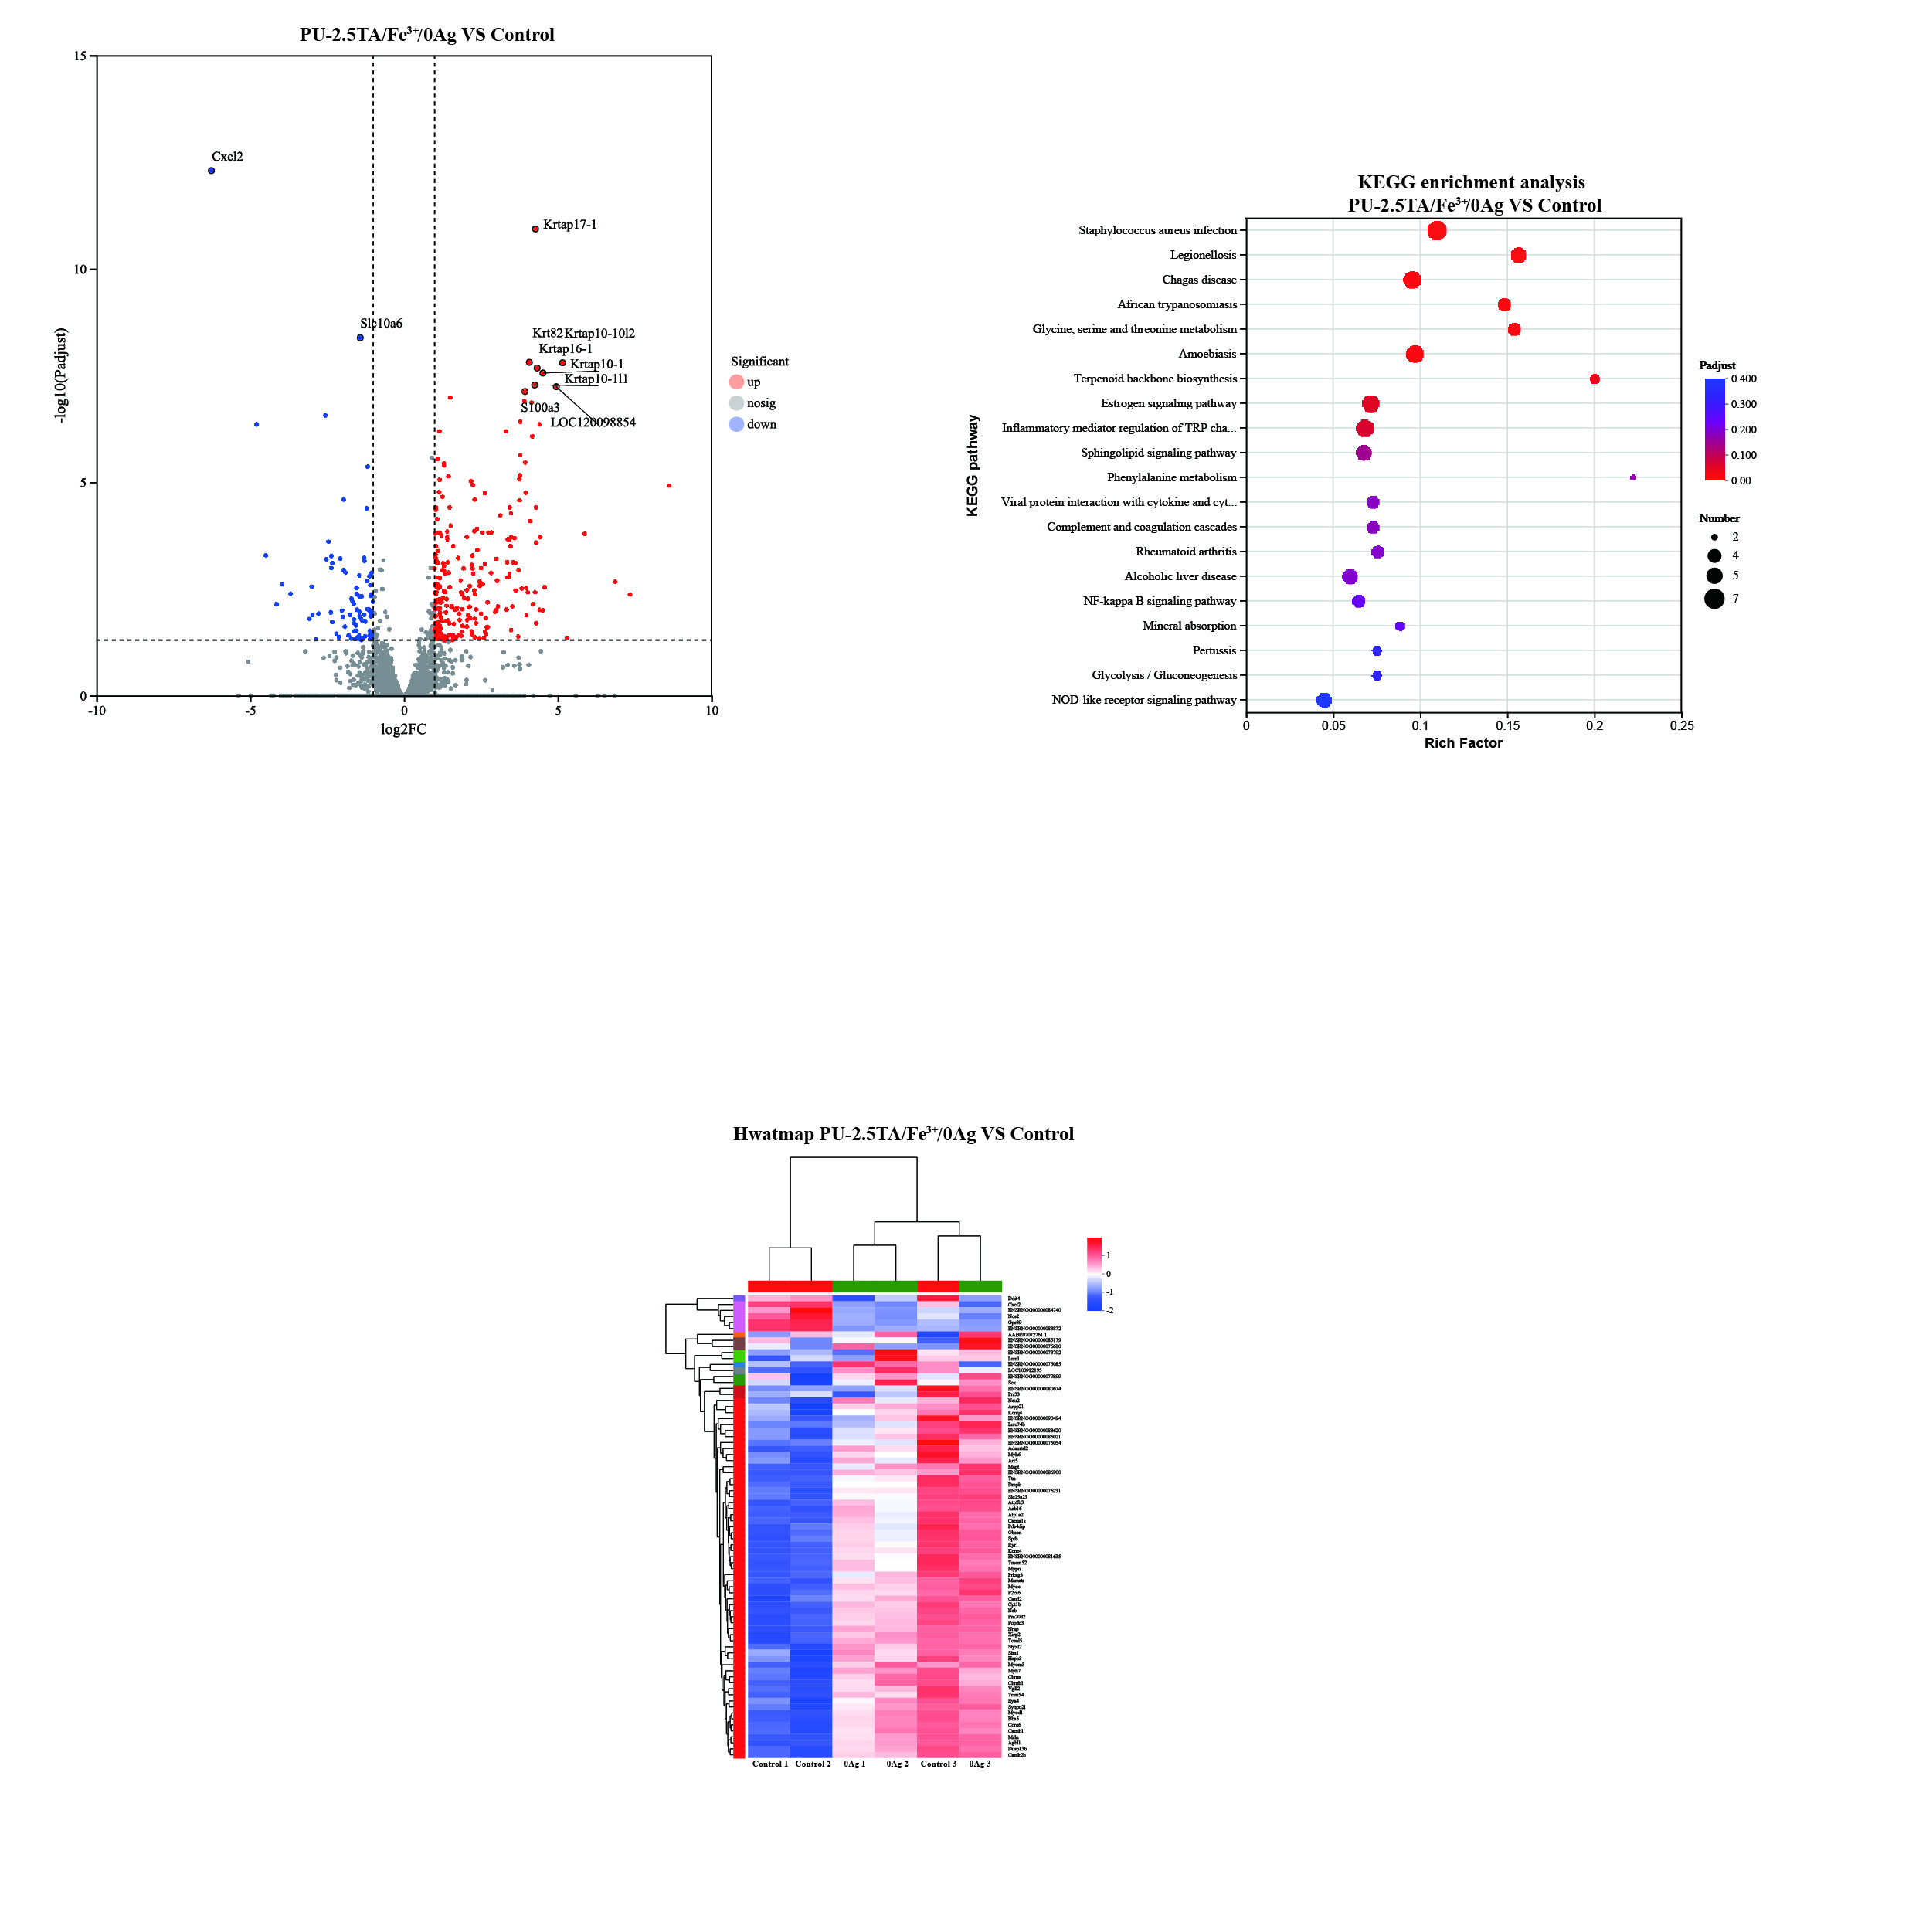
Figure S23. Volcano plots of differentially expressed genes (DEGs) in the PU-2.5TA/Fe³⁺/0Ag@PU group and the Control group on the 14th day.
Figure S24. KEGG enrichment analysis in the PU-2.5TA/Fe³⁺/0Ag@PU group and the Control group on the 14th day.
Figure S25. Heat map in the PU-2.5TA/Fe³⁺/0Ag@PU group and the Control group on the 14th day.

