Supplementary materials
Table S1. Mean and standard deviation (SD) of the biological variables collected and included in the analyses.
Variable | Mean | SD
BMI | 25.12 | 3.82
Leptin | 14.55 | 9.66
Adiponectin | 7.82 | 6.38
BDNF | 10.56 | 6.52
IL-5 | 2.98 | 1.41
IL-6 | 6.45 | 8.60
IL-7 | 6.14 | 6.12
IL-8 | 8.44 | 5.05
IL-10 | 5.26 | 5.99
IL-12 | 14.22 | 10.66
IL-13 | 3.38 | 1.23
CCL2 | 32.34 | 22.15
CCL4 | 174.37 | 98.75
TNF-α | 9.19 | 9.75
Cortisol 8 a.m. | 7.38 | 4.82
Cortisol 12 a.m. | 5.06 | 3.53
Cortisol 6 p.m. | 4.32 | 3.34
Cortisol (AUC) | 52.16 | 32.51

Table S2. Eigenvalue, percent of variance explained and factor loadings by PCA of variables. * PC loadings: < -0.50 or > 0.50, pointing out a strong correlation between the biological variable and the PCA factor. Total N. of subjects included: 44.
 | PC1 | PC2 | PC3 | PC4 | PC5 | PC6 | PC7 | PC8 | PC9 | PC10 | PC11 | PC12 | PC13 | PC14
Eigenvalue | 3.54 | 2.70 | 1.86 | 1.34 | 1.18 | 0.78 | 0.68 | 0.60 | 0.41 | 0.31 | 0.28 | 0.14 | 0.13 | 0.06
Variance % | 25.27 | 19.29 | 13.28 | 9.56 | 8.44 | 5.56 | 4.83 | 4.32 | 2.94 | 2.23 | 1.99 | 0.98 | 0.91 | 0.40
Cumulative variance % | 25.27 | 44.56 | 57.84 | 67.40 | 75.84 | 81.40 | 86.23 | 90.55 | 93.49 | 95.73 | 97.71 | 98.69 | 99.60 | 100.00
Leptin | 0.75* | -0.45 | -0.21 | -0.20 | -0.07 | -0.20 | 0.00 | 0.03 | 0.15 | 0.03 | 0.12 | 0.12 | 0.23 | 0.03
Adiponectin | -0.78* | 0.31 | 0.00 | 0.25 | -0.08 | 0.22 | 0.01 | 0.00 | -0.03 | -0.14 | 0.38 | -0.01 | 0.09 | 0.04
BDNF | -0.10 | -0.23 | 0.23 | 0.68* | 0.08 | -0.56* | -0.17 | 0.22 | -0.12 | 0.08 | 0.06 | 0.00 | -0.02 | 0.00
IL-5 | 0.26 | 0.71* | -0.23 | 0.17 | 0.42 | -0.02 | -0.11 | -0.31 | -0.08 | 0.09 | -0.01 | 0.18 | -0.04 | 0.09
IL-6 | 0.04 | 0.26 | 0.65* | -0.52* | 0.06 | 0.00 | 0.13 | 0.33 | -0.31 | 0.04 | 0.02 | 0.07 | 0.01 | 0.05
IL-7 | 0.84* | -0.05 | -0.26 | -0.11 | -0.17 | -0.11 | 0.21 | 0.04 | 0.00 | -0.04 | 0.28 | 0.02 | -0.21 | -0.02
IL-8 | 0.79* | -0.07 | 0.11 | 0.23 | 0.16 | 0.16 | -0.20 | 0.10 | -0.11 | -0.43 | -0.08 | 0.01 | 0.01 | 0.00
IL-10 | 0.22 | 0.55* | 0.05 | 0.42 | -0.60* | 0.12 | 0.22 | 0.04 | -0.08 | 0.04 | -0.10 | 0.14 | 0.05 | -0.08
IL-12 | 0.46 | 0.69* | 0.31 | 0.11 | -0.27 | -0.16 | 0.14 | -0.02 | 0.23 | -0.03 | -0.05 | -0.16 | 0.02 | 0.12
IL-13 | 0.58* | 0.48 | -0.43 | 0.05 | 0.32 | 0.09 | 0.03 | 0.10 | -0.21 | 0.15 | 0.05 | -0.19 | 0.10 | -0.06
CCL2 | 0.51* | -0.28 | 0.38 | 0.20 | -0.13 | 0.47 | -0.38 | 0.09 | 0.09 | 0.25 | 0.07 | 0.00 | -0.04 | 0.03
CCL4 | 0.09 | -0.32 | 0.32 | 0.36 | 0.55* | 0.20 | 0.52* | 0.09 | 0.17 | 0.03 | -0.01 | 0.03 | 0.01 | 0.00
TNF-a | 0.03 | 0.69* | 0.52* | -0.21 | 0.26 | -0.15 | -0.20 | 0.01 | 0.28 | -0.03 | 0.09 | 0.04 | 0.00 | -0.13
AUC-cortisol | -0.30 | 0.35 | -0.64* | -0.02 | 0.07 | 0.07 | -0.08 | 0.56* | 0.20 | -0.01 | -0.07 | 0.06 | -0.04 | 0.03

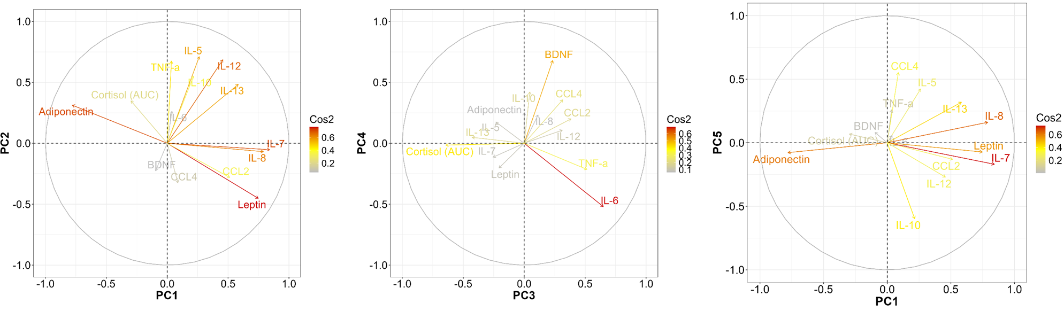
Figure S1. Correlation between variables and PC factors. Leptin positively correlates with PC1, as well as IL-7 and IL-8; by contrast, adiponectin negatively correlates with this PC. A little contribution of IL-13 is also observed. AS for PC2, it mainly correlates with IL-5, IL-12 and TNF- α. IL-6 and cortisol are associated with PC3 showing opposite directions, while only BDNF appears to be correlated with PC4. CCL4 positively correlates with PC5 and the opposite is true for IL-10.

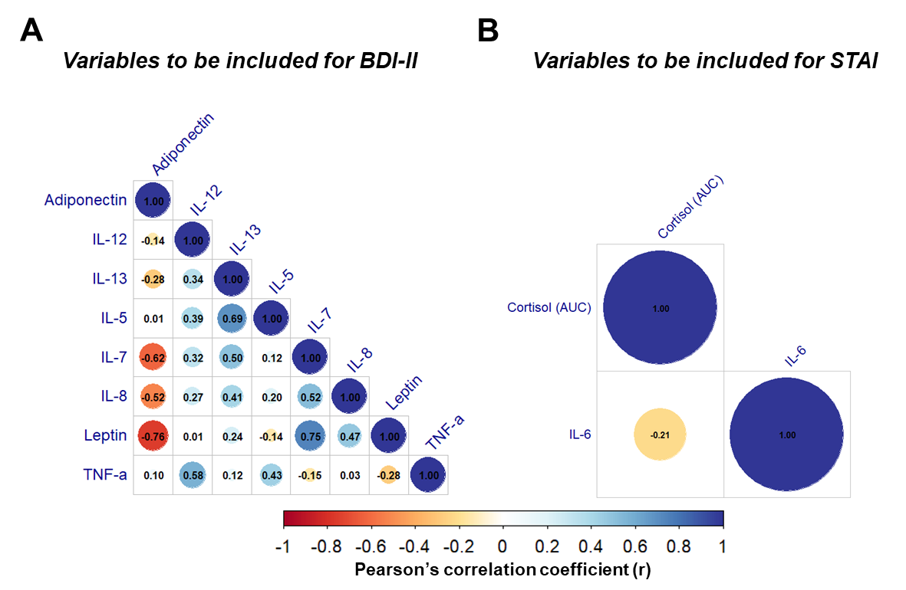
Figure S2. Correlation between biological variables. A) Correlation between variables representing PC1 and PC2 to choose predictors of depressive symptoms. Leptin, IL-5 and IL-12 were used as independent variables. B) Correlation between variables representing PC3 to choose predictors of anxiety symptoms. IL-6 and cortisol (AUC) were added to the model.
Table S3. Logistic regression outcome of the full model evaluating the association between biological markers and depressive symptoms (High-DS vs. Low-DS). * p<0.05, ^ p<0.10 pointing out an association between the biological variable and depressive symptoms. Total N. of subjects included: 43.
 | β coefficient | z-value | p-value | Odds ratio | 95% C.I.
Intercept | -5.7819 | -1.231 | 0.2184 | 0.0031 | 3.09e-07 - 30.7557
Leptin | -0.1470 | -2.271 | 0.0231* | 0.8633 | 0.7604 - 0.9800
IL-5 | 1.0296 | 1.632 | 0.1027 | 2.7999 | 0.8129 - 9.6429
IL-12 | -0.0946 | -1.422 | 0.1551 | 0.9097 | 0.7943 - 1.0365
Age | -0.0493 | -0.590 | 0.5553 | 0.9519 | 0.8082 - 1.1213
Staging | 0.1894 | 0.273 | 0.7852 | 1.2085 | 0.3096 - 4.7168
Grading | 0.3024 | 0.209 | 0.8347 | 1.3531 | 0.0791 - 23.1513
Surgery | 0.3311 | 0.289 | 0.7724 | 1.3926 | 0.1476 - 13.1393
HER2+ | 1.3389 | 0.967 | 0.3337 | 3.8148 | 0.2526 - 57.6106
ER+ | -18.0317 | -0.007 | 0.9947 | <0.0001 | 0.00e+00 - Inf
PgR+ | 17.6760 | 0.006 | 0.9948 | 4.75E+07 | 0.00e+00 - Inf
BMI | 0.2980 | 1.654 | 0.0980^ | 1.3471 | 0.9465 - 1.9174

Table S4. Logistic regression outcome of the second model evaluating the association between biological markers and depressive symptoms (High-DS vs. Low-DS). Only BMI was included as covariate. * p<0.05, ^ p<0.10 pointing out an association between the biological variable and depressive symptoms. Total N. of subjects included: 43.
 | β coefficient | z-value | p-value | Odds ratio | 95% C.I.
Intercept | -6.0936 | -1.930 | 0.0535 | 0.0023 | 4.64e-06 - 1.0975
Leptin | -0.1388 | -2.571 | 0.0101* | 0.8704 | 0.7830 - 0.9675
IL-5 | 0.7446 | 1.667 | 0.0955^ | 2.1056 | 0.8773 - 5.0535
IL-12 | -0.0539 | -1.173 | 0.2409 | 0.9475 | 0.8659 - 1.0368
BMI | 0.2343 | 2.044 | 0.0410* | 1.2641 | 1.0096 - 1.5826

Table S5. Logistic regression outcome of the final model evaluating the association between biological markers and depressive symptoms (High-DS vs. Low-DS). Only leptin and IL-5 were kept as independent variables; only BMI was included as covariate. * p<0.05, ** p<0.01 pointing out an association between the biological variable and depressive symptoms. Total N. of subjects included: 43.
 | β coefficient | z-value | p-value | Odds ratio | 95% C.I.
Intercept | -6.1244 | -2.004 | 0.0451 | 0.0022 | 5.48e-06 - 0.8742
Leptin | -0.1364 | -2.605 | 0.0092** | 0.8725 | 7.87e-01 - 0.9668
IL-5 | 0.5601 | 1.371 | 0.1703 | 1.7508 | 7.86e-01 - 3.8982
BMI | 0.2272 | 2.055 | 0.0399* | 1.2551 | 1.01e+00 - 1.5589

Table S6. Logistic regression outcome of the full model evaluating the association between biological markers and anxiety symptoms (High-AS vs. Low-AS). * p<0.05, ^ p<0.10 pointing out an association between the biological variable and anxiety symptoms. Total N. of subjects included: 43.
 | β coefficient | z-value | p-value | Odds ratio | 95% C.I.
Intercept | 10.3149 | 2.039 | 0.0415 | 3.02E+04 | 1.4901 - 6.11e+08
IL-6 | -0.0393 | -0.528 | 0.5974 | 0.9319 | 0.8762 - 0.9910
Cortisol (AUC) | -0.0706 | -2.247 | 0.0246* | 0.9614 | 0.8310 - 1.1124
Age | -0.0801 | -1.181 | 0.2375 | 0.9231 | 0.8083 - 1.0542
Staging | -0.3150 | -0.437 | 0.6623 | 0.7298 | 0.1775 - 2.9997
Grading | 0.5115 | 0.447 | 0.6548 | 1.6678 | 0.1771 - 15.7026
Surgery | 0.6042 | 0.555 | 0.5789 | 1.8297 | 0.2167 - 15.4509
HER2+ | 3.2616 | 1.817 | 0.0692^ | 26.0906 | 0.7740 - 879.4295
ER+ | 0.2979 | 0.187 | 0.8513 | 1.3471 | 0.0598 - 30.3685
PgR+ | 2.1141 | 1.436 | 0.1510 | 8.2821 | 0.4623 - 148.3717
BMI | -0.1227 | -0.798 | 0.4247 | 0.8845 | 0.6545 - 1.1954

Table S7. Logistic regression outcome of the final model evaluating the association between biological markers and anxiety symptoms (High-AS vs. Low-AS). Only IL-6 and cortisol (AUC) were kept as independent variables; only HER2 was included as covariate. * p<0.05, pointing out an association between the biological variable and anxiety symptoms. Total N. of subjects included: 43.
 | β coefficient | z-value | p-value | Odds ratio | 95% C.I.
Intercept | 2.0706 | 2.156 | 0.0311 | 7.9296 | 1.2069 - 52.0973
IL-6 | 0.0255 | 0.410 | 0.6816 | 1.0258 | 0.9082 - 1.1587
Cortisol (AUC) | -0.0296 | -1.994 | 0.0462* | 0.9789 | 0.9430 - 0.9995
HER2+ | 1.6658 | 1.350 | 0.1769 | 5.2898 | 0.4715 - 59.3575

Table S8. Logistic regression outcome of the full model evaluating the association between biological markers and stress symptoms (High-SS vs. Low-SS). Total N. of subjects included: 43.
 | β coefficient | z-value | p-value | Odds ratio | 95% C.I.
Intercept | -2.5033 | -0.630 | 0.5290 | 0.0818 | 3.39e-05 - 197.2581
BDNF | 0.0270 | 0.387 | 0.6990 | 1.0274 | 0.8959 - 1.1782
Age | 0.0523 | 0.885 | 0.3760 | 1.0537 | 0.9385 - 1.1830
Staging | -0.7833 | -1.087 | 0.2770 | 0.4569 | 0.1113 - 1.8760
Grading | -0.0433 | -0.042 | 0.9660 | 0.9576 | 0.1273 - 7.2042
Surgery | 1.1372 | 1.169 | 0.2430 | 3.1181 | 0.4631 - 20.9960
HER2+ | 0.9178 | 0.893 | 0.3720 | 2.5037 | 0.3341 - 18.7646
ER+ | 1.1616 | 0.777 | 0.4370 | 3.1951 | 0.1708 - 59.7578
PgR+ | -1.8428 | -1.451 | 0.1470 | 0.1584 | 0.01315 - 1.9071
BMI | -0.0198 | -0.127 | 0.8990 | 0.9804 | 0.7233 - 1.3290

Table S9. Logistic regression outcome of the final model evaluating the association between biological markers and stress symptoms (High-SS vs. Low-SS). Only BDNF was kept as independent variable; no covariate was included. Total N. of subjects included: 43.
 | β coefficient | z-value | p-value | Odds ratio | 95% C.I.
Intercept | -1.7835 | -2.413 | 0.0158 | 0.1680 | 0.0395 - 0.7153
BDNF | 0.0613 | 1.111 | 0.2666 | 1.0632 | 0.9542 - 1.1846

