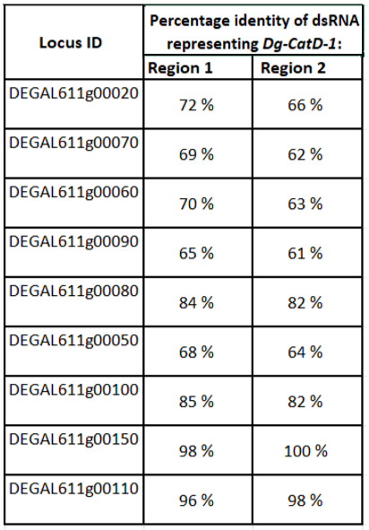
Table S2. Percentage nucleotide identity between Region 1 and Region 2 of Dg-CatD-1 (HE565350) and Dg-CatD orthologs present in the D. gallinae genome.

