Methods

Sampling and physical and chemical analysis
The analysis of dissolved inorganic nutrients and the rest of water environmental variables was carried out following the standard methods mostly as described in APHA (2005). Briefly, soluble reactive orthophosphate (SRP) was determined by the phosphomolybdic acid-ascorbic procedure. Nitrate concentration was obtained by the second derivative UV/Visible spectroscopy procedure. Ammonia was measured using the modified indophenol blue method (Golterman, 2007). Sulphate concentrations were determined by the barium sulphate precipitation turbidimetric procedure. Alkalinity was measured by titration with HCl using a pH shift indicator. Total suspended solids (TSS) were determined gravimetrically after drying at 105ºC. Water organic matter content proxy (LOI) was obtained by the loss on ignition method at 460 °C for 6 hours from dryed TSS filters (Heiri et al., 2001).
For the studied wetlands, metabolic rates were determined following Morant et al. (2020a). Gross primary production (GPP) and aerobic respiration rates were measured for both the plankton and benthos of the studied wetlands by in situ measurements of the variation in oxygen concentration in incubations under light and dark conditions, which were transformed into carbon, assuming that one mole of O₂ generated or consumed implies one mole of CO₂ consumed or generated (Morant et al., 2020a; Morant 2022). Methane emissions, which are a balance between microbial production and consumption of this gas, were determined using the procedure described in Camacho et al. (2017), obtaining sediment cores for each wetland and sampling time using transparent methacrylate tubes which were incubated, inside climatic chambers at a temperature corresponding to that of the sampling period, for 2 to 5 days depending on the wetland. The balance of methane generated/consumed during that time was measured by gas chromatography and/or by an Aeroqual Gas A200 CH₄ methane meter calibrated by gas chromatography (Camacho et al., 2017; Morant et al., 2020a; Morant 2022). Methane concentration measurements were transformed into carbon emission rates per unit time using the ideal gas law equation (Morant et al., 2020a; Morant 2022).
DNA sequencing
The sequencing of the V4 region of the 16S rRNA gene was carried out in the Illumina MiSeq System (2x250 bp) according to the facilities and protocols of the RTSF-MSU (Michigan State University, USA). For each sample, Illumina compatible and dual indexed amplicon libraries of the V4 hypervariable region of the 16S rRNA gene were obtained with the primers 515f/806r (Kozich et al., 2013). Then, completed libraries where batch normalized using Invitrogen SequalPrep DNA Normalization Plates. The product recovered from the plates was pooled and quantified using a combination of Qubit dsDNA HS, Agilent 4200 TapeStation High Sensitivity DNA and Kapa Illumina Library Quantification qPCR assays. The pool obtained was loaded on a standard Illumina MiSeq v2 flow cell and sequencing was carried out in a 2x250 bp paired end format using a MiSeq v2 500 cycle reagent cartridge. Custom sequencing and index primers, complementary to the 515/806 target sequences, were added to appropriate wells of reagent cartridge. Base calling was done by Illumina Real Time Analysis (RTA) v1.18.54 and output of RTA was demultiplexed and converted to FastQ format with Illumina Bcl2fastq v2.19.1. The raw sequence data of this study was deposited in the NCBI Sequence Read Archive (SRA) under BioProject accession number PRJNA595160.
Topological roles of the network nodes
The topological roles of the individual nodes that formed the networks were calculated following the classification of Olesen et al. (2007), that divides them into 4 groups: peripheral nodes, which maintain few connections with the rest of the nodes; connector nodes, which connect modules of the network and are very important for maintaining the network; module hubs, which are very important nodes for maintaining the organization of the module of which they are part; and network hubs, which are important nodes for maintaining the coherence of both the module where they are located and also the overall network. The membership of a node in one of these specific types was established by calculating its within-module connectivity (Z_{i}) and among-module connectivity (P_{i}) (Olesen et al., 2007), and the result was visualized with a Z_{i}-P_{i} graph, where the nodes are placed in 4 regions, corresponding to each of the 4 possible roles, based on their Z_{i} and P_{i} values. For this analysis, the water and sediment networks were reconstructed, respectively, with the same metrics and minimum values of ZOTU abundances as before but considering only the co-occurrence relationships and not the co-exclusion relationships.

Tables and Figures
Supplementary Table 1. Water environmental variables of the deltaic wetlands. TSS: Total Suspended Solids. LOI: Organic Matter, expressed as percentage of dry weight. SRP: Soluble Reactive Orthophosphate. 1: Winter. 2: Spring. 3: Summer.
 | ALFA1 | ALFA2 | ALFA3 | ENCA1 | ENCA2 | ENCA3 | FBIO1 | FBIO2 | FBIO3
Depth (cm) | 100 | 100 | 100 | 20 | 20 | 15 | 50 | 50 | 50
Oxygen (mg·L⁻¹) | 10.6 | 9.9 | 1.9 | 10.9 | 5.2 | 2.9 | 11.6 | 6.4 | 4.4
Temperature (ºC) | 8.1 | 12.3 | 27.9 | 4.3 | 15 | 29.2 | 5.4 | 14.8 | 28.7
Conductivity (mS·cm⁻¹) | 62.8 | 34.5 | 62.8 | 10.7 | 50.7 | 35 | 2.2 | 2.4 | 1.7
pH | 8.2 | 8.3 | 7.7 | 8 | 8 | 7.9 | 8.2 | 7.7 | 7.4
Chlorophyll-a (µg·L⁻¹) | 2 | 4 | 7.7 | 5.4 | 34.6 | 60.3 | 25.6 | 23.7 | 36.3
TSS (mg·L⁻¹) | 64.7 | 79.8 | 78.8 | 39.5 | 137.9 | 78.6 | 18.1 | 36.4 | 42.8
LOI (%) | 25.9 | 29.5 | 29.2 | 29.7 | 27.7 | 38.4 | 40.7 | 26.2 | 28.5
Alkalinity (meq·L⁻¹) | 3.2 | 3.2 | 4.2 | 3.8 | 3.8 | 3.9 | 3.8 | 3.4 | 4
SRP (µM) | 0 | 0.94 | 1.88 | 0.07 | 0.98 | 1.89 | 0.01 | 0.33 | 0.65
Nitrate (µM) | 40.9 | 41.5 | 39.4 | 29.8 | 37.8 | 35.1 | 9.2 | 0 | 10.8
Ammonia (µM) | 7.6 | 14.9 | 12.7 | 39.5 | 11.6 | 9.4 | 12.4 | 2.1 | 1.9
Sulphate (g·L⁻¹) | 3.3 | 4 | 3 | 1.5 | 3.3 | 2.2 | 0.3 | 0.1 | 0.1

Supplementary Table 2. Sediment environmental variables of the deltaic wetlands. LOI: Organic Matter. LOI and Carbonate expressed as percentage of dry weight. 1: Winter. 2: Spring. 3: Summer.
 | ALFA1 | ALFA2 | ALFA3 | ENCA1 | ENCA2 | ENCA3 | FBIO1 | FBIO2 | FBIO3
Conductivity (mS·cm⁻¹) | 35.2 | 65.7 | 36.4 | 19.0 | 54.6 | 35.0 | 0.9 | 1.8 | 2.3
pH | 8.3 | 7.9 | 7.7 | 7.9 | 7.6 | 7.3 | 8.1 | 7.2 | 7.3
LOI (%) | 13.9 | 45.9 | 20.6 | 15.9 | 32.9 | 28.8 | 4.1 | 3.5 | 3.2
Carbonate (%) | 20.3 | 15.9 | 10.4 | 21.1 | 15.5 | 14.9 | 15.8 | 15.5 | 15.9

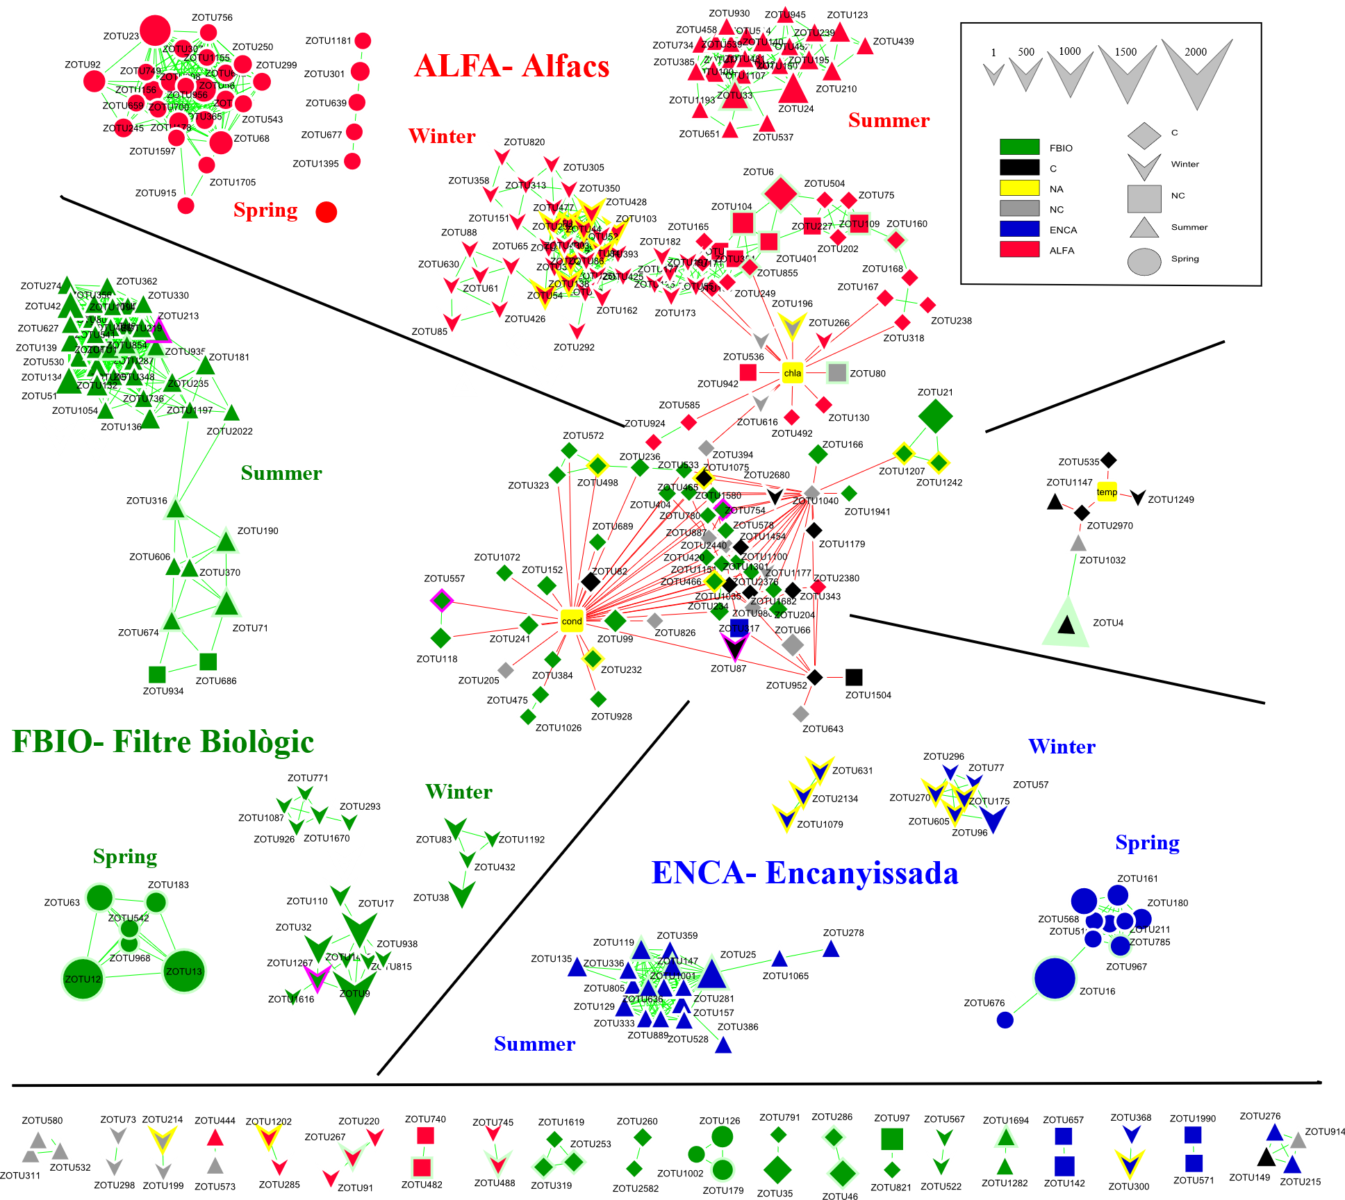
Supplementary Figure 1. Co-occurrence network of water prokaryotic communities. The ZOTUs are represented as nodes and the relationships between them as lines called edges. Nodes representing environmental variables are coloured in yellow (Cond: Conductivity, Chla: Chlorophyll-a). The colour of the lines representing the relationships between the nodes is green if the relationship is co-presence and red if the relationship is mutual exclusion. The shape of the node indicates the season in which the ZOTU is in the majority and the colour of the node the wetland in which the ZOTU is in the majority. The size of the node indicates its abundance in number of reads. The colour of the node border indicates which of the following genes is present in the ZOTU: yellow (dsrB), green (psbA), blue (pmoA). In the legend, C applies to ZOTUs present in all wetlands (cosmopolitan) in the wetland legend or in all seasons (core) in the season legend. NC applies to ZOTUs that are shared between different wetlands or between different seasons, but not being in all of them at the same time.

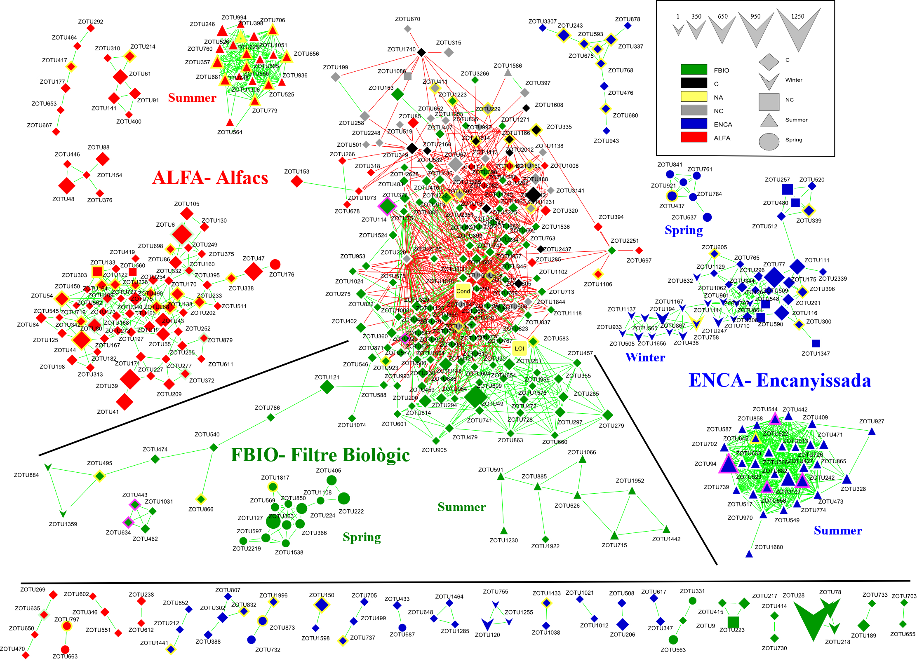
Supplementary Figure 2. Co-occurrence network of sediment prokaryotic communities. The ZOTUs are represented as nodes and the relationships between them as lines called edges. Nodes representing environmental variables are coloured in yellow (Cond: Conductivity, LOI: Organic matter). The colour of the lines representing the relationships between the nodes is green if the relationship is co-presence and red if the relationship is mutual exclusion. The shape of the node indicates the season in which the ZOTU is in the majority and the colour of the node the wetland in which the ZOTU is in the majority. The size of the node indicates its abundance in number of reads. The colour of the node border indicates which of the following genes is present in the ZOTU: yellow (dsrB), green (psbA), blue (pmoA/amoA). In the legend, C applies to ZOTUs present in all wetlands (cosmopolitan) in the wetland legend or in all seasons (core) in the season legend. NC applies to ZOTUs that are shared between different wetlands or between different seasons, but not being in all of them at the same time.

Supplementary Figure 3. Distribution of the number of ZOTUs present throughout all the year (C) and of the ZOTUs specific of each season in the water and sediment co-occurrence networks.

Supplementary Figure 4. Z_{i}- P_{i} graph showing, for water and for sediment, the distribution of nodes forming the co-occurrence networks based on their topological roles. The size of the symbol representing the nodes is proportional to their abundance in the network, and the colour indicates which of the following genes is present in the ZOTU the node represents: yellow (dsrB), green (psbA), blue (pmoA). Z_{i}: within-module connectivity. P_{i}: among-module connectivity.

