Supplementary information
Title. Systematic review on the laboratory methodology for conducting wastewater surveillance for Salmonella
Journal. Archives of Mircobiology
Authors. Lucky Sangal, Vishesh Sood, Karin Haar*, Takana Silubonde Moyana, Yuka Jinnai, Suman Rijal
Corresponding Author: Karin Haar, haark@who.int
Contents
S1. 2020 PRISMA Checklist 2
Supplementary Table T1 2
Supplementary Table T2 5
S2. Search Strategy 6
Supplementary Figure S1 6
Supplementary Table T6 6
Supplementary Table T7 7
Supplementary Table T8 8
Supplementary Figure S2 8
Supplementary Table T9 9
S3. Inclusion and Exclusion Criteria 10
Supplementary Table T3 10
S4. Structured Data Extraction Template 11
S4.1. Data Extraction Template 11
Supplementary Table T4 11
S4.2. Quality Assessment Template 12
Supplementary Table T5 12
S5. Supplementary Results 14
Supplementary Table T10 14
Supplementary Table T11 16
Supplementary Figure S3 19
Supplementary Figure S4 19
Supplementary Figure S5 20
Supplementary Figure S6 21

S1. 2020 PRISMA Checklist
Supplementary Table T1: PRISMA Checklist
Section and Topic | Item # | Checklist item | Location where item is reported
TITLE
Title | 1 | Identify the report as a systematic review. | Page 1
ABSTRACT
Abstract | 2 | See the PRISMA 2020 for Abstracts checklist. | Supplementary Table T2
INTRODUCTION
Rationale | 3 | Describe the rationale for the review in the context of existing knowledge. | Page 3
Objectives | 4 | Provide an explicit statement of the objective(s) or question(s) the review addresses. | Page 3
METHODS
Eligibility criteria | 5 | Specify the inclusion and exclusion criteria for the review and how studies were grouped for the syntheses. | Supplementary Table
Information sources | 6 | Specify all databases, registers, websites, organisations, reference lists and other sources searched or consulted to identify studies. Specify the date when each source was last searched or consulted. | Page 4
Search strategy | 7 | Present the full search strategies for all databases, registers and websites, including any filters and limits used. | Page 4, Supplementary file
Selection process | 8 | Specify the methods used to decide whether a study met the inclusion criteria of the review, including how many reviewers screened each record and each report retrieved, whether they worked independently, and if applicable, details of automation tools used in the process. | Page 5
Data collection process | 9 | Specify the methods used to collect data from reports, including how many reviewers collected data from each report, whether they worked independently, any processes for obtaining or confirming data from study investigators, and if applicable, details of automation tools used in the process. | Page 5
Data items | 10a | List and define all outcomes for which data were sought. Specify whether all results that were compatible with each outcome domain in each study were sought (e.g. for all measures, time points, analyses), and if not, the methods used to decide which results to collect. | Page 5, Supplementary file
Data items | 10b | List and define all other variables for which data were sought (e.g. participant and intervention characteristics, funding sources). Describe any assumptions made about any missing or unclear information. | Supplementary Table T3
Study risk of bias assessment | 11 | Specify the methods used to assess risk of bias in the included studies, including details of the tool(s) used, how many reviewers assessed each study and whether they worked independently, and if applicable, details of automation tools used in the process. | Page 6
Effect measures | 12 | Specify for each outcome the effect measure(s) (e.g. risk ratio, mean difference) used in the synthesis or presentation of results. | Not applicable
Synthesis methods | 13a | Describe the processes used to decide which studies were eligible for each synthesis (e.g. tabulating the study intervention characteristics and comparing against the planned groups for each synthesis (item #5)). | Not applicable
Synthesis methods | 13b | Describe any methods required to prepare the data for presentation or synthesis, such as handling of missing summary statistics, or data conversions. | Not applicable
Synthesis methods | 13c | Describe any methods used to tabulate or visually display results of individual studies and syntheses. | Not applicable
Synthesis methods | 13d | Describe any methods used to synthesize results and provide a rationale for the choice(s). If meta-analysis was performed, describe the model(s), method(s) to identify the presence and extent of statistical heterogeneity, and software package(s) used. | Not applicable
Synthesis methods | 13e | Describe any methods used to explore possible causes of heterogeneity among study results (e.g. subgroup analysis, meta-regression). | Not applicable
Synthesis methods | 13f | Describe any sensitivity analyses conducted to assess robustness of the synthesized results. | Not applicable
Reporting bias assessment | 14 | Describe any methods used to assess risk of bias due to missing results in a synthesis (arising from reporting biases). | Not applicable
Certainty assessment | 15 | Describe any methods used to assess certainty (or confidence) in the body of evidence for an outcome. | Not applicable
RESULTS
Study selection | 16a | Describe the results of the search and selection process, from the number of records identified in the search to the number of studies included in the review, ideally using a flow diagram. | Page 7
Study selection | 16b | Cite studies that might appear to meet the inclusion criteria, but which were excluded, and explain why they were excluded. | Page 7
Study characteristics | 17 | Cite each included study and present its characteristics. | Page 8-10
Risk of bias in studies | 18 | Present assessments of risk of bias for each included study. | Supplementary file
Results of individual studies | 19 | For all outcomes, present, for each study: (a) summary statistics for each group (where appropriate) and (b) an effect estimate and its precision (e.g. confidence/credible interval), ideally using structured tables or plots. | Not applicable
Results of syntheses | 20a | For each synthesis, briefly summarise the characteristics and risk of bias among contributing studies. | Not applicable
Results of syntheses | 20b | Present results of all statistical syntheses conducted. If meta-analysis was done, present for each the summary estimate and its precision (e.g. confidence/credible interval) and measures of statistical heterogeneity. If comparing groups, describe the direction of the effect. | Not applicable
Results of syntheses | 20c | Present results of all investigations of possible causes of heterogeneity among study results. | Not applicable
Results of syntheses | 20d | Present results of all sensitivity analyses conducted to assess the robustness of the synthesized results. | Not applicable
Reporting biases | 21 | Present assessments of risk of bias due to missing results (arising from reporting biases) for each synthesis assessed. | Not applicable
Certainty of evidence | 22 | Present assessments of certainty (or confidence) in the body of evidence for each outcome assessed. | Not applicable
DISCUSSION
Discussion | 23a | Provide a general interpretation of the results in the context of other evidence. | Page 20
Discussion | 23b | Discuss any limitations of the evidence included in the review. | Page 21
Discussion | 23c | Discuss any limitations of the review processes used. | Page 21
Discussion | 23d | Discuss implications of the results for practice, policy, and future research. | Page 22
OTHER INFORMATION
Registration and protocol | 24a | Provide registration information for the review, including register name and registration number, or state that the review was not registered. | Supplementary file
Registration and protocol | 24b | Indicate where the review protocol can be accessed, or state that a protocol was not prepared. | Supplementary file
Registration and protocol | 24c | Describe and explain any amendments to information provided at registration or in the protocol. | Not applicable
Support | 25 | Describe sources of financial or non-financial support for the review, and the role of the funders or sponsors in the review. | Page 23
Competing interests | 26 | Declare any competing interests of review authors. | Page 23
Availability of data, code and other materials | 27 | Report which of the following are publicly available and where they can be found: template data collection forms; data extracted from included studies; data used for all analyses; analytic code; any other materials used in the review. | Page 5-6

From: Page MJ, McKenzie JE, Bossuyt PM, Boutron I, Hoffmann TC, Mulrow CD, et al. The PRISMA 2020 statement: an updated guideline for reporting systematic reviews. BMJ 2021;372:n71. doi: 10.1136/bmj.n71. This work is licensed under CC BY 4.0. To view a copy of this license, visit https://creativecommons.org/licenses/by/4.0/

Supplementary Table T2: PRISMA Checklist for Abstract
Section and Topic | Item # | Checklist item | Reported (Yes/No)
TITLE
Title | 1 | Identify the report as a systematic review. | Yes
BACKGROUND
Objectives | 2 | Provide an explicit statement of the main objective(s) or question(s) the review addresses. | Yes
METHODS
Eligibility criteria | 3 | Specify the inclusion and exclusion criteria for the review.
Information sources | 4 | Specify the information sources (e.g. databases, registers) used to identify studies and the date when each was last searched. | Yes
Risk of bias | 5 | Specify the methods used to assess risk of bias in the included studies.
Synthesis of results | 6 | Specify the methods used to present and synthesise results. | Not applicable
RESULTS
Included studies | 7 | Give the total number of included studies and participants and summarise relevant characteristics of studies. | Yes
Synthesis of results | 8 | Present results for main outcomes, preferably indicating the number of included studies and participants for each. If meta-analysis was done, report the summary estimate and confidence/credible interval. If comparing groups, indicate the direction of the effect (i.e. which group is favoured). | Yes
DISCUSSION
Limitations of evidence | 9 | Provide a brief summary of the limitations of the evidence included in the review (e.g. study risk of bias, inconsistency and imprecision).
Interpretation | 10 | Provide a general interpretation of the results and important implications. | Yes
OTHER
Funding | 11 | Specify the primary source of funding for the review.
Registration | 12 | Provide the register name and registration number.

From: Page MJ, McKenzie JE, Bossuyt PM, Boutron I, Hoffmann TC, Mulrow CD, et al. The PRISMA 2020 statement: an updated guideline for reporting systematic reviews. BMJ 2021;372:n71. doi: 10.1136/bmj.n71. This work is licensed under CC BY 4.0. To view a copy of this license, visit https://creativecommons.org/licenses/by/4.0/

S2. Search Strategy

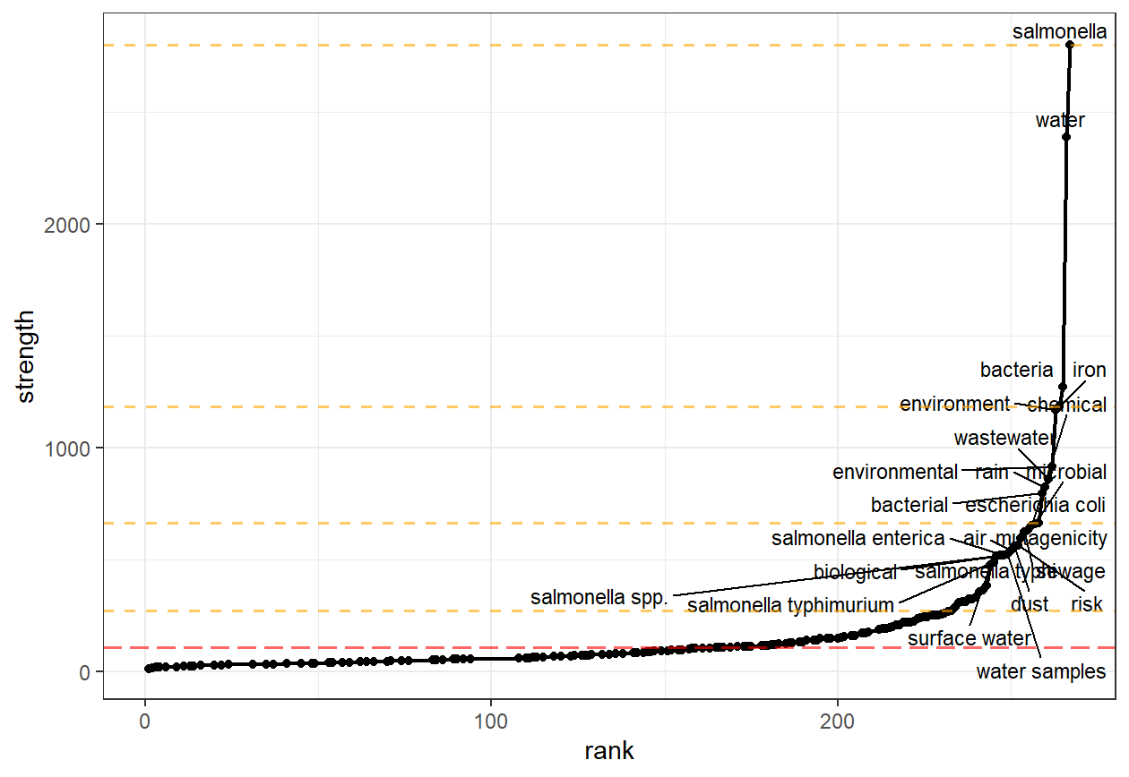
Supplementary Fig. S1: Unbiased identification of keywords from naïve search in PubMed using easyPubMed and litsearchr packages in R.

Supplementary Table T3: Identified Keywords from naïve search
salmonella enterica | salmonella typhi | salmonella typhimurium
sewage sludge | surface water | treatment plant
wastewater treatment | water quality | water samples
agricultural | air | bacteria
bacterial | biological | chemical
Dust | e. coli | environment
environmental | escherichia coli | gel
genotoxicity | indicators | iron
microbial | mutagenicity | prevalence
Rain | risk | salmonella
salmonella spp. | Sewage | soil
wastewater | water

Supplementary Table T4: Studies selected for optimization of PubMed search query
Title | Year | PMID
Detection of carriers of typhoid bacilli by sewerage-tracing surveillance in Matsuyama City | 1981 | 7334709
Surveillance for typhoid fever in Matsuyama city during 1974-1981 and detection of Salmonella typhi in sewage and river waters | 1983 | 6632352
Novel surveillance of Salmonella enterica serotype Heidelberg epidemics in a closed community | 2007 | 17883321
Behaviour of pathogenic and indicator bacteria during urban wastewater treatment and sludge composting, as revealed by quantitative PCR | 2008 | 17659319
Municipal Wastewater as a Microbial Surveillance Platform for Enteric Diseases: A Case Study for Salmonella and Salmonellosis | 2018 | 29630348
Characterization and evolution of antibiotic resistance of Salmonella in municipal wastewater treatment plants | 2019 | 31539702
Reviving the “Moore Swab”: a Classic Environmental Surveillance Tool Involving Filtration of Flowing Surface Water and Sewage Water To Recover Typhoidal <i>Salmonella</i> Bacteria | 2020 | 32332133
Review of Methods Suitable for Environmental Surveillance of Salmonella Typhi and Paratyphi | 2020 | 32725228
Characterization of Salmonella Isolates from Wastewater Treatment Plant Influents to Estimate Unreported Cases and Infection Sources of Salmonellosis | 2020 | 31936747
Case-Control Study of Household and Environmental Transmission of Typhoid Fever in India | 2021 | 35238355
Development of Moore Swab and Ultrafiltration Concentration and Detection Methods for Salmonella Typhi and Salmonella Paratyphi A in Wastewater and Application in Kolkata, India and Dhaka, Bangladesh | 2021 | 34335510
Using Wastewater Surveillance to Monitor Gastrointestinal Pathogen Infections in the State of Oklahoma | 2023 | 37764037
Environmental sampling for typhoidal Salmonellas in household and surface waters in Nepal identifies potential transmission pathways | 2023 | 37851667
Vibrio cholerae and Salmonella Typhi culture-based wastewater or non-sewered sanitation surveillance in a resource-limited region | 2024 | 38177335
Large outbreak of typhoid fever on a river cruise ship used as accommodation for asylum seekers, the Netherlands, 2022 | 2024 | 38304948
Detection of Salmonella Typhi bacteriophages in surface waters as a scalable approach to environmental surveillance | 2024 | 38329937
Environmental Surveillance for Salmonella Typhi and its Association With Typhoid Fever Incidence in India and Malawi | 2024 | 37775091

Supplementary Table T5: Search queries used for optimization of search results. (Date of retrieval – September 2024)
SN | Query | Results
 | ("Salmonella" OR "Salmonella typhi" OR "Typhoid") AND ("Survei*" OR "environmental survei*" OR "wastewater survei*") AND ("Sewage" OR "Waste*") | 66
 | ("Salmonella" OR "Salmonella typhi" OR "Typhoid Fever" or “pathogen”) AND ("Survei*" OR "environmental survei*" OR "wastewater survei*") AND ("Sewage" or "wastewater" OR "surface water" OR "environmental samp*") | 471
 | ("Salmonella" OR "Salmonella typhi" OR "Typhoid Fever") AND ("Survei*" OR "environmental survei*" OR "wastewater survei*" or "Antibiotic*") AND ("Sewage*" or "wastewat*" OR "surface water" OR "environmental samp*" OR "WWTP*" OR "river" or "stream" or "drain") | 496
 | ("Salmonella" OR "Salmonella typhi" OR "Typhoid Fever") AND ("Survei*" OR "environmental survei*" OR "wastewater survei*" OR "antibiotic resistance") AND ("Sewage*" OR "wastewat*" OR "surface water" OR "environmental samp*" OR "WWTP*" OR "river" OR "stream" OR "drain") | 355

Supplementary Figure S2: Optimization of PubMed search query to achieve 100% sensitivity for selected studies in supplementary Table T5.

Supplementary Table T6: Search queries used for searching the selected databases
Database | Search String
PubMed | ("Salmonella" OR "Salmonella typhi" OR "Typhoid Fever") AND ("Survei*" OR "environmental survei*" OR "wastewater survei*" OR "antibiotic resistance") AND ("Sewage*" OR "wastewat*" OR "surface water" OR "environmental samp*" OR “wastewater treatment” OR "WWTP*" OR "river" OR "stream" OR "drain")
Embase | ('salmonella' OR 'salmonella typhi' OR 'typhoid fever') AND ('survei*' OR 'environmental survei*' OR 'wastewater survei*' OR 'antibiotic resistance') AND ('sewage*' OR 'wastewat*' OR 'surface water' OR 'environmental samp*' OR 'wastewater treatment' OR 'wwtp*' OR 'river' OR 'stream' OR 'drain')
Web of Science | TS=("Salmonella" OR "Salmonella typhi" OR "Typhoid Fever") AND TS=("Survei*" OR "environmental survei*" OR "wastewater survei*" OR "antibiotic resistance") AND TS=("Sewage*" OR "wastewat*" OR "surface water" OR "environmental samp*" OR "wastewater treatment" OR "WWTP*" OR "river" OR "stream" OR "drain")

S3. Inclusion and Exclusion Criteria
Supplementary Table T7: Inclusion and exclusion criteria for the systematic review
 | Inclusion Criteria | Exclusion Criteria
Sample details | - Samples collected from wastewater or wastewater-contaminated water bodies resulting from human excrement containing Salmonella typhi.  - Studies explaining laboratory methods, as mentioned below | - Samples collected from  - freshwater sites, environmental sites (such as land or air),  - veterinary sites (including animal rearing and animal production facilities)  - contaminated food.  - Studies not explaining laboratory methods.
Methodology | - Methodology-based articles for environmental surveillance of S.typhi provide descriptions for the detection or isolation of Salmonella from wastewater or wastewater-contaminated water sources from a community. | - No method for isolation or characterization of S. typhi from the sample
Type of studies | - Peer-reviewed research articles in the English language | - Articles belonging to the following categories will be excluded:  - Pre-prints  - Reviews,  - Systematic or meta-reviews,  - Lectures,  - Opinion articles,  - Perspectives,  - News articles, or  - Protocol submissions.

S4. Structured Data Extraction Template

S4.1. Data Extraction Template
Supplementary Table T8: Structured data extraction template used for extracting the data. The extracted data is available from the following link (DOI to be shared).
S.No. | Data element | Details to be extracted
1. | Sampling Sites | Type of sampling site  - Drain, wastewater treatment plant, rivers, tanks, others (specify)
1.1 | Name of Country | Name of the country reporting the method  - Classification into LIC, LMIC, UMIC, and HIC based on the World Bank classification
1.2 | Specific details (sites) | Any details specified by the authors on sampling sites
2. | Sample type | Type(s) of sample(s) collected.  - Grab, trap, composite, Moore, other (specify)
2.2 | Sample collection | Details of sample collection
2.3 | Number of sampling sites | Number of sampling sites used for the study
2.4 | Specific details (collection) | Any details specified by the authors on the sample collection
3. | Sample handling | Sample handling and transportation  - Cold chain, no information, other (specify)
3.1 | Specific details (handling) | Any detail specified by the authors on sample handling
4. | Sample processing | Sample processing before sample testing in the lab  - Centrifugation, Filteration, Enrichment, PEG precipitation, no information, other (specify)
4.1 | Specific details (processing) | Any details specified for processing the sample
5. | Sample testing | Sample testing methodology  - Culture; Most Probable Number; Characterization – phenotypic (biotyping, serotyping, antimicrobial susceptibility, others), genotyping (molecular, other), genomics (sequencing, whole genome sequencing, metagenomics)
5.1 | Specific details (testing) | Any details specified for testing the samples
6. | Limitations | Limitations mentioned by the authors

S4.2. Quality Assessment Template
Supplementary Table T9: Quality Assessment Template with assessment categories, questions used, and criteria for classifying the study as 'Yes', 'Partial', or 'No' on the evaluation criteria. The extracted data is available from the following link (DOI to be shared)
Category | Question | Guidance on “Yes” | Guidance on “Partial” | Guidance on “No”
Site selection | Q1. The study provided details of sampling sites. | The study outlines the details of sampling sites, including parameters such as location, catchment area, and population. | The study describes a few of the characteristics. | No information is provided.
Site selection | Q2. The study has well-defined criteria for selecting the sampling site. | The study has rationalized site selection through a central question or hypothesis | The study provided some rationale for selection. | No rationale is provided.
Sample collection | Q3. The study provides details of sample collection. | The study has clearly defined sample collection details such as type, volume, and frequency | The study covered some sample collection details | No information is provided.
Sample handling and transport | Q4. The study provides details of sample handling and transport. | The study provides information on sample handling after collection, storage conditions, transport conditions, and transit times | The study covered some of the sample handling and transport details | No information is provided.
Sample processing | Q5. The study provided details of sample processing before laboratory testing. | The study provided detailed steps for sample processing (if used), OR no processing steps were used. | The study provided steps without details. | No information is provided.
Sample testing | Q6. The study provided a detailed description of the testing methodology | The study provided a detailed outline of the methods used | The study provided some details but did not capture all aspects. | No information was provided.
Sample testing | Q7. The study provided details about performing the laboratory testing | The study provided detailed information on conditions, kits, and reagents used for the testing, including any inferences used for interpretation | The study provided some details but did not capture all aspects. | No information was provided.
Sample testing | Q8. The study provided information on quality control or quality assurance aspects of laboratory testing | The study provided QC steps for all laboratory methods used | The study provided QC steps for some of the methods used | No information was provided.

Scoring Criteria for Quality Assessment
Q1 – Yes = 0.5, Partial = 0.25, No = 0
Q2 – Yes = 0.5, Partial = 0.25, No = 0
Q3 – Yes = 1.0, Partial = 0.5, No = 0
Q4 – Yes = 1.0, Partial = 0.5, No = 0
Q5 – Yes = 2.0, Partial = 1.0, No = 0
Q6 – Yes = 2.0, Partial = 1.0, No = 0
Q7 – Yes = 1.0, Partial = 0.5, No = 0
Q8 – Yes = 2.0, Partial = 1.0, No = 0

Methodology quality assessment criteria
Score >=9 – Study methodology: Excellent
Score 8-9 – Study methodology: Robust
Score 7-8 – Study methodology: Good
Score 6-7 – Study methodology: Fair
Score <6 – Study methodology: Low

S5. Supplementary Results
Supplementary Table T10: Clustering of reported methods into pathways based on the reporting country, sample, and steps of protocol used. Some papers used multiple samples and methods. Six pathways (P1-P6) were identified. Studies excluded from the analysis have been assigned pathway as “NA.”
S.No. | Study ID | Paper ID | Method ID | Pathway
1 | Abraham D et al. 2025 | Paper_001 | Method_001 | P5
 |  |  | Method_002 | P1
2 | Acheamfour CL et al. 2021 | Paper_002 | Method_003 | P1
3 | Agbo O et al. 2024 | Paper_003 | Method_004 | P2
4 | Allsing N et al. 2023 | Paper_004 | Method_005 | P6
5 | Arvanitidou M et al. 1997 | Paper_005 | Method_006 | P2
6 | Ballesteros-Nova NE et al. 2022 | Paper_006 | Method_007 | P1
7 | Bell JB et al. 1980 | Paper_007 | Method_008 | P3
8 | Berge ACB et al. 2006 | Paper_008 | Method_009 | P3
9 | Cangola J et al. 2025 | Paper_009 | Method_010 | P2
10 | Ceballos BSO et al. 2003 | Paper_010 | Method_011 | NA
11 | Chen Z et al. 2024 | Paper_011 | Method_012 | NA
12 | Cheung S et al. 2025 | Paper_012 | Method_013 | P6
13 | Chigwechokha et al. 2024 | Paper_013 | Method_014 | P2
14 | Cho S et al. 2022 | Paper_014 | Method_015 | P2
15 | Cho S et al. 2023 | Paper_015 | Method_016 | P2
16 | Chukwu EE et al. 2024 | Paper_016 | Method_017 | P2
17 | Cioffi B et al. 2021 | Paper_017 | Method_018 | P2
18 | Díaz-Palafox et al. 2023 | Paper_018 | Method_019 | P2
19 | Díaz-Torres O et al. 2020 | Paper_019 | Method_020 | P2
20 | Economou V et al. 2013 | Paper_020 | Method_021 | P2
21 | El-Tayeb MA et al. 2017 | Paper_021 | Method_022 | NA
22 | Espigares E et al. 2006 | Paper_022 | Method_023 | P2
23 | Fu S et al. 2023 | Paper_023 | Method_024 | P4
24 | Goldblum ZS et al. 2024 | Paper_024 | Method_025 | P4
25 | Guruge SK et al. 2025 | Paper_025 | Method_026 | P6
26 | Guzman-Otazo J et al. 2019 | Paper_026 | Method_027 | NA
27 | Hasani K et al. 2023 | Paper_027 | Method_028 | P2
28 | Ho Y-N et al. 2018 | Paper_028 | Method_029 | P2
29 | Hooban B et al. 2022 | Paper_029 | Method_030 | P2
30 | Hooda Y et al. 2024 | Paper_030 | Method_031 | NA
31 | Hu L et al. 2024 | Paper_031 | Method_032 | NA
32 | Huang X et al. 2024 | Paper_032 | Method_033 | P6
33 | Jahan F et al. 2025 | Paper_033 | Method_034 | P5
34 | Jiménez-Belengue A et al. 2012 | Paper_034 | Method_035 | P2
35 | Jokinen CC et al. 2010 | Paper_035 | Method_036 | P2
36 | Jokinen CC et al. 2015 | Paper_036 | Method_037 | P2
37 | Kawabe H et al. 2025 | Paper_037 | Method_038 | NA
38 | Khalefa HS et al. 2021 | Paper_038 | Method_039 | P2
39 | Khan HA et al. 2024 | Paper_039 | Method_040 | P2
40 | Kim NY et al. 2023 | Paper_040 | Method_041 | P5
41 | Klangnurak W et al. 2025 | Paper_041 | Method_042 | P6
42 | Kokkinos P et al. 2015 | Paper_042 | Method_043 | NA
43 | Kraft AL et al. 2023 | Paper_043 | Method_044 | P2
44 | Krzyzanowski F et al. 2014 | Paper_044 | Method_045 | NA
45 | Kuhn KG et al. 2023 | Paper_045 | Method_046 | P4
46 | LeBoa C et al. 2023 | Paper_046 | Method_047 | P5
47 | Li N et al. 2025 | Paper_047 | Method_048 | P2
48 | Liu P et al. 2021 | Paper_048 | Method_049 | P1
 |  |  | Method_050 | P5
49 | Mafu NC et al. 2009 | Paper_049 | Method_051 | P2
50 | Malayil L et al. 2022 | Paper_050 | Method_052 | P6
51 | Masarikova M et al. 2016 | Paper_051 | Method_053 | P3
52 | Meena B et al. 2020 | Paper_052 | Method_054 | P2
53 | Mendoza-Guido B et al. 2024 | Paper_053 | Method_055 | P2
54 | M'ikanatha NM et al. 2024 | Paper_054 | Method_056 | P4
55 | Mondal L et al. 2024 | Paper_055 | Method_057 | P2
56 | Moriñigo MA et al., 1990 | Paper_056 | Method_058 | P2
57 | Odjadjare EC et al. 2015 | Paper_057 | Method_059 | P2
58 | Okorie CN et al. 2024 | Paper_058 | Method_060 | P4
59 | Oktaria V et al. 2025 | Paper_059 | Method_061 | P5
 |  |  | Method_062 | P1
60 | Olawale SI et al. 2020 | Paper_060 | Method_063 | P2
61 | Onuoha SC 2017 | Paper_061 | Method_064 | P2
62 | Ooms D et al. 2024 | Paper_062 | Method_065 | P2
63 | Owusu M et al. 2025 | Paper_063 | Method_066 | P5
 |  |  | Method_067 | P1
64 | Pignato S et al. 2010 | Paper_064 | Method_068 | NA
65 | Rahim K et al. 2024 | Paper_065 | Method_069 | P2
66 | Rigby J et al. 2022 | Paper_066 | Method_070 | P2
 |  |  | Method_071 | P3
67 | Salih H et al. 2022 | Paper_067 | Method_072 | P6
68 | Santiago P et al. 2018 | Paper_068 | Method_073 | P5
 |  |  | Method_074 | P2
69 | Sarekoski A et al. 2024 | Paper_069 | Method_075 | P4
70 | Schwartzbrod J et al. 1983 | Paper_070 | Method_076 | P3
71 | Shinohara N et al. 1981 | Paper_071 | Method_077 | P3
72 | Shinohara N et al. 1983 | Paper_072 | Method_078 | P3
73 | Shrestha P et al. 2023 | Paper_073 | Method_079 | NA
74 | Shrestha S et al. 2024 | Paper_074 | Method_080 | P5
75 | Shrestha S et al. 2024 | Paper_075 | Method_081 | NA
76 | Shrestha S et al. 2025 | Paper_076 | Method_082 | P5
77 | Siqueira JAM et al. 2024 | Paper_077 | Method_083 | P5
78 | Skariyachan S et al. 2013 | Paper_078 | Method_084 | P2
79 | Song Q et al. 2018 | Paper_079 | Method_085 | P2
80 | Sthapit N et al. 2024 | Paper_080 | Method_086 | P5
81 | Suzuki Y et al. 2016 | Paper_081 | Method_087 | P2
82 | Tajammul A et al. 2025 | Paper_082 | Method_088 | P5
83 | Tesfaye H et al. 2019 | Paper_083 | Method_089 | P2
84 | Toyting J et al. 2024 | Paper_084 | Method_090 | NA
85 | Uzzell CB et al. 2024 | Paper_085 | Method_091 | P5
 |  |  | Method_092 | P1
86 | Uzzell CB et al. 2024 | Paper_086 | Method_093 | P5
 |  |  | Method_094 | P1
87 | Viancelli A et al. 2015 | Paper_087 | Method_095 | NA
88 | Victoria NS et al. 2022 | Paper_088 | Method_096 | P2
89 | Victoria TNS et al. 2024 | Paper_089 | Method_097 | P2
90 | Vincent V et al. 2007 | Paper_090 | Method_098 | P2
91 | Xi X et al. 2015 | Paper_091 | Method_099 | NA
92 | Yan T et al. 2018 | Paper_092 | Method_100 | P4
93 | Yanagimoto K et al. 2020 | Paper_093 | Method_101 | P2
94 | Zhang CM et al. 2019 | Paper_094 | Method_102 | P2

Supplementary Table T11: Identification of domains from the title, abstracts, and keywords of manuscripts selected for extraction. Eight domains were identified; A) outbreak detection and investigation, B) disease prevalence, C) antimicrobial resistance prevalence, D) mechanisms of antimicrobial resistance, E) wastewater monitoring, F) environmental health, G) one health, and H) method validation.
Paper ID | Study ID | A | B | C | D | E | F | G | H
Paper_001 | Abraham D et al. 2025 | No | Yes | No | No | No | No | No | No
Paper_002 | Acheamfour CL et al. 2021 | No | Yes | No | No | Yes | Yes | No | No
Paper_003 | Agbo O et al. 2024 | No | Yes | No | Yes | No | No | No | No
Paper_004 | Allsing N et al. 2023 | No | No | No | No | No | Yes | No | No
Paper_005 | Arvanitidou M et al. 1997 | No | No | Yes | Yes | No | No | No | No
Paper_006 | Ballesteros-Nova NE et al. 2022 | No | No | No | No | No | Yes | Yes | No
Paper_007 | Bell JB et al. 1980 | No | No | Yes | Yes | No | No | No | No
Paper_008 | Berge ACB et al. 2006 | No | Yes | No | No | No | Yes | No | No
Paper_009 | Cangola J et al. 2025 | No | No | Yes | No | Yes | No | No | No
Paper_010 | Ceballos BSO et al. 2003 | No | Yes | No | No | Yes | Yes | No | No
Paper_011 | Chen Z et al. 2024 | No | Yes | No | No | No | No | Yes | No
Paper_012 | Cheung S et al. 2025 | No | No | No | No | No | Yes | No | No
Paper_013 | Chigwechokha et al. 2024 | No | No | No | No | No | No | No | Yes
Paper_014 | Cho S et al. 2022 | No | No | Yes | No | No | Yes | No | No
Paper_015 | Cho S et al. 2023 | No | No | Yes | No | No | Yes | No | No
Paper_016 | Chukwu EE et al. 2024 | Yes | Yes | No | No | No | No | No | No
Paper_017 | Cioffi B et al. 2021 | No | No | No | No | No | Yes | No | No
Paper_018 | Díaz-Palafox et al. 2023 | No | No | Yes | Yes | No | No | No | No
Paper_019 | Díaz-Torres O et al. 2020 | No | Yes | No | No | No | Yes | No | No
Paper_020 | Economou V et al. 2013 | No | Yes | Yes | No | No | No | Yes | No
Paper_021 | El-Tayeb MA et al. 2017 | No | Yes | Yes | Yes | No | No | No | No
Paper_022 | Espigares E et al. 2006 | No | No | Yes | No | No | Yes | No | No
Paper_023 | Fu S et al. 2023 | Yes | No | No | No | No | No | Yes | No
Paper_024 | Goldblum ZS et al. 2024 | Yes | No | No | No | No | No | No | No
Paper_025 | Guruge SK et al. 2025 | No | No | No | Yes | No | No | No | No
Paper_026 | Guzman-Otazo J et al. 2019 | No | Yes | Yes | No | No | Yes | No | No
Paper_027 | Hasani K et al. 2023 | No | No | Yes | Yes | No | No | No | No
Paper_028 | Ho Y-N et al. 2018 | No | Yes | No | No | No | No | No | No
Paper_029 | Hooban B et al. 2022 | No | Yes | Yes | No | No | Yes | No | No
Paper_030 | Hooda Y et al. 2024 | Yes | Yes | No | No | No | No | No | No
Paper_031 | Hu L et al. 2024 | No | Yes | No | Yes | No | No | No | No
Paper_032 | Huang X et al. 2024 | No | Yes | No | No | No | Yes | No | No
Paper_033 | Jahan F et al. 2025 | Yes | No | No | No | No | Yes | No | No
Paper_034 | Jiménez-Belengue A et al. 2012 | No | No | No | No | Yes | No | No | No
Paper_035 | Jokinen CC et al. 2010 | Yes | Yes | No | No | No | No | No | No
Paper_036 | Jokinen CC et al. 2015 | No | Yes | Yes | No | No | No | Yes | No
Paper_037 | Kawabe H et al. 2025 | No | No | No | No | No | No | No | Yes
Paper_038 | Khalefa HS et al. 2021 | No | No | No | No | No | No | Yes | No
Paper_039 | Khan HA et al. 2024 | No | Yes | Yes | No | No | No | No | No
Paper_040 | Kim NY et al. 2023 | Yes | No | No | No | No | No | Yes | Yes
Paper_041 | Klangnurak W et al. 2025 | No | No | No | No | No | Yes | No | No
Paper_042 | Kokkinos P et al. 2015 | No | No | No | No | Yes | No | No | No
Paper_043 | Kraft AL et al. 2023 | No | No | No | No | No | No | Yes | Yes
Paper_044 | Kryzanowski F et al. 2014 | No | Yes | Yes | No | Yes | No | Yes | No
Paper_045 | Kuhn KG et al. 2023 | Yes | No | No | No | No | No | No | No
Paper_046 | LeBoa C et al. 2023 | No | No | No | No | No | Yes | No | No
Paper_047 | Li N et al. 2025 | No | No | No | No | Yes | No | No | No
Paper_048 | Liu P et al. 2021 | No | No | No | No | No | No | No | Yes
Paper_049 | Mafu NC et al. 2009 | No | Yes | Yes | No | No | No | No | No
Paper_050 | Malayil L et al. 2022 | No | No | No | No | Yes | Yes | No | No
Paper_051 | Masarikova M et al. 2016 | No | No | No | No | No | No | Yes | No
Paper_052 | Meena B et al. 2020 | No | No | No | No | No | Yes | No | No
Paper_053 | Mendoza-Guido B et al. 2024 | No | No | No | Yes | No | Yes | No | No
Paper_054 | M'ikanatha NM et al. 2024 | Yes | No | No | No | No | No | No | No
Paper_055 | Mondal L et al. 2024 | No | No | Yes | No | No | No | No | No
Paper_056 | Moriñigo MA et al., 1990 | No | No | Yes | No | No | No | No | No
Paper_057 | Odjadjare EC et al. 2015 | No | Yes | Yes | No | No | Yes | No | No
Paper_058 | Okorie CN et al. 2024 | No | Yes | Yes | No | No | Yes | No | No
Paper_059 | Oktaria V et al. 2025 | No | Yes | No | No | No | No | No | No
Paper_060 | Olawale SI et al. 2020 | No | No | Yes | Yes | No | Yes | No | No
Paper_061 | Onuoha SC 2017 | No | No | Yes | No | No | Yes | No | No
Paper_062 | Ooms D et al. 2024 | Yes | No | No | No | No | No | No | No
Paper_063 | Owusu M et al. 2025 | Yes | Yes | No | No | No | No | No | Yes
Paper_064 | Pignato S et al. 2010 | No | Yes | Yes | Yes | No | No | No | No
Paper_065 | Rahim K et al. 2024 | No | Yes | Yes | Yes | No | No | No | No
Paper_066 | Rigby J et al. 2022 | No | No | No | No | No | No | No | Yes
Paper_067 | Salih H et al. 2022 | No | No | No | Yes | No | No | No | Yes
Paper_068 | Santiago P et al. 2018 | No | No | No | No | Yes | No | No | Yes
Paper_069 | Sarekoski A et al. 2024 | No | Yes | No | No | No | No | No | Yes
Paper_070 | Schwartzbrod J et al. 1983 | No | No | Yes | No | No | No | No | No
Paper_071 | Shinohara N et al. 1981 | Yes | No | No | No | No | No | No | No
Paper_072 | Shinohara N et al. 1983 | Yes | No | No | No | No | Yes | No | No
Paper_073 | Shrestha P et al. 2023 | No | No | Yes | No | No | Yes | No | No
Paper_074 | Shrestha S et al. 2024 | No | No | No | No | No | No | No | Yes
Paper_075 | Shrestha S et al. 2024 | Yes | No | No | No | No | No | No | No
Paper_076 | Shrestha S et al. 2025 | No | No | No | No | No | No | No | Yes
Paper_077 | Siqueira JAM et al. 2024 | No | No | No | No | No | Yes | No | No
Paper_078 | Skariyachan S et al. 2013 | No | No | No | No | No | Yes | No | No
Paper_079 | Song Q et al. 2018 | No | No | Yes | No | No | Yes | No | No
Paper_080 | Sthapit N et al. 2024 | Yes | No | No | No | No | No | No | No
Paper_081 | Suzuki Y et al. 2016 | No | Yes | Yes | No | No | No | No | No
Paper_082 | Tajammul A et al. 2025 | Yes | No | No | No | No | No | No | No
Paper_083 | Tesfaye H et al. 2019 | No | Yes | Yes | No | No | No | No | No
Paper_084 | Toyting J et al. 2024 | Yes | No | No | Yes | No | No | No | No
Paper_085 | Uzzell CB et al. 2024 | Yes | Yes | No | No | No | No | No | No
Paper_086 | Uzzell CB et al. 2024 | No | Yes | No | No | No | No | No | No
Paper_087 | Viancelli A et al. 2015 | No | No | No | No | No | Yes | No | No
Paper_088 | Victoria NS et al. 2022 | No | Yes | Yes | No | No | No | No | No
Paper_089 | Victoria TNS et al. 2024 | No | Yes | Yes | No | No | Yes | No | No
Paper_090 | Vincent V et al. 2007 | Yes | No | No | No | No | No | No | No
Paper_091 | Xi X et al. 2015 | No | No | No | No | No | Yes | No | No
Paper_092 | Yan T et al. 2018 | Yes | No | No | No | No | No | No | No
Paper_093 | Yanagimoto K et al. 2020 | Yes | No | No | No | No | No | No | No
Paper_094 | Zhang CM et al. 2019 | No | No | Yes | No | No | No | No | No

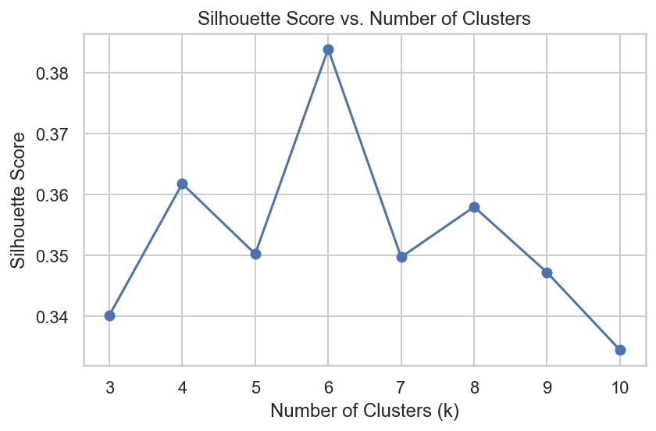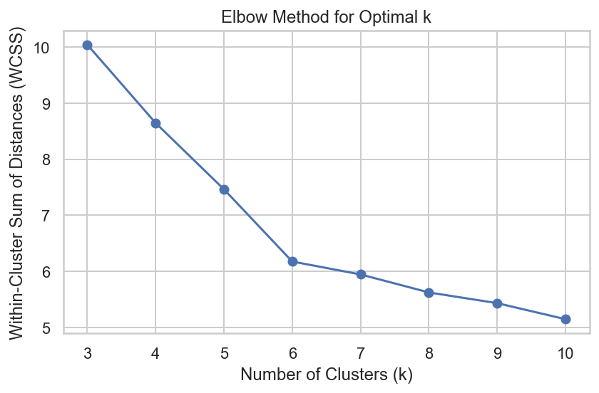
Supplementary Fig. S3: A) Silhouette score; and B) Elbow method for determining the optimum number of clusters in the classification of methods to similar pathways.

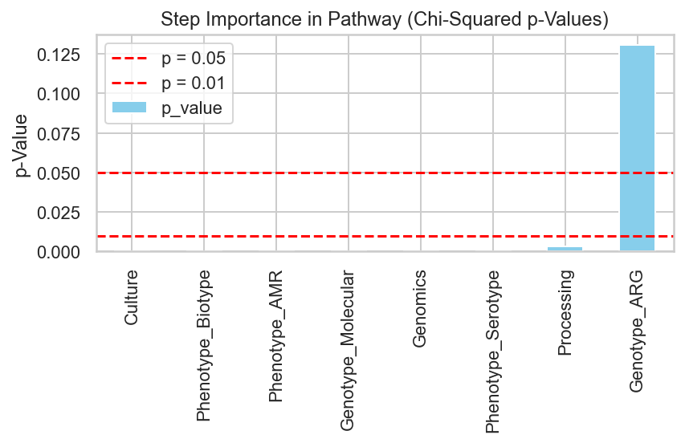
Supplementary Figure S4: Chi-squared p-values (at significance level of p=0.05 and 0.01) calculated by chi-squared test comparing the observed count of the presence and absence of steps in a pathway with expected counts under a null hypothesis of no difference.

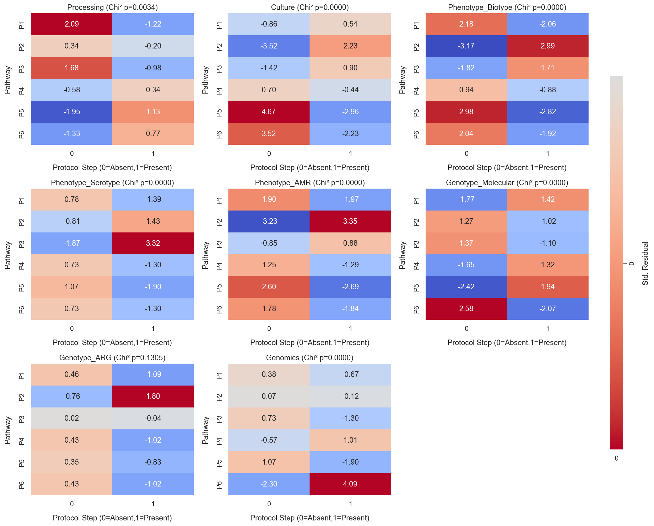
Supplementary Figure S5: post-hoc residual analysis of the chi-squared test across pathways. Residuals ≥ 2 indicate strong overrepresentation, meaning the pathway has more methods with the protocol step than expected under a random distribution. Conversely, residuals ≤ -2 indicate strong underrepresentation, meaning the pathway has fewer or no methods with the protocol step. A strong association of a step with one or more pathways can explain statistically significant p-values observed in the chi-squared test.

Supplementary Figure S6.The quality of studies was evaluated based on eight criteria. Q1. The study provides details of sampling sites (location, catchment area, population, etc.) [score: 0.5 for yes, 0.25 for partial], Q2. The study has well-defined criteria for selecting the sampling site (e.g., hypothesis or central question) [0.5 for yes, 0.25 for partial], Q3. The study provides details of sample collection (sample type, volume, and frequency) [1 for yes, 0.5 for partial], Q4. The study provides details of sample transport, including transport conditions and transit time [1 for yes, 0.5 for partial], Q5. The study provides details of sample pre-processing or processing before laboratory testing [2 for yes, 1 for partial], Q6. The study offers a detailed description of the testing methodology [2 for yes, 1 for partial], Q7. The study supplies details about conducting the laboratory testing [1 for yes, 0.5 for partial], Q8. The study includes information on quality control or quality assurance aspects of the laboratory testing method [2 for yes, 1 for partial]. Studies received a score of zero if they did not meet the quality criteria.

