The Supplementary Material

Supplementary Figures
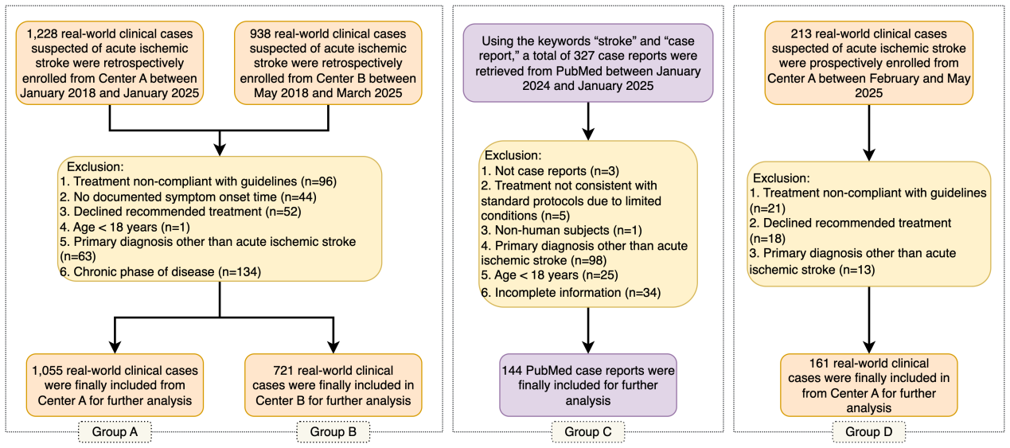
Supplementary Figure S1. Participant flow through the study. Flow diagram summarizing inclusion and exclusion across four datasets: Group A—retrospective cases from Center A (Jan 2018–Jan 2025) for prompt optimization and framework testing; Group B—retrospective cases from Center B (May 2018–Mar 2025) for framework testing and validation; Group C—PubMed case reports (Jan 2024–Jan 2025) for framework testing and validation; and Group D—prospective cases from Center A (Feb–May 2025) for framework validation and human–AI interaction evaluation.

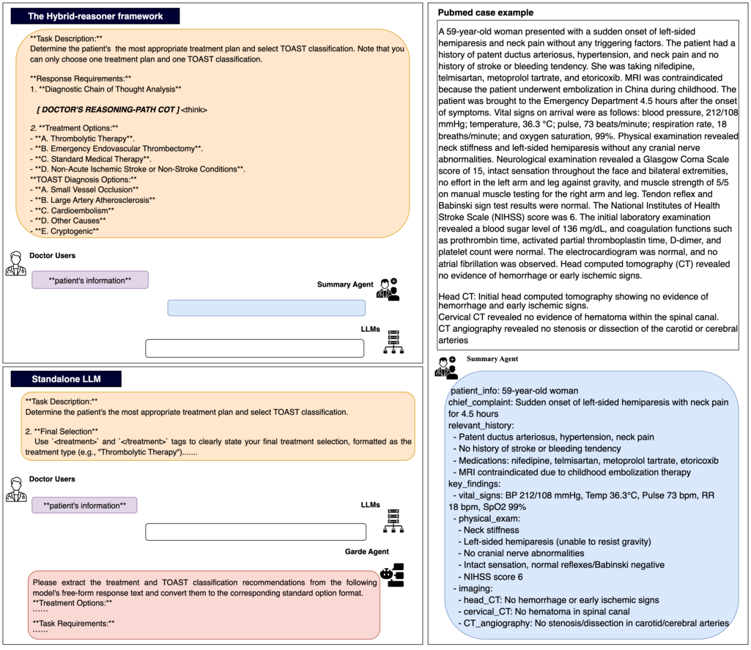
Supplementary Figure S2. Visualization of interaction interfaces for standalone LLM and hybrid-reasoner framework augmented LLM. Schematic illustrating the research workflow and output formats. The interface contrasts the hybrid-reasoner framework augmented LLM with standalone LLM. In first scenario, clinicians provide chain-of-thought reasoning using <think> tags and specify final treatment recommendation and TOAST classifications using <treatment> and <diagnosis> tags. A Summary Agent can optionally compress inputs to reduce token length. In second scenario, where responses are unconstrained, a Grade Agent extracts and standardizes answers. The right panel shows a PubMed case example demonstrating input information and structured output generation.
Supplementary Material Figure S3. Hybrid-reasoner framework enhances accuracy of LLMs in TOAST classification. ACC comparisons are shown for six LLMs of increasing scale (Baichuan-M1-14B, GPT-OSS-20B, Qwen2.5-32B, DeepSeek-R1-Distill-Qwen-32B, GPT-OSS-120B, and DeepSeek-R1-671B) across four evaluation groups (from group A to D). Within each group, paired bars represent standalone performance (pink) and Hybrid-reasoner framework augmented performance (blue).
Supplementary Table S1. Performance of LLMs in treatment recommendation and TOAST classification in Group A.
Models | ACC | Standalone LLM | Hybrid-reasoner Framework | P value | F1 Score | Standalone LLM | Hybrid-reasoner Framework | P value
Baichuan-M1-14B | ACC of Treatment | 0.546 (0.517, 0.576) | 0.687 (0.658, 0.713) | <0.001 | F1 of Treatment | 0.707 (0.682, 0.731) | 0.814 (0.794, 0.832) | 0.760
Baichuan-M1-14B | ACC of TOAST | 0.665 (0.637, 0.695) | 0.695 (0.669, 0.724) | 0.001 | F1 of TOAST | 0.303 (0.277, 0.328) | 0.275 (0.247, 0.351) | 0.796
GPT-OSS-20B | ACC of Treatment | 0.433 (0.400, 0.465) | 0.487 (0.456, 0.518) | <0.001 | F1 of Treatment | 0.604 (0.571, 0.635) | 0.655 (0.627, 0.682) | <0.001
GPT-OSS-20B | ACC of TOAST | 0.508 (0.472, 0.544) | 0.706 (0.681, 0.735) | <0.001 | F1 of TOAST | 0.224 (0.200, 0.248) | 0.235 (0.209, 0.299) | <0.001
Qwen2.5-32B | ACC of Treatment | 0.574 (0.543, 0.603) | 0.697 (0.673, 0.725) | 0.009 | F1 of Treatment | 0.729 (0.704, 0.753) | 0.822 (0.804, 0.84) | <0.001
Qwen2.5-32B | ACC of TOAST | 0.678 (0.650, 0.708) | 0.731 (0.705, 0.76) | <0.001 | F1 of TOAST | 0.275 (0.241, 0.314) | 0.307 (0.271, 0.406) | 0.090
DeepSeek-Distill-Qwen-32B | ACC of Treatment | 0.609 (0.579, 0.637) | 0.762 (0.735, 0.788) | <0.001 | F1 of Treatment | 0.757 (0.733, 0.778) | 0.865 (0.847, 0.882) | <0.001
DeepSeek-Distill-Qwen-32B | ACC of TOAST | 0.694 (0.665, 0.723) | 0.738 (0.709, 0.764) | <0.001 | F1 of TOAST | 0.347 (0.315, 0.383) | 0.354 (0.319, 0.388) | 0.004
GPT-OSS-120B | ACC of Treatment | 0.737 (0.710, 0.763) | 0.851 (0.829, 0.872) | 0.005 | F1 of Treatment | 0.849 (0.830, 0.865) | 0.92 (0.907, 0.932) | <0.001
GPT-OSS-120B | ACC of TOAST | 0.731 (0.704, 0.76) | 0.749 (0.722, 0.777) | 0.823 | F1 of TOAST | 0.426 (0.367, 0.481) | 0.417 (0.373, 0.462) | 0.550
DeepSeek-R1-671B | ACC of Treatment | 0.687 (0.658, 0.714) | 0.847 (0.826, 0.868) | <0.001 | F1 of Treatment | 0.814 (0.794, 0.833) | 0.917 (0.905, 0.929) | <0.001
DeepSeek-R1-671B | ACC of TOAST | 0.733 (0.705, 0.763) | 0.796 (0.770, 0.820) | 0.118 | F1 of TOAST | 0.420 (0.375, 0.459) | 0.474 (0.427, 0.520) | 0.336
The table presents ACC (accuracy) and F1 scores for standalone and framework-augmented LLMs in Group A, with corresponding P values for paired comparisons. Values are reported as point estimates, with 95% confidence intervals (CIs) shown in parentheses. ACC, accuracy.
Supplementary Table S2. Performance of LLMs in Treatment recommendation and TOAST classification in Group B.
Models | ACC | Standalone | Hybrid-reasoner Framework | P value | F1 score | Standalone | Hybrid-reasoner Framework | P value
Baichuan-M1-14B | ACC of Treatment | 0.595 (0.559, 0.631) | 0.684 (0.652, 0.718) | <0.001 | F1 of Treatment | 0.746(0.717, 0.774) | 0.812 (0.789, 0.836) | 0.190
Baichuan-M1-14B | ACC of TOAST | 0.583 (0.545, 0.623) | 0.620 (0.581, 0.656) | 0.027 | F1 of TOAST | 0.267 (0.229, 0.308) | 0.262 (0.223, 0.302) | 0.044
GPT-OSS-20B | ACC of Treatment | 0.459 (0.423, 0.499) | 0.592 (0.555, 0.632) | <0.001 | F1 of Treatment | 0.629 (0.594, 0.665) | 0.744 (0.714, 0.775) | <0.001
GPT-OSS-20B | ACC of TOAST | 0.576 (0.534, 0.616) | 0.686 (0.651, 0.723) | 0.001 | F1 of TOAST | 0.232 (0.200, 0.263) | 0.27 (0.228, 0.316) | <0.001
Qwen2.5-32B | ACC of Treatment | 0.587 (0.551, 0.623) | 0.671 (0.638, 0.706) | 0.022 | F1 of Treatment | 0.740 (0.710, 0.768) | 0.803 (0.779, 0.828) | 0.110
Qwen2.5-32B | ACC of TOAST | 0.633 (0.592, 0.674) | 0.694 (0.656, 0.728) | 0.683 | F1 of TOAST | 0.280 (0.228, 0.335) | 0.296 (0.247, 0.344) | 0.204
DeepSeek-Distill-Qwen-32B | ACC of Treatment | 0.587 (0.551, 0.623) | 0.678 (0.644, 0.714) | 0.382 | F1 of Treatment | 0.740 (0.710, 0.768) | 0.808 (0.783, 0.833) | <0.001
DeepSeek-Distill-Qwen-32B | ACC of TOAST | 0.593 (0.554, 0.629) | 0.627 (0.591, 0.664) | 0.505 | F1 of TOAST | 0.309 (0.252, 0.365) | 0.26 (0.225, 0.294) | 0.004
GPT-OSS-120B | ACC of Treatment | 0.699 (0.667, 0.732) | 0.798 (0.770, 0.828) | <0.001 | F1 of Treatment | 0.823 (0.800, 0.845) | 0.887 (0.870, 0.906) | 0.042
GPT-OSS-120B | ACC of TOAST | 0.622 (0.583, 0.658) | 0.676 (0.640, 0.712) | 0.752 | F1 of TOAST | 0.315 (0.269, 0.359) | 0.353 (0.300, 0.400) | 0.004
DeepSeek-R1-671B | ACC of Treatment | 0.671 (0.638, 0.705) | 0.813 (0.785, 0.841) | <0.001 | F1 of Treatment | 0.803 (0.779, 0.827) | 0.897 (0.880, 0.913) | 0.176
DeepSeek-R1-671B | ACC of TOAST | 0.600 (0.562, 0.634) | 0.679 (0.646, 0.715) | 0.131 | F1 score of TOAST | 0.351 (0.288, 0.404) | 0.39 (0.334, 0.442) | <0.001
The table reports ACC and F1 scores for standalone and framework-augmented LLMs in Group B, with corresponding P values for paired comparisons. Values are presented as point estimates, with 95% CIs shown in parentheses.
Supplementary Table S3. Performance of LLMs in treatment recommendation and TOAST classification in Group C.
Models | ACC | Standalone LLM | Hybrid-reasoner Framework | P value | F1 score | Standalone LLM | Hybrid-reasoner Framework | P value
Baichuan-M1-14B | ACC of Treatment | 0.507 (0.424, 0.59) | 0.667 (0.583, 0.743) | 0.011 | F1 score of Treatment | 0.673 (0.595, 0.742) | 0.800 (0.737, 0.853) | 0.872
Baichuan-M1-14B | ACC of TOAST | 0.549 (0.459, 0.631) | 0.568 (0.480, 0.656) | 0.480 | F1 score of TOAST | 0.444 (0.362, 0.517) | 0.474 (0.374, 0.581) | 0.942
GPT-OSS-20B | ACC of Treatment | 0.497 (0.42, 0.573) | 0.671 (0.594, 0.748) | 0.111 | F1 score of Treatment | 0.664 (0.591, 0.729) | 0.803 (0.745, 0.856) | 0.044
GPT-OSS-20B | ACC of TOAST | 0.400 (0.317, 0.483) | 0.468 (0.387, 0.565) | 1.0 | F1 score of TOAST | 0.300 (0.232, 0.361) | 0.419 (0.332, 0.507) | 0.378
Qwen2.5-32B | ACC of Treatment | 0.618 (0.542, 0.701) | 0.674 (0.590, 0.743) | 0.689 | F1 score of Treatment | 0.764 (0.703, 0.824) | 0.805 (0.742, 0.853) | 0.018
Qwen2.5-32B | ACC of TOAST | 0.488 (0.400, 0.576) | 0.656 (0.576, 0.736) | 0.480 | F1 score of TOAST | 0.369 (0.296, 0.441) | 0.560 (0.447, 0.667) | 0.126
DeepSeek-Distill-Qwen-32B | ACC of Treatment | 0.528 (0.451, 0.611) | 0.688 (0.604, 0.764) | 0.153 | F1 score of Treatment | 0.691 (0.622, 0.759) | 0.815 (0.753, 0.866) | 0.042
DeepSeek-Distill-Qwen-32B | ACC of TOAST | 0.496 (0.415, 0.585) | 0.664 (0.584, 0.744) | 1.0 | F1 score of TOAST | 0.393 (0.316, 0.467) | 0.534 (0.452, 0.608) | 0.498
GPT-OSS-120B | ACC of Treatment | 0.597 (0.514, 0.674) | 0.750 (0.681, 0.826) | 0.677 | F1 score of Treatment | 0.748 (0.679, 0.805) | 0.857 (0.810, 0.905) | 0.002
GPT-OSS-120B | ACC of TOAST | 0.608 (0.528, 0.688) | 0.688 (0.616, 0.768) | 1.0 | F1 score of TOAST | 0.513 (0.413, 0.613) | 0.590 (0.483, 0.696) | 0.852
DeepSeek-R1-671B | ACC of Treatment | 0.646 (0.562, 0.722) | 0.729 (0.653, 0.799) | 0.844 | F1 score of Treatment | 0.785 (0.720, 0.839) | 0.843 (0.790, 0.888) | 0.022
DeepSeek-R1-671B | ACC of TOAST | 0.648 (0.568, 0.728) | 0.768 (0.696, 0.840) | 1.0 | F1 score of TOAST | 0.558 (0.443, 0.663) | 0.708 (0.556, 0.814) | 0.460
The table summarizes ACC and F1 scores for standalone and framework-augmented LLMs in Group C, with corresponding P values for paired comparisons. Values are reported as point estimates, with 95% CIs shown in parentheses.
Supplementary Table S4. Performance of LLMs in treatment recommendation and TOAST classification in Group D.
Models | ACC | Standalone | Hybrid-reasoner Framework | P value | F1 score | Standalone | Hybrid-reasoner Framework | P value
Baichuan-M1-14B | ACC of Treatment | 0.665 (0.584, 0.739) | 0.820 (0.758, 0.876) | 0.780 | F1 of Treatment | 0.799 (0.737, 0.85) | 0.901 (0.862, 0.934) | 0.228
Baichuan-M1-14B | ACC of TOAST | 0.566 (0.491, 0.648) | 0.629 (0.547, 0.704) | 0.022 | F1 of TOAST | 0.255 (0.211, 0.461) | 0.271 (0.224, 0.41) | 0.010
GPT-OSS-20B | ACC of Treatment | 0.633 (0.557, 0.709) | 0.547 (0.466, 0.627) | 0.034 | F1 of Treatment | 0.775 (0.715, 0.83) | 0.707 (0.636, 0.771) | <0.001
GPT-OSS-20B | ACC of TOAST | 0.597 (0.517, 0.671) | 0.654 (0.579, 0.730) | 0.080 | F1 of TOAST | 0.312 (0.261, 0.455) | 0.249 (0.207, 0.329) | 0.474
Qwen2.5-32B | ACC of Treatment | 0.727 (0.652, 0.789) | 0.783 (0.714, 0.851) | 0.025 | F1 of Treatment | 0.842 (0.789, 0.882) | 0.878 (0.833, 0.919) | 0.014
Qwen2.5-32B | ACC of TOAST | 0.604 (0.528, 0.679) | 0.635 (0.56, 0.711) | <0.001 | F1 of TOAST | 0.257 (0.216, 0.467) | 0.306 (0.251, 0.548) | 0.004
DeepSeek-Distill-Qwen-32B | ACC of Treatment | 0.652 (0.578, 0.727) | 0.845 (0.789, 0.901) | <0.001 | F1 of Treatment | 0.789 (0.732, 0.842) | 0.916 (0.882, 0.948) | 0.258
DeepSeek-Distill-Qwen-32B | ACC of TOAST | 0.624 (0.548, 0.694) | 0.635 (0.560, 0.711) | 0.052 | F1 of TOAST | 0.298 (0.25, 0.542) | 0.371 (0.258, 0.548) | 0.208
GPT-OSS-120B | ACC of Treatment | 0.870 (0.814, 0.919) | 0.839 (0.776, 0.894) | 0.579 | F1 of Treatment | 0.93 (0.897, 0.958) | 0.912 (0.874, 0.944) | 0.968
GPT-OSS-120B | ACC of TOAST | 0.747 (0.682, 0.818) | 0.629 (0.553, 0.704) | 0.027 | F1 of TOAST | 0.422 (0.377, 0.698) | 0.328 (0.263, 0.555) | 0.638
DeepSeek-R1-671B | ACC of Treatment | 0.770 (0.702, 0.832) | 0.882 (0.826, 0.932) | <0.001 | F1 of Treatment | 0.87 (0.825, 0.908) | 0.937 (0.905, 0.965) | <0.001
DeepSeek-R1-671B | ACC of TOAST | 0.679 (0.604, 0.748) | 0.818 (0.755, 0.881) | 0.683 | F1 of TOAST | 0.395 (0.35, 0.644) | 0.479 (0.431, 0.628) | 0.016
The table shows ACC (Accuracy) and F1 scores for standalone and framework-augmented LLMs in Group D, with corresponding P values for paired comparisons. Values are presented as point estimates, with 95% CIs shown in parentheses.
Supplementary Table S5. Clinical safety indicators of LLMs during preliminary deployment.
Models | Setting | Instruction coherent | 1: Factual Accuracy | 2: Logical Consistency | 3: Clinical Relevance | Overall Evaluation Score of 1-3 | Hallucination | Omission
Baichuan-M1-14B | Framework | 0.994 | 3.995 | 4.390 | 3.696 | 4.027 | 18.9% | 24.3%
Baichuan-M1-14B | Standalone | 0.889 | 3.576 | 4.143 | 3.320 | 3.680 | 38.3% | 42.5%
GPT-OSS-20B | Framework | 0.801 | 3.491 | 3.723 | 2.853 | 3.356 | 33.6% | 40.4%
GPT-OSS-20B | Standalone | 0.573 | 2.895 | 3.296 | 2.578 | 2.923 | 53.2% | 61.6%
Qwen2.5-32B | Framework | 0.997 | 4.002 | 4.383 | 3.627 | 4.004 | 26.1% | 29.8%
Qwen2.5-32B | Standalone | 0.916 | 3.697 | 4.189 | 3.321 | 3.736 | 34.6% | 39.0%
DeepSeek-R1-Distill-Qwen32B | Framework | 0.994 | 3.988 | 4.422 | 3.616 | 4.007 | 22.3% | 23.7%
DeepSeek-R1-Distill-Qwen32B | Standalone | 0.928 | 3.596 | 4.193 | 3.317 | 3.702 | 35.2% | 37.5%
GPT-OSS-120B | Framework | 0.998 | 4.227 | 4.666 | 4.0 | 4.298 | 11.7% | 14.0%
GPT-OSS-120B | Standalone | 0.978 | 4.044 | 4.622 | 3.833 | 4.166 | 20.0% | 23.4%
DeepSeek-R1-671B | Framework | 0.998 | 4.280 | 4.760 | 4.027 | 4.355 | 10.9% | 14.7%
DeepSeek-R1-671B | Standalone | 0.966 | 3.903 | 4.484 | 3.677 | 4.021 | 20.4% | 26.9%
Safety metrics of LLMs in standalone and augmented settings. Overall score is the mean of factual accuracy, logical consistency, and clinical relevance. Hallucination and omission were also assessed.
Models | Model size | Developer | Type | Licence | Language support | Version date | Reference
Baichuan-M1# | 14B | Baichuan-Inc | Medical | Apache License 2.0 | Chinese, English | 2025.2 | https://arxiv.org/abs/2502.12671
GPT-OSS& | 20B | OpenAI | General | Apache License 2.0 | Chinese, English | 2025.8 | https://cdn.openai.com/pdf/419b6906-9da6-406c-a19d-1bb078ac7637/oai_gpt-oss_model_card.pdf
Qwen2.5 | 32B | Alibaba | General | Apache License 2.0 | Chinese, English | 2024.9 | https://arxiv.org/abs/2412.15115
DeepSeek-R1-Distill-Qwen | 32B | DeepSeek-AI | General | MIT License | Chinese, English | 2025.2 | https://arxiv.org/abs/2501.12948
GPT-OSS& | 120B | OpenAI | General | Apache License 2.0 | Chinese, English | 2025.8 | https://cdn.openai.com/pdf/419b6906-9da6-406c-a19d-1bb078ac7637/oai_gpt-oss_model_card.pdf
Deepseek-R1† | 671B | DeepSeek‑AI | General | MIT License | Chinese, English | 2025.5 | https://arxiv.org/abs/2501.12948
Supplementary Table S6. The detailed information on the six LLMs used in this study.
Detailed information on the six LLMs evaluated in this study, including model size, developer, application type, license, language support, version date, and reference source.
#Baichuan-M1 was released as a medical-domain–oriented model.
&GPT-OSS models (20B and 120B) were released by OpenAI with official model cards as technical references.
† DeepSeek-R1 and DeepSeek-R1-Distill-Qwen were developed under the MIT licence, providing large-scale general-domain models with bilingual support.

