Attached file
Supplementary Table
Supplementary Table 1 Yield of flavonoids from dried Allium mongolicum Regel leaf and a comparison of the relative contents of main active compound (dry matter basis).
Main active compound | Molecular mass | Flavonoids from dried Allium mongolicum Regel leaf

Flavone
Crysoeriol O-glucuronic acid | 476.10 | 26900
Apigenin | 270.05 | 665000
Chrysoeriol 7-O-hexoside | 462.20 | 108000
Tricin 7-O-hexoside | 492.10 | 319000
Chrysoeriol | 300.06 | 639000
Velutin | 314.08 | 48200

Flavonol
Isorhamnetin | 316.06 | 4570000
Rhamnetin(7-O-methxyl quercetin) | 316.06 | 72500
Laricitrin | 332.05 | 27800
Quercetin | 302.04 | 4760000
Kumatakenin | 314.08 | 63100
Morin | 302.04 | 40700000

Flavanone
Homoeriodictyol | 302.28 | 2510000
Isosakuranetin(4'-Methylnaringenin) | 286.08 | 102000
Hesperetin | 302.08 | 62400

Flavone C-glycosides
Luteolin 6-C-glucoside | 448.10 | 189000
Chrysoeriol 8-C-hexoside | 462.10 | 27800

Isoflavone
Biochanin A | 284.07 | 62400
Prunetin | 284.07 | 78000

Terpenoids
Phytocassane C | 318.10 | 108000

Organic acids
2-Hydroxybutanoic acid | 104.05 | 602000
α-Hydroxyisobutyric acid | 104.05 | 147000
(R)-lipoic acid | 206.04 | 4330
Rosmarinic acid | 360.30 | 4930
2-Hydroxyisocaproic acid | 132.08 | 1520000
D-Pantothenic dcid | 476.17 | 11000

Phenolamides
N-p-Coumaroyl hydroxyagmatine | 292.20 | 31900

Hydroxycinnamoyl derivatives
Caffeic aldehyde | 164.10 | 182000
Syringaldehyde | 182.10 | 34400

Alkaloids
Isoquinoline | 129.10 | 12800

Phytohormones
Gibberellin A20 | 332.16 | 1160
N6-Isopentenyladenine | 203.12 | 6760
Methyl indole-3-acetate | 189.08 | 10800
Indole 3-acetic acid | 175.06 | 134000

Anthocyanins
Cyanidin 3-O-rutinoside | 595.00 | 60700

Alcohols and polyols
DL-threitol | 122.06 | 134000

Supplementary Table 2 Composition and nutrient levels of the basal diet (air-dry basis /%)
Items | Fattening stages
Items | Phase I（Day 1 to 30） | Phase II（Day 31 to 60） | Phase III（Day 61 to 124）
Ingredients, % of DM
Corn | 25.00 | 35.00 | 35.00
Soybean meal | 9.00 | 9.00 | 17.00
Corn silage | 20.00 | 18.00 | 11.00
Soybean straw | 23.00 | 17.00 | 9.00
Oats | 13.00 | 11.00 | 7.00
Cottonseed meal | 9.00 | 9.00 | 12.00
Rapeseed meal | - | - | 8.00
Stone powder | 0.75 | 0.75 | 0.75
Premix¹ | 0.25 | 0.25 | 0.25
Total | 100.00 | 100.00 | 100.00
Nutrient levels
Metabolizable energy, MJ/kg² | 10.13 | 10.29 | 11.13
Ash | 10.90 | 10.08 | 9.10
Crude protein | 16.28 | 15.23 | 16.02
Ether extract | 3.00 | 3.30 | 3.10
Neutral detergent fiber | 41.20 | 39.90 | 40.02
Acid detergent fiber | 25.80 | 24.80 | 25.20
Ca | 1.19 | 1.30 | 0.86
P | 0.39 | 0.38 | 0.36
Note: Abbreviations: ME = metabolizable energy, CP = crude protein, EE = ether extract, neutral detergent fiber, acid detergent fiber, Ca = calcium, P = phosphorus.
1 Each kilogram of the premix contains: 550 kIU of vitamin A, 75 kIU of vitamin D3, 6 kIU of vitamin E, 1600 mg of Cu, 9400 mg of Fe, 10400 mg of Mn, 8000 mg of Zn, 200 mg of I, 60 mg of Se, and 72 mg of Co.
2 The metabolizable energy values were calculated according to the Ministry of Agriculture of P. R. China (2021)-Nutrient requirements of meat-type sheep and goat (NY/T816-2021).

Supplemental Figure
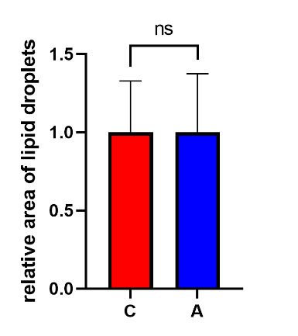
Supplemental Figure 1 Oil Red O staining-based visualization and quantitative analysis of the relative area of Liver lipid droplets in Saanen dairy goats.
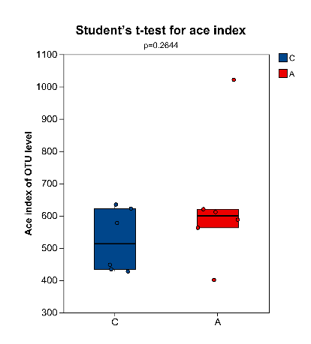
a
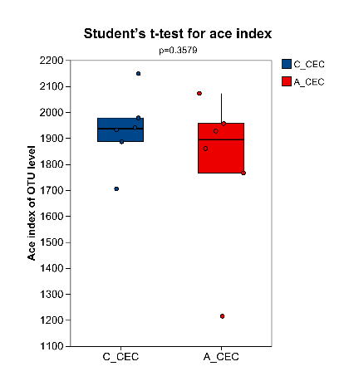
b
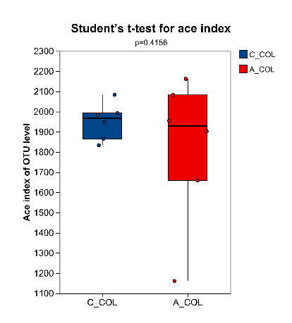
c
Supplemental Figure 2a-c Analysis of the effect of dietary AMRF supplementation on the Alpha diversity (Ace index) of microbial communities in different intestinal segments (a: rumen, b: cecum, c: colon) in Saanen dairy goats.
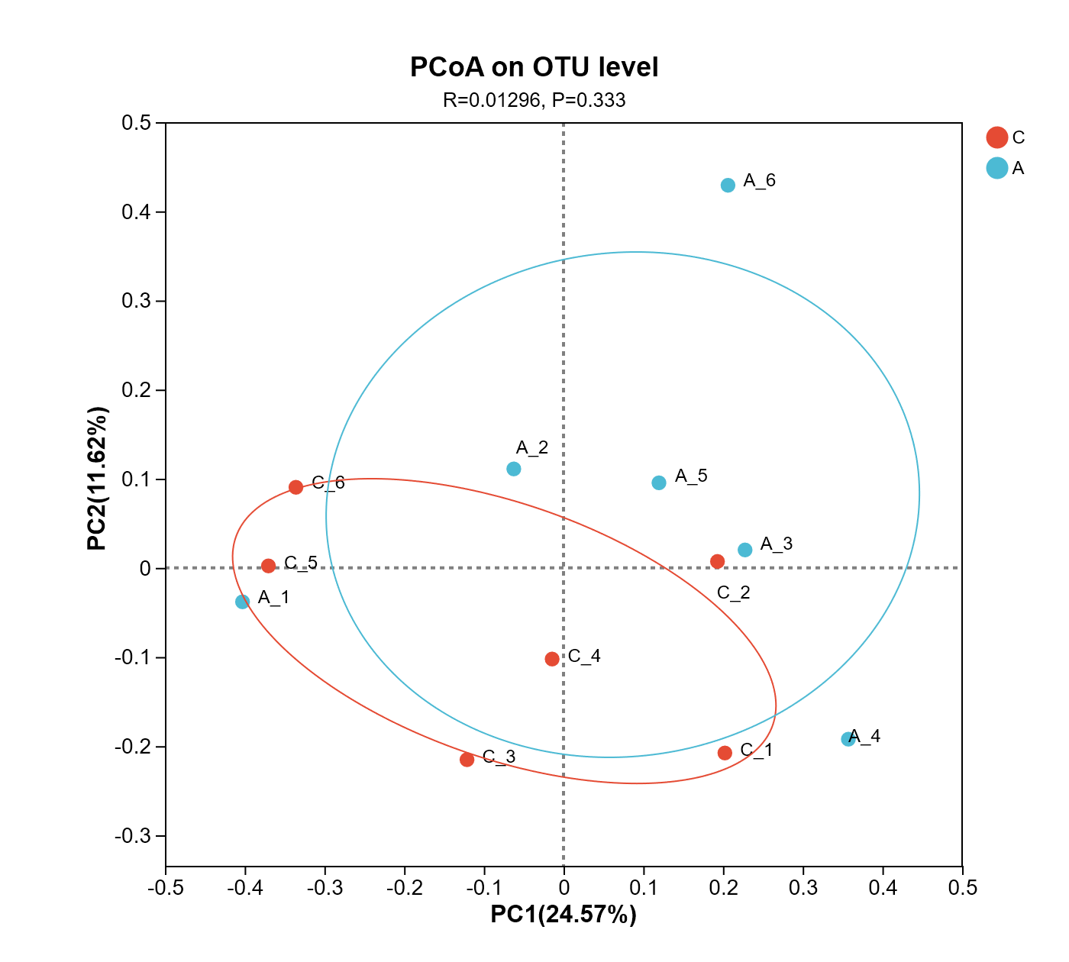
a
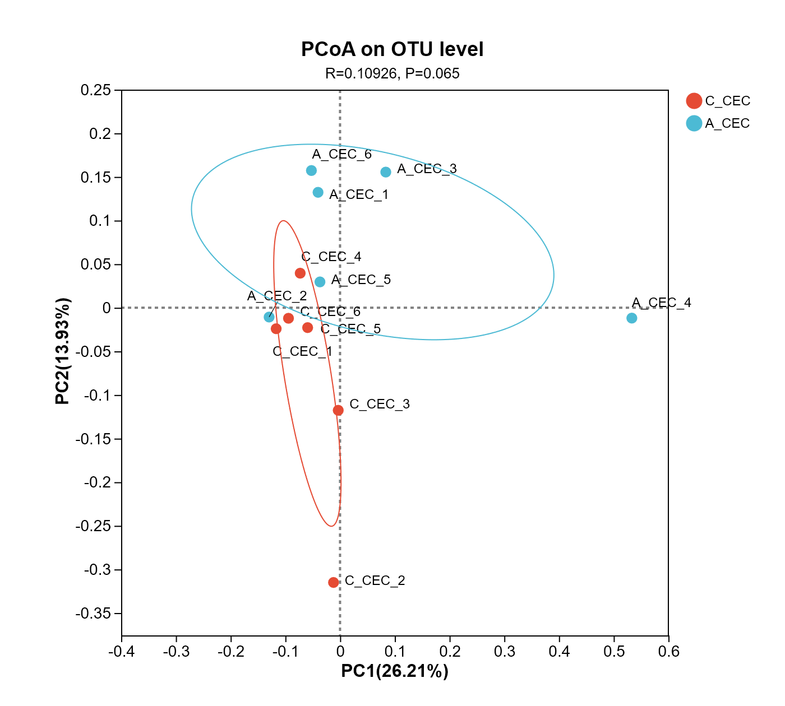
b
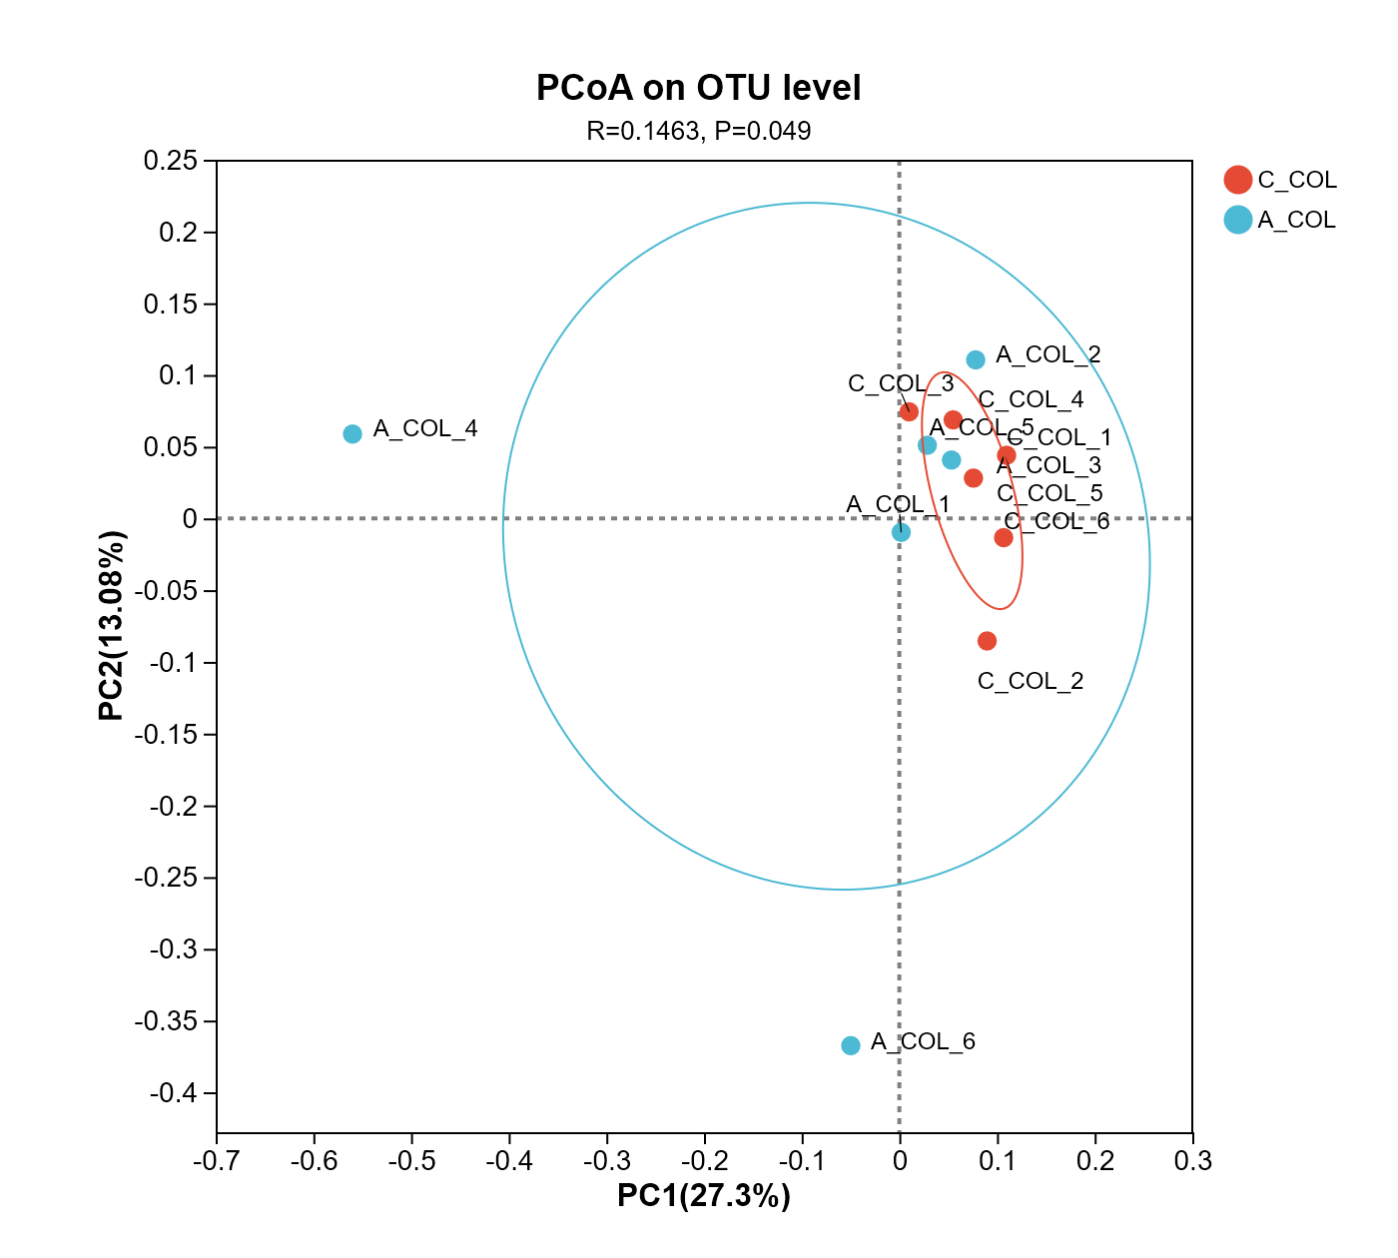
c
Supplemental Figure 3a-c Principal Coordinate Analysis (P-CoA) of Beta diversity of microbial communities in different intestinal segments (a: rumen, b: cecum, c: colon) in Saanen dairy goats at the OTU (Operational Taxonomic Unit) level.

