SI Appendix

Figure S1. Characterization of MuSC signals and myofiber structure.
(A) Representative confocal images of live myofibers at T0 (directly after isolation) reveal tdTomato⁺ satellite cells before and after photobleaching. The left panels correspond to Dmd^{EGFP/y};Pax7^{CreERT2/+};Rosa^{tdT/+} myofibers, whereas the right panels display Pax7^{CreERT2/+};Rosa^{tdT/+} myofibers (negative control). tdTomato⁺ MuSCs appear in red, and dystrophin-EGFP appears in green. Before bleaching, a faint EGFP background signal was detectable in satellite cells in both models (white arrowheads). Following bleaching, EGFP fluorescence was markedly increased in both conditions (white arrows). In total, 15 MuSCs from four Dmd^{EGFP/y};Pax7^{CreERT2/+};Rosa^{tdT/+}mice and 12 MuSCs from two Pax7^{CreERT2/CreERT2};Rosa^{tdT/tdT} mice are presented. Scale bars: 10 µm. (B) Confocal microscopy of TA muscle cryosections from Pax7^{CreERT2/+};Rosa^{tdT/+}mice highlights sarcolemmal β-sarcoglycan and tdTomato+ MuSCs. In examples 1 and 2, β-sarcoglycan is present along the sarcolemma of one myofiber but is notably absent from the adjacent fiber precisely at the satellite cell’s location (framed area, white arrowheads). Enlarged views of the framed regions are presented in the rightmost images. In total, 48 MuSCs from five different individuals were analyzed. Scale bar: 10 µm. (C) Representative images of mechanically isolated fibers (MIF) and enzymatically isolated fibers (EIF) stained with SiR-actin to highlight sarcomeres. The double-headed arrows span 10 sarcomeres. The diagram (right side) depicts sarcomere length in MIF compared with that in EIF. N = 3 fields of view for 15 fibers, giving 45 measurements per group. Statistical significance was assessed using Student’s t-test.

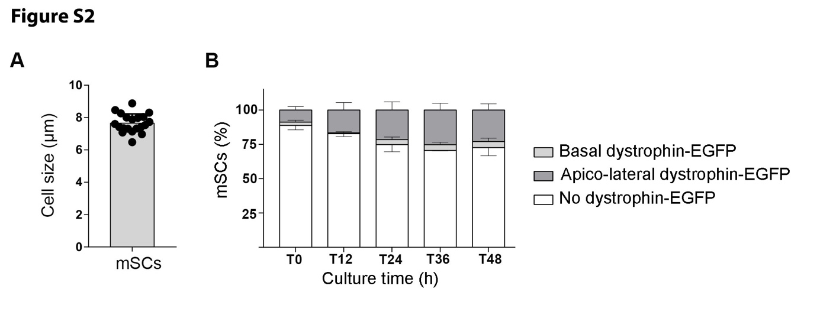Figure S2. MuSC size and dystrophin-EGFP dynamics.
(A) The diagram depicts the diameter of MuSCs. Data are presented as the mean ± SEM (n = 20 MuSCs). (B) The diagram presents the proportion of MuSCs with associated dystrophin-EGFP accumulation on myofibers from adult Dmd^{EGFP} mice directly after isolation (T0) and after 12, 24, 36, and 48 h of culture (T12–48) and immunostaining against PAX7. White columns represent MuSCs without associated dystrophin-EGFP, dark gray columns represent MuSCs with apical–lateral accumulation of dystrophin-EGFP, and light gray columns represent MuSCs with basally accumulated dystrophin-EGFP. Error bars represent the SEM. N = 300–600 MuSCs from fibers derived from two mice. Statistical significance was assessed using two-way ANOVA.

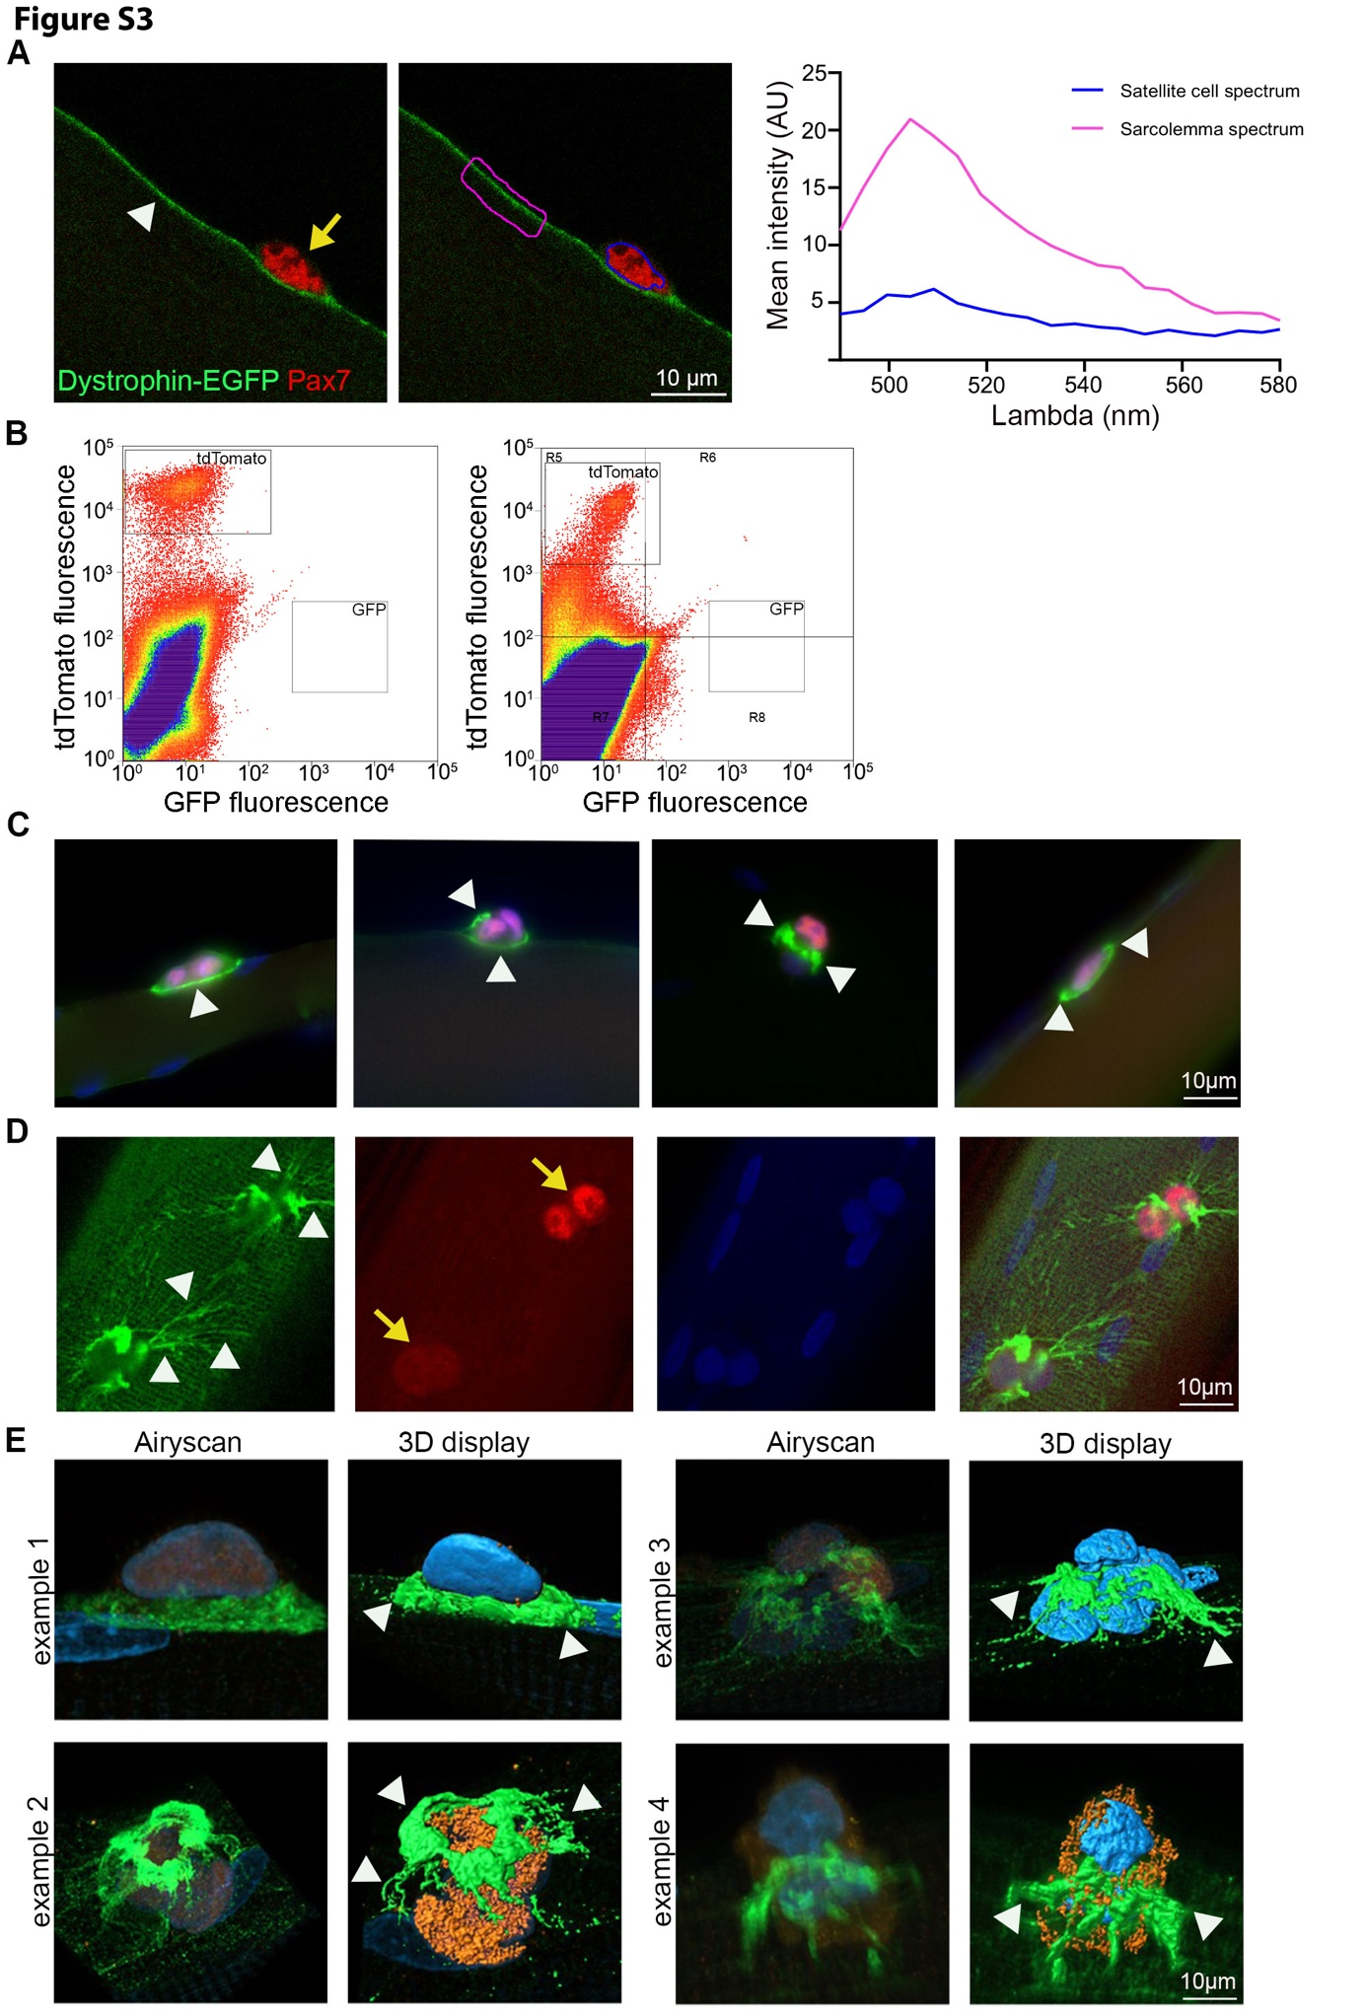

Figure S3. Specificity of dystrophin-EGFP and MuSC-associated dystrophin.
(A) The left image presents sarcolemmal dystrophin-EGFP (green, white arrowhead) in a myofiber freshly isolated from an adult Dmd^{EGFP} mouse and labeled with anti-PAX7 antibody to depict MuSCs (red, yellow arrow). The right image depicts the outlines of the ROI of spectral acquisition of the dystrophin-EGFP signal (sarcolemmal region outlined in magenta, and MuSCs outlined in blue). The diagram illustrates that no EGFP spectrum was emitted from MuSCs (eight MuSCs from six myofibers, blue curve), whereas it was highly emitted from sarcolemma (magenta curve). Scale bar: 25 µm. (B) Frequency analysis of GFP⁺ and tdTomato⁺ cell populations following FACS of MuSCs from Pax7^{CreERT2/CreERT2};Rosa^{tdT/tdT} mice (positive control, left diagram) and Dmd^{EGFP/mdx/y};Pax7^{CreERT2/+};Rosa^{tdT/+} mice (negative control, right diagram). The y-axis represents native tdTomato fluorescence, and the x-axis represents GFP fluorescence. MuSCs only positive for tdTomato clustered in the R1 quadrant. MuSCs only positive for GFP (R8 quadrant) and double-positive MuSCs (quadrant) were absent. (C–D) Fluorescence microscopy images of myofibers isolated from EDL muscle from adult rats, cultured for 48 h, and subjected to co-immunocytochemistry against dystrophin (green), PAX7 (red or orange), and DAPI for nuclear staining (blue). The epifluorescence image in (D) depicts MuSC-associated dystrophin accumulation in continuation with sarcolemmal dystrophin that is organized in costameres (arrowheads). Airyscan images in (E) present additional examples of dystrophin accumulation at the MuSC level (see also Figure 3C). N = 16 MuSCs. Scale bars: 10 µm.

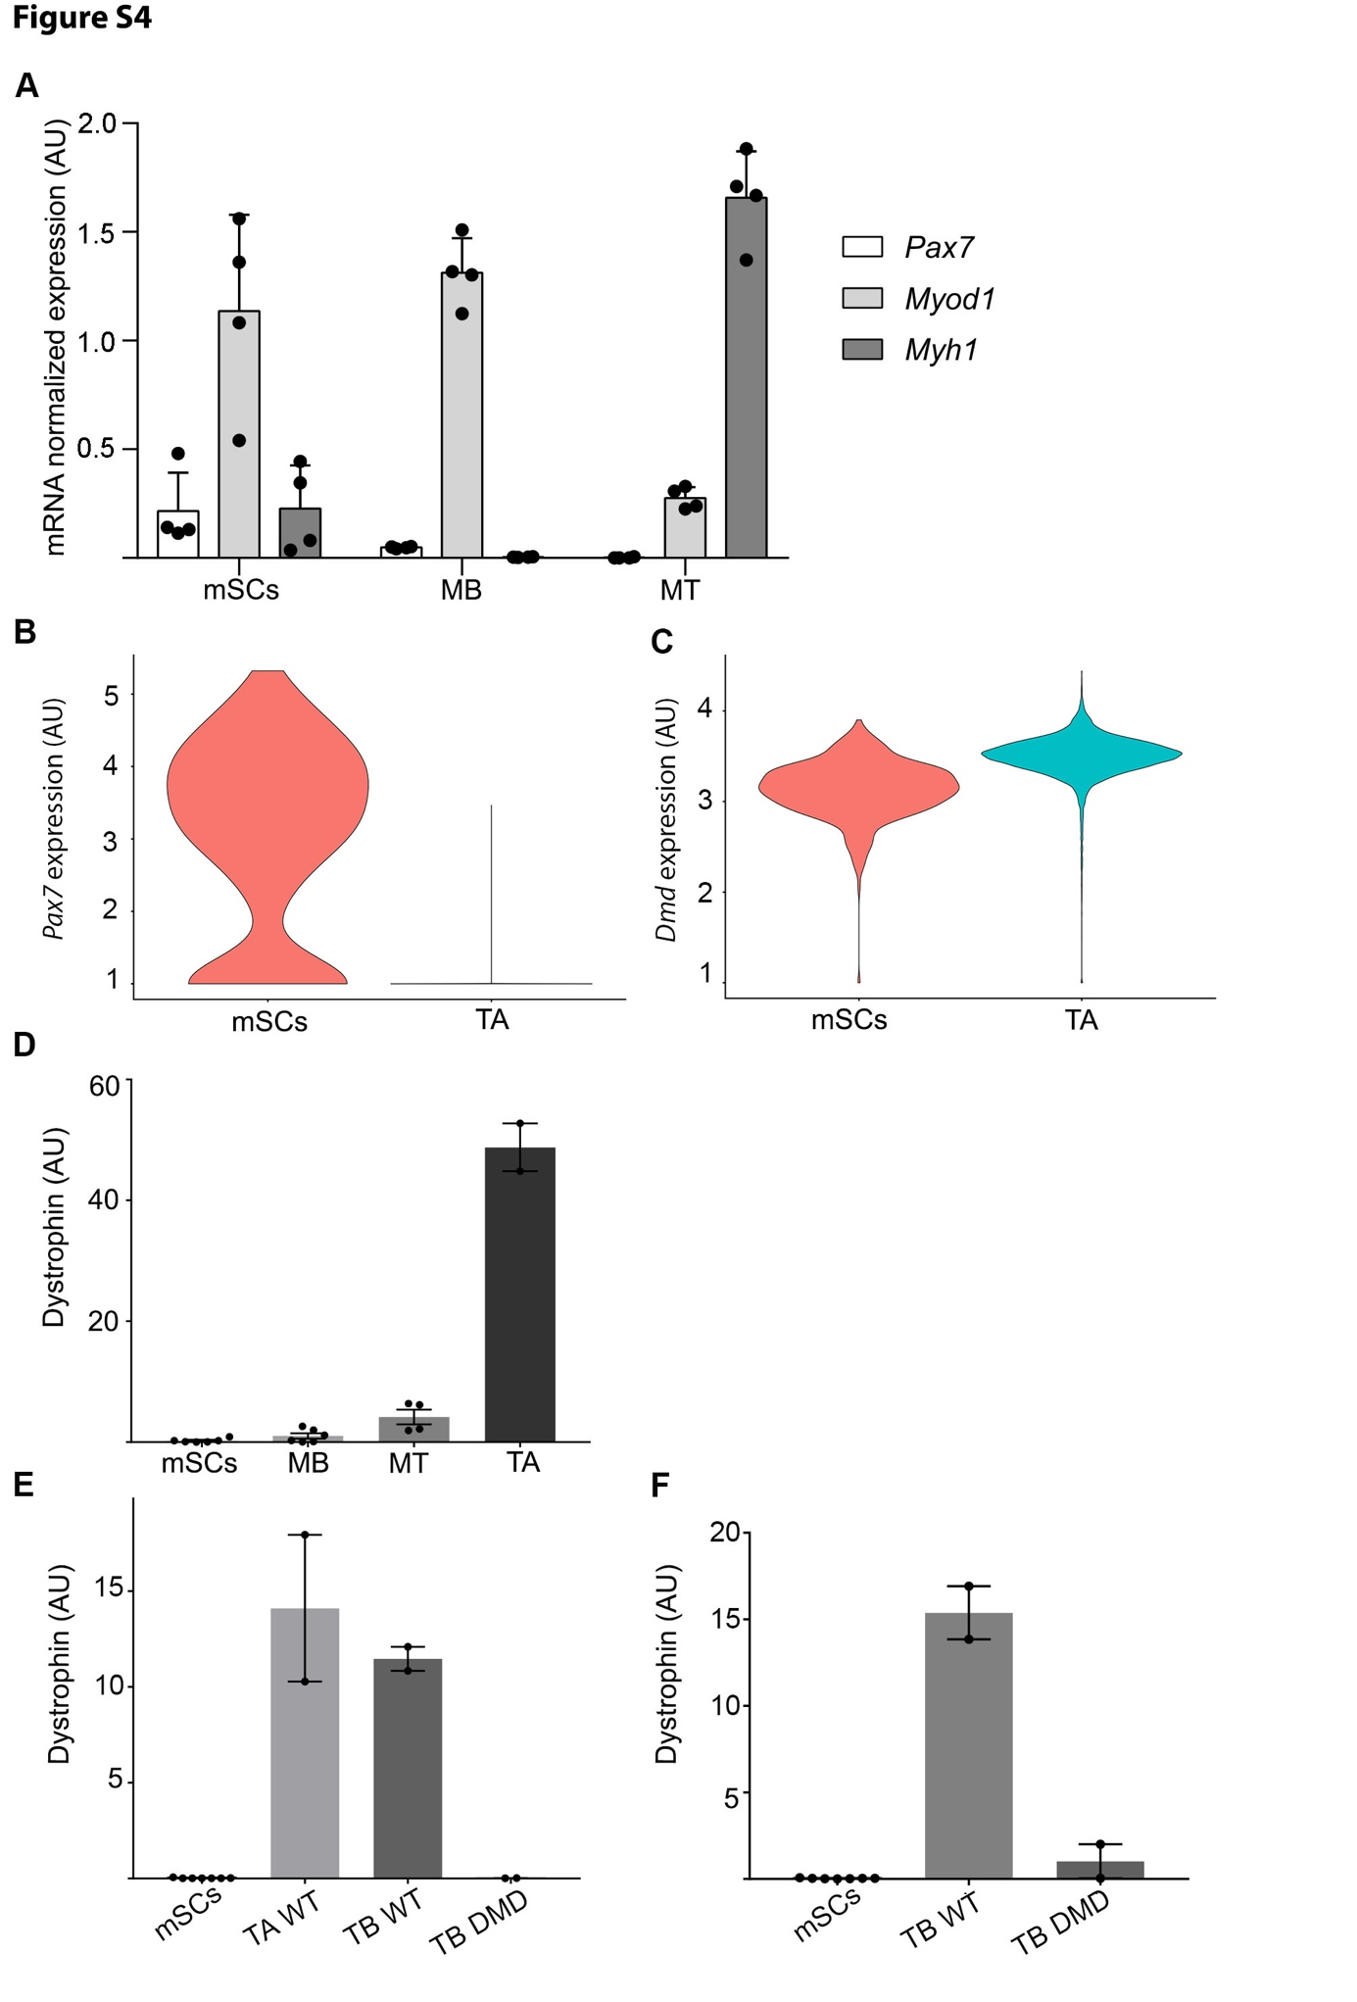

Figure S4. Transcript and protein profiling of dystrophin and myogenic markers in MuSCs.
MuSCs freshly derived from 14 day-old wild-type mice or cultured for 3 and 13 days to obtain myoblasts (MB) and myotubes (MT). (A) Diagram of ddPCR analysis depicts the transcript levels of Pax7, Myod, and Myh1 in freshly isolated MuSCs, MB, and MT, with expression normalized to GAPDH (four cultures from 3–7 mice). (B–C) Violin plot of TA muscle from adult Dmd^{EGFP/wt} mice following snRNA-Seq illustrates Dmd and Pax7 co-expression in the nucleus of the MuSC cluster. (D) Diagram of capillary electrophoresis depicts the level of dystrophin protein in MACS-sorted MuSCs, MB, MT (n = 6 mice; n = 4–6 culture replicates) and positive-control muscle (tibialis anterior [TA]; n = 2) using an antibody against the rod domain region of dystrophin. Statistical analysis was performed using one-way ANOVA and Tukey’s multiple comparisons test (ns = not significant; *P < 0.05; **P < 0.01). (E–F) Diagram of capillary electrophoresis depicts the quantity of dystrophin protein in MACS-sorted MuSCs (seven biological repeats from seven rats), TA (TA WT) and triceps brachii (TB WT) muscles from wild-type adult rats (serving as positive controls), and triceps brachii (TB DMD) muscles from adult DMD rats (n = 2 for different control muscles) using an antibody targeting the C-terminal region of dystrophin (E) and an antibody targeting the rod domain region of dystrophin (F).

Movie S1. Time-lapse imaging of tdTomato+ MuSCs on isolated fibers from Dmd^{EGFP/y};Pax7^{CreERT2/+};Rosa^{tdT/+} mice.
Time-lapse microscopy was initiated at 44 h of culture, with images collected every 10 min over a 6-h period. The movie shows that dystrophin-EGFP frequently accumulates at the apical side of MuSCs but does not track their migration. As MuSCs relocate, they leave behind a stable dystrophin-EGFP footprint that remains visible at the sarcolemma Scale bar 20 µm.

