Supplementary Table S1. Integron vs Antibiotic Resistance Prevalence

Antibiotic | Int+ R/Total | Int- R/Total | p | q
AMC | 19/37 | 20/28 | 0.1018 | 0.7966
TZP | 4/37 | 6/28 | 0.3064 | 0.7966
CXM | 15/37 | 15/28 | 0.2967 | 0.7966
FOX | 2/37 | 3/28 | 0.6444 | 0.9722
CAZ | 14/37 | 9/28 | 0.6344 | 0.9722
CRO | 14/37 | 9/28 | 0.6344 | 0.9722
FEP | 11/37 | 7/28 | 0.673 | 0.9722
ERT | 0/37 | 0/28 | 1.0 | 1.0
MEM | 0/37 | 0/28 | 1.0 | 1.0
AK | 1/37 | 0/28 | 1.0 | 1.0
GN | 1/37 | 0/28 | 1.0 | 1.0
CIP | 20/37 | 19/28 | 0.2607 | 0.7966
SXT | 26/37 | 15/28 | 0.1672 | 0.7966
p = Chi‑square or Fisher exact as appropriate; q = Benjamini–Hochberg FDR. AMC: amoxicillin/clavulanate; TZP: piperacillin/tazobactam; CXM: cefuroxime; FOX: cefoxitin; CAZ: ceftazidime; CRO: ceftriaxone; FEP: cefepime; ERT: ertapenem; MEM: meropenem; CN: gentamicin; AK: amikacin; CIP: ciprofloxacin; SXT: trimethoprim/sulfamethoxazole.

Supplementary Table S2. Firth-penalised multivariable logistic regression

Variable | β | OR | 95% CI Lower | 95% CI Upper | p-value
Intercept | -3.5 | 0.03 | 0.003 | 0.31 | 0.003
MAR index (per 0.01) | 3.53 | 34.2 | 4.0 | 292.0 | <0.001
Integron | 0.09 | 1.1 | 0.26 | 4.0 | 0.81
CTX‑M | -2.14 | 0.12 | 0.01 | 1.0 | 0.05
qnrS | 0.77 | 2.1 | 0.4 | 11.8 | 0.37
qnrB | 1.11 | 3.0 | 0.29 | 31.5 | 0.35
aac(6')‑Ib‑cr | 0.07 | 1.07 | 0.1 | 11.5 | 0.96
Bias‑reduced (Firth) model; MAR index is the only significant predictor (p < 0.001).

Supplementary Table S3. Full isolate-level dataset
The complete isolate-level dataset is provided as an Excel file: Additional file 1

Supplementary Table S4. PCR cycling parameters

Reaction | First Denaturation | Denaturation | Elongation | Extension | Final Extension | Cycle
intI1/intI2 integrase | 94 °C (5 min) | 94 °C (1 min) | 57 °C (5 min) | 72 °C (1 min) | 72 °C (10 min) | 34
Class 1 Integron | 94 °C (2 min) | 94 °C (30 sec) | 56°C (45 sec) | 72 °C (3 min) | 72 °C (5min) | 34
Class 2 Integron | 94 °C (3 min) | 94 °C (45 sec) | 55 °C (1 min) | 72 °C (2 min) | 72 °C (5 min) | 34
bla_{TEM} | 94 °C (5 min) | 94 °C (1 min) | 56 °C (1 min) | 72 °C (1 min) | 72 °C (7 min) | 34
bla_{SHV} | 94 °C (2 min) | 94 °C (30 sec) | 60 °C (30 sec) | 72 °C (1 min) | 72 °C (4 min) | 35
bla_{CTX-M} | 94 °C (2 min) | 95 °C (20sec) | 51 °C (30 sec) | 72 °C (30 sec) | 72 °C (3 min) | 35
bla_{CTX-M} Groups 1, 2, 8 and 9 | 95 °C (2 min) | 95 °C (1 min) | 55 °C (1 min) | 72 °C (1min) | 72 °C (10 min) | 30
Quinolone resistance genes | 94 °C (5 min) | 94 °C (1 min) | 55 °C (1 min) | 72 °C (1 min) | 72 °C (10 min) | 30
Phylogenetic groups | 94 °C (4 min) | 94 °C (5 sec) | 59 °C (10 sec) | 72 °C (5 min) | 72 °C (5 min) | 30

Supplementary Table S5. Phylogenetic group analyses

Supplementary Table S5a. Distribution of phylogenetic groups among 65 E. coli isolates (REC1–REC65).
Supplementary Table S5b–f. Crosstab analyses of phylogenetic groups vs. MAR≥0.20, ciprofloxacin resistance, CTX-M positivity, any ESBL gene, and integron presence.
Supplementary Table S5g. Statistical test summary (test type and p-values).
Additional file 2. S3_phylogroup_tables.xlsx – Excel workbook containing all tables S5a–g.

Supplementary Figure S1. Firth-adjusted odds ratios for ciprofloxacin resistance.
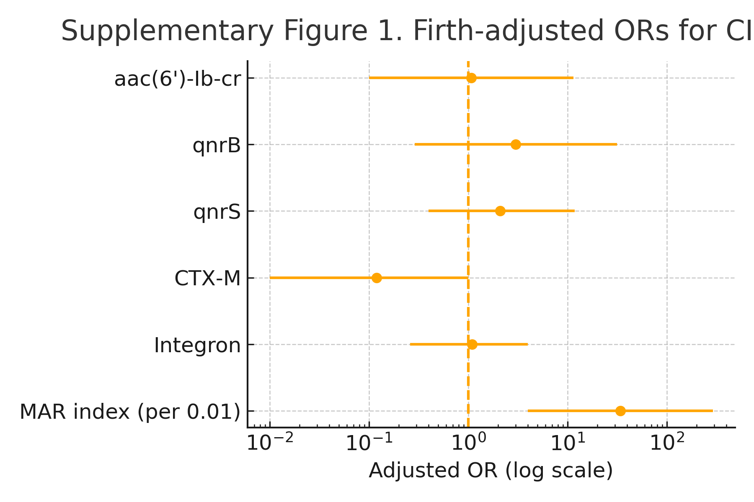
Forest plot from bias‑reduced (Firth) logistic regression showing adjusted odds ratios (dots) with 95 % confidence intervals on a log scale. MAR index remains the only significant predictor (p < 0.001).
Supplementary Figure S2. Bar plot showing the distribution of 65 E. coli isolates (REC1–REC65) across phylogenetic groups (A, B1, B2, D). The y-axis indicates proportion (0–1); total n = 65.
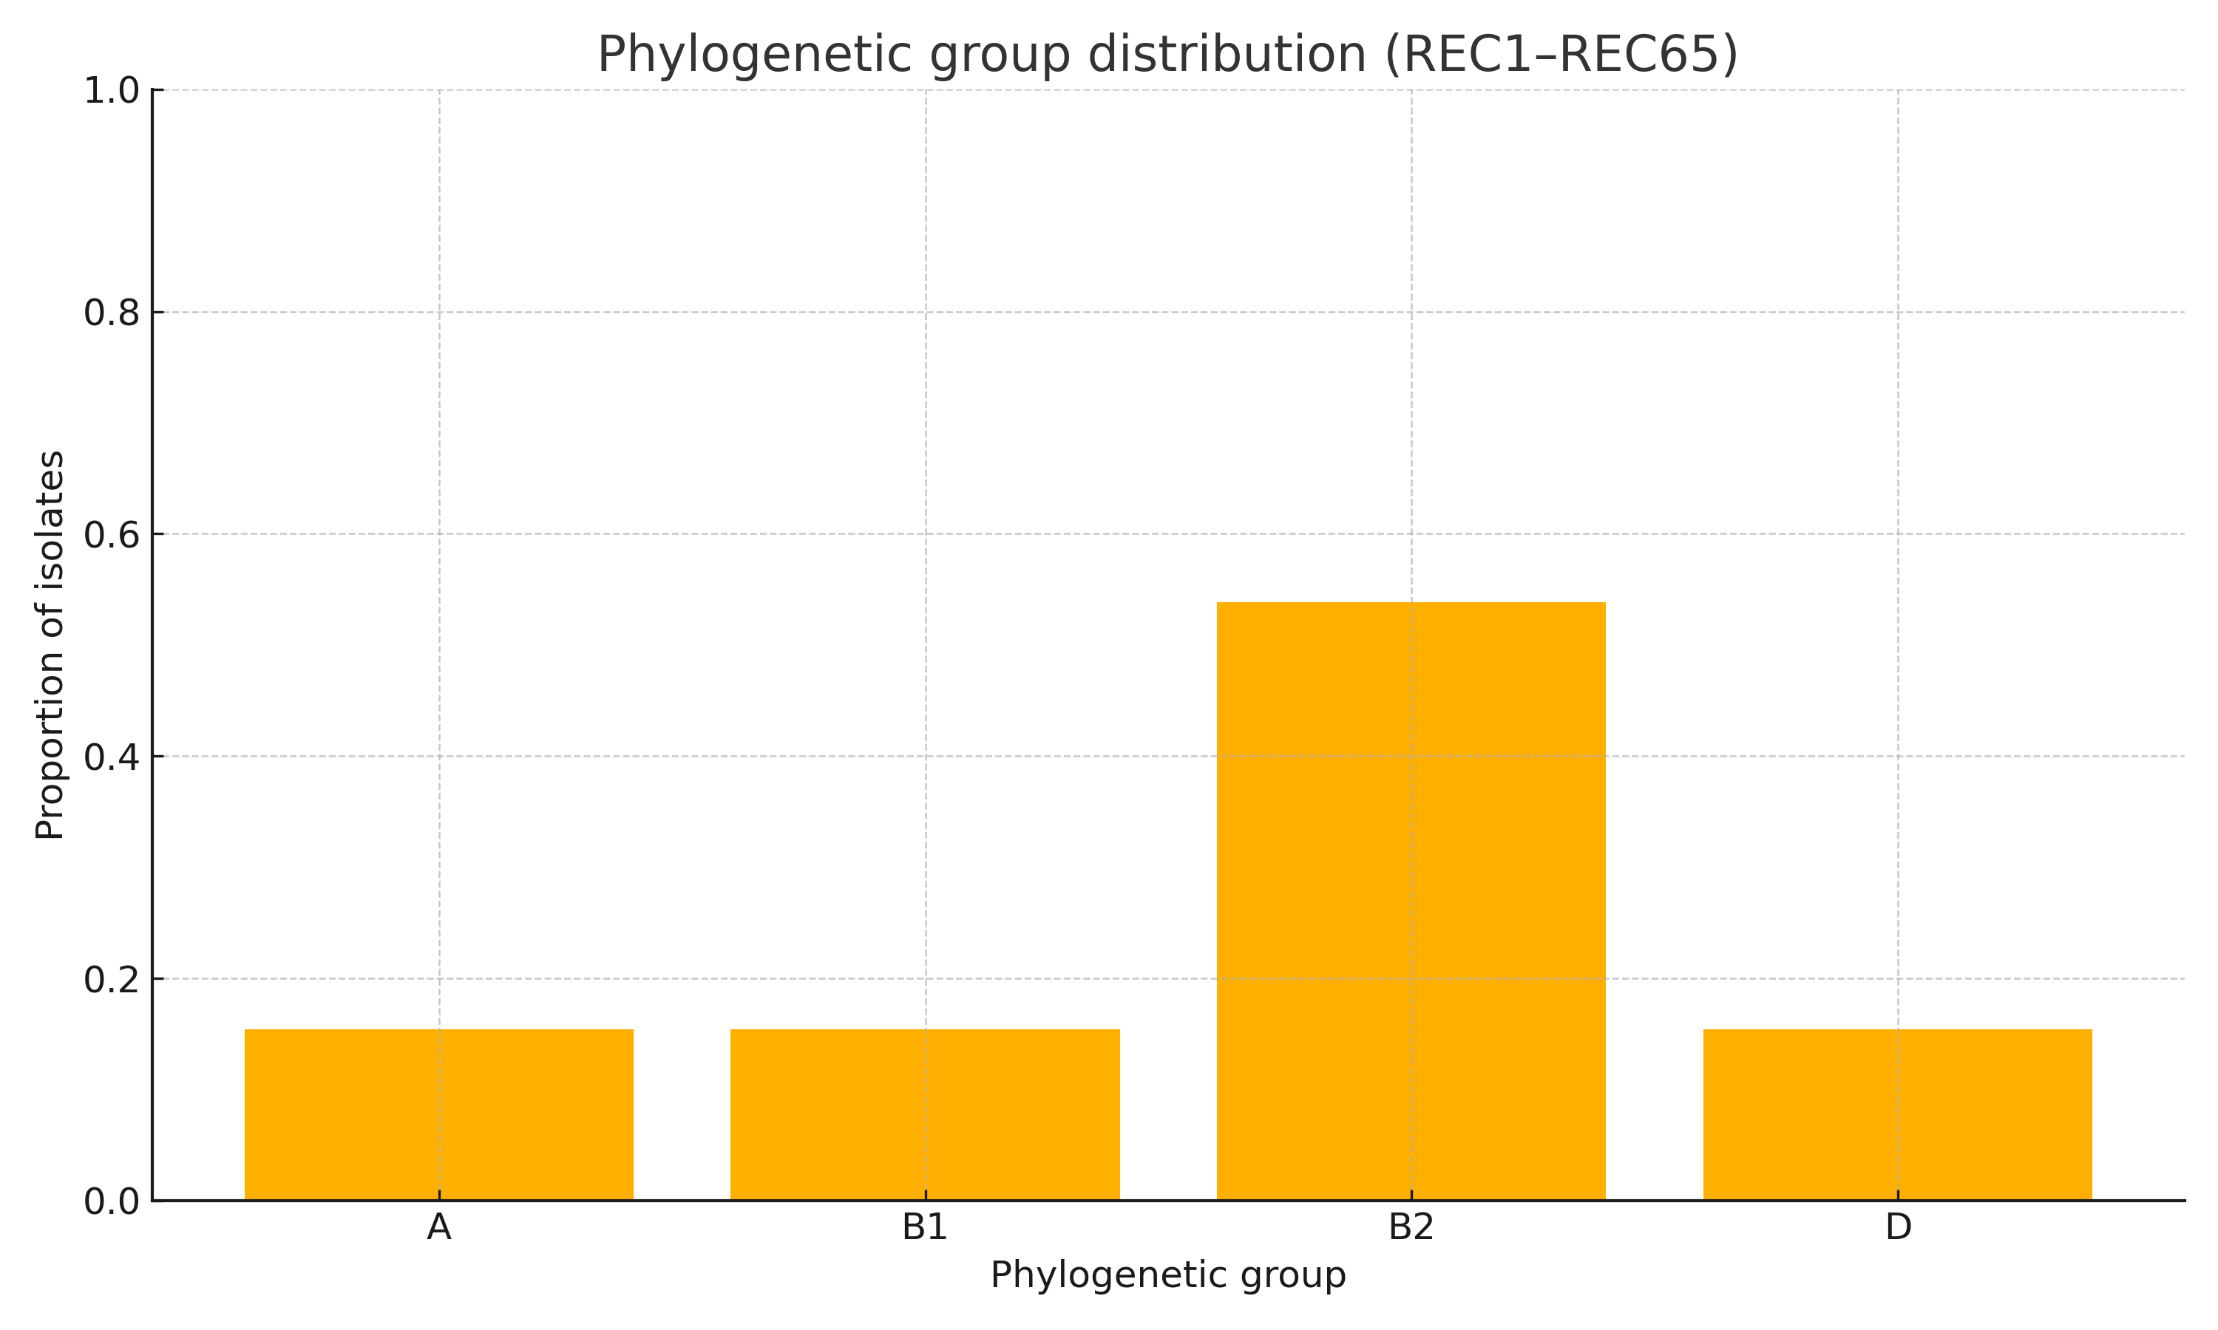
Supplementary Figure S3. Proportion of ciprofloxacin-resistant (CIP-R) isolates by phylogenetic group. The y-axis indicates proportion (0–1). No significant differences were detected (χ², all p > 0.18; see Supplementary Table S5g).
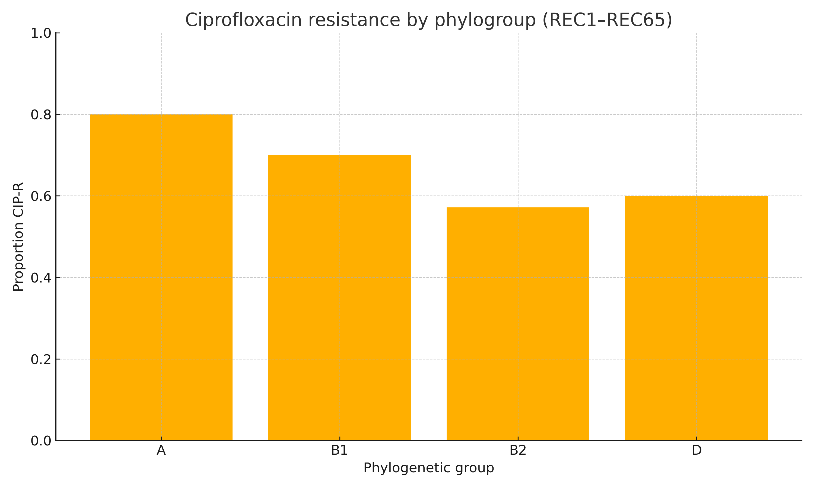
Supplementary Figure S4. Proportion of CTX-M–positive isolates by phylogenetic group. The y-axis indicates proportion (0–1). No significant differences were detected (χ², p > 0.18; see Supplementary Table S5g).
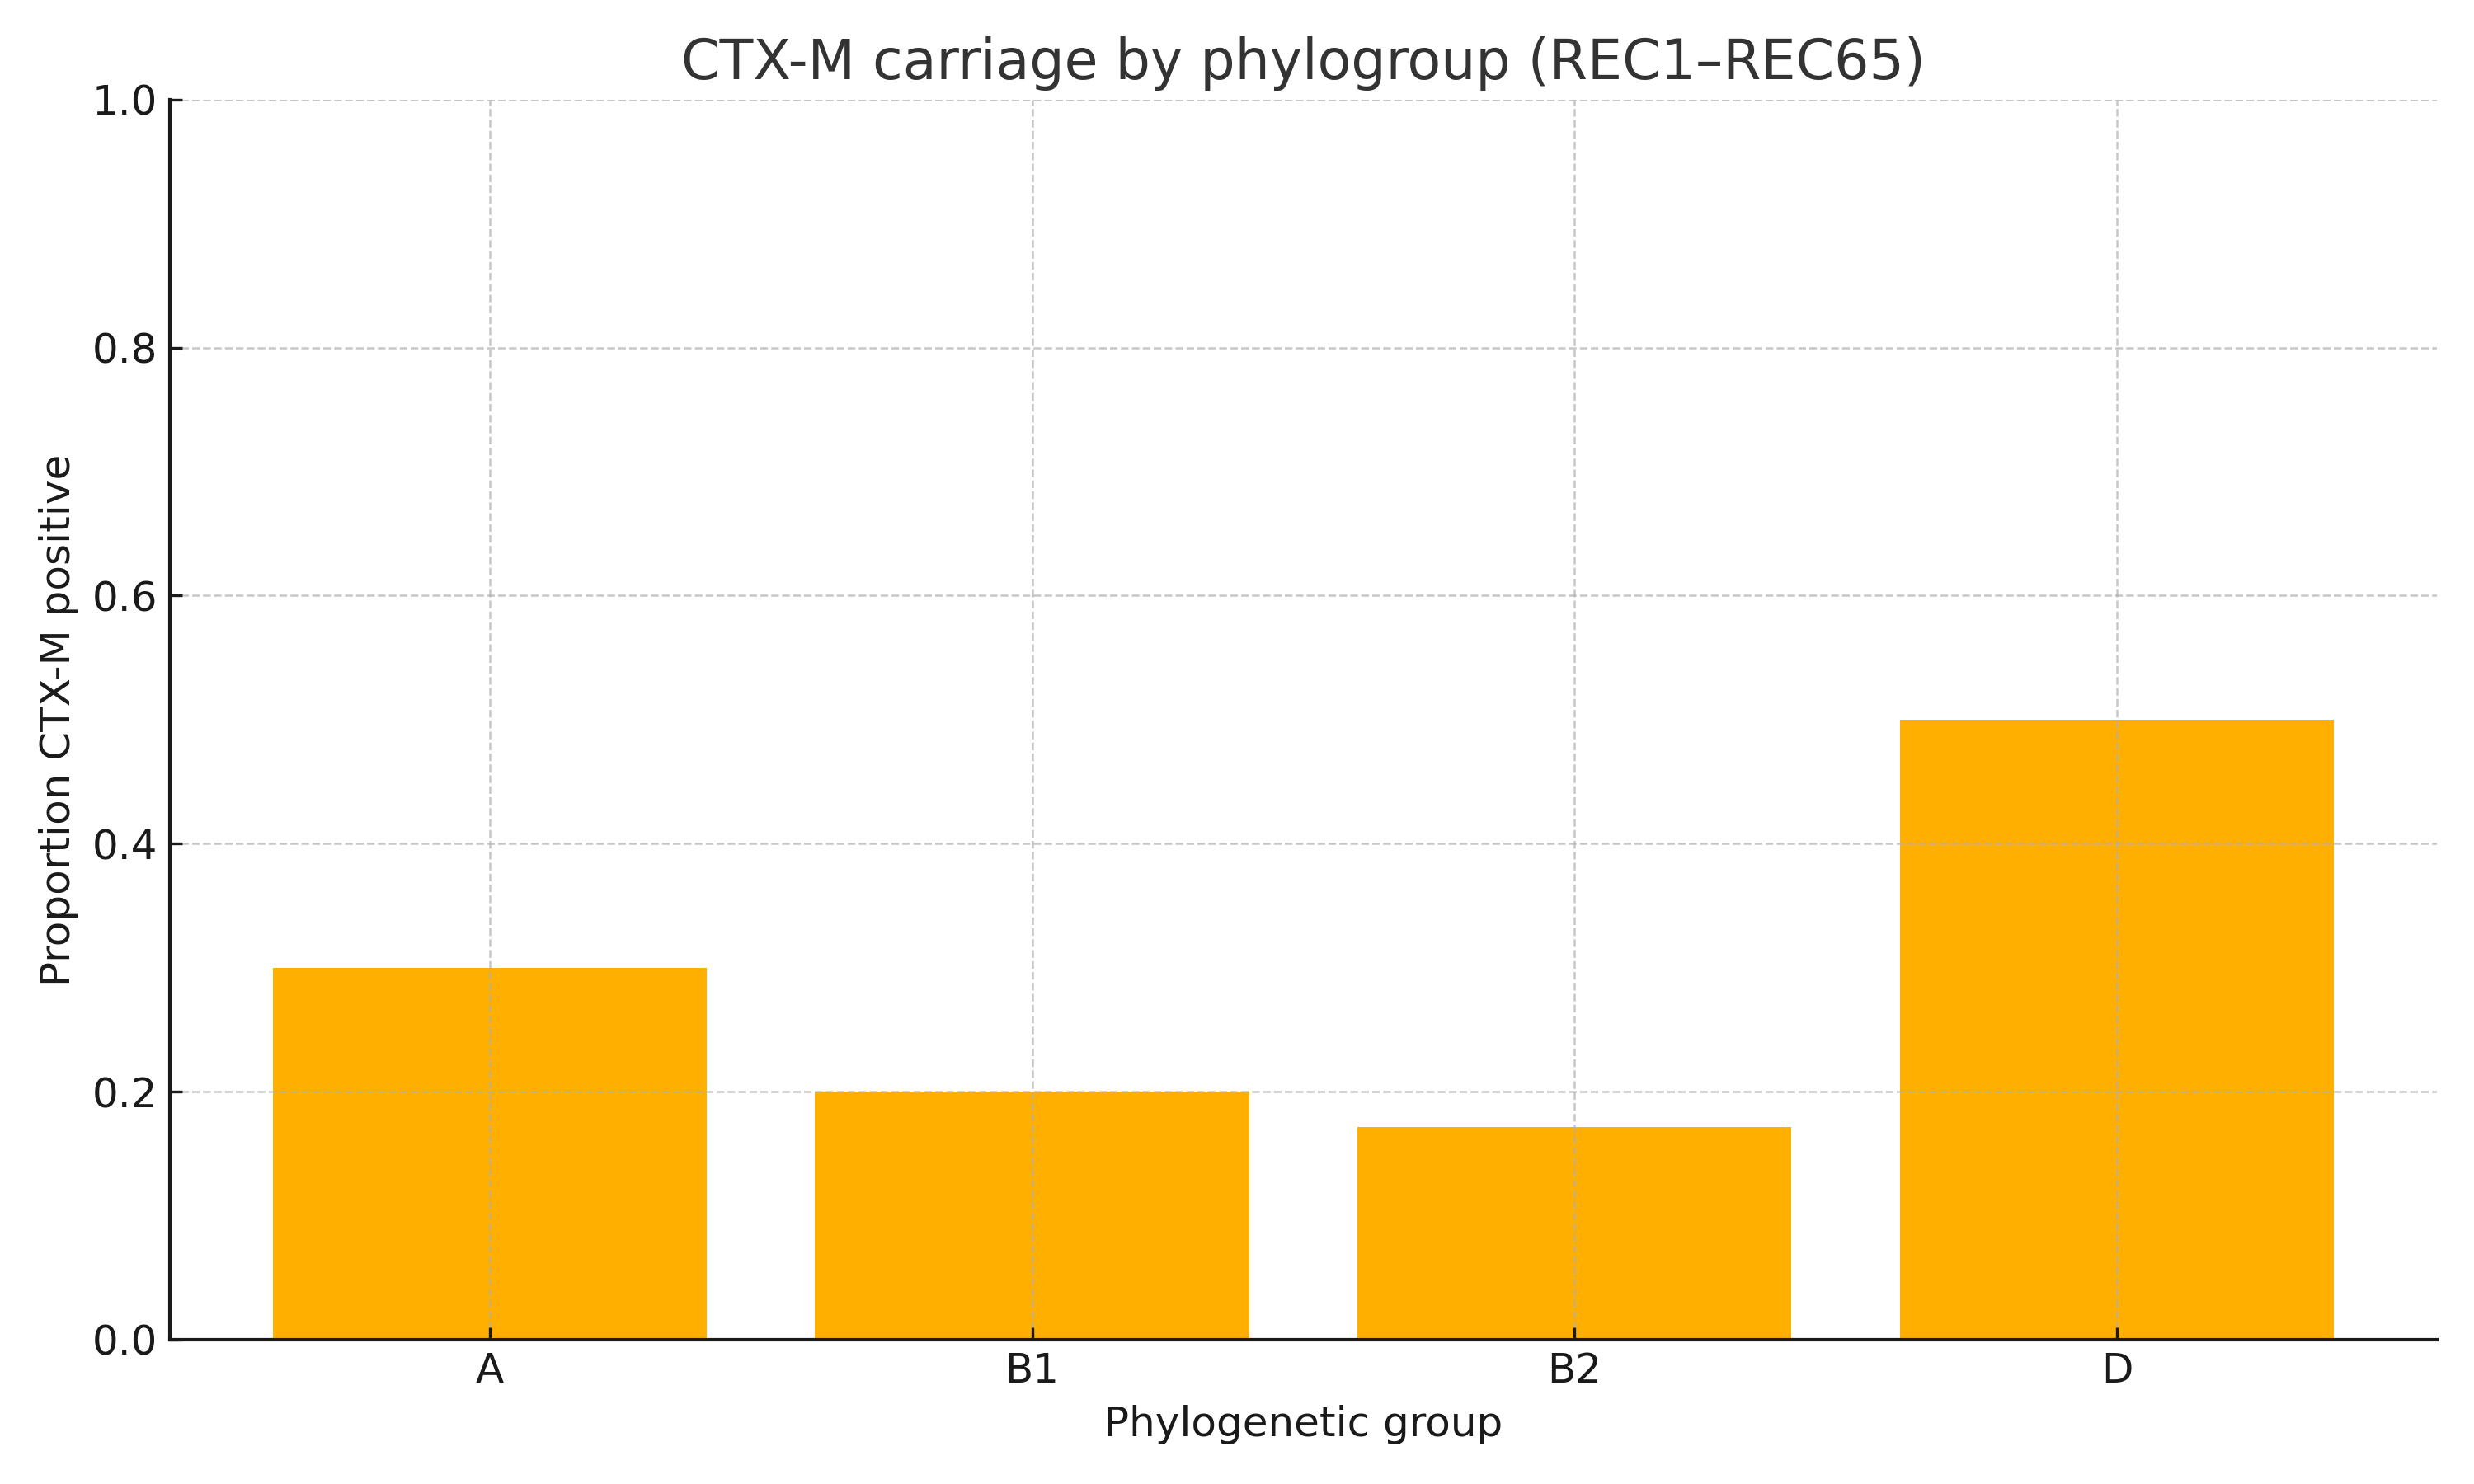
Supplementary Figure S5. Proportion of isolates carrying any ESBL gene (CTX-M/SHV/TEM/PER/VEB/GES/OXA) by phylogenetic group. The y-axis indicates proportion (0–1). No significant differences were detected (χ², p > 0.18; see Supplementary Table S5g).
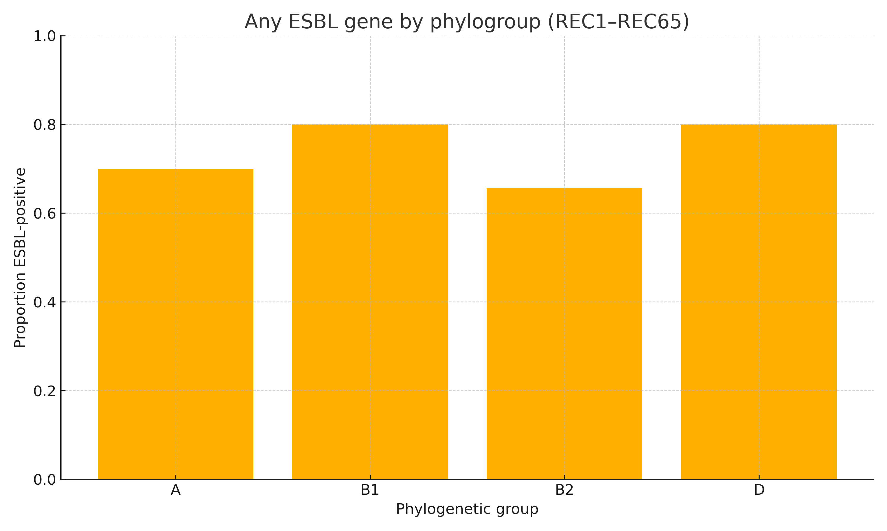
Supplementary Figure S6. Proportion of integron-positive isolates by phylogenetic group. The y-axis indicates proportion (0–1). No significant differences were detected (χ², p > 0.18; see Supplementary Table S5g).
