Supplemental Information
3D Structural Hijacking of Pathological α-Synuclein Fibrillar Architectures by Carbon Dot Nanoeraser Prevents Neurodegeneration
Supplementary Methods
Characterization of CDs. The morphological and structural characteristics of the P-CDs were examined with a Talos F200S Transmission Electron Microscope (TEM) (FEI, OR, USA) at 200 kV. Additionally, the thickness of the P-CDs was measured by the Atomic Force Microscope (AFM) (Bruker, Karlsruhe, Germany). Fourier transform infrared (FTIR) spectra were recorded from 400 to 4000 cm-1 on a Thermo Scientific spectrophotometer (Thermo Scientific, USA) to identify the functional groups present in the P-CDs. The chemical states and elemental composition of the P-CDs were analyzed by X-ray photoelectron spectroscopy (XPS) using a K-Alpha spectrometer (Thermo Scientific, USA). The X-ray diffraction (XRD) patterns were collected on a Rigaku D/MAX-2600 diffractometer (Japan).
Synthesis of P-CDs-A. A mixture containing 20 mL of P-CDs solution (5 mg/mL), 1 g of 1, 3-propanesultone (PS), 20 mL of 1,4-dioxane, and 2 mL of triethylamine was stirred in a sealed beaker at 40 °C for 24 h. The solvent was subsequently removed by rotary evaporation. The product was redissolved in water and dialyzed using a 500 Da dialysis bag against 0.1 M NaCl solution at room temperature for 24 h, followed by ultrapure water for 3 days. The resulting material was then freeze-dried. The obtained product was stirred with 20 mL of 0.5 M NaOH at 40 °C for 24 h. The pH was adjusted to neutral using HCl, followed by dialysis against ultrapure water for 3 days and subsequent freeze-drying, yielding the final product P-CDs-A.
Cell culture. Rat pheochromocytoma (PC12) cells and SH-SY5Y cells were purchased from the Cell Bank of the Chinese Academy of Science (Shanghai, China). HEK293T cells stably expressing YFP-labeled human α-synuclein (HEK293-α-Syn-YFP) were kindly gifted from Jichun Zhang lab (Shandong First Medical University, China). BV2 cells and 293T cells were cultured in Dulbecco’s Modified Eagle’s Medium (DMEM) supplemented with 10 % fetal bovine serum (FBS, Pricella), and 1% penicillin/streptomycin (Solarbio). PC12 cells were maintained in Roswell Park Memorial Institute (RPMI) 1640 containing 10 % fetal bovine serum (FBS, Pricella), and 1 % penicillin/streptomycin (Solarbio). Cells were incubated at 37°C in a humidified chamber containing 5 % CO₂.
Cell viability assays.
PC12 cells were plated on 96-well plate at a density 10,000 cells/well and cultured for 24 h to ensure full stretch. The cells were treated with α-syn PFFs (5 μg/mL) in the absence and presence of different concentrations of P-CDs. After 24 hours of culture, 10 μL of CCK8 solution (Target Mol) was added to each well and continued to incubate in the incubator for 2h. The absorbance was measured at 450 nm by a microplate reader (Bio-Rad). The cell viability was calculated by the absorbance.
Detection of the efficiency of P-CDs entry cells. PC12 cells were inoculated in confocal dishes and incubated with P-CDs. The distribution of P-CDs in the cells was observed by confocal microscopy (ZEISS LSM980).
Calcein/PI Staining.
The Calcein/PI Cell Viability/Cytotoxicity Assay Kit (C2015S, Beyotime) was used to detect cell viability. Living cells were stained with Calcein AM and showed green fluorescence, while dead cells were stained with Propidium Iodide (PI) and showed red fluorescence. PC12 cells were treated with α-syn PFFs (5 μg/mL) in the absence and presence of different concentrations of P-CDs for 24 h. The cells were stained with a Calcein/PI Cell Viability/CytotoxicityAssay Kit, following the manufacturers’ instructions. Representative images were captured by fluorescence microscopy. Fluorescence intensity was quantified using Image J software.
Mitochondrial membrane potential measurement. JC-1 (C2003S, Beyotime) is an ideal fluorescent probe for detecting ∆Ψm of mitochondrial membrane potential. PC12 cells were plated on 6-well plate and cultured for 24 h to ensure full stretch. The cells were treated with α-syn PFFs (5 μg/mL) in the absence and presence of different concentrations of P-CDs for 24 h. The cells were stained with JC-1 solution for 20 min. After incubation, fluorescence intensity values were captured using a fluorescence microscopy and quantified using ImageJ software, as a measure of mitochondrial membrane potential based on the ratio of JC-1 aggregates (red) to monomers (green).
Western blot.
Cells and brain tissue samples were lysed using RIPA buffer containing PMSF, phosphatase inhibitor, and protease inhibitor. Total protein was quantified with a BCA Protein Assay Kit (P0012, Beyotime) and adjusted to a consistent concentration. The protein samples (20 μg) were separated by electrophoresis on 10% or 15% sodium dodecyl sulfate-polyacrylamide gels, and then transferred onto PVDF membrane (Merck Millipore, Billerica, MA, USA). The PVDF membranes were then blocked with 5% bovine serum albumin solution for one hour at room temperature. The PVDF membranes were then incubated overnight at 4°C with primary antibody: Anti-Bax antibody (Cat. #2772, 1:1000, CST), Anti-Bcl-2 antibody (Cat. #3498, 1:1000, CST), Anti-Cleaved Caspase-3 antibody (Cat. #9664,1:1000, CST), Anti-GAPDH antibody (Cat. #2118, 1:1000, CST), Anti-Alpha-synuclein antibody (ab212184, 1:1000, abcam), anti-Tyrosine Hydroxylase antibody (ab137869, 1:1000, abcam), Anti-Alpha-synuclein (phospho S129) antibody (ab51253, 1:1000, abcam). The PVDF membranes were washed three times with TBST for 5 minutes each time, and then incubated with secondary antibody. The target protein signal was detected by enhanced chemiluminescence (ECL) solution (cat. no. 180-5001, Tanon™). The gray value was analyzed with Image J.
Immunofluorescence staining. The cells or brain sections from mice were fixed in 4 % PFA for 15 min at room temperature, and then washed three times with PBS buffer. The cells or brain sections were permeabilized in PBS with 0.3 % Triton X-100 for 20 min, and then blocked with 5 % bovine serum albumin and 5 % normal goat serum for 2 h at room temperature. The cells or brain sections were incubated for 24 h at 4 °C with primary antibody: Anti-Alpha-synuclein (phospho S129) (ab51253, 1:500, abcam), Anti-Tyrosine Hydroxylase antibody (GTX10372, 1:500, GeneTex). Cell or tissue samples were washed three times with PBS and then incubated with Alexa Fluor® 488/594 secondary antibody (ab150077 and ab150116) for 2 h at 4 °C, followed by staining with Hoechst 33342 to visualize the nuclei for 10 minutes. Representative images were taken by confocal microscopy (ZEISS LSM980).
TEM imaging. The α-syn fibrils were diluted with PBS (1:10), and then added to glow discharge grids (EMCN, 400 mesh carbon-coated copper grids) for 1 min, and carefully washed twice with Tris-HCl (50 mM, pH 7.4). The grids were stained with 1 drop of 0.75 % uranyl formate for 1 minute. After the grids were naturally dried, the images were observed by transmission electron microscopy (Talos™ F200i TEM).

Supplementary Figures
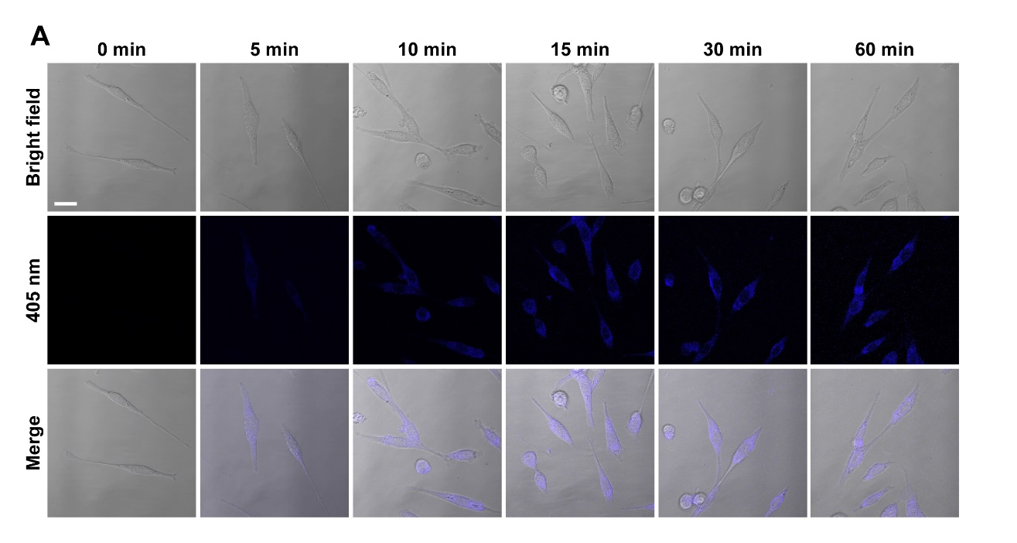
Figure S1. Cellular uptake of P-CDs. Laser confocal scanning microscopy images of PC-12 cells incubated with P-CDs for 1 hour and imaged under 405 nm. Scale bar: 20 μm.
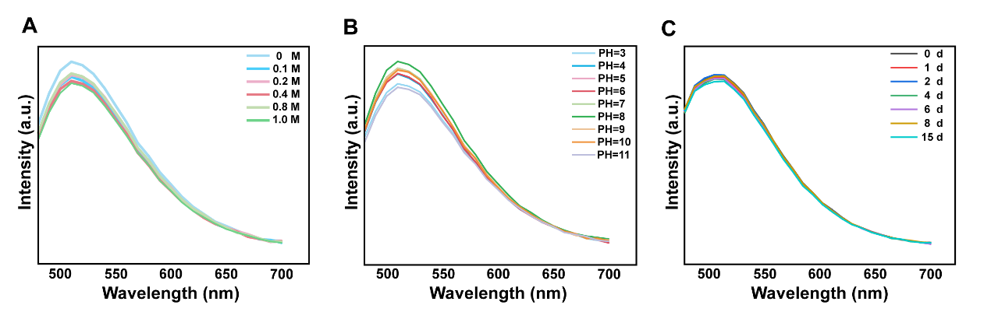
Figure S2. Stability of P-CDs. (A) The fluorescence intensity at different NaCl concentrations of P-CDs. (B) The fluorescence intensity at different pH values of P-CDs. (C) The fluorescence intensity at different time of P-CDs.
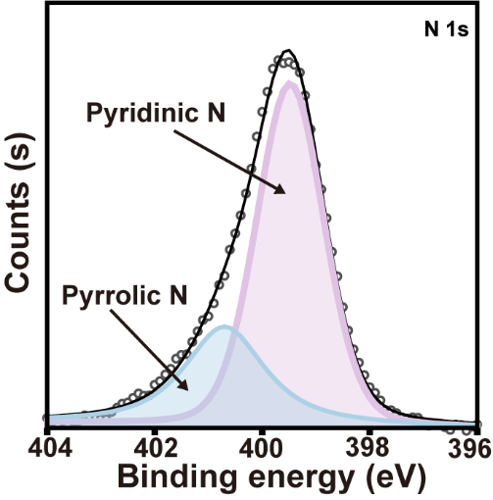
Figure S3. High-resolution N 1s XPS spectrum of P-CDs.
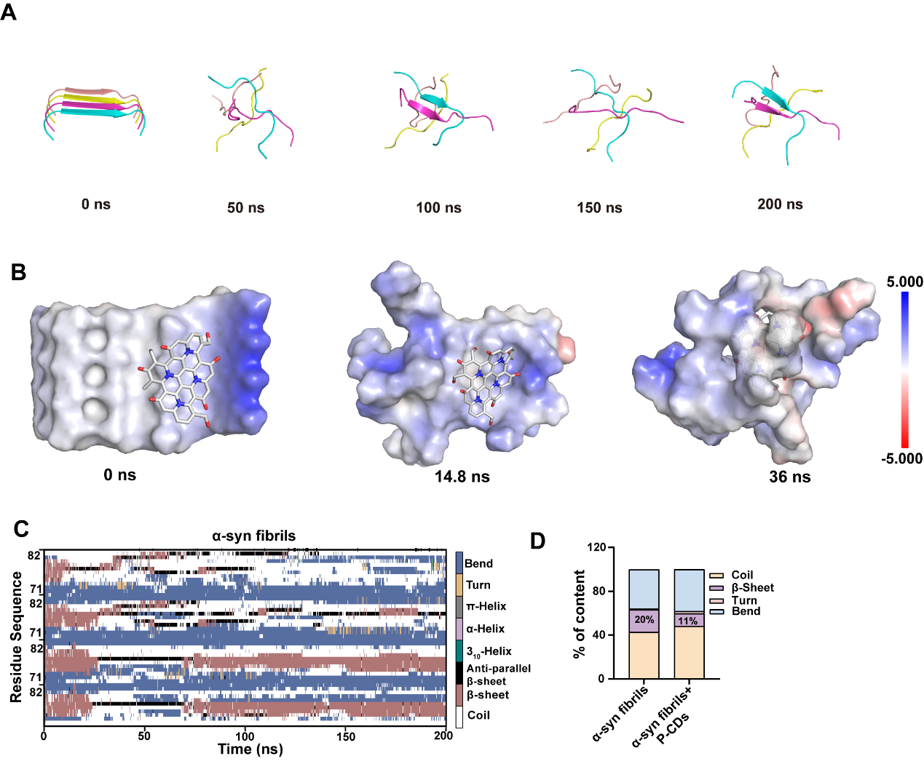
Figure S4. (A) Simulated dynamics of α-syn fibrils in aqueous solution over 200 ns, and 0, 50, 100, 150, 200 ns snapshot image. (B) Electrostatic distribution map of the simulation structure of P-CDs and α-syn fibrils. (C) Calculation of the secondary structure plot over time using the DSSP algorithm in the α-syn fibrils group. (D) Fractional secondary structure contents ratio of α-syn fibrils and α-syn fibrils disaggregated by P-CDs.
Figure S5. Zeta potential of P-CDs.
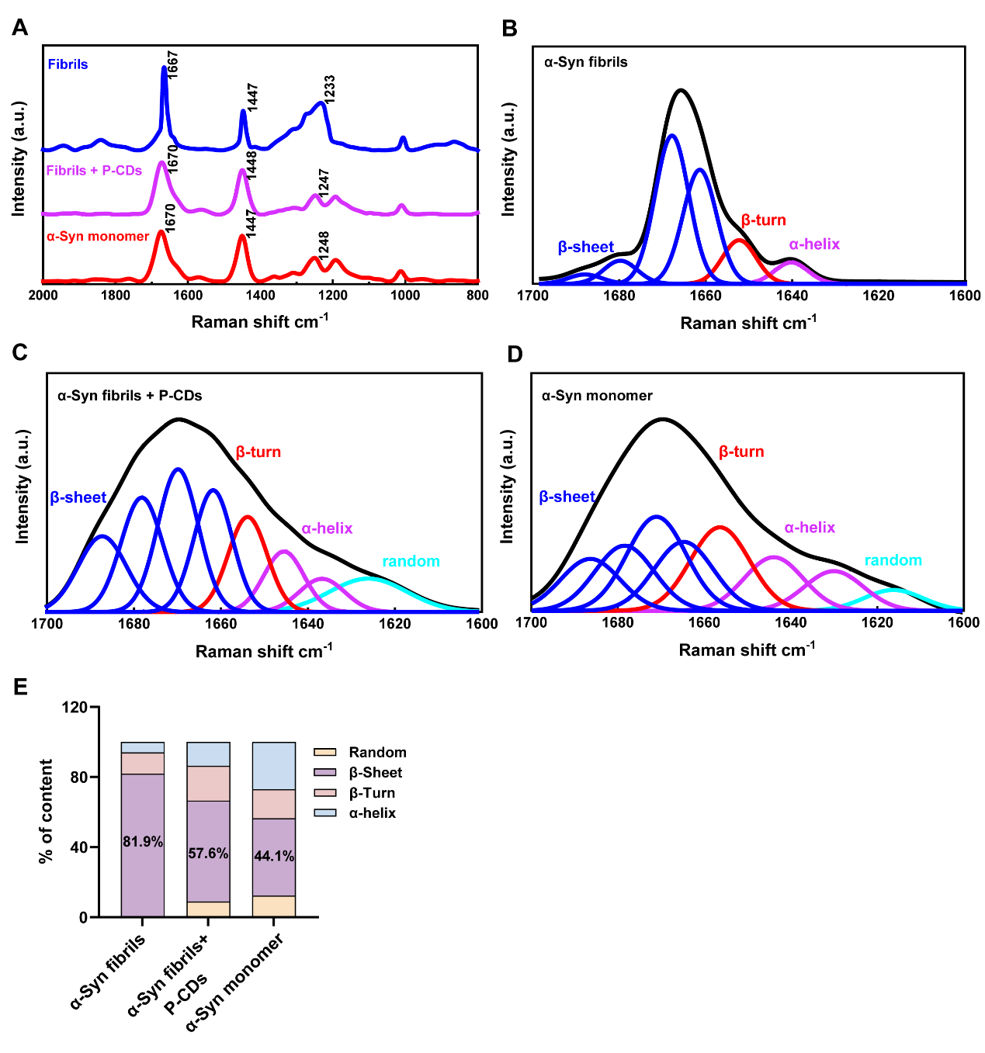
Figure S6. Raman spectroscopy was performed to analyze the structural features of α-syn fibrils after P-CDs treatment. (A) Comparison of spontaneous Raman spectra of α -syn monomers, fibrils and P-CDs treated fibrils solutions. (B) Deconvolution of α-syn fibrils signal in amide I region (1600−1700 cm⁻¹). (C) Deconvolution of α-syn fibrils signal in the presence of P-CDs in amide I region (1600−1700 cm⁻¹). (D) Deconvolution of α-syn monomers signal in amide I region (1600−1700 cm⁻¹). (E) The integral areas of the deconvoluted bands were used to estimate the ratio of these secondary structural components.
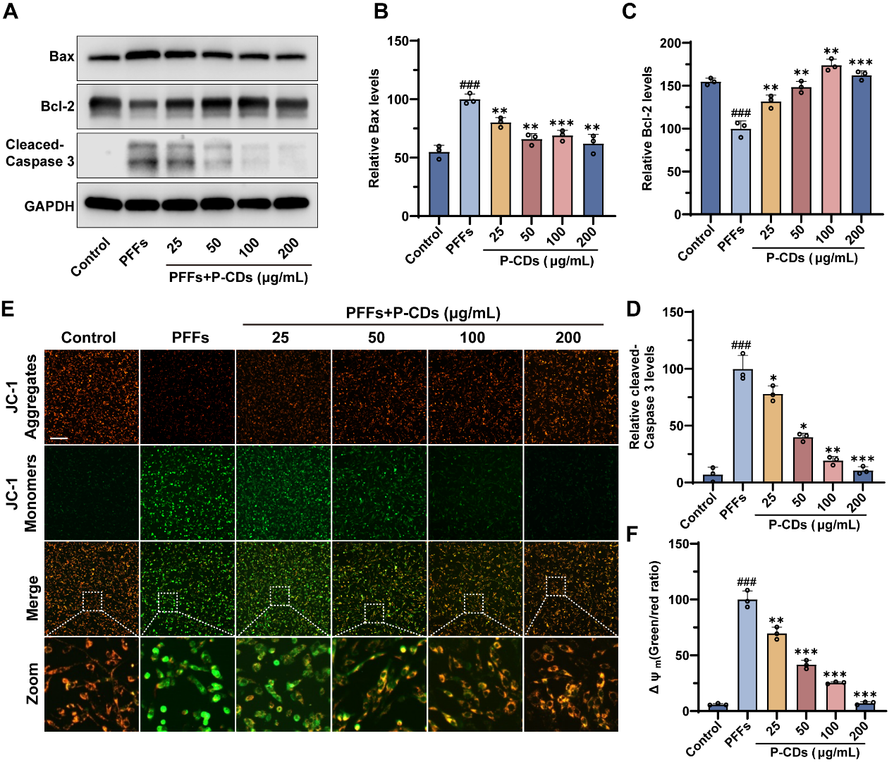
Figure S7. Effect of P-CDs on α-syn PFFs-induced mitochondrial damage and neuronal death in PC12 cells. (A) Western blotting to detect changes in cleaved-Caspase-3, Bcl-2 and Bax protein levels. (B, C, D) Quantification of Bax, Bcl-2, and cleaved-Caspase-3 expression levels. (E) Representative images of PFFs-induced changes in mitochondrial membrane potential in PC12 cells in the presence or absence of P-CDs by JC-1 staining. (Scale bar: 100 μM). (F) Quantitative analysis of mitochondrial membrane potential. Data are expressed as means ± SD. ###P<0.001, vs. control group. *P<0.05, **P<0.01, ***P<0.001, vs. PFFs group.
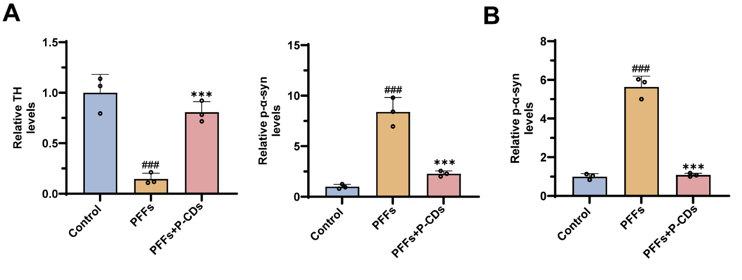
Figure S8. (A) Quantitative analysis of p-α-syn and TH immunostaining micrographs in PC12 cells treated with α-syn PFFs in the absence and presence of P-CDs. (B) Quantitative analysis of p-α-syn immunostaining micrographs in primary neurons treated with α-syn PFFs in the absence and presence of P-CDs.
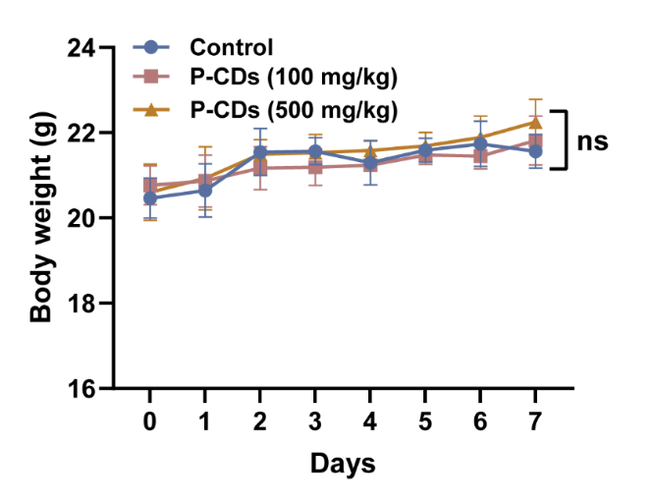
Figure S9. Body weight changes in mice treated with different concentrations of P-CDs.

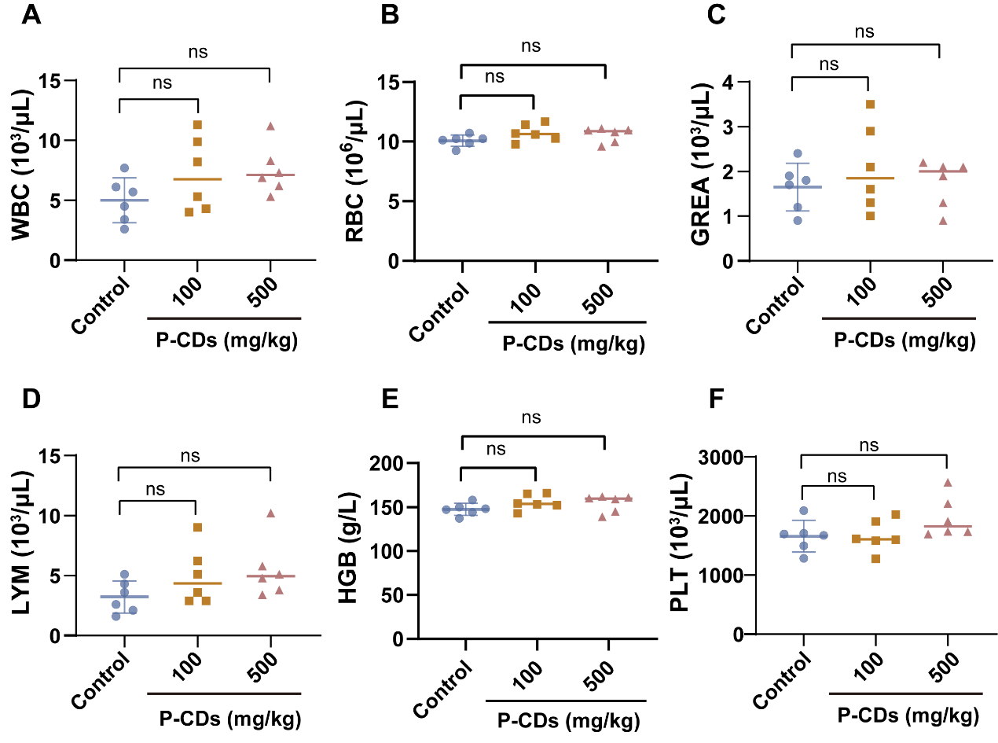
Figure S10. Biosafety evaluation of P-CDs. Routine blood indicators including WBC (A), RBC (B), GREA (C), LYM (D), HGB (E), and PLT (F) in mice following administration of P-CDs for 7 days. The data are expressed as mean ± SD. NS indicates insignificant, n=6.

