Additional file 2 for
Unraveling Rare Codon Bias in Actinomycetota: Lineage-Specific and 5’ Terminal Enrichment Across 1936 Genomes

Anna Rudenko¹, Thomas James Booth¹, Sam Edward Williams¹, Kai Blin¹, Hyun Uk Kim², Tilmann Weber¹, Pep Charusanti^{1*}

¹DTU Biosustain, Technical University of Denmark, Kgs. Lyngby, 2800, Denmark
²Department of Chemical and Biomolecular Engineering, Korea Advanced Institute of Science and Technology, Daejeon, 34141, South Korea

*Corresponding author

Contact Information:
Anna Rudenko: annasve@biosustain.dtu.dk
Thomas James Booth: thobo@biosustain.dtu.dk
Sam Edward Williams: saedwi@biosustain.dtu.dk
Kai Blin: kblin@biosustain.dtu.dk
Hyun Uk Kim: ehukim@kaist.ac.kr
Tilmann Weber: tiwe@biosustain.dtu.dk
Pep Charusanti: pecha@biosustain.dtu.dk

Additional file 2 includes:
Figures S1-S5

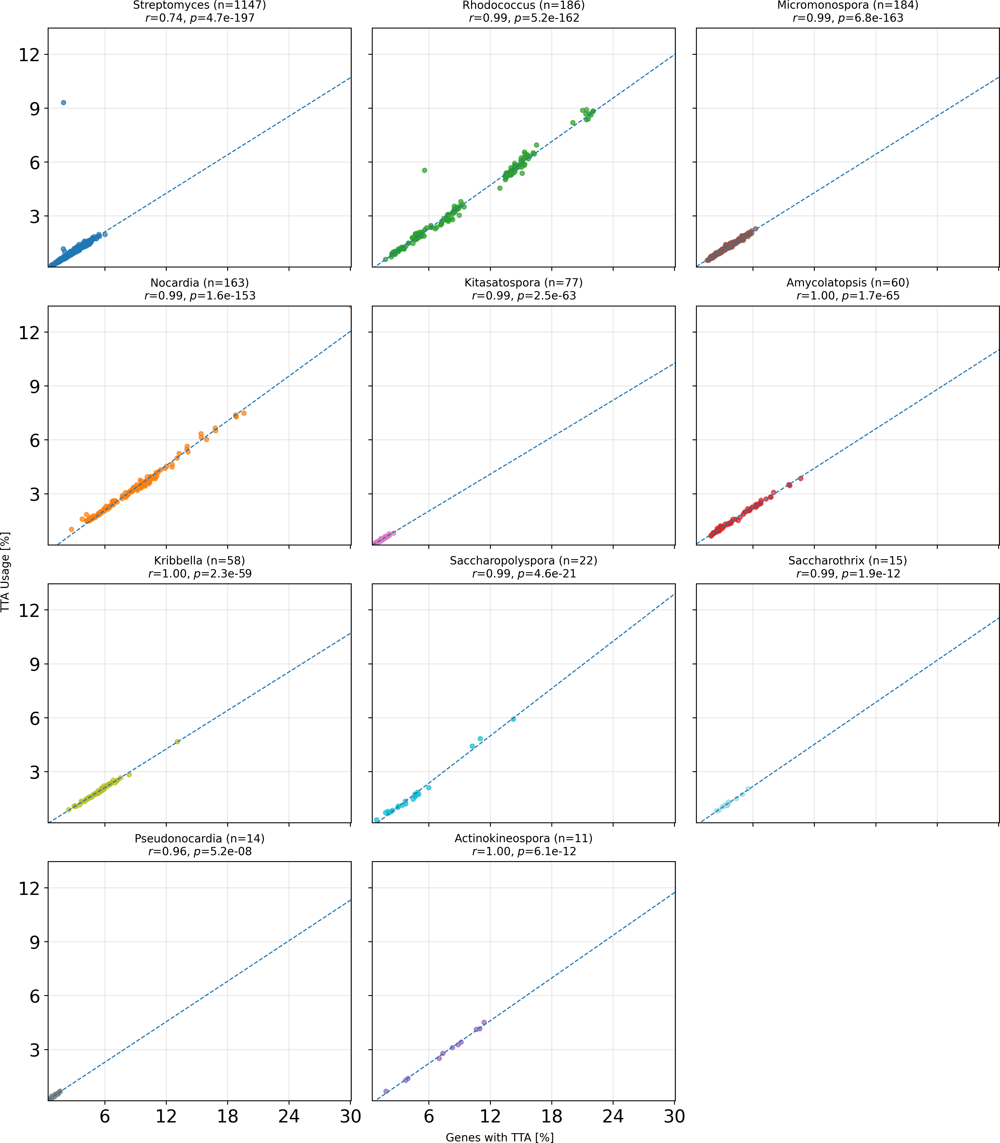
Fig. S1 Comparison of TTA codon usage and gene-level TTA presence across genera. Each panel shows a scatter plot of genomes from a single genus, plotting the percentage of genes that contain at least one TTA codon on the x-axis (“Genes with TTA [%]”) against the total frequency of TTA codon usage across all genes on the y-axis (“TTA Usage [%]”). A linear regression line is shown in dashed style for each genus, with the number of genomes (n), Pearson correlation coefficient (r), and corresponding p-value indicated.

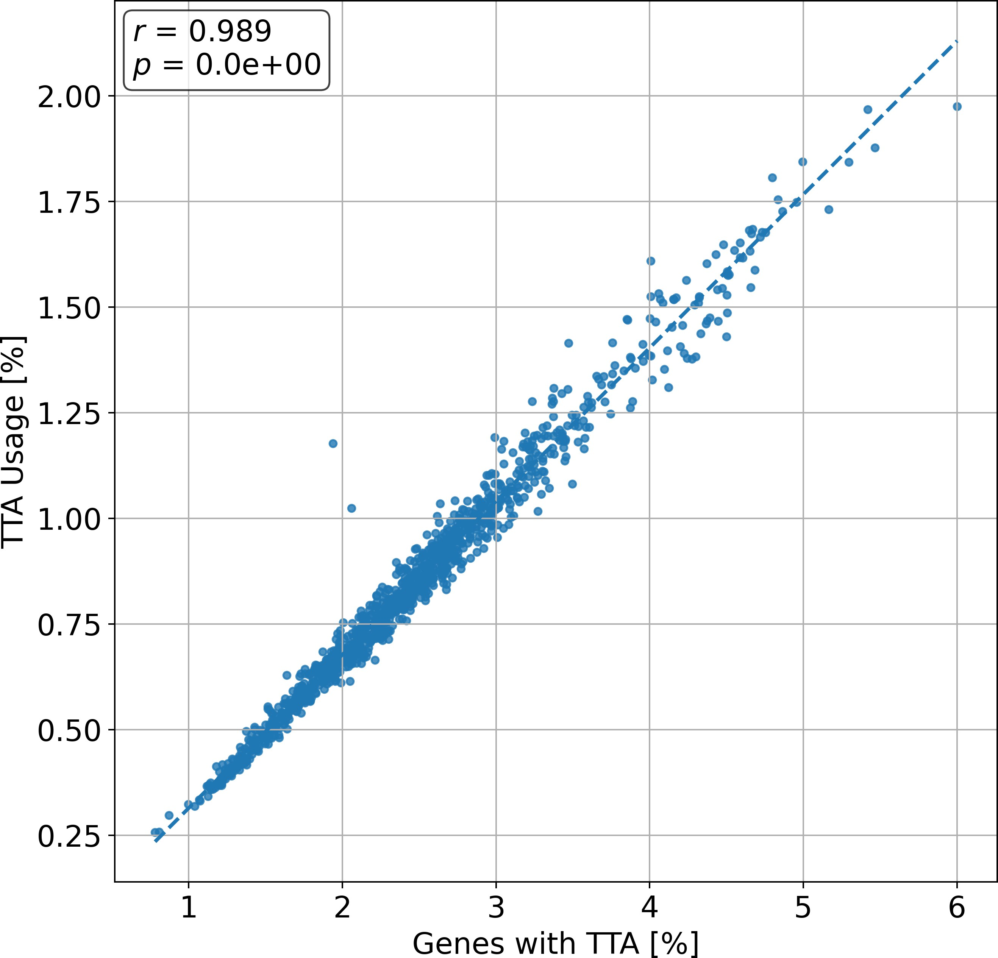
Fig. S2 Relationship between the percentage of genes with TTA codons (” Genes with TTA [%]”) and overall TTA codon usage (” TTA Usage [%]”) in Streptomyces genomes after removal of a single outlier. A linear regression line is shown in dashed style. The number of genomes (n), Pearson correlation coefficient (r), and corresponding p-value are indicated on the plot.

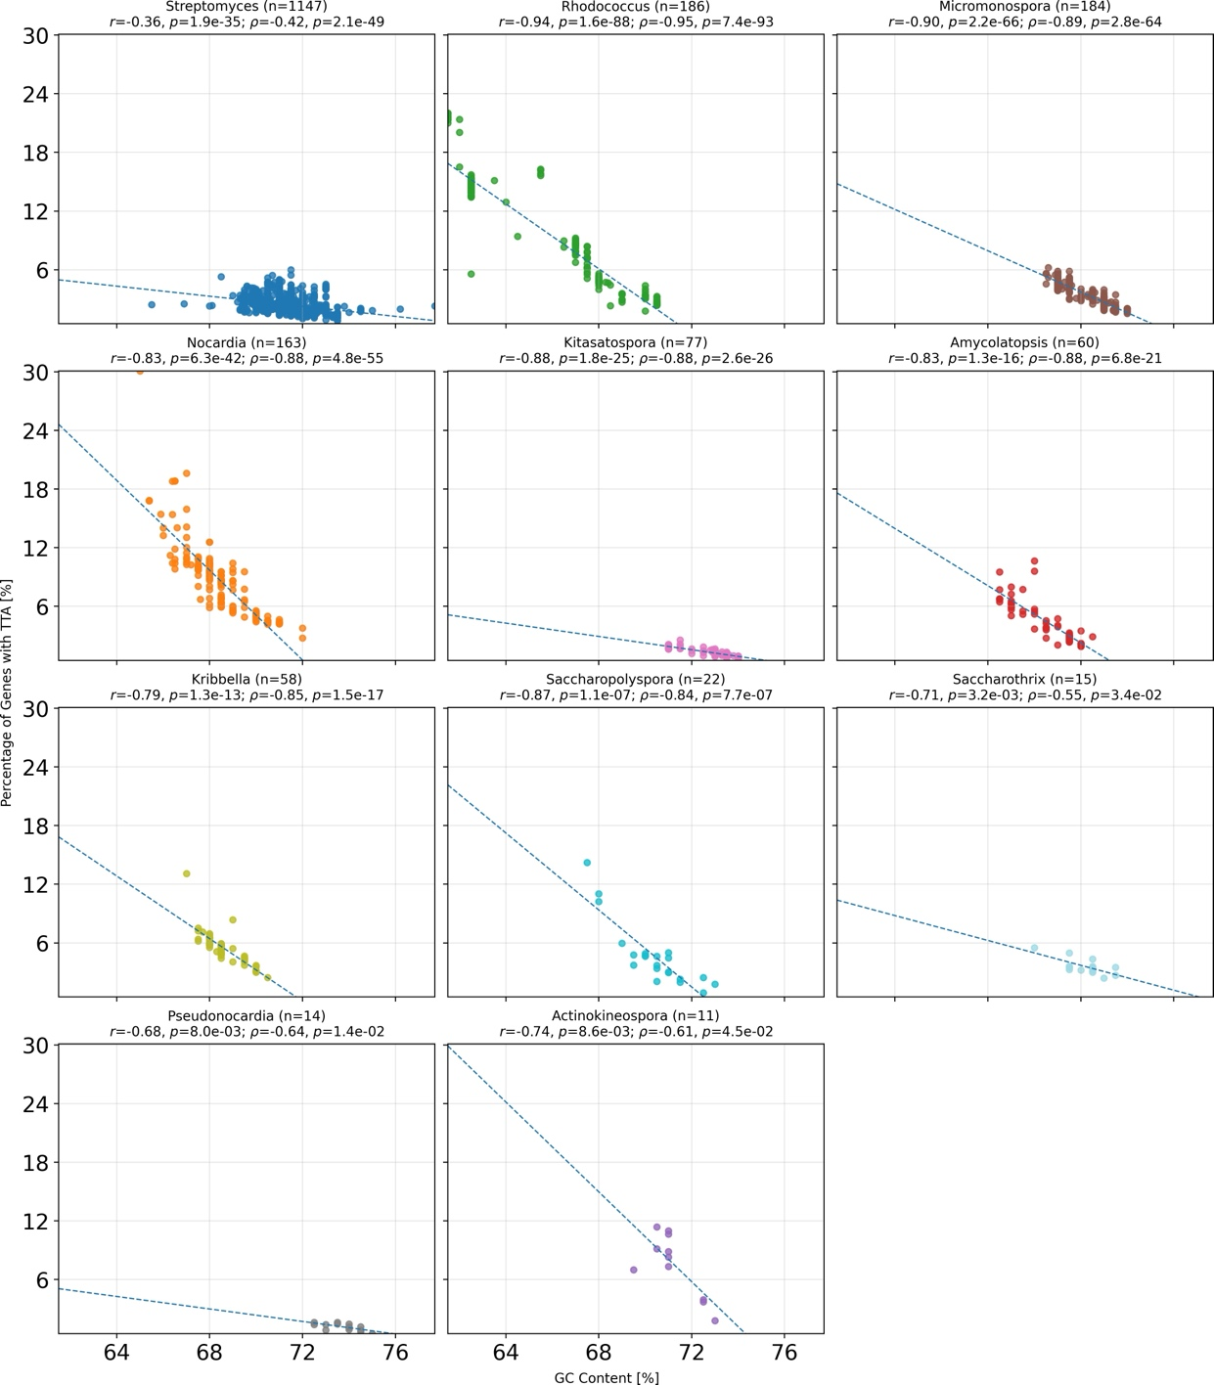
Fig. S3 Relationship between genomic GC content and the percentage of genes containing the TTA codon across Actinobacterial genera. Each panel shows a scatter plot of genomes from a single genus, plotting GC content on the x-axis and the percentage of genes that contain at least one TTA codon on the y-axis. A linear regression line is shown in dashed style for each genus with the number of genomes (n), Pearson correlation coefficient (r), Spearman correlation coefficients (ρ) and corresponding p- values indicated.

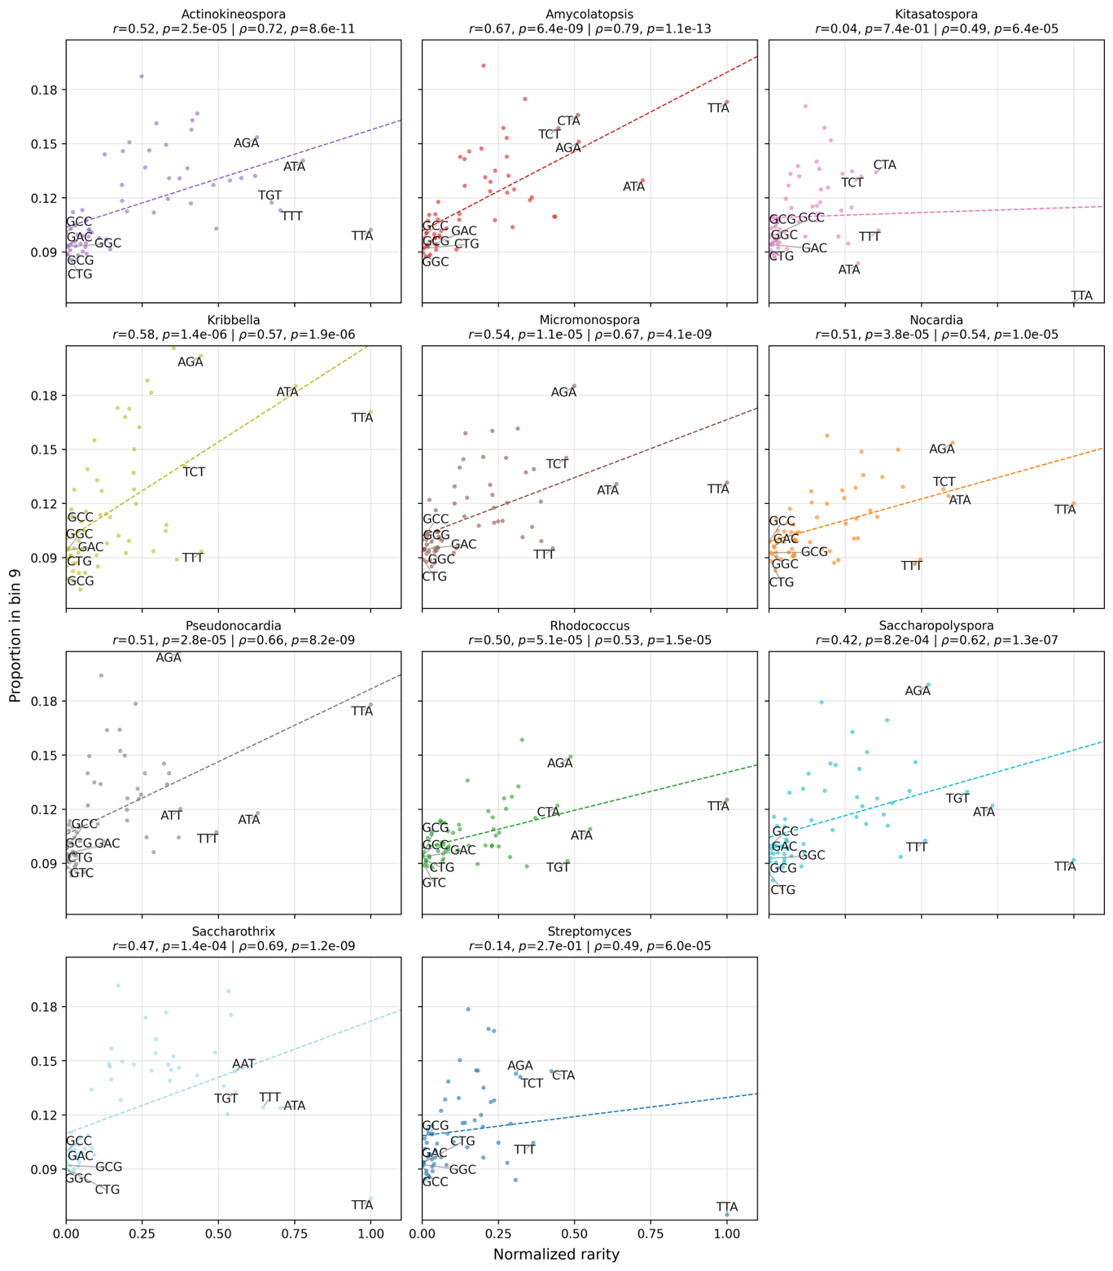
Fig. S4 Pearson and Spearman correlation between normalized codon rarity and bin 9 (gene end) enrichment across genera. Each panel corresponds to a different genus. The x-axis indicates normalized rarity (0–1, with 1 being rarest); the y-axis represents the proportion of each codon found in bin 9. Dashed lines indicate linear regression fits based on Pearson correlation. The five most frequently and five least frequently used codons are labelled.

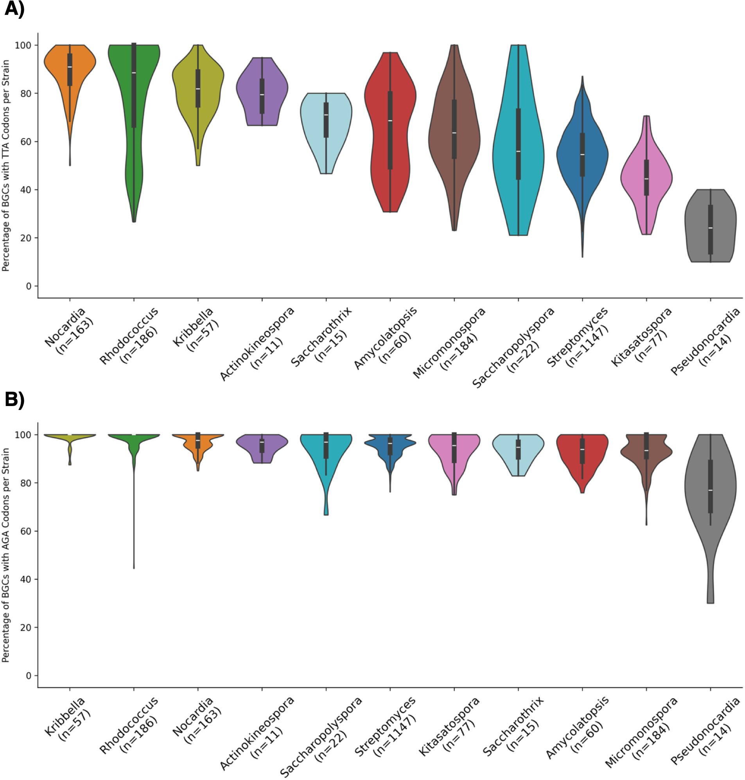

Fig. S5 Presence of TTA and AGA codons in BGCs. A) Percentage of BGCs per strain that contain at least one TTA codon. B) Percentage of BGCs per strain that contain at least one AGA codon. In both panels, data are grouped by genus and labeled with sample size (n). The black bar in the center represents the interquartile range (IQR), and the white dot indicates the median.

