Supplementary figures
Supplementary figure 1
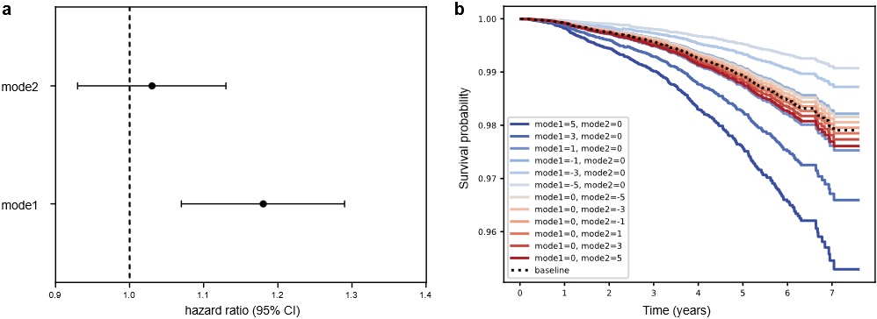
The survival analysis results of the two brain structural modes. a. Hazard ratio results of survival analysis. The widths of the lines extending from the center points represent 95% CI. b. Survival curves for the two brain structural modes. Keeping one brain mode unchanged, we divided the subjects into 6 groups based on the other brain mode scores (-5, -3, -1, 1, 3, and 5), and observed how the survival varies for the 6 group subjects compared to their baseline function. All these models were adjusted for age and sex.

Supplementary figure 2
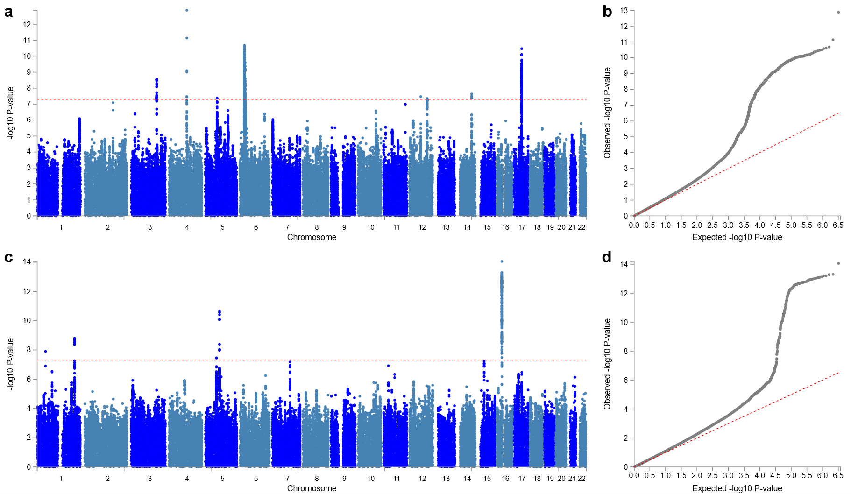
Manhattan and quantile-quantile plots from the GWAS analyses of the two brain structural modes. a, c. Manhattan plots from the GWAS analyses of brain mode 1 (a) and brain mode 2 (c). The horizontal red line represents the threshold for genome-wide significance ($P=5×{10}^{-8}$). b, d. Quantile-quantile plots from the GWAS analyses of brain mode 1 (b) and brain mode 2 (d).

Supplementary figure 3
Manhattan plots from the GWAS analyses of the two mental health modes and their primary MHQ subcategories. a, b. Manhattan plots from the GWAS analyses of mental health mode 1 (a) and trauma (b). c, d. Manhattan plots from the GWAS analyses of mental health mode 2 (c) and mental distress (d). The horizontal red line represents the threshold for genome-wide significance ($P=5×{10}^{-8}$).

Supplementary figure 4
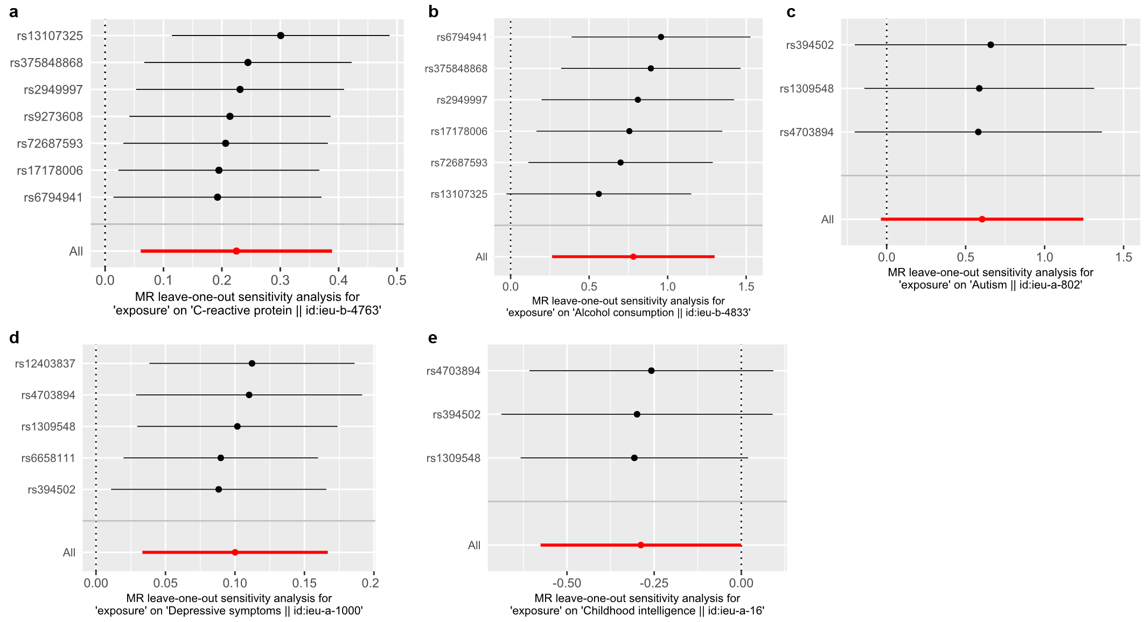
Leave-one-out sensitivity analysis of genetic causal effects. a, b. Leave-one-out tests of genetic causal effects from brain mode 1 to C-reactive protein (a) and alcohol consumption (b). c, d, e. Leave-one-out tests of genetic causal effects from brain mode 2 to ASD (c), depressive symptoms (d), and childhood intelligence (e).

