# | Penaeidae species | 1 | 2 | 3 | 4 | 5 | 6 | 7 | 8 | 9 | 10 | 11 | 12 | 13 | 14 | 15 | 16 | 17 | 18 | 19 | 20 | 21 | 22 | 23 | 24 | 25 | 26 | 27 | 28
1 | P_monodon_Atl_Oc |  | 5.9 | 6.6 | 8.7 | 29.1 | 31.2 | 36.1 | 40.0 | 43.4 | 41.1 | 34.2 | 36.9 | 27.3 | 32.7 | 30.7 | 36.5 | 37.7 | 36.6 | 37.3 | 40.1 | 39.2 | 41.9 | 31.4 | 53.4 | 38.6 | 33.1 | 32.6 | 84.7
2 | P_monodon_Pac_Oc | 0.059 |  | 6.0 | 6.3 | 29.5 | 31.5 | 35.7 | 41.9 | 47.6 | 46.9 | 37.5 | 36.7 | 27.9 | 33.5 | 31.0 | 35.1 | 38.4 | 37.5 | 40.0 | 40.8 | 41.6 | 42.5 | 31.4 | 54.2 | 37.4 | 32.1 | 33.7 | 84.7
3 | P_monodon_Ind_Oc | 0.066 | 0.060 |  | 4.7 | 29.8 | 31.6 | 35.4 | 43.1 | 50.1 | 50.4 | 39.6 | 36.4 | 28.3 | 34.0 | 31.1 | 34.2 | 38.7 | 38.1 | 41.7 | 41.2 | 43.0 | 42.6 | 31.4 | 54.7 | 36.7 | 31.4 | 34.3 | 84.5
4 | P_monodon_Aquac | 0.087 | 0.063 | 0.047 |  | 31.1 | 32.5 | 35.1 | 46.7 | 56.5 | 60.4 | 45.6 | 36.6 | 29.4 | 35.9 | 31.6 | 32.3 | 40.2 | 39.8 | 46.7 | 42.8 | 47.2 | 43.5 | 32.0 | 57.6 | 35.2 | 29.9 | 36.3 | 86.1
5 | P_semisulcatus_Pac_Oc | 0.291 | 0.295 | 0.298 | 0.311 |  | 5.0 | 21.6 | 36.1 | 48.5 | 41.4 | 33.9 | 35.9 | 33.4 | 31.3 | 37.1 | 35.8 | 43.9 | 44.8 | 45.7 | 37.3 | 42.9 | 39.0 | 44.1 | 41.8 | 44.6 | 38.8 | 35.1 | 67.6
6 | P_semisulcatus_Ind_Oc | 0.312 | 0.315 | 0.316 | 0.325 | 0.050 |  | 18.6 | 36.2 | 46.3 | 42.6 | 31.2 | 33.9 | 35.6 | 30.5 | 35.9 | 33.9 | 40.3 | 40.9 | 55.1 | 38.6 | 46.7 | 38.6 | 35.5 | 44.0 | 37.4 | 33.7 | 34.5 | 66.3
7 | P_semisulcatus_Arab_Pen | 0.361 | 0.357 | 0.354 | 0.351 | 0.216 | 0.186 |  | 39.4 | 54.1 | 49.6 | 33.5 | 35.5 | 38.7 | 44.2 | 37.8 | 35.4 | 39.3 | 41.6 | 61.8 | 41.7 | 59.4 | 51.5 | 41.3 | 46.3 | 39.3 | 34.4 | 36.3 | 62.6
8 | L_vannamei | 0.400 | 0.419 | 0.431 | 0.467 | 0.361 | 0.362 | 0.394 |  | 29.6 | 22.5 | 32.5 | 35.3 | 33.2 | 31.1 | 38.0 | 38.4 | 41.8 | 46.3 | 58.6 | 48.0 | 48.6 | 43.9 | 47.8 | 55.9 | 56.0 | 45.8 | 42.3 | 83.7
9 | L_setiferus | 0.434 | 0.476 | 0.501 | 0.565 | 0.485 | 0.463 | 0.541 | 0.296 |  | 6.5 | 30.1 | 45.4 | 36.9 | 39.1 | 47.9 | 38.4 | 45.4 | 36.8 | 31.1 | 45.9 | 43.9 | 53.0 | 55.0 | 42.0 | 39.8 | 43.5 | 38.2 | 79.3
10 | L_schmitti | 0.411 | 0.469 | 0.504 | 0.604 | 0.414 | 0.426 | 0.496 | 0.225 | 0.065 |  | 25.6 | 37.8 | 31.4 | 33.9 | 35.0 | 35.2 | 44.2 | 33.2 | 30.4 | 44.7 | 35.8 | 47.4 | 55.7 | 41.8 | 44.7 | 40.6 | 35.7 | 67.5
11 | F_duorarum | 0.342 | 0.375 | 0.396 | 0.456 | 0.339 | 0.312 | 0.335 | 0.325 | 0.301 | 0.256 |  | 20.5 | 17.7 | 18.6 | 24.1 | 22.0 | 28.1 | 49.3 | 45.2 | 48.2 | 47.5 | 46.1 | 42.9 | 40.3 | 40.2 | 32.0 | 39.4 | 65.5
12 | F_californiensis | 0.369 | 0.367 | 0.364 | 0.366 | 0.359 | 0.339 | 0.355 | 0.353 | 0.454 | 0.378 | 0.205 |  | 15.3 | 17.7 | 20.2 | 6.2 | 23.1 | 60.7 | 65.6 | 59.2 | 55.5 | 49.9 | 35.7 | 52.6 | 35.3 | 28.0 | 36.5 | 73.1
13 | F_isabelae | 0.273 | 0.279 | 0.283 | 0.294 | 0.334 | 0.356 | 0.387 | 0.332 | 0.369 | 0.314 | 0.177 | 0.153 |  | 6.1 | 9.4 | 12.7 | 14.2 | 50.9 | 53.6 | 54.7 | 47.2 | 45.9 | 41.1 | 40.6 | 38.4 | 27.2 | 36.7 | 79.6
14 | F_subtilis | 0.327 | 0.335 | 0.340 | 0.359 | 0.313 | 0.305 | 0.442 | 0.311 | 0.391 | 0.339 | 0.186 | 0.177 | 0.061 |  | 12.9 | 16.8 | 18.8 | 58.4 | 57.7 | 60.7 | 51.4 | 41.9 | 45.8 | 37.8 | 33.1 | 27.9 | 37.6 | 82.9
15 | F_paulensis | 0.307 | 0.310 | 0.311 | 0.316 | 0.371 | 0.359 | 0.378 | 0.380 | 0.479 | 0.350 | 0.241 | 0.202 | 0.094 | 0.129 |  | 16.7 | 17.7 | 63.8 | 70.2 | 76.0 | 57.1 | 65.7 | 47.0 | 50.1 | 49.5 | 39.2 | 52.2 | 89.1
16 | F_brasiliensis | 0.365 | 0.351 | 0.342 | 0.323 | 0.358 | 0.339 | 0.354 | 0.384 | 0.384 | 0.352 | 0.220 | 0.062 | 0.127 | 0.168 | 0.167 |  | 19.6 | 60.2 | 63.2 | 61.2 | 62.3 | 47.3 | 43.3 | 58.3 | 34.0 | 29.0 | 46.1 | 67.0
17 | F_aztecus | 0.377 | 0.384 | 0.387 | 0.402 | 0.439 | 0.403 | 0.393 | 0.418 | 0.454 | 0.442 | 0.281 | 0.231 | 0.142 | 0.188 | 0.177 | 0.196 |  | 66.2 | 73.3 | 62.6 | 63.1 | 53.6 | 45.8 | 52.2 | 42.8 | 40.4 | 47.8 | 90.1
18 | P_murrayi | 0.366 | 0.375 | 0.381 | 0.398 | 0.448 | 0.409 | 0.416 | 0.463 | 0.368 | 0.332 | 0.493 | 0.607 | 0.509 | 0.584 | 0.638 | 0.602 | 0.662 |  | 21.5 | 6.1 | 22.1 | 39.7 | 47.0 | 38.0 | 36.3 | 33.0 | 33.4 | 55.8
19 | Par_longirostris | 0.373 | 0.400 | 0.417 | 0.467 | 0.457 | 0.551 | 0.618 | 0.586 | 0.311 | 0.304 | 0.452 | 0.656 | 0.536 | 0.577 | 0.702 | 0.632 | 0.733 | 0.215 |  | 20.8 | 7.3 | 41.8 | 58.8 | 44.5 | 47.4 | 49.2 | 40.3 | 73.3
20 | Par_investigatoris | 0.401 | 0.408 | 0.412 | 0.428 | 0.373 | 0.386 | 0.417 | 0.480 | 0.459 | 0.447 | 0.482 | 0.592 | 0.547 | 0.607 | 0.760 | 0.612 | 0.626 | 0.061 | 0.208 |  | 18.1 | 35.5 | 46.8 | 33.6 | 44.0 | 35.7 | 42.0 | 50.2
21 | Par_americanus | 0.392 | 0.416 | 0.430 | 0.472 | 0.429 | 0.467 | 0.594 | 0.486 | 0.439 | 0.358 | 0.475 | 0.555 | 0.472 | 0.514 | 0.571 | 0.623 | 0.631 | 0.221 | 0.073 | 0.181 |  | 43.9 | 51.6 | 44.7 | 53.5 | 54.4 | 29.5 | 53.4
22 | Mel_latisulcatus | 0.419 | 0.425 | 0.426 | 0.435 | 0.390 | 0.386 | 0.515 | 0.439 | 0.530 | 0.474 | 0.461 | 0.499 | 0.459 | 0.419 | 0.657 | 0.473 | 0.536 | 0.397 | 0.418 | 0.355 | 0.439 |  | 40.8 | 29.7 | 41.7 | 37.9 | 47.4 | 81.4
23 | Mel_kerathurus | 0.314 | 0.314 | 0.314 | 0.320 | 0.441 | 0.355 | 0.413 | 0.478 | 0.550 | 0.557 | 0.429 | 0.357 | 0.411 | 0.458 | 0.470 | 0.433 | 0.458 | 0.470 | 0.588 | 0.468 | 0.516 | 0.408 |  | 33.0 | 36.1 | 35.9 | 41.4 | 79.3
24 | Mel_japonicus | 0.534 | 0.542 | 0.547 | 0.576 | 0.418 | 0.440 | 0.463 | 0.559 | 0.420 | 0.418 | 0.403 | 0.526 | 0.406 | 0.378 | 0.501 | 0.583 | 0.522 | 0.380 | 0.445 | 0.336 | 0.447 | 0.297 | 0.330 |  | 46.9 | 45.8 | 39.4 | 87.7
25 | Fen_penicillatus | 0.386 | 0.374 | 0.367 | 0.352 | 0.446 | 0.374 | 0.393 | 0.560 | 0.398 | 0.447 | 0.402 | 0.353 | 0.384 | 0.331 | 0.495 | 0.340 | 0.428 | 0.363 | 0.474 | 0.440 | 0.535 | 0.417 | 0.361 | 0.469 |  | 6.5 | 29.8 | 87.4
26 | Fen_merguiensis | 0.331 | 0.321 | 0.314 | 0.299 | 0.388 | 0.337 | 0.344 | 0.458 | 0.435 | 0.406 | 0.320 | 0.280 | 0.272 | 0.279 | 0.392 | 0.290 | 0.404 | 0.330 | 0.492 | 0.357 | 0.544 | 0.379 | 0.359 | 0.458 | 0.065 |  | 26.6 | 72.1
27 | Fen_indicus | 0.326 | 0.337 | 0.343 | 0.363 | 0.351 | 0.345 | 0.363 | 0.423 | 0.382 | 0.357 | 0.394 | 0.365 | 0.367 | 0.376 | 0.522 | 0.461 | 0.478 | 0.334 | 0.403 | 0.420 | 0.295 | 0.474 | 0.414 | 0.394 | 0.298 | 0.266 |  | 65.5
28 | Euphasia_longirostris | 0.847 | 0.847 | 0.845 | 0.861 | 0.676 | 0.663 | 0.626 | 0.837 | 0.793 | 0.675 | 0.655 | 0.731 | 0.796 | 0.829 | 0.891 | 0.670 | 0.901 | 0.558 | 0.733 | 0.502 | 0.534 | 0.814 | 0.793 | 0.877 | 0.874 | 0.721 | 0.655
Supplement 1. Genetic divergence (upper: percentage, lower: distance) for penaeids species using the gene COI. Yellow: intraspecific divergence and blue: interspecific divergence

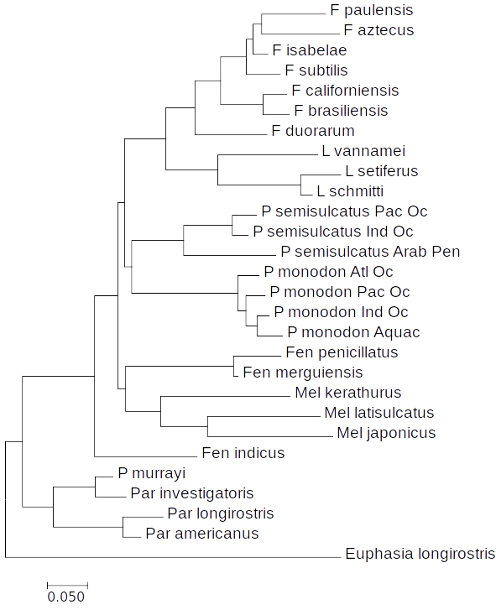
Neighbor joining method summarizing genetic divergence relationships

