Appendix 1:
Online Behavior Questions: (OBQ)

- How old were you when you received your first smartphone?
- Please estimate the number of hours a day that you spend in all sorts of online activities (writing and talking to friends, gaming, watching clips, movies, Netflix, Youtube, Studying, etc.,):
- 1-3 hours a day.
- 4-5 hours a day.
- 6-7 hours a day.
- More than 8 hours a day.
- Mark the two online activities that you use the most:
a. Writing or talking to friends on social media (WhatsApp, Instagram, TikTok, etc,).
b. Creative activities: Drafts, DIY, cooking, drawing, etc.
c. Listening to music.
d. Playing games: Candy Crash, Roblox, Fortnite, Minecraft, etc.
e. Watching video clips, movies, or TV series.
f. Scrolling (being updated on my friends' profile, just scrolling around, etc.).
g. Content creation: posts, pics, Youtube, clips, etc.
- How does the following correspondence make you feel*?
a. it is funny.
b. I don’t really care.
c. it makes me feel uncomfortable.
d. it makes me feel sad.
e. it makes me feel angry.
- How do you think you would react if you were part of this correspondence*?
a. I would write something funny about it.
b. I would laugh about it.
c. I would ignore it.
d. I would report it or ask for help.
e. I would try and help the girl.
- How often have you been exposed to content like this toward other people in the past*?
a. Not at all.
b. Rarely.
c. Sometimes.
d. Often.
e. All the time.
- How many hours a day (weekends excluded) do you use each of the following online categories:
- General time in online activities.
- Writing or talking to friends on social media (WhatsApp, Instagram, TikTok, etc,).
- Listening to music.
- Watching video clips, movies, or TV series.
- Scrolling (being updated on my friends' profile, just scrolling around, etc.).
- Playing games: candy crash, Roblox, Fortnite, Minecraft, etc.
- Creative activities: Drafts, DIY, cooking, drawing, etc.
- How often are you exposed to unpleasant online content toward someone whom you are familiar with?
a. Not at all.
b. Rarely.
c. Sometimes.
d. Often.
e. All the time.
- To what extent do you agree with the following statements
9a. I share everything about my online activities, with my parents:
- I strongly agree.
- I agree.
- I partly agree.
- I disagree.
- I strongly disagree.
9b. In our house there are clear rules about internet uses and social media communication:
- I strongly agree.
- I agree.
- I partly agree.
- I disagree.
- I strongly disagree.
9c. If something bad happens to me online, I turn to my parents for help:
- I strongly agree.
- I agree.
- I partly agree.
- I disagree.
- I strongly disagree.
9d. My parents make sure they always know what I'm doing online:
- I strongly agree.
- I agree.
- I partly agree.
- I disagree.
- I strongly disagree.
9e. My parents supervise the time and the content I consume online:
- I strongly agree.
- I agree.
- I partly agree.
- I disagree.
- I strongly disagree.
- How often are you exposed to you exposed to online troubling, weird, scary content(or any other unpleasant content?
a. Not at all.
b. Rarely.
c. Sometimes.
d. Often.
e. All the time.
- How does the following correspondence make you feel**?
a. it is funny.
b. I don’t really care.
c. it makes me feel uncomfortable.
d. it makes me feel sad.
e. it makes me feel angry.
- How do you think you would react if you were part of this correspondence**?
a. I would write something funny about it.
b. I would laugh about it.
c. I would ignore it.
d. I would report it or ask for help.
e. I would try and help the girl.
- How often have you been exposed to content like this toward other people in the past**?
a. Not at all.
b. Rarely.
c. Sometimes.
d. Often.
e. All the time.
- What do you think is the right thing to do if something troubling is happening online? (e.g.: someone hurting someone else, scary content distributed, etc.)
a. to write something funny about it.
b. to laugh about it.
c. to ignore it.
d. to report it or ask for help.
e. to try and help the person.
- How does the following correspondence make you feel***?
a. it is funny.
b. I don’t really care.
c. it makes me feel uncomfortable.
d. it makes me feel sad.
e. it makes me feel angry.
- How do you think you would react if you were part of this correspondence***?
a. I would write something funny about it.
b. I would laugh about it.
c. I would ignore it.
d. I would report it or ask for help.
e. I would try and help the girl.
- How often have you been exposed to content like this toward other people in the past***?
a. Not at all.
b. Rarely.
c. Sometimes.
d. Often.
e. All the time.
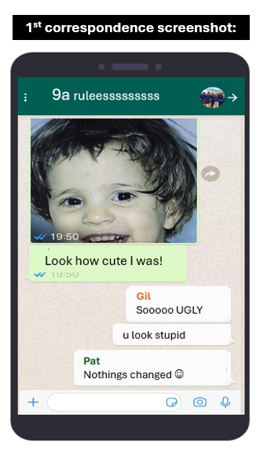
Appendix 2: Correspondence screenshots:

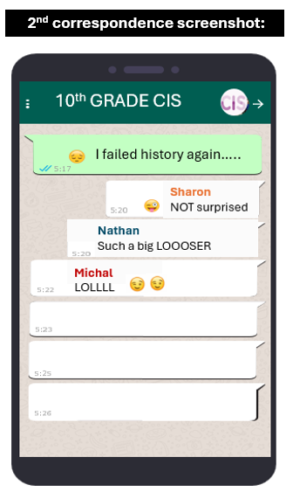

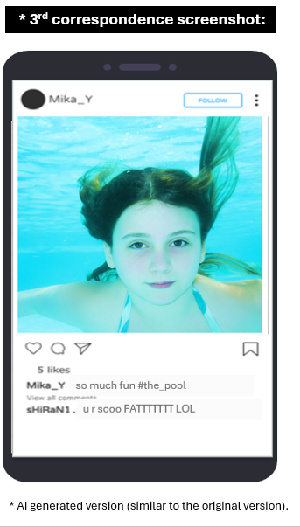

Table 1:

Schwartz's Values, Defining Goals, and Motivations

