Appendix

8.1. Supplementary figures
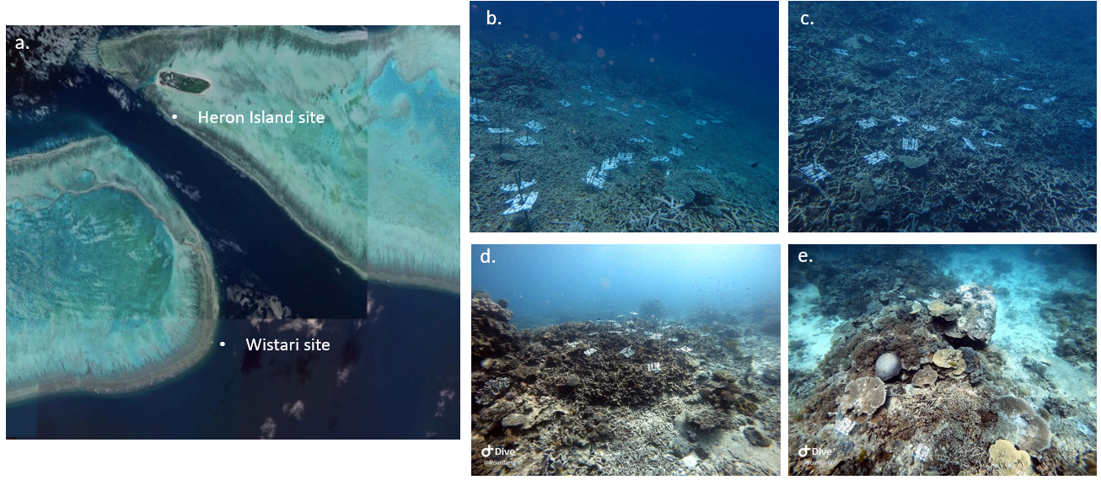
Figure 1. Fieldwork sites: a) Heron Island Reef and Wistari Reef; b) the loose rubble bed located at the Heron Reef site; c) the interlocked rubble bed located at the Heron Reef site; d) the interlocked rubble bed located at the Wistari Reef site; e) the hard carbonate reef located at the Wistari Reef site.
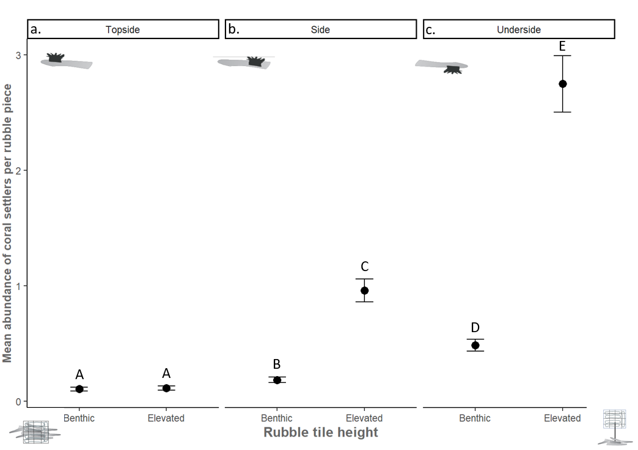
Figure 2. Coral settler abundance (mean ± SE) per rubble piece on either the benthic or elevated tiles concerning the rubble piece microhabitat a) topside, b) side, and c) underside, averaged across both rubble habitats (loose and interlocked) at Heron Reef.
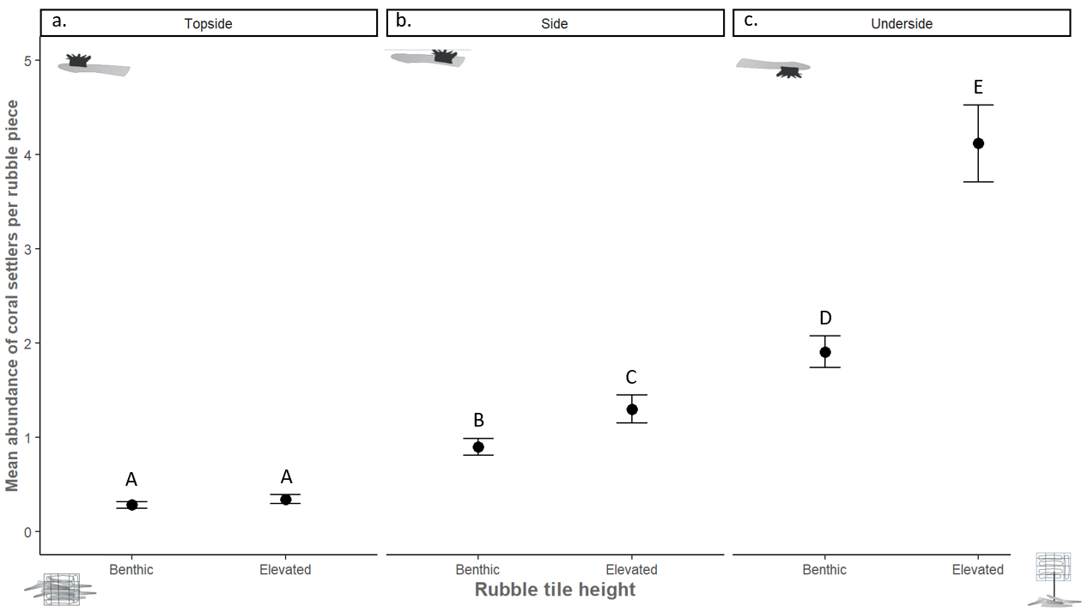Figure 3. Coral settler abundance (mean ± SE) per rubble piece on either the benthic or elevated tiles concerning the rubble piece microhabitat a) topside, b) side, and c) underside, averaged across both substrate habitats (interlocked and hard carbonate reef) at Wistari Reef.
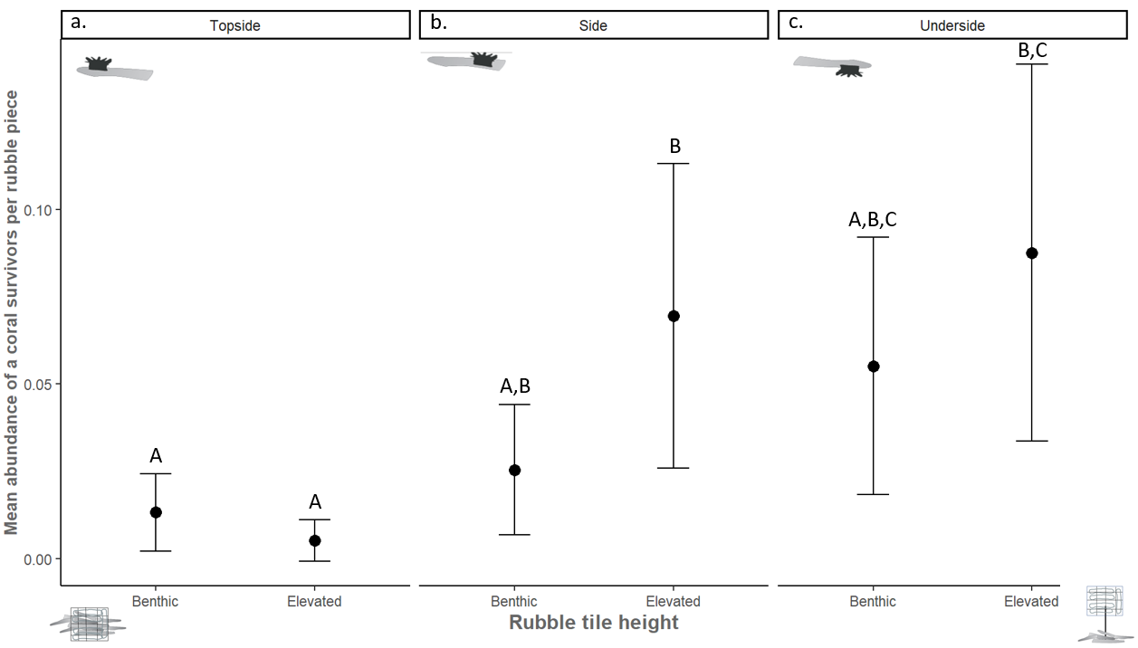
Figure 4. Coral recruitment abundance (mean ± SE) on the microhabitats of a rubble piece: a) topside, b) side, and c) underside, on benthic and elevated tiles, 12 months post-deployment; averaged across the loose and interlocked rubble bed of Heron Reef.
Figure 5. Coral settlement (mean ± SE) across the three microhabitats of a rubble piece: a) topside, b) side, and c) underside, on benthic and elevated tiles, averaged across the interlocked rubble bed and hard carbonate reef of Wistari Reef.

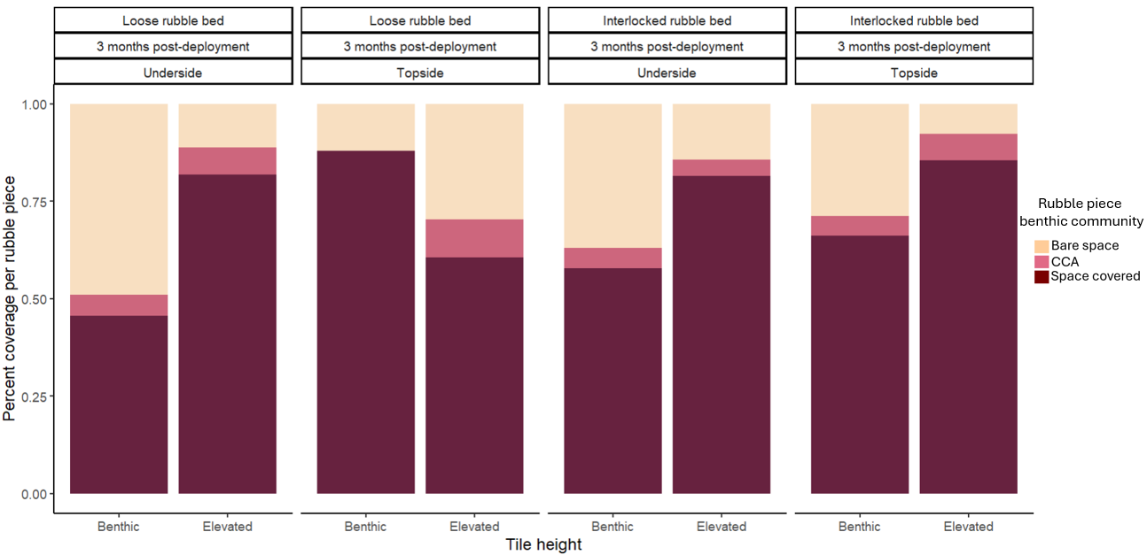
Figure 6. The percentage of space colonised by rubble-encrusting organisms: bare space, CCA, and competitors on the rubble pieces comprising the undersides and topsides of benthic and elevated tiles in the loose and interlocked rubble beds at three months post-deployment on Heron Reef.
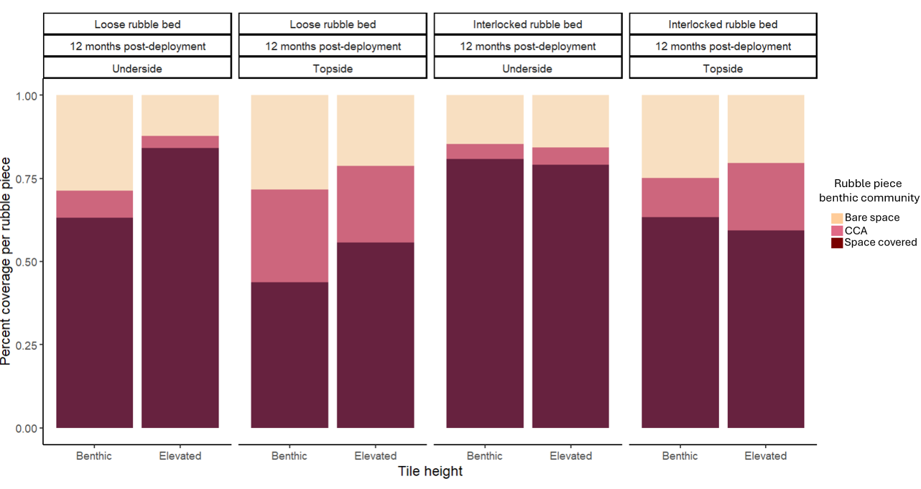Figure 7. The percentage of space colonised by rubble-encrusting organisms: bare space, CCA, and competitors on the rubble pieces comprising the undersides and topsides of benthic and elevated tiles in the loose and interlocked rubble beds at 12 months post-deployment on Heron Reef.
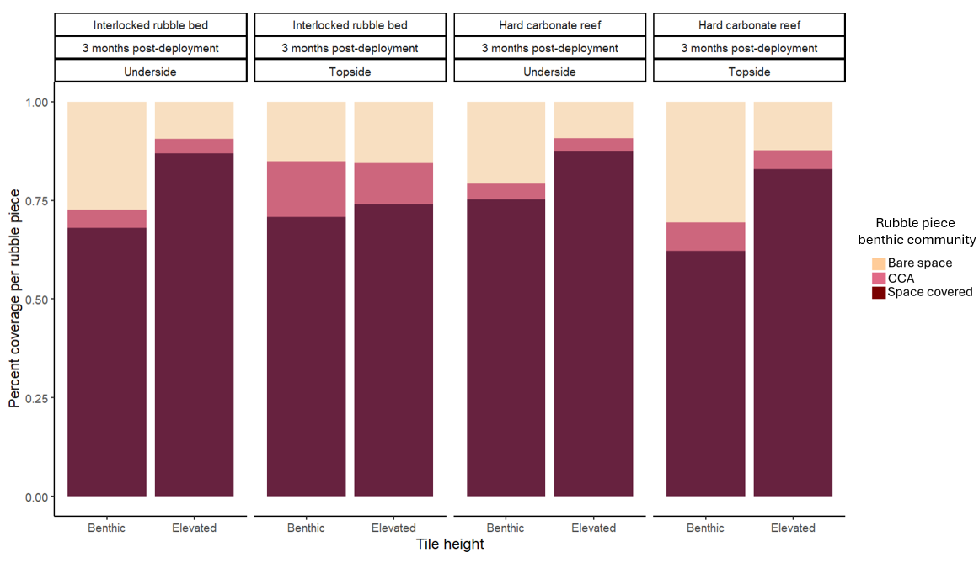Figure 8. The percentage of space colonised by rubble encrusting organisms: bare space, CCA, and competitors on the rubble pieces comprising the undersides and topsides of benthic and elevated tiles in the interlocked rubble bed and hard carbonate reef at three months post-deployment on Wistari Reef

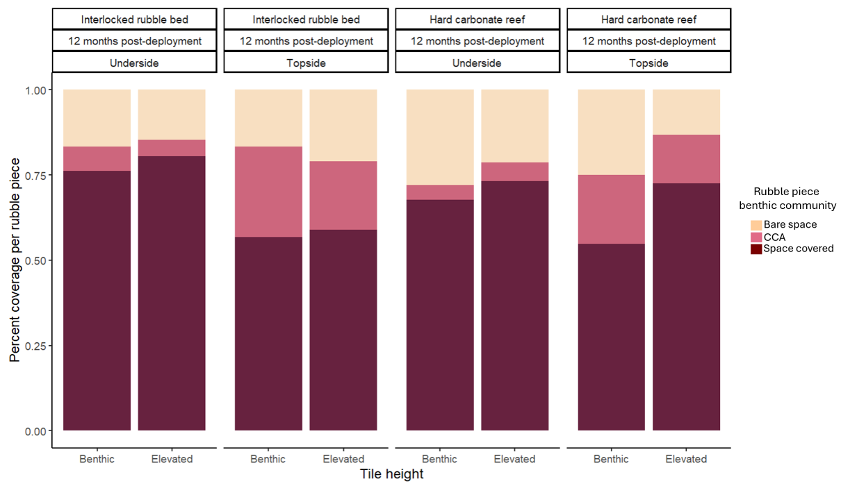
Figure 9. The percentage of space colonised by rubble-encrusting organisms: bare space, CCA, and competitors on the rubble pieces comprising the undersides and topsides of benthic and elevated tiles in the interlocked rubble bed and hard carbonate reef at 12 months post-deployment on Wistari Reef.
Table 1. Pair-wise test analysis of the difference in the composition of the rubble encrusting community per rubble piece as a response to the 3-way interaction of (rubble substrate x tile height x time of deployment) concerning timepoint at 12 months-post-deployment and/or concerning the elevated tiles in the loose and interlocked rubble bed of Heron Reef. Where a significant difference in the encrusting community occurs between the interaction and specific variable is denoted with an asterisk (*) and in bold under the P-value column. The column furthest to the right includes results from the SIMPER analysis for each Pair-wise significant interaction. Given from top to bottom in this column is the rubble encrusting category that drove the difference in the composition of the community, the tile height, time of deployment, or substrate habitat where the greater average abundance of said rubble encrusting category occurred and the contribution of said rubble encrusting category driving the difference in the composition.
PAIR-WISE TEST
3 WAY INTERACTION x Tile height
Loose rubble bed | Benthic Vs. Elevated tiles | 12 months post-deployment | 0.001* | Bare space  Higher on benthic  Contribution: 38.5%
Interlocked rubble bed | Benthic Vs. Elevated tiles | 12 months post-deployment | 0.043* | CCA  Higher on: Benthic tiles  Contribution: 49%
3 WAY INTERACTION x Time period
Loose rubble bed | Elevated | 3 months Vs. 12 months | 0.09 | NA
Interlocked rubble bed | Elevated | 3 months Vs. 12 months | 0.001* | CCA  Higher at: 3 months  Contribution: 48.2%
3 WAY INTERACTION x Habitat
Loose  Vs.  Interlocked rubble | Elevated | 12 months post-deployment | 0.75 | NA

Table 2. Pair-wise test analysis of the difference in the composition of the rubble encrusting community per rubble piece as a response to the 3-way interaction of (rubble substrate x tile height x time of deployment) concerning timepoint at 12 months-post-deployment and/or concerning the elevated tiles in the interlocked rubble bed and hard carbonate of Wistari Reef. Where a significant difference in the encrusting community occurs between the interaction and specific variable is denoted with an asterisk (*) and in bold under the P-value column. The column furthest to the right includes results from the SIMPER analysis for each Pair-wise significant interaction. Given from top to bottom in this column is the rubble encrusting category that drove the difference in the composition of the community, the tile height, time of deployment, or substrate habitat where the greater average abundance of said rubble encrusting category occurred and the contribution of said rubble encrusting category driving the difference in the composition.
PAIR-WISE TEST
3 WAY INTERACTION x Tile height
Interlocked rubble bed | Benthic Vs.  Elevated | 12 months post-deployment | 0.06 | NA
Hard carbonate reef | Benthic Vs.  Elevated | 12 months  post-deployment | 0.008* | CCA  Higher on: Benthic tiles  Contribution: 40%
3 WAY INTERACTION x Time period
Interlocked rubble bed | Elevated | 3 months Vs. 12 months | 0.004* | Bare space  Higher at: 3 months  Contribution: 37.2%
Hard carbonate reef | Elevated | 3 months Vs. 12 months | 0.002* | Bare space  Higher at: 3 months  Contribution: 40.2%
3 WAY INTERACTION x Habitat
Interlocked rubble  Vs.  Hard carbonate reef | Elevated | 12 months post-deployment | 0.061* | CCA  Higher in: Interlocked rubble  Contribution: 41.9%

