Supplementary data
Actinomycin analogs from soil-derived Streptomyces sp. PSU-S4-23 with activity against MRSA

Figure S1. Neighbour-joining tree based on 16S rRNA gene sequences showing the relationship between strain PSU-S4-23 and other closely related Streptomyces. All positions containing gaps and missing data were eliminated. There were a total of 1389 positions in the final dataset. Bootstrap values (>50 %) based on 1000 replicates are shown at branch nodes. Streptacidiphilus albus JL 83^{T} was used as the outgroup. Bar, 0.005 nucleotide substitution rate (Knuc) units.

Figure S2. Maximum-likelihood phylogenetic tree based on 16S rRNA gene sequences showing
the relationship between strain PSU-S4-23 and closely related Streptomyces. All positions containing gaps and missing data were eliminated. There were a total of 1389 positions in the final dataset. Streptacidiphilus albus JL 83^{T} was used as an outgroup. Bootstrap values 50 % (based on 1000 replications) are shown at branch points. Bar, 0.005 substitutions per nucleotide position

Figure S3. Phylogenomic tree generated by autoMLST showing the relationship of strain PSU-S4-23 to related species within the genus Streptomyces.

Figure S4. Average Nucleotide Identity (ANI) heatmap and clustering of Streptomyces genomes.

Figure S5. Digital DNA–DNA hybridization (dDDH) heatmap among Streptomyces genomes.

Table S1. Comparative analysis of the BGC Cluster 20 in PSU-S4-23 and the actinomycin D cluster (BGC0000296).

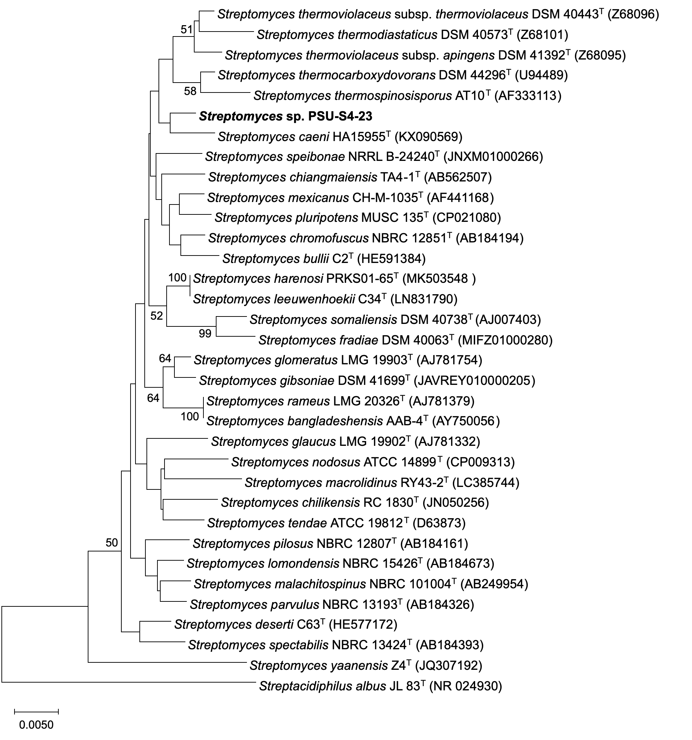

Figure S1. Neighbour-joining tree based on 16S rRNA gene sequences showing the relationship between strain PSU-S4-23 and other closely related Streptomyces. All positions containing gaps and missing data were eliminated. There were a total of 1389 positions in the final dataset. Bootstrap values (>50 %) based on 1000 replicates are shown at branch nodes. Streptacidiphilus albus JL 83^{T} was used as the outgroup. Bar, 0.005 nucleotide substitution rate (Knuc) units.

Figure S2. Maximum-likelihood phylogenetic tree based on 16S rRNA gene sequences showing
the relationship between strain PSU-S4-23 and closely related Streptomyces. All positions containing gaps and missing data were eliminated. There were a total of 1389 positions in the final dataset. Streptacidiphilus albus JL 83^{T} was used as an outgroup. Bootstrap values 50 % (based on 1000 replications) are shown at branch points. Bar, 0.005 substitutions per nucleotide position

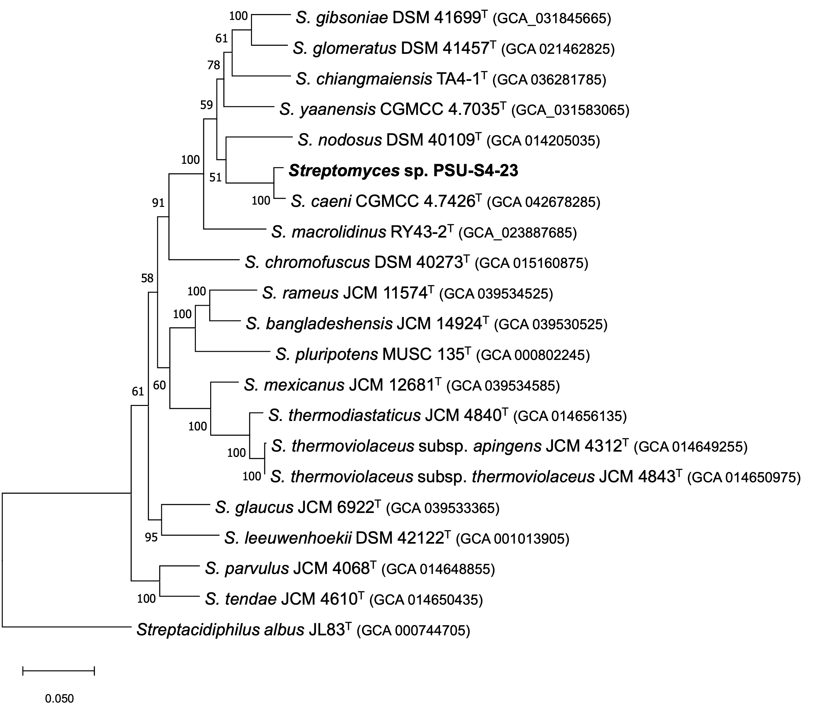

Figure S3. Phylogenomic tree generated by autoMLST showing the relationship of strain PSU-S4-23 to related species within the genus Streptomyces.

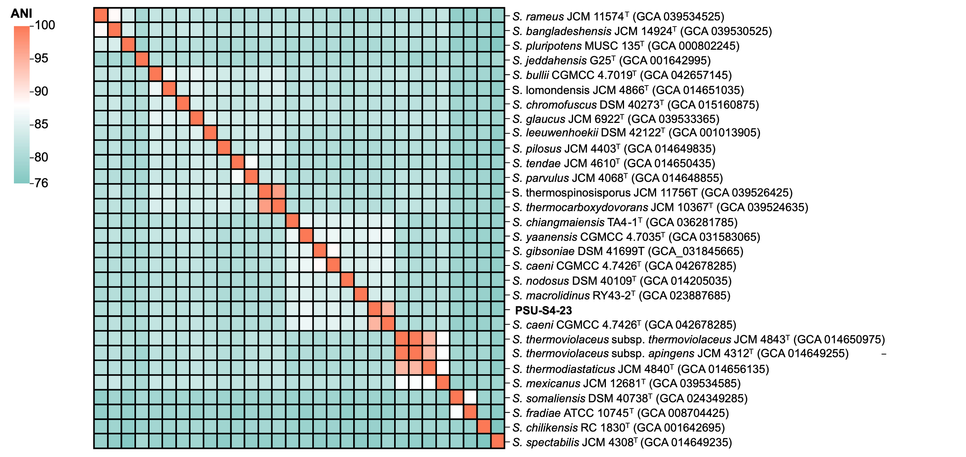

Figure S4. Average Nucleotide Identity (ANI) heatmap and clustering of Streptomyces genomes.

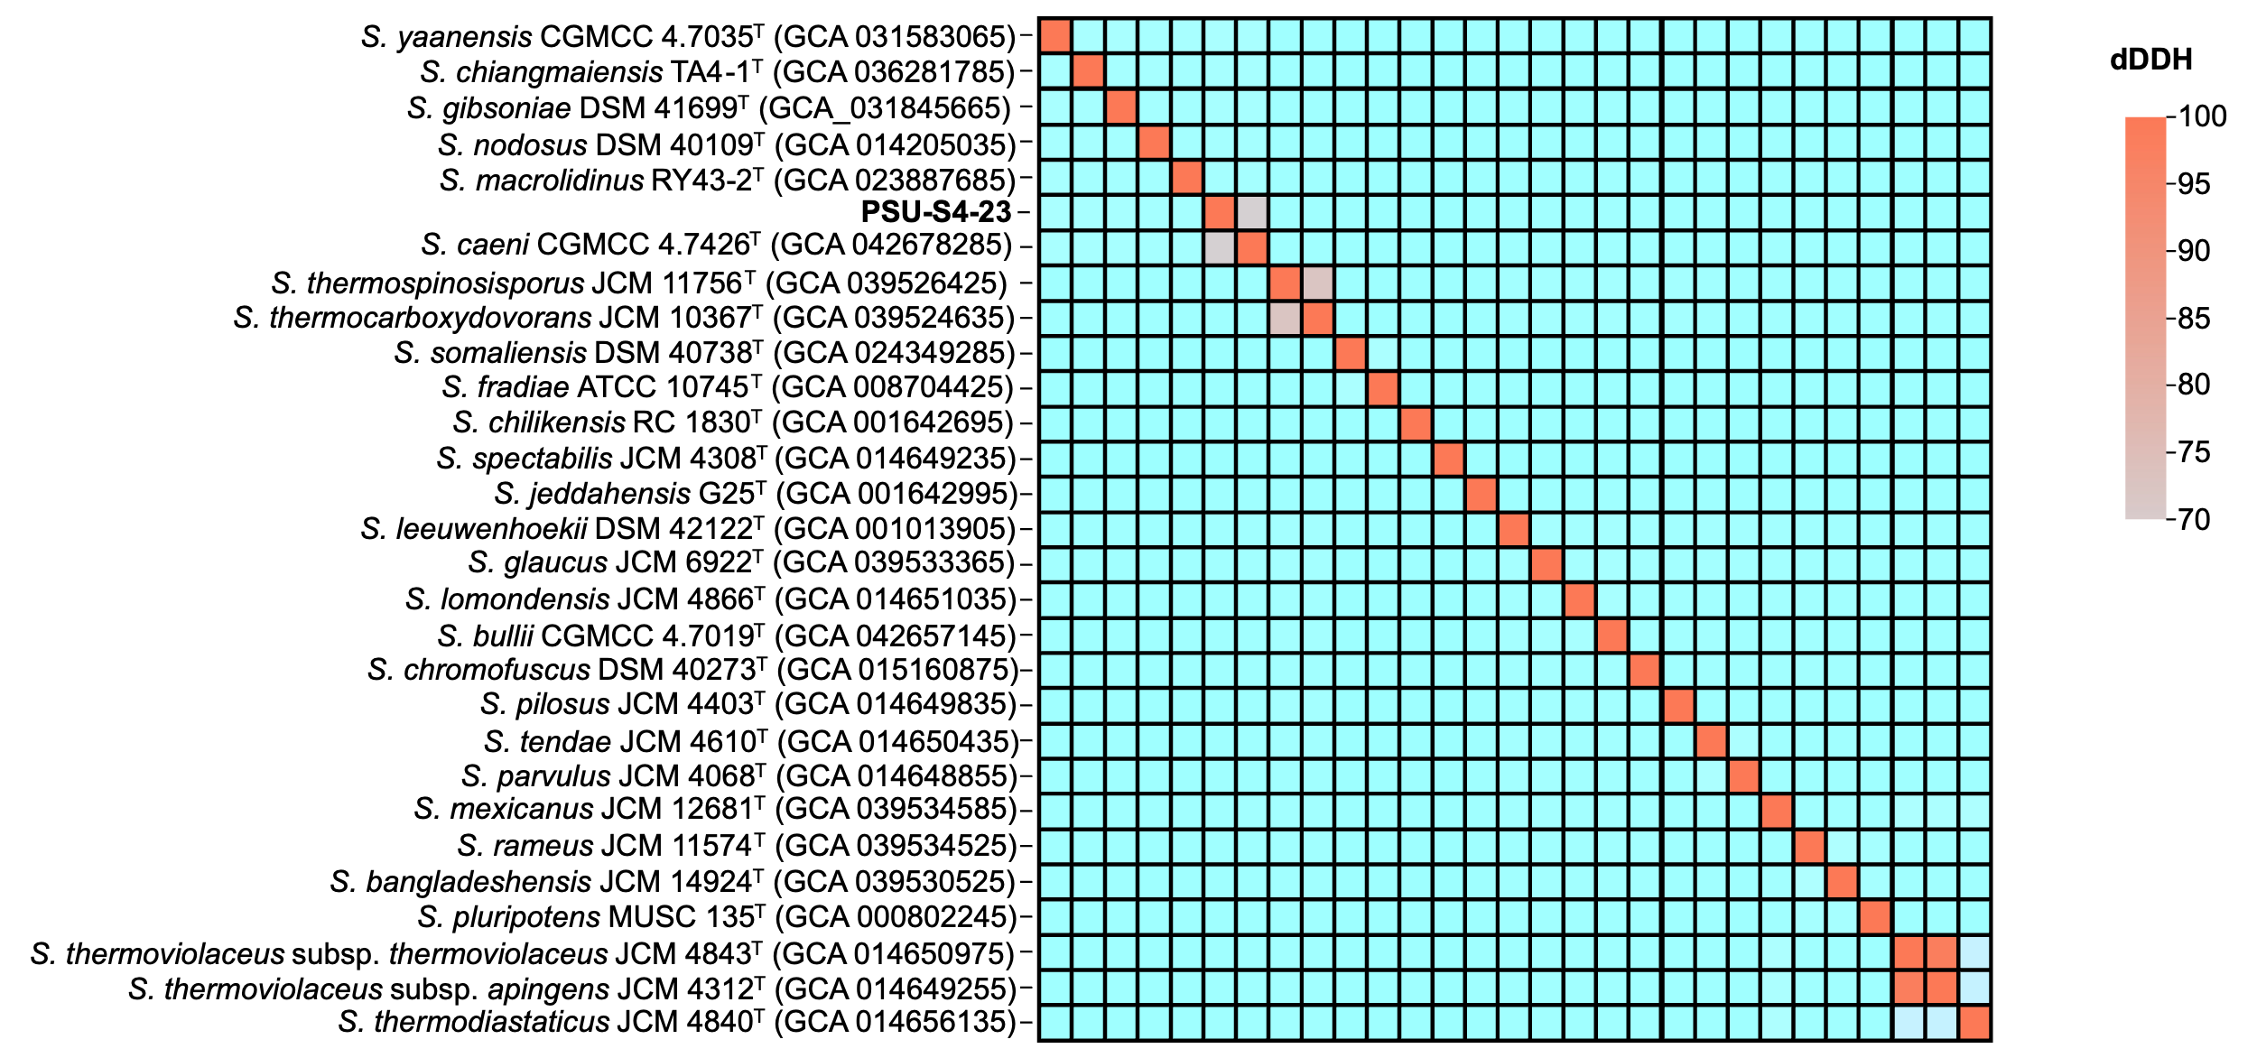

Figure S5. Digital DNA–DNA hybridization (dDDH) heatmap among Streptomyces genomes.

Table S1. Comparative analysis of the BGC Cluster 20 in PSU-S4-23 and the actinomycin D cluster (BGC0000296).
PSU-S4-23 BGC cluster 20 |  |  |  |  | Actinomycin D BGC (BGC0000296) |  |  |  |  |  | Amino-acid identity (%)
locus | start | end | strand | Amino-acid length | locus | start | end | strand | Amino-acid length | BGC product | Amino-acid identity (%)
ctg2_6390 | 5573 | 5920 | + | 115 | orf120 | 47456 | 47818 | - | 120 | transposase | 35.8
ctg2_6398 | 14798 | 15289 | - | 163 | orf157 | 47962 | 48435 | - | 157 | transposase | 37.4
ctg2_6401 | 16299 | 16931 | - | 210 | acmT | 11598 | 12233 | - | 211 | hypothetical protein | 73.5
ctg2_6402 | 16928 | 17491 | - | 187 | acmS | 12244 | 12804 | - | 186 | unknown | 73.8
ctg2_6403 | 17501 | 17701 | - | 66 | acmR | 12817 | 13017 | - | 66 | MbtH-like protein | 78.8
ctg2_6404 | 17747 | 17983 | - | 78 | acmD | 13084 | 13320 | - | 78 | 4-MHA carrier protein | 71.8
ctg2_6405 | 17980 | 19383 | - | 467 | acmA | 13317 | 14735 | - | 472 | peptide synthetase | 72.7
ctg2_6406 | 20001 | 27827 | + | 2608 | acmB | 15166 | 23001 | + | 2611 | peptide synthetase | 73.6
ctg2_6407 | 27824 | 40537 | + | 4237 | acmC | 22998 | 35741 | + | 4247 | peptide synthetase | 77.7
ctg2_6408 | 40609 | 41238 | + | 209 | acmE | 35738 | 36445 | + | 235 | hypothetical protein | 70.2
ctg2_6409 | 41243 | 42136 | + | 297 | acmF | 36480 | 37394 | + | 304 | aryl formamidase | 79.3
ctg2_6410 | 42133 | 42975 | + | 280 | acmG | 37391 | 38233 | + | 280 | tryptophan 2,3-dioxygenase | 77.1
ctg2_6411 | 43048 | 44310 | + | 420 | acmH | 38294 | 39556 | + | 420 | kynureninase | 81.4
ctg2_6412 | 44363 | 45403 | + | 346 | acmL | 9455 | 10495 | - | 346 | methyltransferase | 97.4
ctg2_6415 | 47031 | 47678 | - | 215 | acmO | 7181 | 7828 | + | 215 | LbmU-like protein | 89.8
ctg2_6416 | 47905 | 48747 | - | 280 | acmP | 6112 | 6954 | + | 280 | TetR family transcriptional regulator | 93.2
ctg2_6417 | 48863 | 49747 | + | 294 | acmQ | 5113 | 5997 | - | 294 | siderophore-interacting protein | 96.6
ctg2_6418 | 49734 | 50810 | + | 358 | acmrA | 4050 | 5033 | - | 327 | ABC transporter ATPase subunit | 88.0
ctg2_6419 | 50800 | 51567 | + | 255 | acmrB | 3293 | 4060 | - | 255 | ABC 2-type transporter | 97.3
ctg2_6420 | 51654 | 53924 | + | 756 | acmrC | 936 | 3206 | - | 756 | UrvA-like protein | 96.6

