EXTENDED RESULTS

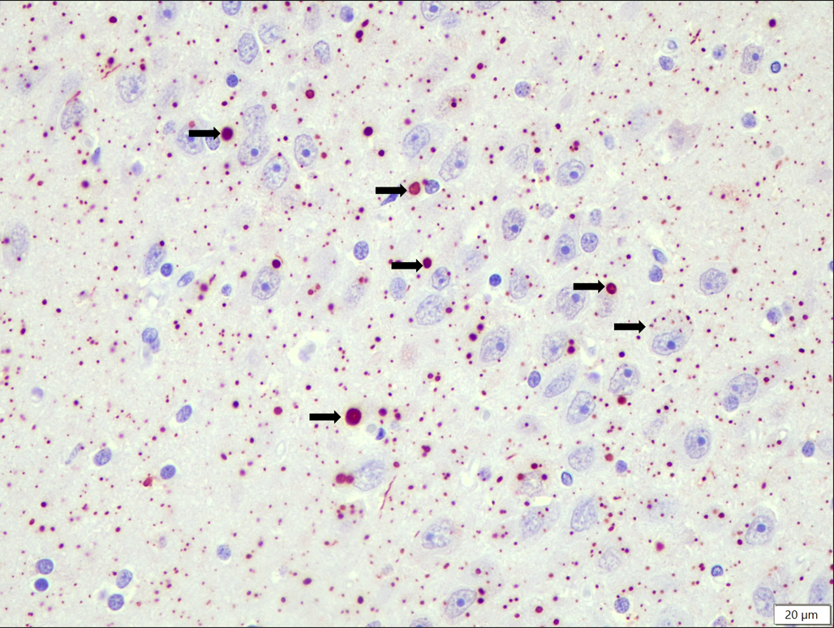
Extended Figure 1: Identification of rabies in brain samples of Cape fur seal. Light microscopy image of generalised positive labelling (arrows indicating variable sized, miliary distributed, round red-brown foci) of the rabies virus antigen in formalin-fixed hippocampal neurons and neuropil of a Cape fur seal (IMP method using a known positive control; 400x magnification).

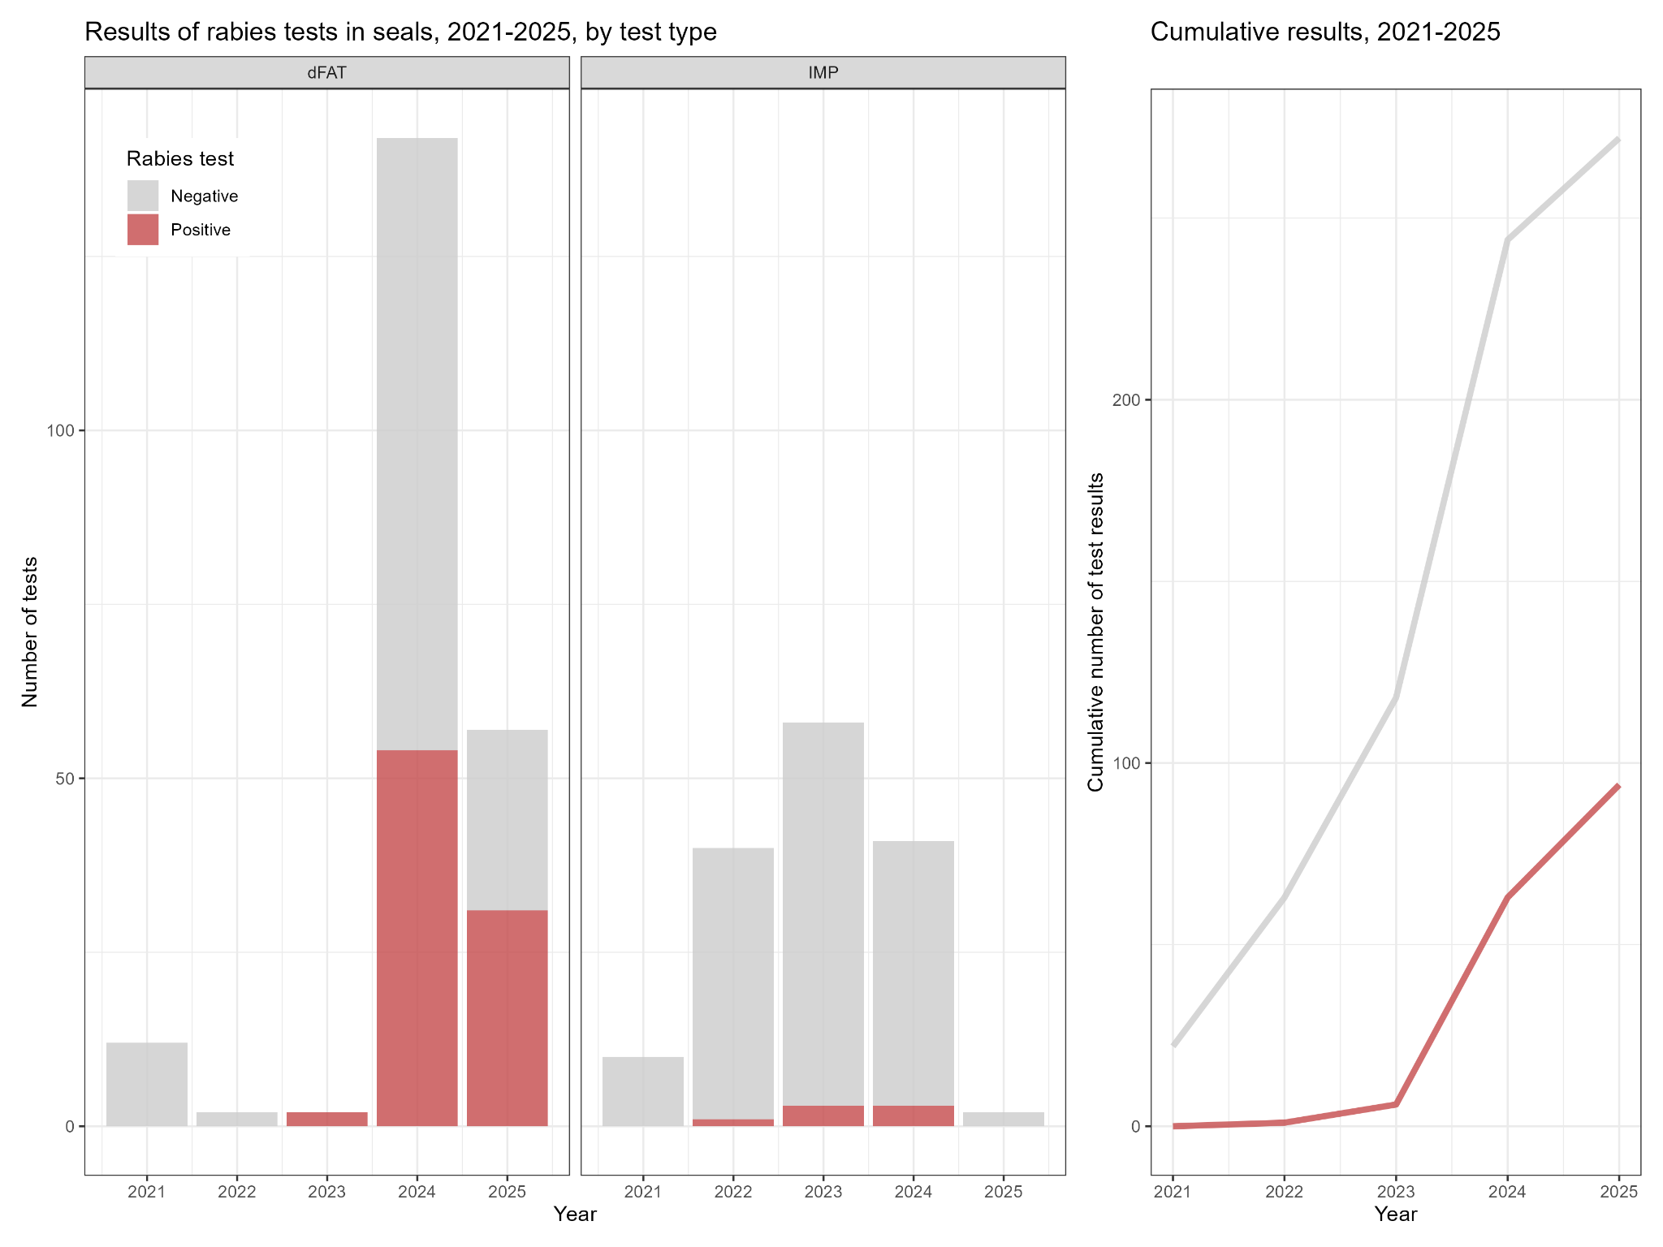
Extended Fig 2. Summary of rabies incidence and testing effort 2021-2025 of CFS samples from South Africa. Incidence calculated as the total number of tests conducted through IMP and dFAT, across years. The IMP method was used for retrospective testing of formalin fixed brain samples collected 2021 to 2024, and random non-suspect rabies cases from June 2024 onwards. Testing with dFAT was conducted on fresh and frozen brain samples collected from 2023 to 2025, which were mostly case definition classified as high-suspect rabies cases. On the z-axis, the cumulative number of tests are shown, demonstrating a rapid increase in testing following the May 2024 rabies diagnosis.

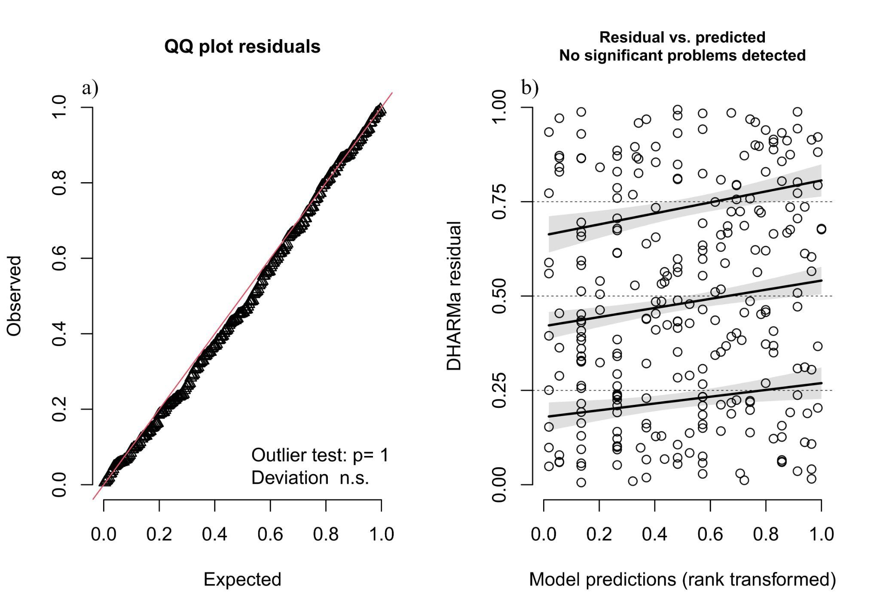
Extended Fig. 3: Model diagnostics indicating a good fit to the data. a) Quantile-quantile (Q-Q) plot of the distribution of model residuals relative to a normal distribution with no evidence of deviation from normality (KS test, p = 0.45), no over- or under dispersion (dispersion test, p = 0.96), and no detected outliers (outlier test, p = 1). b) The residuals vs. predicted plot shows that the scaled residuals are evenly scattered across the rank-transformed predicted values, indicating residual homogeneity and independence. These results indicate a good GLMM fit investigating features of rabies in CFS.

Extended Results Table 1. GLMM model fitting in a stepwise fashion with associated degrees of freedom (df) and AIC values for model selection; *indicates best model fit

Models | df | AIC
glmer(Rabies ~ AgeClass + Sex + BodyCond + Alive + Injuries + (1|Location), data = seal1, family = binomial) | 10 | 188.3
glmer(Rabies ~ AgeClass + Sex + BodyCond + Survey + Injuries + (1|Location), data = seal1, family = binomial) | 10 | 195.4
glmer(Rabies ~ AgeClass + Sex + BodyCond + Alive + (1|Location), data = seal1, family = binomial)* | 9 | 186.7
glmer(Rabies ~ AgeClass + Sex + BodyCond + Survey + (1|Location), data = seal1, family = binomial) | 9 | 193.4
glmer(Rabies ~ AgeClass + Sex + BodyCond + (1|Location), data = seal1, family = binomial) | 8 | 205.1
glmer(Rabies ~ AgeClass + Sex + (1|Location), data = seal1, family = binomial) | 6 | 258.9
glmer(Rabies ~ AgeClass + BodyCond + (1|Location), data = seal1, family = binomial) | 6 | 203.5

Extended Results Table 2. Model diagnostics through assessment of model fit (1), dispersion (2), zero-inflation (3), and variance explained (4) by fixed and random effects (conditional R²) and fixed effects only (marginal R²)
Selected model | glmer(Rabies ~ AgeClass + Sex + BodyCond + Alive + (1|Location), data = seal1, family = binomial)
1. Kolmogorov–Smirnov test | p = 0.45
2. Model dispersion test | dispersion = 1.0; p = 0.96
3. Zero-inflation test | ratioObsSim = 1.0; p = 1.0
4. R² | marginal R² = 0.58; conditional R² = 0.58

SUPPLEMENTARY INFORMATION
Supplementary Material 1: Inter-species spillover event of rabies between Cape fur seals and domestic dog - A case description On the evening of May 27th, 2024, a social media post was released by the attending Noordhoek veterinary practice, which confirmed the rabies diagnosis in an adult male pitbull from Cape Town, South Africa. The rabies transmission route was curious, as the dog (adult male pitbull, APB1) had not travelled outside the province and was not known to have had contact with any other dogs with rabies. The owner recounted that on one occasion in recent memory, the dog sustained an injury whilst roaming the Kommetjie Beach (Cape Town), which broke the skin, raising the owner’s suspicions of a seal bite. The owner first submitted her 9-month-old pitbull (male, JPB1) for veterinary assessment on the morning of May 21st, citing increased aggression and an altercation towards APB1. The assessment found JPB1 subdued and covered in multiple minor fresh bite wounds and he was subsequently euthanised. Over the same time frame, APB1 developed symptoms that progressed from fever with excessive panting over the night of May 20th to 21st, to extreme episodic aggression, including inexplicable and uncharacteristic attacking of furniture throughout the night of May 21st. By the morning of May 22nd, APB1 was exhibiting clear rabies symptoms of hyper-aggression, including biting through car upholstery and, although administered with the sedative IM xylazine, inflicting significant bite wounds to the receiving veterinary nurse. He was subsequently euthanised. Rabies testing of brain tissue was conducted on both dogs using the direct fluorescent antibody test (dFAT), which is globally considered the ‘gold standard’ for rabies testing and is the only accredited and approved diagnostic method for rabies reporting in South Africa. Although JPB1 tested rabies negative, APB1 was rabies positive. Phylogenetic mapping of the rabies sequence determined that APB1 had been infected with the canine biotype most similar to that identified during an outbreak of rabies in Cape fur seals - supporting a seal to domestic dog rabies spillover event in Cape Town, 2024 (DALRRD 2024).

Supplementary Information 2:
Links to YouTube videos which demonstrate the behaviour of Cape fur seals with rabies
1a) Video demonstrating the lack of fear and behaviour of a Cape fur seal pup (2 - 3 months old) with rabies, as well as the potential risk to the public from young seals with rabies along the coast of South Africa. The seal was subsequently euthanised and a brain sample tested positive for rabies through dFAT. https://youtu.be/bEjN_EIYLs4?si=rtBCaHQSQvldEs8E

1b) The clinical presentation and behaviour of an adult female Cape fur seal with rabies. The seal was observed for > 1 hr on the 14th November 2024. Local authorities subsequently euthanised the seal and a brain sample tested positive for rabies through dFAT. https://youtu.be/hrWEK7Wtk68?si=ianWDTwoq-OYn4s4

Supplementary Information 3:

Contextual information on the framework of rabies reporting in South Africa relative to the Animal Diseases Act
Rabies is a controlled animal disease in South Africa as per the Animal Diseases Act, 1984 (Act No. 35 of 1984) and any suspect or confirmed animals must be reported to the responsible state veterinary office. Rabies in humans is a Category 1 Notifiable Medical Condition as per the National Health Act, 2003 (Act No. 61 of 2003) and any suspect or confirmed case must be reported to the local health authority. In South Africa, animal and other relevant samples collected for research purposes require approval in terms of Section 20 of the Animal Diseases Act, 1984 (Act No 35 of 1984) to ensure evaluation of biosafety and biosecurity measures in place to prevent the potential spread of animal diseases. Biosecurity requirements for such approvals have been reviewed and improved following the detection of rabies in samples collected from Cape fur seals, to mitigate potential disease spread to animals and humans. The incidence of rabies being detected during research has highlighted the need for adequate biosafety and biosecurity approaches.

