Supplementary Materials

Supplementary Materials 1

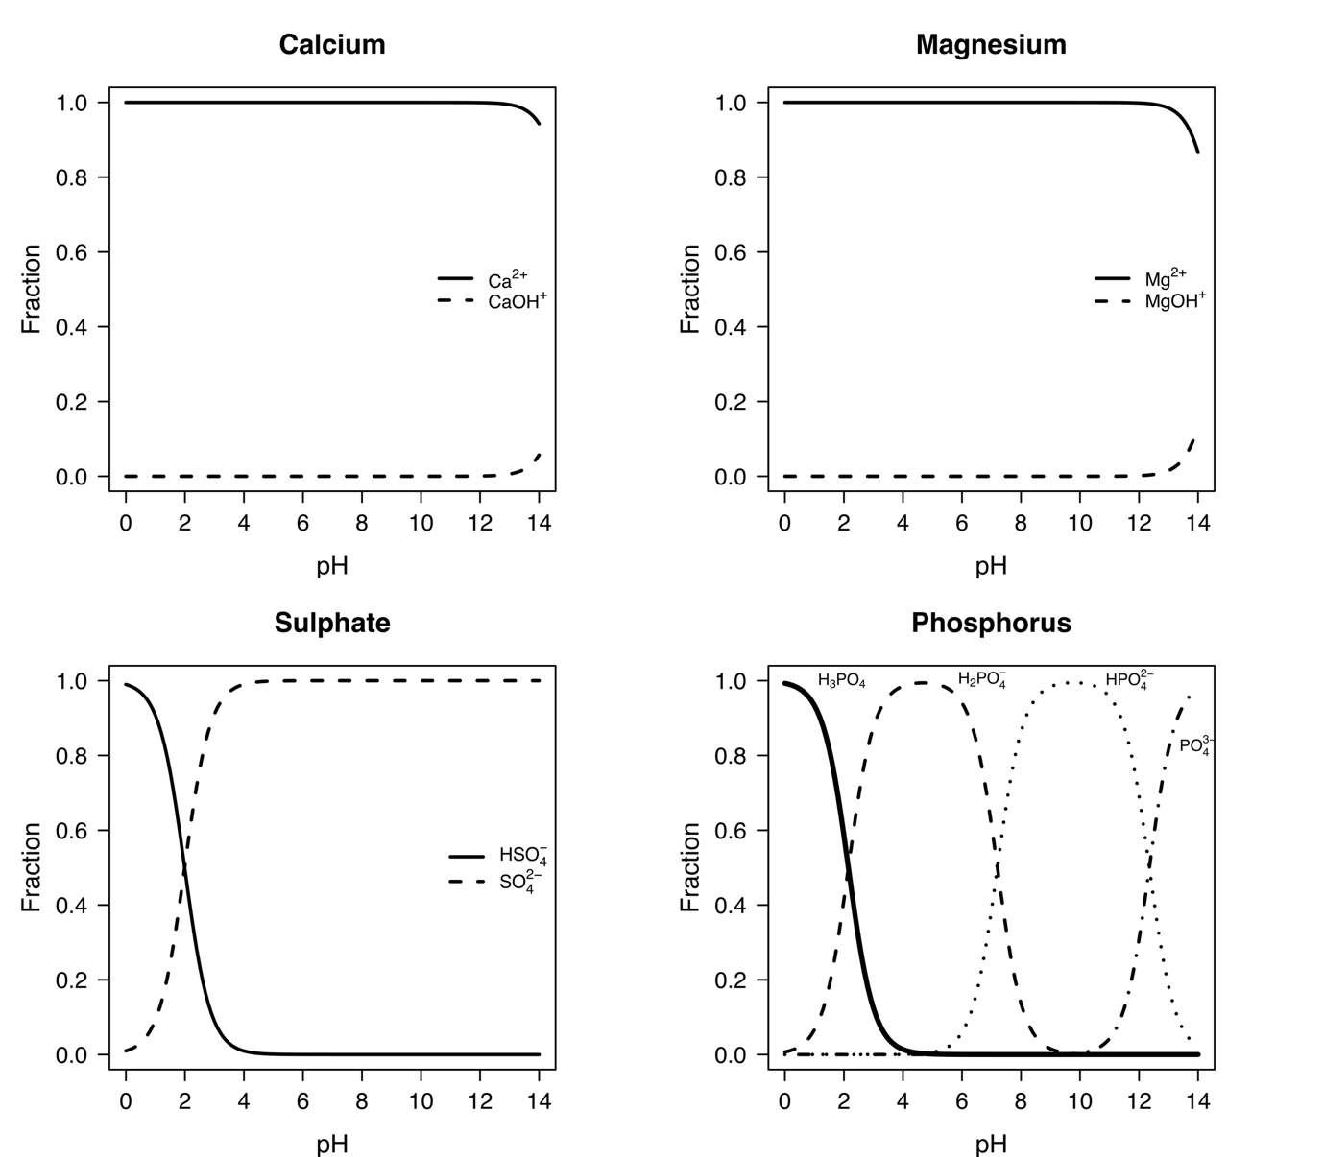

Figure 1.1. pH-dependent charge speciation of calcium, magnesium, sulphate and phosphorus in ultrapure water (ionic strength = 0) at 25 ºC. Changes in ionic forms and net charge across the pH range demonstrate their role in buffering capacity and provide the charge coefficients used in Equation 4 (Main Text: Method - Carbon Sequestration Potential).

Supplementary Materials 2

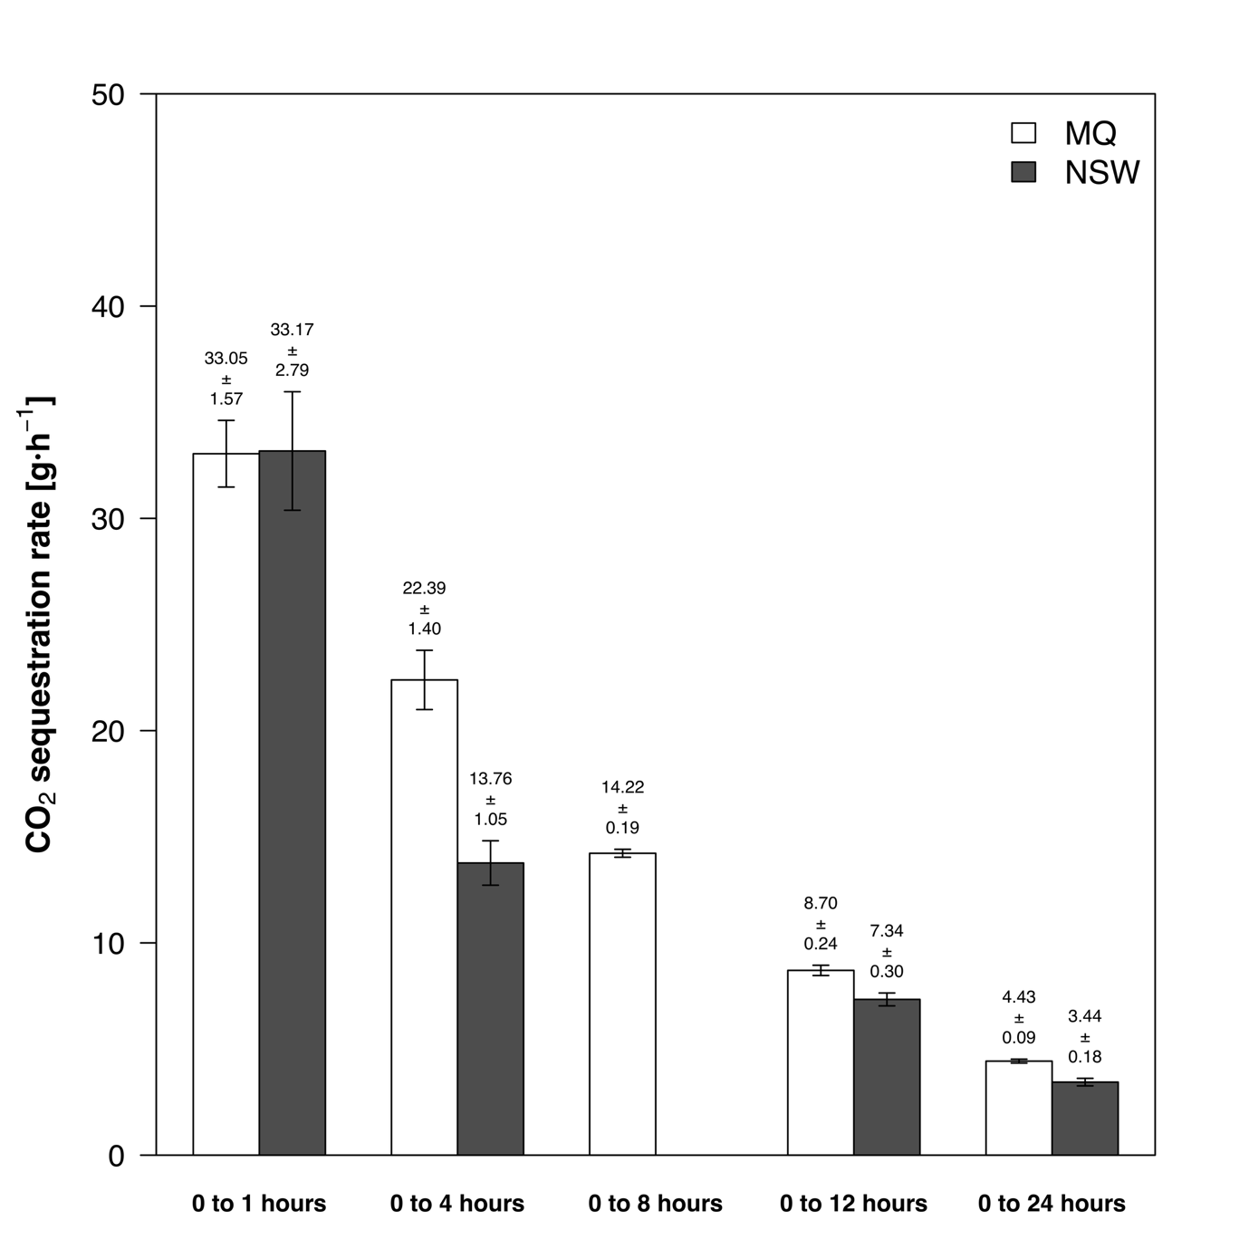
Figure 2.1. CO₂ sequestration rates measured at cumulative time intervals (0-1, 0-4, 0-8, 0-12, and 0-24 hours) for ultrapure water (MQ) and natural seawater (NSW) setups. Rates are shown as bar charts illustrating the gradual decline in capture efficiency over extended reaction times from the gas phase. An additional sampling point at 8 h was included in the ultrapure water setup based on preliminary observations, to provide intermediate measurements between 4 h and 12 h.

Supplementary Materials 3

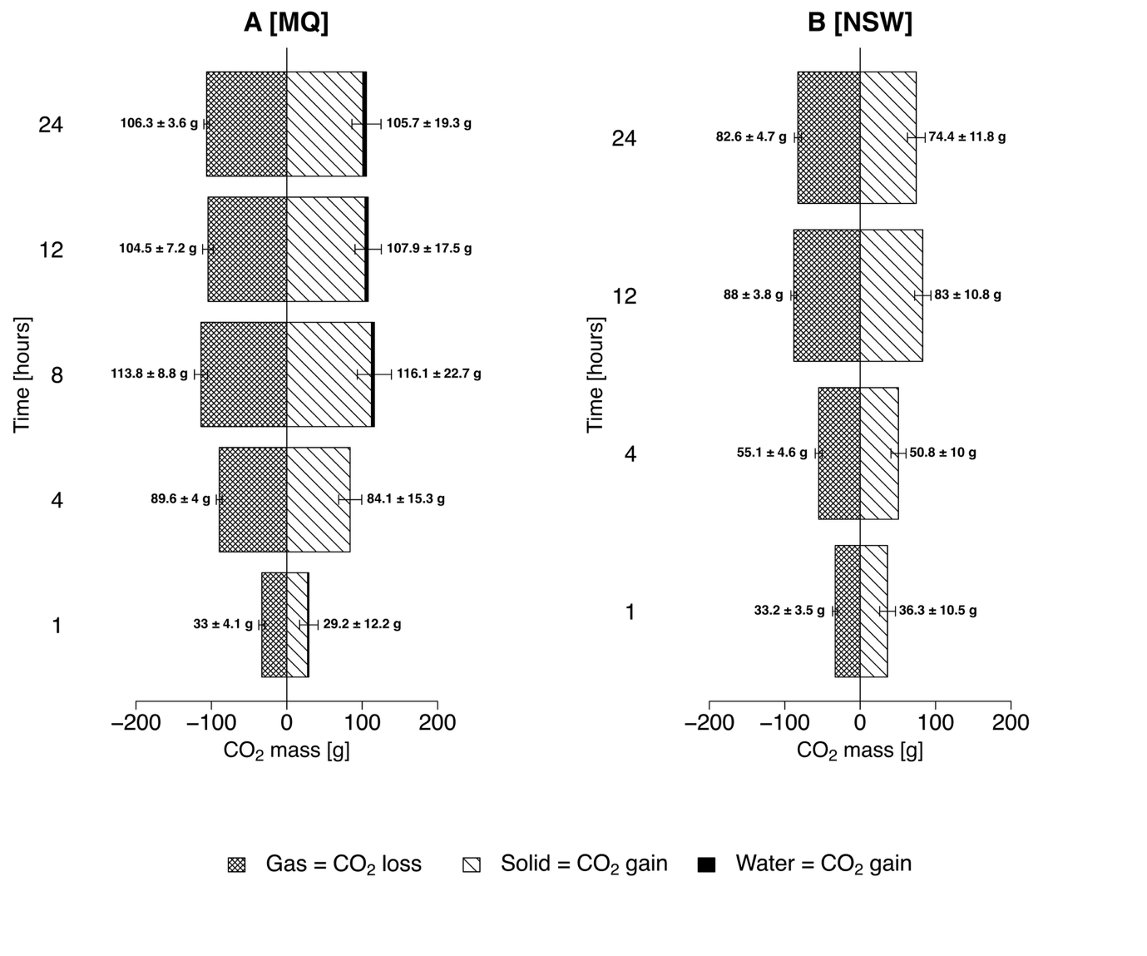
Figure 3.1. CO₂ sequestration budget: CO₂ loss from the gas phase (uptake) and corresponding CO₂ gain in the solid and liquid phases (sequestration), illustrating the partitioning of sequestered carbon across phases during the experiment.

Supplementary Materials 4

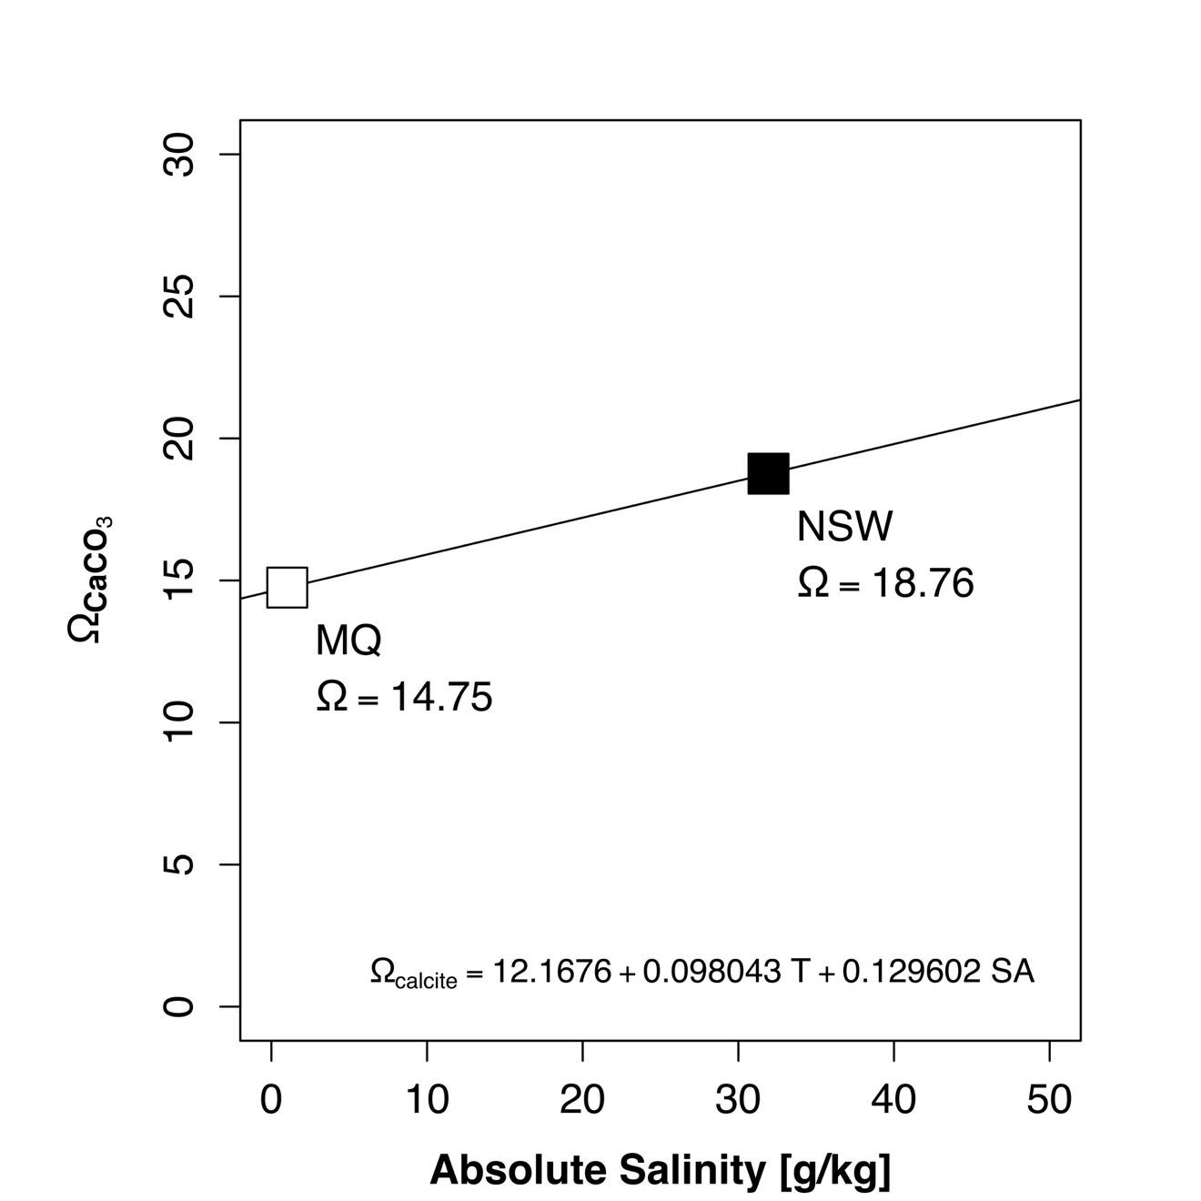

Figure 4.1. Pseudo-homogenised precipitation index derived from temperature (T = 25 ºC), pressure (P = at atmospheric pressure), and absolute salinity (SA)(Marion et al., 2009). Absolute salinity was calculated from electrical conductivity (EC) using the Practical Salinity Scale 1978 (Lewis & Perkin, 1981). Reported values represent the average after the experimental period (t > 0).
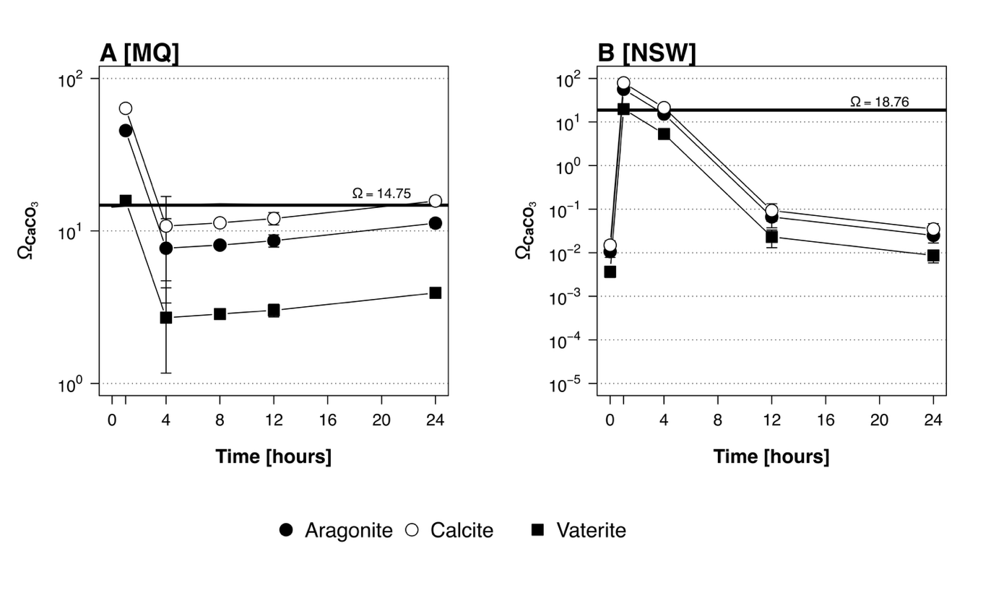
Figure 4.2 Saturation index of CaCO₃ mineral phases during the experiment (0–24 h) in (A) ultrapure water and (B) natural seawater setups. The bold line represents the pseudo-homogenised precipitation index calculated from temperature (T), pressure (P), and absolute salinity (S_{A}) (Supplementary Material 4; Marion et al. (2009) and Lewis and Perkin (1981)).

Supplementary Materials 5

Table 5.1. Quantitative analysis of mineral phases in slag samples. The crystalline phases, e.g., silicates, carbonates, and halides were quantified from the XRD diffractograms as shown in Figure 5.1, and the amorphous phase was estimated as the residual using an internal database and in-house software. NSW indicates the sample from the natural seawater setup, while MQ refers to the samples from the ultrapure water setups post experiment.

Mineral Phase |  | Steel Slag - Initial | Steel Slag - Post MQ | Steel Slag - Post NSW
Silicates | Beta C2S (Larnite) | 4.3 ± 1.8 | 2.1 | 1.9
Silicates | Alpha C2S | 1.8 ± 0.6 | 2.2 | 1.4
Silicates | Ellestadite/Apatite | 0.8 ± 0.2 | 0.6 | 1.5
Silicates | Hydrogarnet | 4.1 ± 0.8 | 2.0 | 1.0
Silicates | Melilite group | 1.0 ± 0.2 | 0.3 | 0.6
Silicates | Wollastonite | 1.6 ± 1.2 | - | -
Carbonates | Calcite | 7.6 ± 3.3 | 17.8 | 24.3
Carbonates | Aragonite | 1.4 ± 0.1 | - | 0.7
Carbonates | Ankerite | - | 0.7 | 0.7
Carbonates | Vaterite | 1.9 ± 1.2 | - | 5.4
Halides | NaCl | - | 1.8 | -
Oxides/Hydroxides | Spinel-type minerals | 0.9 ± 0.3 | 0.5 | 0.7
Oxides/Hydroxides | Wuestite | 2 ± 0.6 | 2.5 | 2.2
Oxides/Hydroxides | Nordstrandite | 1.6 ± 0.7 | 0.4 | -
Oxides/Hydroxides | Lime | 0.6 ± 0.5 | 0.3 | 0.3
Oxides/Hydroxides | Portlandite | 8.2 ± 4.7 | 0.2 | 0.4
Oxides/Hydroxides | Periclase | 0.8 ± 0.2 | 0.3 | 0.4
Oxides/Hydroxides | Afm | 0.7 ± 0.3 | 0.1 | 0.2
Oxides/Hydroxides | Srebrodolskite | 7.4 ± 1.7 | 7.6 | 6.3
Oxides/Hydroxides | Mayenite | 1.9 ± 0.3 | - | 0.7
Amorphous | Amorphous | 53.2 ± 2.5 | 60.5 | 51.2
Note: Amorphous content was estimated from residual background in Rietveld refinement, representing poorly crystalline or non-crystalline phases.

Table 5.2. Mineral formulae and calculated C contents, with XRD-derived C-normalised abundances (%) for initial slag, MQ, and NSW experiments. Note: For ankerite, the formula is simplified to CaMg(CO₃)₂ (1:1 Ca:Mg, Fe excluded).

Mineral | Formula | C content (wt%) | XRD-derived C fraction (%) |  |  | PIC (%)
Mineral | Formula | C content (wt%) | Initial | MQ | NSW | Initial | MQ | NSW
Calcite | CaCO₃ | 0.12 | 0.91 ± 0.4 | 2.14 | 2.92
Aragonite | CaCO₃ | 0.12 | 0.17 ± 0.0 | - | 0.08
Ankerite | CaMg(CO₃)₂ | 0.13 | - | 0.09 | 0.09
Vaterite | CaCO₃ | 0.12 | 0.23 ± 0.14 | - | 0.65
Total %C |  |  | 1.31 ± 0.42 | 2.23 | 3.74 | 1.18 ± 0.26 | 2.3 ± 0.1 | 3.1 ± 0.6

The discrepancies between XRD-derived C fractions and EA are relatively small and fall within analytical uncertainty. The residual differences are likely due to sample heterogeneity and/or the carbonates precipitating in amorphous form, which cannot be identified and quantified precisely by XRD.

