Supplementary material
Supplementary table 1. Individual Pangram score of the letters from author #1 and #2.
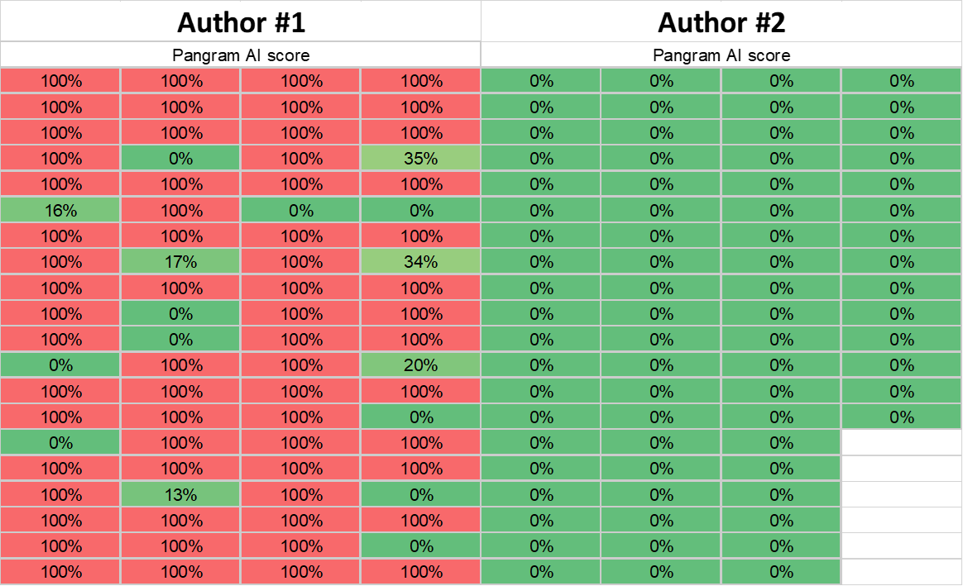

For the case study, we also constructed a scientific collaboration network for letters and all other publications using the Bibliometrix R package. This is a network diagram in which the nodes represent authors, while the links indicate co-authorships. This type of analysis is considered one of the most well-documented forms of scientific collaboration (25).
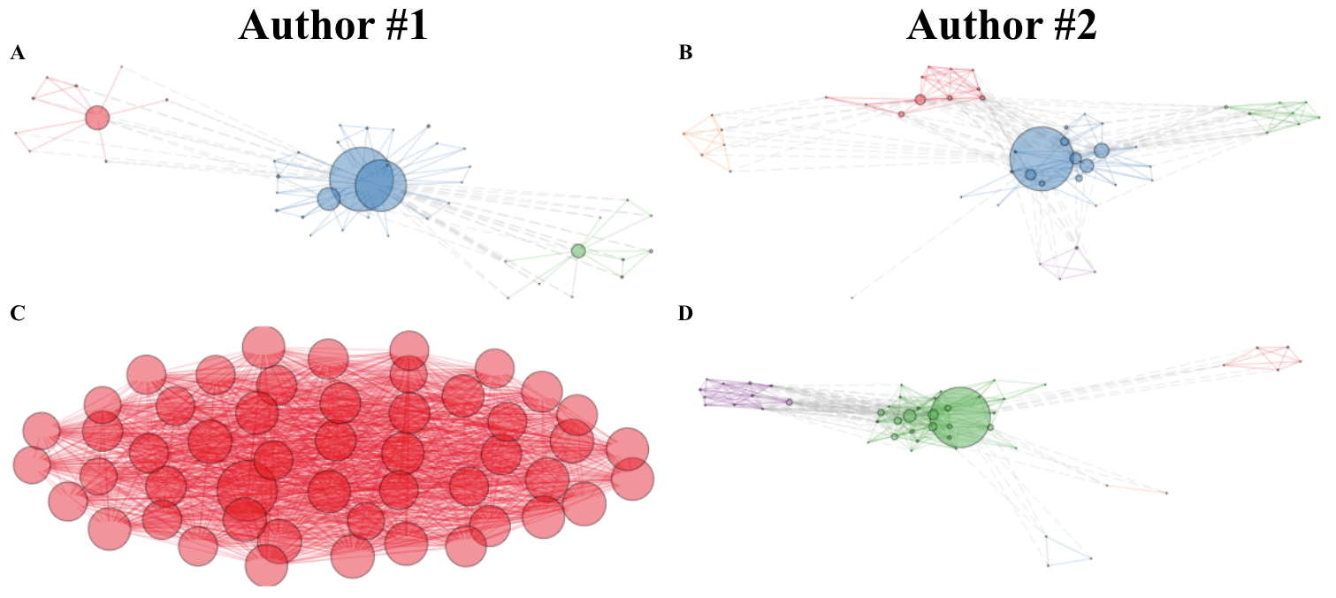
Supplementary figure 1. Co-authorship collaboration networks comparing letters and general publications for Author #1 and Author #2. These networks were generated using the Bibliometrix R package. Each node represents an author, and the lines (links) indicate co-authorship connections. Node size is directly proportional to the author's number of publications, and link thickness reflects collaboration strength. (A) Author #1's letter network: Shows a compact, centralized network. The central blue node (Author #1) acts as the main hub coordinating most of the activity, while peripheral co-authors represent occasional collaborations. (B) Author #2's letter network: Presents a similar hub structure but is characterized by multiple distinct clusters (indicated by different colors) connected by weaker ties. This suggests several groups working together but with less interconnection among them. (C) Author #1's general publication network: Unlike their letter network (A), the general publication network is much larger, denser, and more uniform. The high density of red nodes and links indicates extensive collaboration with numerous researchers. (D) Author #2's general publication network: This network also shows a centralized structure, though it is notably more modular than Author #1's (C). A central hub node (green) connects several defined groups that likely collaborate on similar topics or within the same institutions.

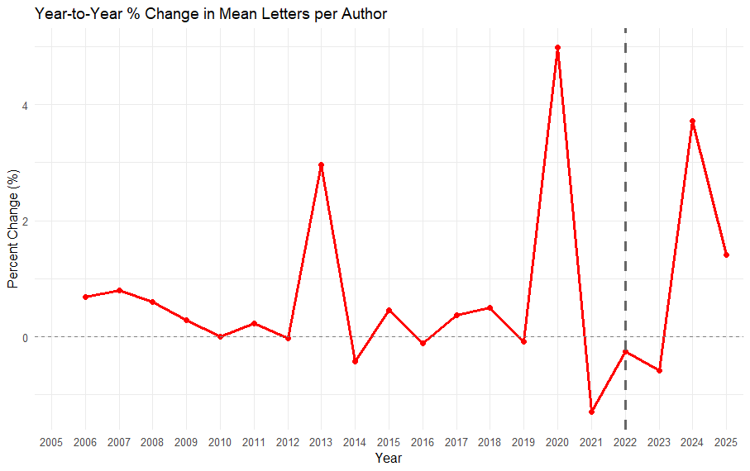
Supplementary figure 2. Year to year proportional change in the mean number of letters per author. The vertical dashed line marks the end of 2022, when ChatGPT became publicly available. Note sudden productivity increases in 2013, 2020 and 2024 coinciding respectively with indexing changes in MEDLINE, the COVID-19 pandemic and the popularization of large language models.
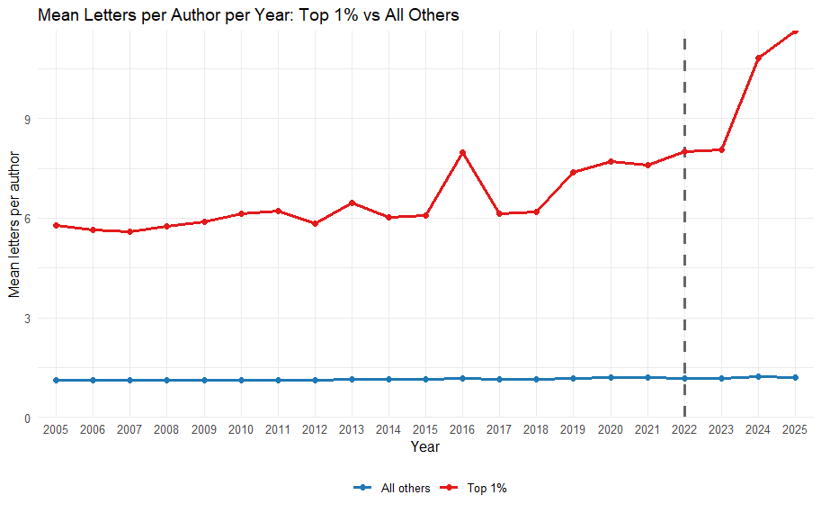
Supplementary figure 3. Longitudinal changes in letter output by authors in percentile 99 vs all others by year.
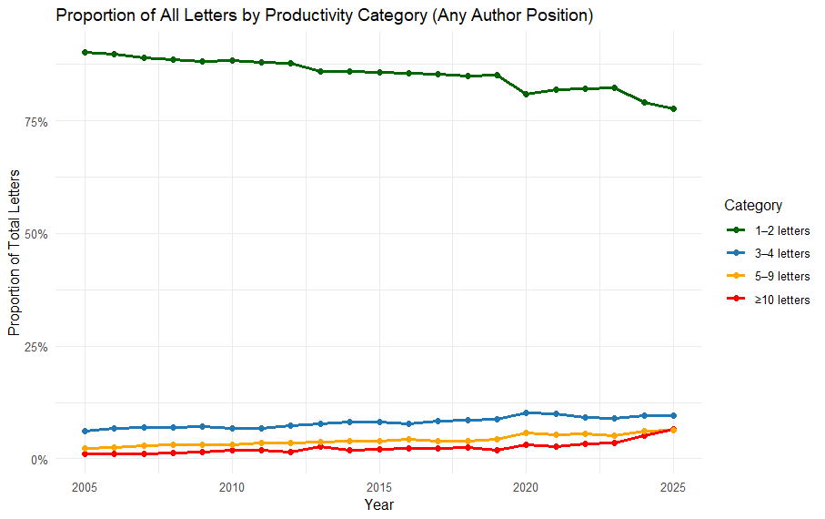
Supplementary figure 4. Longitudinal changes in the output of authors by productivity category

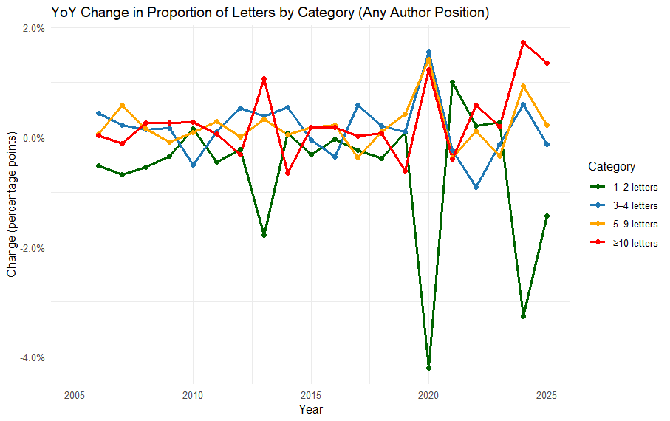
Supplementary figure 5. Year to year variation in the proportion of letters written that year by authors in the different categories. Note the distinct increments in output of the most prolific authors in 2013, 2020 and 2024, following the events described above, with the difference that previous surges had always corrected the following year while the 2024 one does not seem to be correcting in 2025.

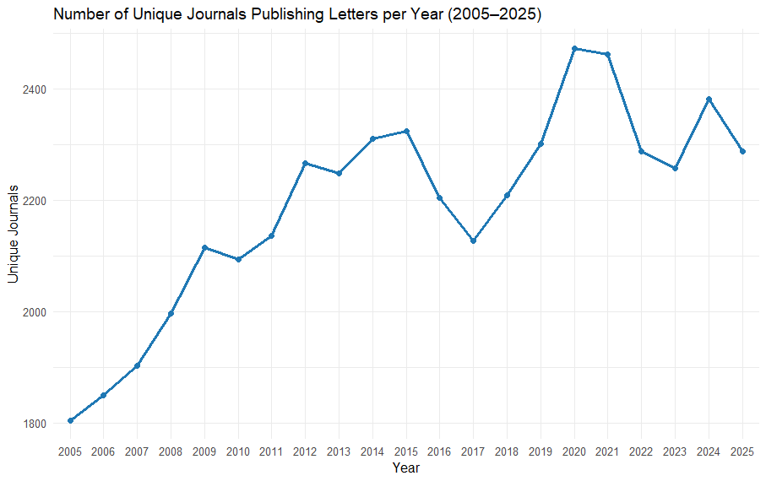
Supplementary figure 6. Numbers of journals publishing letters to the editor 2005-2025

Supplementary table 2. Crude value and year to year change (crude and proportional) of the Gini coefficient and the Herfindahl-Hirschman Index of LTE authorship 2005-2025.
