Dynamics of antiretroviral restriction factor expression in sheep naturally infected with Small Ruminant Lentivirus (SRLV).

Supplementary Material

Variable | Z1 | Z3 | BST2 | Serology | Viral load | Proviral load | Time
APOBEC3 Z1 | 1 | 0.229  (*** ) | 0.261  (*** ) | –0.122  (* ) | 0.140  (* ) | –0.094  (ns) | –0.259  (*** )
APOBEC3 Z3 |  | 1 | 0.329  (*** ) | 0.050  (ns) | 0.088  (ns) | 0.109  (ns) | 0.174  (** )
BST2 |  |  | 1 | 0.088  (ns) | –0.076 (ns) | 0.171  (** ) | 0.405  (*** )
Serology |  |  |  | 1 | 0.070  (ns) | 0.020  (ns) | 0.343  (*** )
Viral load |  |  |  |  | 1 | –0.158  (** ) | –0.029  (ns)
Proviral load |  |  |  |  |  | 1 | 0.249  (*** )
Time |  |  |  |  |  |  | 1
Table S1 Spearman’s rank correlation coefficients (ρ) between gene expression of APOBEC3 Z1 (Z1), Z3 (Z3), and BST2 (Tetherin), and infection parameters (viral load, proviral load, serology, and time). Significance levels: ns (non-significant, p ≥ 0.05), * (p < 0.05), ** (p < 0.01), *** (p < 0.001).

Response | Source | df | Sum of Squares | Mean Square | F | p-value
APOBEC3  Z1 | Time | 5 | 207.94 | 41.59 | 35.54 | < 0.001 ***
 | Error | 276 | 322.96 | 1.17
APOBEC3  Z3 | Time | 5 | 23753 | 4750.7 | 14.30 | < 0.001 ***
 | Error | 276 | 91689 | 332.2
BST2 | Time | 5 | 10318 | 2063.53 | 39.49 | < 0.001 ***
 | Error | 276 | 14422 | 52.26
Table S2 MANOVA results evaluating the effect of time on the expression of APOBEC3 Z1, Z3, and BST2. All genes showed significant temporal variation (p < 0.001).

A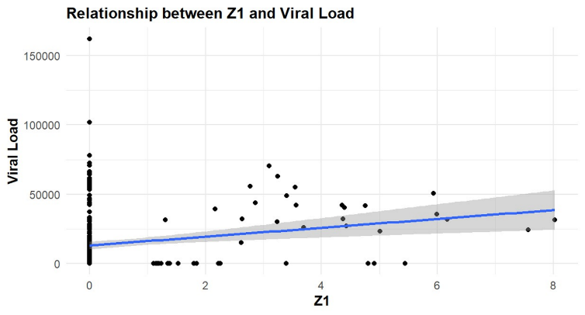 | B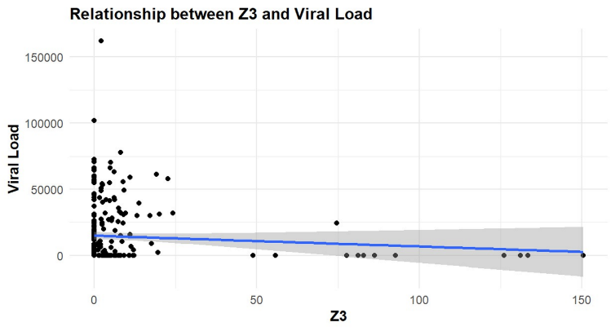
C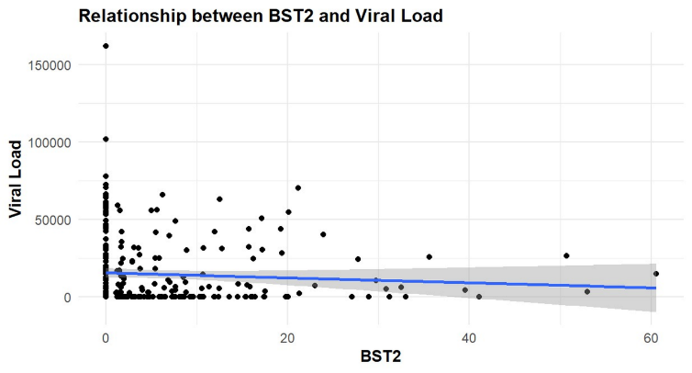
Figure S1. Linear regressions showing associations between gene expression and viral load. A) Z1 vs viral load; B) Z3 vs viral load C) BST2 vs viral load. The blue line represents the regression trend, and the shaded area indicates the 95% confidence interval.

A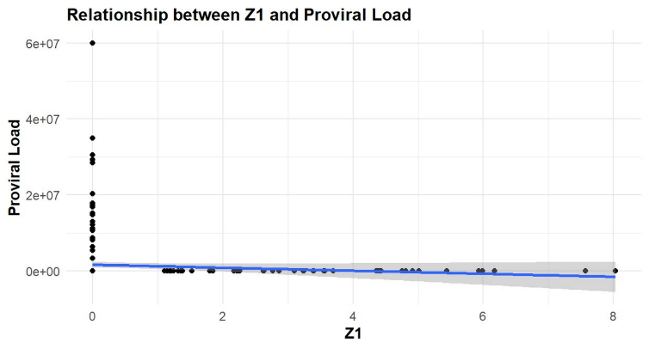 | B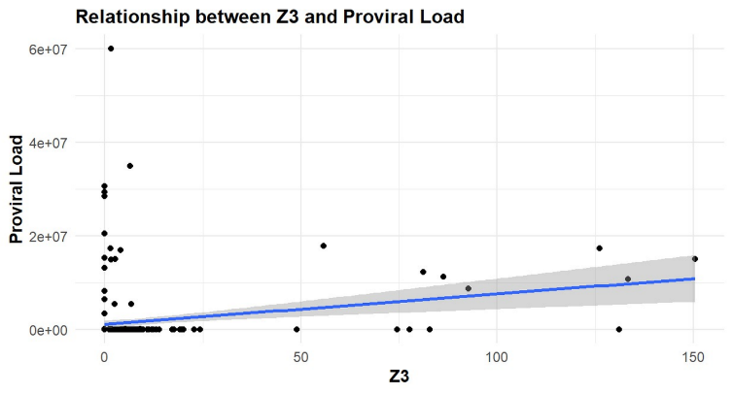
C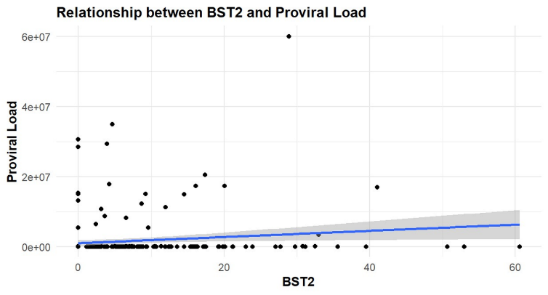

Figure S2. Linear regressions showing associations between gene expression and proviral load: A) Z1 vs proviral load; B) Z3 vs proviral load; C) S6: BST2 (Tetherin) vs proviral load. The blue line represents the regression trend and the shaded area denotes the 95% confidence interval.

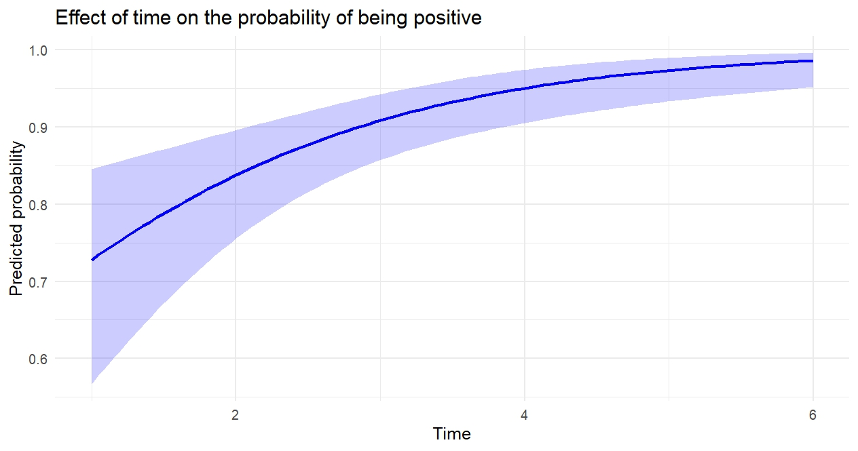

Figure S3. Logistic regression model showing the predicted probability of seropositivity over time. Shaded area represents the 95% confidence interval.

Bayesian Models
Variable | β (Estimate) | 95% CI Lower | 95% CI Upper | Significant*
Intercept | 4.02 | 2.69 | 5.34 | ✔️
APOBEC3 Z1 | 0.92 | 0.35 | 1.48 | ✔️
APOBEC3 Z3 | –0.86 | –1.40 | –0.28 | ✔️
BST2 | –0.25 | –0.81 | 0.33 | ❌
Time | 0.45 | 0.10 | 0.80 | ✔️
Table S3. Bayesian regression model for viral load, including posterior means, 95% credible intervals, and significance markers. Z1 and Z3 expression showed significant associations. Values whose 95% credible interval does not include zero are marked with a ✔️, indicating a potential significant association.
Variable | β (Estimate) | 95% CI Lower | 95% CI Upper | Significant*
Intercept | 1.09 | –0.29 | 2.47 | ❌
APOBEC3 Z1 | –0.55 | –1.12 | 0.02 | ❌†
APOBEC3 Z3 | 1.28 | 0.72 | 1.83 | ✔️
BST2 | 0.49 | –0.10 | 1.09 | ❌
Time | 0.41 | 0.05 | 0.77 | ✔️
Table S4. Bayesian regression model for proviral load. Z3 expression and time showed significant associations. Variables whose CrI does not include zero are marked with ✔️, indicating a statistically meaningful association under the Bayesian framework. The † symbol denotes parameters whose lower or upper CrI limit approaches zero, suggesting a potential marginal trend.

Variable | β (Estimate) | Standard error | z-value | p-value | Significant*
Intercept | 0.345 | 0.430 | 0.801 | 0.423 | ❌
APOBEC3 Z1 | –0.145 | 0.137 | –1.055 | 0.291 | ❌
APOBEC3 Z3 | 0.001 | 0.025 | 0.055 | 0.956 | ❌
BST2 | 0.008 | 0.033 | 0.231 | 0.818 | ❌
Time | 0.656 | 0.175 | 3.745 | 0.00018 | ✔️
Table S5. Logistic regression model for SRLV seropositivity. Only time was a statistically significant predictor (p < 0.001). Variables showing a statistically significant association are marked with ✔️ (p < 0.05)

